Supporting Information

A Nanozyme-linked immunosorbent assay for Aflatoxin B1 detection with High Sensitivity and Excellent Reproducibility
Shuang Peng¹, Kai Li¹, Yi-xuan Wang¹, Lin Li¹, Yun-Hui Cheng¹, Zhou Xu¹*
¹ Hunan Provincial Key Laboratory of Cytochemistry, School of Food Science and Bioengineering, Changsha University of Science & Technology, Changsha, 410114, Hunan, China

Table S1. Comparison of kinetic parameters by various catalysts
Catalysts | Substrate | Km (M) | Vmax (Ms⁻¹) | Reference
HRP | TMB | 4.34×10⁻⁴ | 1.00×10⁻⁷ | (Aghayan et al. 2019)
HRP | H₂O₂ | 3.70×10⁻³ | 8.71×10⁻⁵ | (Aghayan et al. 2019)
MIL-88(Fe) | TMB | 1.50×10⁻² | 4.00×10⁻⁸ | (Xu et al. 2021a)
MIL-88(Fe) | H₂O₂ | 1.70×10⁻² | 6.70×10⁻⁸ | (Xu et al. 2021a)
hemin | TMB | 4.26×10⁻³ | 1.11×10⁻⁸ | (Feng et al. 2012, Zhang et al. 2019)
hemin | H₂O₂ | 2.95×10⁻³ | 6.37×10⁻⁷ | (Feng et al. 2012, Zhang et al. 2019)
Cu-hemin | TMB | 1.42×10⁻³ | 2.62×10⁻⁷ | (Liu et al. 2016)
Cu-hemin | H₂O₂ | 2.18×10⁻³ | 1.16×10⁻⁸ | (Liu et al. 2016)
NanoPCN-222(Fe) | TMB | 1.63×10⁻³ | / | (Feng et al. 2012)
NanoPCN-222(Fe) | H₂O₂ | / | / | (Feng et al. 2012)
Fe/Zr MOF | TMB | 2.30×10⁻⁴ | 7.16×10⁻⁷ | This work
Fe/Zr MOF | H₂O₂ | 2.0×10⁻⁴ | 1.24×10⁻⁶ | This work

Table S2. Comparison of detection limits and detection ranges between MOFLISA and other methods
Detection methods | Detection ranges (ng/mL) | Detection limits (ng/mL) | Reference
Au-Pt Nanozyme and  aptamer- based immunosorbent assay | 0.01-1000 | 0.005 | (Wu et al. 2020)
Enzyme-responsive just-in-time generation of a MnO2 based nanocatalyst | 0.1-100 | 0.1 | (Lai et al. 2018)
Electrochemical immunosensor | 0.1-10 | 0.06 | (Tan et al. 2009)
Aptamer capture based ELASA | 0.001-1000 | 0.001 | (Mukherjee et al. 2018)
Indirect competitive electrochemical ELISA | 0.1-10 | 0.09 | (Ammida et al. 2006)
DLS enhanced dcELISA | 1×10⁻⁵-0.01 | 1.2×10⁻⁴ | (Zhan et al. 2021)
Competitive immunoassay microarray | 0.001-1 | 0.243 | (Li et al. 2020)
Traditional ELISA | － | 3 | (Mukherjee et al. 2018, Wu et al. 2020)
Immunochromatographic Assay | 0.005-0.06 | 4.2×10⁻⁴ | (Ren et al. 2014)
Surface-enhanced Raman scattering  (SERS)-based immunoassay | 1-105 | 0.1 | (A et al. 2015)
MOFLISA | 0.01-20 | 0.009 | (Xu et al. 2021)
Ed-MOFLISA | 0.005-10 | 0.00296 | This work

Table S3. Comparison of ranges of CV between Ed-MOFLISA based on NanoPCN-223(Fe)and other detection methods based on nanozyme
Detection methods | Detection material | coefficient of variation (%) | Reference
NAISA | Au-Pt Nanozyme and aptamer | 4.10-10.60 | (Wu et al. 2020)
Amperometric Immunosensor | AuNP-decorated CNFs network | 10.04–13.80 | (Huang et al. 2021)
(SERS)-based immunoassay | Au@Ag NP | 11.40-16.70 | (Wang et al. 2020)
Multiplex SERS-based lateral flow immunosensor | Au@Ag core-shell nanoparticles | 9.90-15.60 | (Zhang et al. 2020)
Fluorescent immunochromatographic assay | McAb@QDNBs | 11.46-14.36 | (Hou et al. 2020)
Colorimetric immunoassay | AuNP@CTAB | 9.55-14.20 | (Guo et al. 2020)
Colorimetric immunoassay | M13DON@AuNPs@Ag | 5.27-11.90 | (Fang et al. 2021)
Sandwich ELISA | MNB–Au@Pd | 1.70-11.60 | (Gurmessa et al. 2021)
MOFLISA | MIL-88 | 2.63-10.36 | (Xu et al. 2021)
Ed-MOFLISA | Nano NanoPCN-223(Fe) | 0.78-3.85 | This work
Ic-ELISA: indirect competitive enzyme-linked immunosorbent assay; CDs：carbon dots; NAISA: nanozyme and aptamer-based immunosorbent assay; CNF: carbon nanofibers network; SERS: surface enhanced raman scattering; CTAB: cetyltrimethylammonium bromide; MNB: magnetic nanobead;

3. Fabrication of NanoPCN-223(Fe)@Ab2
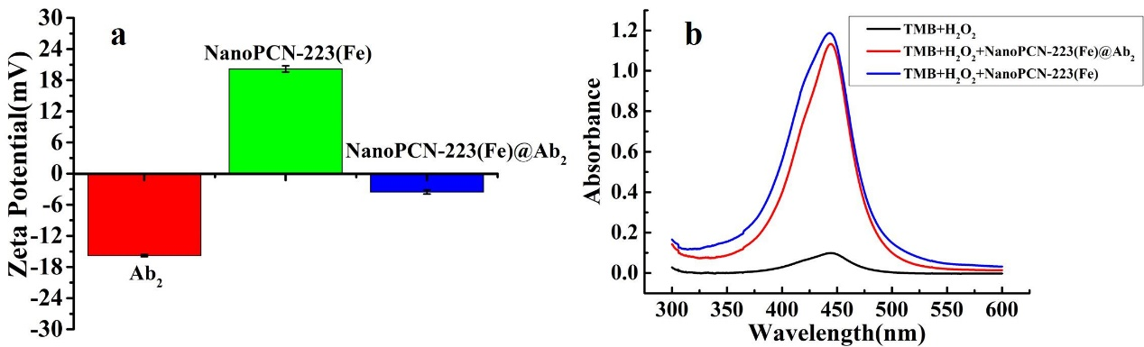
Fig S1. (a)The δ-potential of NanoPCN-223(Fe), Ab2 and NanoPCN-223(Fe)@Ab2. (b) Absorption spectra of each reaction systems.

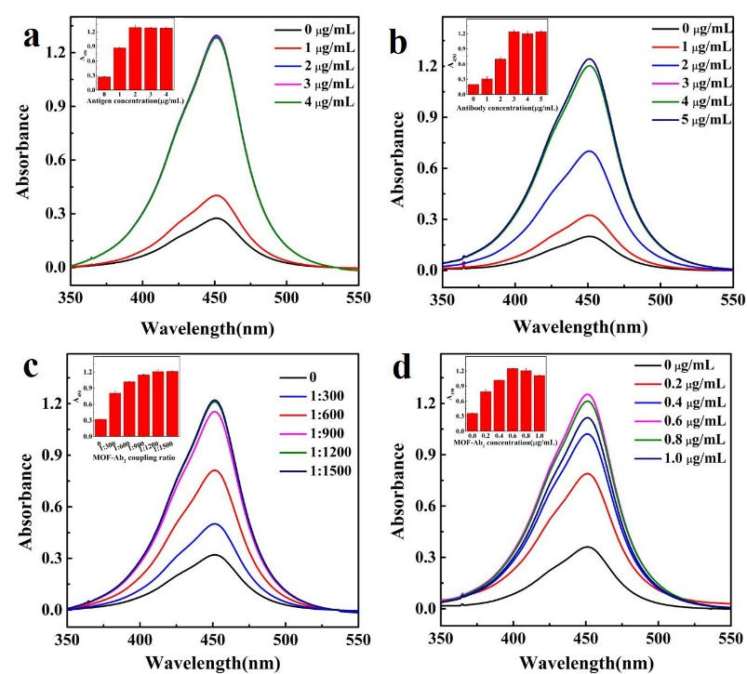
Fig S2. (a) Absorbance of different antigen concentration systems. (b) The absorbance of different antibody concentration systems. (c) The absorbance of different NanoPCN-222(Fe)-Ab2 coupling ratio systems. (d)The absorbance of different NanoPCN-222(Fe)@Ab2 concentration systems.

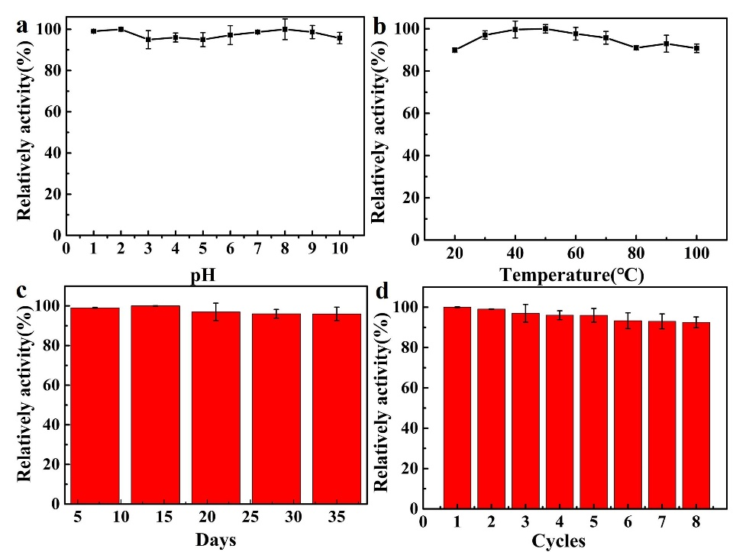
Fig. S3 The catalytic relative activity of NanoPCN-223(Fe) MOF with different pH (a), different temperature (b), different storage time (c) and eight NanoPCN-223(Fe) catalytic cycles treatment (d). (TMB, 1mM; NanoPCN-223(Fe), 0.01 mg/mL; H₂O₂, 10 μM; NaAc-HAc buffer, pH=4, 0.2 M).

References
A JK, B CL, A JC (2015) Highly sensitive SERS-based immunoassay of aflatoxin B1 using silica-encapsulated hollow gold nanoparticles. J Hazard Mater 285: 11-17. https://dx.doi.org/10.1016/j.jhazmat.2014.11.018
Aghayan M, Mahmoudi A, Nazari K, Dehghanpour S, Sohrabi S, et al (2019) Fe(III) porphyrin metal-organic framework as an artificial enzyme mimics and its application in biosensing of glucose and H2O2. J Porous Mater 26: 1507-1521. https://dx.doi.org/10.1007/s10934-019-00748-4
Ammida NHS, Micheli L, Piermarini S, Moscone D, Palleschi G (2006) Detection of Aflatoxin B1in Barley: Comparative Study of Immunosensor and HPLC. Anal Lett 39: 1559-1572. https://dx.doi.org/10.1080/00032710600713248
Fang H, Zhan S, Feng L, Chen X, Guo Q, et al (2021) Chemical modification of M13 bacteriophage as nanozyme container for dramatically enhanced sensitivity of colorimetric immunosensor. Sens Actuators B Chem 346: 130368. https://dx.doi.org/10.1016/j.snb.2021.130368
Feng D, Gu Z-Y, Li J-R, Jiang H-L, Wei Z, Zhou H-C (2012) Zirconium-Metalloporphyrin PCN-222: Mesoporous Metal-Organic Frameworks with Ultrahigh Stability as Biomimetic Catalysts. Angew Chem Int Ed 51: 10307-10310. https://dx.doi.org/10.1002/anie.201204475
Guo Y, Zhou Y, Xiong S, Zeng L, Huang X, et al (2020) Natural enzyme-free colorimetric immunoassay for human chorionic gonadotropin detection based on the Ag+-triggered catalytic activity of cetyltrimethylammonium bromide-coated gold nanoparticles. Sens Actuators B Chem 305: 127439. https://dx.doi.org/10.1016/j.snb.2019.127439
Gurmessa SK, Tufa LT, Kim J, Lee K-I, Kim Y-M, et al (2021) Colorimetric Detection of Mycobacterium tuberculosis ESX-1 Substrate Protein in Clinical Samples Using Au@Pd Nanoparticle-Based Magnetic Enzyme-Linked Immunosorbent Assay. ACS Appl Nano Mater 4: 539-549. https://dx.doi.org/10.1021/acsanm.0c02833
Hou S, Ma J, Cheng Y, Wang H, Sun J, Yan Y (2020) Quantum dot nanobead-based fluorescent immunochromatographic assay for simultaneous quantitative detection of fumonisin B-1, dexyonivalenol, and zearalenone in grains. Food Control 117: 107331. https://dx.doi.org/10.1016/j.foodcont.2020.107331
Huang Y, Zhu F, Guan J, Wei W, Zou L (2021) Label-Free Amperometric Immunosensor Based on Versatile Carbon Nanofibers Network Coupled with Au Nanoparticles for Aflatoxin B-1 Detection. Biosensors (Basel) 11: 5. https://dx.doi.org/10.3390/bios11010005
Lai W, Zeng Q, Tang J, Zhang M, Tang D (2018) A conventional chemical reaction for use in an unconventional assay: A colorimetric immunoassay for aflatoxin B1 by using enzyme-responsive just-in-time generation of a MnO2 based nanocatalyst. MICROCHIM ACTA 185: 2. https://dx.doi.org/10.1007/s00604-017-2651-z
Li J, Cai T, Li W, Li W, Zheng T (2020) Highly Sensitive Simultaneous Detection of Multiple Mycotoxins Using a Protein Microarray on a TiO 2 -Modified Porous Silicon Surface. J Agric Food Chem 69: 528-536. https://dx.doi.org/10.1021/acs.jafc.0c06859
Liu F, He J, Zeng M, Hao J, Guo Q, et al (2016) Cu–hemin metal-organic frameworks with peroxidase-like activity as peroxidase mimics for colorimetric sensing of glucose. J Nanopart Res 18: 106. https://dx.doi.org/10.1007/s11051-016-3416-z
Mukherjee M, Manonmani HK, Bhatt P (2018) Aptamer as capture agent in enzyme-linked apta-sorbent assay (ELASA) for ultrasensitive detection of Aflatoxin B1. Toxicon 156: 28-33. https://dx.doi.org/10.1016/j.toxicon.2018.11.001
Ren M, Xu H, Huang X, Kuang M, Xiong Y, et al (2014) Immunochromatographic Assay for Ultrasensitive Detection of Aflatoxin B-1 in Maize by Highly Luminescent Quantum Dot Beads. ACS Appl Mater Interfaces 6: 14215-14222. https://dx.doi.org/10.1021/am503517s
Tan Y, Chu X, Shen G-L, Yu R-Q (2009) A signal-amplified electrochemical immunosensor for aflatoxin B1 determination in rice. Anal Biochem 387: 82-86. https://dx.doi.org/10.1016/j.ab.2008.12.030
Wang J, Chen Q, Jin Y, Zhang X, He L, et al (2020) Surface enhanced Raman scattering-based lateral flow immunosensor for sensitive detection of aflatoxin M-1 in urine. Anal Chim Acta 1128: 184-192. https://dx.doi.org/10.1016/j.aca.2020.06.076
Wu L, Zhou M, Wang Y, Liu J (2020) Nanozyme and aptamer- based immunosorbent assay for aflatoxin B1. J Hazard Mater 399: 123154. https://dx.doi.org/10.1016/j.jhazmat.2020.123154
Xu Z, Long L-L, Chen Y-Q, Chen M-L, Cheng Y-H (2021) A nanozyme-linked immunosorbent assay based on metal-organic frameworks (MOFs) for sensitive detection of aflatoxin B1. Food Chem 338: 128039-128039. https://dx.doi.org/10.1016/j.foodchem.2020.128039
Zhan S, Hu J, Li Y, Huang X, Xiong Y (2021) Direct competitive ELISA enhanced by dynamic light scattering for the ultrasensitive detection of aflatoxin B-1 in corn samples. Food Chem 342: 128327. https://dx.doi.org/10.1016/j.foodchem.2020.128327
Zhang W, Tang S, Jin Y, Yang C, He L, et al (2020) Multiplex SERS-based lateral flow immunosensor for the detection of major mycotoxins in maize utilizing dual Raman labels and triple test lines. J Hazard Mater 393: 122348. https://dx.doi.org/10.1016/j.jhazmat.2020.122348
Zhang X, Yu Y, Shen J, Qi W, Wang H (2019) Fabrication of polyethyleneimine-functionalized reduced graphene oxide-hemin-bovine serum albumin (PEI-rGO-hemin-BSA) nanocomposites as peroxidase mimetics for the detection of multiple metabolites. Anal Chim Acta 1070: 80-87. https://dx.doi.org/https://doi.org/10.1016/j.aca.2019.04.028

