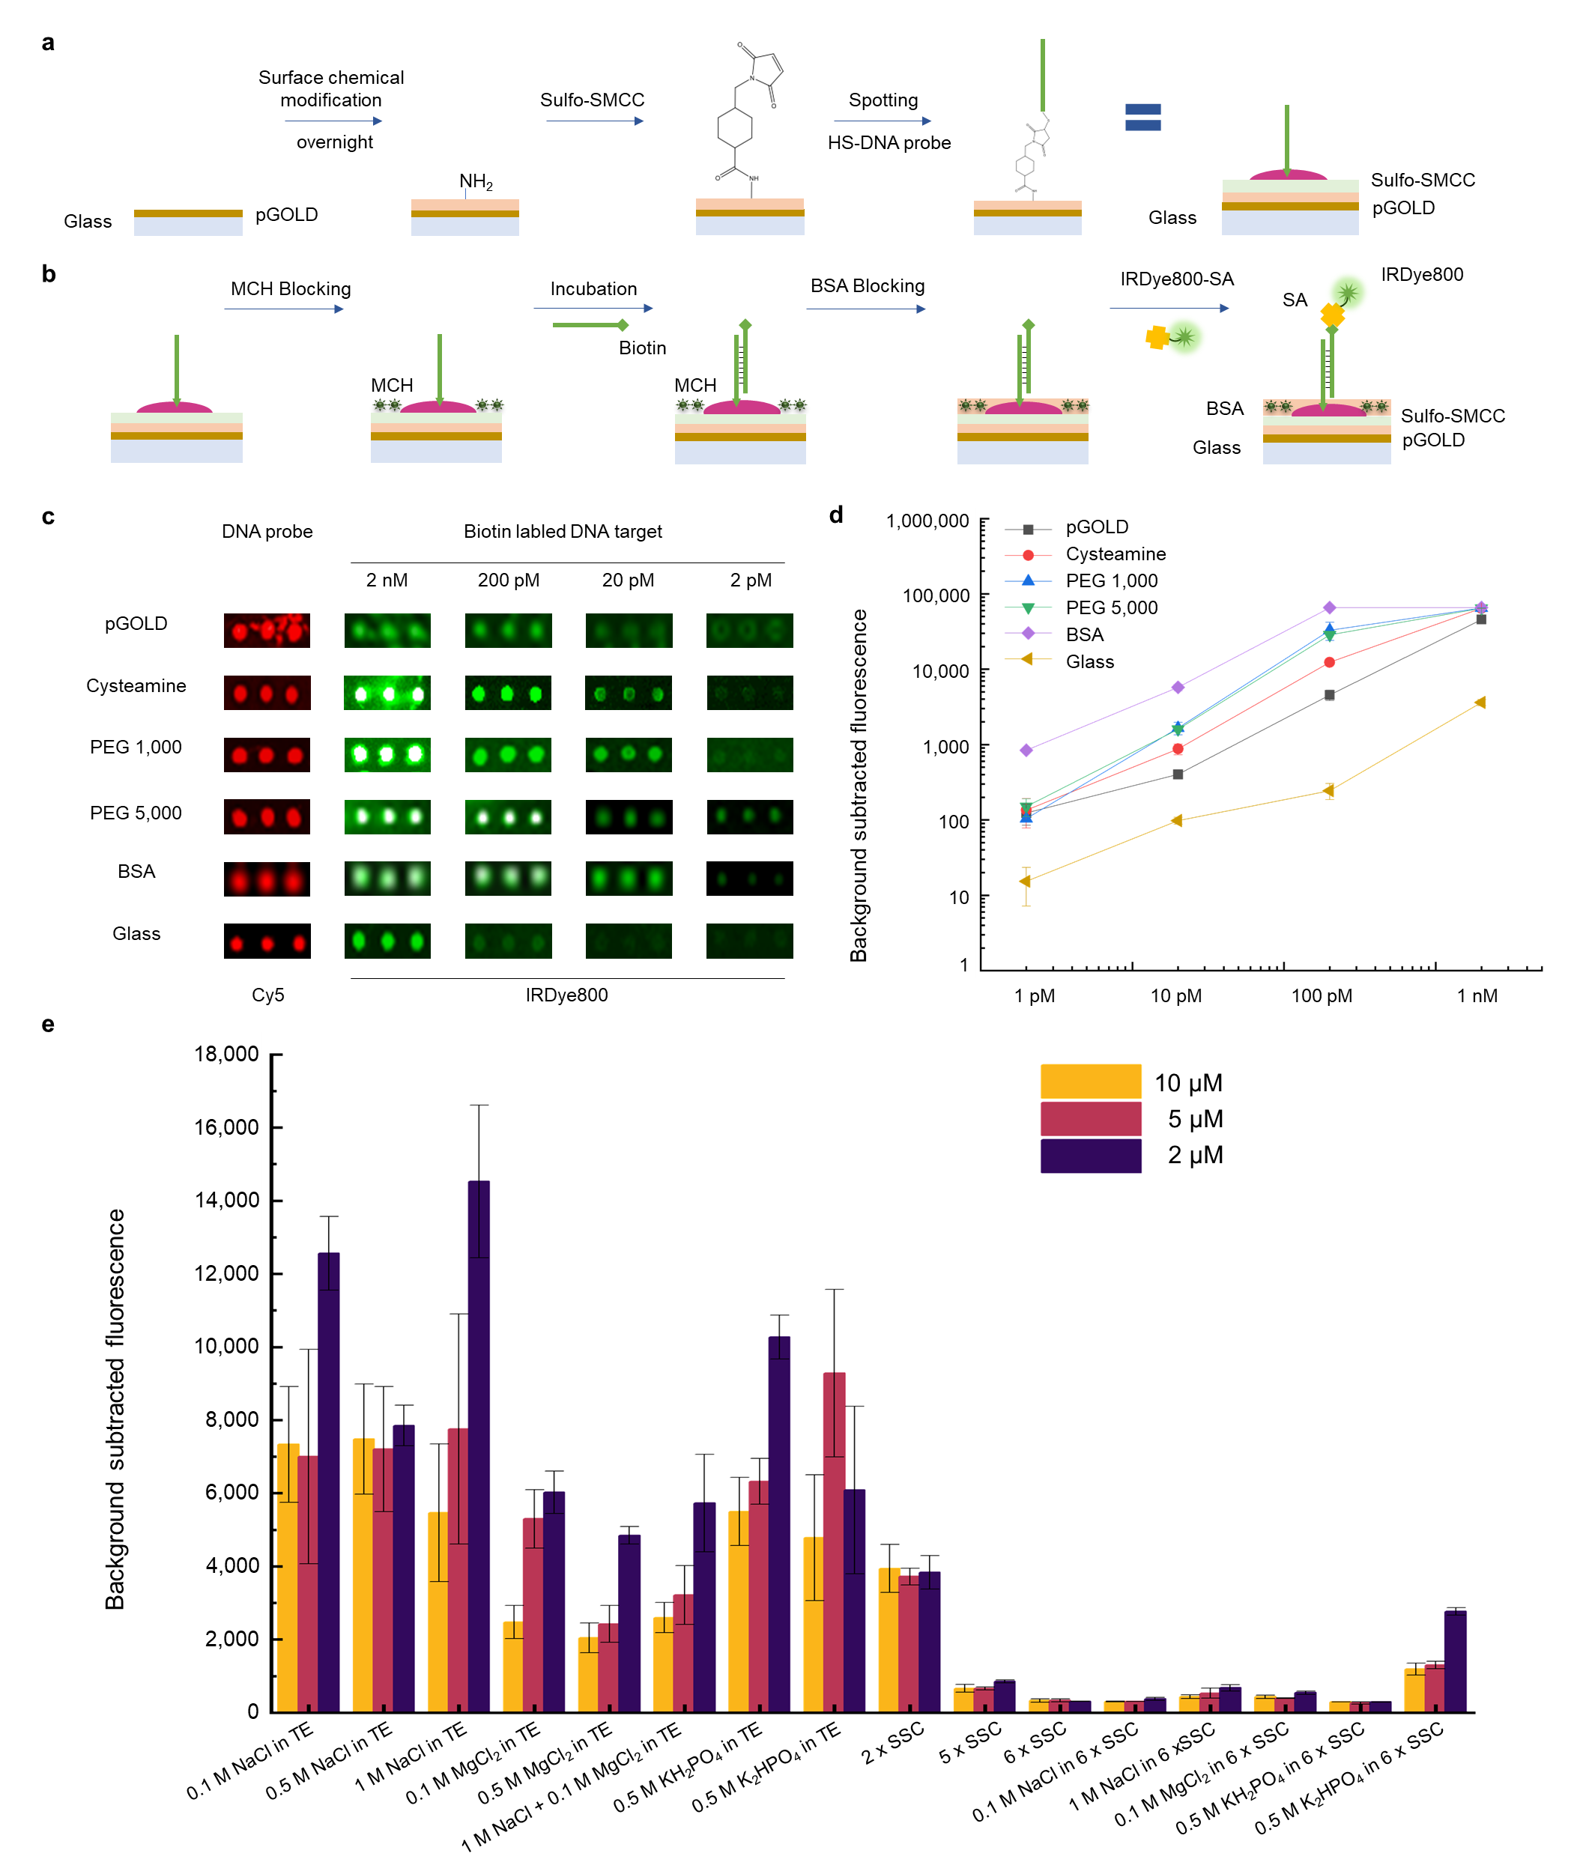

Extended Data Fig. 1 | Constructing DNA microarray on modified pGOLD substrate. a. Schematic of surface chemical modification on pGOLD substrate and construction of FEMMAN chip with N501N-probe (Supplementary Table 2). b. Detailed molecular schematic of DNA detection without amplification. c. IRDye800 fluorescence image of a typical titration curve for N501N-target-20 nt (Supplementary Table 4) detection from 2 nM to 2 pM on bare pGOLD substrate, cysteamine modified pGOLD substrate, PEG (Mw = 1,000) modified pGOLD substrate, PEG (Mw = 5,000) modified pGOLD substrate, BSA modified pGOLD substrate and glass substrate. d. Fluorescence quantification of DNA titration on the six substrates. e. Optimization of binding buffer in DNA hybridization, 10 μM, 5 μM and 2 μM represented the DNA probe concentration used in spotting.

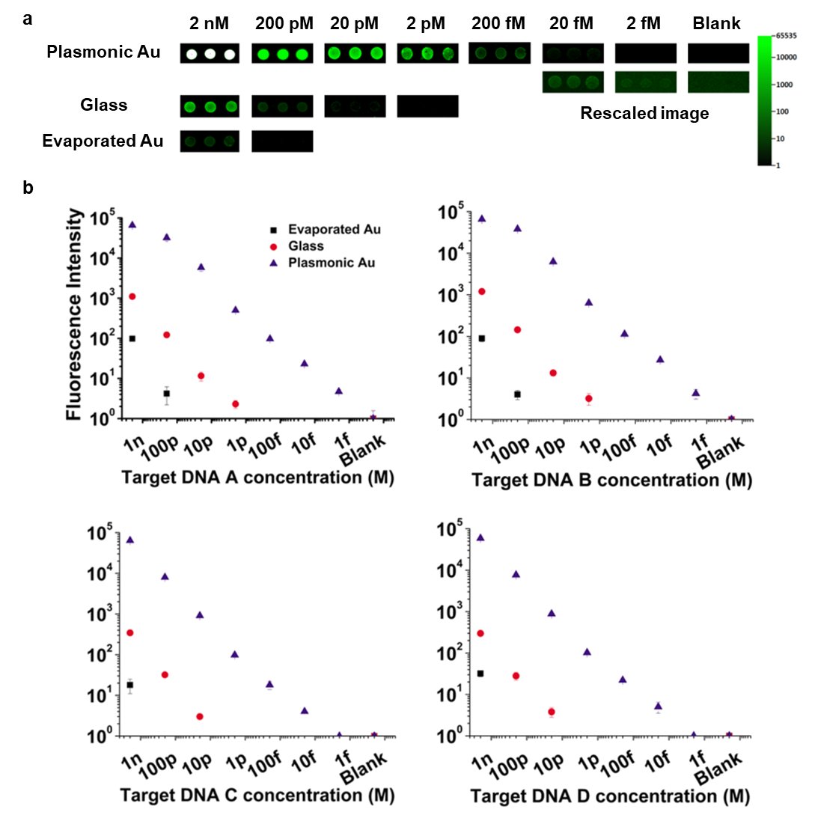

Extended Data Fig. 2 | DNA detection on FEMMAN chip reaching femto-molar sensitivity without amplification. a. IRDye800 fluorescence images of a typical titration curve for a 22 nt DNA target (Target A in Supplementary Table 4) detection from 2 nM to 2 fM on pGOLD substrate, glass substrate and evaporated Au film with Probe A (Supplementary Table 2). b. Fluorescence quantification of DNA titration on the three substrates for 4 DNA sequences (Probe A, B, C & D in Supplementary Table 2, Target A, B, C & D in Supplementary Table 4).

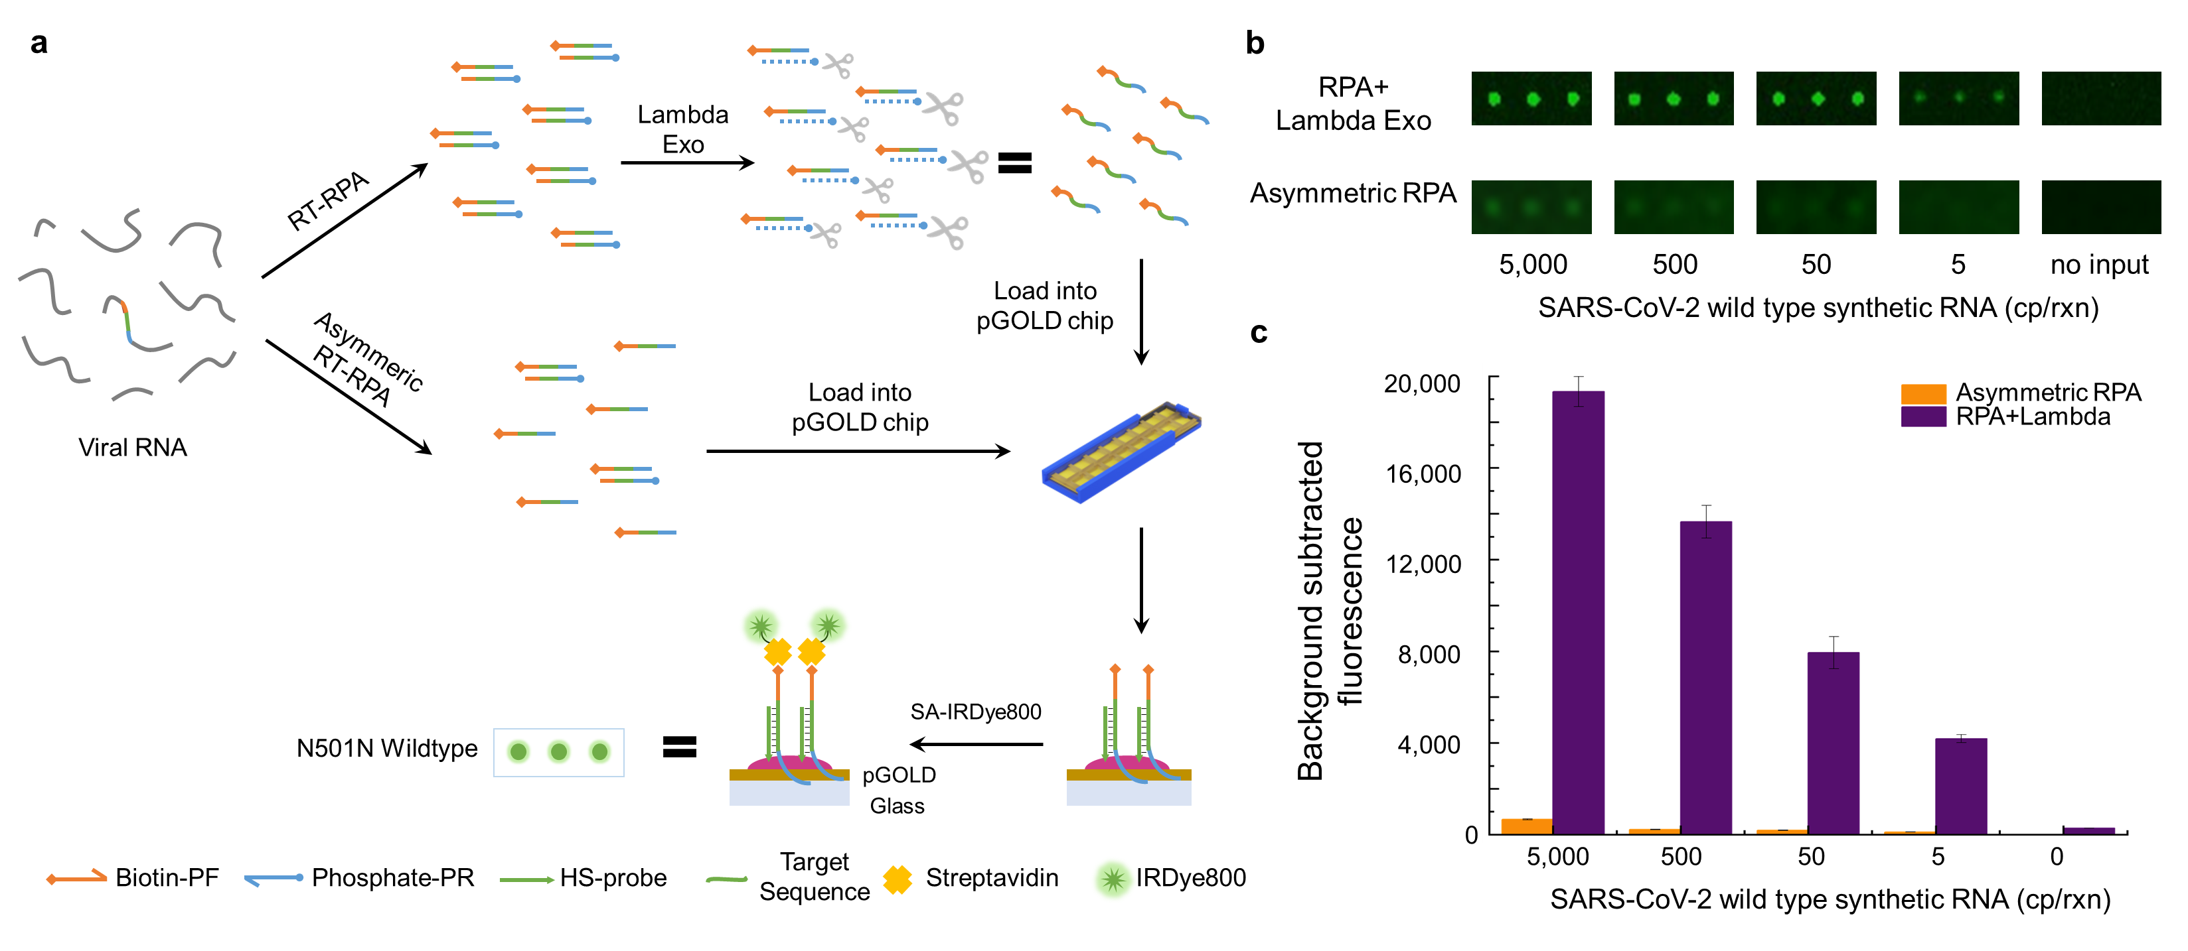

Extended Data Fig. 3 | Simplified alternative route with asymmetric RPA and comparison to RPA with Lambda Exonuclease digestion. a. Detailed molecular schematic of SARS-CoV-2 wild type viral RNA detection using FEMMAN combined with RPA & Lambda Exonuclease digestion or asymmetric RPA. b. IRDye800 fluorescence images and c. fluorescence quantification of SARS-CoV-2 detection by FEMMAN combined with RPA & Lambda Exonuclease or asymmetric RPA with viral RNA concentration from 5,000 to 5 copies per reaction.

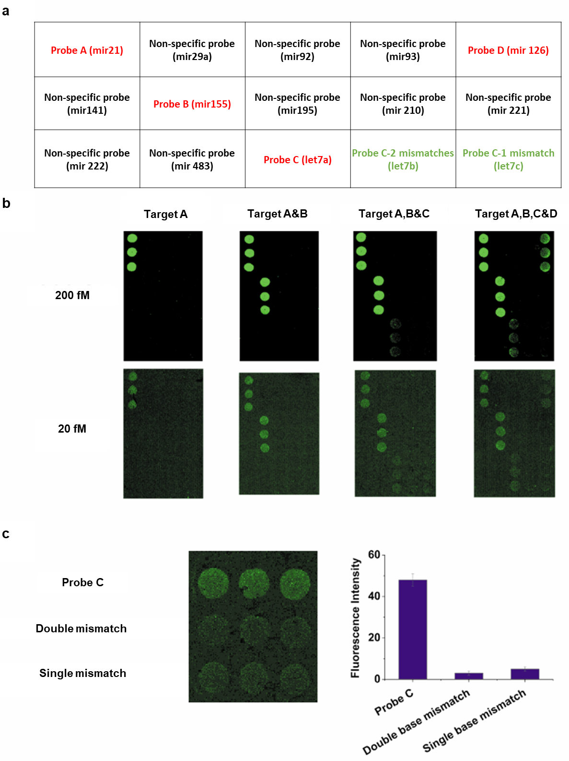

Extended Data Fig. 4 | Multiplexed DNA sensing on FEMMAN chip. a. DNA probe layout on FEMMAN chip (sequences listed in Supplementary Table 2). b. IRDye800 fluorescence images for multiplexed DNA microarray when different combination of DNA targets (Target A, B, C & D in Supplementary Table 4) at 200 fM/20 fM were probed. c. Fluorescence image (left) and signal quantification (right) of DNA hybridization selectivity test for single base pair (Probe C-1 mismatch) and double base pair mismatch (Probe C-2 mismatch).

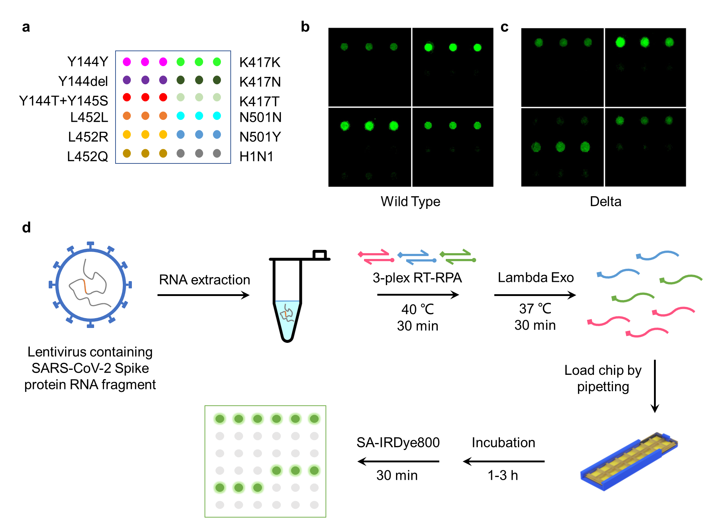

Extended Data Fig. 5 | SARS-CoV-2 panel verification by reference material of viral RNA. a. Layout of DNA array for SARS-CoV-2 panel with 4 sites (Y144-145, K417, L452 and N501, Sequences listed in Supplementary Table 2). IRDye800 fluorescence images for synthetic RNA of SARS-CoV-2 b. wild type and c. Delta variant detection by FEMMAN assay with quadruple RPA. Block in top left corner represent G142-Y145 target site, block in top right corner represent K417 target site, block in left bottom corner represent L452 target site, and block in right bottom corner represent N501 target site and negative control (H1N1). d. Schematic of lentivirus detection by FEMMAN-RPA with extracted RNA.

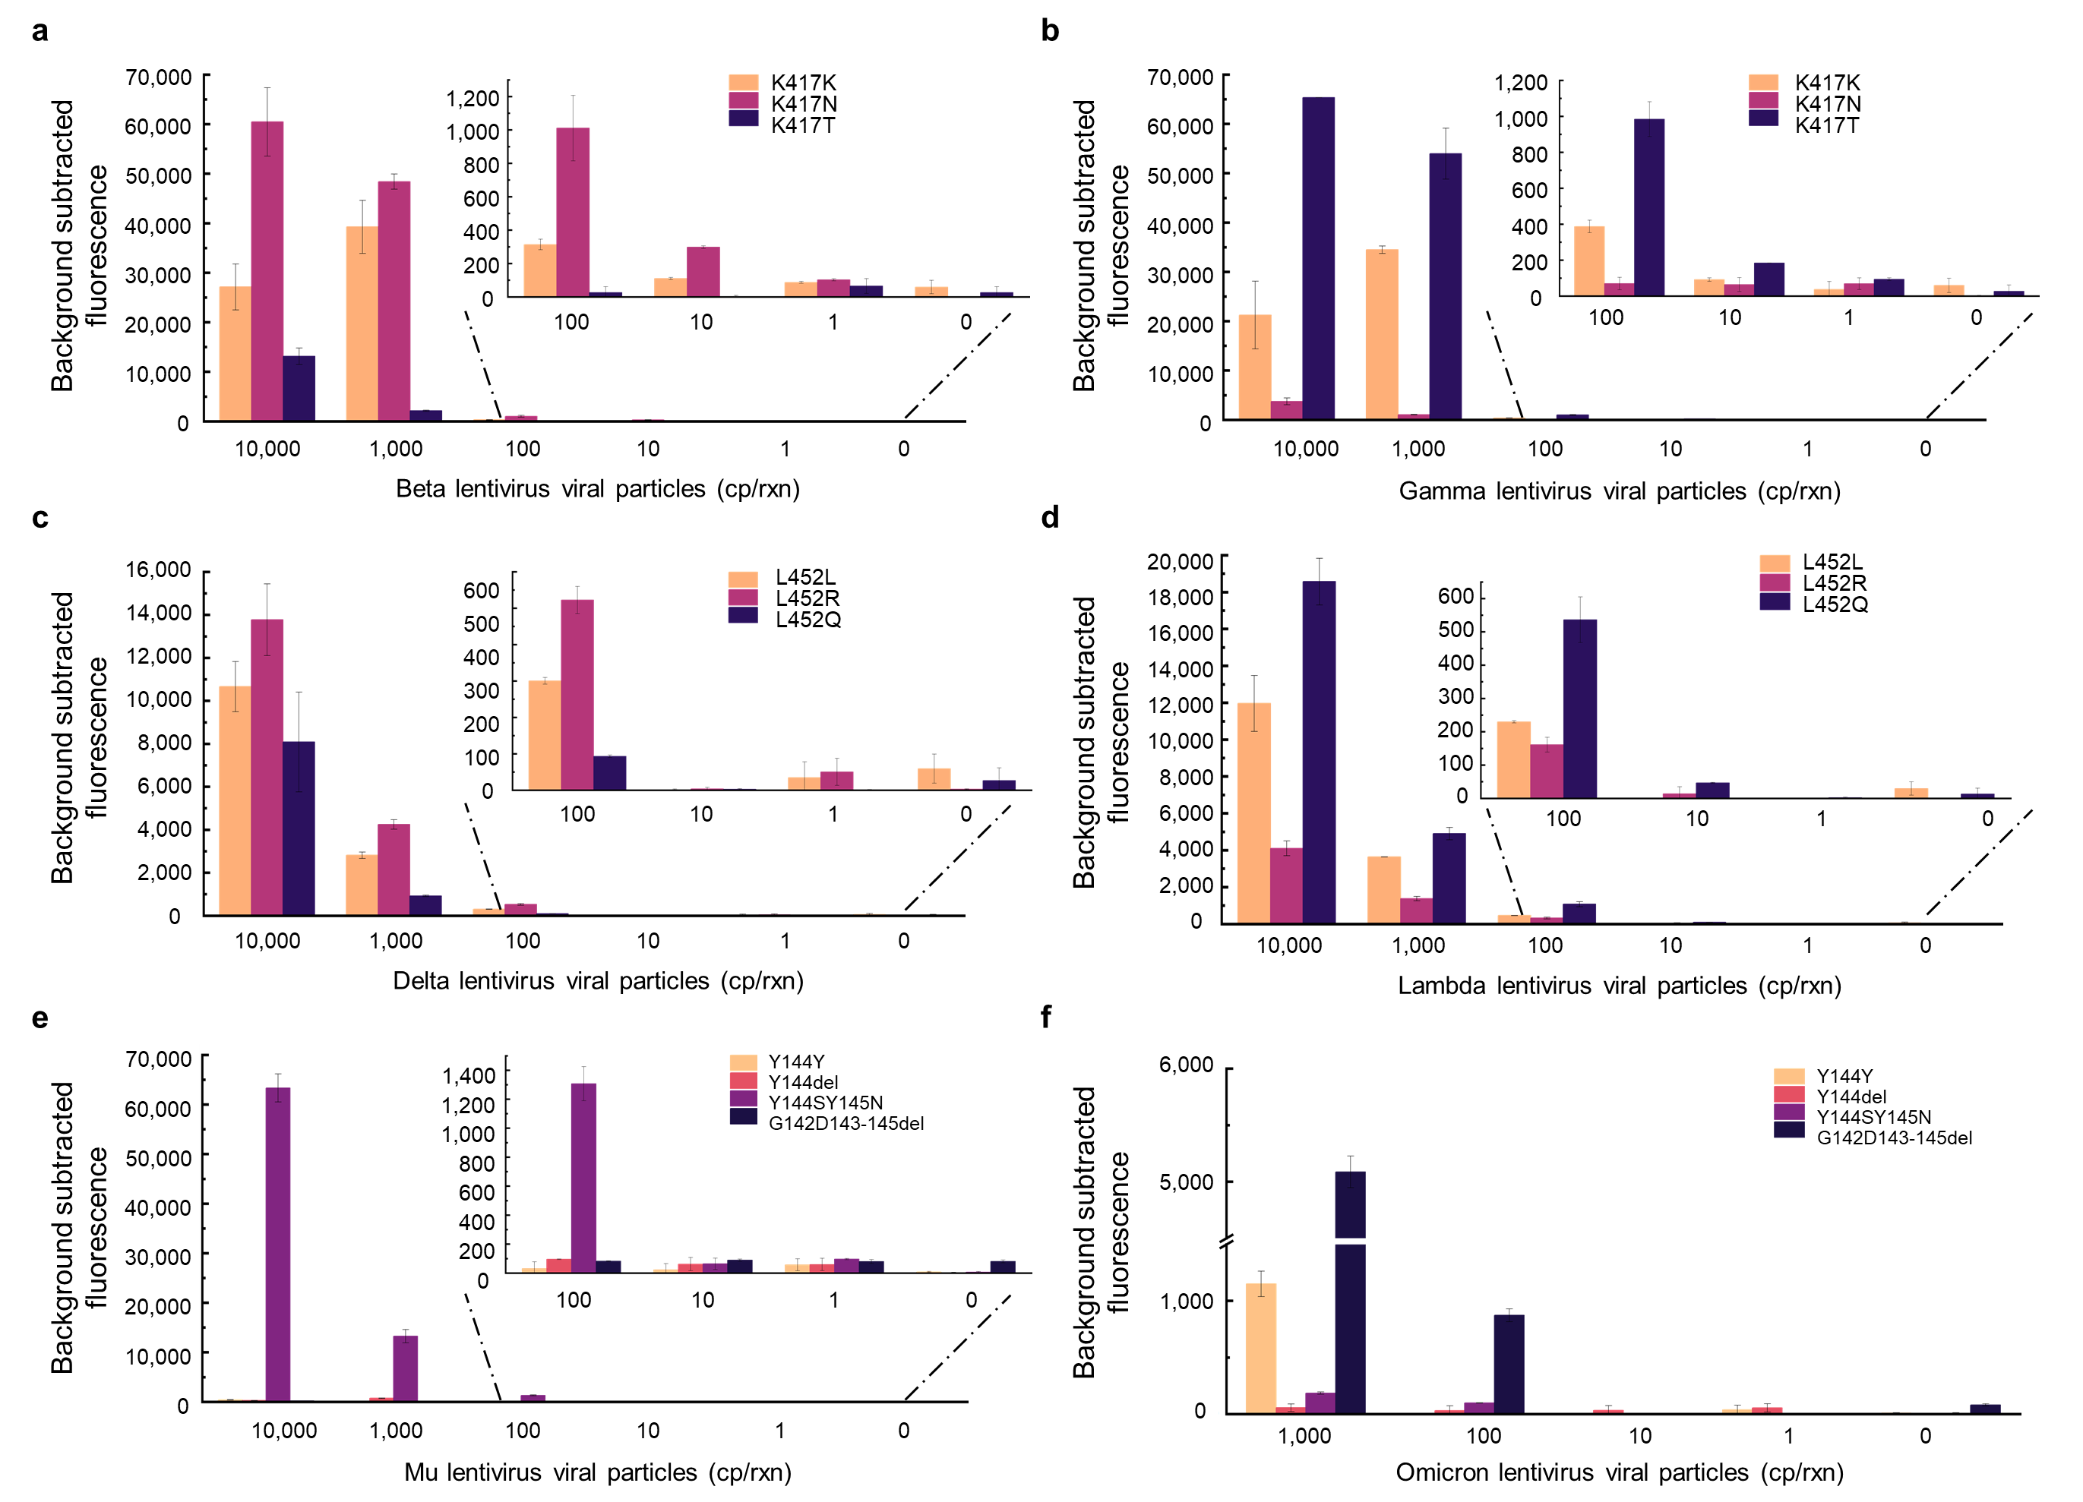

Extended Data Fig. 6 | SARS-CoV-2 lineage identification by FEMMAN-RPA with gradually diluted thermal lysed lentivirus sample. Fluorescence intensity statistics of K417 site for SARS-CoV-2 a. Beta variant and b. Gamma variant, L452 site for c. Delta variant and d. Lambda variant, G142-Y145 site for e. Mu variant and f. Omicron variant detected by FEMMAN-RPA from 10,000 copies/rxn or 1,000 copies/rxn to 1 copies/rxn. Lentiviruses of Beta, Gamma, Delta, Lambda and Mu were applied at 10,000 and gradually diluted to 1 copies/μL, lentivirus of Omicron was applied at 1,000 and gradually diluted to 1 copies/μL, measured by ddPCR.

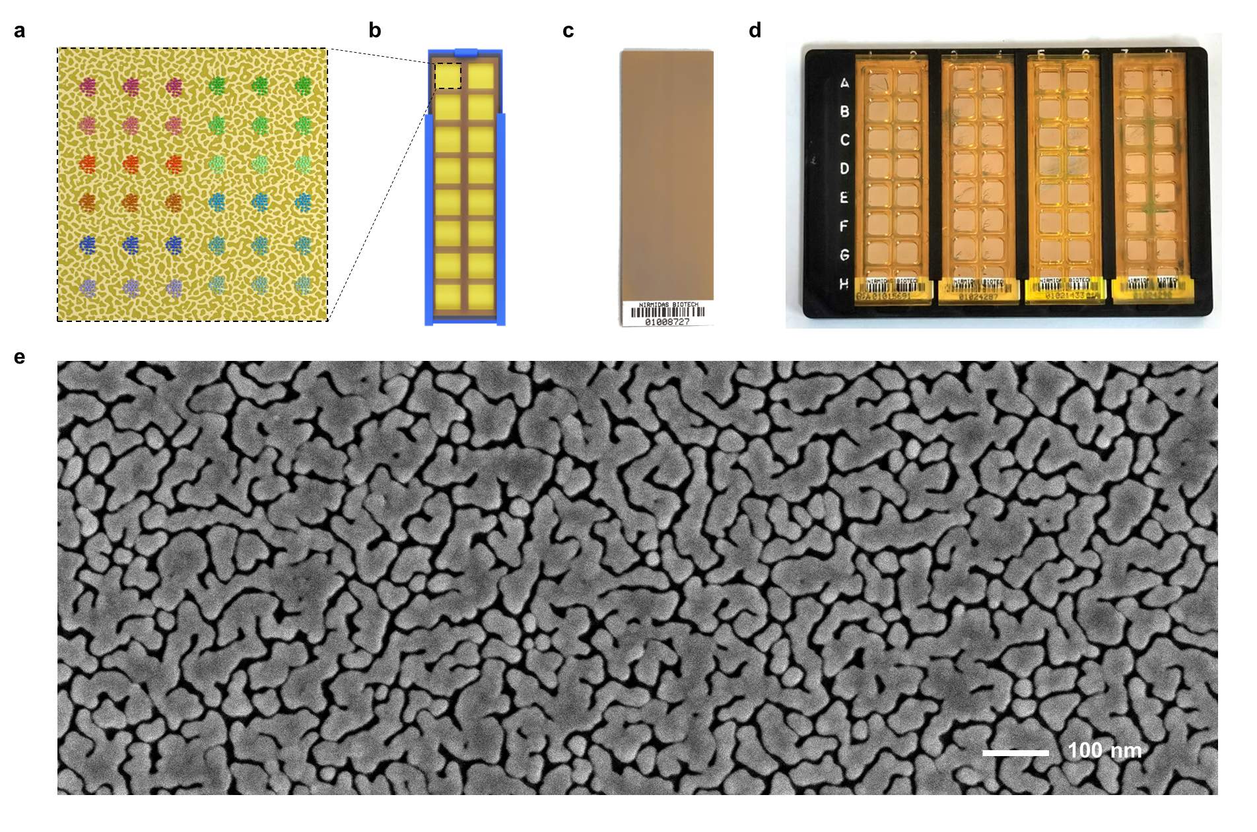

Extended Data Fig. 7 | Construction and characterization of FEMMAN chip. a. Layout of DNA array on FEMMAN chip. b. Schematic of a standard FEMMAN chip in frame for detection. c. Photograph of a standard pGOLD chip. d. Photograph of a standard detection set with 4 chips. e. Top-view SEM image of pGOLD chip (randomly selected).

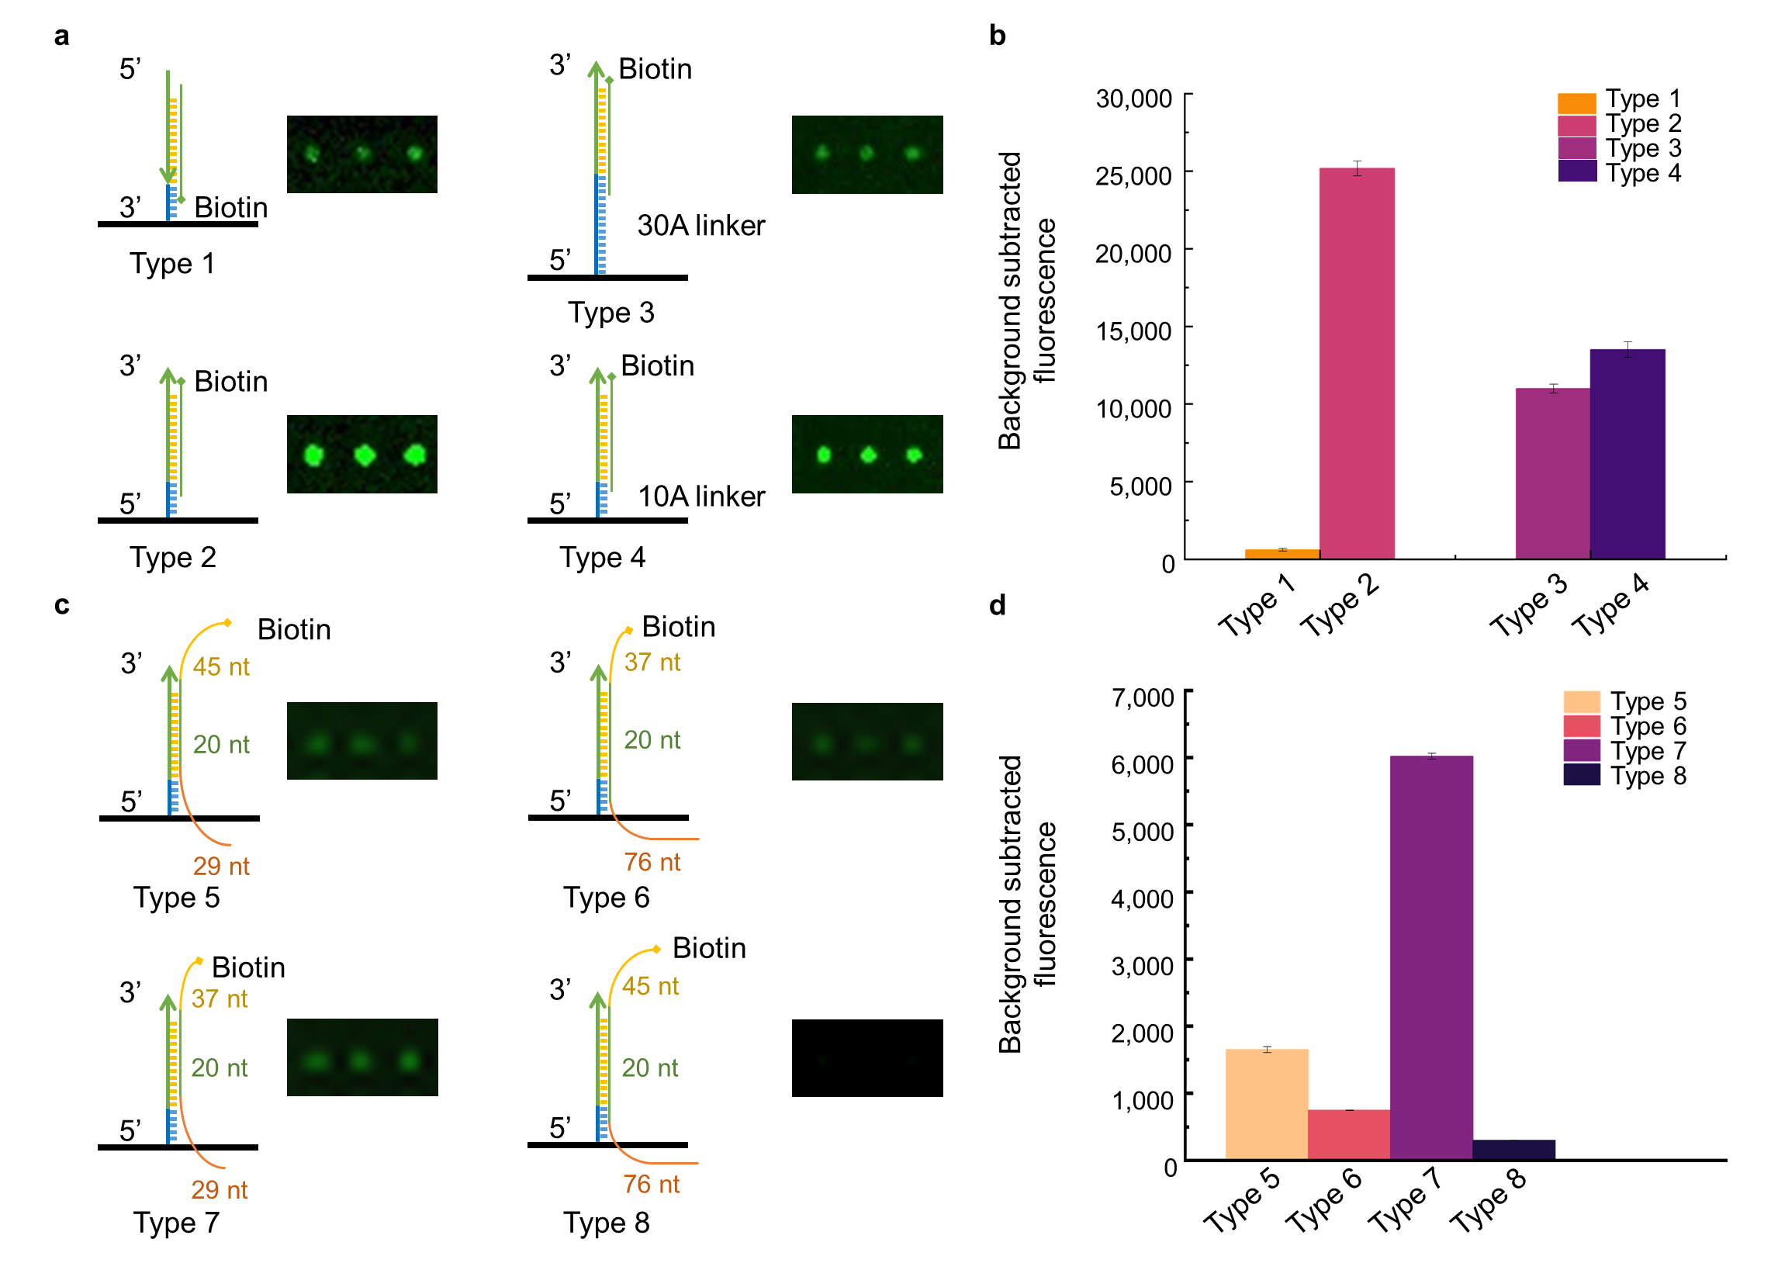

Extended Data Fig. 8 | Simulation and optimization of amplicon captured by DNA probe on FEMMAN chip. a. Schematic and corresponding IRDye800 fluorescence images of 20 nt DNA target (N501N-target-20 nt in Supplementary Table 4) detection on FEMMAN chip. DNA probes in Type 1 (Type 1-probe in Supplementary Table 2) and Type 2 (N501N-probe in Supplementary Table 2) had reverse direction for DNA target hybridization. The spacer containing 10 Adenosine bases (dA10) was inserted between DNA probe and thiol group in Type 4 (N501N-probe in Supplementary Table 2) and dA30 in Type 3 (Type 3-probe in Supplementary Table 2). b. Fluorescence quantification comparison between Type1 & Type 2, and Type 3 & Type 4. c. Schematic and corresponding IRDye800 fluorescence images of amplicon detection on FEMMAN chip. The forward primer used for Type 5 and Type 8 was N501-RPA-FP1, for Type 6 and Type 7 was N501-RPA-FP2; The reverse primer used for Type 6 and Type 8 was N501-RPA-RP1, for Type 5 and Type 7 was N501-RPA-RP2 (primer sequence in Supplementary Table 1, target sequence in Supplementary Table 4). d. Fluorescence quantification of Type5, Type 6, Type 7, and Type 8.

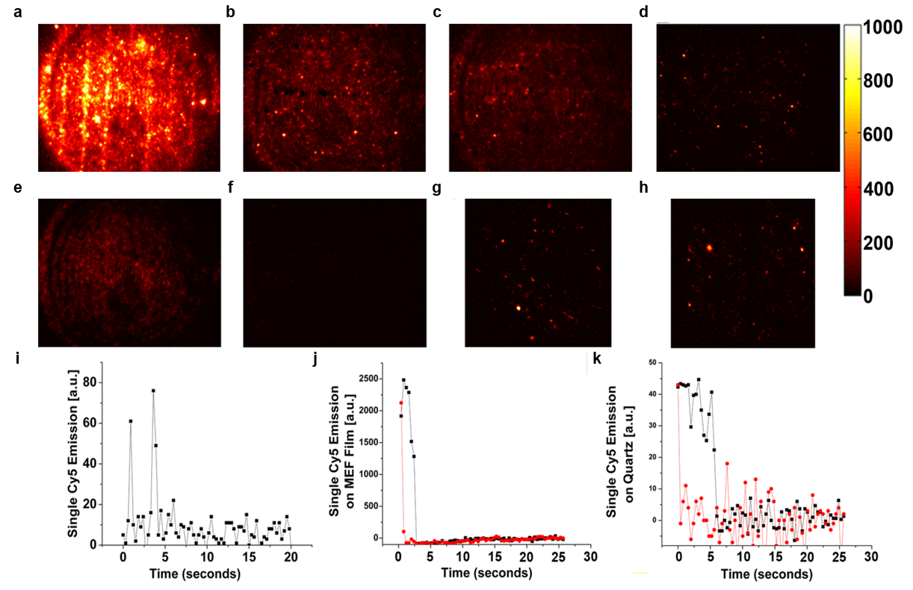

Extended Data Fig. 9 | Fluorescence imaging of DNA chip with Cy5 labeling. Fluorescence images of Cy5 on pGOLD substrate at a. 200 pM, b. 20 pM, c. 2 pM, and d. 200 fM compared to a quartz substrate at e. 200 pM and f. 20 pM. The Cy5 fluorophore density at 20 pM on both the g. plasmonic substrate and h. the quartz substrate was comparable. i. Single Cy5 blinking events were observed on the 20 pM pGOLD substrate using a lower 658 nm laser power (60 mW) while representative photobleaching curves on both the j. pGOLD and k. quartz substrate were obtained using a high 658 nm laser power (120 mW) and indicated a ~ 50 × enhancement factor on the pGOLD substrate.

Extended Data Table 1. Consumables cost calculation concerning FEMMAN-RPA
SARS-CoV-2 panel
Category | Cost (USD) | Number of tests | Cost per test (USD)
pGOLD | 47.10 | 14 | 3.36
BSA | 237.19 | 1,000 | 0.24
probes | 595.29 | 125,000 | 0.00
Reagents used in spotting | 346.94 | 6,400 | 0.10
RPA & Lambda Exo
Category | Cost (USD) | Number of tests | Cost per test (USD)
RPA kit | 241.76 | 240 | 1.01
R.T. & R.I. | 118.84 | 100 | 1.19
primers | 225.56 | 1,500 | 0.15
Lambda Exo | 96.58 | 200 | 0.48
FEMMAN assay
Category | Cost (USD) | Number of tests | Cost per test (USD)
SA-IRDye800 | 442.70 | 22,250,000 | 0.00
TE buffer | 7.79 | 160 | 0.05
PBS buffer | 5.49 | 160 | 0.03
Reagents used in assay | 15.70 | 2,500 | 0.01
 |  | Sum (per sample) | 6.62

