Supplementary Information for

Light-matter-interaction beyond Born-Oppenheimer approximation mediated by stimulated phonon polaritons

Yao Lu,¹ Qiang Wu,^{1,*} Hao Xiong,¹ Xu Zhou,¹ Zhixuan Li,¹ Jiwei Qi,^{1,#} Xitan Xu,¹ Ruobin Ma,¹ Jiang Fan,¹ Zhigang Chen,^{1,‡} and Jingjun Xu^{1,†}

¹ The Key Laboratory of Weak-Light Nonlinear Photonics, Ministry of Education, TEDA Applied Physics Institute and School of Physics, Nankai University, Tianjin 300457, China
* wuqiang@nankai.edu.cn
# qijw@nankai.edu.cn
‡ zgchen@nankai.edu.cn
† jjxu@nankai.edu.cn

- Fabrication of the LN photonic crystal
We use the femtosecond (fs) laser direct writing technique to fabricate the microcavity structure used in our experiment¹. About 2 $μ$m protective coatings (SiO₂) are deposited on both surfaces of the LiNbO₃ slab. Subsequently, 5 $μ$J fs-laser pulses (amplified Ti:sapphire laser pulses, 800 nm central wavelength, 120 fs duration, 1 kHz repetition rate) are focused with a 0.25 NA objective to a spot size of approximately 4 $μ$m and then used to mill the microcavity. A three-dimensional translation stage holds the 50 $μ$m-thick LiNbO₃ slab and is programmed to move laterally such that the outline of a circle is irradiated and drilled through the depth of the slab. Repeated operations of this sort are used to carve a series of periodic structures. After machining, the SiO₂ layers are removed with a hydrofluoric acid solution, which also removes any LiNbO₃ debris that is ejected during the machining process. These steps guarantee an optical-quality surface.
- Generation and probing of the THz PhPs
The experiments are carried out using a Ti:sapphire fs laser system with a central wavelength of 800 nm, a repetition rate of 1 kHz, and a pulse duration of about 120 fs. As shown in Supplementary Fig. 1, the laser output is split into a pump-pulse (400 $μ$J) and a probe-pulse (frequency-doubled, 400 nm, 50 $μ$J), which can be delayed relative to one another.
The pump pulse is directed to a mechanical time-delay line, and then line-focused into the center of the microcavity by a cylindrical lens with a focal length of 15 cm. After the pump pulses enter the sample, the THz PhPs are generated by a nonlinear optical process. Due to the polarization of the pump pulse being chosen parallel with the optical axis of the sample ($z$-direction), the generated THz pulses mainly propagate as the transverse electric modes of the slab microcavity. Here, the time-dependent information is obtained by adjusting the time delay of the pump pulse.
Supplementary Fig. 1: Experimental scheme of generation and time-resolved imaging of THz PhPs. The schematic shows the pump-probe design and the time-resolved phase-contrast imaging technique. BS: beam splitter; TD: time delay line; M: mirror; CyL: cylindrical lens; HWP: half-wave plate; P: polarizer; CL: convex lens; PH: pinhole; LN: LiNbO₃ sample; PP: $λ$/4 phase plate.

The generated THz PhPs propagate along the $x$-direction in the microcavity². In order to visualize this field, a probe beam is employed that is spatially filtered and expanded to homogeneously illuminate the entire sample. This beam propagates in the $y$-direction through the sample of thickness $l$ and thereby gathers an integral phase shift of $Δϕ_{probe}\left(x,z\right)$. Because the refractive index of the LiNbO₃ at a THz frequency is higher, it propagates slower than the probe beam. Thus, this integral phase-shift maps approximately the effective projection $E_{THz}\left(x,z\right)$ of the electric field of the THz PhPs along the beam path, i.e., it is more or less the integral of the electric field along the beam path. The relation between this projection field $E_{THz}\left(x,z\right)$ and the phase-shift is given by the following equation:
$$Δϕ_{probe}\left(x,z\right)=2π\frac{l}{λ_{probe}}Δn\left(x,z\right)=2π\frac{l}{λ_{probe}}\frac{n_{e}^{3}r_{33}}{2}E_{THz}\left(x,z\right),$$ | (S1)
where $l$ is the thickness of the sample and $λ_{probe}$ is the wavelength of the probe beam. The extraordinary polarization is chosen for all the electromagnetic fields, i.e., the pump, probe, and the THz waves, to achieve an optimum signal for the LiNbO₃ crystal under investigation. Accordingly, $n_{e}$ and $r_{33}$ denote in Eq. (S1) the (extraordinary) refractive index and the electro-optic coefficient of the LiNbO₃ crystal, respectively.
To make the phase-shift visible, a phase-contrast imaging technique is employed: it consists of a CCD camera together with a 4f system (with two achromatic lenses each having a focal length of 10 cm) and a $λ/4$ phase-plate in the Fourier plane of the system. The phase-plate introduces a $λ/4$ phase-shift to the zero-order diffraction component in the Fourier plane. Thus, the phase image was transformed into an intensity image according to the equation²:
$$I\left(x,z\right)=I_{0}\left(x,z\right)\left\{3-2\left[\cos{Δ}ϕ_{probe}\left(x,z\right)-\sin{Δ}ϕ_{probe}\left(x,z\right)\right]\right\}$$  $$≈I_{0}\left(x,z\right)\left[1+2Δϕ_{probe}\left(x,z\right)\right]$$ | (S2)
where $I_{0}\left(x,z\right)$ is the intensity distribution of the original probe beam (at $Δϕ_{probe}=0$). The phase in the sample is retrieved from:
$$Δϕ_{probe}\left(x,z\right)≈\frac{1}{2}\left[\frac{I\left(x,z\right)}{I_{0}\left(x,z\right)}-1\right]=\frac{1}{2}\frac{ΔI\left(x,z\right)}{I_{0}\left(x,z\right)},$$ | (S3)
with $\text{ΔI}=I-I_{0}$.
- Measurement and simulation of LN complex refractive index
In order to simulate the microcavity without the contribution of the phonon-polariton-based light-matter interaction through FDTD, a reasonable complex refractive index is required.
Considering the strong structural dispersion of the LiNbO₃ slab acting as a subwavelength waveguide, the material dispersion is ignored. Our previous work has demonstrated the rationality of this approximation^{2, 3}, where we compared the propagation mode of experimental results and theoretical ones with material dispersion being ignored, and they showed a very good agreement.
Actually, Wu et al. measured the complex refractive index of LiNbO₃ crystal in 2015, and showed a refractive index of 5.1 and an absorption coefficient of 3.3 cm⁻¹ at 0.4 THz for extraordinary waves⁴. To exclude the fluctuations between different samples, we measure the same LiNbO₃ crystal that we used in the microcavity experiment.
Supplementary Fig. 2: Measurement of the refractive index of LiNbO₃ crystal in our experiment. a Illustration of the scheme to generate THz PhPs from the microcavity structures. b the propagation modes of the PhPs in LiNbO₃ slab. The dashed green curves show the theoretical results of the transverse electric mode in 50 μm LiNbO₃ waveguide, the solid white lines theoretically indicate the light cones in vacuum and bulk LiNbO₃, and the hot-color mapping represents the experimental results. c the propagation decay of THz PhPs (0.4 THz) in LiNbO₃ subwavelength waveguide. The blue circles, orange triangles, and the solid black line indicates the experiment, simulation, and the corresponding fitting, respectively.
As shown in Supplementary Fig. 2a, the THz phonon polaritons (PhPs) out of the microcavity are excited by the fs laser pulses, and the subsequent propagation results are recorded. Similar to the microcavity experiment, the generated THz PhPs are recorded by a time-resolved imaging technique. By analyzing the propagation modes, we find the experimental results agree well with the calculated transverse electric modes (for extraordinary component, $E_{z}$ distribution) in the 50 μm LiNbO₃ waveguide, shown in Supplementary Fig. 2b. The spatiotemporal propagation of the THz PhPs can be described by a discrete function of $E(x,t)$, the propagation modes can be obtained by a two-dimensional Fourier transformation, which is
$${\tilde{E}}_{D}\left(k,ω\right)=\frac{1}{2π}\iint_{0}^{max}{E\left(x,t\right)e^{ikx}e^{-iωt}dxdt}.$$ | (S4)
More details for the methods about the calculation of propagation modes and the theoretical waveguide modes can be found in our previous work³. This result suggests that the real part of the refractive index of LiNbO₃ that we used is $Re\left(n_{e}\right)=5.1$ at 0.4 THz.
The propagation attenuation of the THz PhPs is also recorded. We can apply a one-dimensional Fourier transformation to $E(x,t)$ upon time $t$, so we obtain
$${\tilde{E}}_{A}\left(x,ω\right)=\frac{1}{2π}\int_{0}^{max}{E\left(x,t\right)e^{-iωt}dt}.$$ | (S5)
The result of ${\tilde{E}}_{A}\left(x,ω\right)$ indicates the propagation loss for THz PhPs at each frequency. By selecting 0.4 THz, we can get the experimental attenuation, shown by the blue circles in Supplementary Fig. 2c. Through a fitting by the Beer-Lambert law, we get a decay of -0.37 mm⁻¹ in the LiNbO₃ subwavelength waveguide, shown by the solid black line in Supplementary Fig. 2c.
If a complex refractive index of $n_{e}=5.10+2.20×{10}^{-2}i$ is set in FDTD simulation, an identical decay curve is obtained, shown by the orange triangles in Supplementary Fig. 2c, which demonstrates the rationality of this value.
- SHG measurement of near-infrared laser pulses
Near-infrared fs laser pulses with 120 fs duration, 800 nm central wavelength, and 350 $μ$J energy are employed. A pulse shaper (MIIPS) is used to compensate for the dispersion of the laser pulses to obtain transform-limit pulses (about 90 fs duration). After that, the transform-limit pulses are directed and diffracted by a 1200 mm⁻¹ grating. The incident angle to the blazing grating is about 46°, which yields a tilt angle of about 20° of first-order diffraction light. The diffracted light is focused by a convex lens with a 5 cm focal length and then irradiates the LiNbO₃ sample perpendicularly. After passing through the LiNbO₃ sample, the laser pulses are frequency-doubled and collected by a spectrometer through a convex lens of 15 cm focal length, with the near-infrared components of the transmitted pulses are discarded by a blue filter before collection.
In our setting, the distance between the grating and the lens is about 22 cm, so there is about 1.5 cm distance from the image plane to the focus plane. During collection, the LiNbO₃ sample is moved from the image plane to the focus plane gradually, in which the SHG signal is recorded by each 0.5 mm at low signal regions and each 0.1 mm near the focus plane and image-plane regions. Here, the moving direction cannot be reversed, because the sample will be destroyed immediately after reaching the focus plane.
In order to evaluate the SHG enhancement, we consider the focus process of the laser pulses. The beam waist of 4 mm is about 5 m from lens. After being focused by a 5-cm lens, the beam radius is calculated according to the Gaussian beam theory⁵, and the calculated beam radii are shown in Supplementary Figure 3.
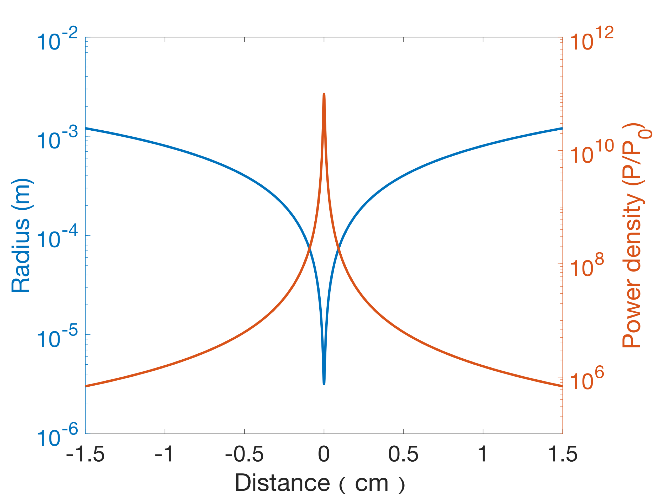
Supplementary Fig. 3: Beam radii of the laser pulses after being focused by a 5-cm lens. The beam radii are shown by the blue curve, while the power density is indicated by orange curve. Zero distance indicates the beam waist of about 3.2 × 10⁻⁶ m at the focus plane, and the image plane at 1.5 cm shows a beam radius of about 1.2 × 10⁻³ m. Power density P is 9.3 × 10¹¹P₀ at the focus plane and 6.9 × 10⁵P₀ at the image plane, with P₀ representing the power density before the lens.

According to SHG formula of $χ^{(2)}∝E_{400}/E_{800}^{2}$, the SHG enhancement is
$$\frac{χ_{IP}^{\left(2\right)}}{χ_{FP}^{\left(2\right)}}=\frac{E_{400,IP}}{E_{400,FP}}⋅\frac{I_{800,FP}}{I_{800,IP}},$$ | (S6)
where the E and I indicate the electric field amplitude and power density, respectively. The subscripts of 400 and 800 represent the wavelengths for the SHG signal and the input laser, respectively. The subscripts of FP and IP show the signals at the focus plane and the image plane, respectively.
The SHG signal ratio as read from Fig. 4 is
$$\frac{E_{400,IP}}{E_{400,FP}}=\sqrt{\frac{I_{400,IP}}{I_{400,FP}}}=0.36.$$
Therefore, the SHG enhancement is about 4.8 × 10⁵.

Supplementary References
- P. Sivarajah, C. A. Werley, B. K. Ofori-Okai, et al., “Chemically assisted femtosecond laser machining for applications in LiNbO₃ and LiTaO₃,” Applied Physics A 112, 615-622 (2013).
- Q. Wu, C. A. Werley, K. H. Lin, et al., “Quantitative phase contrast imaging of THz electric fields in a dielectric waveguide,” Optics Express 17, 9219-9225 (2009).
- C. Yang, Q. Wu, et al., “Experimental and theoretical analysis of THz-frequency, direction-dependent, phonon-polariton modes in a subwavelength, anisotropic slab waveguide,” Optics Express 18, 26351-26364 (2010).
- X. Wu, et al., “Temperature dependent refractive index and absorption coefficient of congruent lithium niobate crystals in the terahertz range,” Optics Express 23, 29729 (2015).
- E. Hecht, Optics, Fifth edition (Pearson Education Limited, 2017), Global ed.

