1. Multispectral images of the whole “Prince Sattva Sacrifices Himself to the Starving Tigress” mural (A1–A4).
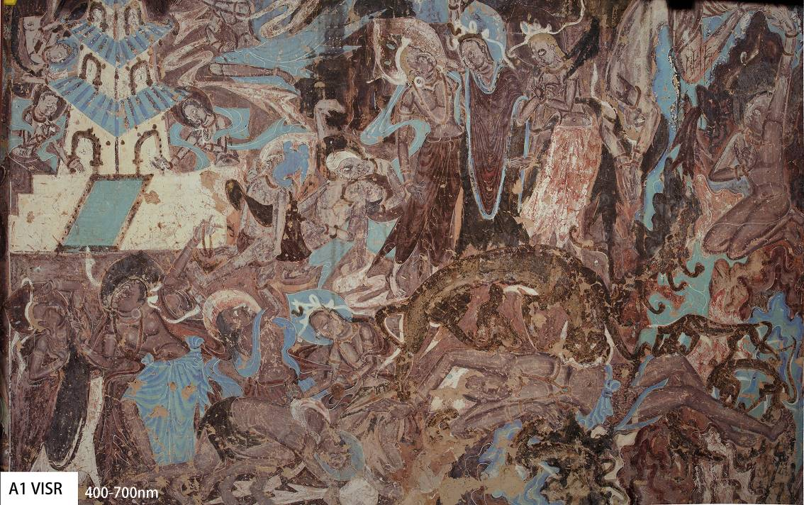
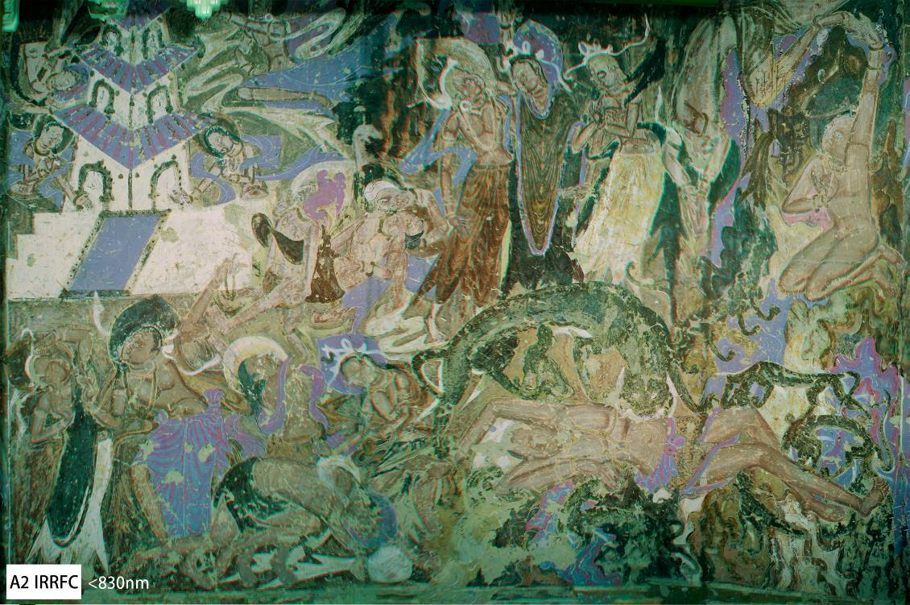
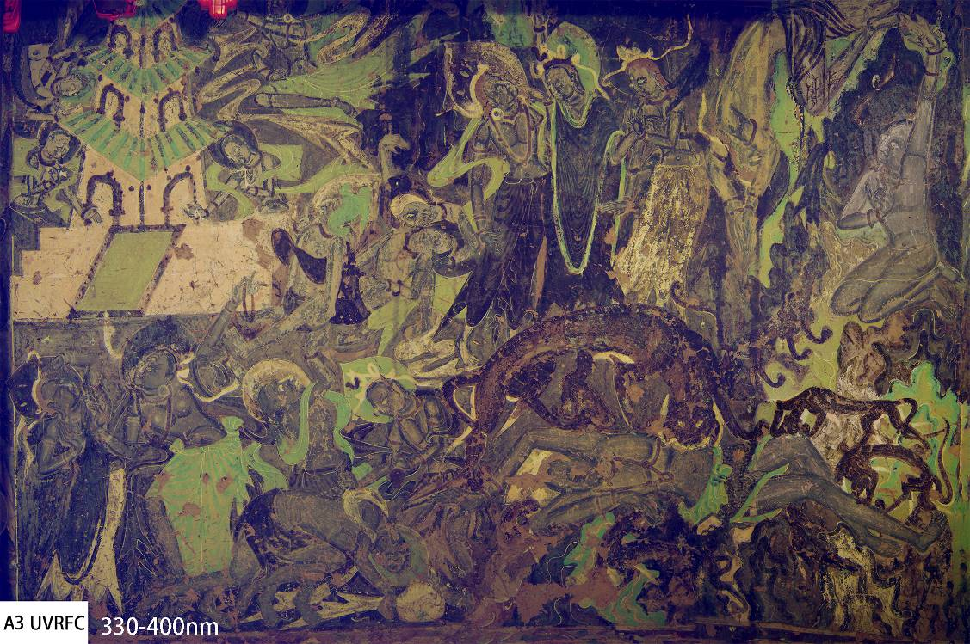

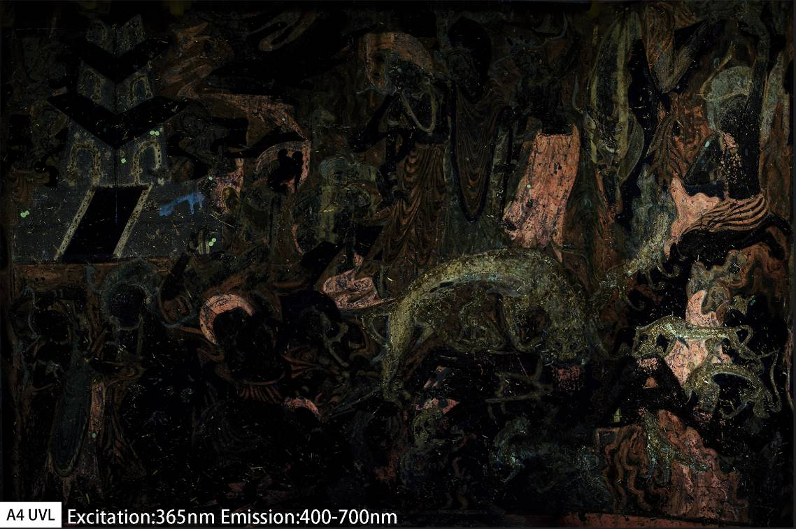

2. Multispectral references of the pigment samples
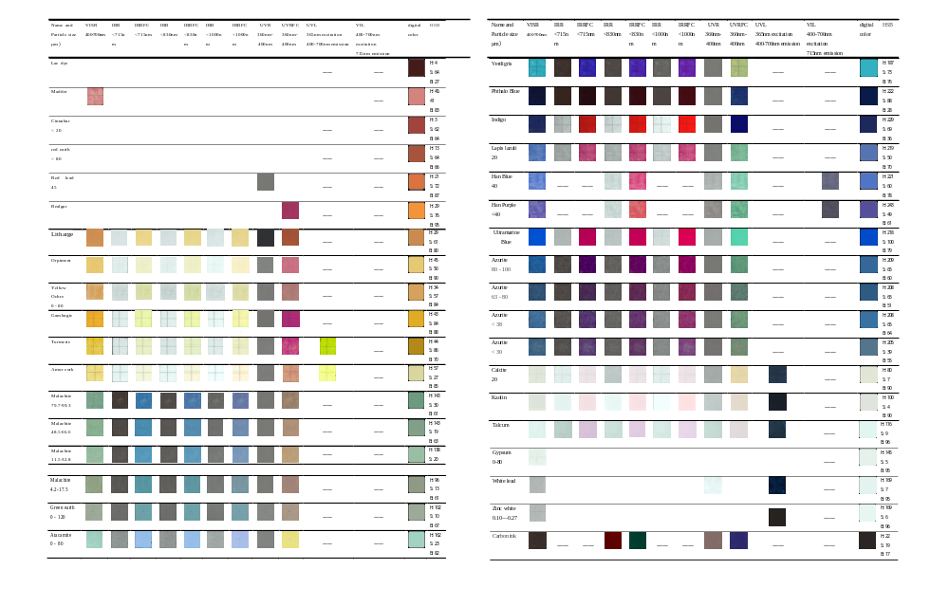
3. Sources of the pigment samples used for the multispectral references
No. | Item Name | Main Phase | Chromogenic Phase | Chemical Formula of the  Chromogenic Phase | Particle Size (µm) | Source of Pigment
1 | Red earth | Quartz, Calcite, Albite, Chlorite, Hematite | Hematite | Fe₂O₃ | <80 | China-Tibet
2 | Cinnabar | Cinnabar, Calcite (trace amounts) | Cinnabar | HgS | <20 | China-Tibet
3 | Lac | —— | —— | C₂₀H₁₄O₁₁ | —— | Natural Pigments  (USA)
4 | Madder | —— | —— | —— | —— | Commercial (China)
5 | Red lead | Red lead | Red lead | Pb₃O₄ | 45 | China-Tibet
6 | Realgar | Arsenic Sulfide | Arsenic Sulfide | As₄S₄ | —— | China-Tibet
7 | litharge | litharge | litharge | PbO | —— | China-Tibet
8 | Orpiment | Orpiment | Orpiment | As₂S₃ | —— | China-Tibet
9 | Yellow Ochre | Quartz, Muscovite, Albite,  Lepidocrocite, Chlorite | Lepidocrocite | FeO(OH) | 0–80 | China-Tibet
10 | Gambogic | —— | —— | —— | —— | Commercial (China)
11 | Turmeric | —— | —— | —— | —— | Commercial (China)
12 | Amur cork | —— | —— | —— | —— | Commercial (China)
13 | Malachite | Malachite | Malachite | CuCO₃·Cu(OH)₂ | 79.7–99.3 | China-Tibet
14 | Malachite | Malachite | Malachite | CuCO₃·Cu(OH)₂ | 48.5–66.6 | China-Tibet
15 | Malachite | Malachite | Malachite | CuCO₃·Cu(OH)₂ | 11.5–32.8 | China-Tibet
16 | Malachite | Malachite | Malachite | CuCO₃·Cu(OH)₂ | 4.2–17.5 | China-Tibet
17 | Atacamite | Atacamite, Malachite (small amounts) | Atacamite, Malachite (small amounts) | Cu₂Cl(OH)₃  Cu₂(CO₃)(OH)₂ | 0–80 | KREMER Company (Germany)
18 | Green earth | Quartz, Glauconite, Calcite | Glauconite | K(Fe,Al)₂(Si,Al)₄O₁₀(OH)₂ | 0–120 | China-Tibet
19 | Verdigris | —— | —— | Cu(CH₃COO)₂·[Cu(OH)₂]₃·2H₂O | —— | KREMER Company (Germany)
20 | Phthalo Blue | —— | —— | Fe₄[Fe(CN)₆]₃ | —— | KREMER Company (Germany)
21 | Lapis lazuli | Lapis,  Sodalite | Lapis, Sodalite | Na₂O₃Al₆SiO₂·2Na₂S  Na₄Al₃(SiO₄)₃Cl | 20 | KREMER Company (Germany)
22 | Azurite | Azurite, Quartz, Rosasite | Azurite, Rosasite | Cu₃(CO₃)₂(OH)₂  CuZn(CO₃)(OH)₂ | 80–100 | KREMER Company (Germany)
23 | Azurite | Azurite, Quartz, Rosasite | Azurite, Rosasite | Cu₃(CO₃)₂(OH)₂  CuZn(CO₃)(OH)₂ | 63–80 | KREMER Company (Germany)
24 | Azurite | Azurite, Quartz, Rosasite | Azurite, Rosasite | Cu₃(CO₃)₂(OH)₂  CuZn(CO₃)(OH)₂ | <38 | KREMER Company (Germany)
25 | Azurite | Azurite, Quartz, Rosasite | Azurite, Rosasite | Cu₃(CO₃)₂(OH)₂  CuZn(CO₃)(OH)₂ | <38 | KREMER Company (Germany)
26 | Ultramarine Blue | Ultramarine Blue | Ultramarine Blue | Na₆Ca₂Al₆Si₆O₂₄(SO₄)₂ | —— | KREMER Company (Germany)
27 | Han Blue | Barium Copper Silicate | Barium Copper Silicate | BaCuSi₄O₁₀  BaCuSi₂O₆ | 40 | KREMER Company (Germany)
28 | Han Purple | Barium Copper Silicate | Barium Copper Silicate | BaCuSi₂O₆ | <40 | KREMER Company (Germany)
29 | Indigo | Indigo, quartz, albite | Indigo | C₁₆H₁₀N₂O₂ | —— | KREMER Company (Germany)
30 | Calcite | Calcite | Calcite | CaCO₃ | 20 | KREMER Company (Germany)
31 | Kaolin | Kaolinite, Quartz, Albite, Chlorite, Muscovite, Amphibole | Kaolinite | Al₄Si₄O₁₀·(OH)₈ | —— | Commercial (China)
32 | Talcum | Talc, Magnesite, Quartz, Chlorite | Talc, Magnesite | Mg₆Si₈O₂₀(OH)₄, MgCO₃ | —— | Commercial (China)
33 | Plaster | Gypsum | Gypsum | CaSO₄·2H₂O | 0–80 | KREMER Company (Germany)
34 | White lead | White lead | White lead | PbCO₃ | —— | Commercial (China)
35 | Zinc white | Zinc white | Zinc white | ZnO | 0.10–0.27 | Commercial (China)
36 | Carbon ink | —— | —— | C | —— | Commercial (China)

