Enhancing the delivery of SOD1 antisense oligonucleotides to the murine brain using lipid nanoparticles and image-guided focused ultrasound
Gayathri R. Ediriweera, Nicholas L. Fletcher, Gary Cowin, Joshua D. Simpson, Liyu Chen, Joanna M. Wasielewska, Jeremy S. Lum, Luke McAlary, Mikayla Brown, Justin J. Yerbury, Kristofer J. Thurecht and Kara L. Vine*

Experimental
Synthesis of Cy5-SOD1 ASO CaP lipid NPs.
Cy5-SOD1 ASO CaP lipid NPs were synthesised following the procedure of Chen et al. with minor modifications.¹ The anionic lipid coated CaP cores were firstly prepared by a water-in-oil micro-emulsion method. Briefly, 300 μL of freshly prepared 500 mM CaCl₂ and 50 μL of 2 mg/mL Cy5-SOD1 ASO were added into 15 mL cyclohexane/Igepal CO-520 (70/30 v/v) solution dropwise to form a very well dispersed water-in-oil reverse micro-emulsion at 900 rpm. To form the phosphate phase, 300 μL of freshly prepared 5 mM Na₂HPO₄ (pH = 9.0), 50 μL of 2 mg/mL Cy5-SOD1 ASO and 200 μL of 20 mg/mL DOPA in chloroform were dispersed by dropwise addition in another 15 mL cyclohexane/Igepal solution. Then, the phosphate phase was added to the calcium phase in a dropwise manner using a glass pipette. The solution was stirred for 20 min to form the CaP cores encapsulating Cy5-SOD1 ASO. The micro-emulsion was divided equally into two 50 mL falcon tubes after the addition of 30 mL of absolute ethanol. The tubes were centrifuged at 15,000 × g for 30 min at 4 °C. The pellet of CaP cores was washed and rinsed with absolute ethanol 3 times (3 × 30 mL) by centrifuging as above each time. The pellet was resuspended in 1 mL chloroform and stored in a small glass vial for subsequent lipid coating. The final Cy5-SOD1 ASO CaP lipid NPs were prepared by the thin film hydration method. Briefly, to 500 μL of CaP cores, 50 μL 10mM DOTAP/Cholesterol (1:1) and 50 μL 3 mM DSPE-PEG-2000 were mixed in a 4 mL glass vial for 5 minutes. For cellular uptake studies, LissRd B-DSPE (12.5 μL of a 16mM stock solution) was also added. The solution was transferred into a round bottom flask and the chloroform was slowly evaporated off using a rotary evaporator. Tris-HCl buffer (1 mL; 5 mM; pH 7.4) was then added into the round bottom flask to rehydrate the lipid film and was left in the fridge for 2 h, followed by the gentle sonication for 5 min. The final Cy5-SOD1 ASO CaP lipid NPs were sterile filtered (0.22 μm) and stored at 4 °C for subsequent characterisation and biological evaluation. The same procedure was followed for the synthesis of non-loaded CaP lipid NPs without the addition of Cy5-SOD1 ASO.
Characterisation of Cy5-SOD1 ASO CaP lipid NPs.
The particle size and concentration were measured using flow nanoanalyzer (NanoFCM Inc., Xiamen, China) according to manufacturer’s instructions. Silica nanospheres cocktail (S16M-Exo 68-155 nm, NanoFCM, Inc.) was used as the size standard to construct a calibration curve according to particle sizes and side scattering intensities. The scattering from non-loaded CaP lipid NPs was used to gate the Cy5-SOD1 ASO NP population. The NP morphology was visualised using Transmission Electron Microscopy (TEM). The TEM images were taken using a Hitachi HT7700 transmission electron microscope, operating at an acceleration voltage of 120 kV. A 5 µL aliquots of samples were deposited onto 200-mesh glow discharged carbon-coated copper grids for 3 min, air-dried, and then stained with 1% ammonium molybdate for 1 min and air-dried prior to imaging. The zeta potential of NPs were determined at room temperature using a dynamic light scattering device (DLS, Zetasizer Nano, Malvern, UK). To determine the oligonucleotide loading of CaP lipid NPs, Cy5-SOD1 ASO CaP lipid NPs (50 µL) were dissolved in an equal volume of lysis buffer (2 mM EDTA and 0.05% Triton X-100 in pH 7.8 Tris buffer) and heated at 65 ˚C for 20 min to release the entrapped Cy5-SOD1 ASO. The UV-Visible absorbance at 647 nm of the mixture was measured using a plate reader (Tecan M200 Pro Infinate). The amount of Cy5-SOD1 ASO loaded into CaP lipid NPs was then determined by interpolation of absorbance at 647 nm from a free Cy5-SOD1 ASO standard curve.
pH-responsive dissociation and in vitro serum stability of Cy5-SOD1 ASO and Cy5-SOD1 ASO CaP lipid NPs.
For pH-responsive studies, first Cy5-SOD1 ASO CaP lipid NPs were diluted in 1:10 ratio (v/v) in PBS (pH 7.4, 6.5, or 5). The pHs were chosen to mimic physiological conditions (7.4), endosomal conditions (6.5), and lysosomal conditions (5.0). They were then incubated for 4 h at 37 °C with constant shanking at 200 RPM. The change in particle size at different time points was determined using flow nanoanalyzer.
The pH-responsive release of Cy5-SOD1 ASO from CaP lipid NPs was also examined in solutions with pH 7.4 and 5.0 using agarose gel electrophoresis. Briefly, Cy5-SOD1 ASO CaP lipid NPs were diluted in 1:10 ratio with disodium hydrogen phosphate–citric acid buffer solution (0.2 M) with its pH being adjusted to 7.4 or 5.0, and incubated with shaking at 37 °C for 30 min, 2 h and 4 h. At each predetermined time point, the sample was centrifuged at 20,000 g for 10 min at 4 °C to remove the non-dissolved particles, and 10 mL of the supernatant was loaded into a 1% agarose gel in 1 × TAE buffer containing 6 µL of RedSafe dye. Electrophoresis was carried out at a voltage of 100 V for 40 min. The image of agarose gel was recorded using a Geldoc (Bio-Rad Laboratories, Inc., Hercules, CA).
The capability of CaP lipid NPs to protect SOD1 ASO from degradation by serum enzymes was studied via agarose gel electrophoresis. Firstly, the Cy5-SOD1 ASO CaP lipid NPs were incubated in DMEM medium containing 50% fetal bovine serum (FBS) at 37 °C in 1:10 ratio (v/v). At 0, 2 and 4 h, a 20 µL aliquot was taken out and was mixed with a same volume of lysis buffer (2 mM EDTA and 0.05% Triton X-100 in pH 7.8 20 mM Tris-HCl buffer) to stop the degradation and release the encapsulated ASO. Afterwards, 10 µL of each sample was mixed with 2 µL of Gel loading dye Orange and were loaded into the wells of a 1% agarose gel containing RedSafe dye in 1 × TAE buffer. Electrophoresis was carried out at a constant voltage of 100 V for 30 min. The final gel was imaged using a Geldoc (Bio-Rad Laboratories, Inc., Hercules, CA). The same procedure was repeated for free Cy5-SOD1 ASO in order to confirm its stability in serum as well.
In vitro transfection and gene-silencing.
HEK293T cells were seeded in a 6-well plate at a density of 2 × 10⁵ cells per well. After incubating the cells overnight at 37 °C, they were treated with Cy5-SOD1 ASO CaP lipid NPs, non-loaded CaP lipid NPs with free Cy5-SOD1 ASO and Cy5-SOD1 ASO with Lipofectamine3000 (positive control). The cells were then incubated for 72 h at 37 °C. Each treatment delivered an equivalent amount of Cy5-SOD1 ASO (50 nM). A well of cells without any treatment was used as the negative control. After 72 h, the cells were washed twice with cold PBS and harvested using Trypsin-EDTA. An equal amount of cells (2 × 10⁶ cells) from each sample was taken and RIPA lysis buffer (25 mM pH7.6 Tris-HCl, 150 mM NaCl, 1% Triton X-100, 1% Na-deoxycholate and 1% SDS) supplemented with PMSF protease inhibitor cocktail (1% protease inhibitor and 1% EDTA; ThermoFisher Scientific) were then added to each tube and were incubated on ice for 30 min. The final protein extracts were obtained after centrifuging (14,000 × g, 20 min) the aspirated cell lysates. The cell lysates (50 µL) were mixed with 30 µL of 2:1 laemmli buffer: reducing agent mixture and were incubated at 95 ˚C for 5 min. From each sample, 25 µL were loaded on a pre-cast sodium dodecyl sulfate polyacrylamide gel (Invitrogen) and electrophoresed at 200 mV for 30 min. The proteins were transferred to a pure nitrocellulose blotting membrane at 1.3 A and 20 V for 7 min using the Bio-Rad Trans- Blot Turbo system. The membrane was blocked with 5% skim milk in PBST on a horizontal shaker at room temperature for 1 h. The membrane was incubated with 1:2000 rabbit polyclonal antibody to SOD1 (ab13498) for 1 h at room temperature on a horizontal shaker followed by washing and incubation with 1:2000 HRP-conjugated goat anti-rabbit IgG secondary antibody for 1 h at room temperature on a horizontal shaker. Finally, SuperSignal West Pico Chemiluminescent Substrate (ThermoFisher Scientific) was added to the membrane and it was exposed using ChemiDoc (Bio-Rad Laboratories, Inc., Hercules, CA).
In vitro cellular association and internalization of Cy5-SOD1 ASO CaP lipid NPs.
The in vitro cellular uptake studies were conducted on mouse motor neuron cell line (NSC-34), a hybrid cell line produced by fusion of neuroblastoma with mouse motor neuron-enriched primary spinal cord cells. The cells were routinely cultured in DMEM/F12 media supplemented with 10% (v/v) FBS and 100 U/mL penicillin and 100 µg/mL streptomycin. Cells were maintained in an incubator at 37 °C under a humidified atmosphere containing 5% (v/v) CO₂.
The cellular association of Cy5-SOD1 ASO CaP lipid NPs was first assessed using flow cytometry. NSC-34 cells were seeded at the density of 1.5 × 10⁵ cells per well in 6-well plates and were incubated overnight. The culture medium was then replaced with 1.0 mL of fresh DMEM/F12 media (10% FBS) containing Cy5-SOD1 ASO CaP lipid NPs (NPs containing 3.12, 6.25, 12.5, 25 and 50 nM Cy5-SOD1 ASO) in each well and the cells were incubated at 37 °C for 1 h. Afterwards, the media was removed and the cells were washed 3 times with phosphate-buffered saline (PBS, pH 7.4) to remove excess particles. The cells were then harvested with 0.1% Trypsin and washed with FACS wash (PBS containing 2% FBS) and resuspended in 200 µL of FACS wash for flow cytometry analysis. The cell samples were subsequently analysed using fluorescence-activated cell sorting (FACS) on a Cytoflex S (Beckman Coulter). Data was acquired for 10,000 events measuring Cy5 fluorescence intensity (APC channel) along with the forward and side scatter. Untreated cells were used to gate the population of viable cells. The same procedure was repeated for 25 nM and 50 nM samples by increasing the incubation time for 4 h to investigate the change in cellular association over time.
In order to further investigate the cellular internalization of NPs confocal microscopy was performed. NSC-34 cells were seeded on coverslips at a density of 5 × 10⁵ cells per dish. After 24 h of incubation at 37 ˚C, the cells were washed with opti-MEM media and again incubated for 1 h with 25 nM Cy5-SOD1 ASO CaP lipid NPs and Cy5-SOD1 ASO CaP lipid NPs containing LissRd B-DSPE in the outer lipid coating in 1 mL of media. The cells were also exposed to Hoechst 33342 and Lysotracker as per supplier protocols to stain the nuclei and lysosomes respectively. The images were acquired over a period of 1 h for each sample using Zeiss LSM 510 laser scanning confocal fluorescence microscope (Carl Zeiss MicroImaging GmbH, Oberkochen, Germany).
In vitro cellular cytotoxicity analysis of Cy5-SOD1 ASO CaP lipid NPs.
The cytotoxicity of Cy5-SOD1 ASO CaP lipid NPs was investigated with NSC-34 cells using MTS assay. First, the cells were seeded in 96-well plates with same density (10⁴ cells per well) and were incubated for 24 h at 37 °C. Cy5-SOD1 ASO NPs with varying amounts of ASO (25 nM, 12.5 nM, 6.25 nM, 3.13 nM, 1.56 nM and 0.78 nM) were then added in serum-supplemented tissue culture media and again incubated for 48 h at 37 °C. After 48 h, the cells were washed twice with serum-supplemented tissue culture media followed by the incubation with 100 μL of MTS solution (20 μL CellTiter 96 Aqueous One Solution Reagent and 80 μL of tissue culture medium) for 3 h, and the absorbance was measured at 490 nm using a microplate reader. Using the cell viability of untreated cells (absorbance at 490 nm) as a benchmark, an IC₅₀ was calculated by statistical software GraphPad Prism 8.0 using the relative fluorescence of the different treatment groups.
$$\% Cell viablity=\frac{(Sample absorbance-Blank absorbance)}{(Cell absorbance-Blank absorbance)} ×100$$
All experimental data related to cytotoxicity analysis were obtained in triplicate and are presented as mean ± standard deviation.
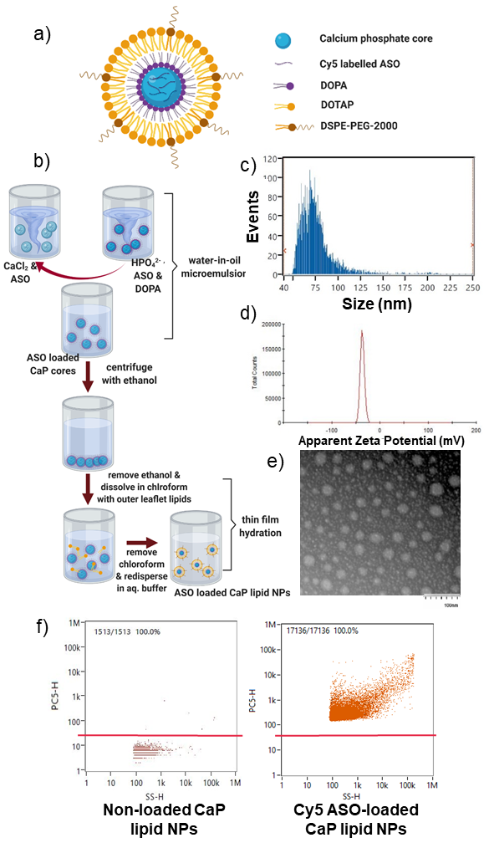
Figure S 1: Physical properties of Cy5-SOD1 ASO CaP lipid NPs a) schematic diagram of a Cy5-SOD1 ASO CaP lipid NP b) the water-in-oil microemulsion formulation process of Cy5-SOD1 ASO CaP lipid NPs c) particle size (d.nm) of NPs determined by the flow nanoanalyzer d) zeta potential of NPs determined by the DLS e) transmission electron micrograph (TEM) of Cy5-SOD1 ASO CaP lipid NPs visualized by negative staining d) scatter plots in the Cy5 channel, of the non-loaded CaP lipid NPs (left) and Cy5-SOD1 ASO CaP lipid NPs (right) as determined by the flow nanoanalyzer.

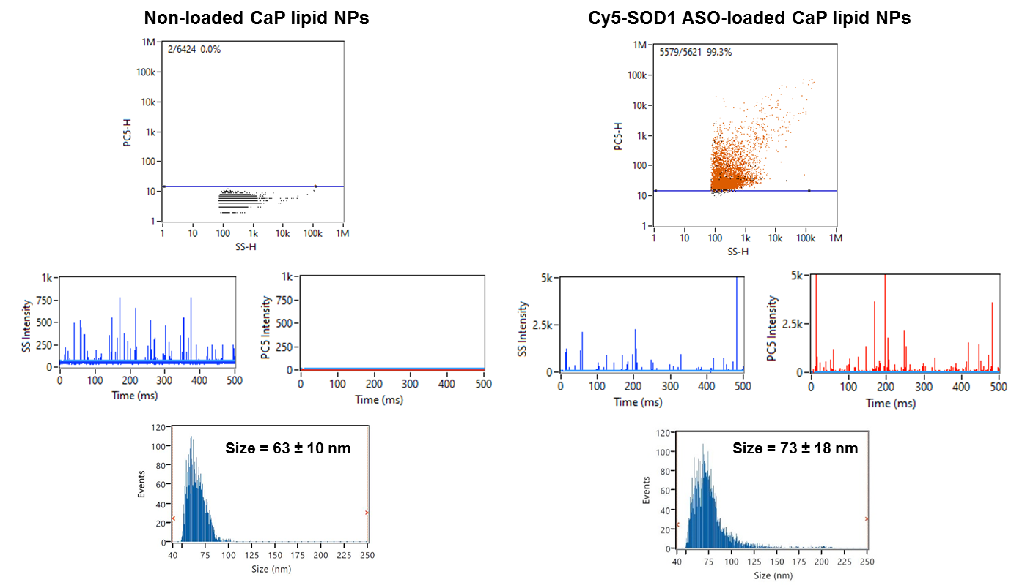
Figure S 2: Analysis of non-loaded and Cy5-SOD1 ASO-loaded CaP lipid nanoparticles through flow nananalyzer displaying the overlap of Cy5 signals in the APC channel with side-scattering signals in the case of Cy5-SOD1 ASO-loaded CaP lipid NPs.

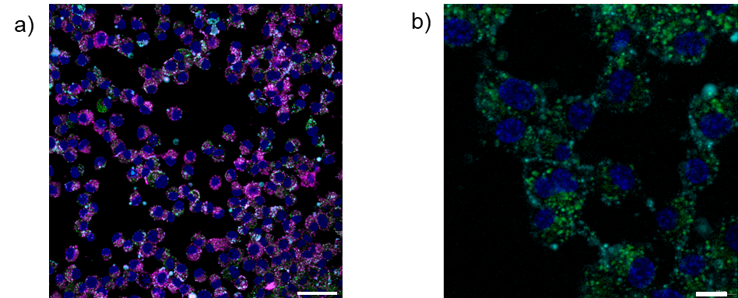
Figure S 3: a) Early association of Cy5-SOD1 ASO NPs containing LissRd B-DSPE with the cell membrane when incubated with NSC-34 cells – scale bar: 50 µm (dark blue-Hoechst staining nuclei, magenta-LissRd B-DSPE in the outer lipid layer of NPs, cyan-Cy5-SOD1 ASO, green-lysotracker) b) co-localization of Cy5-SOD1 ASO NPs (without LissRd B-DSPE) with lysotracker – scale bar: 10 µm (dark blue- Hoechst staining nuclei, cyan-Cy5-SOD1 ASO, green-lysotracker)
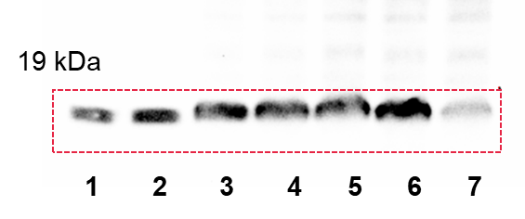
Figure S 4: Knockdown of SOD1 protein expression in HEK293T cells incubated with 1 – Cy5-SOD1 CaP lipid NPs (50 nM), 2 – Cy5-SOD1 CaP lipid NPs (20 nM), 3 – Inactive CaP lipid NPs (50 nM), 4 – Non loaded CaP lipid NPs, 5 – Non loaded CaP lipid NPs + Cy5-SOD1 ASO, 6 – Cell only (negative control), 7 – SOD1 ASO with lipofectamine (50 nM) (positive control).
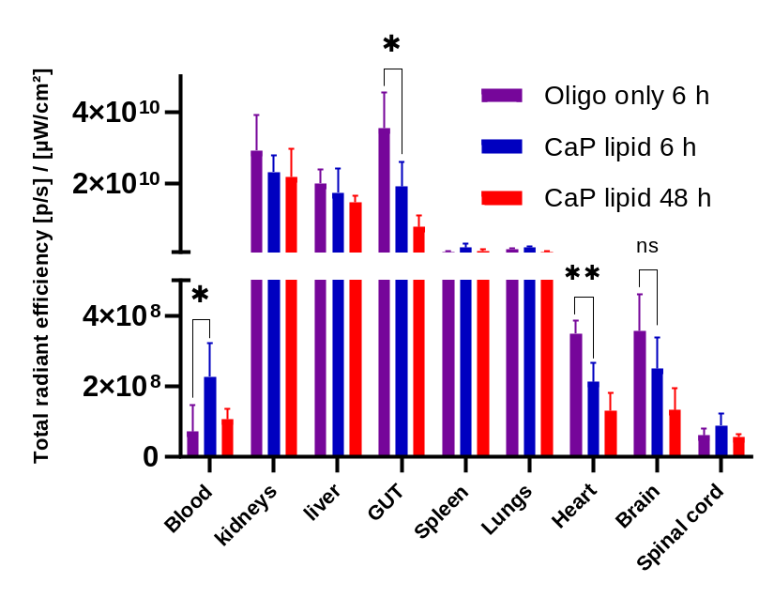
Figure S 5: Ex vivo fluorescence from organs in C57BL/6 mice 6 h and 48 h after i.v administration of free Cy5-SOD1 ASO and Cy5-SOD1 ASO-loaded CaP lipid NPs (Statistical analysis has been performed for Oligo only 6 h and CaP lipid 6 h groups).

Table S1: Summary of experimental parameters used in the optimisation of FUS conditions
Group | Frequency | Sonication length | MB dose | Observation via T2-weighted MRI
1 | 0.33 MI | 120 sec | 0.4 mL/kg | Excessive opening of BBB  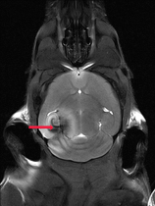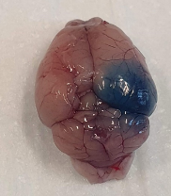
2 | 0.33 MI | 120 sec | 0.15 mL/kg | Transient opening of BBB  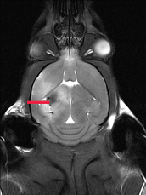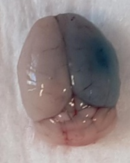
3 | 0.14 MI | 120 sec | 0.4 mL/kg | Absence of BBB opening  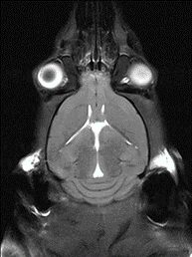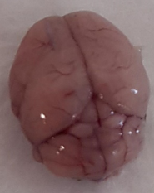
4 | 0.22 MI | 120 sec | 0.4 mL/kg | Absence of BBB opening
5 | 0.319 MI | 120 sec | 0.15 mL/kg | Absence of BBB opening  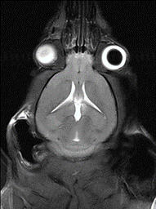
6 | 0.319 MI | 120 sec | 0.4 mL/kg | Absence of BBB opening
7 | 0.325 MI | 120 sec | 0.15 mL/kg | Absence of BBB opening  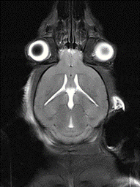
8 | 0.325 MI | 120 sec | 0.4 mL/kg | Absence of BBB opening
9 | 0.33 MI | 30 sec | 0.15 mL/kg | Modest and transient opening of BBB with rapid recovery  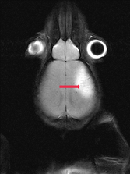

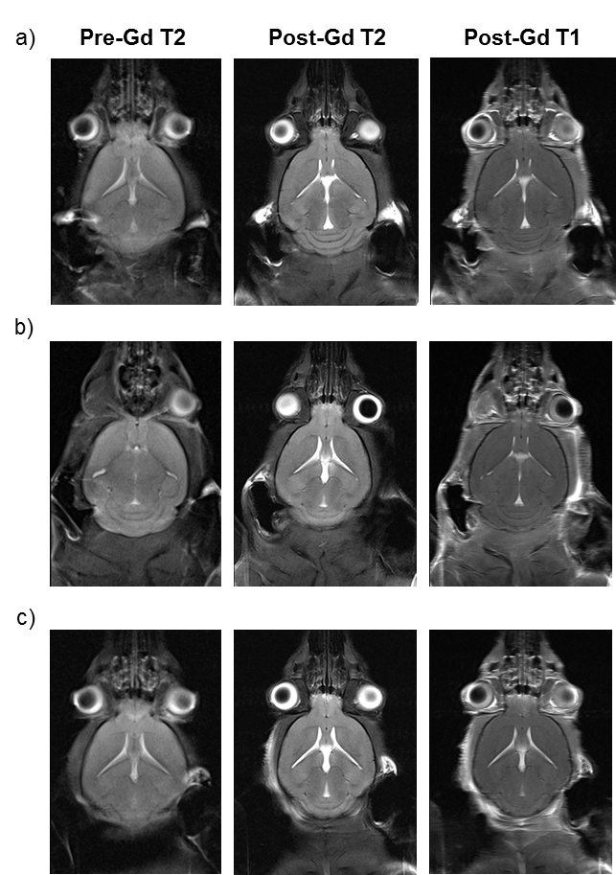
Figure S 6: Coronal views of the mouse brain demonstrating the absence of any contrast enhancement after Gd administration in a) 0.14 MI/120 sec b) 0.319 MI/120 sec and c) 0.325 MI/120 sec FUS groups confirming the absence of any BBB opening with these parameters.
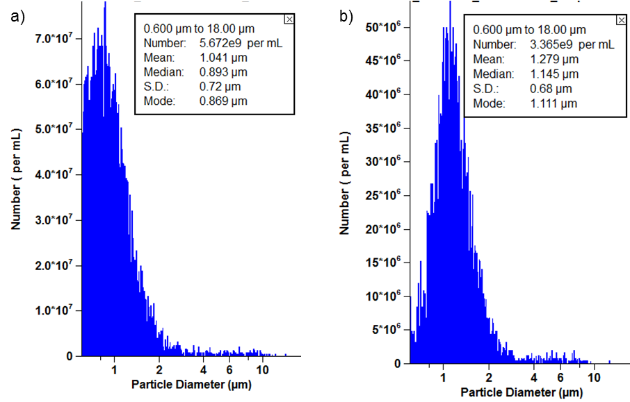
Figure S 7: Characterization of the MB dose administered to mouse 2 and 3 in the FUS group using coulter counter.
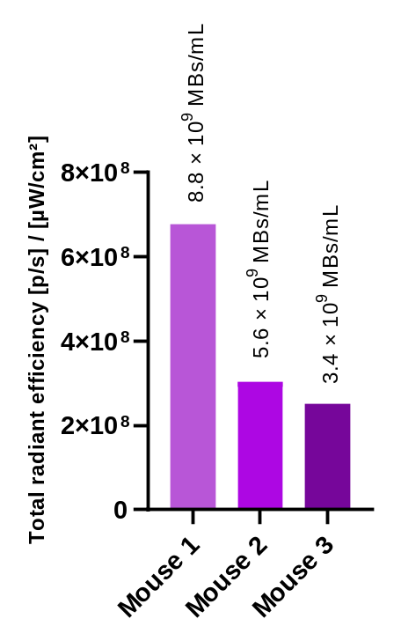
Figure S 8: Change in NP uptake in the brain in individual mice in FUS group with the difference in the amount of MBs in a given volume (as per subsequent coulter counter analysis)
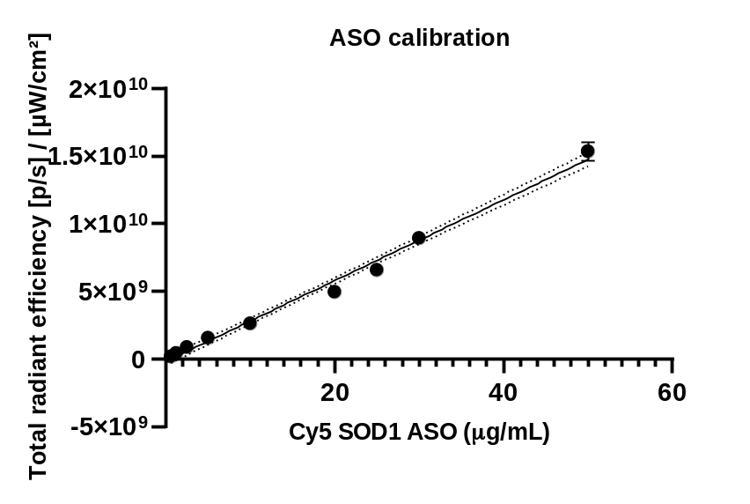
Figure S 9: Calibration curve of Cy5-SOD1 ASO derived by measuring the fluorescence of a concentration range of Cy5-SOD1 ASO through IVIS fluorescence imaging
References
1 Chen, L. et al. Improving the delivery of SOD1 antisense oligonucleotides to motor neurons using calcium phosphate-lipid nanoparticles. Frontiers in neuroscience 11, 476 (2017).

