Supplementary Appendix
List of investigators in the NADESICO study
Masanao Naya (Hokkaido University Hospital, Sapporo, Japan)
Masafumi Watanabe (Yamagata University Hospital, Yamagata, Japan)
Tetsu Watanabe (Yamagata University Hospital, Yamagata, Japan)
Satoshi Yasuda (Tohoku University Hospital, Sendai, Japan)
Michihiro Yoshimura (Jikei University School of Medicine, Tokyo, Japan)
Makoto Kawai (Jikei University School of Medicine, Tokyo, Japan)
Tomonori Okamura (Keio University School of Medicine, Tokyo, Japan)
Hiroaki Naito (Nissei Hospital, Osaka, Japan)
Masahiro Higashi (National Hospital Organization Osaka National Hospital, Osaka, Japan)
Hideaki Morita (Osaka Medical College, Takatsuki, Japan)
Kunihiro Nishimura (National Cerebral and Cardiovascular Center, Suita, Japan)
Yasuhide Asaumi (National Cerebral and Cardiovascular Center, Suita, Japan)
Hiroyuki Miura (National Cerebral and Cardiovascular Center, Suita, Japan)
Yutaka Furukawa (Kobe City Medical Center General Hospital, Tokyo, Japan)
Hiroyuki Tsutsui (Kyusyu University Hospital, Fukuoka, Japan)
Tomohiro Kawasaki (Shin Koga Hospital, Kurume, Japan)
Mitsuru Oishi (Kagoshima University Hospital, Kagoshima, Japan)
Masaaki Miyata (Kagoshima University Hospital, Kagoshima, Japan)
Hitonobu Tomoike (NTT Research, Inc., MEI Lab, Japan)
Atsushi Kohno (Kobe University, Kobe, Japan)
Tetsuya Fukuda (National Cerebral and Cardiovascular Center, Suita, Japan)
Tatsuya Nishii (National Cerebral and Cardiovascular Center, Suita, Japan)
Hisashi Makino (National Cerebral and Cardiovascular Center, Suita, Japan)
Kenji Urano (SoftBank Inc.)
Kanata Ara (SoftBank Inc.)
Yuichi Imai (SoftBank Inc.)
Takayuki Suzuki (SoftBank Inc.)
Junko Masue (National Cerebral and Cardiovascular Center, Suita, Japan)
Yoko Sumita (National Cerebral and Cardiovascular Center, Suita, Japan)
Yusuke Sasahara (National Cerebral and Cardiovascular Center, Suita, Japan)

Supplementary Figure 1. Patient selection
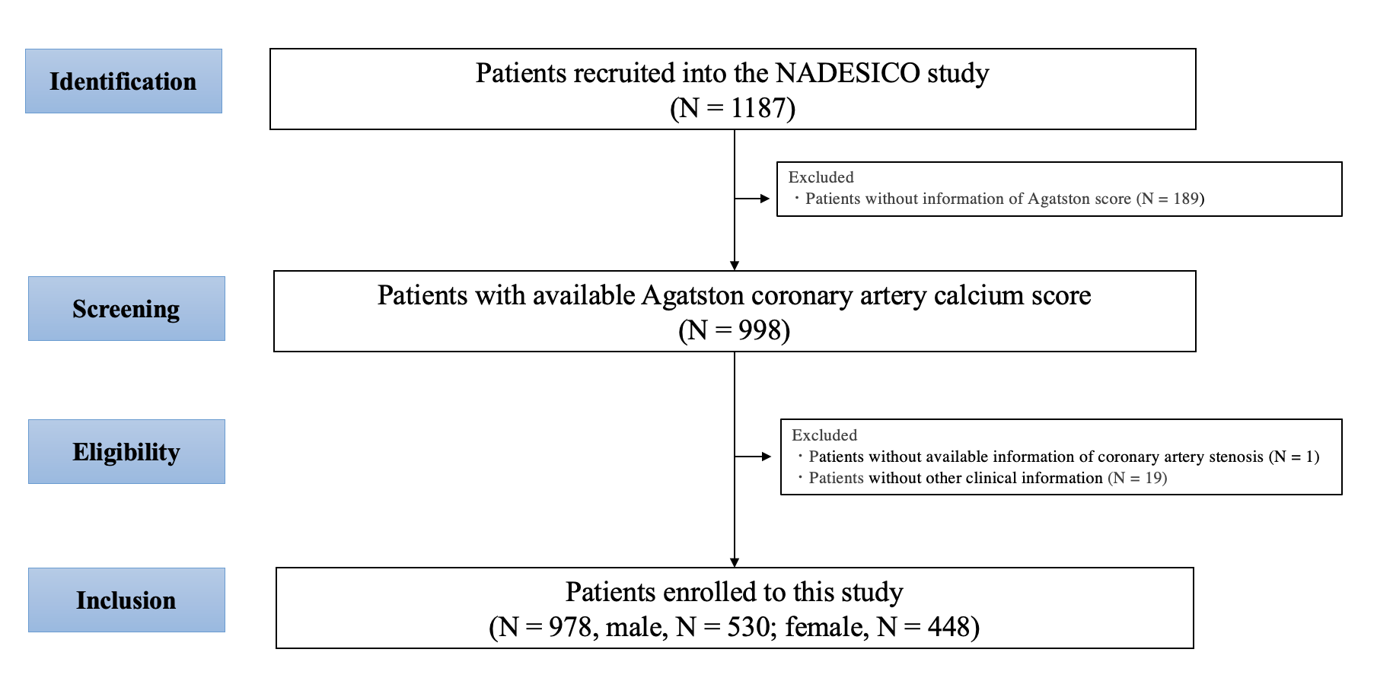

Supplementary Table 1. Baseline characteristics of female-specific factors
 | Total | MACE (−) | MACE (+) | P value
 | N = 448 | N = 427 | N = 21
Menopause at enrollment | 436 (97.3) | 415 (97.2) | 21 (100) | 0.44
Age at menarche, years | 13.7 ± 2.2 | 13.8 ± 2.3 | 13.1 ± 1.2 | 0.21
Experience of delivery | 44 (9.8) | 44 (10.3) | 0 | 0.12
Complications during pregnancy
None | 337 (75.2) | 322 (75.4) | 15 (71.4) | 0.68
Pregnancy hypertension | 14 (3.1) | 13 (3.0) | 1 (4.8) | 0.66
Pregnancy diabetes mellitus | 8 (1.8) | 7 (1.6) | 1 (4.8) | 0.29
Pregnancy proteinuria | 35 (7.8) | 34 (8.0) | 1 (4.8) | 0.59
Gestational toxicosis | 45 (10.0) | 43 (10.1) | 2 (9.5) | 0.94

Data are presented as the means ± standard deviation or N (%).
MACE, major adverse cardiovascular events

Supplementary Table 2. Multivariable analyses of CAC severity including female-specific factors in female patients
 | Any CAC (N = 246)
 | OR | 95% CI | P value
Age (per year) | 1.09 | 1.05–1.14 | <0.01
Body mass index ≥ 25 kg/m² | 1.05 | 0.65–1.70 | 0.85
Hypertension | 2.28 | 1.49–3.48 | <0.01
Diabetes mellitus | 1.99 | 1.13–3.51 | 0.02
Dyslipidemia | 1.46 | 0.95–2.24 | 0.08
Current or past smoking | 1.63 | 0.93–2.85 | 0.09
Menopause at enrollment | 0.76 | 0.19–3.03 | 0.70
Age at menarche (per year) | 1.04 | 0.94–1.15 | 0.45
Experience of delivery | 1.08 | 0.51–2.28 | 0.84
Complications during pregnancy
None | 0.75 | 0.33–1.70 | 0.49
Pregnancy hypertension | 0.44 | 0.12–1.66 | 0.23
Pregnancy diabetes mellitus | 0.22 | 0.04–1.23 | 0.09
Pregnancy proteinuria | 0.97 | 0.36–2.61 | 0.96
Gestational toxicosis | 0.80 | 0.32–1.99 | 0.63

CAC, coronary artery calcification; CI, confidence interval; OR, odds ratio
Any CAC was defined as an Agatston score > 0.
ORs were calculated using a logistic regression model including all factors.

Supplementary Table 3. Association between CAC severity and MACE according to sex
 | Male patients |  | Female patients
 | Adjusted HR | 95% CI | Adjusted HR | 95% CI
No CAC | Reference |  | Reference
Mild CAC | 1.05 | 0.41–2.67 | 1.23 | 0.37–4.14
Moderate CAC | 1.88 | 0.75–4.74 | 1.14 | 0.22–5.88
Severe CAC | 4.61 | 1.99–10.67 | 13.15 | 4.05–42.72

CAC, coronary artery calcification; CI, confidence interval; MACE, major adverse cardiovascular events; HR, hazard ratio
No CAC, Agatston score = 0; mild CAC, 0 < Agatston score < 100; moderate CAC, 100 ≤ Agatston score < 400; severe CAC, Agatston score ≥ 400
HRs were adjusted for age.

Supplementary Table 4. Receiver operating characteristic curves for MACE according to Framingham risk score and CAC Agatston score
Male | AUC | 95% CI | P value
Framingham risk score | 0.653 | 0.585-0.722 | Reference
CAC Agatston score | 0.710 | 0.638-0.782 | 0.22
Framingham risk score + CAC Agatston score | 0.737 | 0.669-0.805 | <0.01
Female
Framingham risk score | 0.637 | 0.506-0.769 | Reference
CAC Agatston score | 0.665 | 0.526-0.804 | 0.70
Framingham risk score + CAC Agatston score | 0.693 | 0.549-0.838 | 0.09

AUC, area under the receiver operating characteristic curve; CAC: coronary artery calcification; CI, confidence interval; MACE, major adverse cardiovascular events

Supplementary Table 5. Comparison of different models based on cardiovascular risk factors and CAC according to sex using Harrell’s concordance statistics.

 | Male |  |  | Female
 | C-statistic | 95% CI | P value | C-statistic | 95% CI | P value
Framingham risk score | 0.639 | 0.564-0.714 | Reference | 0.656 | 0.522-0.789 | Reference
Framingham risk score + Any CAC | 0.647 | 0.572-0.723 | 0.59 | 0.664 | 0.538-0.791 | 0.75
Framingham risk score + 100CAC | 0.688 | 0.614-0.762 | 0.051 | 0.691 | 0.552-0.831 | 0.44
Framingham risk score + 200CAC | 0.695 | 0.624-0.766 | 0.045 | 0.687 | 0.540-0.833 | 0.35
Framingham risk score + 300CAC | 0.688 | 0.618-0.758 | 0.08 | 0.706 | 0.558-0.855 | 0.12
Framingham risk score + 400CAC | 0.690 | 0.624-0.756 | 0.07 | 0.713 | 0.564-0.862 | 0.08
Framingham risk score + CAS | 0.726 | 0.656-0.795 | < 0.01 | 0.681 | 0.532-0.830 | 0.46
Framingham risk score + Any CAC + CAS | 0.725 | 0.656-0.795 | < 0.01 | 0.685 | 0.539-0.831 | 0.39
Framingham risk score + 100CAC + CAS | 0.733 | 0.663-0.802 | < 0.01 | 0.711 | 0.571-0.852 | 0.20
Framingham risk score + 200CAC + CAS | 0.736 | 0.668-0.805 | < 0.01 | 0.704 | 0.553-0.855 | 0.20
Framingham risk score + 300CAC + CAS | 0.733 | 0.667-0.800 | < 0.01 | 0.720 | 0.567-0.873 | 0.10
Framingham risk score + 400CAC + CAS | 0.735 | 0.670-0.799 | < 0.01 | 0.727 | 0.573-0.881 | 0.07

CAC, coronary artery calcification; CAS, coronary artery stenosis; CI, confidence interval;
Any CAC, Agatston score > 0; 100 CAC, Agatston score ≥ 100; 200 CAC, Agatston score ≥ 200; 300 CAC, Agatston score ≥ 300; 400 CAC, Agatston score ≥ 400

