Supplementary Information
Perovskite CsPbBr₃ single-crystal detector operating at 10¹⁰ photons/s/mm² for ultra-high flux X-ray detection
Lei Pan^{1§}, Indra Raj Pandey^{1,2§}, Antonino Miceli^{3*}, Vladislav V. Klepov¹, Duck Young Chung², and Mercouri G. Kanatzidis^{1,2,4*}
¹Department of Chemistry, Northwestern University, Evanston, IL 60208, USA
²Materials Science Division, Argonne National Laboratory, Lemont, IL 60439, USA
³X-ray Science Division, Argonne National Laboratory, Lemont, IL 60439, USA
⁴Department of Materials Science and Engineering, Northwestern University, Evanston, IL 60208, USA
§equally contributed
*Correspondence to: m-kanatzidis@northwestern.edu, amiceli@anl.gov

Supplementary Table 1. high flux performance comparison of CsPbBr₃ with CdTe and CZT reported in literatures.
High-Z semiconductor | X-ray energy | Flux tested | Polarization or not? | Time scale tested
CdTe¹ | 61 keV | < 2$×$10¹⁰ keV/s/mm² | No | -
CdTe¹ | 61 keV | > 9$×$10¹⁰ keV/s/mm² | Yes | Several Seconds
CdTe and CZT² | 80 keV | ~ 10⁷ photons/s/mm² | No | -
CZT³ | - | >10⁹ photons/s/mm² | Somewhat | -
CZT⁴ | 120 kVp | ~ 2$×$10⁷ photons/mm² | No | Tens of seconds
CZT⁵ | 120 kVp | ~ 10⁸ photons/s/mm² | No | -
CZT⁶ | 120 kVp | ~ 2.5$×$10⁸ photons/s/mm² | No | -
CZT⁷ | 60 kVp | < 2$×$10⁸ photons /s/mm² | No | -
CsPbBr₃ (This work) | 58.61 keV | ~ 10¹⁰ photons/s/mm² | No | Hundreds of seconds
Note: kVp stands for the high voltage potential of X-ray tube. “-” means no report.
References
(1) Gadkari, D.; et al. Journal of Instrumentation 2022, 17 (03), P03003.
(2) Brambilla, A.; et al. Spectrometric performances of CdTe and CdZnTe semiconductor detector arrays at high X-ray flux. In 2009 IEEE (NSS/MIC), 2009; IEEE: pp 1753-1757.
(3) Strassburg, M.; et al. CdTe/CZT under high flux irradiation. Journal of Instrumentation 2011, 6 (1), C01055
(4) Barber, W. C.; et al. Photon-counting energy-resolving CdTe detectors for high-flux X-ray imaging. In IEEE NSS MIC, 2010; IEEE: pp 3953-3955.
(5) Prokesch, M.; et al. IEEE Transactions on Nuclear Science 2016, 63 (3), 1854-1859.
(6) Prokesch, M.; et al. J Appl Phys 2018, 124 (4), 44503. DOI: 10.1063/1.5041006.
(7) Iniewski, K.; et al. CZT Growth, Characterization, Fabrication, and Electronics for Operation at 1-100 Mcps/mm 2 Count Rates. In workshop on Medical Applications of Spectroscopic X-Ray Detectors, CERN, 2015

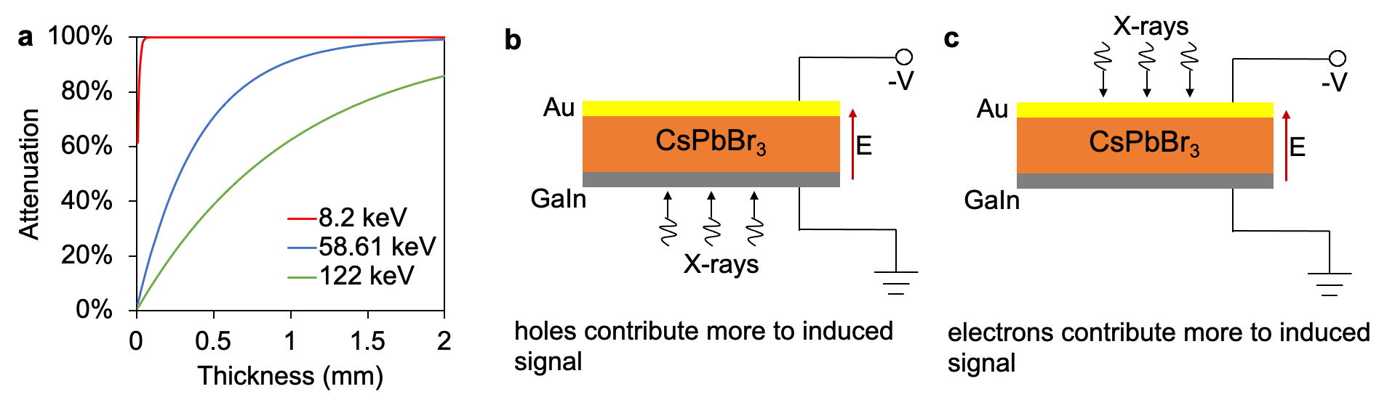
Supplementary Figure 1. Attenuation efficiency of CsPbBr₃ to photons with different energies. Experimental setup to have holes/electrons contribute more to the induced signal under reverse bias voltage. A 1.7 mm thick CsPbBr₃ can attenuate 98.5% and 81% of 58.6 keV and 122 keV photons, respectively. Density of CsPbBr₃ is 4.85 g/cm³.

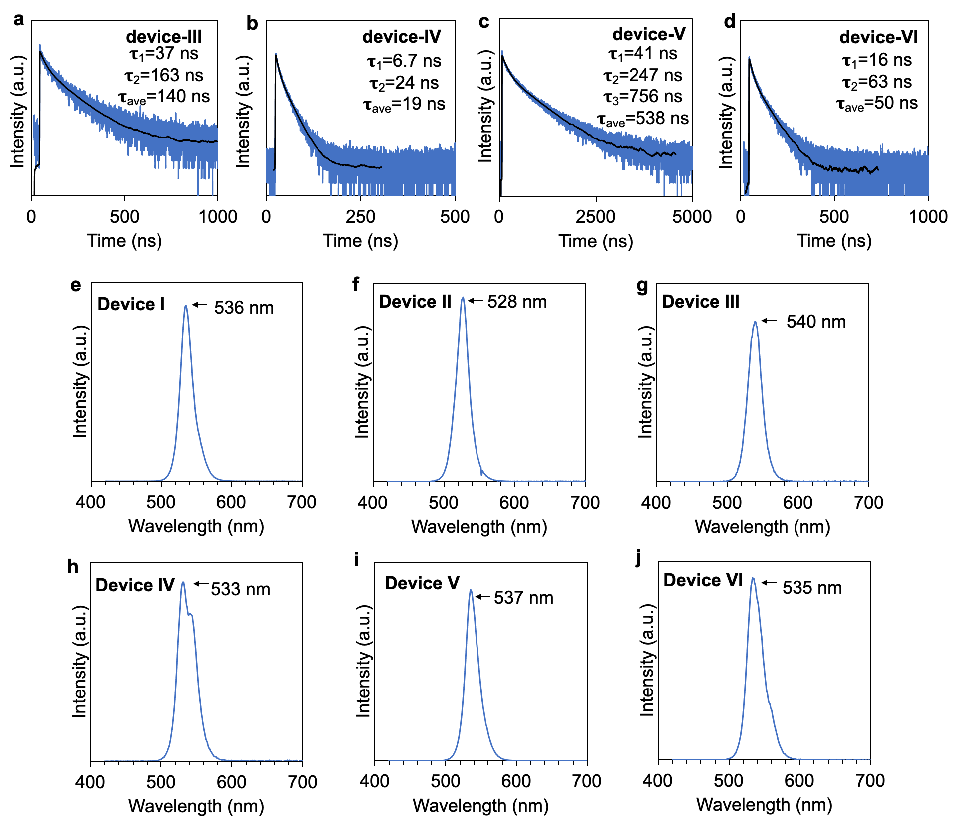
Supplementary Figure 2. Time-resolved photoluminescence spectrum and emission spectrum of CsPbBr₃ crystals that were fabricated into devices. a - d, Time-resolved PL of devices III, IV, V and VI. e – j, PL emission spectrum of all devices.
An FS5 spectrofluorometer (Edinburgh Instruments) was used to measure the time-resolved PL spectra and PL emission spectra at room temperature. Exciting wavelength for PL measurement is 375 nm generated by a laser. The measured time-resolved PL data was fitted to a multi-exponential decay equation $R\left(t\right)=B_{1}e^{-t/τ_{1}}+B_{2}e^{-t/τ_{2}}+B_{3}e^{-t/τ_{3}}$, where $R\left(t\right)$ is measured photoluminescence intensity, $B_{1}$, $B_{2}$, $B_{3}$ are proportionality coefficients. $τ_{ave}$ is intensity averaged lifetime calculated as $τ_{ave}=\frac{\sum{B_{i}τ_{i}^{2}}}{\sum{B_{i}τ_{i}}}$.

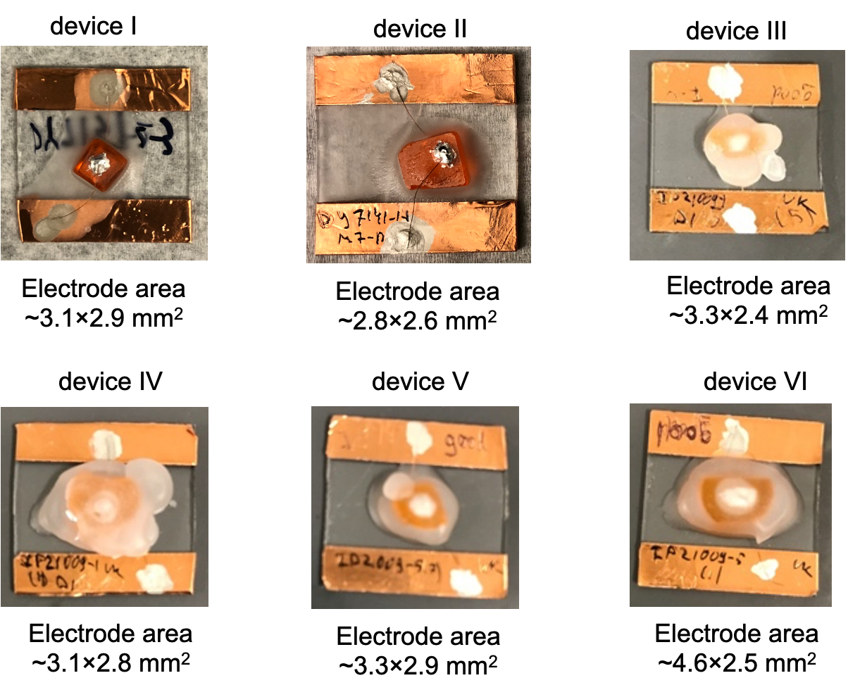
Supplementary Figure 3. device pictures and electrode area.

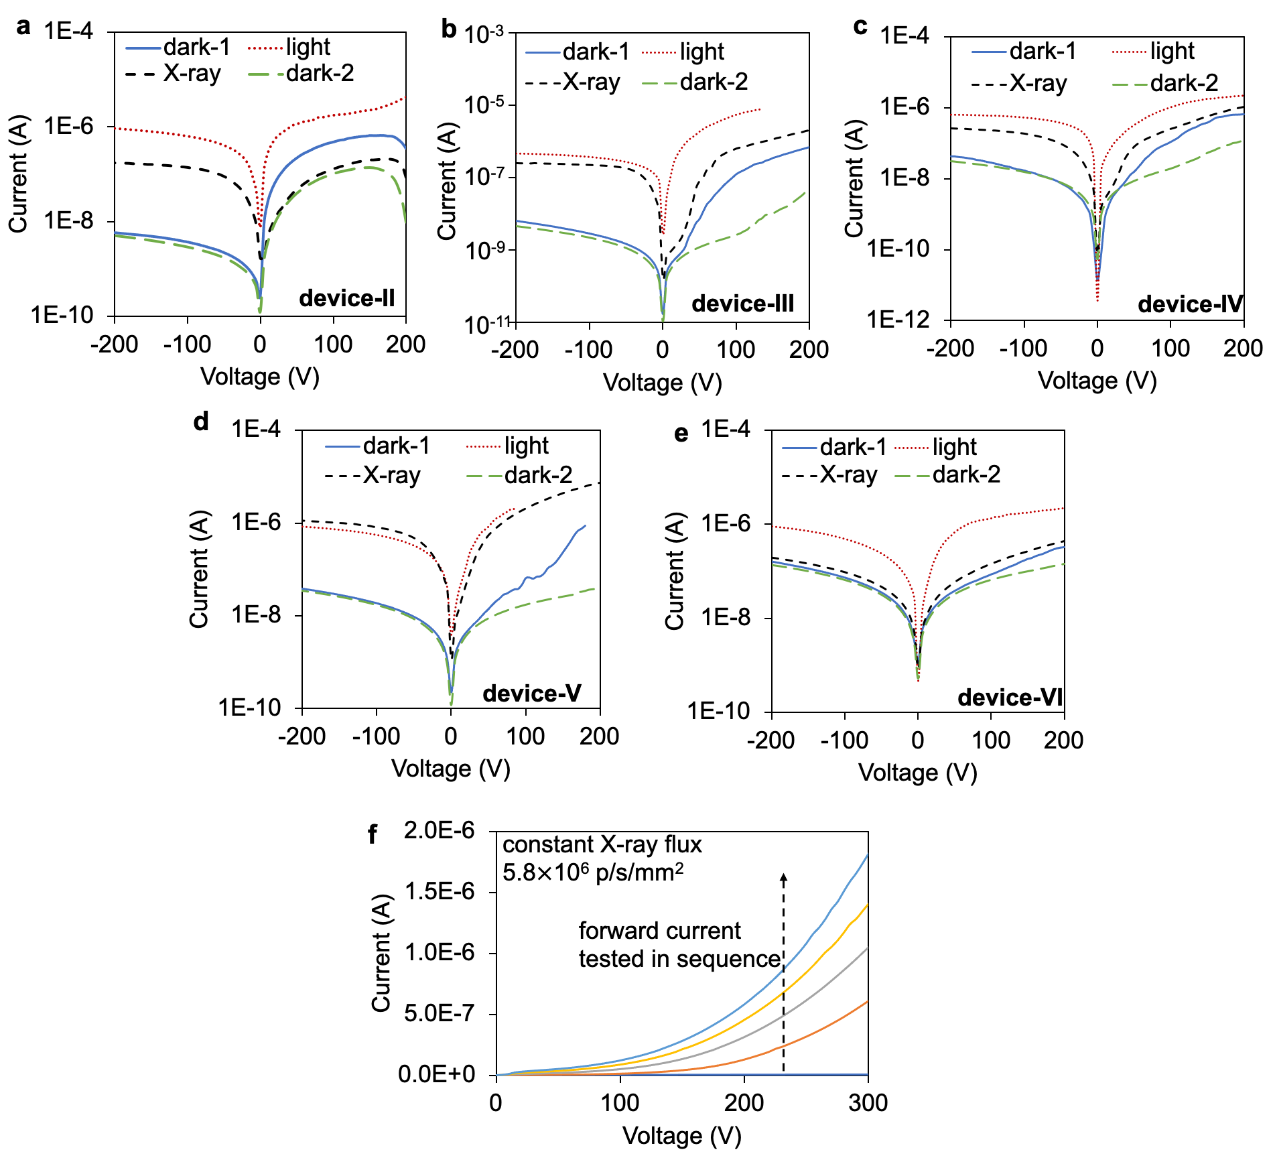
Supplementary Figure 4. I-V curves measured under different conditions for device a, II, b, III, c, IV, d, V, e, VI. I-V curve testing sequence was “dark-1”, “light”, “X-ray” and “dark-2”, where “dark-1” stands for I-V measured in dark before X-ray irradiation, “light” stands for I-V measured under ambient room light, “X-ray” stands for I-V measured under constant X-ray irradiation, and “dark-2” stands for I-V measured in dark right after X-ray irradiation. X-ray flux for “X-ray” is 3.2$×$10⁹ p/s/mm² at 8.2 keV for device II, and 3.4$×$10⁹ p/s/mm² at 58.61 keV for device III, IV, V and VI. I-V measurement under each condition was performed immediately following the prior measurement and duration is ~ 3 mins each. Voltage sweep direction is from +200 V to -200 V. f, repeated forward current testing under constant X-ray irradiation. Voltage sweep direction is from 0V to 300V.

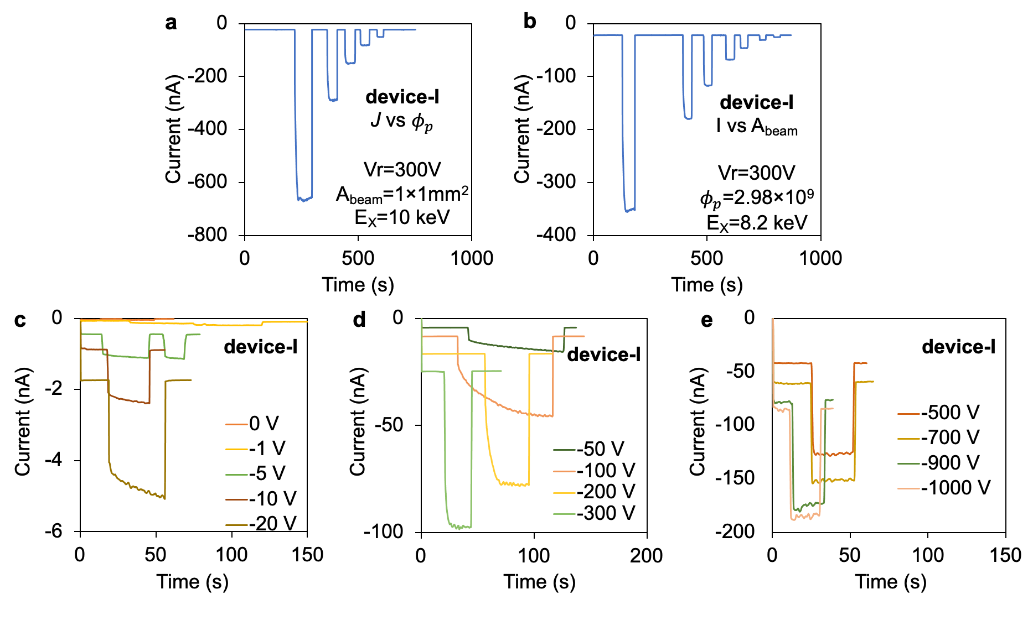
Supplementary Figure 5. Raw current response of device-I under synchrotron X-ray. a, current response at E_{X} = 10 keV b, current response under different X-ray beam size. E_{X} = 8.2 keV c, d, e, current response under different detector reverse voltage at $ϕ_{p}$ = 0.75$×$10⁹ p/s/mm² and X-ray energy E_{X} = 10 keV, A_{beam} = 1$×$1 mm². Note that the current become large and unstable at high bias voltage (e.g., > 900V)
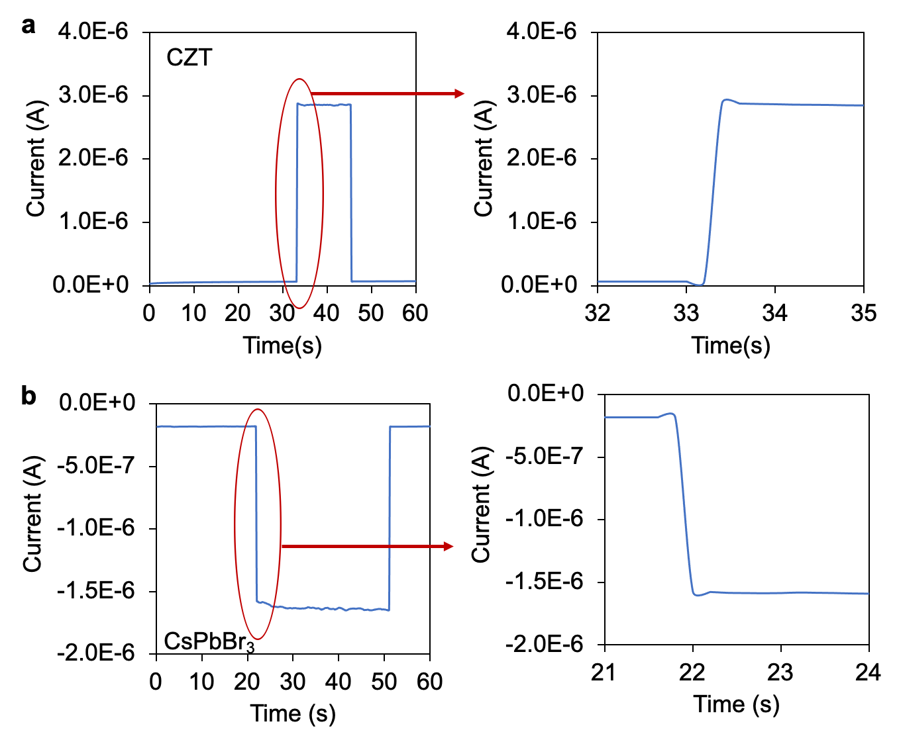
Supplementary Figure 6. response time comparison of a spectrometer CZT detector and a CsPbBr₃ detector (device V). CZT thickness is 1.85 mm with a bias voltage of 200V, and an X-ray flux of 3.9$×$10⁹ p/s/mm². CsPbBr₃ device V thickness is 1.7 mm with a bias voltage of 1000V, and an X-ray flux of 3.4$×$10⁹ p/s/mm². Same X-ray beam area A_{beam} = 0.5$×$0.5 mm² was used for both CZT and CsPbBr₃ testing. The response time of the CZT and the CsPbBr₃ detector is less than 1s.

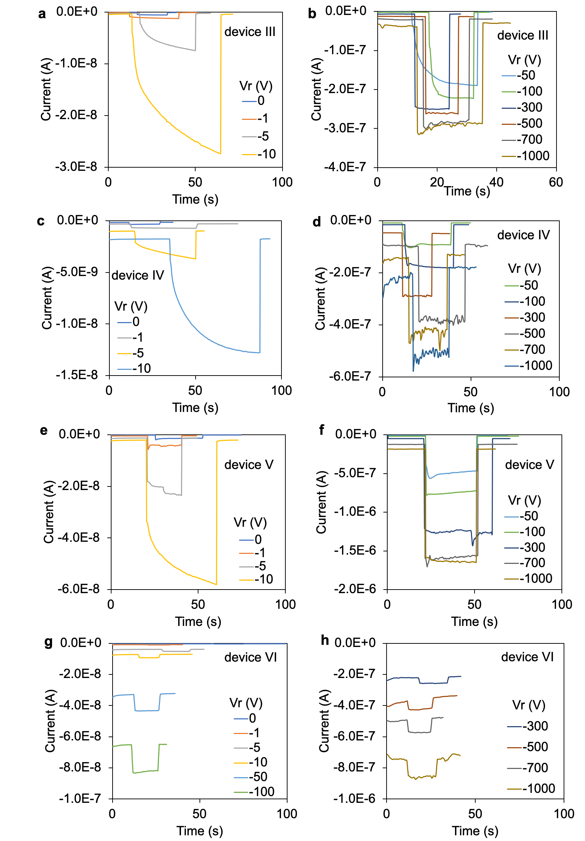
Supplementary Figure 7. Raw current response of device III, IV, V and VI, at different applied bias voltage under a fixed synchrotron X-ray flux of $ϕ_{p}$ = 3.4$×$10⁹ p/s/mm². (A_{beam} = 0.2$×$0.2 mm² for device III, IV, and VI. A_{beam} = 0.5$×$0.5 mm² for device V). The long current response time at low bias voltage is due to radiation induced polarization. Although a high bias voltage is critical to reduce polarization, it can also lead to large and unstable dark current (compare the current response at 1000V with that at lower bias voltage).

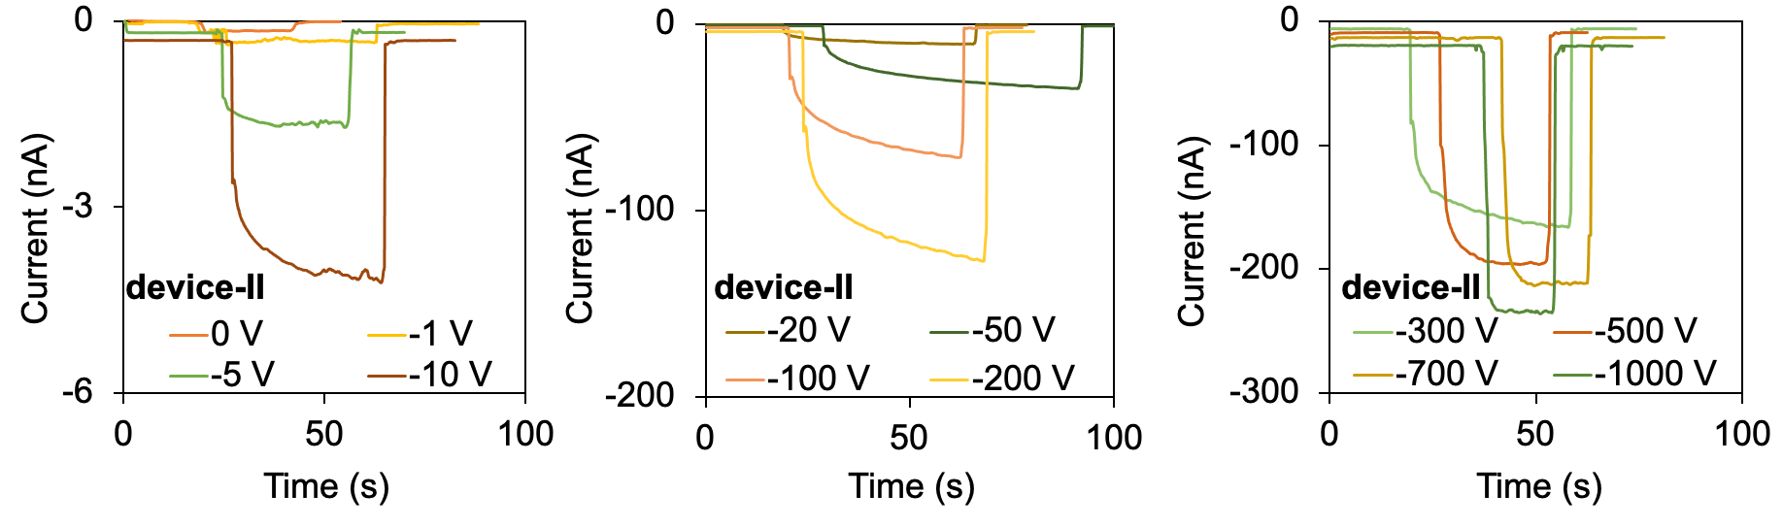
Supplementary Figure 8. Raw current response of device-II under different detector reverse voltage at $ϕ_{p}$ = 2.57$×$10⁹ p/s/mm² and X-ray energy E_{X} = 8.2 keV (A_{beam} = 1$×$1 mm²).

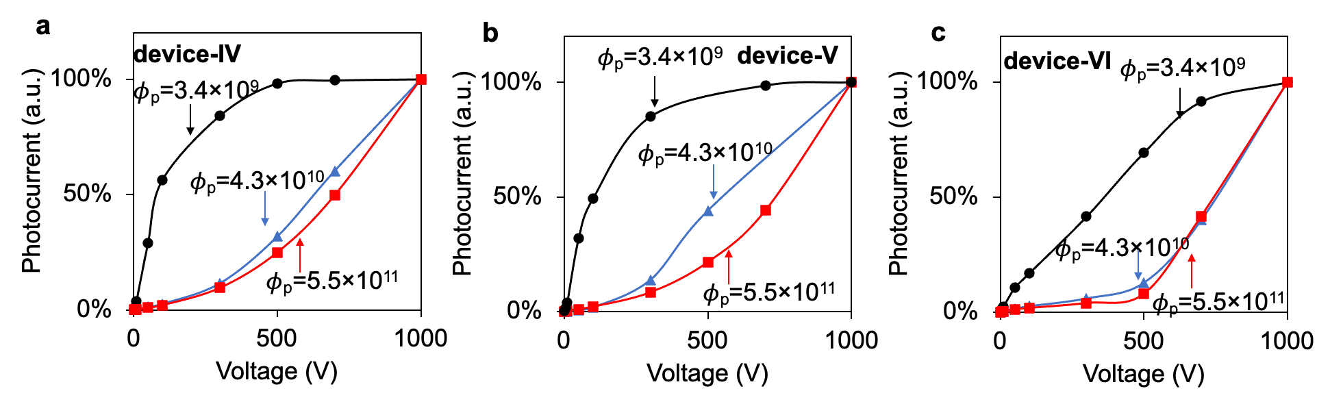
Supplementary Figure 9. Photocurrent vs bias voltage of device IV, V and VI under different fixed fluxes. X-ray beam area A_{beam} = 0.2$×$0.2 mm². The photocurrents are normalized to that of 1000 V to highlight the trend of photocurrent increasing instead of the actual value of the photocurrent.
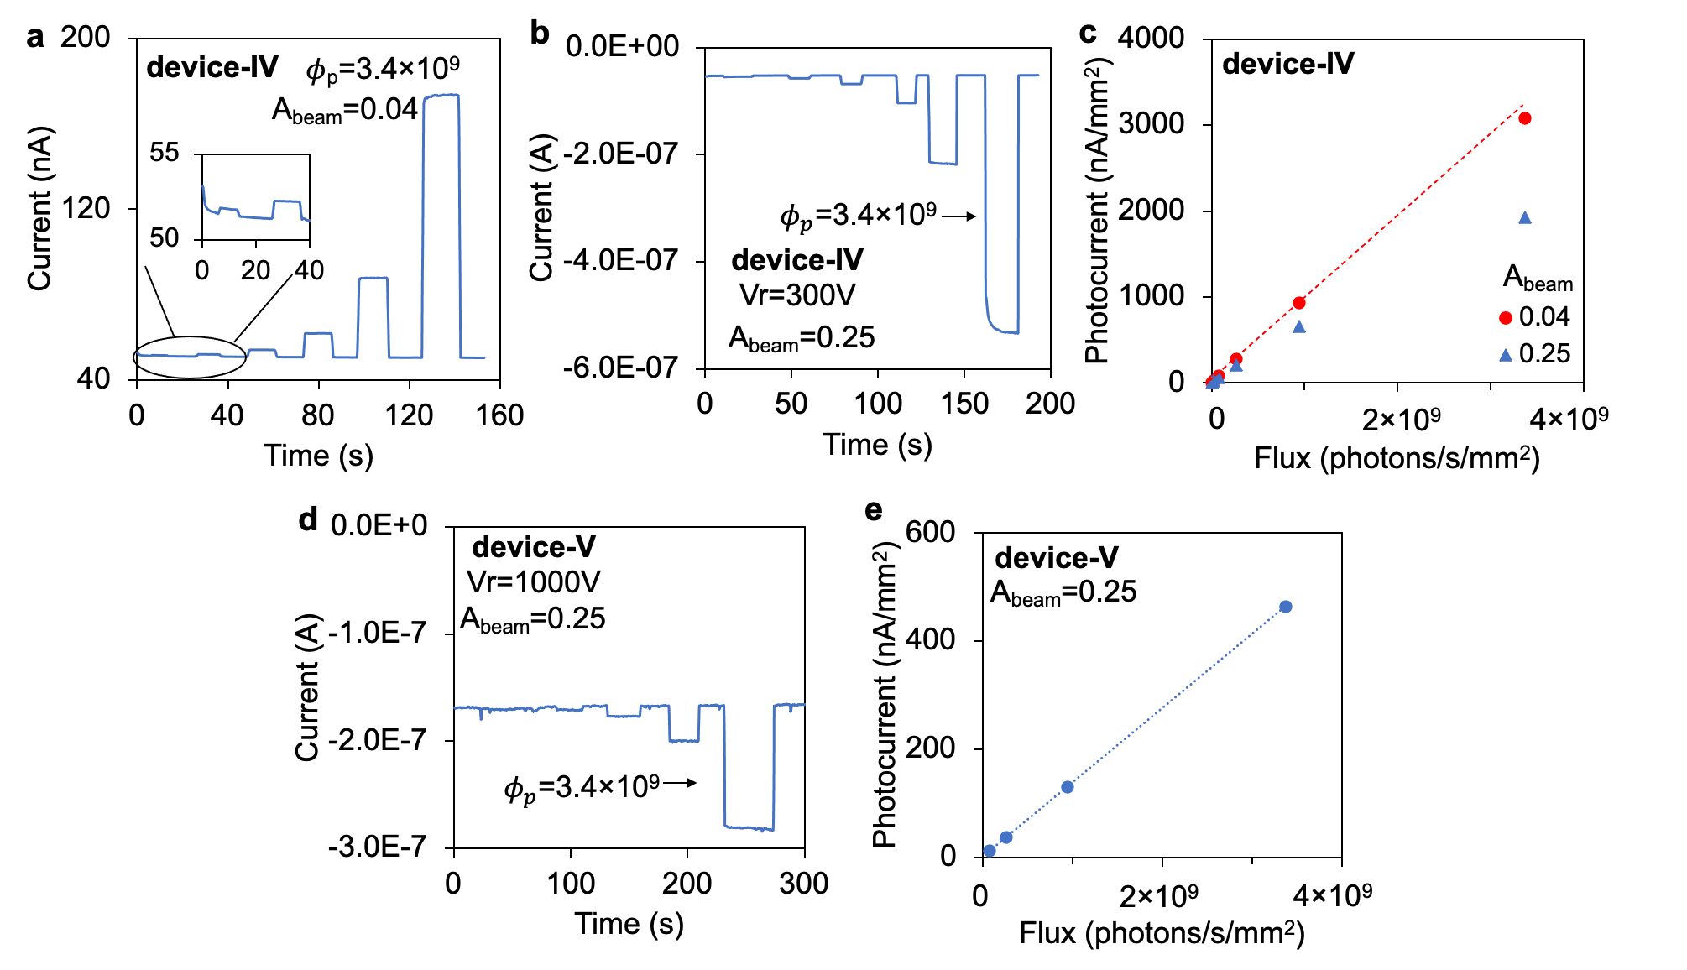
Supplementary Figure 10. Raw current response of device IV and V under synchrotron X-ray with X-ray energy E_{X} = 58.61 keV. Unit of A_{beam} is mm². The dark current deceasing shown in a is due to ion migration. It is also noted that the photocurrent of different device may vary significantly, which is due to the different device polarization history.
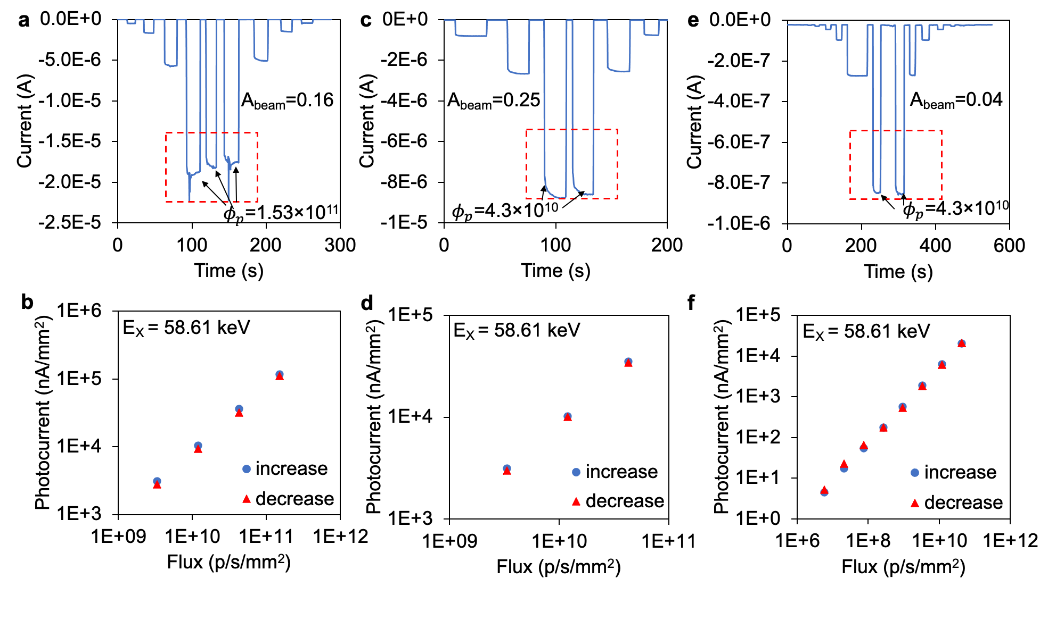
Supplementary Figure 11. Device III raw current response under different beam area. X-ray energy is E_{X} = 58.61 keV. a, beam area is A_{beam} = 0.16 mm², highest flux is $ϕ_{p}$ = 1.53$×$10¹¹ p/s/mm². The testings inside the red dashed box used the same X-ray flux. b, photocurrent vs flux measured in a, where “increase” stands for photocurrent when increasing from low flux value to high flux value initially and “decrease” stands for photocurrent when decreasing flux from high value to low value. c, beam area is A_{beam} = 0.25 mm², highest flux is $ϕ_{p}$ = 4.3$×$10¹⁰ p/s/mm². d, photocurrent vs flux measured in c. e, beam area is A_{beam} = 0.04 mm², highest flux is $ϕ_{p}$ = 4.3$×$10¹⁰ p/s/mm². f, photocurrent vs flux measured in e.

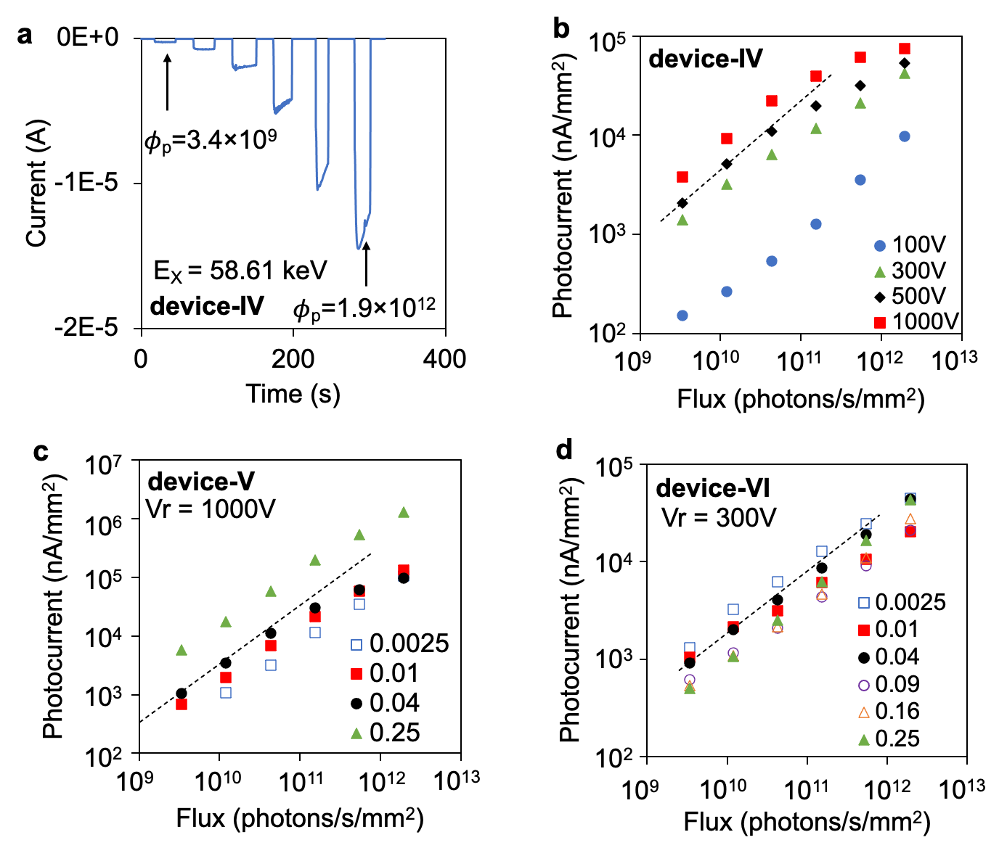
Supplementary Figure 12. Device IV, V and VI photocurrent vs flux and photocurrent vs bias voltage. X-ray energy E_{X} = 58.61 keV. a, Device IV raw current response to different X-ray flux, bias voltage 300 V. A_{beam} = 0.2$×$0.2 mm². b, Device IV photocurrent vs flux at different bias voltage. A_{beam} = 0.2$×$0.2 mm². c, Device V photocurrent vs flux at different beam area. A_{beam} = 0.2$×$0.2 mm². d, Device VI photocurrent vs flux at different beam area. A_{beam} = 0.2$×$0.2 mm².
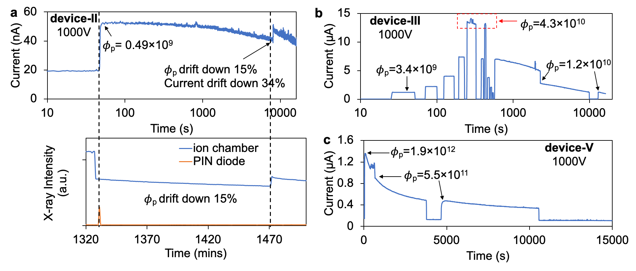
Supplementary Figure 13. CsPbBr₃ device II, III and V current decreasing during continuous X-ray irradiation in several hours. A_{beam} = 1$×$1 mm² for device II. A_{beam} = 0.2$×$0.2 mm² for device III and V.

Supplementary Table 2. flux calibration of beamline 11-ID-B at X-ray energy 58.61 keV
Number of attenuators | Attenuation factor | Number of attenuators | Attenuation factor | Number of attenuators | Attenuation factor
0 | 1 | 7 | 85.6 | 14 | 7330
1 | 1.89 | 8 | 162 | 15 | 13800
2 | 3.57 | 9 | 305 | 16 | 26100
3 | 6.73 | 10 | 577 | 17 | 49400
4 | 12.7 | 11 | 1090 | 18 | 93200
5 | 24 | 12 | 2060 | 19 | 176000
6 | 45.3 | 13 | 3880 | 20 | 333000
Attenuators (tantalum) have same thickness (0.102 mm). The highest X-ray flux $ϕ_{p}$, corresponding to 0 attenuator, is read from Si PIN diode (Hamamatsu S3584-06) calibrated by Physikalisch-Technjsche Bundesanstalt. Then X-ray fluxes at different attenuators are obtained as highest X-ray flux $ϕ_{p}$ divided by attenuation factor.

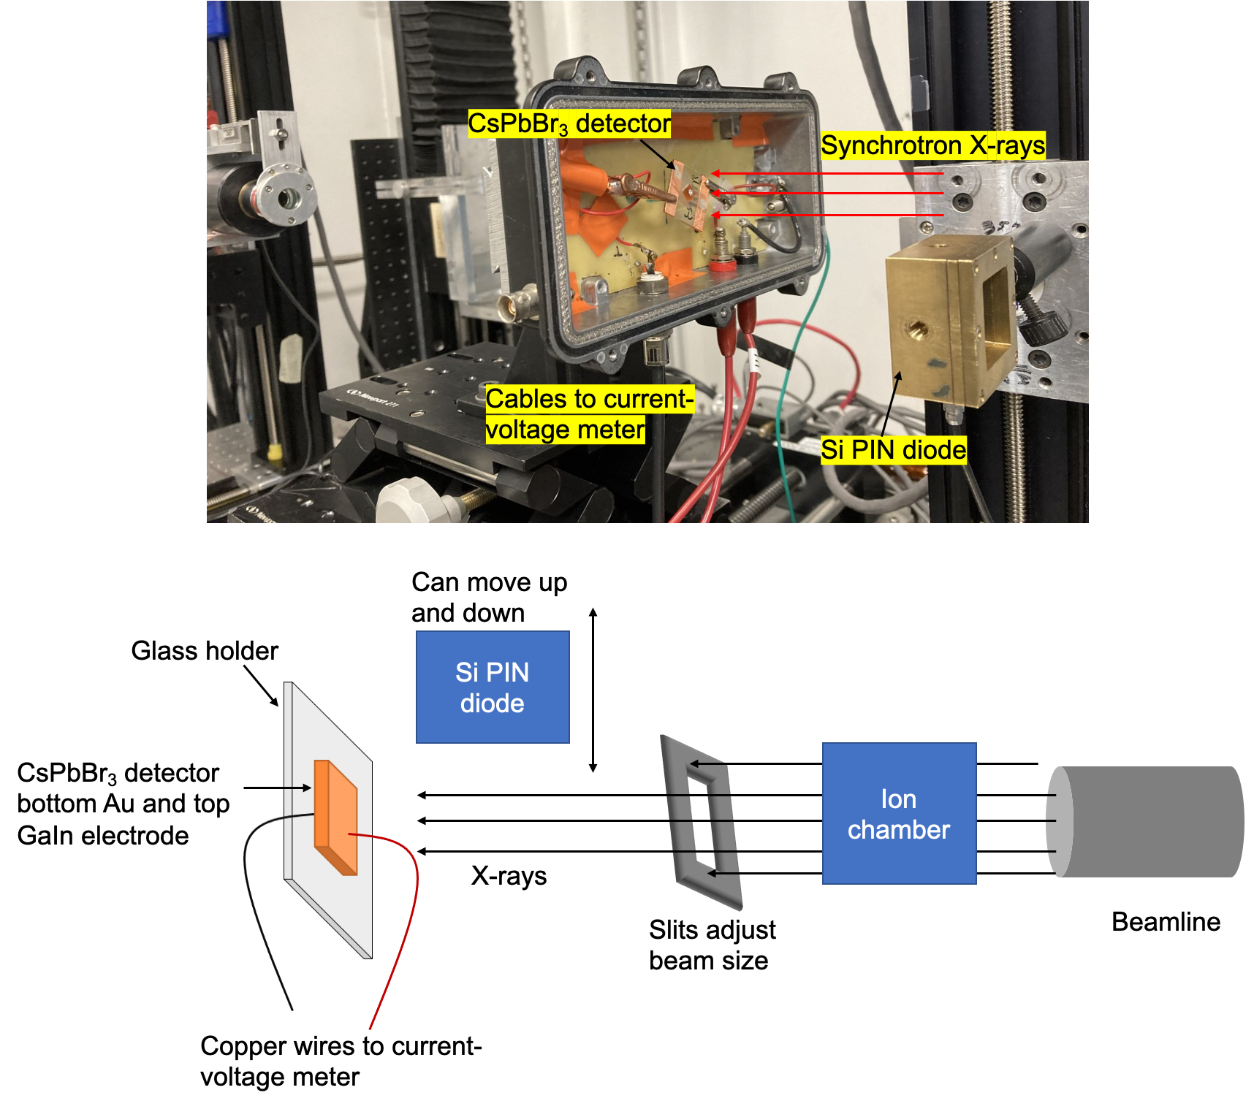
Supplementary Figure 14. Detector testing setup under synchrotron X-ray. Beamline 1-BM-B consists of a Si(111) double crystal monochromator and beamline 11-ID-B consists of a Si(311) monochromator.

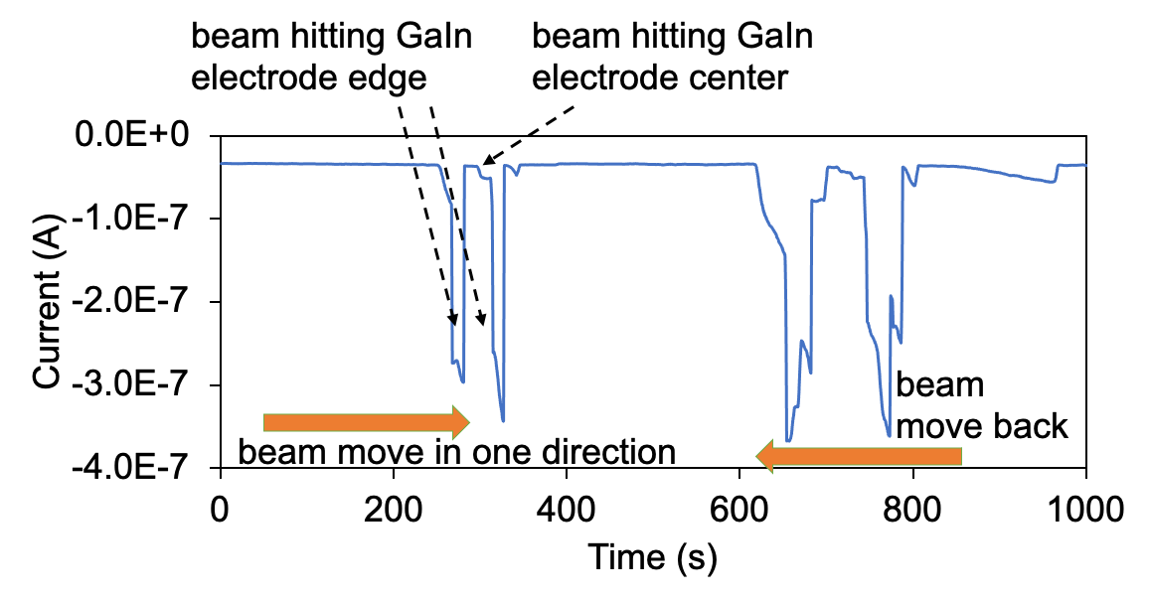
Supplementary Figure 15. a detector alignment procedure using the X-ray beam. The beam moves across the entire electrode region. Because the GaIn is liquid, it has higher thickness in the center and lower thickness in the edge. When beam irradiates the center of GaIn electrode, the current is much smaller than that at the edge area due to absorption of 8.2 keV or 10 keV X-rays. The detector testing position is selected at the location that generates the maximum current. It is noted that the detector position was manually changed. Because the detector movement speed may change, the current shape seen at “beam move back” is not the same as “beam move in one direction”
Calculations and derivations
Estimation of 3dB cutoff frequency. A photodiode’s response speed may be limited by the carrier transit time or the RC time constant of the circuit⁸. The transit-time-limited 3dB cutoff frequency $f_{3dB}^{tr}$ is calculated as $f_{3dB}^{tr}=0.443/τ_{tr}$, where $τ_{tr}$ is charge carrier drift time. $τ_{tr}$ can be estimated as $τ_{tr}=d^{2}/(μV)$, where $d$ is the detector thickness, $μ$ is carrier mobility and $V$ is detector bias voltage. According to our previous results⁹, CsPbBr₃ has a hole mobility of ~52 cm²/V/s. With thickness $d$ = 1.7 mm and a bias voltage of 300 V, $τ_{tr}$ and $f_{3dB}$ is calculated to be ~ 1.85 $μ$s and ~ 0.2 MHz. The RC-limited 3dB cutoff frequency is $f_{3dB}^{RC}=1/2πRC$, where $R$ is load resistance and $C$ is detector capacitance. The CsPbBr₃ detector can be fully depleted at several hundred volts (see Estimation of CsPbBr₃ detector depletion region). For a fully depleted detector, the detector capacitance is dominated by the junction capacitance that can be calculated as $C=ε_{0}ε_{r}A/d$, $A$ is electrode area, $d$ is detector thickness. The capacitance is estimated to be in the pF order for detector thickness d = 1.7 mm and electrode area of several mm². Assuming a common load resistance of 50 $Ω$, we estimate the $f_{3dB}^{RC}$ to be ~ GHz order, much higher than $f_{3dB}^{tr}$, which means the CsPbBr₃ detector response speed is limited by the charge carrier transit time instead of the RC effect.
Theoretical calculation of sensitivity $S$. Let $α$ be the portion of X-rays absorbed by the CsPbBr₃ crystal and CCE is the Charge Collection Efficiency. Then the photocurrent density is calculated as follows.
 | $$J \left(\frac{nA}{{mm}^{2}}\right)=\frac{ϕ_{E }(\frac{\frac{keV}{s}}{{mm}^{2}})×α×CCE×1000×1.6×{10}^{-19}×{10}^{9}}{ε_{pair}(eV)}$$ | (1)
Given the definition of sensitivity $S$, we have
 | $$S\left(\frac{nC}{keV}\right)≡\frac{J \left(\frac{nA}{{mm}^{2}}\right)}{ϕ_{E }\left(\frac{\frac{keV}{s}}{{mm}^{2}}\right)}=\frac{α×CCE×1000×1.6×{10}^{-19}×{10}^{9}}{ε_{pair}(eV)}$$ | (2)
When all X-rays are absorbed by the CsPbBr₃ crystal, that is, $α$ = 100%, and CCE = 100%, the sensitivity $S$ is the theoretically highest sensitivity $S_{0}$, that can be calculated below.
 | $$S_{0}\left(\frac{nC}{keV}\right)=\frac{1.6×{10}^{-7}}{ε_{pair}}$$ | (3)
With $ε_{pair}$ = 5.3 eV for CsPbBr₃, $S_{0}$ is calculated to be 3 × 10⁻⁸ nC/keV.
Calculation of 8.2 keV and 10 keV X-rays absorbed by the CsPbBr₃ device I. Assuming CCE = 100%, $α$ can be obtained from a rearrangement of equation (1). For example, at 2.94$×$10⁹ p/s/mm² and X-ray energy 8.2 keV, $ϕ_{E }(\frac{\frac{keV}{s}}{{mm}^{2}})$= 2.94$×$10⁹$×$8.2. The measured photocurrent density $J \left(\frac{nA}{{mm}^{2}}\right)$=313. $ε_{pair}\left(eV\right)$=5.3. Inserting these numbers into equation (1), we have $α$ = 43%, which means 43% of the 8.2 keV X-rays were absorbed by the crystal with the rest absorbed by the GaIn electrode.
Estimation of higher limit of flux. To estimate the higher limit of flux under which the CsPbBr₃ detector can operate without concern of polarization in several hundreds of seconds, we define the current drift D, manifestation of polarization, as below.
$D ≡ \frac{I_{0}-I_{t}}{I_{0}t} × 100\%$,
where $I_{0}$ is the peak photocurrent before decreasing; $I_{t}$ is the photocurrent at the time when the X-ray is turned “off”, and $t$ is the time duration between $I_{0}$ and $I_{t}$. The current drift can be understood as the CCE decreasing in percentage per unit time. Based on the experimental observation of current drifting, the flux under which D < 0.1%/s for measurement time longer than 10 s is tentatively taken as the higher limit of flux of the detector. The values of the current drift D calculated for different devices under different fluxes are shown in the table below. Accordingly, the higher limit of flux for device III, IV and V is estimated to be 8.1$×$10¹⁰ p/s/mm², 3.4$×$10⁹ p/s/mm², and 1.2$×$10¹⁰ p/s/mm², respectively.
Supplementary Table 3. Current drift D calculated for device III, IV and V under different X-ray flux for higher limit of flux estimation.
X-ray flux (p/s/mm²) | 1.9$×$10¹² | 5.5$×$10¹¹ | 1.5$×$10¹¹ | 8.1×10¹⁰ | 4.3×10¹⁰ | 1.2×10¹⁰ | 3.4×10⁹
D-device III | 1.7%/s | 0.4%/s | 0.1%/s | <0.1%/s
D-device IV | 1.1%/s | 1.2%/s | 0.9%/s | - | 0.4%/s | 0.1%/s | <0.1%/s
D-device V | 1.2%/s | 1.2%/s | 0.6%/s | - | 0.2%/s | <0.1%/s
X-ray energy 58.61 keV. A_{beam} = 0.2$×$0.2 mm² for device III and IV; A_{beam} = 0.5$×$0.5 mm² for device V; It is noted that the orders of flux have more practical value as reference for detector operation instead of the exact numbers.
Estimation of CsPbBr₃ detector depletion region.
According to our previous work¹⁰, the Schottky contact depletion region width W can be calculated as W=(2$ε_{0}ε_{r}$(V_{bi}+V_{a}) $ρμ_{p}$)^{1/2}, where $ε_{0}$ is the vacuum permittivity, $ε_{r}$=29.4 is the static dielectric constant of CsPbBr₃ single crystal¹¹, V_{bi} is the built-in potential of the Schottky barrier, V_{a} is the applied reverse bias, $ρ$ is resistivity and $μ_{p}$ is hole mobility. Our previous work^{10, 12} has estimated the Schottky barrier height to be 0.84 eV, 0.82 eV and 1.09 eV for Ga, Ti and Bi metal electrode, respectively. Hence, given a similar work function of In metal with Ga, Ti and Bi, we expect the GaIn metal alloy electrode to have a similar Schottky barrier height ~ 0.8 - 1 eV. For a CsPbBr₃ detector with a thickness of 2-3 mm, $ρ$ ~ 10⁹-10¹⁰ $Ω*cm$, $μ_{p}$~52 cm²/V/s, it will be fully depleted at a reverse bias of several hundred volts.
References
(8) Ahmed, M. S.; et al. Bandwidth Analysis of a p-π-n Si Photodetector. International Journal of Computer Applications 2016, 975, 8887.
(9) He, Y.; et al. High spectral resolution of gamma-rays at room temperature by perovskite CsPbBr3 single crystals. Nat Commun 2018, 9 (1), 1609. DOI: 10.1038/s41467-018-04073-3.
(10) Pan, L.; et al.. Comparison of Zr, Bi, Ti, and Ga as Metal Contacts in Inorganic Perovskite CsPbBr₃ Gamma-Ray Detector. IEEE Transactions on Nuclear Science 2020, 67 (10), 2255-2262. DOI: 10.1109/TNS.2020.3018101.
(11) Miyata, K.; et al. Large polarons in lead halide perovskites. Science Advances 2017, 3 (8), e1701217.
(12) He, Y.; et al.Sensitivity and Detection Limit of Spectroscopic‐Grade Perovskite CsPbBr3 Crystal for Hard X‐Ray Detection. Advanced Functional Materials 2022, 2112925.

