Supplementary information for:

Climate change mitigation benefits for labor exceed mitigation costs

Luke A. Parsons*¹, Drew Shindell¹, Emily Nagamoto¹, Jonny Chang¹, Greg Faluvegi^{2,3}, Timm Kroeger⁴
¹ Nicholas School of the Environment, Duke University, Durham, NC
² Center for Climate Systems Research, Columbia University, New York, NY
³ NASA Goddard Institute for Space Studies, New York, NY
⁴ Global Science, The Nature Conservancy, Arlington, VA

*Corresponding author: Luke Parsons (luke.parsons@duke.edu)

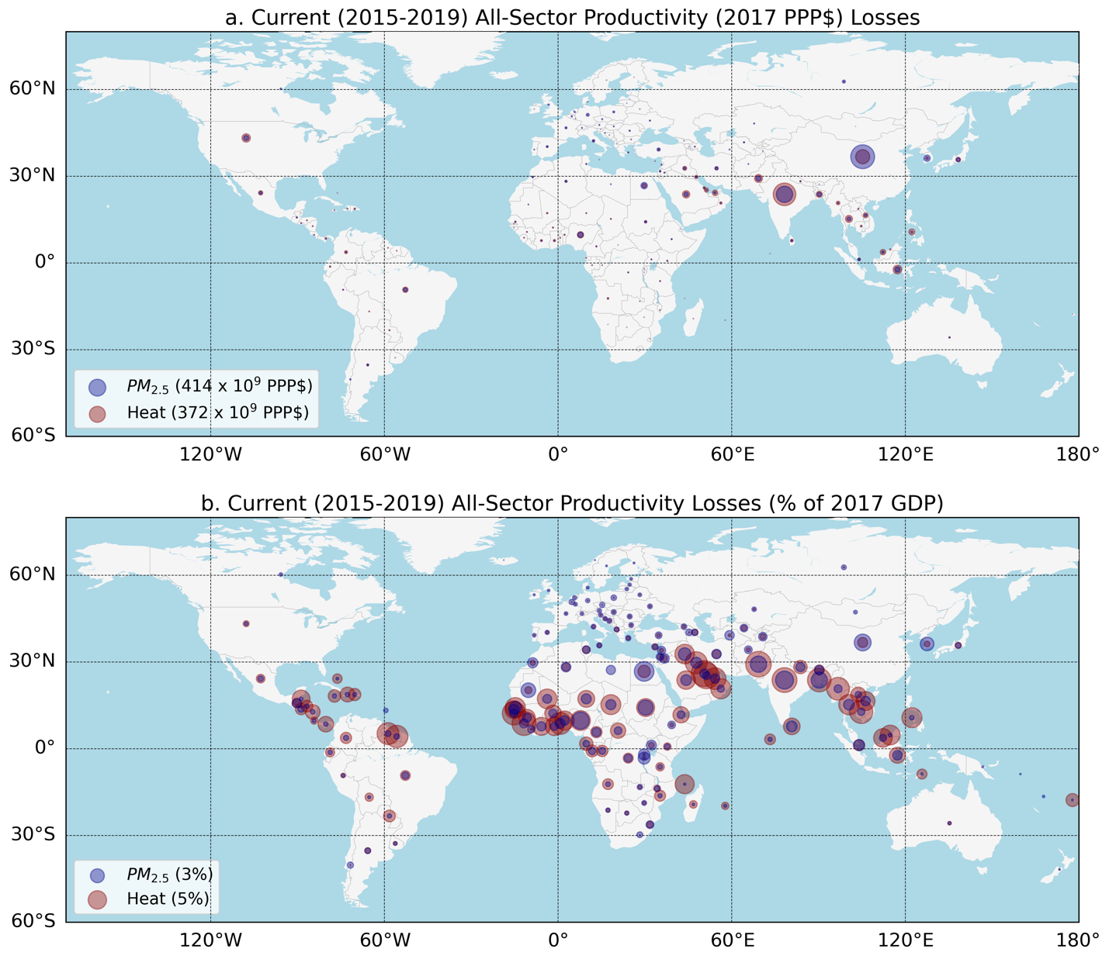
Figure S1. Current country-level productivity associated with heat and air pollution. Circles on each country show annual country-level productivity losses (2017 PPP$) currently (2015-2019 mean) under SSP3-7.0 (a) and as a fraction of each country’s GDP in 2017 (b). Red circles show losses associated with humid heat, and blue circles show losses associated with air pollution. The area of the circle increases as a function of loss; the legend illustrates how the area of the circle increases with losses. Losses from humid heat are calculated using the exposure response function from Kjellstrom et al., 2018 using hourly ERA5 data (present). Labor losses associated with air pollution are calculated using CMIP6 SSP3-7.0 PM_{2.5} data (2015-2019 mean) and a concentration response function (CRF) from the WHO (Methods).

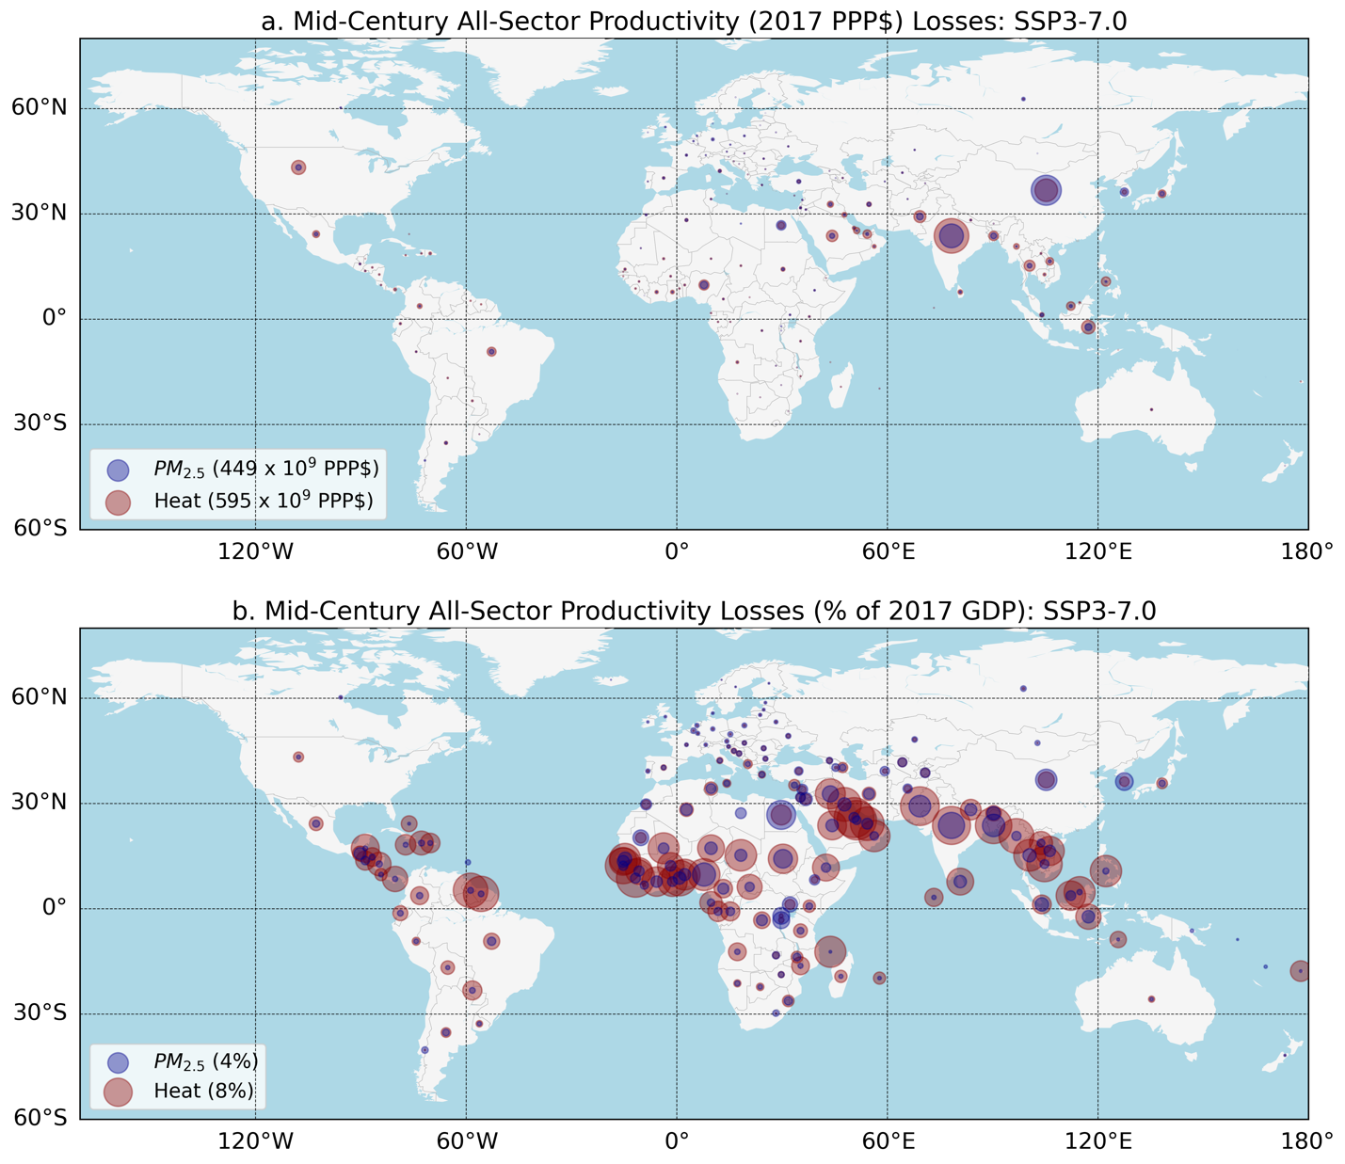
Figure S2. Mid-century country-level productivity losses associated with humid heat and air pollution exposure. As in Figure S1, but circles on each country show annual country-level productivity losses (2017 PPP$) mid-century (2050-2054 mean) under SSP3-7.0 with 1°C of warming, both in absolute 2017 PPP$ (a) and in terms of each country’s 2017 Gross Domestic Product (GDP, b). Losses associated with heat exposure are calculated using the exposure response function from Kjellstrom et al., 2018 using hourly ERA5 data combined with CMIP6 patterns of warming to project changes at 1°C warming. Labor losses for air pollution are calculated from CMIP6 PM_{2.5} projections for 2050-2054.

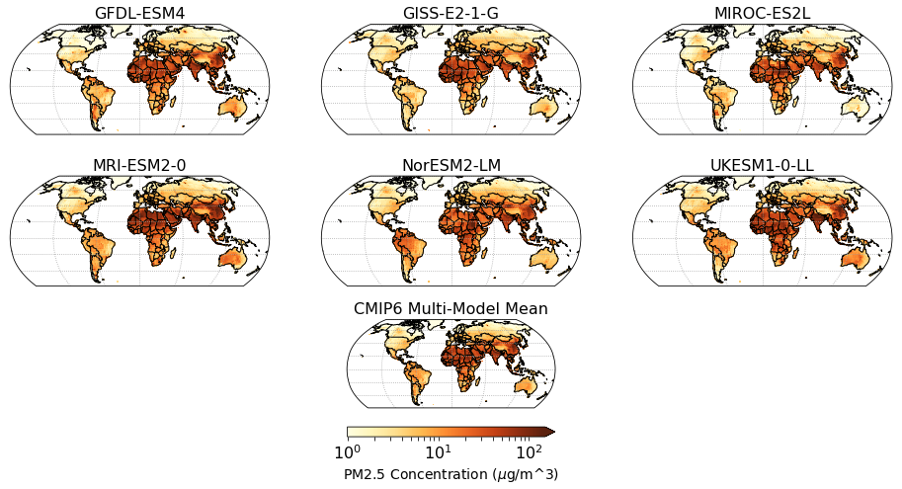

Figure S3. Present PM_{2.5} concentration in CMIP6 models. Mean 2015-2019 near-surface PM_{2.5} concentration in the SSP1-2.6 experiment. Upper panels show individual CMIP6 models used in analysis, with the multi-model mean PM_{2.5} shown in the bottom center. PM_{2.5} definition in Methods.
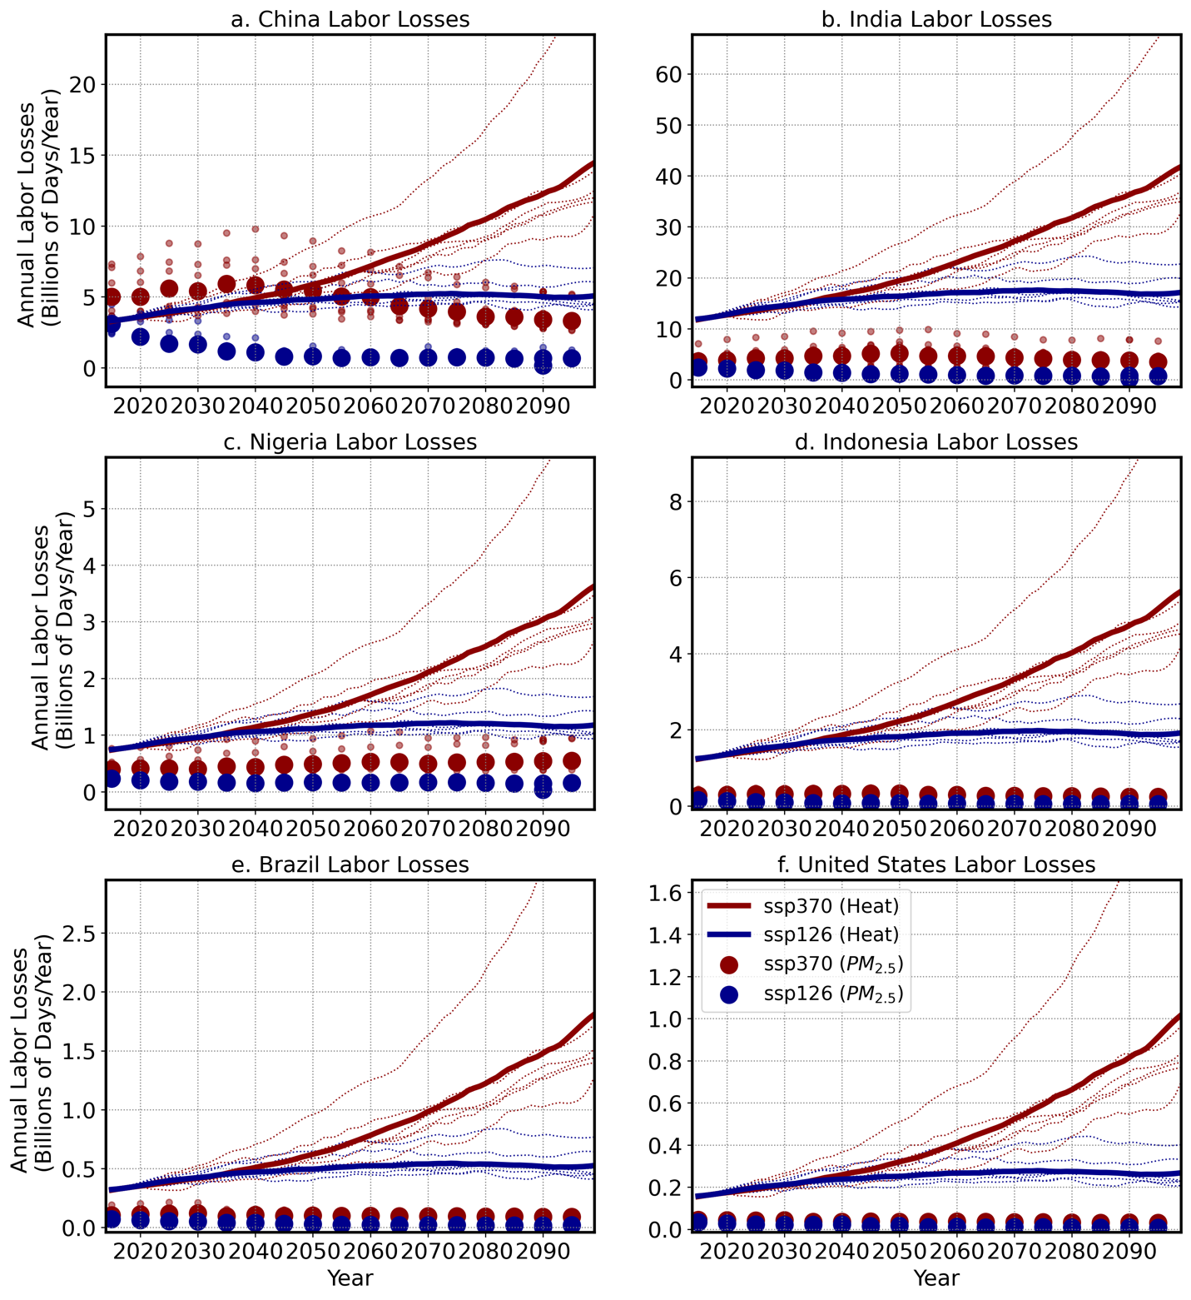
Figure S4. Country-level labor losses associated with heat and air pollution. Time series showing country-level sums of potential labor losses associated with exposure to heat (lines) and air pollution (dots) under SSP1-2.6 (red) and SSP3-7.0 (blue). Thin lines and small dots show the individual CMIP6 model results, and thick lines and large dots show the multi-model median results.
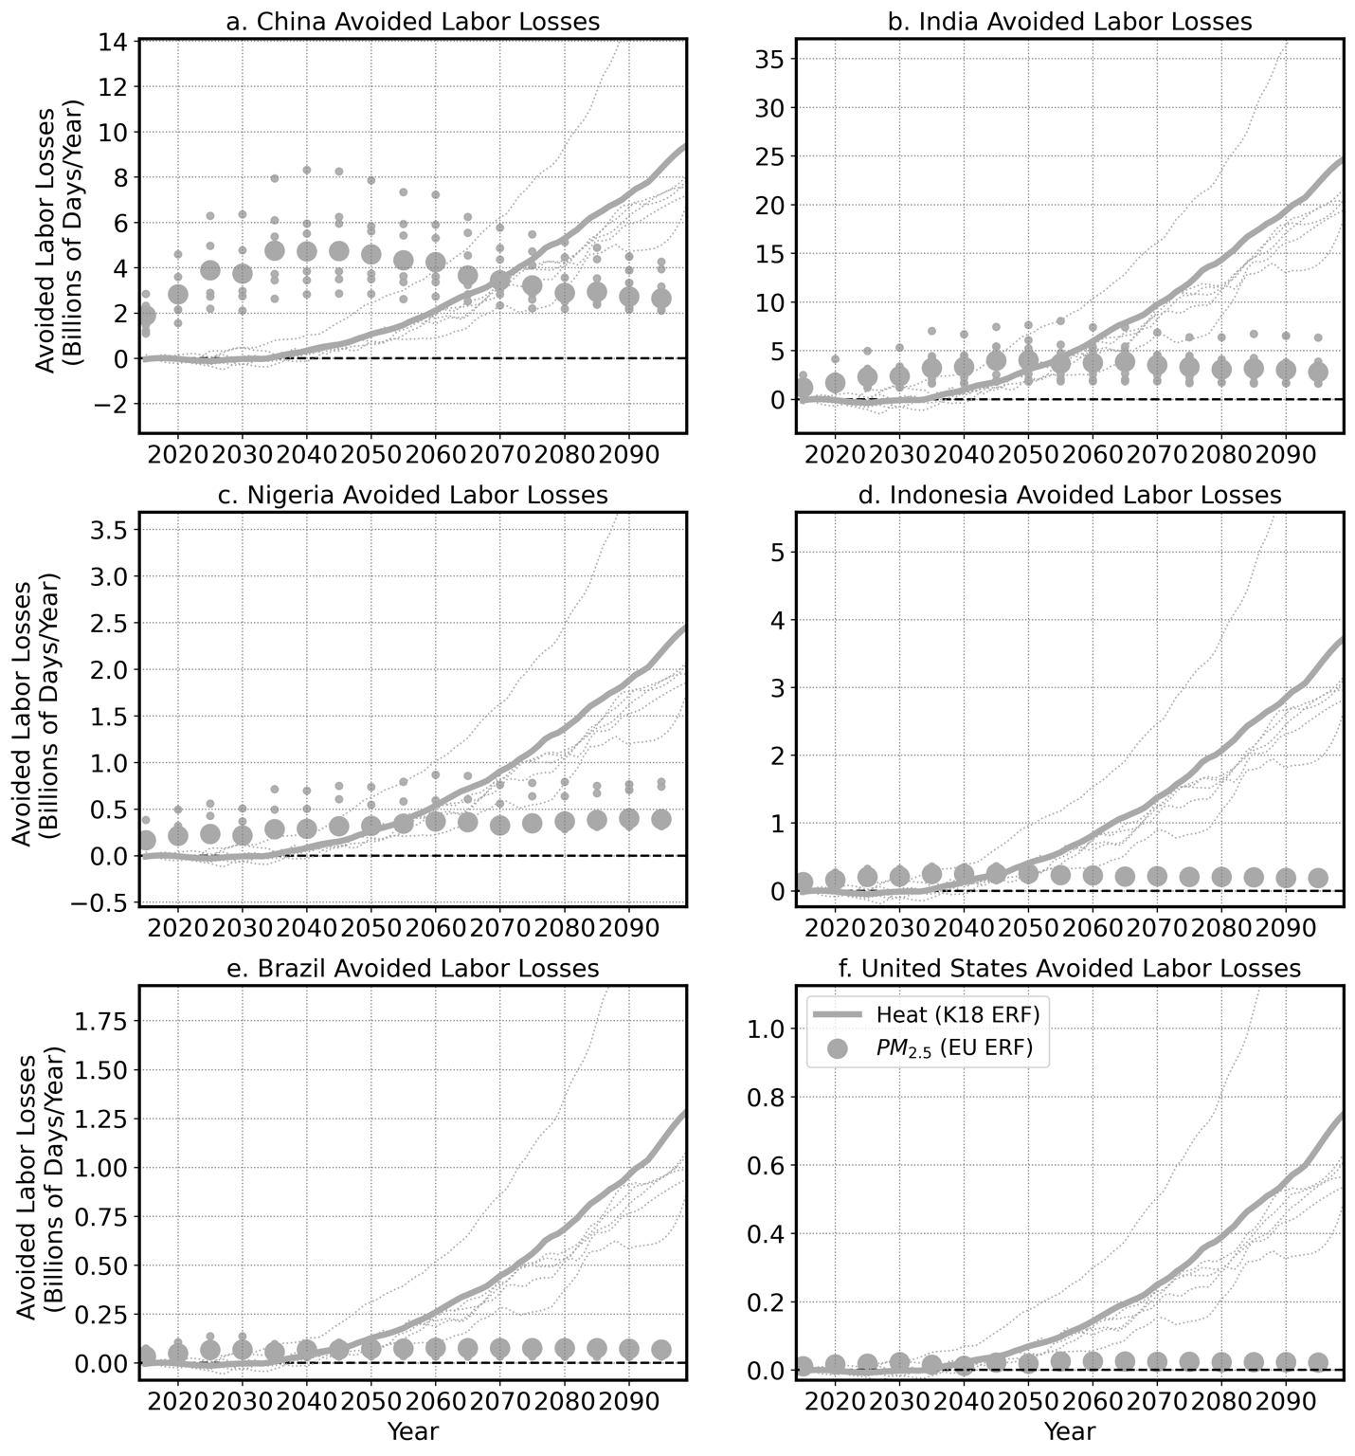
Figure S5. Avoided country-level labor losses associated with heat and air pollution. Time series showing avoided country-level potential labor losses associated with avoided exposure to heat (lines) and air pollution (dots). Avoided losses are calculated as the difference between losses in CMIP6 SSP1-2.6 and SSP3-7.0. Thin lines and small dots show the individual CMIP6 model results, and thick lines and large dots show the multi-model median results.
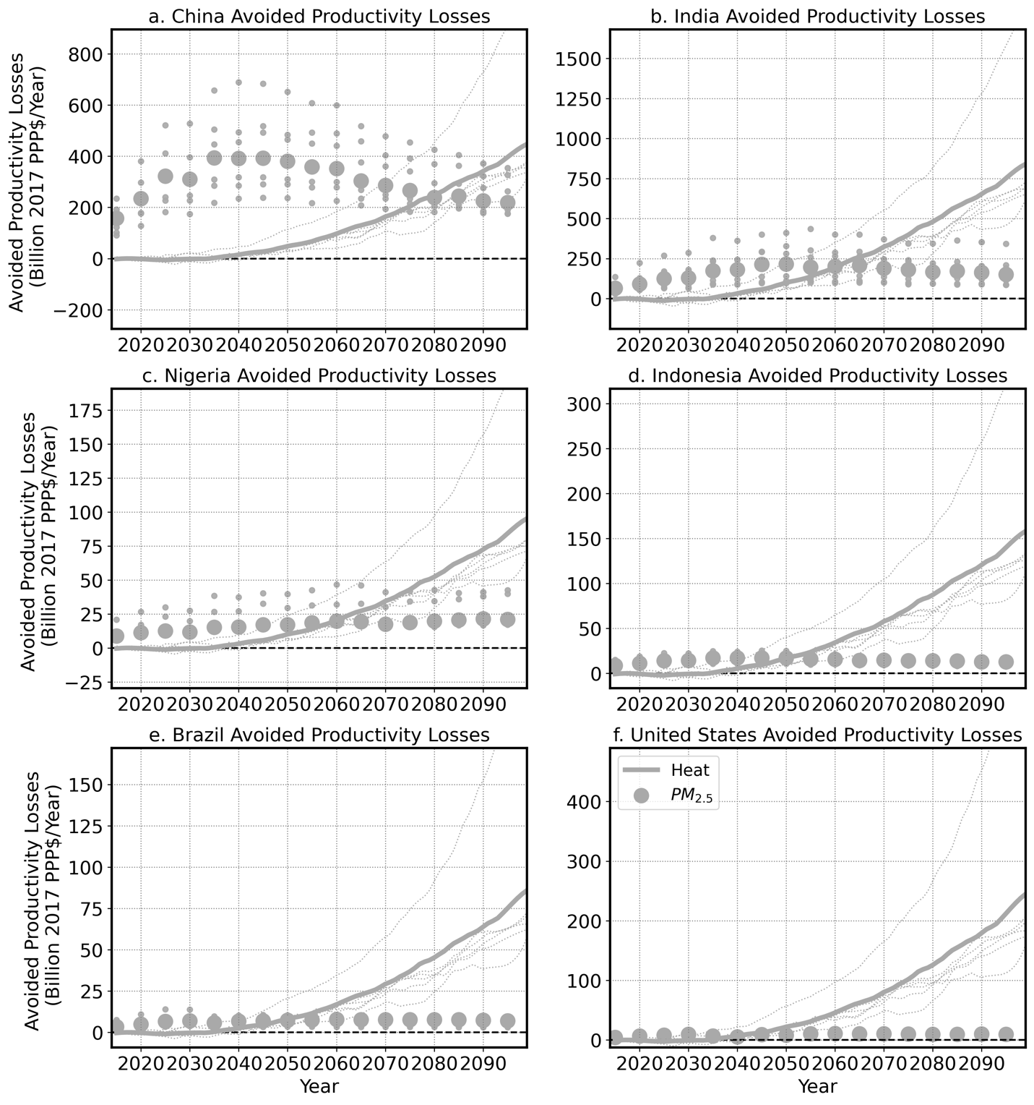
Figure S6. Avoided country-level productivity losses associated with heat and air pollution. Time series showing avoided country-level potential productivity losses (2017 PPP$) associated with avoided exposure to heat (lines) and air pollution (dots). Avoided losses are calculated as the difference between losses in CMIP6 SSP1-2.6 and SSP3-7.0. Thin lines and small dots show the individual CMIP6 model results, and thick lines and large dots show the multi-model median results.
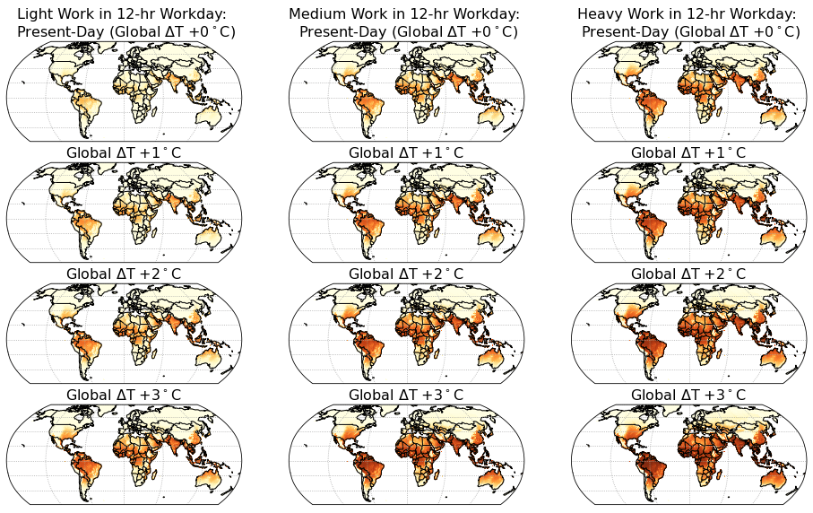
Figure S6. Light, medium, and heavy intensity labor productivity losses associated with heat exposure, currently and with global warming. Annual totals of light (left column), medium (center column), and heavy (right column) intensity labor (hours/person/year, with a theoretical maximum of 4,380 lost work hours/year, or 12 hours/day and 365 days/year of work) calculated from Kjellstrom et al. 2018 humid heat exposure response function and hourly sWBGT calculated from ERA5 data for the present as well as for global temperature changes (‘Global ΔT’) of +1°C, +2°C, and +3°C relative to the present. For future warming, patterns of CMIP6 simplified Wet Bulb Globe Temperatures (sWBGT) warming patterns are used (Parsons et al., 2021). For the present, annual sums of labor lost (2015-2019) are calculated from the hourly sWBGT ERA5 data, the average over the 2015-2019 time period is shown (Methods).

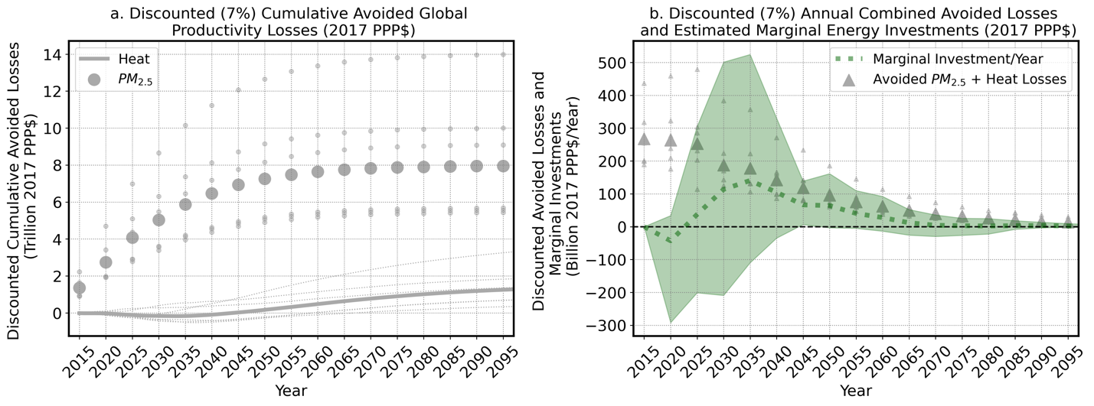
Figure S7. Global avoided labor productivity losses from air pollution and heat using a 7% annual discount rate.
Time series showing avoided cumulative productivity losses discounted at an annual 7% rate (a), and combined annual productivity and marginal investments losses discounted at an annual 7% rate. Avoided losses are due to avoided labor losses associated with heat exposure (lines) and air pollution exposure (dots) under Shared Socioeconomic Pathways (SSPs) SSP1-2.6 vs SSP3-7.0. Thin lines and small dots show the individual Coupled Model Intercomparison Project Phase 6 (CMIP6) model results, and thick lines and large dots show the multi-model median results. The grey triangles (b) show the combined avoided global productivity (2017 PPP$) losses from avoided heat and PM_{2.5} exposure under SSP1-2.6 vs SSP3-7.0, and the green shading outlines the annual estimated marginal investments to transform the energy system to limit warming to 2°C, with the dashed green line showing the mean estimate in McCollum et al.²⁵ also discounted at an annual 7% rate.

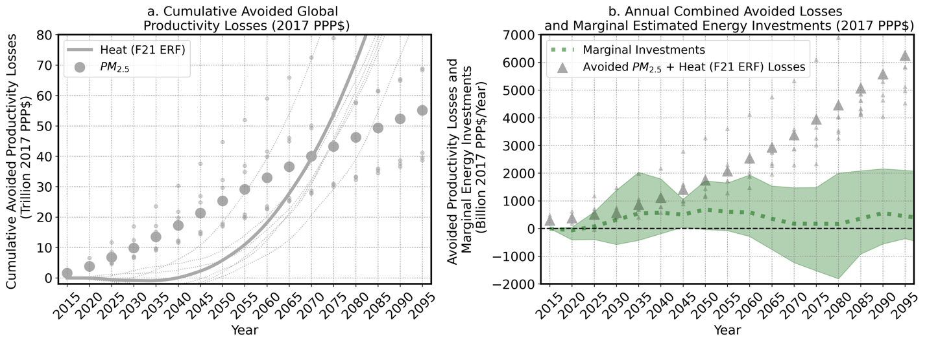
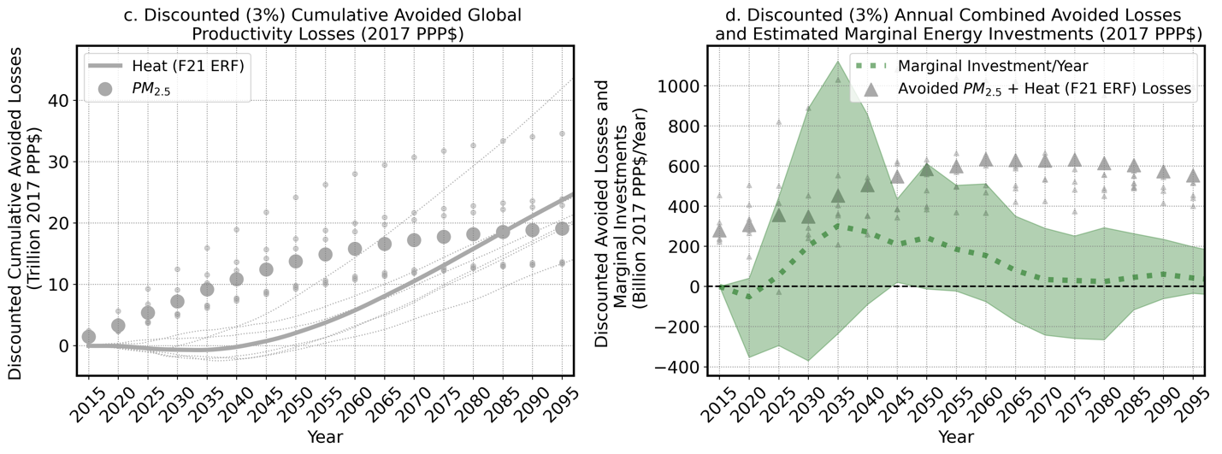
Figure S8. Avoided labor productivity losses using Foster et al. 2021 exposure response function. Similar to Figure 4 in the main text, but in place of the Kjellstrom et al. 2018 heat exposure response function (ERF), here the Foster et al. (2021) ERF is used, which produces labor losses at humid heat as low as 18°C, whereas the Kjellstrom ERF does not begin to show labor losses until humid heat reaches at least ~23°C. Above a humid heat threshold of ~33°C, the Foster ERF begins to show lower productivity loss than the Kjellstrom ERF. Time series (a) shows cumulative avoided global productivity (2017 PPP$) losses from heat and air pollution separately and (b) combined annual avoided productivity (2017 PPP$) losses from heat and air pollution as well as estimated marginal costs of energy investments needed to limit warming to 2°C, with the dashed green line showing the mean estimate and the shading showing the range of estimates from McCollum et al.²³. Time series (c) shows avoided losses and combined annual productivity and marginal investments (d) discounted at an annual 3% rate.

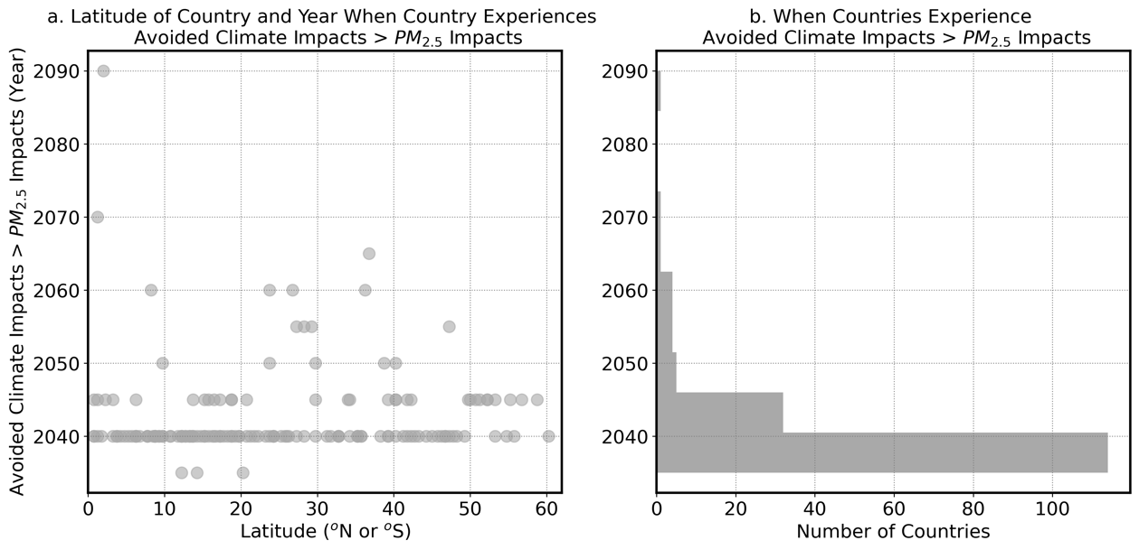

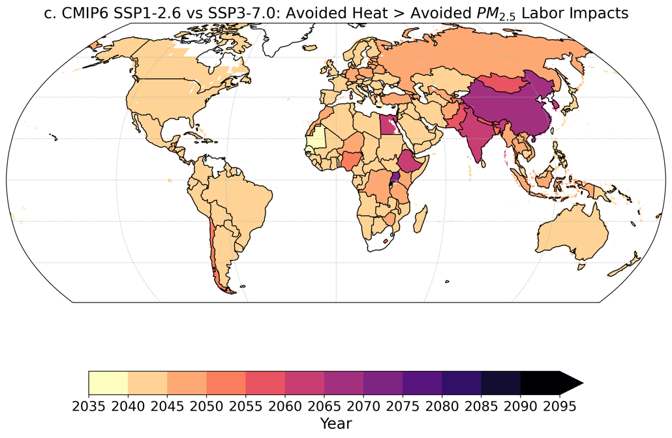

Figure S9. Projected time horizon when climate benefits outweigh air pollution benefits for labor using the Foster et al. 2021 exposure response function. Similar Figure 5 in the main text, but in place of the Kjellstrom et al. 2018 heat exposure response function (ERF), here the Foster et al. (2021) ERF is used. Scatter plot (a) shows latitude and year when each country is expected to show greater benefits from climate mitigation than air pollution, bar graph (b) shows distribution of countries by latitude as a function of when each country is expected to show greater climate as opposed to air pollution benefits, and map (c) shows the approximate year for each country in which climate benefits overtake air pollution benefits from emissions reductions, with darker colors indicating more delayed climate relative to air pollution benefits.

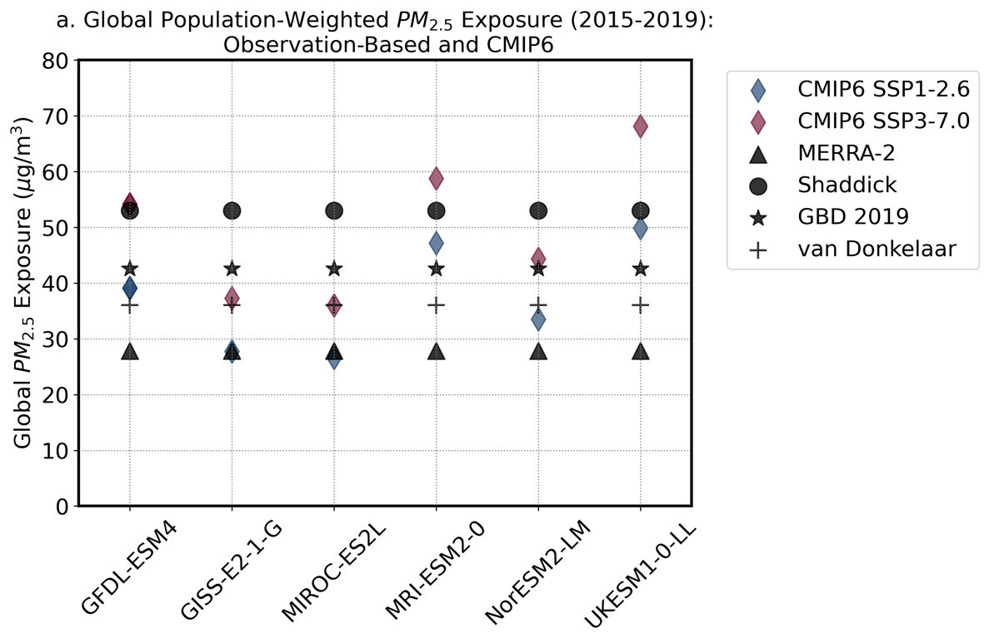

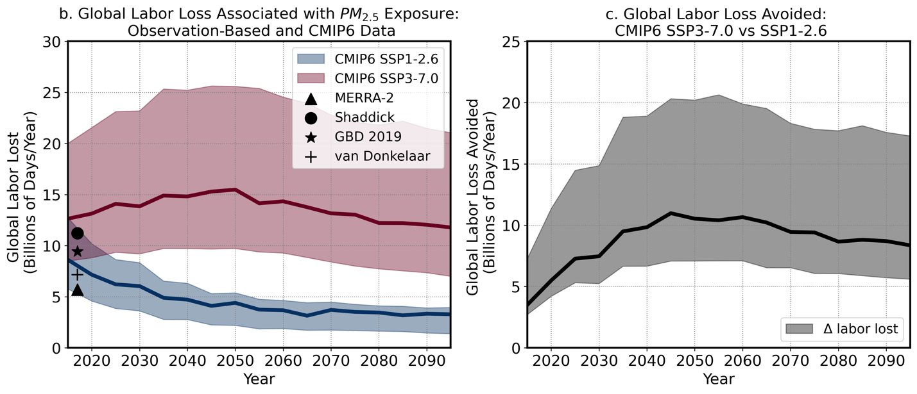Figure S10. Global, annual mean population-weighted PM_{2.5} exposure (a), global, annual days of labor loss associated with annual PM_{2.5} exposure (b) from ‘model + satellite’ Aerosol Optical Depth (AOD) estimates compared with the values in the Coupled Model Intercomparison, Phase 6 (CMIP6) models used in the main text, and avoided labor losses in CMIP6 SSP3-7.0 vs CMIP6 SSP1-2.6 (c). CMIP6 PM_{2.5} data are unbiased (Methods). In (a), CMIP6 SSP1-2.6 are shown with blue squares, CMIP6 SSP3-7.0 are shown with red squares, and the ‘model + satellite’-based observations are shown with black symbols. Observations and model data use average annual ambient PM_{2.5} from the 2015-2019 time period, with the exception of the Shaddick data, which is shown as an average of 2014-2016 time period. Note that with the exception of the MRI and UKESM models, both the SSP1-2.6 and SSP3-7.0 global mean exposure values fall within the range of observation-based estimates in the lower panel.

Table S1. CMIP6 models with necessary data to calculate global-mean temperatures and PM_{2.5}.

CMIP6 Model | Variant or Ensemble Member
GFDL-ESM4 | r1i1p1f1
GISS-E2-1-G | r1i1p3f1
MIROC-ES2L | r1i1p1f2
MRI-ESM2-0 | r1i1p1f1
NorESM2-LM | r1i1p1f1
UKESM1-0-LL | r1i1p1f2

Table S2. Labor intensity and values used to calculate loss fraction from heat exposure.

Labor Intensity | WBGTaver | WBGTSD
Light: 200 W | 35.533 | 3.948
Medium: 300 W | 33.492 | 3.948
Heavy: 400 W | 32.465 | 4.1607

