supporting information for
One-pot and environmentally beneficial synthesis of benzylamine and 1,2,3-triazole derivatives with choline chloride/sodium salts
Ehsan kamali, Abolazl Mohammadkhani, Farzane Pazoki and, Akbar Heydari¹*
Benzyl azide is generated at the first step. After that, urea activates an aromatic aldehyde to form an electrophilic center at the carbonyl carbon (1) in an initial step that might synthesize 1 2, 3 -triazoles. An activated aldehyde mixed with the nitro-methane anion, which was made by combining nitro-methane and acetate, to make nitrostyrene intermediate ^{(2).} Next, benzyl azide underwent [3+2] cycloaddition to yield intermediate (H). Urea plus counter ion were used to carry out an elimination process (figure 1) (3-6)
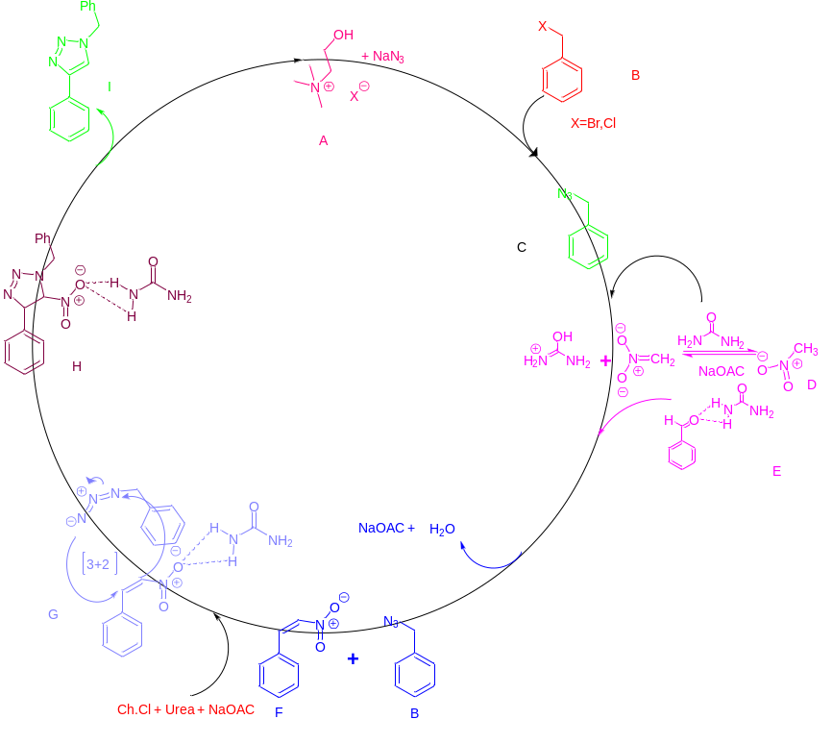
Figure1. Proposed pathway for the synthesis of 1, 2, 3 -triazoles in the present in choline chloride/urea

General Materials and Methods
Experimental
All chemicals were purchased from Merck, Aldrich, or Fluka were used without further purification
. The NMR spectra were recorded on a BRUKERDRX-400AVANCE Advance spectrometer. Gas chromatography was performed on a Trace GC ultra from the Thermo Company equipped with an FID detector and Rtx®-1 capillary column. Melting points of products were measured with an Electrothermal 9100 apparatus and were uncorrected. IR spectra (with spectroscopic grade KBr) were recorded by Nicolet IR100 instrument, and the spectra were obtained over the region 400–4000 cm⁻¹.
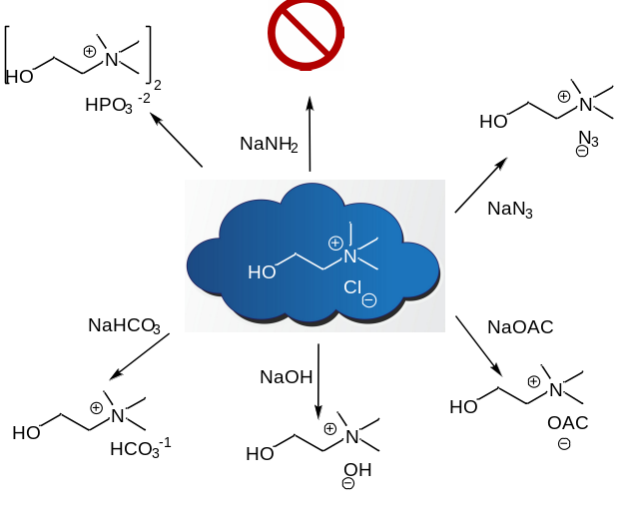
Scheme 1 preparation of Cholines
General Produce:
General Procedure for benzyl amines: 1 mol of choline chloride, 1 mol sodium amide was stirred at 60 ºC for 45 minutes, then the Benzyl halides (1 mmol) were added after completion of the reaction monitored by TLC, benzylamine was extracted with chloroform (2 × 2 ml) and water. All of the products are known as compounds and were reported previously.

Preparation of derivatives of choline chloride: 1-mol choline chloride and 1-mol sodium salt were added to 500 ml methanol in a 1L round bottom flask. The flask was refluxed and stirred for 12h. As a result of ion exchange, the white sodium chloride was settled as sediment. The cooled bulk filtered off, and the derivative choline solution evaporated under reduced pressure, and the products remained.
Choline acetate: a colorless crystal, and the melting point was 67 ^{O}C (7, 8). IR: ν 3405 , 2917, 1740 ,1478, 1408.(8) Fig S₂ and S₃
Choline bicarbonate is a white-cream powder, and the melting point was 114- 116 ^{O}C(9).Fig S₂
Di choline phosphate is a yellow-cream crystal. IR: ν 3030, 1655, 1479, 1373, 1033, 954, 843, 527 cm ⁻¹⁽¹⁰⁾.Fig S₂
Choline Hydroxide: a yellow oily residue IR: ν 3363 1293 and 1085 cm⁻¹(11).Fig S₂ and S₄
Choline azide: a yellow oily residue IR: ν 2959 2030(N₃) 1480 1390 1253 1085 955 and 865 (C-H sp3)(12). Fig S₂ and S₅
General Procedure for Synthesis of 1, 2, 3 triazoles :
1 mol of cholines and 1 mol sodium azide were stirred at 60 ºC for 45 minutes. The Benzyl halides (1 mmol) were added after completion of the reaction monitored by TLC, then Benzaldehyde (1 mmol), nitro-methane (1.0 mmol), and urea (2mol) were added after completion of the reaction monitored by TLC. The organic solvents were extracted with chloroform (2 × 2 ml). The organic solvents were separated, and the pure product was obtained by recrystallization with CHCl₃: n-Hexane (1:3). All of the products are known as compounds and were reported previously.
Recrystallization of choline chloride: choline chloride is recrystallized in ethyl acetate/ethanol or ethyl acetate /acetone. The FT-IR of harvest came in (Fig1). Its spectra show characteristics bonds at 3421,2950, 1481, and 1357 and 1054 cm-1 assigned to –OH, C-H sp3, and the C–N and C–O groups, respectively (13).
Characterization of Products
The compounds 4a', 4b', 4c', 4d', 4e', 4f', 4g', 4h', 4i', 4a, 4b, 4c, 4d, 4e, 4f, 4g, 4h, 4i,2a, 2c, 2e, 2m, are known compounds and were reported previously.

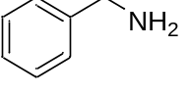phenyl methan amine 4a' yellow liquid ¹H NMR (400 MHz, DMSO) δ 7.49 – 7.42 (m, 2H), 7.40 (dd, J = 8.5, 6.6 Hz, 2H), 7.35 – 7.26 (m, 1H), 3.86 (s, 2H), 2.67 (s, 2H). FT-IR (KBr) ν: 3649, 3366, 3289, 3081 ,3061 ,3026 ,2916 ,2859,1951 ,1882 ,1603 ,1494 ,1452 ,1384 ,1342 ,1028 ,870 ,and 581cm⁻¹ Molecular weight:107, Molecular weight found :107

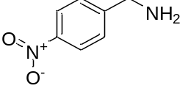(4-nitrophenyl)methanamine 4b' yellow M.P. 39-40 (Lit(14). M.P. :39-40 ºC) FT-IR (KBr- Ethyl-acetate ) ν: 3548 ,3464 ,3010 ,3994 ,2894 ,2091 ,1769 ,1637 ,1520 ,1474 ,1382 ,1312 ,1244 ,1056 ,947 ,856 ,and 626cm⁻¹ Molecular weight:153, Molecular weight found :153
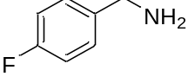(4-fluorophenyl)methanamine 4c' colorless liquid: ¹H NMR (400 MHz, CDCl₃) δ 7.17 (dt, J = 8.5, 3.1 Hz, 2H), 6.92 (td, J = 8.6, 2.2 Hz, 2H), 3.72 (S, 2H), 1.55 (s, 2H). ¹³C NMR (101 MHz, CDCl₃) δ 162.87, 160.44, 138.92, 128.61, 128.54, 115.19, 114.98, 45.56. FT-IR (KBr) ν: 3662 ,3368 ,3040 ,2924 ,2864 ,1892,1602 ,1508 ,1459 ,1416 ,1383 ,1221 ,1156 ,1093 ,1014 ,823 ,738 ,and553 cm⁻¹ Molecular weight:125, Molecular weight found :125

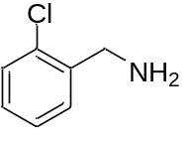(2-chlorophenyl) methanamine4d' colorless liquid, ¹H NMR (400 MHz, CDCl₃) δ 7.32 (ddd, J = 7.6, 5.3, 1.6 Hz, 2H), 7.18 (dtd, J = 23.4, 7.5, 1.6 Hz, 2H), 3.88 (s, 2H), 1.57 (s, 2H). ¹³C NMR (101 MHz, CDCl₃) δ 140.57, 133.27, 129.47, 128.90, 128.15, 127.05, 44.50, 44.06. FT-IR (KBr) ν: 3654 ,3373 ,3291 ,3064 ,2925 ,2869 ,1919 ,1801 ,1593 ,1573 ,1472 ,1442 ,1383 ,1347 ,1037 ,881 ,753 ,679 ,and 591cm⁻¹ Molecular weight:141, Molecular weight found :141

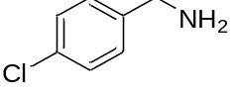(4-chlorophenyl)methanamine 4e' colorless liquid, ¹H NMR (400 MHz, CDCl₃) δ 7.30 – 7.25 (m, 2H), 7.22 (d, J = 8.6 Hz, 2H), 3.82 (s, 2H), 1.48 (s, 2H). ¹³C NMR (100 MHz, CDCl₃) δ 141.68, 132.34, 128.56, 128.46, 45.75. FT-IR (KBr) ν: 3654 ,3372 ,3288 ,3043 ,2918 ,2852 ,1889 ,1782 ,1594 ,1490 ,1407 ,1382 ,1344 ,1090 ,1041 ,813 ,716 ,641 ,and 528 cm⁻¹ Molecular weight:141, Molecular weight found :141

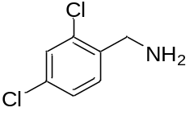(2,4-dichlorophenyl)methanamine 4f' yellow liquid, FT-IR (KBr- Ethyl-acetate) ν: 3557 ,3486 ,3413 ,2994 ,2956 ,2994 ,2854 ,2090 ,1910 ,1838 ,1769 ,1758 ,1683 ,1590 ,1561 ,1382 ,1243 ,1200 ,1052 ,935 ,853 ,and 629cm⁻¹ Molecular weight:175, Molecular weight found :175
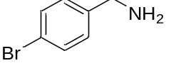(4-bromophenyl)methanamine 4g' yellow M.P. 25 (Lit(15). M.P. :25 ºC) , FT-IR (KBr- Ethyl-acetate) ν: 3475 ,3418 ,2957 ,2924 ,2854 ,1837 ,1719 ,1638 ,1460 ,1370 ,1265 ,1071 ,1010 ,741 ,592 ,and 450 cm⁻¹ Molecular weight:184, Molecular weight found :184
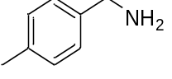p-tolylmethanamine 4h' colorless liquid, ¹H NMR (400 MHz, CDCl₃) δ 7.23 (d, J = 8.0 Hz, 2H), 7.18 (d, J = 7.8 Hz, 2H), 3.84 (s, 2H), 2.37 (s, 3H), 1.57 (s, 2H). ¹³C NMR (101 MHz, CDCl₃) δ 140.42, 136.32, 129.24, 127.08, 46.26, 21.11. FT-IR (KBr) ν: 3629 ,3367 ,3297 ,3018 ,2920 ,2860 ,1920 ,1799 ,1590 ,1514 ,1452 ,1381 ,1344 ,1199 ,1106 ,1040 ,1019 ,881 ,802 ,734 ,553 ,and 470 cm⁻¹ Molecular weight:121, Molecular weight found :121.9

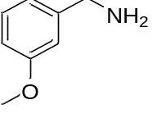(3-methoxyphenyl)methanamine 4i' colorless liquid, FT-IR (KBr- Ethyl-acetate) ν: 3706 ,3506 ,3413 ,3090 ,3994 ,2879 ,2089 ,1769 ,1655 ,1458 ,1381 ,1231 ,1055 ,931 ,850 ,787 ,628 ,and 460cm⁻¹ Molecular weight:137, Molecular weight found :137.
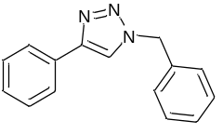 1-benzyl-4-phenyl-1H-1, 2,3-triazole (4a) white powder M.P. 131-133(Lit(16). M.P. :130-133 ºC) ¹H NMR (400 MHz, CDCl₃⁾ δ 7.87 – 7.78 (m, 2H), 7.69 (s, 1H), 7.45 – 7.32 (m, 7H), 5.61 (s, 2H).
.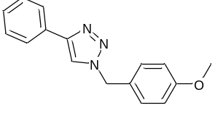1-(4-methoxybenzyl)-4-phenyl-1H-1, 2, 3-triazole (4b) white powder M.P.:118 ᵒC (Lit. (17) M.P. 117-119 ºC) ¹H NMR (400 MHz, CDCl₃) δ 7.87 – 7.77 (m, 2H), 7.68 (s, 1H), 7.46 – 7.28 (m, 4H), 6.96 – 6.84 (m, 2H), 5.55 (s, 2H), 3.80 (s, 3H).

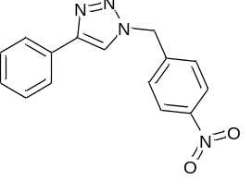1-(4-nitrobenzyl)-4-phenyl-1H-1,2,3-triazole (4c) yellow, powder M.P. 140-141(Lit(18). M.P. 140-142ºC) ¹H NMR (400 MHz, CDCl₃): ¹H NMR (300 MHz, CDCl₃) δ 8.27 (d, J = 8.3 Hz, 2H), 7.87 – 7.75 (m, 2H), 7.50 – 7.34 (m, 5H), 5.73 (s, 2H).

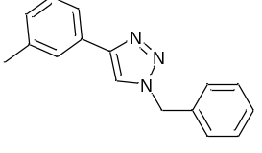 1-benzyl-4-(m-tolyl)-1H-1,2,3-triazole(4d) white powder M.P.: 146ᵒC (Lit.(6) M.P. 146-147ºC) ¹H NMR (400 MHz, CDCl₃) δ 7.83 – 7.79 (m, 2H), 7.67 (s, 1H), 7.43 – 7.38 (m, 2H), 7.35 – 7.26 (m, 2H), 7.20 – 7.11 (m, 3H), 5.53 (s, 2H), 2.35 (s, 3H).
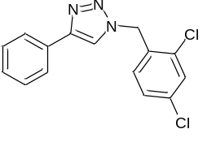1-(2, 4-dichlorobenzyl)-4-phenyl-1H-1, 2, 3-triazole (4e) white crystal M.P. 116 (Lit(19). M.P. 116-117 ºC) ¹H NMR (400 MHz, CDCl₃) δ 7.91 – 7.70 (m, 3H), 7.49 – 7.21 (m, 5H), 5.68 (s, 2H).
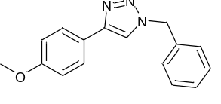 1-benzyl-4-(4-methoxyphenyl)-1H-1,2,3-triazole1-benzyl-4-(4-methoxyphenyl)-1H-1,2,3-triazole (4f) with powder M.P. 141-142 (Lit(20). M.P. 141-142 ºC) ¹H NMR (400 MHz) δ 7.75 (d, J = 8.2 Hz, 2H), 7.60 (s, 1H), 7.45 – 7.31 (m, 4H), 6.96 (d, J = 8.3 Hz, 2H), 5.59 (s, 2H), 3.86 (s, 3H).
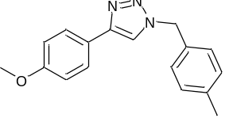 4-(4-methoxyphenyl)-1-(4-methylbenzyl)-1H-1, 2(21), 3-triazole (4g), with powder M.P. 149-151(Lit. M.P.149-151(21) ºC) ¹H NMR (400 MHz, CDCl₃): δ 7.74 (d, J = 8.3 Hz, 2H), 7.57 (s, 1H), 7.29 (s, 3H), 6.95 (d, J = 8.3 Hz, 2H), 5.54 (s, 2H), 3.85 (s, 3H), 2.38 (s, 3H).
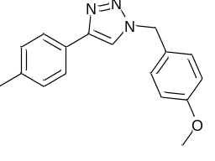1-(4-methoxybenzyl)-4-(p-tolyl)-1H-1,2,3-triazole (4h), with powder M.P. 133-134(Lit.(22) M.P. 133-136 ºC) ¹H NMR (400 MHz, CDCl₃ δ 7.69 (d, J = 7.9 Hz, 2H), 7.60 (s, 1H), 7.30 – 7.26 (m, 2H), 7.22 (d, J = 7.8 Hz, 1H), 6.96 – 6.86 (m, 2H), 5.51 (s, 2H), 3.83 (s, 3H), 2.38 (s, 3H).

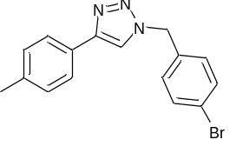1-(4-bromobenzyl)-4-(p-tolyl)-1H-1, 2, 3-triazole (4i) yellow-with M.P. =202- 203(Lit.(18) M.P. 201-203 ºC) ¹H NMR (400 MHz, CDCl₃): δ 7.74 – 7.64 (m, 2H), 7.54 (d, J = 7.8 Hz, 1H), 7.24 (dd, J = 17.8, 9.0 Hz, 5H), 5.55 (s, 2H), 2.39 (s, 3H).

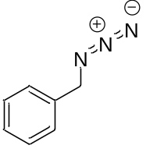Benzyl azide(2a) IR (KBr-ethyl acetate) ν: 3416, 2925, 2851, 2366, 2100, 1630, 1451, 1388, 1253, 696, 590,and 424 cm⁻¹ Molecular weight:133, Molecular weight found :134(23).
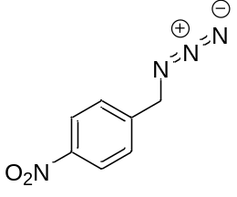 4-nitrobenzyl azide(2c): IR(KBr-ethyl acetate): 3479, 3410, 3232, 2926, 2370, 2120, 1747,1618,1524,1344 cm⁻¹ Molecular weight:178, Found: 177.2
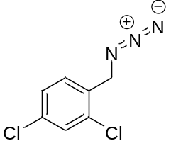2, 4-dichloro benzyl azide (2e): IR (KBr-ethyl acetate): ν 3484, 2990, 2373, 2107, and 1085 cm⁻¹ Molecular weight: 200.99, Found: 201.0.
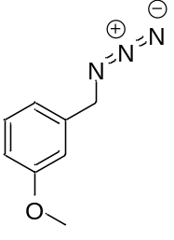3-methoxy benzyl azide (2m): IR (KBr-ethyl acetate) ν: 3457, 2990, 2370, 2099, 1766, 1242, 1046 cm⁻¹ Molecular weight: 163.1

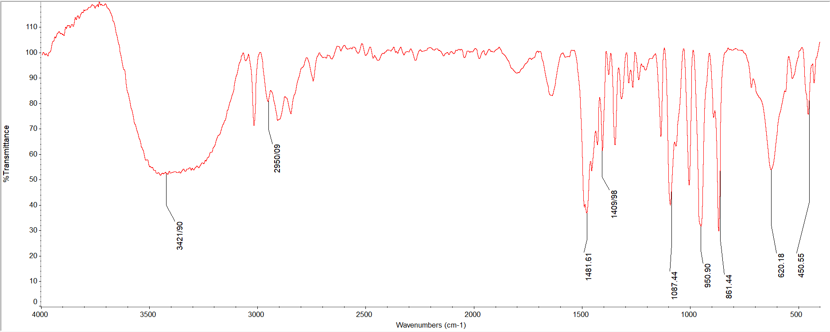
Figure S₁-FT-IR spectrum of Choline Chloride
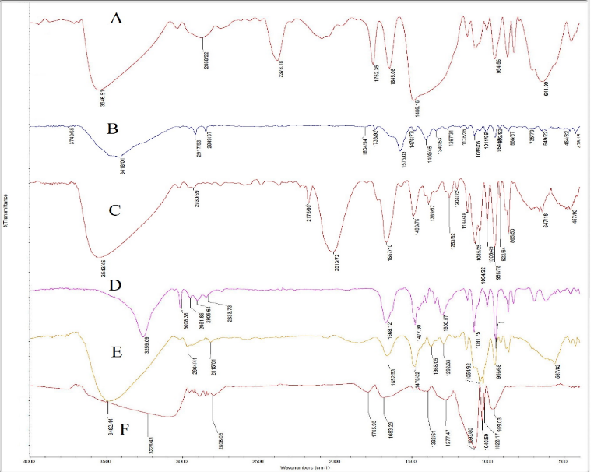
Figure S₂ the FT-IR of Cholines: A: carbonate B: acetate C: azide D: carbonate E: hydroxide F: hydrogen-diphosphate

Figure-S₃ Thermal gravimetric analysis of Choline acetate

Figure-S₃ Thermal gravimetric analysis of Choline nitrate

Figure-S₄Thermal gravimetric analysis of Choline hydroxide

Figure-S₅Thermal gravimetric analysis of Choline azide

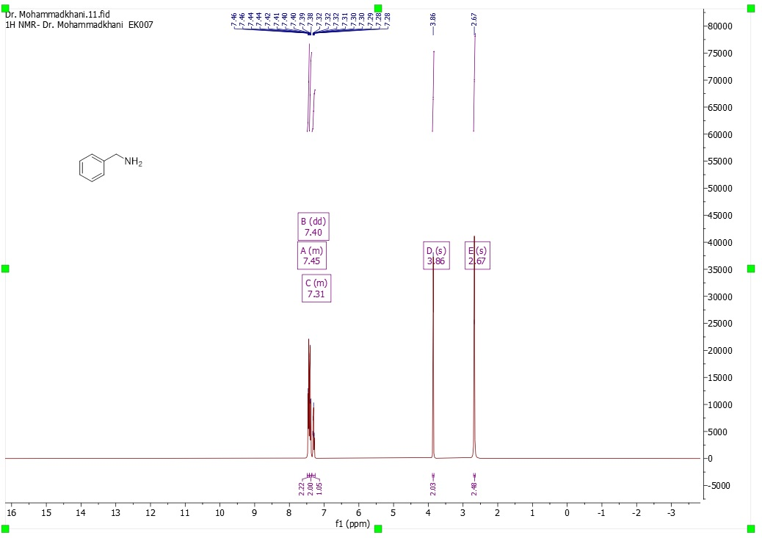
FigureS₆ the ¹H NMR spectrum of 4a' in CDCl₃

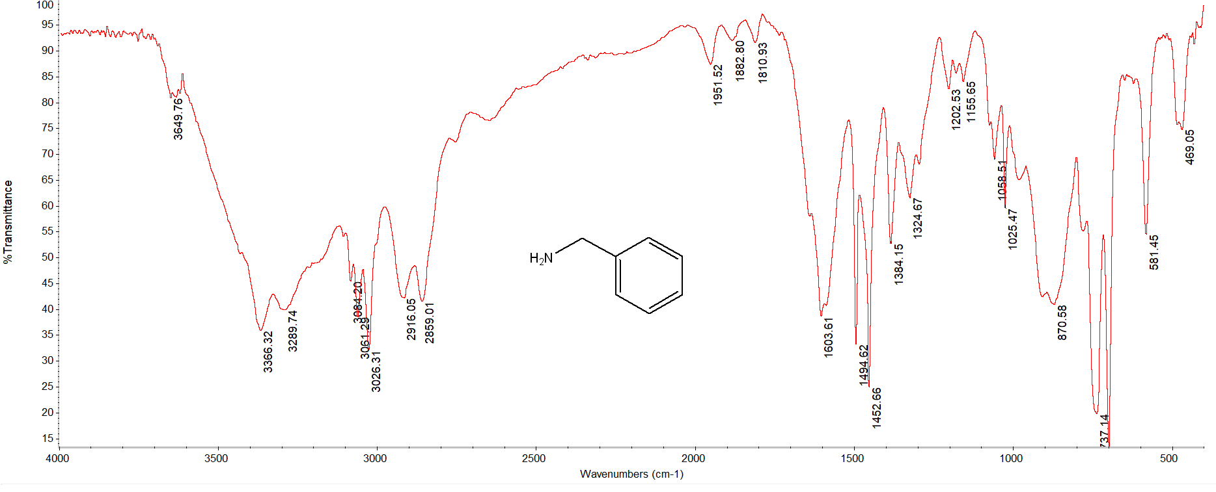
FigureS₇ FT-IR spectrum of 4a'

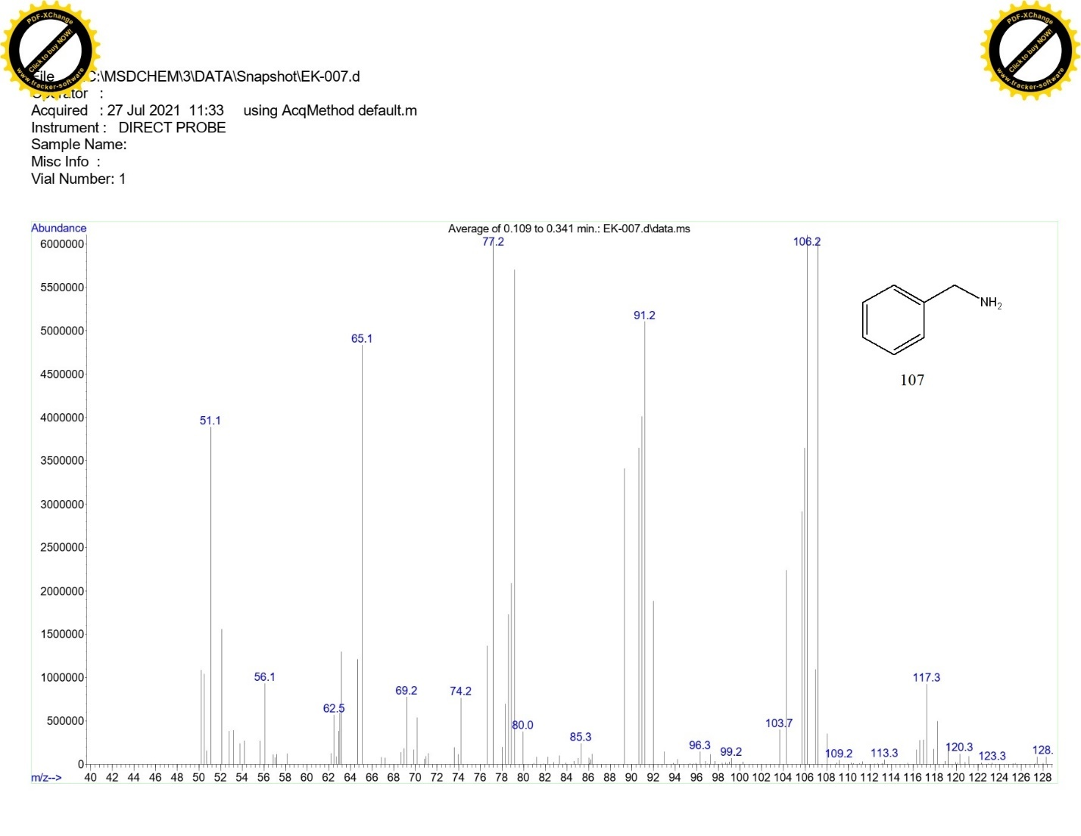
FigureS₈ Mass spectrum of 4a'

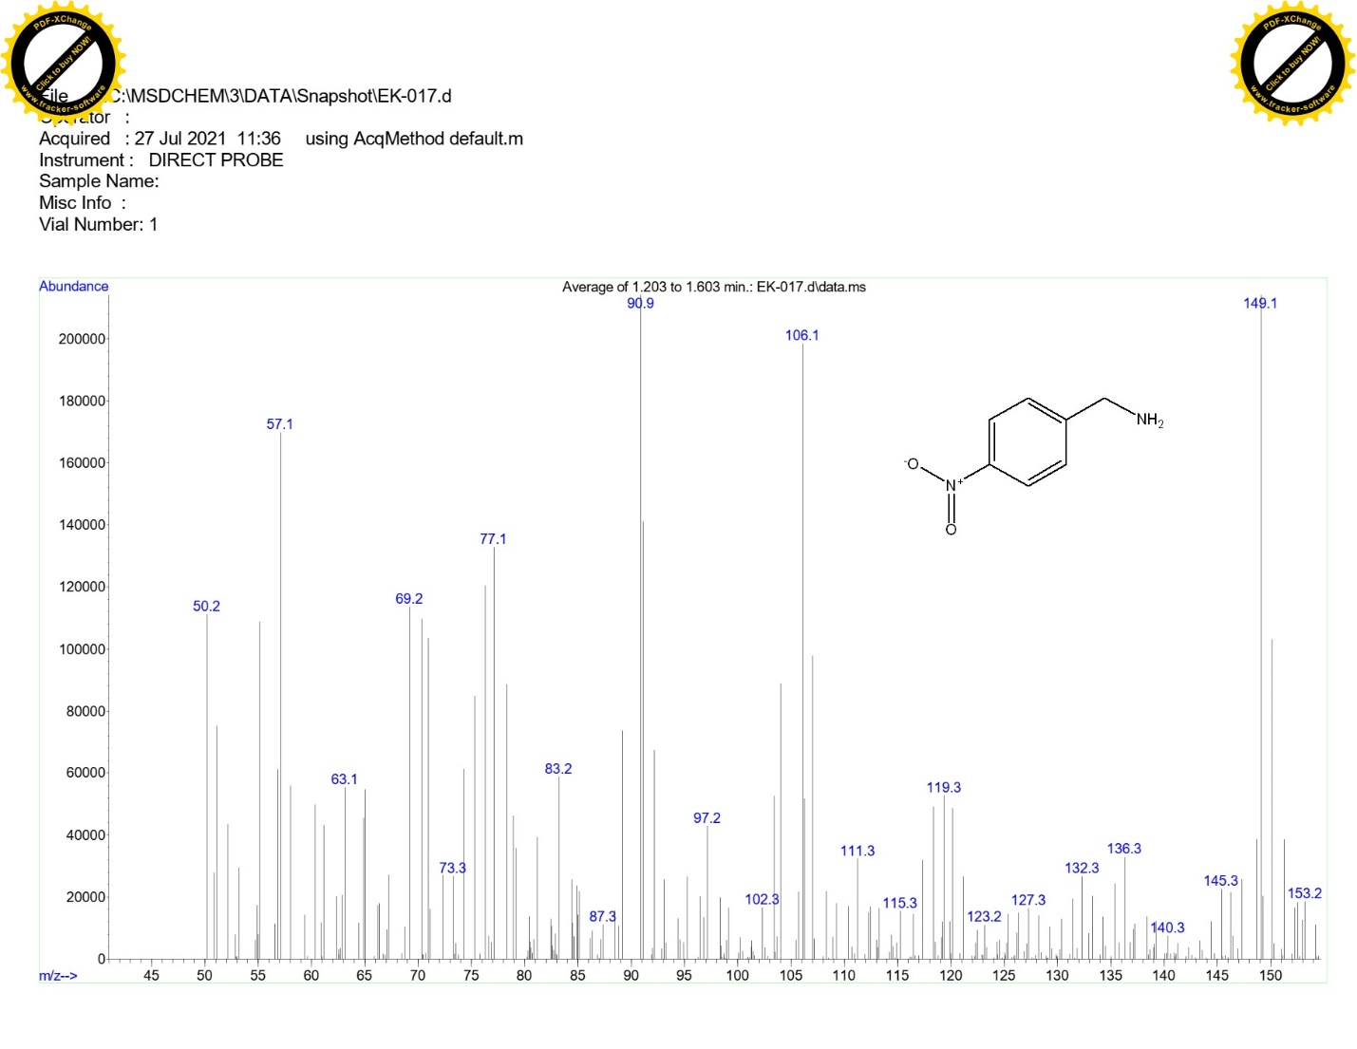
FigureS₉ Mass spectrum of 4b'
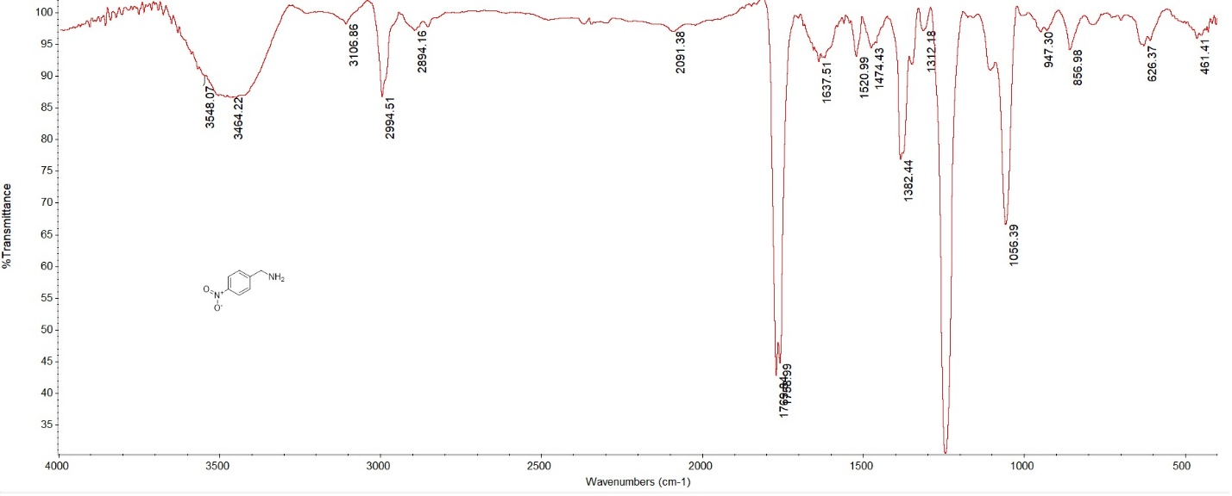
FigureS₁₀FT-IR spectrum of 4b'

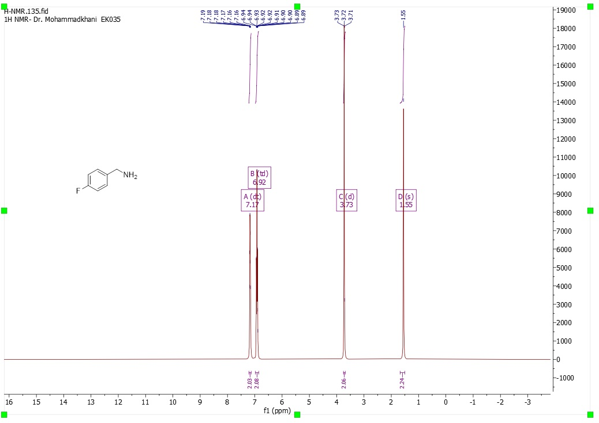
FigureS₁₁ the ¹H NMR spectrum of in CDCl₃ 4c'

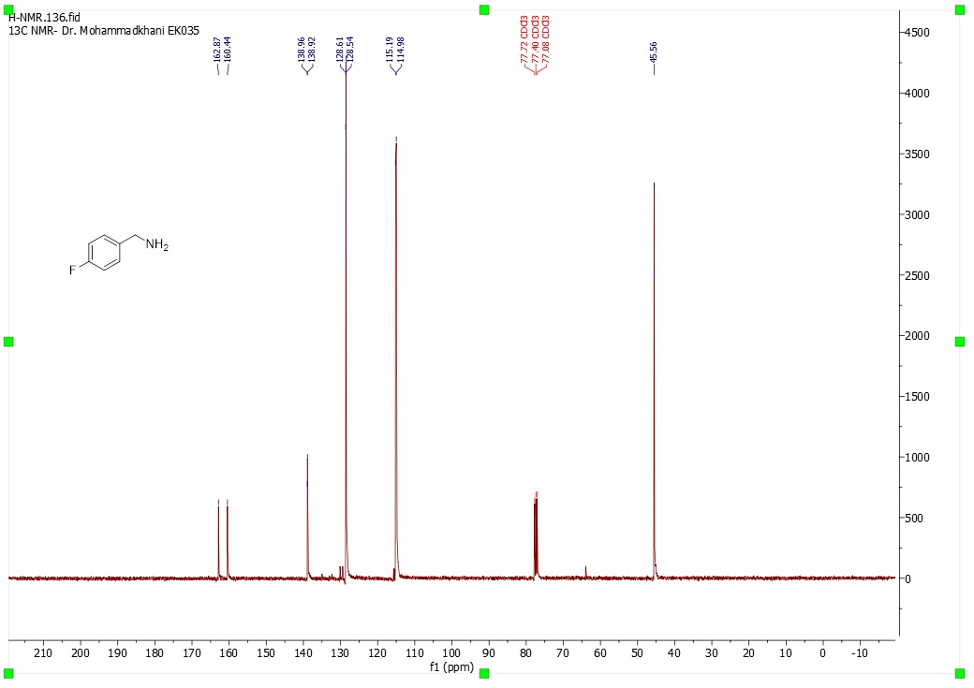
FigureS₁₂ the ¹³C NMR spectrum of 4c' in CDCl₃

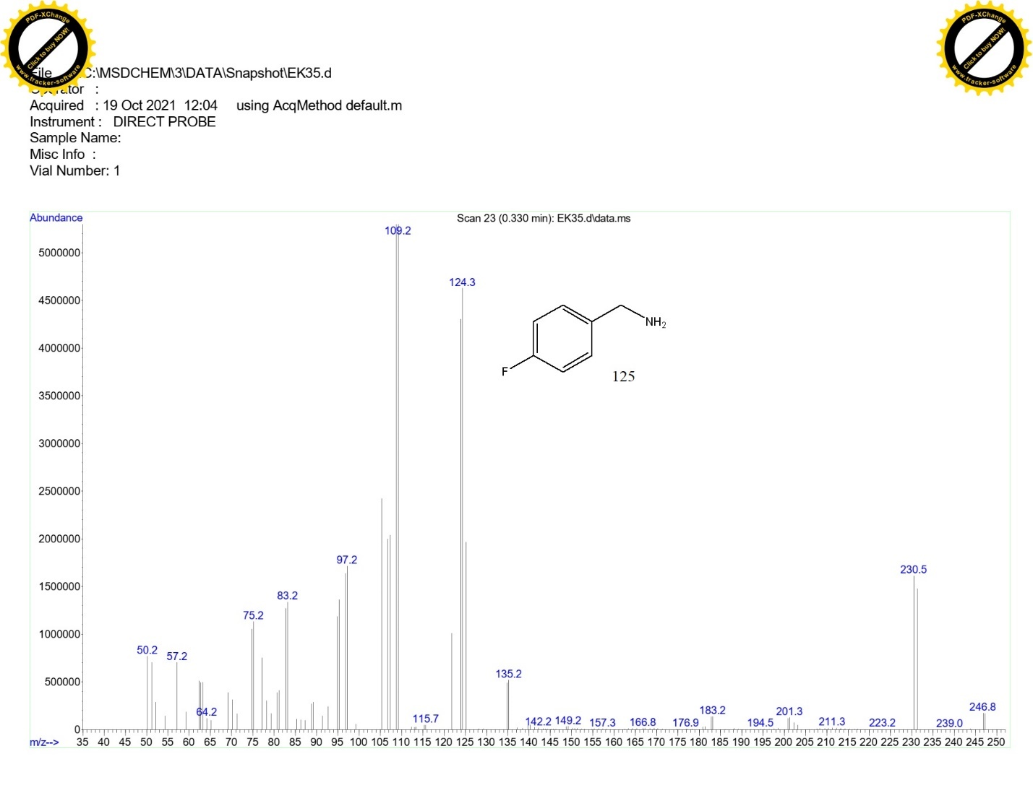
FigureS₁₃ Mass spectrum of 4c'

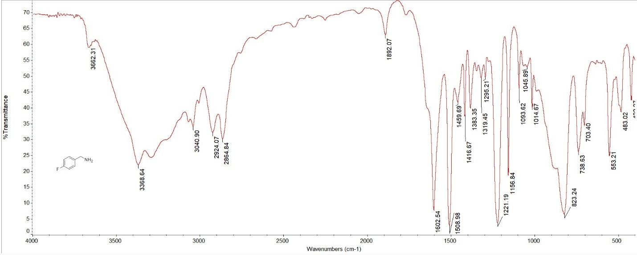
FigureS₁₄ FT-IR spectrum of 4c'

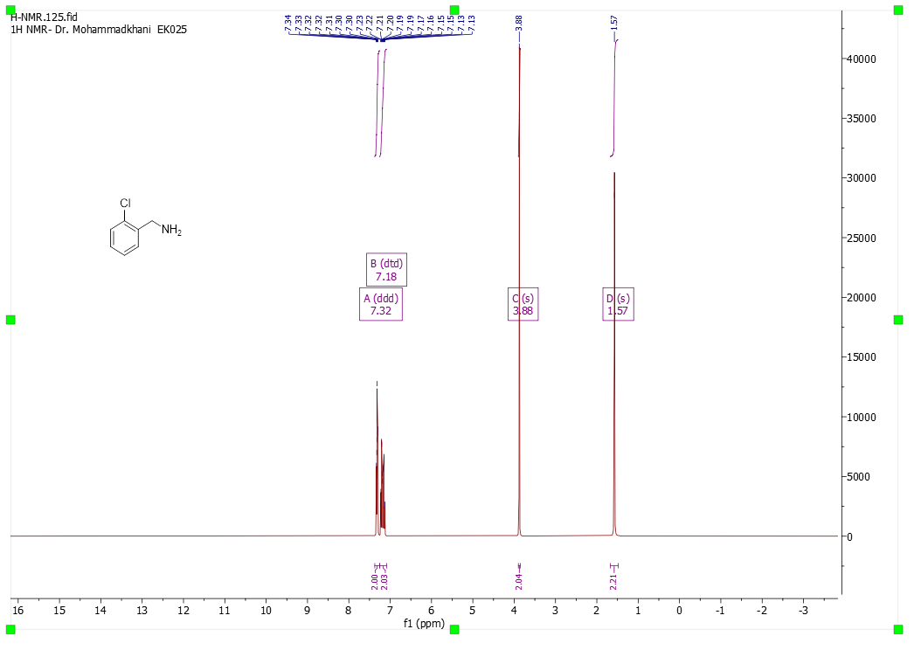
FigureS₁₅ the ¹H NMR spectrum of 4d' in CDCl₃

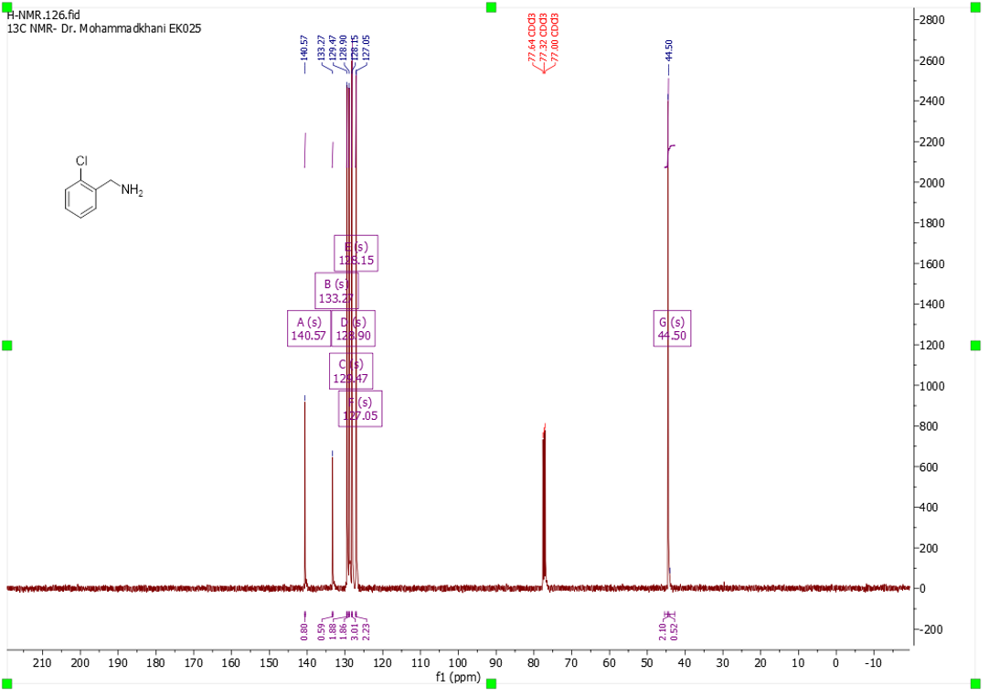
FigureS₁₆ the ¹³C NMR spectrum of 4d' in CDCl₃

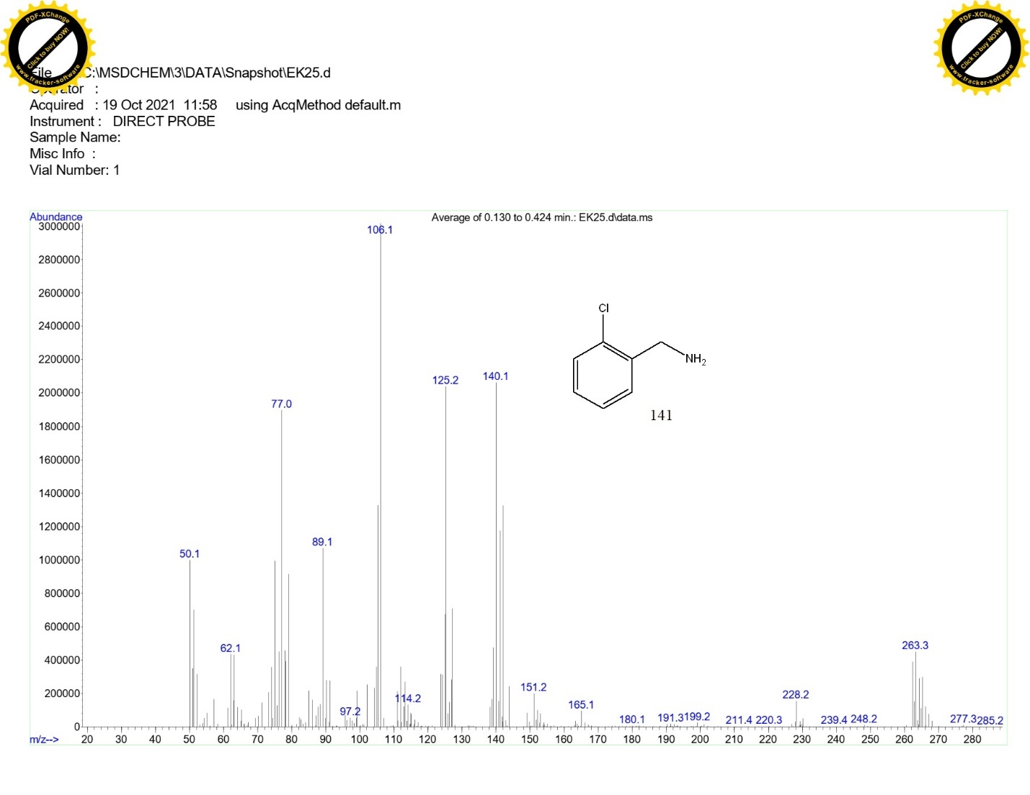
FigureS₁₇ Mass spectrum 4d'

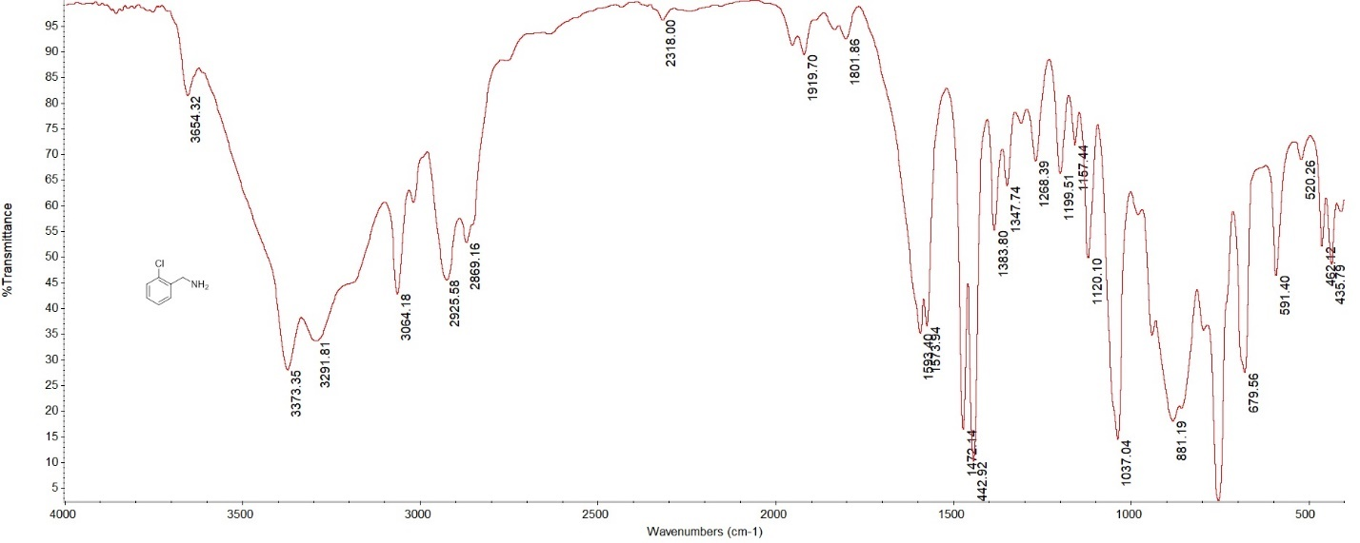
FigureS₁₈ FT-IR spectrum of 4d'

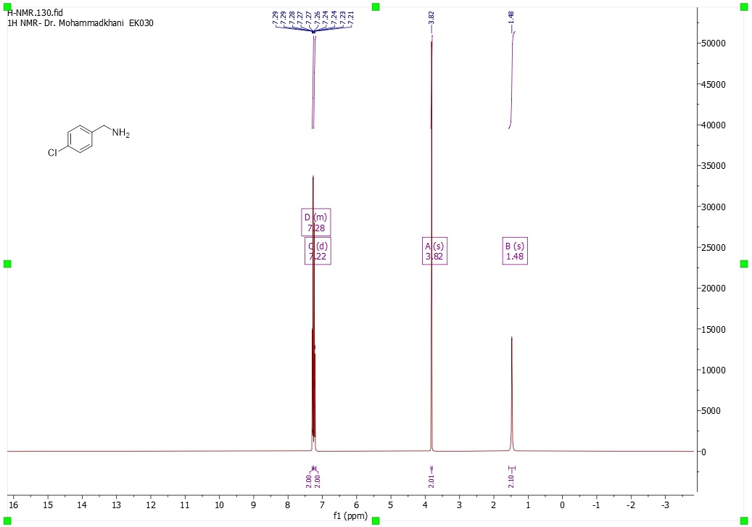
FigureS₁₉ the ¹H NMR spectrum of 4e' in CDCl₃

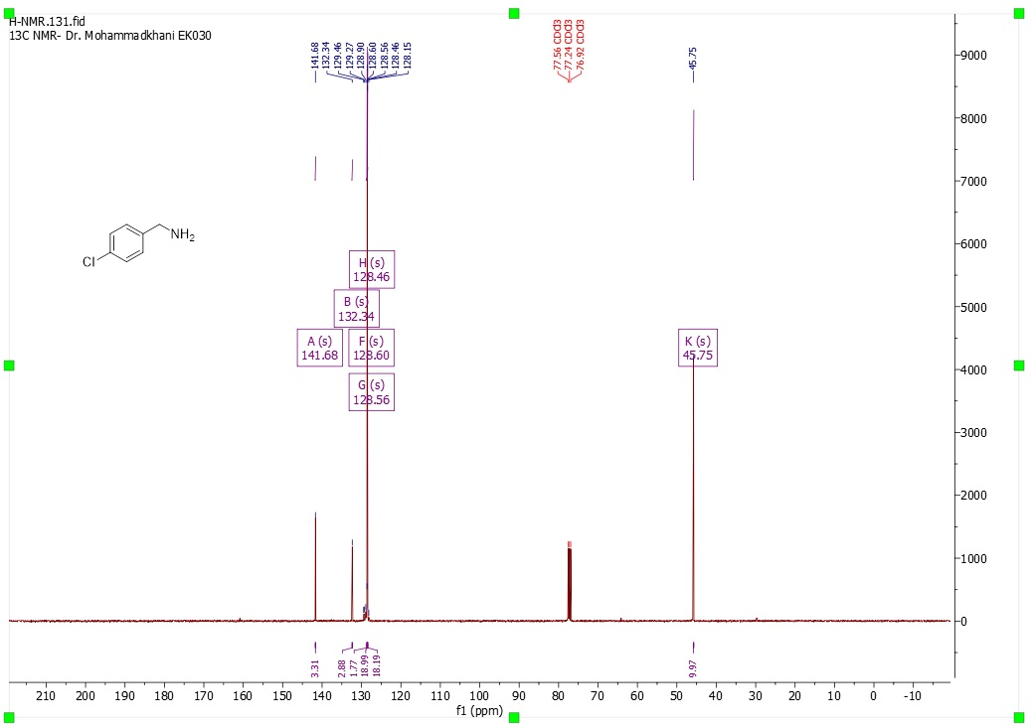
FigureS₂₀ the ¹³C NMR spectrum of 4e' in CDCl₃

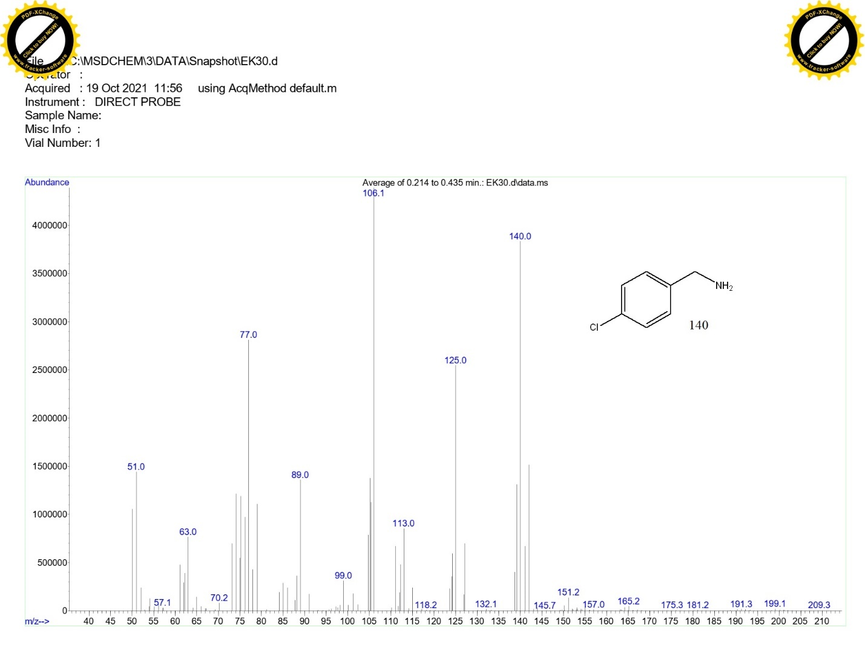
FigureS₂₁ Mass spectrum of 4e'

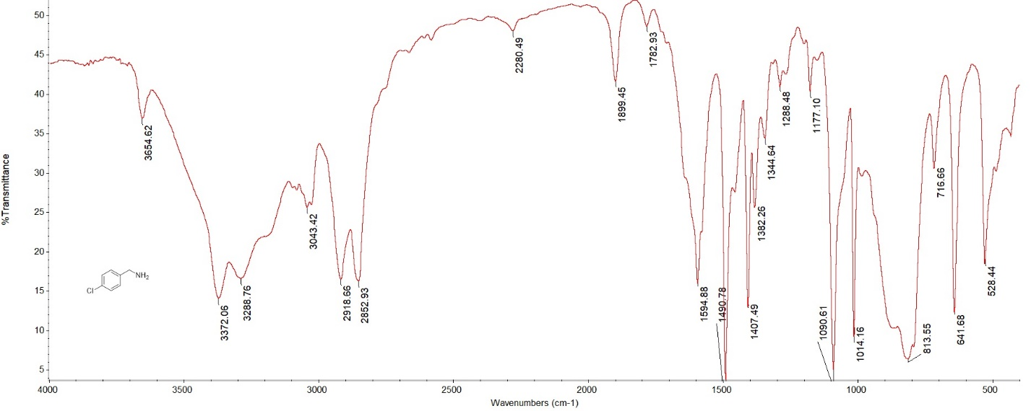
FigureS₂₂ FT-IR spectrum of 4e'

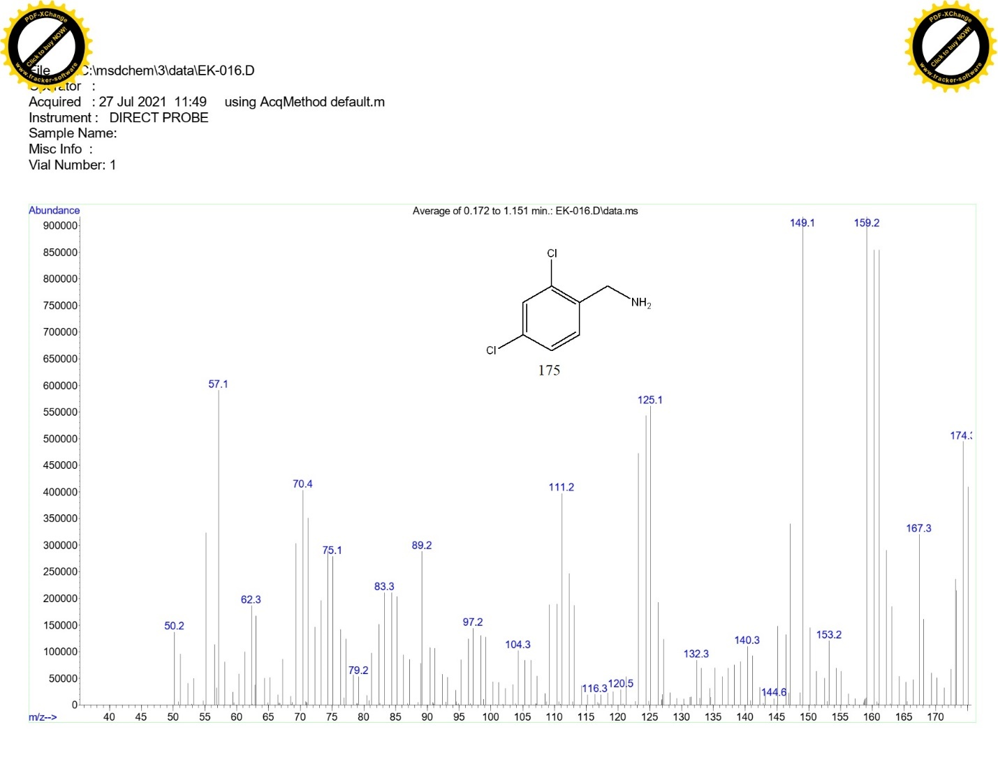
FigureS₂₃Mass spectrum of 4f'

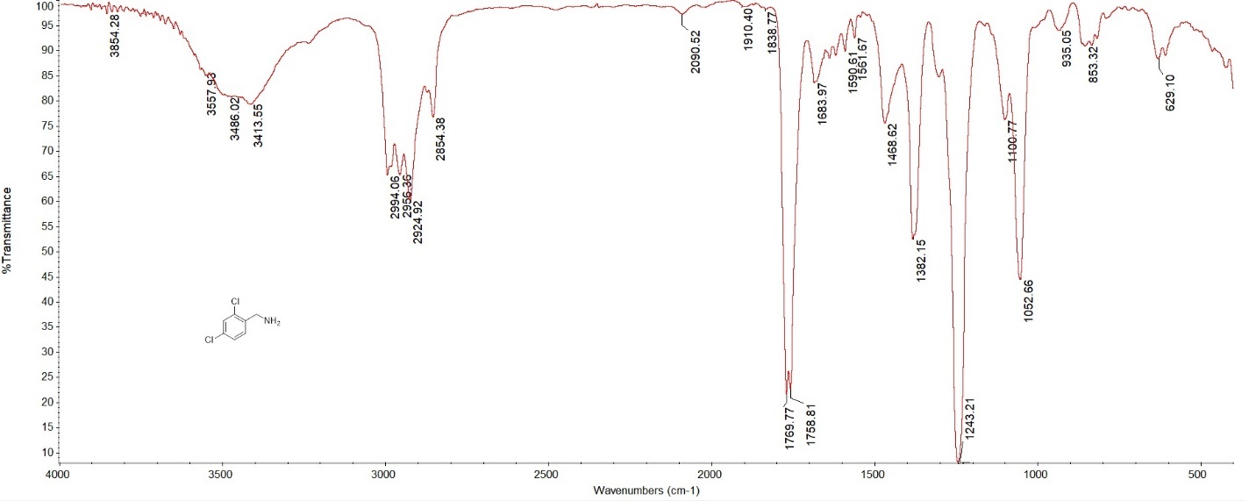
FigureS₂₄ FT-IR spectrum of 4f'

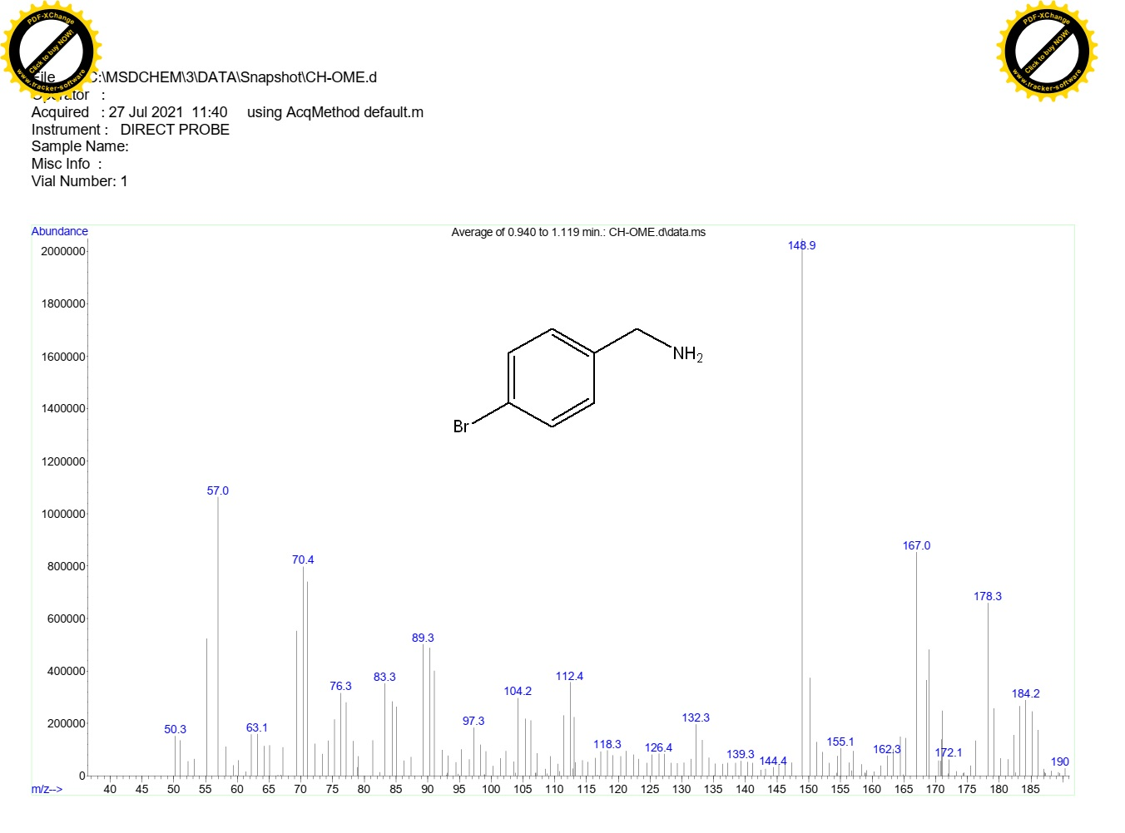
FigureS₂₅ Mass spectrum of 4g'

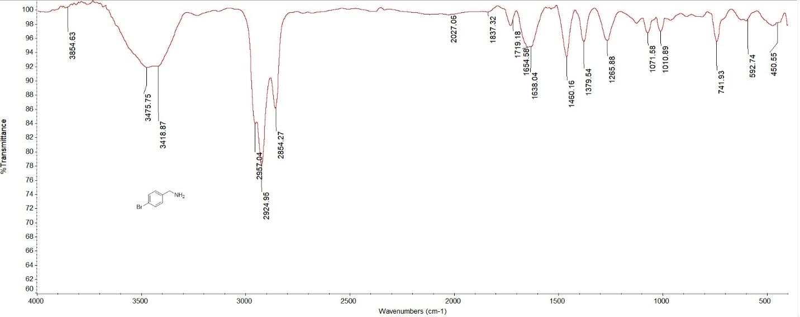
FigureS₂₆ FT-IR spectrum of 4g'

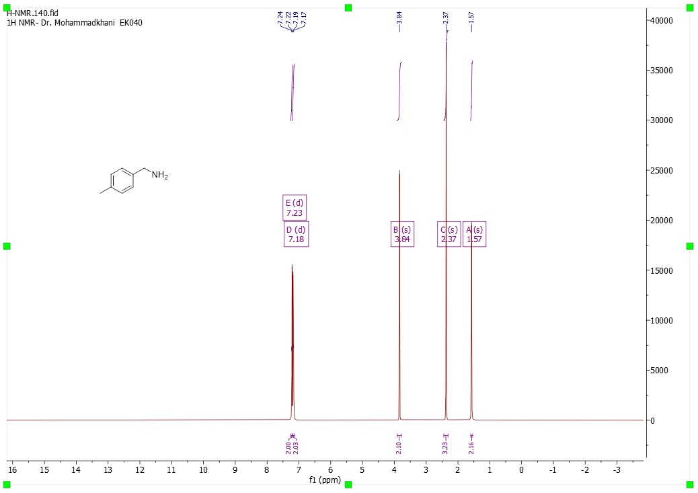
FigureS₂₇ the ¹H NMR spectrum of 4h' in CDCl₃

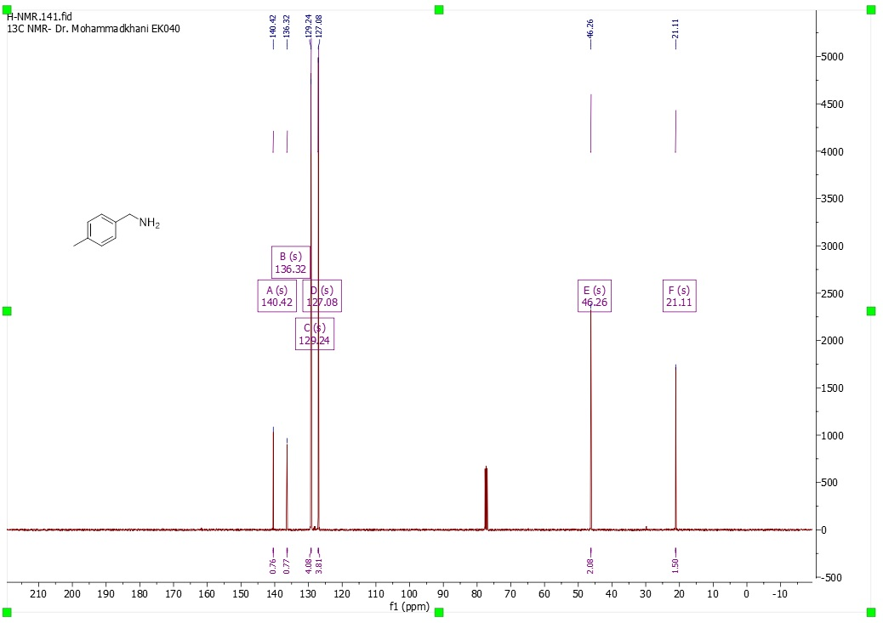
FigureS₂₈ the ¹³C NMR spectrum of 4h' in CDCl₃

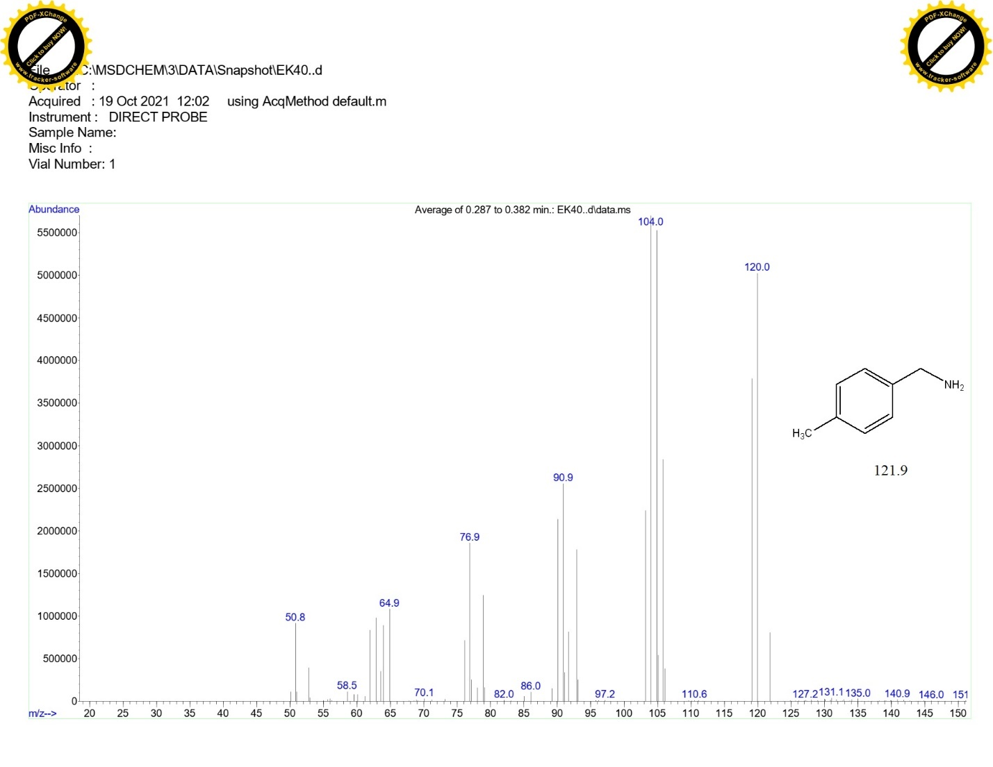
FigureS₂₉ Mass spectrum of 4h'

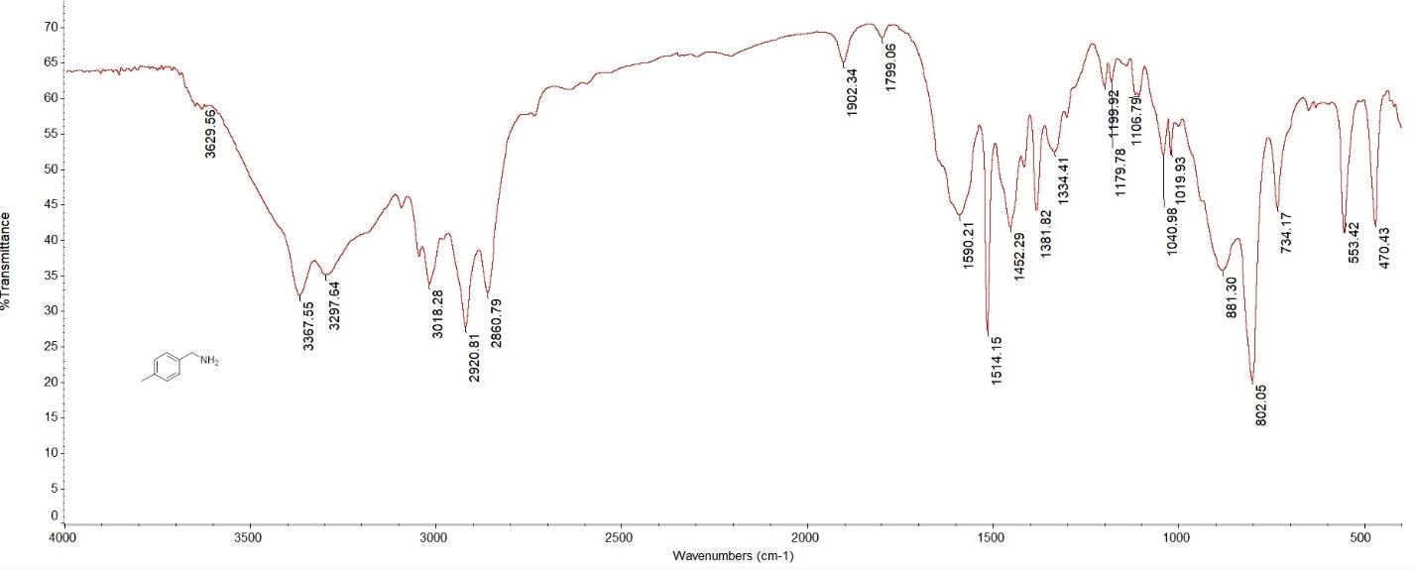
FigureS₃₀ FT-IR spectrum of 4h'

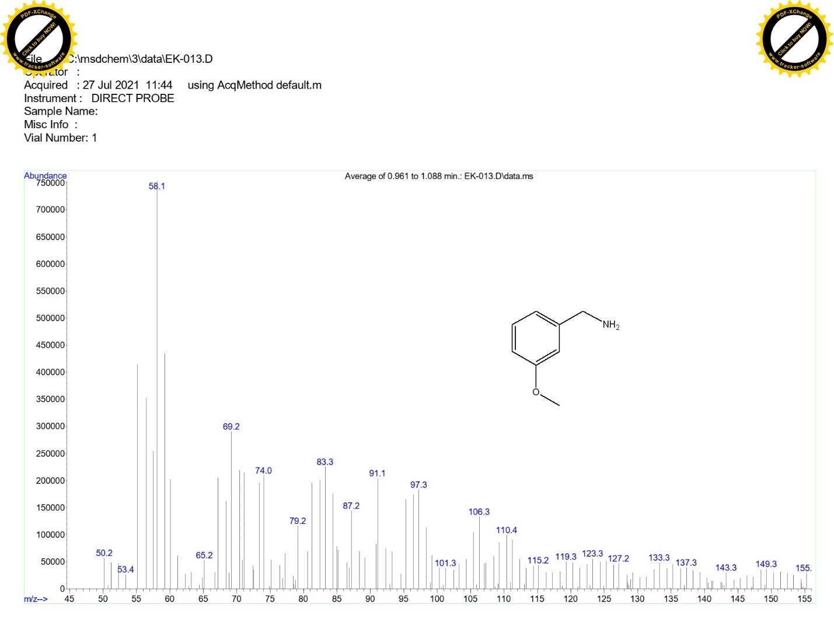
FigureS₃₁ Mass spectrum of 4i'

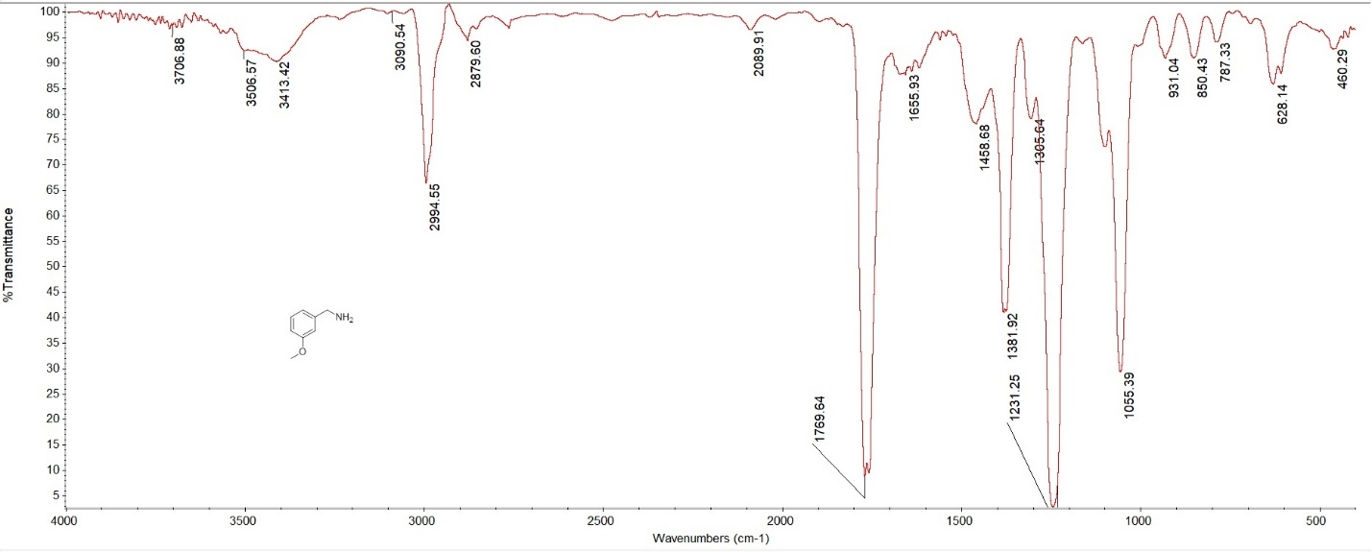
FigureS₃₂ FT-IR spectrum of 4i'

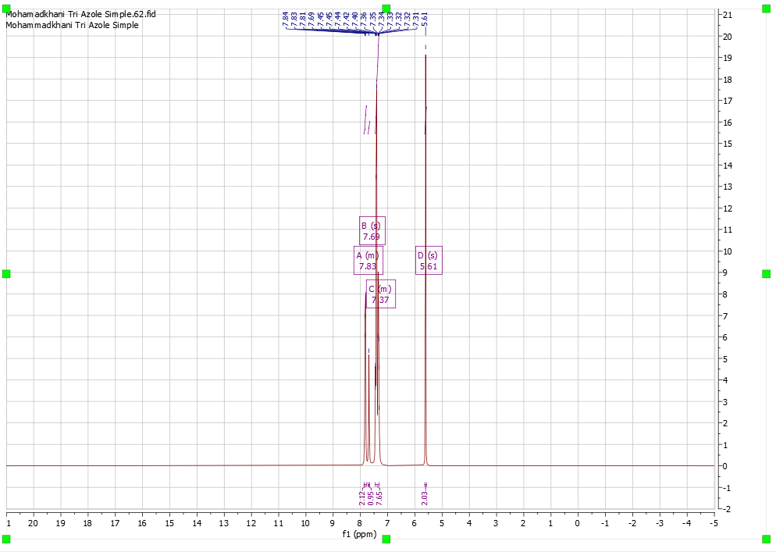
FigureS₃₃ the ¹H NMR spectrum of 4a in CDCl₃
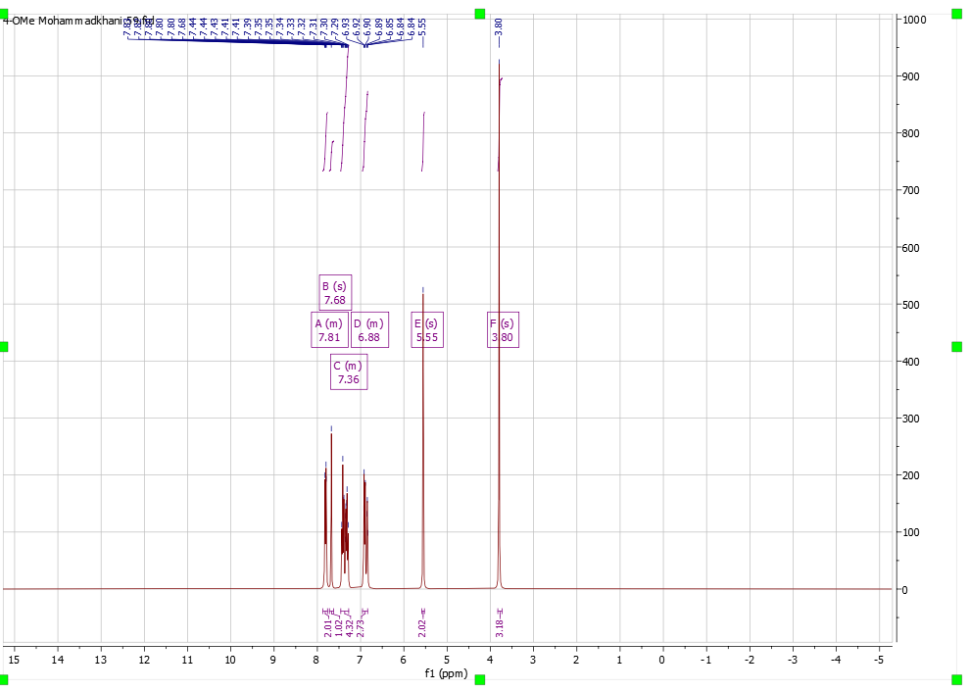
FigureS₃₄the 1H NMR spectrum of 4b in CDCl₃
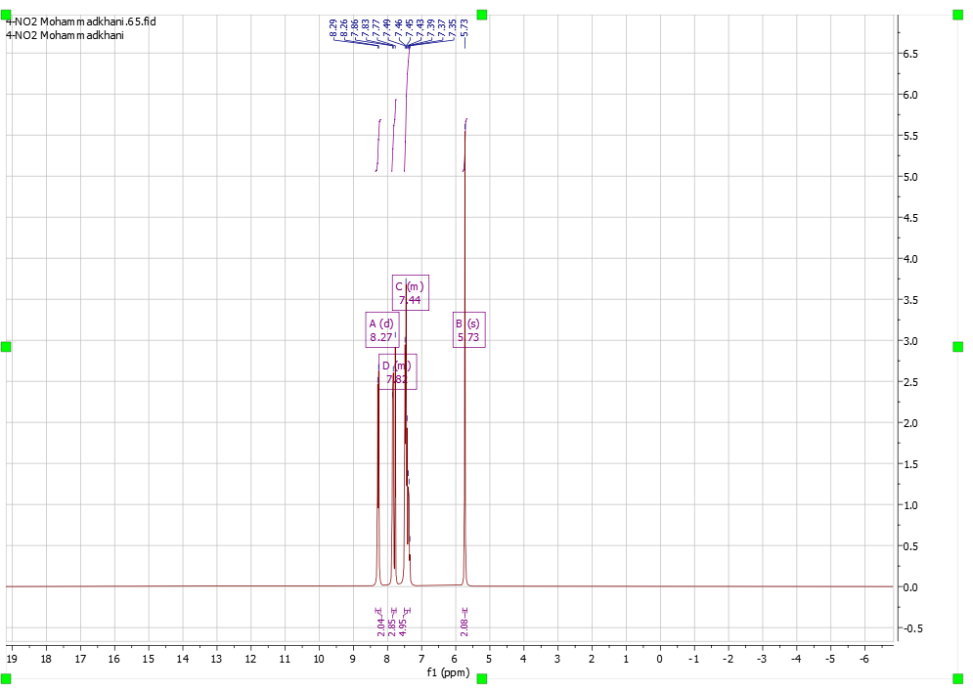
FigureS₃₅ the 1H NMR spectrum of 4c in CDCl₃
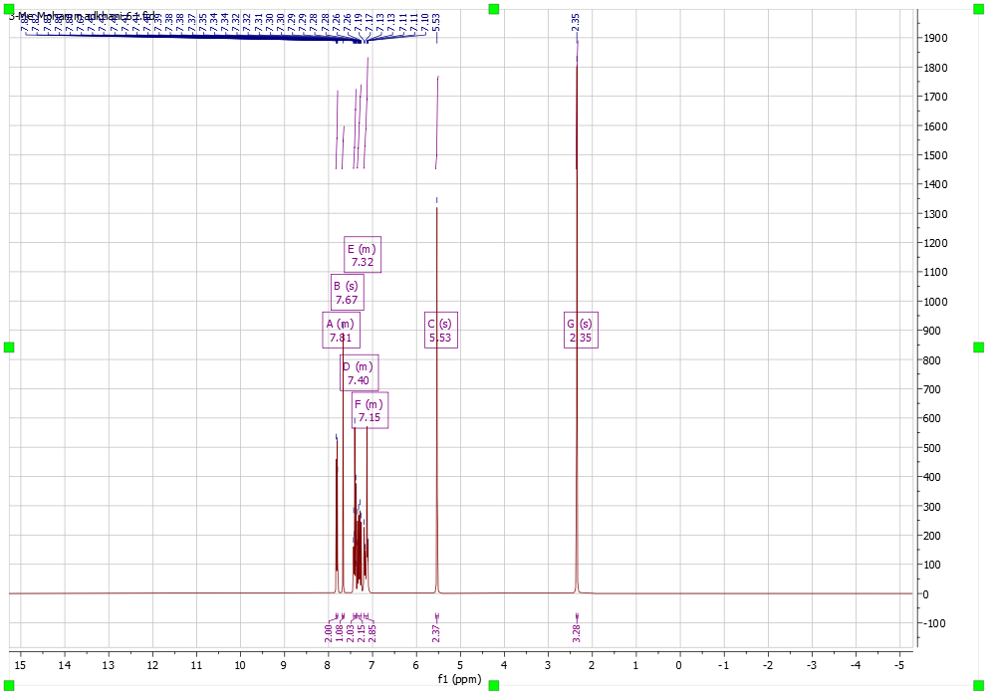. FigureS₃₆ the 1H NMR spectrum of 4d in CDCl₃

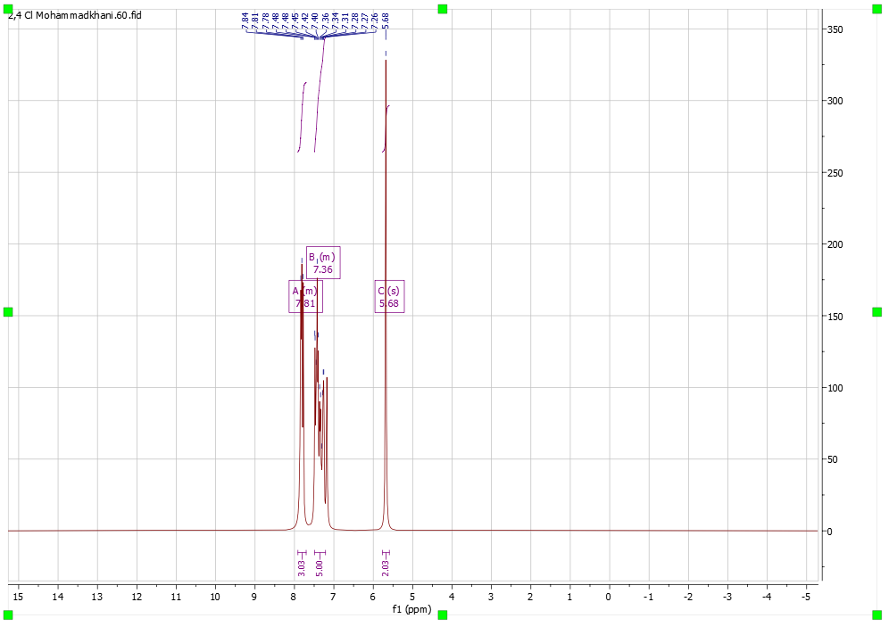
. FigureS₃₇the 1H NMR spectrum of 4e in CDCl₃
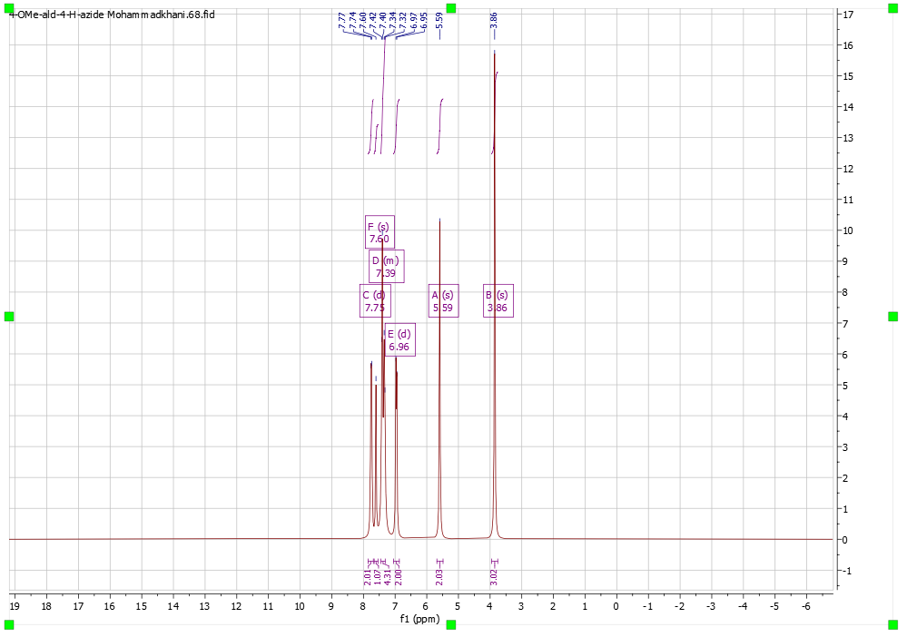

. FigureS₃₈the 1H NMR spectrum of 4f in CDCl₃
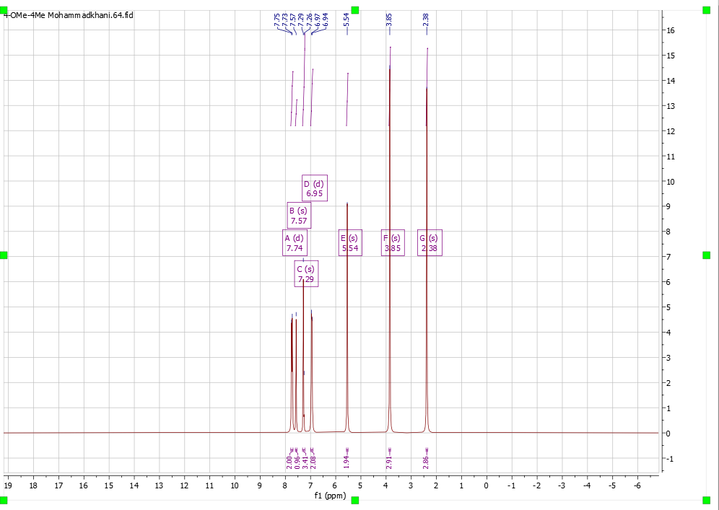
. FigureS₃₉ the 1H NMR spectrum of 4g in CDCl₃
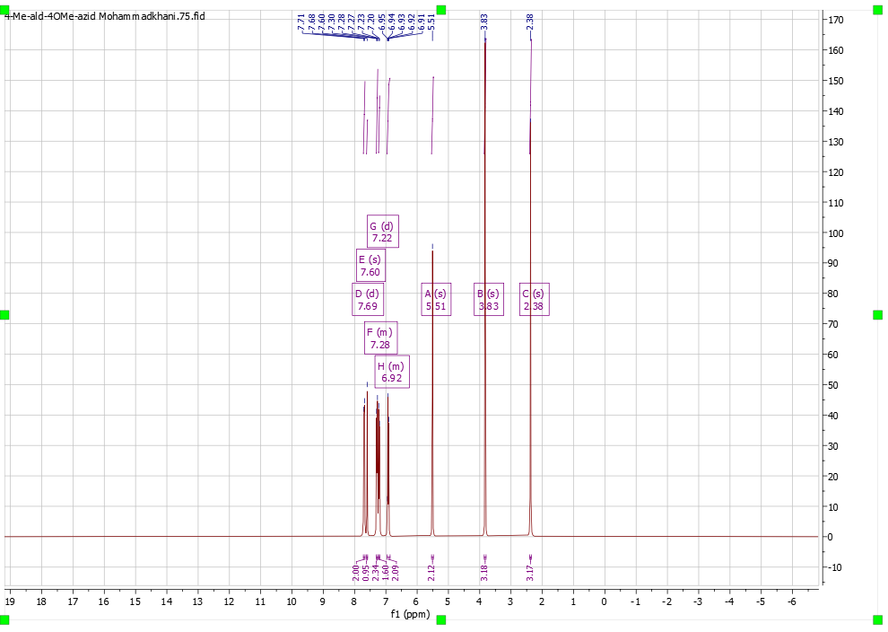
. FigureS₄₀ the 1H NMR spectrum of 4h in CDCl₃
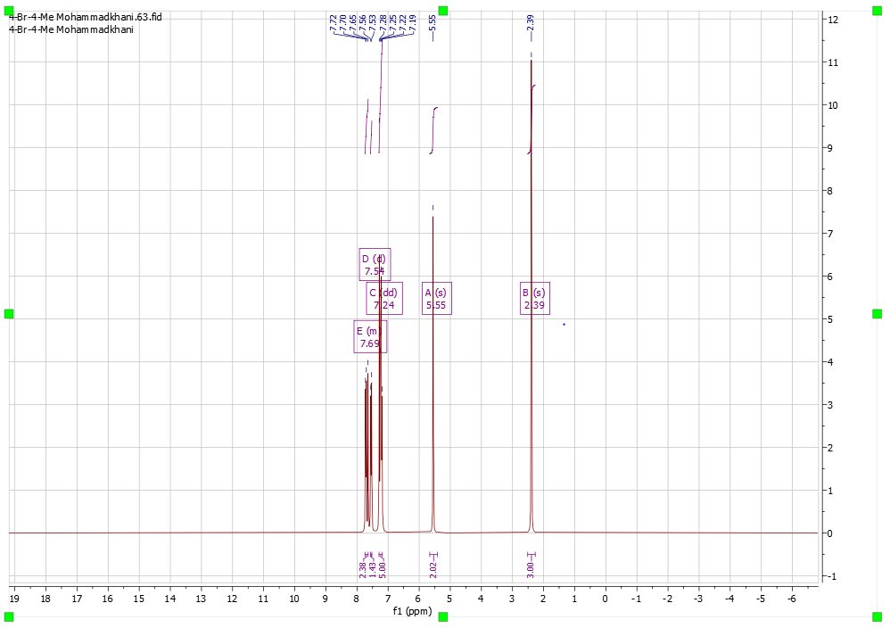
FigureS₄₁the 1H NMR spectrum of 4i in CDCl₃

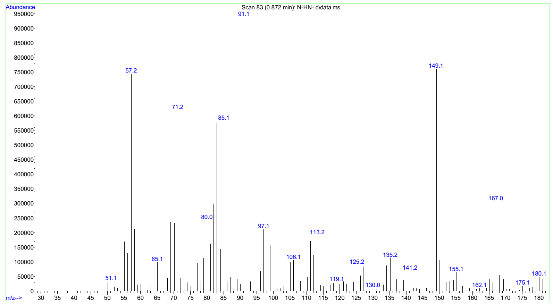
FigureS₄₂Mass spectrum of 2a
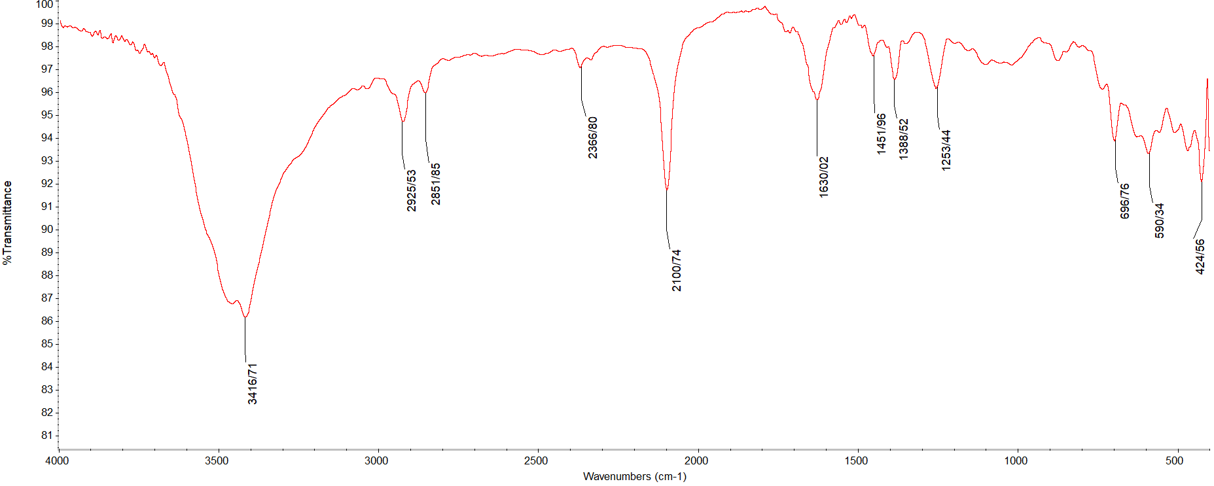
FigureS₄₃ FT-IR spectrum of 2a
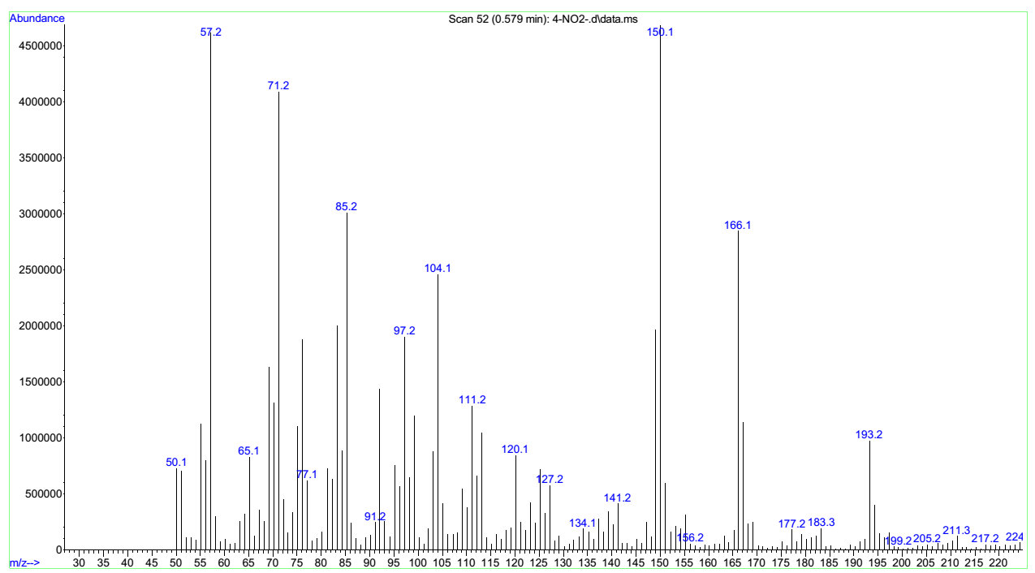
FigureS₄₄Mass spectrum of 2c

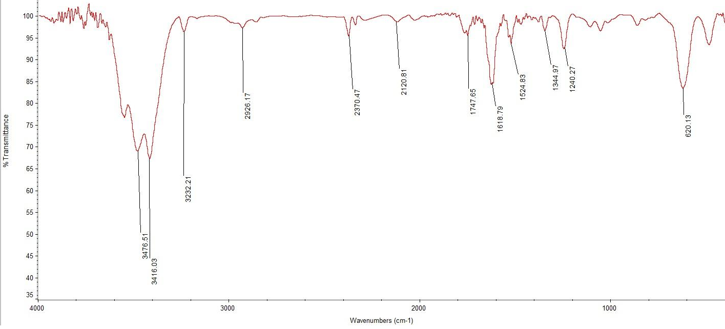
FigureS₄₅FT-IR spectrum of 2c
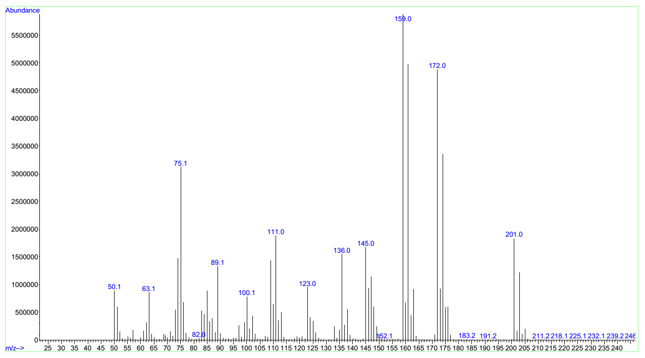
FigureS₄₆Mass spectrum of 2e

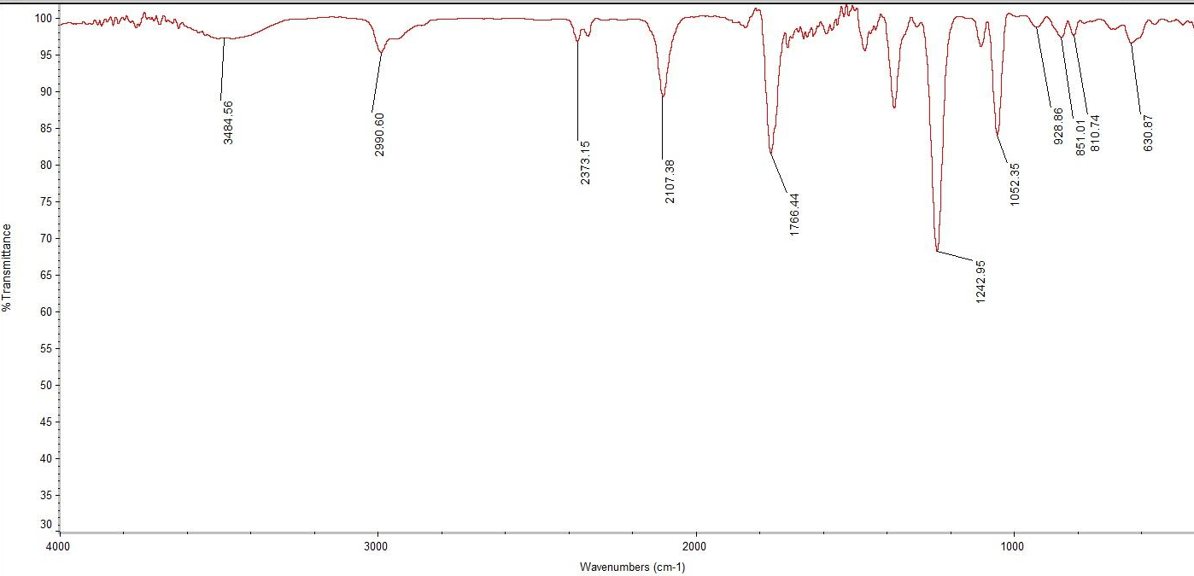
FigureS₄₇ FT-IR spectrum of 2e

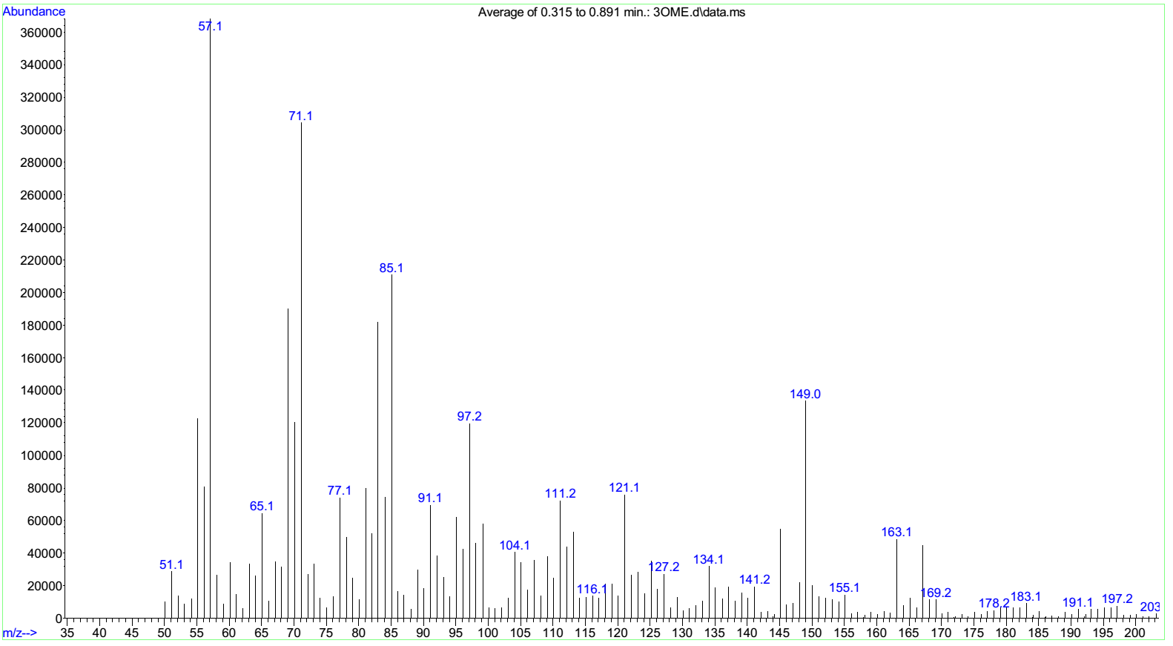
FigureS₄₈Mass spectrum of 2m

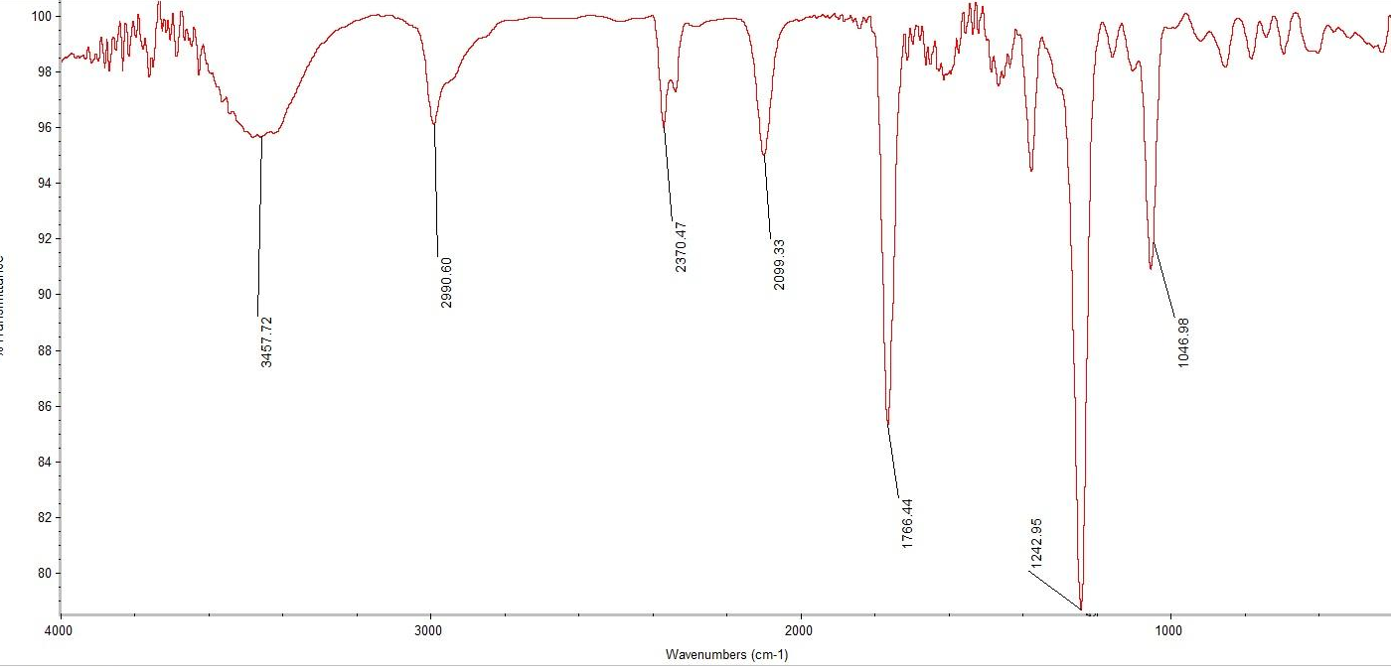
FigureS₄₉FT-IR spectrum of 2m

Reference

1. A. Shaabani, S. E. Hooshmand, M. T. Nazeri, R. Afshari, S. Ghasemi, Deep eutectic solvent as a highly efficient reaction media for the one-pot synthesis of benzo-fused seven-membered heterocycles. Tetrahedron Lett. 57, 3727-3730 (2016).
2. V. R. Velpuri, K. Muralidharan, Multicomponent click reaction catalyzed by organic surfactant-free copper sulfide (sf-CuS) nano/micro flowers. J. Organomet. Chem. 884, 59-65 (2019).
3. V. A. Bakulev, T. Beryozkina, J. Thomas, W. Dehaen, The Rich Chemistry Resulting from the 1,3-Dipolar Cycloaddition Reactions of Enamines and Azides. Eur. J. Org. Chem. 2018, 262-294 (2018).
4. V. V. Rostovtsev, L. G. Green, V. V. Fokin, K. B. Sharpless, A stepwise huisgen cycloaddition process: copper (I)‐catalyzed regioselective “ligation” of azides and terminal alkynes. angew. chem. int. ed 114, 2708-2711 (2002).
5. B. I. Vergara-Arenas et al., Multicomponent synthesis of 4-aryl-NH-1, 2, 3-triazoles in the presence of Al-MCM-41 and sulfated zirconia. Tetrahedron Lett. 58, 2690-2694 (2017).
6. A. Wangweerawong, J. R. Hummel, R. G. Bergman, J. A. Ellman, Preparation of enantiomerically pure perfluorobutanesulfinamide and its application to the asymmetric synthesis of α-amino acids. J. Org. Chem. 81, 1547-1557 (2016).
7. A. Xu, X. Guo, Y. Zhang, Z. Li, J. Wang, Efficient and sustainable solvents for lignin dissolution: aqueous choline carboxylate solutions. Green Chem. 19, 4067-4073 (2017).
8. W. Zhao et al., Eco-friendly acetylcholine-carboxylate bio-ionic liquids for controllable N-methylation and N-formylation using ambient CO 2 at low temperatures. Green chem. 21, 567-577 (2019).
9. J. F. B. Pereira et al., Molecular interactions in aqueous biphasic systems composed of polyethylene glycol and crystalline vs. liquid cholinium-based salts. Phys. Chem. Chem. Phys. 16, 5723-5731 (2014).
10. A. Zhu et al., Cleaner enzymatic production of biodiesel with easy separation procedures triggered by a biocompatible hydrophilic ionic liquid. Green Chemis.22, 1944-1951 (2020).
11. H. P. Kalmode, K. S. Vadagaonkar, K. Murugan, S. Prakash, A. C. Chaskar, Deep eutectic solvent: a simple, environmentally benign reaction media for regioselective synthesis of 2,3,4-trisubstituted 1H-pyrroles. RSC Adv.5, 35166-35174 (2015).
12. J. A. Mehraban, K. Azizi, M. S. Jalali, A. Heydari, Choline Azide: New Reagent and Ionic Liquid in Catalyst-Free and Solvent-Free Synthesis of 5-Substituted-1H-Tetrazoles: A Triple Function Reagent. ChemistrySelect 3, 116-121 (2018).
13. L. Zhou et al., Alcoholysis of polyethylene terephthalate to produce dioctyl terephthalate using choline chloride-based deep eutectic solvents as efficient catalysts. Green Chem. 21, 897-906 (2019).
14. H. Feuer, D. Braunstein, Reduction of oximes, oxime ethers, and oxime esters with diborane. Novel synthesis of amines. J. Org. Chem 34, 1817-1821 (1969).
15. C. W. Shoppee, 265. The effect of nuclear halogen substituents on triad prototropic systems in relation to aromatic side-chain reactions. J. Chem. Soc. (Resumed), 1117-1120 (1933).
16. V. H. Reddy, Y. R. Reddy, B. Sridhar, B. S. Reddy, Green catalytic process for click synthesis promoted by copper oxide nanocomposite supported on graphene oxide. Adv. Synth. Catal. 358, 1088-1092 (2016).
17. A. Adenot, E. B. Landstrom, F. Gallou, B. H. Lipshutz, Fe/ppm Cu nanoparticles as a recyclable catalyst for click reactions in water at room temperature. Green Chem.19, 2506-2509 (2017).
18. H. Naeimi, R. Shaabani, Ultrasound promoted facile one pot synthesis of triazole derivatives catalyzed by functionalized graphene oxide Cu (I) complex under mild conditions. Ultrason. sonochem. 34, 246-254 (2017).
19. A. Mouradzadegun, M. A. Mostafavi, Copper-loaded hypercrosslinked polymer decorated with pendant amine groups: a green and retrievable catalytic system for quick [3+ 2] Huisgen cycloaddition in water. RSC adv. 6, 42522-42531 (2016).
20. K. Asano, S. Matsubara, Effects of a flexible alkyl chain on a ligand for CuAAC reaction. Org. Lett. 12, 4988-4991 (2010).
21. A. Szadkowska, S. Staszko, E. Zaorska, R. Pawłowski, A theophylline based copper N-heterocyclic carbene complex: synthesis and activity studies in green media. RSC adv.6, 44248-44253 (2016).
22. P. V. Chavan, K. S. Pandit, U. V. Desai, M. A. Kulkarni, P. P. Wadgaonkar, Cellulose supported cuprous iodide nanoparticles (Cell-CuI NPs): A new heterogeneous and recyclable catalyst for the one pot synthesis of 1, 4-disubstituted–1, 2, 3-triazoles in water. RSC adv.4, 42137-42146 (2014).
23. J. Cao et al., Novel leucine ureido derivatives as aminopeptidase N inhibitors using click chemistry. Bioorg. Med. Chem. 26, 3145-3157 (2018).

ª Chemistry Department, Tarbiat Modares University, Tehran, PO Box:14155-4838,Iran E-mail: heydar_a@modares.ac.ir

