Supporting Information
Cancer Regulator EGFR‑ErbB4 Heterodimer is Stabilized Through Glycans at the Dimeric Interface
Zahra Motamedi¹, Mehri Shahsavari¹, Hassan Rajabi-Maham¹ and Maryam Azimzadeh Irani¹*
¹Faculty of Life Sciences and Biotechnology, Shahid Beheshti University, Tehran, Iran.

*Corresponding author:
E-mail: m_azimzadeh@sbu.ac.ir
Address: Faculty of Life Sciences and Biotechnology, Shahid Beheshti University, Tehran, Iran. Post Code: 1983969411.
Tel: +98-21-29901
Fax: +98- 21-22431919

Glycosylation sites in Heterodimer EGFR-ErbB4
EGFR | ErbB4
ASN 104, ASN 151, ASN172, ASN337, ASN 389, ASN 420, ASN 504, ASN 544, ASN 579, ASN599 | ASN113, ASN149, ASN333, ASN385, ASN448, ASN470, ASN523, ASN595

Table S.1. The glycosylated Aspargines in the EGFR-ErbB4 heterodimer.

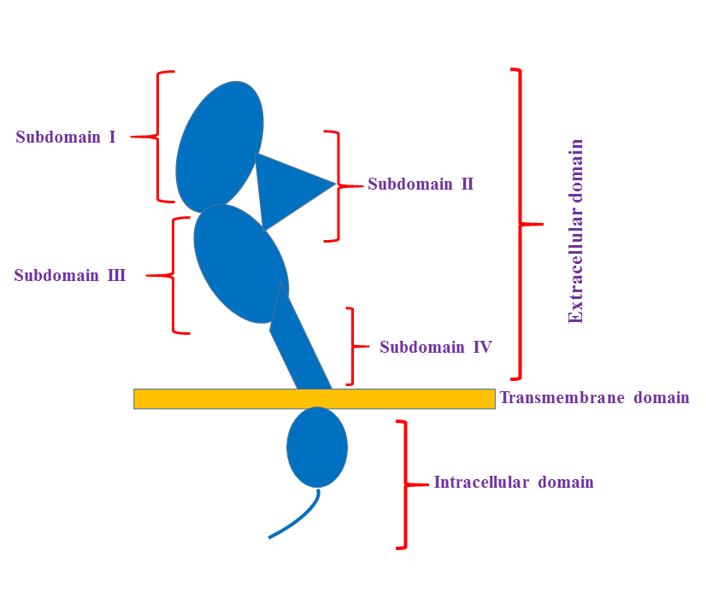

Figure S.1. The schematic architecture of the ErbB proteins. The ErbB receptors consist of an extracellular domain which includes subdomains I to IV, a transmembrane domain, and an intracellular tyrosine kinase domain.

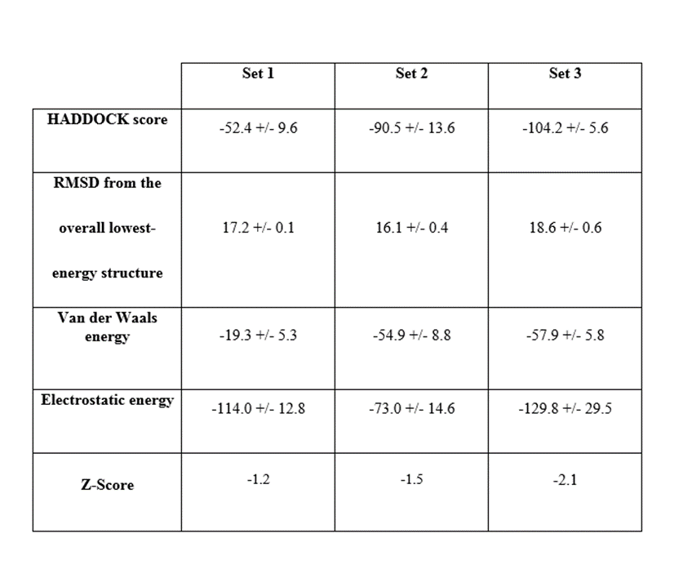
Table S.2. The Haddock results for EGFR-ed-ErbB4-ed docking. Outputs of the top cluster from all three sets of dockings are listed. RMSD values are reported with A units and the VDW and Electrostatic energies are reported by kcal/mol units.

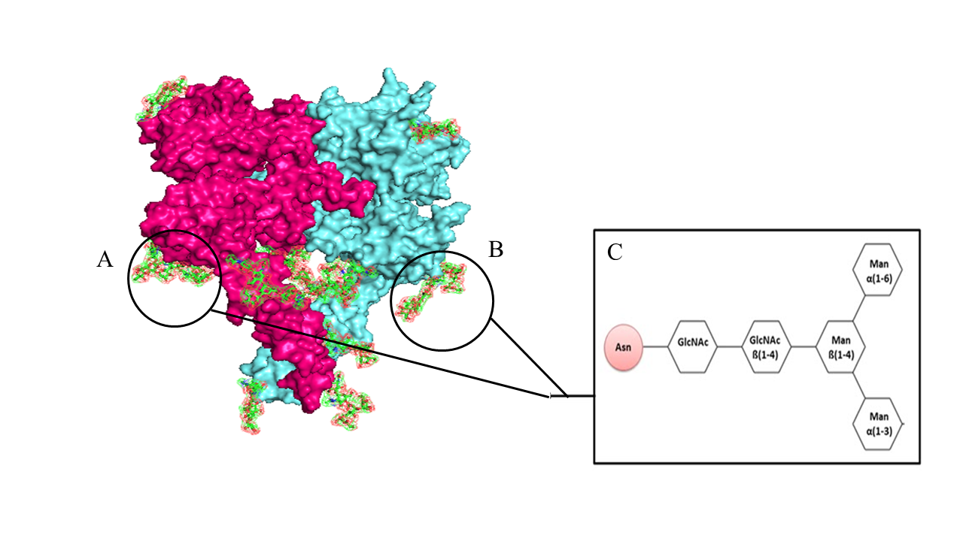

Figure S.2. Oligosaccharide glycans attached to EGFR-ErbB4 heterodimer. (A) Glycans that are attached to EGFR and (B) ErbB4 receptors are shown with atom name sticks. Details of the monosaccharide units and the glycosidic linkages are schematically shown in (C).

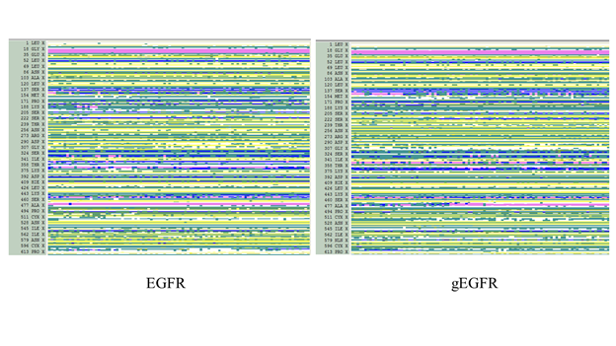
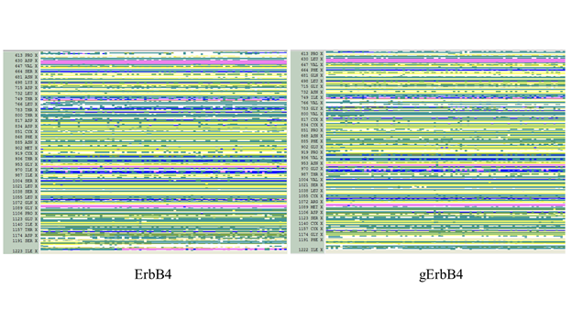

Figure S.3. Secondary structure composition of the EGFR, gEGFR, ErbB4 and gErbB4 extracellular domains calculated over 50ns of the first replicate simulation.
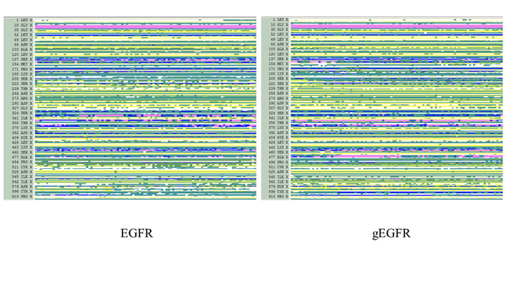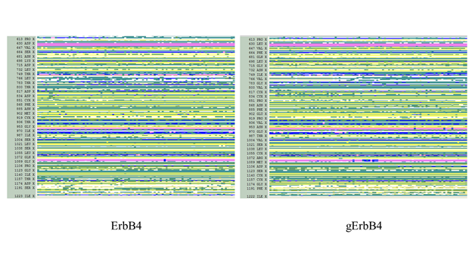

Figure S.4. Secondary structure composition of the EGFR, gEGFR, ErbB4 and gErbB4 extracellular domains calculated over 50ns of the second replicate simulation.

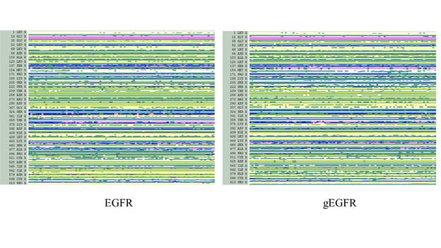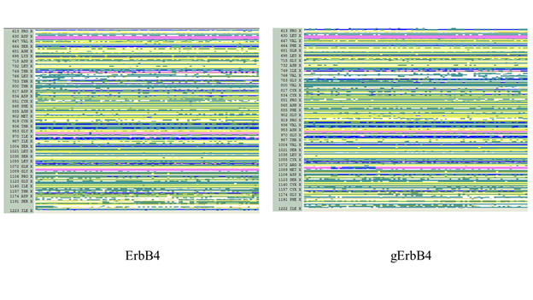
Figure S.5.Secondary structure composition of the EGFR, gEGFR, ErbB4 and gErbB4 extracellular domains calculated over 50ns of the third replicate simulation.

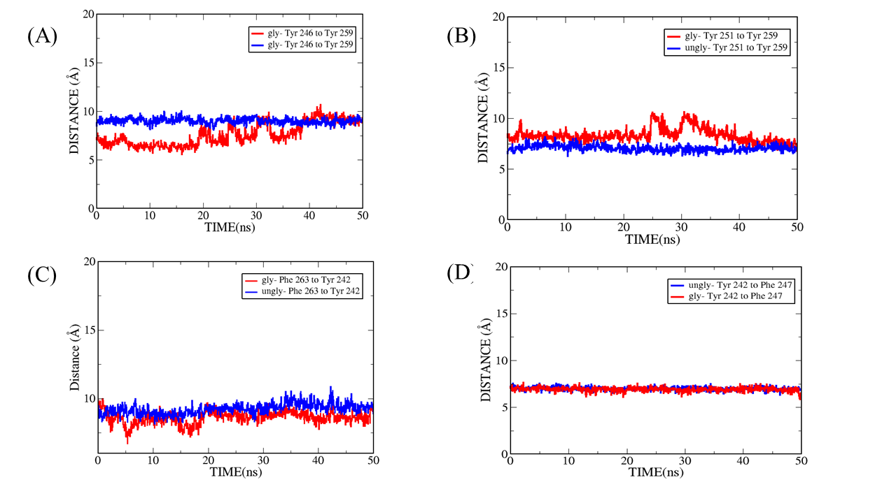
Figure S.6. The distance plots between Cα atoms of the amino acid pairs in the hydrophobic core of the dII dimeric interface of the glycosylated and unglycosylated heterodimer. Calculated over 50ns of one replicate simulation for both glycosylated and unglycosylated systems. Blue and red plots present the unglycosylated and glycosylated systems respectively. (A) The distance plots between Tyr 246 of EGFR and Tyr 259 of ErbB4. (B) The distance plots between Tyr 251 of EGFR and Tyr 259 of ErbB4. (C) The distance plots between Phe 263 of EGFR and Tyr 242 of ErbB4. (D) The distance plots between Tyr 242 of EGFR and Phe 247 of ErbB4.

