Supporting information
Autonomous Electrochemical System for Ammonia Oxidation Reaction Measurements at the International Space Station
Camila Morales-Navas¹*, Roberto A. Martínez-Rodríguez^{1,2}, Francisco J. Vidal-Iglesias², Armando Peña³, Joesene Soto¹, Pedro Trinidad¹, José Solla-Gullón², Toshko Tzvetkov⁴, Jonathan Doan⁴, Eugene S. Smotkin^{4,5}, Eduardo Nicolau¹, Juan M. Feliu², and Carlos R. Cabrera^{1,3}*
¹Department of Chemistry, University of Puerto Rico, Río Piedras Campus, San Juan, Puerto Rico 00925-2537
²Institute of Electrochemistry, University of Alicante Ap. 99, 03080 Alicante, Spain
³Department of Chemistry and Biochemistry, University of Texas at El Paso, El Paso, Texas 79968
⁴NuVant Systems, Inc., 130 N. West Street Crown Point, Indiana 46307
⁵Department of Chemistry and Chemical Biology, Northeastern University, 360 Huntington Ave., Boston, Massachusetts 02115

- Platinum synthesis
Catalysts were synthesized in the laboratory. In particular,platinum nanocubes were ynthesized by the water in oilemulsion method presented by Martinez-Rodriguez et al. 11 g of Brij30 and 2.1 mL of chloroplatinic acid 0.1M were added to 38.29 g of n-heptane in a container and the mixture was well mixed. Brij30 is a nonionic surfactant used to disperse the chloroplatinic acid particles by steric stabilization. This step was followed by the addition of 0.079g of sodium borohydride toreduce the dispersed platinum precursor. The reaction took place for 20 minutes. After it was finished, acetone was added to induce the precipitation of the platinum nanocubes. Once precipitated the particles were rinsed with acetone,methanol and nanopure water. Cubic particles formationwas induced by adding HCl during the reduction process.The method for making the platinum supported onVulcan™ nanoparticles is as follows: platinum nanoparticleswere reduced with sodium borohydride by the method previously explained, then added 39 mL of a solution of 5mg/L of Vulcan™ in n-Heptane, to make a catalyst with aPt/Vulcan™ ratio of 20:80. The solution was mixed for 30minutes.The platinum loading of the Pt in Vulcan™ catalysts was ca. 20% Pt as determined by thermogravimetric analysis.
- Pt Nanocube Sample Characterization
The samples chosen were cubic shaped platinum nanoparticles and cubic shaped platinum deposit over Vulcan XC 72R carbon support in a mass ratio 20:80 from the same synthesis. Transmission electron microscopy (TEM) was done to have an insight about the shape, size and distribution rate of the particles. The instrument used was a JEOL, JEM-2010 working at 200kV and 120kV. The catalyst was dispersed in isopropanol solution and sonicated for 30s. A small drop of catalyst was deposit in a cooper grid covered by Formvar. More than 200 particles from different places of the grid were analyzed to prepare a particle size histogram (see Figure 1).
b
a
d
c
Figure 1. (a) Sample: Pt cubes/V 20 wt% (Vulcan XC-72R), (b) Pure Pt in water after cleaning, (c) Pt nanocube sample from the micro-emulsion, (d) TEM images with the corresponding histogram.

- Thermogravimetric Analysis
The platinum loading was evaluated by thermogravimetric analysis with a Mettler-toledo balance, TGA/SDTA851. The temperature range was 10 ˚C per minute from 25˚ to 850˚ in oxidative atmosphere of N₂/O₂= 4:1. The experimental and nominal loading agreed, i.e. 20% (See Figure 2).
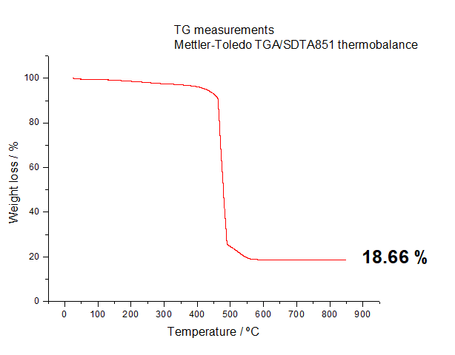

Figure 2. Thermogravimetric Analysis (TGA) of Platinum Nnaocubes at Vulcan XC-72R sample.

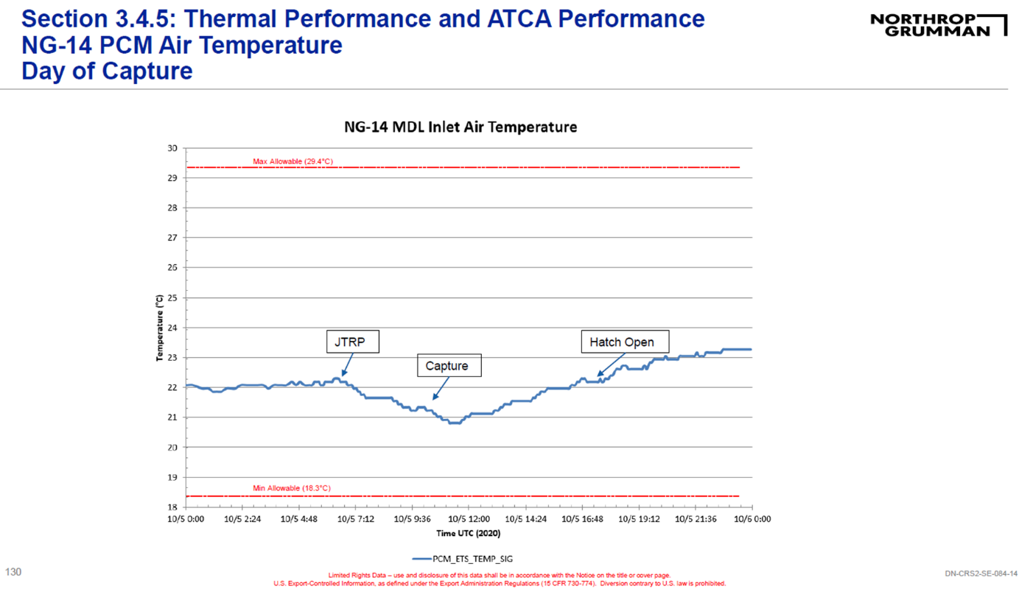
- Temperature profile :
The 1st plot shows PCM cabin temperature in degC from Final Cargo Load until Hatch open. The 2nd plot is a “zoomed in” section that focuses on capture day

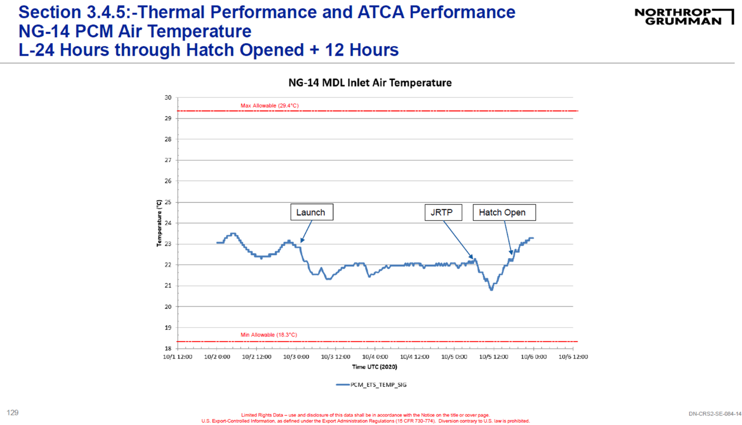



V. Electrochemical Cell Arrey

C: Counter Electrode
W: Carbon Working Electrode
R: Ag quasi reference electrode (AgQRE)

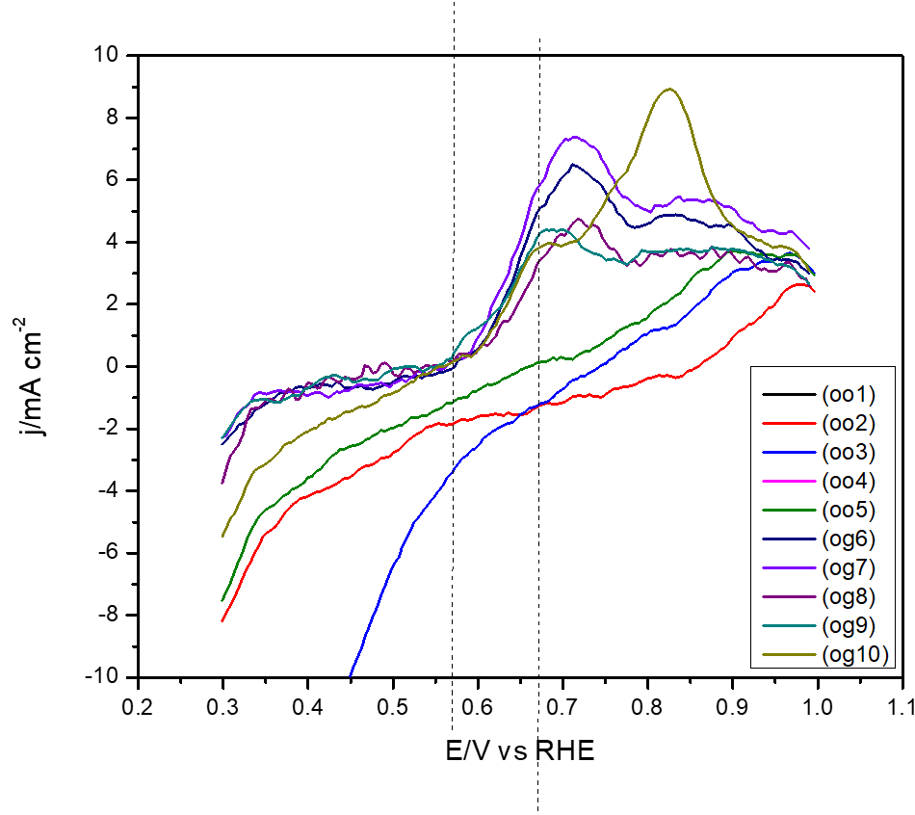
- Cyclic Voltammetry
Figure 3. Cyclic voltammetry profiles nanocube Pt nanoparticle-Vulcan electrode in 0.05M (NH₄)₂SO₄ and 0.18 M NaOH at pH 12.9 at scan rate of 10mV/s. First cycle of each experiment on ground (og) and on-orbit (oo).
- NuVant autonomous potentiostat with its main AELISS electrochemical system components
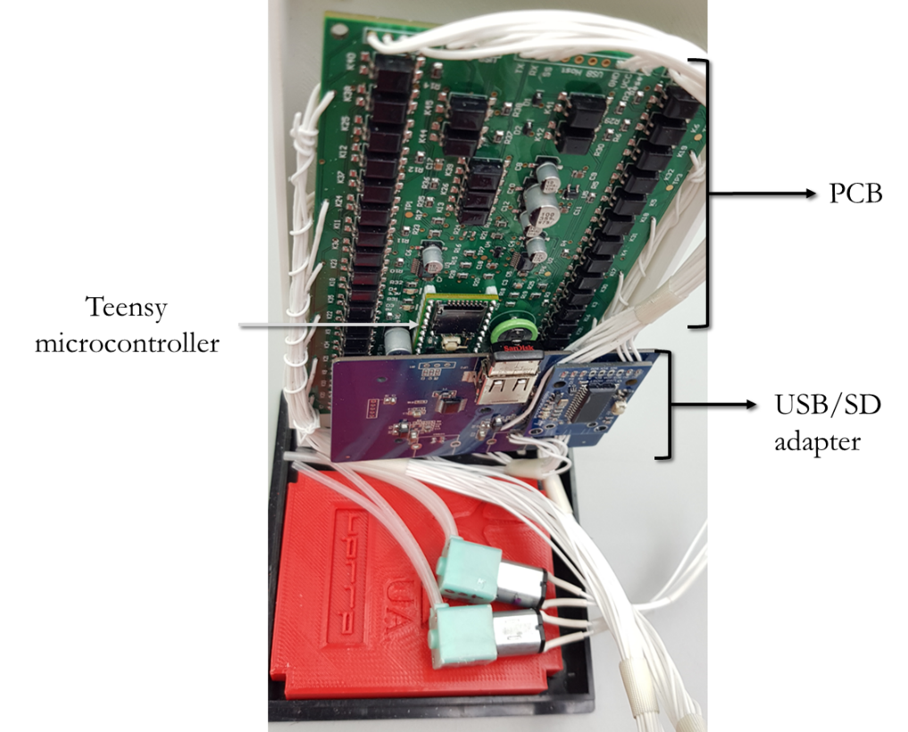

Figure 4. Picture of the NuVant autonomous potentiostat with its main AELISS electrochemical system components.

- Pressure Testing
Payload leak tests are considered adjunctive to payload qualification acceptance tests which are part of the success criteria for NASA approval. The suggested methods to test an "external-to-internal" payload, where the pressure may change, and mass loss may be lost after vacuum exposure, were explored.¹ Pressure testing was done to ensure that the barbed unions and flow bolts could hold the ammonia solution flow without leaking. A summary of the tests performed for each containment is included in Table 4. Phenolphthalein was used as a pH indicator since it is colorless at neutral pH and changes color to red-violet at pH higher than 8.² The testing procedure was the following: First, the containment was sealed as expected for the final launch, sprayed with the indicator to identify possible leakage. Afterward, it was exposed to a vacuum for 5 minutes inside a non-powered vacuum oven. The tests were done at room temperature.
Table 1. Summary of pressure and vacuum results.
Containment | Weight ± 0.1 (g) | Pressure atm (30inHg) | Vacuum (inHg) | Findings
1 | Before: 214.8  After: 214.7 | 1 | 78 | No loss of solution or pH change indicator identified
1 and 2 | Before: 643.0  After: 642.9 | 1 | 78 | No loss of solution or pH change indicator identified
1, 2 and 3 | Before: 661.7  After: 661.6 | 1 | 78 | No loss of solution or pH change indicator identified

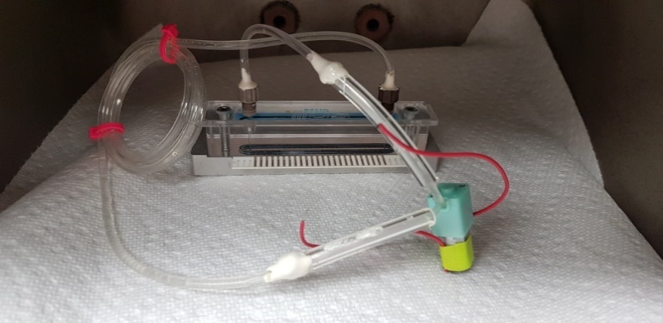
Figure 5 shows the primary containment inside a vacuum oven with a white surface to facilitate the tinted liquid monitoring.

Figure 5. Picture of first containment (electrochemical cell with tubing and pump) inside a vacuum oven where the vacuum tests were performed.

VIII. Assembly process in the laboratory at NASA Wallops Flight Facility

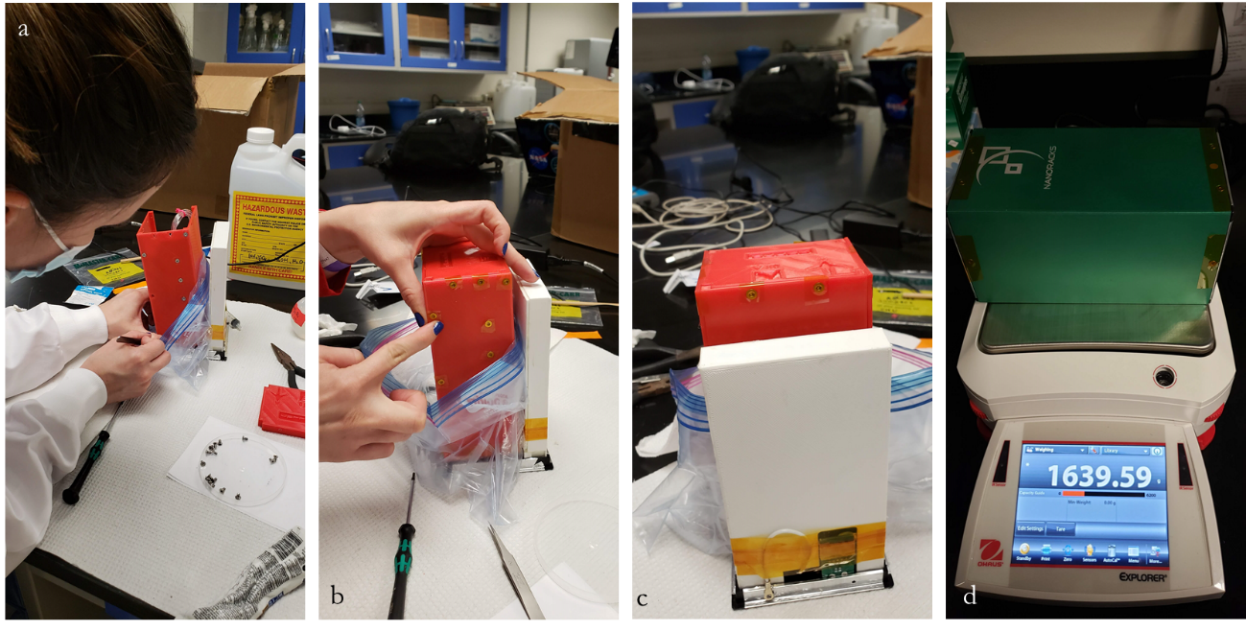

Figure 6. Assembly process in the laboratory at NASA Wallops Flight Facility: (a)set screws, (b) insulating with Kapton® tape, (c) device complete, and (d) AELISS electrochemical system inside the 2U Nanoracks box showing device’s weight in grams.

References
1. Lvovsky, O.; Grayson, C. M., Aerospace Payloads Leak Test Methodology. In American Society for Nondestructive Testing, Fall Conference, NASA: Houston, TX, United States, 2010.
2. Harris, D. C., Quantitative Chemical Analysis. 7th ed.; Craig Bleyer: New York, USA, 2007; p 555.

