Supporting Information for
Regiospecific C-H Amination of (─)-Limonene into (─)-Perillamine by Multi-enzymatic Cascade Reactions
Yue Ge, Zheng-Yu Huang, Jiang Pan, Chun-Xiu Li, Gao-Wei Zheng and Jian-He Xu*
Laboratory of Biocatalysis and Synthetic Biotechnology, State Key Laboratory of Bioreactor Engineering, Shanghai Collaborative Innovation Centre for Biomanufacturing, College of Biotechnology, East China University of Science and Technology, Shanghai 200237, P. R. China.

* Corresponding authors: Prof. Jian-He Xu. E-mail: jianhexu@ecust.edu.cn

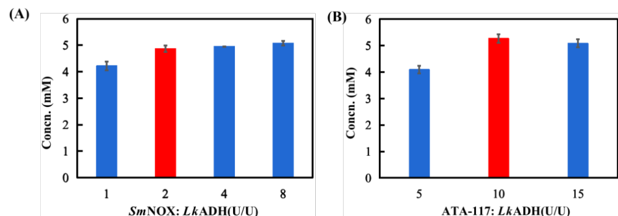
Figure S1. Optimization of the ratio of each elemental enzyme added in Module 2. Reaction conditions (0.5 mL system): KPB buffer (100 mM, pH 7.5), shaken at 35 ℃, 800 rpm for 12 h, 10 mM (−)-perillyl alcohol (with 2% DMSO), 0.2 mM PLP, 0.2 mM NAD⁺, and 80 mM 2-pentanamine, in addition to: a) 0.2 U/mL LkADH, 2 U/mL ATA-117 and varied doses of SmNOX; b) 0.2 U/mL LkADH, 0.4 U/mL SmNOX and varied doses of ATA-117. Concn.: concentration.

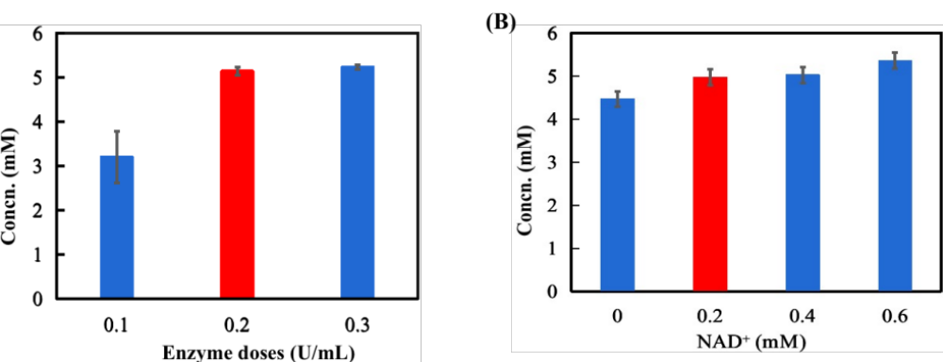
Figure S2. Optimization of enzyme dose of LkADH. Reaction conditions: (-)-perillyl alcohol, 10 mM; 0.1, 0.2 or 0.3 U/mL LkADH; [LkADH]/[NOX]/[ATA-117] = 1/5/10; 0.2 mM NAD⁺; 0.2 mM PLP; 80 mM 2-pentanamine; KPB buffer (100 mM, pH 7.5); 35℃, 800 rpm; 12 h.
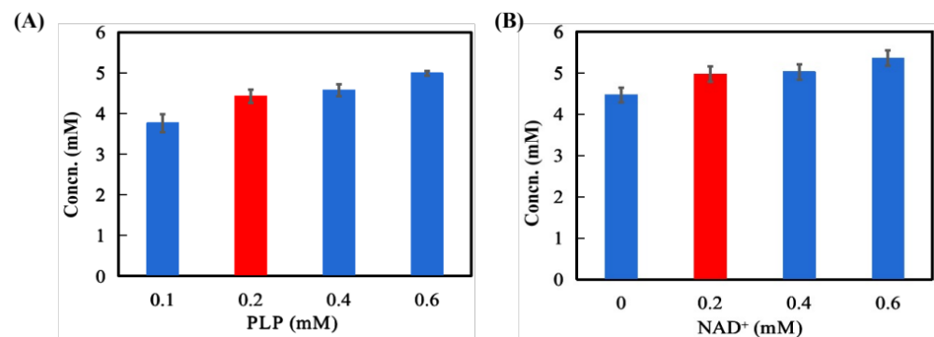
Figure S3. Optimization of cofactor dose. Reaction conditions: (-)-perillyl alcohol, 10 mM; LkADH, 0.2 U/mL; [LkADH]/[NOX]/[ATA-117] = 1/5/10; NAD⁺, 0, 0.2, 0.4, or 0.6 mM; PLP, 0.1, 0.2, 0.4, or 0.6 mM; 2-pentanamine, 80 mM; KPB buffer, 100 mM (pH 7.5); Incubation, 35 ℃, 800 rpm, 12 h.

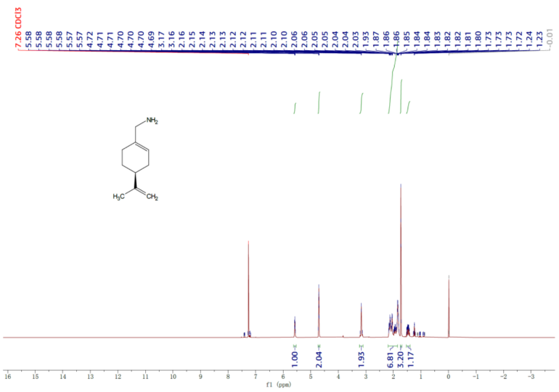
Figure S4. ¹H-NMR spectrum of the purified (-)-perillamine from the multi-enzymatic reaction mixture.

Table S1. Inactivation effect of Triton X-100 on the SmNOX activity.
Enzyme | Residual activity (%)
Enzyme | 0 h | 12 h
SmNOX | 100 | 81 ± 4
SmNOX + Triton X-100 | 94 ± 1 | 37 ± 3
The experiments were performed for triplicates and shown as the average ± standard deviations (SD).

