Supplementary materials
Supplementary Figure 1. Counterbalancing matrix for each experiment.
Note: This figure shows the percentage of participants who viewed each clip in each order for experiment 1 (left) and experiment 2 (right).

Supplementary Figure 2. Distribution of reaction times in experiment 1.

Supplementary Figure 3. Example time course plots of heart rate (left) and skin conductance (right) for a participant.

Supplementary Figure 4. Familiarity plots for Experiment 1 (left) and Experiment 2 (right).
Note: Each experiment asked two questions related to familiarity: ‘Have you seen any of the following series/film before?’ (bold outline), and ‘Have you seen the specific clips used in this experiment before?’ (dashed outline).

Supplementary Figure 5. Example of ISC_{HR} computed across time for ‘The Outlaws’.
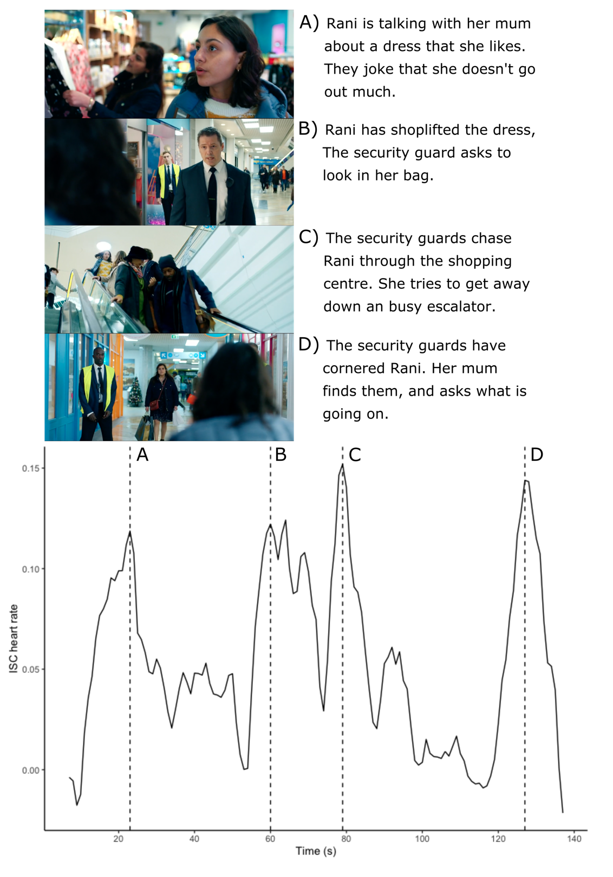
Note: For this clip, ISC_{HR} was computed using a rolling window with a width of 15 s, moved in 1 s increments rather than across the whole clip. This provides a continuous estimate of ISC_{HR} which could be linked to notable moments in the content. Here, we have identified the ISC_{HR} peaks (dashed line) and described what is occurring in the content at those points (A-D).
Supplementary Materials S6.
In experiment 1, we chose to exclude participants with an average of below 50% correct responses. This deviates from our preregistered exclusion criteria of < 75% correct responses. Upon reflection, we do not think it is appropriate to exclude participants for answering incorrectly, as higher error rate may simply be a consequence of higher engagement. However, if the preregistered exclusion criteria was followed, the final sample size would be n = 156. Below, we present the same analyses as in the main results using the pre-registered exclusion criteria to demonstrate that the results are consistent.
We found a significant relationship between reaction time and narrative engagement: r(5) = .880, p = .009, as well as reaction time and our single-item question of immersion, r(5) = .845, p = .017. Individual participant correlations were also significantly greater than zero for both narrative engagement (r = .225, t(156) = 7.01, p = 6.7 x 10⁻¹¹) and immersion (r = .197, t(156) = 6.17, p = 5.64 x 10⁻⁹).
Exploring this relationship using a linear mixed model indicates the same trend for only emotional engagement (b = 15.53, 95% CI[7.30, 23.76]) and clip order (b = 10.95, 95% CI[6.54, 15.36]) to have a significant impact on reaction time.

Similarly to our full analysis, ISC_{RT} was also not related to narrative engagement (r(5) = .438, p = .326), or immersion (r(5) = .372, p = .412). However, individual participant correlations between ISC_{RT} and both narrative engagement (mean r = .223, t(155) = 6.92, p = 1.15 x 10⁻¹⁰) and immersion (mean r = .194, t(155) = 6.07, p = 9.59 x 10⁻⁹) were significant.

