Pembrolizumab in combination with gemcitabine for patients with HER2-negative advanced breast cancer: GEICAM/2015-04 (PANGEA-Breast) study
Supplementary Material
Supplementary Figure 1: Run-in phase design, patient inclusion, and DLTs.
Supplementary Figure 2: Swimmer plot for the intention-to-treat population.
Supplementary Figure 3: TIL density distribution according to tumor subtype and ORR (yes/no).
Supplementary Figure 4: (A) PD-L1 CPS distribution according to tumor subtype and ORR (yes/no). (B) PD-L1 IC distribution according to tumor subtype and ORR (yes/no).
Supplementary Figure 5: Correlation of TIL density and PD-L1 expression.

Supplementary Figure 1. Run-in phase design, patient inclusion, and DLTs. DLT, dose-limiting toxicity; IV, intravenous; RP2D, recommended phase II dose; DL, dose level; PD, progressive disease.
HER2-negative ABC
Gemcitabine IV D1 & D8
plus
Pembrolizumab IV D1
Every 21-day cycles
6+6 Design
DLT window of 21 days
DLT <2
DLT >3
DLT > 4
DLT <3
DLT >4
DLT <3
RP2D
RP2D
End of study
Treatment until disease progression, unacceptable toxicity, or withdrawn informed consent
DL 0
(6 patients)
Gemcitabine 1250 mg/m²
Pembrolizumab 200 mg
6 patients included:
- No DLTs
- 1 NE (early PD)
DL 0
(6 patients)
Gemcitabine 1250 mg/m²
Pembrolizumab 200 mg
8 patients included:
- 1 DLT
- 2 NE (early PD)
DL -1
(12 patients)
Gemcitabine 1000mg/m²
Pembrolizumab 200mg

D1: day1; D8: day 8; NE: not evaluable

Supplementary Figure 2. Swimmer plot for the intention-to-treat population. Blue lines represent patients with partial response (n = 5), green lines represent patients with stable disease of any duration (n = 14), and dark yellow lines represent patients with progressive disease (n = 12). Grey lines on the left side of the figure represent the time period between the beginning of study treatment until the first tumor assessment or clinical PD. Five patients were not included: four patients did not have a post-baseline tumor assessment, and another patient was not assessable.
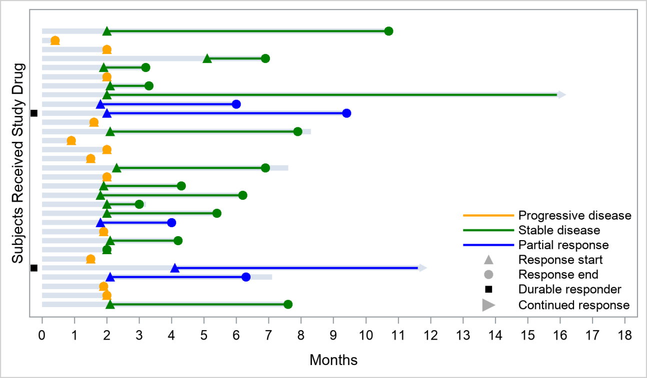

Supplementary Figure 3. TIL density distribution according to tumor subtype (triple negative/HR-positive) and OR (Yes/No), defined as complete response + partial response. Blue and red dots represent median TIL values (%) in OR-Yes and OR-No subgroups, respectively. Median % of TIL levels in TN subtype: OR-Yes group = 17.5 (lower/upper quartiles, 11.25/23.8) and OR-No group = 10 (lower/upper quartiles, 3.5/22.5) (Mann–Whitney U test, p = 0.7045). Median % of TIL levels in HR+ disease: OR-Yes group = 7.5 (lower/upper quartiles, 6.25/8.75) and OR-No group = 5 (lower/upper quartiles, 5/7.5) (Mann–Whitney U test, p = 0.5886). TILs, tumor-infiltrating lymphocytes; OR, objective response; TN, triple negative; HR, hormone receptor
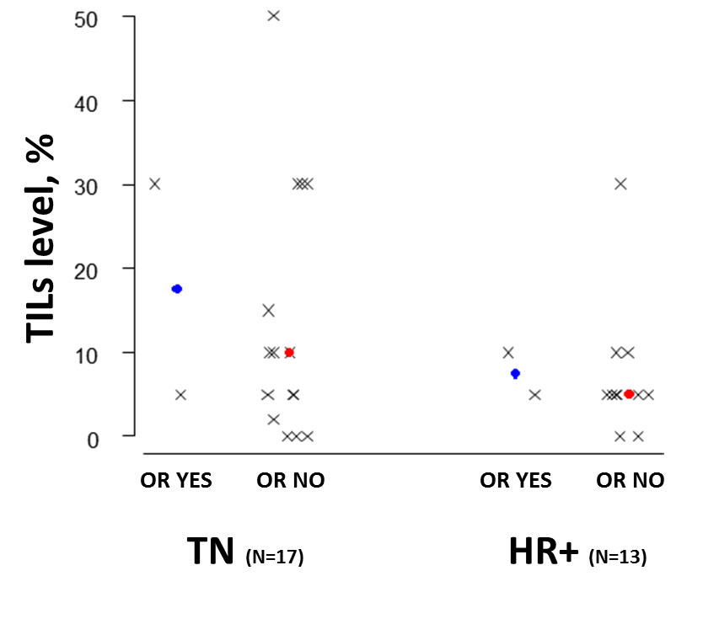

Supplementary Figure 4. (A) PD-L1 CPS distribution according to tumor subtype and OR (Yes/No). Blue and red dots represent median values in OR-Yes and OR-No subgroups, respectively; CPS median levels in TN subtype: OR-Yes group = 25 (lower/upper quartiles, 12.5/37.5) and OR-No group = 5 (lower/upper quartiles, 0/23.75) (Mann–Whitney U test, p = 0.8681). CPS median levels in HR+ subtype: OR-Yes group = 1 (lower/upper quartiles, 0.5/1.5) and OR-No group = 0 (lower/upper quartiles, 0/2) (Mann–Whitney U test, p = 1). (B) PD-L1 IC score (cut-off ≥1) distribution according to tumor subtype and OR (Yes/No). CPS, combined positive score; OR, objective response; TN, triple negative; HR, hormone receptor; IC, immune cells.
(A)

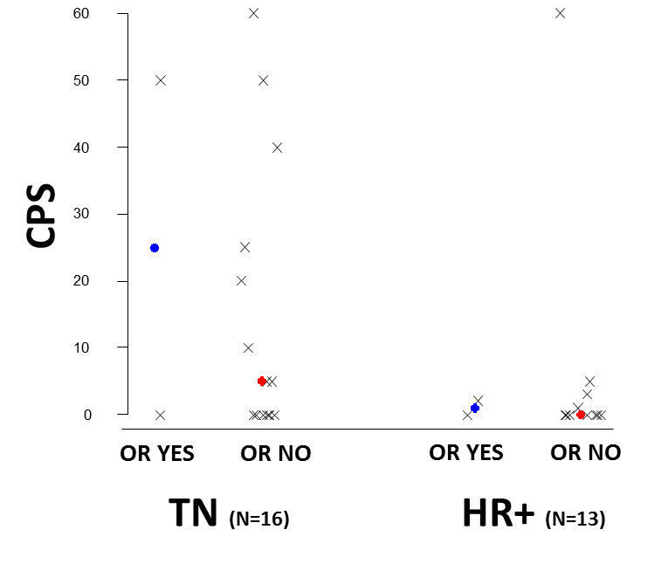

(B)
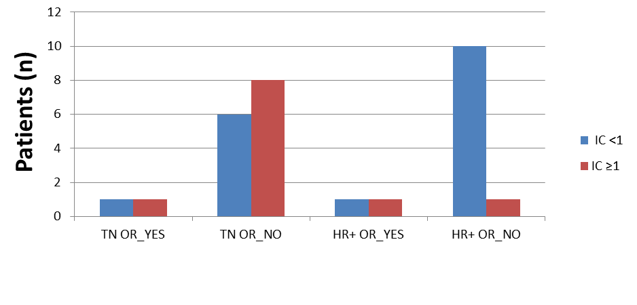

Supplementary Figure 5. Correlation of TIL density and PD-L1 CPS. TILs, tumor-infiltrating lymphocytes; PD-L1, programmed death-ligand 1; CPS, combined positive score.
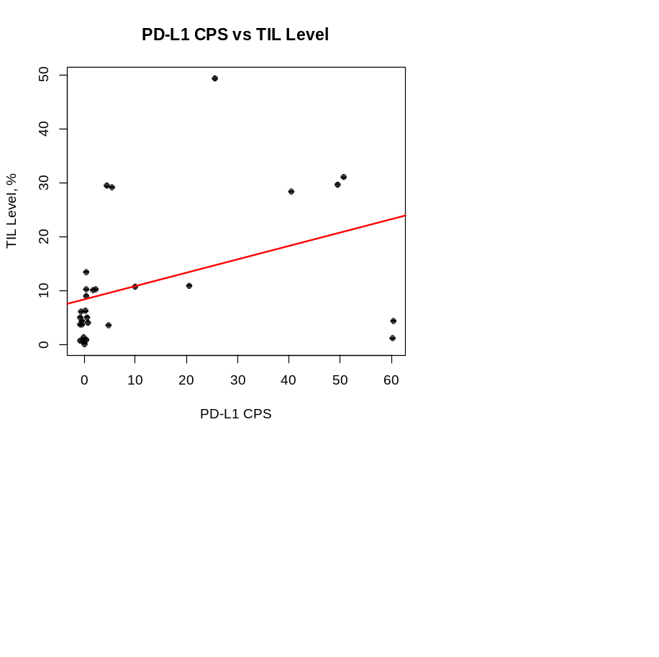
Spearman’s correlation coefficient = 0.567 (p = 0.00134)
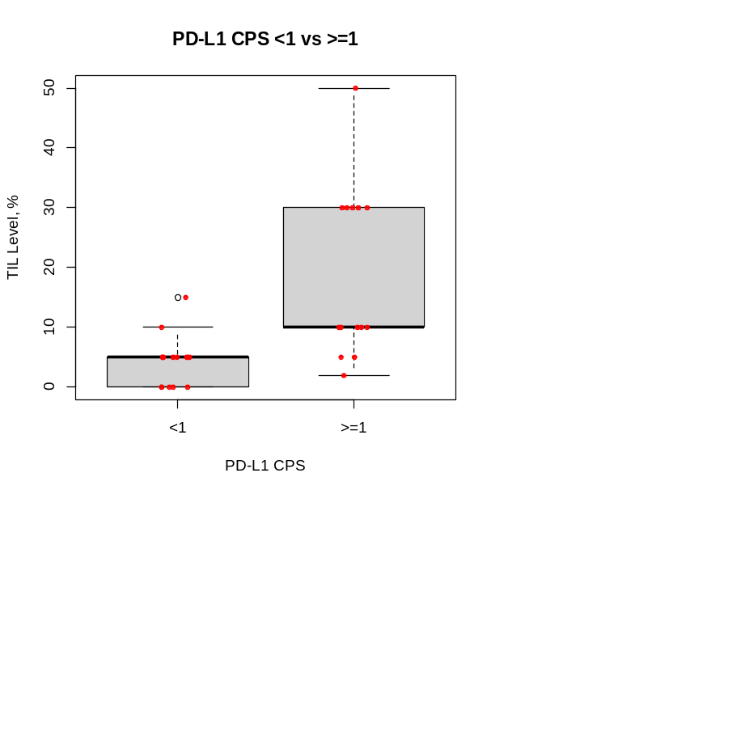
Mann–Whitney correlation p-value = 0.0007394

