Supplementary information file of the article:
From waste to valuable resources: exploitation of mineral waste to use in civil and environmental application.
PADOAN E. *, TEFA L. **, PASSARELLA I.*, DINO G.A. ***
* Department of Agricultural, Forest and Food Sciences (DISAFA), Università di Torino. Largo Paolo Braccini, 2, 10095 Grugliasco (TO), Italy
** Department of Environment, Land and Infrastructure Engineering (DIATI), Politecnico di Torino. 24, Corso Duca degli Abruzzi, 10129 Torino, Italy
** Earth Sciences Department (DST), Università di Torino. Via Valperga Caluso, 25. 10125 Torino, Italy. Corresponding author: giovanna.dino@unito.it

Table SI1. Elemental concentrations in the inorganic waste materials and legislative limits for bioavailable and total concentrations in soils.

 | Pseudototal concentrations (mg/kg) |  |  |  |  |  | Legislative limit *
 | S1 | S2 | S3 | S4 | S5 | S6 | A | B
As | 1 | 2 | 7 | 2 | 3 | 10 | 20 | 50
Cd | 1 | 1 | 1 | <1 | 1 | 2 | 2 | 15
Co | 18 | 120 | 38 | 12 | 16 | 60 | 20 | 250
Cr | 149 | 768 | 274 | 198 | 236 | 450 | 150 | 800
Cu | 39 | 43 | 32 | 36 | 105 | 48 | 120 | 600
Ni | 119 | 482 | 170 | 127 | 166 | 276 | 120 | 500
Pb | 24 | 19 | 35 | 143 | 67 | 55 | 100 | 1000
Zn | 141 | 139 | 268 | 180 | 293 | 344 | 150 | 1500
 | Bioavailable concentrations (mg/kg) |  |  |  |  |  | Legislative limit **
 | S1 | S2 | S3 | S4 | S5 | S6
Co | <0.05 | <0.05 | <0.05 | <0.05 | <0.05 | <0.05 | -
Cr | <0.05 | <0.05 | <0.05 | <0.05 | <0.05 | <0.05 | 15
Cu | 4.9 | 2.2 | 5.9 | 6.7 | 9.9 | 8.1 | 50
Ni | 1.0 | 6.6 | 2.1 | 7.1 | 6.1 | 1.1 | 30
Pb | 3.7 | 1.9 | 7.5 | 5.2 | 11.6 | 8.2 | 50
Zn | 1.4 | 1.6 | 4.6 | 29.5 | 9.7 | 3.9 | 150
* Limit on total concentrations in soils in residential (A) and industrial (B) areas (D.Lgs. 152/2006).
** Limit on bioavailable concentrations in soils according to Regione Piemonte (2000).

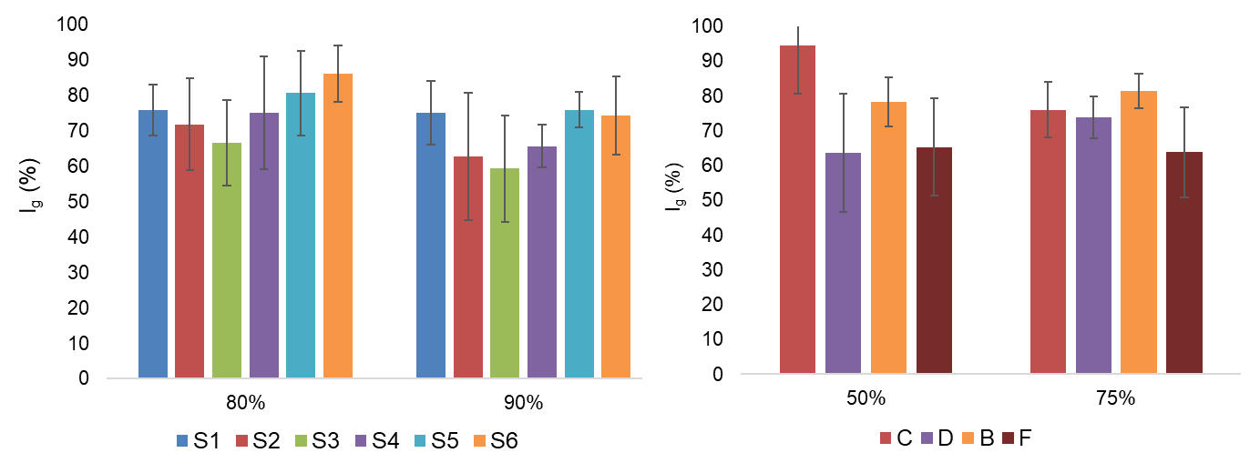
Figure SI1. Germination indexes of the organic and inorganic waste materials.

Table SI2. Agronomic characterization of the mixtures used in the plant growth tests.
Inorganic waste | Mixture | pH | Total N | Organic C | Olsen P | CEC | Exch. Mg | Exch. Mg | Exch. Ca
 |  |  | g/kg s.s. | g/kg s.s. | mg/kg s.s. | meq/100g | meq/100g | meq/100g | meq/100g
1 | S | 8.6 | 0.8 | 7.3 | 8.67 | 2.88 | 0.51 | 0.04 | 4.89
1 | S+C | 8.1 | 1.2 | 11.8 | 35.83 | 3.18 | 1.02 | 0.08 | 6.69
1 | S+D | 8.3 | 0.7 | 7.9 | 27.52 | 3.87 | 0.97 | 0.11 | 5.16
1 | S+B | 8.4 | 0.7 | 8.5 | 11.30 | 4.16 | 0.77 | 0.06 | 5.97
1 | S+F | 8.3 | 0.8 | 7.3 | 12.80 | 3.16 | 0.65 | 0.10 | 5.42
1 | S+D+C | 8.5 | 0.9 | 7.5 | 29.62 | 2.94 | 1.05 | 0.42 | 6.87
1 | S+D+B | 8.4 | 0.6 | 7.3 | 18.51 | 3.69 | 0.85 | 0.37 | 6.09
1 | S+D+F | 8.1 | 0.9 | 7.4 | 20.11 | 3.25 | 0.85 | 0.40 | 4.89
1 | S+C+B | 8.3 | 0.8 | 7.5 | 21.61 | 5.86 | 0.43 | 0.19 | 5.89
1 | S+C+F | 8.2 | 0.9 | 7.7 | 27.62 | 3.46 | 0.94 | 0.37 | 7.09
2 | S | 8.3 | 0.6 | 2.5 | 2.89 | 8.73 | 1.34 | 0.19 | 6.62
2 | S+C | 8.3 | 1.2 | 9.5 | 36.03 | 11.52 | 13.37 | 0.44 | 9.39
2 | S+D | 8.1 | 0.9 | 7.6 | 31.92 | 10.18 | 12.24 | 0.38 | 7.21
2 | S+B | 8.4 | 0.7 | 6.7 | 4.99 | 16.62 | 9.98 | 0.16 | 6.94
2 | S+F | 8.3 | 0.7 | 4.7 | 8.30 | 9.44 | 19.23 | 0.30 | 7.07
2 | S+D+C | 8.3 | 0.9 | 6.3 | 24.61 | 12.14 | 10.29 | 0.28 | 7.42
2 | S+D+B | 8.3 | 0.8 | 7.6 | 12.90 | 11.13 | 6.58 | 0.19 | 7.05
2 | S+D+F | 8.4 | 0.7 | 9.7 | 25.42 | 15.42 | 12.55 | 0.32 | 7.68
2 | S+C+B | 8.3 | 1.0 | 5.9 | 16.11 | 18.53 | 11.42 | 0.26 | 9.31
2 | S+C+F | 8.2 | 1.1 | 6.5 | 22.91 | 17.82 | 11.31 | 0.39 | 8.77
3 | S | 8.3 | 0.6 | 12.4 | 12.40 | 1.71 | 1.16 | 0.00 | 7.78
3 | S+C | 8.2 | 1.5 | 18.6 | 57.65 | 3.40 | 1.55 | 0.86 | 9.50
3 | S+D | 8.3 | 0.7 | 14.9 | 38.13 | 2.83 | 1.55 | 0.90 | 7.90
3 | S+B | 8.5 | 0.6 | 13.3 | 22.61 | 3.44 | 1.20 | 0.90 | 8.40
3 | S+F | 8.1 | 0.7 | 12.4 | 17.01 | 1.94 | 1.48 | 0.80 | 7.90
3 | S+D+C | 8.3 | 1.3 | 20.6 | 48.74 | 2.84 | 1.25 | 0.80 | 7.90
3 | S+D+B | 8.1 | 0.8 | 14.5 | 33.02 | 2.55 | 1.45 | 0.90 | 8.10
3 | S+D+F | 8.3 | 0.8 | 12.4 | 30.62 | 1.99 | 1.30 | 0.80 | 7.80
3 | S+C+B | 8.4 | 1.1 | 20.0 | 47.04 | 3.40 | 1.40 | 0.90 | 8.40
3 | S+C+F | 7.5 | 1.2 | 19.0 | 45.74 | 3.21 | 1.92 | 0.80 | 9.22
4 | S | 8.4 | 1.8 | 17.1 | 40.66 | 6.12 | 2.26 | 0.82 | 10.05
4 | S+C | 8.1 | 3.2 | 23.6 | 83.34 | 8.84 | 9.22 | 1.04 | 12.44
4 | S+D | 8.2 | 3.1 | 19.0 | 81.51 | 7.25 | 4.44 | 1.01 | 10.08
4 | S+B | 8.3 | 2.3 | 17.9 | 36.51 | 6.42 | 4.65 | 0.80 | 11.40
4 | S+F | 8.3 | 2.4 | 22.8 | 63.90 | 6.16 | 4.53 | 1.20 | 10.10
4 | S+D+C | 8.4 | 2.2 | 19.0 | 66.94 | 9.13 | 8.68 | 0.94 | 11.20
4 | S+D+B | 8.3 | 1.7 | 19.5 | 51.89 | 7.36 | 4.18 | 0.80 | 10.40
4 | S+D+F | 8.2 | 2.4 | 20.3 | 71.19 | 6.59 | 4.16 | 1.02 | 10.90
4 | S+C+B | 8.2 | 2.4 | 18.8 | 61.27 | 7.32 | 4.75 | 0.88 | 11.40
4 | S+C+F | 8.2 | 3.2 | 19.1 | 71.39 | 8.80 | 9.17 | 1.19 | 11.66
5 | S | 8.4 | 1.3 | 13.1 | 33.57 | 5.09 | 1.22 | 0.50 | 9.78
5 | S+C | 8.0 | 2.0 | 24.4 | 70.58 | 6.90 | 1.42 | 0.67 | 11.00
5 | S+D | 8.1 | 1.5 | 19.5 | 52.36 | 6.28 | 1.13 | 0.53 | 10.50
5 | S+B | 8.3 | 1.5 | 19.4 | 38.02 | 4.58 | 0.94 | 0.50 | 10.20
5 | S+F | 8.4 | 1.4 | 14.9 | 40.25 | 5.89 | 0.47 | 0.76 | 10.30
5 | S+D+C | 8.3 | 1.6 | 16.6 | 58.64 | 8.41 | 1.34 | 0.63 | 9.81
5 | S+D+B | 8.3 | 1.5 | 17.7 | 42.78 | 5.23 | 1.15 | 0.49 | 9.90
5 | S+D+F | 8.4 | 1.7 | 18.5 | 56.61 | 5.57 | 1.10 | 0.72 | 10.20
5 | S+C+B | 8.1 | 2.0 | 26.2 | 63.90 | 7.28 | 1.41 | 0.67 | 10.95
5 | S+C+F | 8.1 | 1.7 | 17.4 | 50.74 | 6.65 | 1.35 | 0.66 | 9.83
6 | S | 8.3 | 0.7 | 13.1 | 12.72 | 1.12 | 0.47 | 0.37 | 7.62
6 | S+C | 8.2 | 1.1 | 16.6 | 85.36 | 2.42 | 0.79 | 0.67 | 8.78
6 | S+D | 8.4 | 0.6 | 20.3 | 49.36 | 1.34 | 0.47 | 0.53 | 8.30
6 | S+B | 8.1 | 0.9 | 15.1 | 16.26 | 1.95 | 0.46 | 0.50 | 8.16
6 | S+F | 8.3 | 0.7 | 13.2 | 20.11 | 1.25 | 0.53 | 0.67 | 7.90
6 | S+D+C | 8.3 | 0.9 | 14.4 | 46.63 | 2.66 | 0.57 | 0.63 | 7.87
6 | S+D+B | 8.3 | 0.6 | 14.2 | 24.76 | 1.25 | 0.58 | 0.54 | 8.21
6 | S+D+F | 8.2 | 0.7 | 14.4 | 26.28 | 1.20 | 0.56 | 0.62 | 8.20
6 | S+C+B | 8.2 | 0.8 | 14.7 | 33.57 | 2.38 | 0.55 | 0.53 | 8.08
6 | S+C+F | 8.2 | 1.0 | 15.4 | 31.75 | 2.14 | 0.75 | 0.69 | 7.74

