Quantifying flight aptitude variation in wild A. gambiae s.l. in order to identify long-distance migrants

Roy Faiman^{1*}, Alpha S. Yaro², Moussa Diallo², Adama Dao², Samake Djibril², Zana L. Sanogo², Margery Sullivan¹, Asha Krishna¹, Benjamin J. Krajacich¹ and Tovi Lehmann¹
¹ Laboratory of Malaria and Vector Research, National Institute of Allergies and Infectious Diseases, The National Institutes of Health. Rockville, MD, USA
² Malaria Research and Training Center, Faculty of Medicine, Pharmacy and Odonto-Stomatology. Bamako, Mali
*Corresponding author. Email: roy.faiman@nih.gov
Supplementary information file

Flight Sound Extraction
Flight bouts were identified visually in spectrogram view (Fig. S1a) on Audacity (https://www.audacityteam.org/) or Raven Pro 1.4 software (http://ravensoundsoftware.com/raven-downloads/), and questionable flights were confirmed by listening for flight sound directly on the sound file.
Figure S1. Spectrogram view.

Figure S2. Flight Aptitude Indices relationships
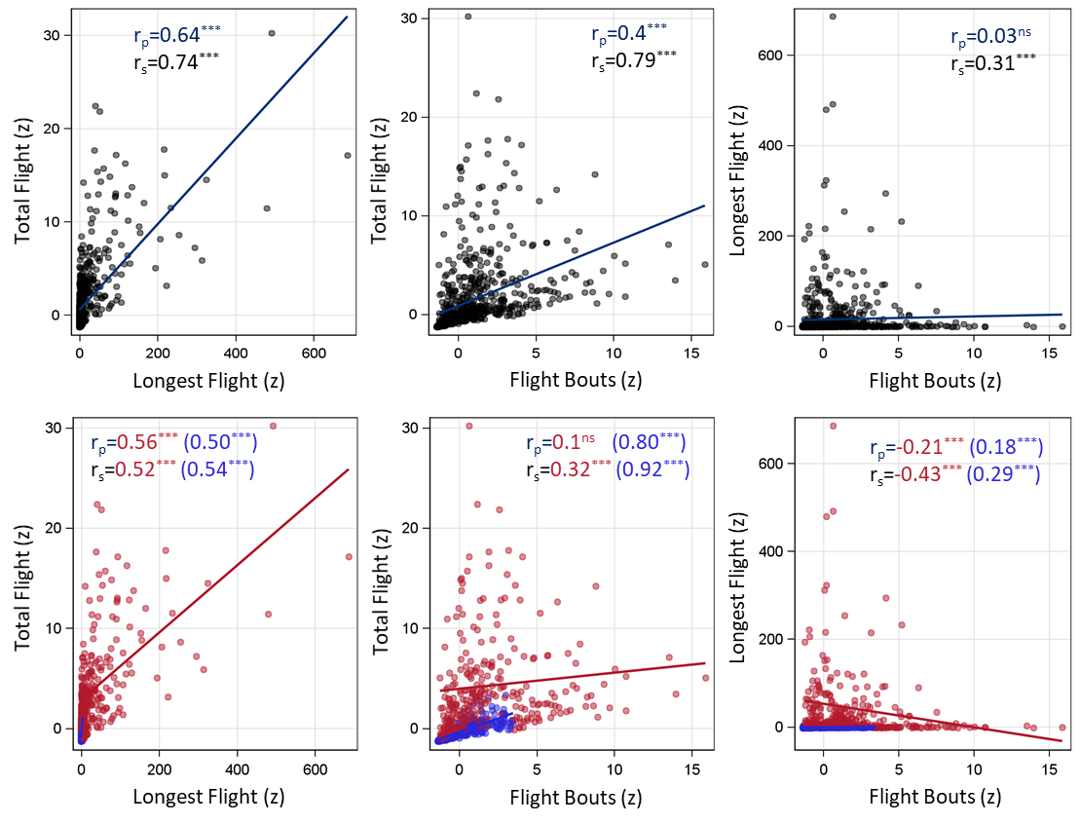

Wing size and Flight Aptitude
Wing length was putatively selected between the two points on the wing best representing its longest aspect (points 1 and 10). The wing width on the other hand, has no agreed upon set landmarks, and no two set points on the wing represent its width loyally. To overcome this, we selected several pairs of points on the wing, representing the proximal, medial and distal sections, and providing different distances. Assessing the degree of correlation between the three widths we eventually selected the mean of the three as the wing width.

Figure S3. Wing length in Anopheles coluzzii by time of year (season).

Table S1. Results summary table for the three flight aptitude indices: total flight, longest flight and flight bouts per test groups (top section). Shared high flight activity (HFA) frequency in the three flight aptitude indices (bottom section).
Group tests | Total Flight | Longest Flight | Flight Bouts
Season ª | * | ** | reverse trend
Species ^{b} | * | similar trend | similar trend
Gonotrophic state ^{c} | similar trend | similar trend | *
Wing morphology (A. coluzzii, wet season)
Wing length | ** | * | reverse trend
Wing width | ** | * | reverse trend
Allometry | * | reverse trend | reverse trend
HFA Shared Frequency (%) ^{d}
Total Flight | 100 | - | -
Longest Flight | 90.3 | 100 | -
Flight Bouts | 23.9 | 10.5 | 100
HFA Overall Frequency (%) ^{e} | 16.0 | 29.7 | 10.0
* significance of P<0.05, ** significance of P<0.001 ªOct-Nov > Aug-Sep = Jul = Dec-Feb > Mar-Apr ^{b}A. coluzzii > A. gambiae > A. arabiensis ^{c}Gravid > Unfed ^{d} Frequency of HFA mosquitoes in two FA indices ^{e} Total frequency of HFAs per FA index

