Supplementary Information
Remarkable piezoelectric properties in thin films of cellulose nanofibers after electrochemical poling
Ayesha Sultana^{1,2}, Md. Mehebub Alam^{1,2}, Eleni Pavlopoulou³, Eduardo Solano⁴, Magnus Berggren^{1,2}, Xavier Crispin^{1,2}*, Dan Zhao^{1,2}*
¹ Laboratory of Organic Electronics, Department of Science and Technology, Linköping University, SE-601 74 Norrköping, Sweden
² Wallenberg Wood Science Center, Linköping University, SE-601 74 Norrköping, Sweden
³ Univ. Bordeaux, CNRS, Bordeaux INP, LCPO, UMR 5629, F-33600 Pessac, France.
⁴ NCD-SWEET beamline of ALBA synchrotron in Barcelona, Spain,

E-mail: xavier.crispin@liu.se, dan.zhao@liu.se

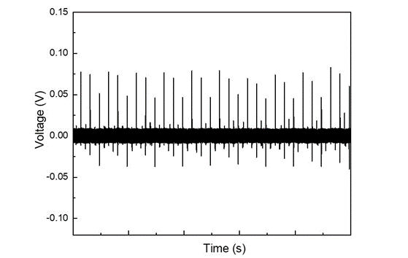
Supplementary Fig. 1: The piezoelectric response of the same poled CNF thin film in Fig. 1 after two weeks, the applied force is kept the same (24N, 3Hz). The asymmetry in the output voltage is probably due to difference of strain rate during press and release process, which was also observed in previous piezoelectric studies [1,2].

Supplementary Table 1. Table of the highest response and the corresponding poling voltage and thickness of CNF thin films poled in room humidity (40% RH). The large distribution of the poling voltage for reaching maximum piezoelectric voltage is due to the non-uniformity of the CNF thin films. The thickness of each film is measured at 6 different locations and the average value is presented.
Thickness (μm) | Maximum output voltage (V) | Poling Voltage (V)
0.93 | 0.08 | 90
1.213 | 0.06 | 40
1.05 | 0.2 | 40
1.21 | 0.22 | 70
0.873 | 0.19 | 20
1.1 | 0.16 | 40

Supplementary Note 1. IV characteristics of P(VDF-TrFE)
The P(VDF-TrFE) film with the thickness of 550 nm was spin-coated on an ITO coated glass, and an Au electrode was deposited on top of the film as the other electrode. As shown in supplementary Fig. 2, when scanning from -40V to 40 V, the polarization switching of ferroelectric P(VDF-TrFE) film (550 nm) results in the two current peaks in the corresponding direction.
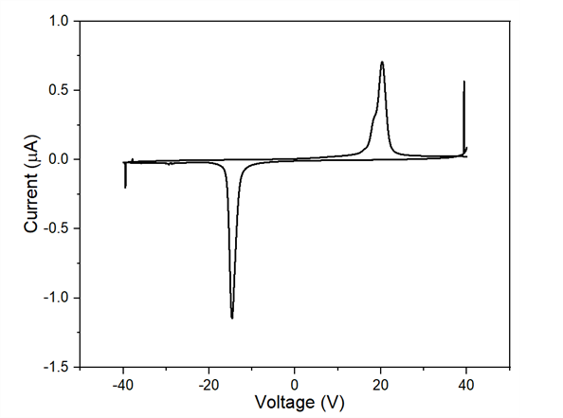
Supplementary Fig. 2: The IV characteristic curve of electric poling of P(VDF-TrFE) film.

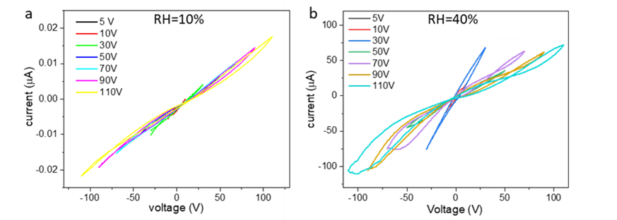
Supplementary Fig. 3: The IV curve of CNF thin films scanned with increasing voltage at (a) low humidity (RH=10%) and (b) room humidity (RH=40%).
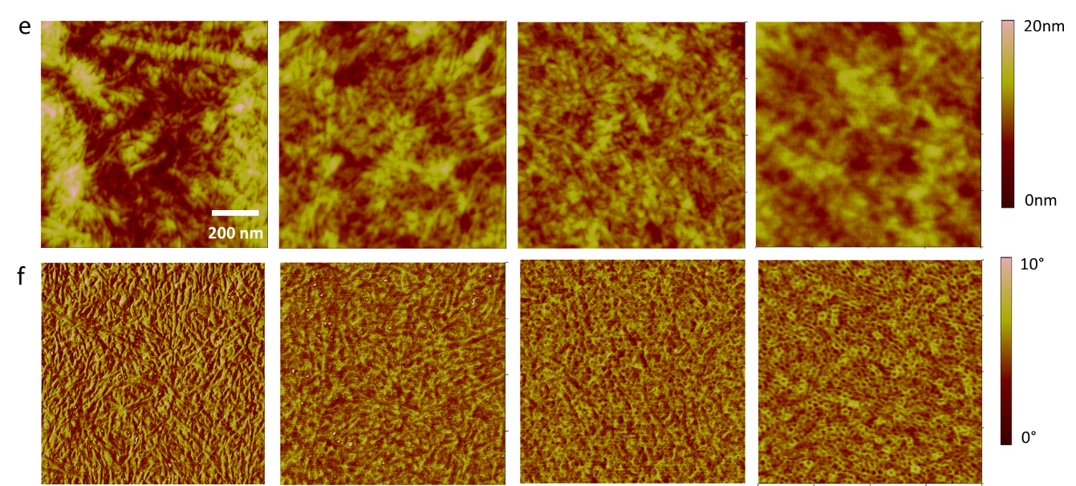
Supplementary Fig. 4: The morphology (a) and phase (b) images of different regions of the CNF film after poling at 40% RH.

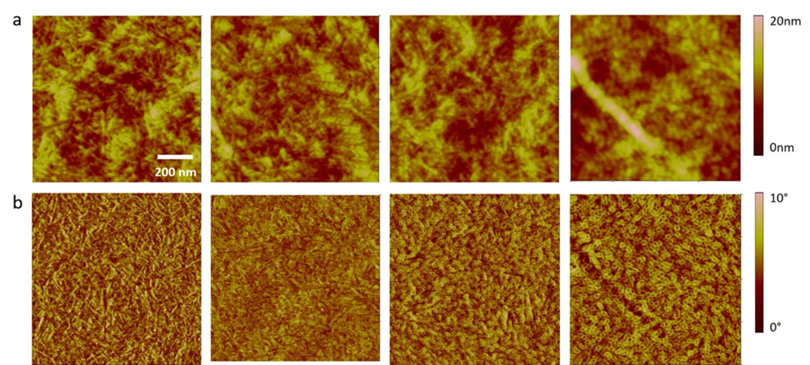Supplementary Fig. 5: The morphology (a) and phase (b) images of different regions of the CNF film after poling at 70% RH.

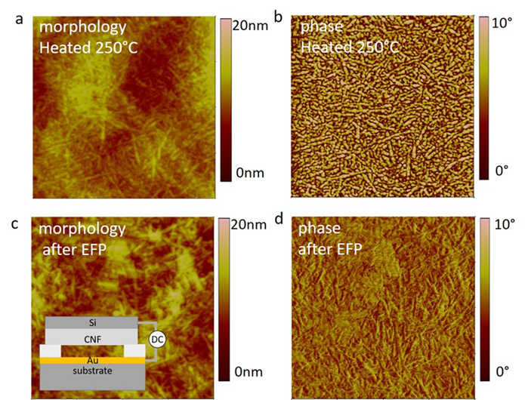
Supplementary Fig. 6: Nanoscale morphology (a) and phase (b) images after heating at 250°C. Nanoscale morphology (c) and phase (d) images after electric field poling. Through this air gap as shown in the inset in Fig. 6c, we could reproduce similar electric field intensities (~1×10⁶ V cm⁻¹) as in the electrochemical poling process.

Supplementary Note 2. Dielectric characterization for CNF film
Impedance spectroscopy is used to understand the changes induced by the electrochemical poling on the dielectric and ionic relaxation phenomena taking place in the CNF thin film. As the poling induces a morphology changes at the interface visuralized by AFM, it is expected that the ionic transport, interfacial electrochemistry, electric double layers are affected too. In the unpoled CNF thin film sample (Supplementary Fig. 7, black curve), we find the various dynamic phenonema that typically observed in electrolytes: the dielectric relaxation at high frequencies (2×10⁵- 2×10⁴ Hz) where the phase angle φ is close to -90° (capacitive character of the impedance); the ionic transport at intermediate frequency range (10⁴ -1 Hz) where φ is close to 0° (resistive character of the impedance); the electric double layer capacitor formation at the electrode-electrolyte interface at low frequencies (1- 10⁻¹ Hz) where φ is back to -90°. After poling (gray curves in Supplementary Fig. 7), we can recognize features such as the dielectric relaxation character (φ close to -90°) at high frequency ~10⁵ Hz, and the ionic relaxation (φ close to 0°) at 10³-10⁴ Hz frequency. However, at frequencies lower than 10³ Hz, the spectra look totally different. One could think that both the change of water content as well as the morphology changes found by AFM could play a role. However, the impedance spectrum does not change greatly 15 hours after poling (well above 7.5 minutes that is necessary to reabsorb all the water as revealed in Fig. 2d) compared to right after poling (Supplementary Fig. 7, red curve). This means that the poling truly leads to an irreversible change of the dielectric properties. It is attributed to the morphology changes observed with the AFM and possibly the formation of a solid electrolyte interphase (SEI) layer, typically formed in metal batteries at the threshold of stability of the electrolyte [3].
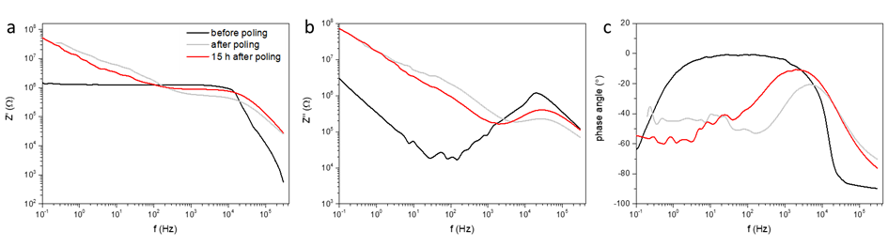
Supplementary Fig. 7: The impedance spectroscopy of CNF film before poling, right after poling and 15 hours after poling. (a) The real part of the impedance. (b) The imaginary part of the impedance and (c) the phase angle.

For each humidity level, we proceeded with a series of measurement made as followed: first poling at a fixed voltage for 30s during which water can be partially consumed, followed by impedance spectroscopy measurement (note that each measurement takes 5 minutes to sweep from high to low frequency, during which some water could partially reabsorb). For the sample poled at low humidity (10% RH), the phase angle and capacitance do not change dramatically for samples poled below 70 V (Supplementary Fig. 8a and 8b) as there is no electrolysis going on upon poling (as indicated by the low current and the absence of threshold in Fig. 2a and Supplementary Fig. 8a). This agrees with the AFM results that did not reveal changes in the morphology. Note however that an electric double layer capacitor is formed at the electrode-cellulose interface as the capacitance rises and reaches 10² nF at low frequency 0.1 Hz (φ close to -90°). This ionic reorganization at the interface is attributed to the motion of mobile cations (Na⁺) present in the film through the carboxylate groups on the surface of cellulose nanofibers (degree of substitution is 0.1). In 40% RH (Supplementary Fig. 8c and 8d), the water contained inside the CNF film results to significant electrochemical poling current (Fig. 2b) correlated to the morphology changes visible with AFM images. From samples poled with 30 V and above, the spectra of the phase angle of the impedance and the capacitance look different as a new relaxation phenomenon kicks in at 10² Hz (Supplementary Fig. 8d). The decrease of capacitance at low frequencies (Supplementary Fig. 8c) suggests that a less conducting layer could form close to the metal surface. Note that this modified dielectric response occurs exactly at the poling voltage (around 30V) at which the piezoelectric voltage starts to increase in Fig. 1c.
Since the capacitance of the device has an impact on V_{piezo}, it is important to evaluate the capacitance change after electrochemical poling of the CNF films. From the impedance spectroscopy of the CNF film poled with different voltage (RH=40%, Supplementary Fig. 8c and 8d), we are only interested at the high frequency response (10⁵- 10⁶ Hz) which is due to the material’s dielectric relaxation. The capacitive response at low and intermediate frequencies is not relevant to the piezoelectric response because that is related to the formation of electric double layer and ionic transport.
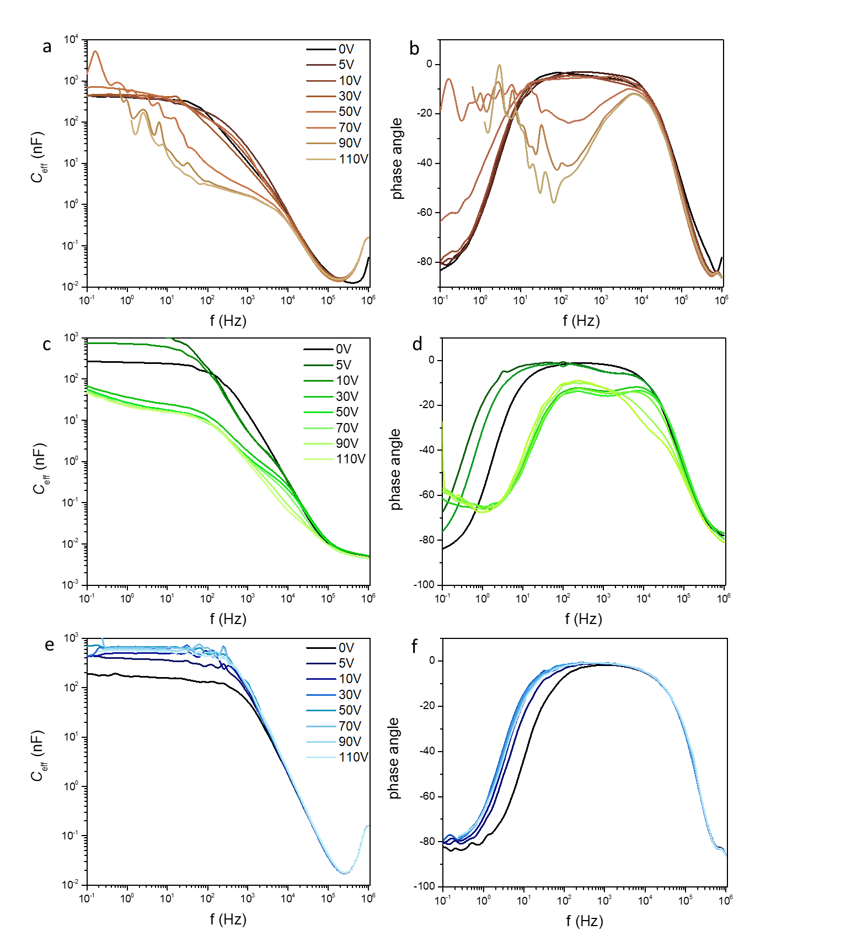
Supplementary Fig. 8: The impedance characterization of CNF films poled at different humidity levels. Capacitance and phase angle of the same sample poled with different voltage at relative humidity level of a) 10%, b) 40% and c) 70%.

For samples poled at high humidity (RH=70%), the capacitance increases and phase angle shifts towards low frequency (Supplementary Fig. 8e and 8f). These modifications do not change back even at high poling voltage because the reabsorption of water in such high humidity atmosphere is fast. Because of that, we see less effect on the impedance spectrum, however the presence of water enables an electrochemical current leading to the morphology changes seen by AFM as well as the piezoelectric voltage enhancement.
The Nyquist plot for CNF film poled with increasing voltage from 5 to 110 V at room humidity (RH=40%) is shown in Supplementary Fig. 9a. The Nyquist plot for the non-poled CNF films is composed of one semicircle in the high frequency region representing the ionic conduction in the bulk, and a vertical spike at low frequency originating from the formation of an electric double layer capacitance at the surface of the electrodes due to mobile ions in the film [4]. After poling with 5 V and 10 V, a small second semicircle appears, and the size of the first semicircle decreases. The splitting of the semicircle has been reported to be related to the formation of grain borders in the bulk of the material [5]. The change of both semicircles become more pronounced and the impedance of the film increase (the diameter sum of both semicircles) with higher poling voltage from 30 V to 110 V. This could be explained by the gradually consumption of water during electrochemical poling of the CNF films. The Nyquist plot of the same CNF thin film kept at different humidity is shown in Supplementary Fig. 9b. We notice that the diameter of the semicircle reduces with increasing humidity, which is a sign of decreasing of bulk resistance. This is because the absorbed water at high humidity environment facilitates the ion transport in CNF films [6]. However, the absence of the second semicircle shows that electric poling indeed induces more structural changes in CNF films than changing the water contents.

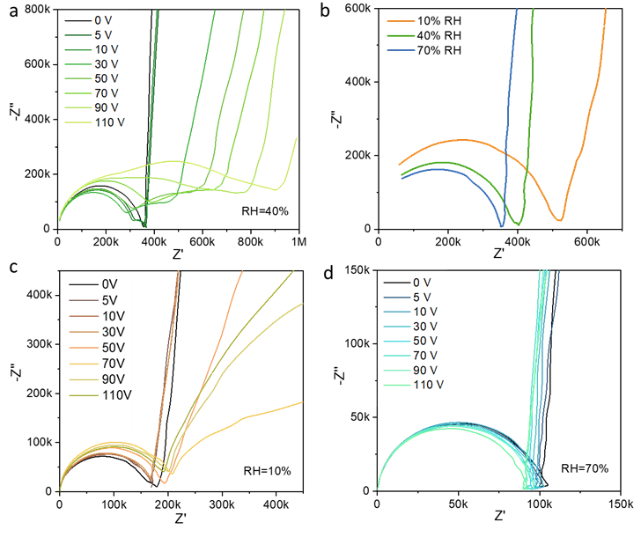
Supplementary Fig. 9: The Nyquist plot of CNF thin film before and after poling with different poling voltage at different humidity level. (a) CNF films poled with different voltage at room humidity (RH=40%). (b) Non-poled CNF films at different humidity. (c) CNF films poled at low (RH=10%) and (d) high humidity (RH=70%).

To evaluate the role of the absorbed water in the electric poling of the CNF films, the same impedance characterizations of CNF films poled with increasing voltage are carried out at two different humidity (RH=10% and 70%). As shown in Supplementary Fig. 9c, the semicircle does not split into two for the completely poling voltage range at low humidity (RH=10%), only the diameter increases with poling voltage, and the slope of the spikes changes. This is due to the insufficient water in the CNF film, and no obvious change can be induced by the limited current during electrochemical poling. Opposite changes were obverse for sample poled at high humidity (RH=70%), the semicircle does not split but experiences a decreasing diameter, while the spikes remain almost unchanged (Supplementary Fig. 9d). We believe this is related to the fast regaining of water during the poling process in high humidity level. The different changes in impedance after poling at different humidity level show that the amount of water plays important role in the structural change of CNF films upon electric poling. Note that the current passing through the CNF film at room humidity (40%) is 4 times larger than that at low humidity (10%) level for the same poling voltage (as shown in Fig. 2, while the impedance in Supplementary Fig. 9b only showing 1.3 times of improved conductivity. This further confirmed that the current during electric poling in room humidity is from electrolysis of water.
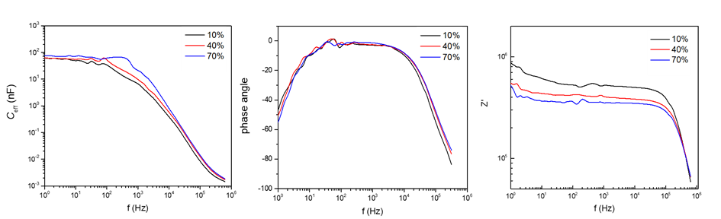
Supplementary Fig. 10: Capacitance, phase angle and impedance of the same sample at different humidity (10%, 40% and 70% RH).

Supplementary Note 3. Spin coated CNF film
To further prove the main contribution is the structure change rather than water content, we prepared control sample of spin-coated CNF films. As shown in Supplementary Fig. 11a and 11b, the mophology of the spin-coated films of the same cellulose content is much flatter compare to the drop-casted ones. The straightly streched fibers could avoid reorientation during electric poling, while the water was still be removed during the poling process (proved by the capacitance at low frequency range in Supplementary Fig. 11c and 11d). However, no improvement of the pizoelectricity was observed (Supplementary Fig. 11e and 11f), which shows that only removing water cannot ehnhance the pizoelectric output votlage of the CNF films. The results of piezoelectric response of films poled at different humidity proved that the enhance piezoelectricity is due to the structure change of the cellulose fibers induced by electrochemical poling.
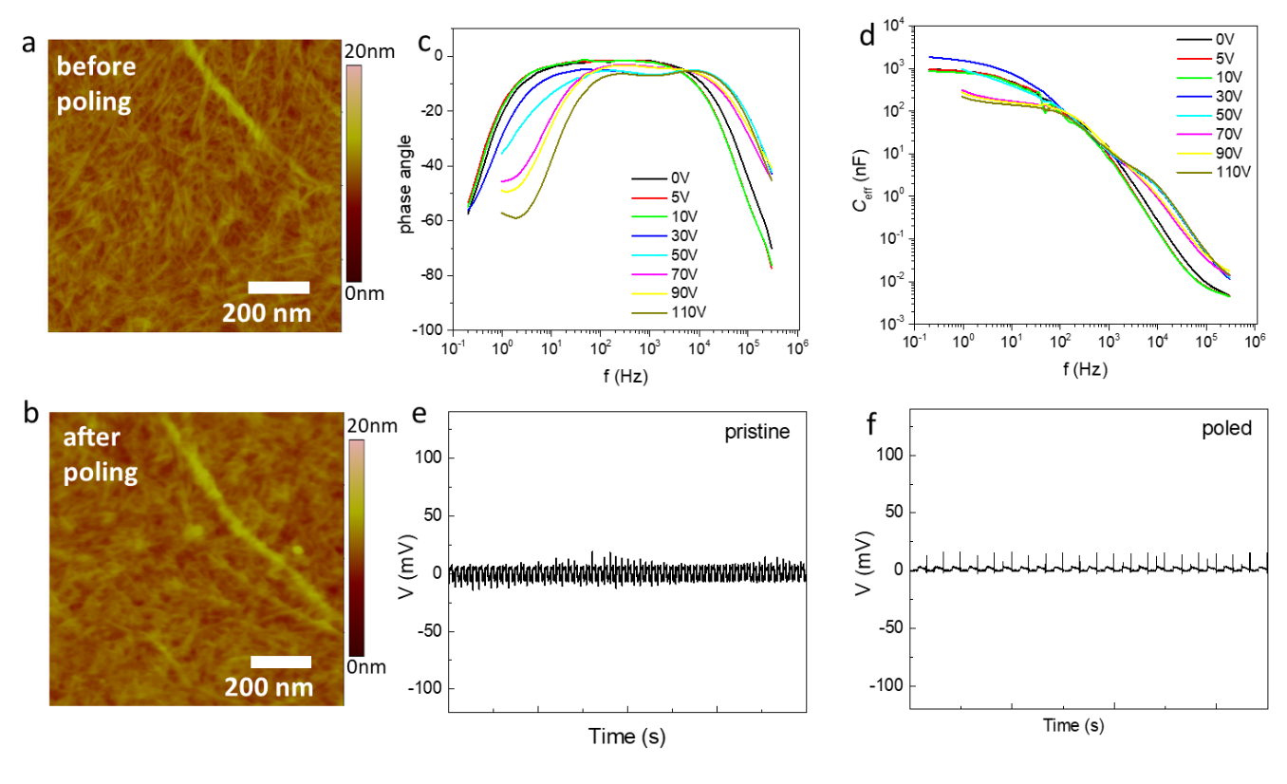
Supplementary Fig. 11: (a) and (b) Morphology of spin coated CNF film on Si substrate before and after poling. c) The phase angle and d) capacitance of the same CNF film poled with increasing voltage from 5V to 110V. Piezoelectric response from (e) pristine and (f) poled spin coated CNF film.

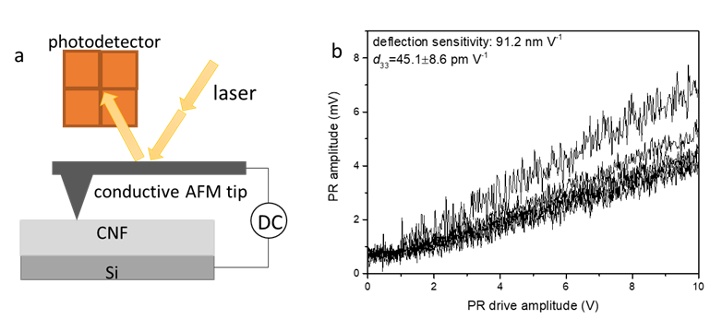
Supplementary Fig. 12: (a) Illustration sketch of PFM. (b) The PFM characterization of P(VDF-TrFE) thin film.

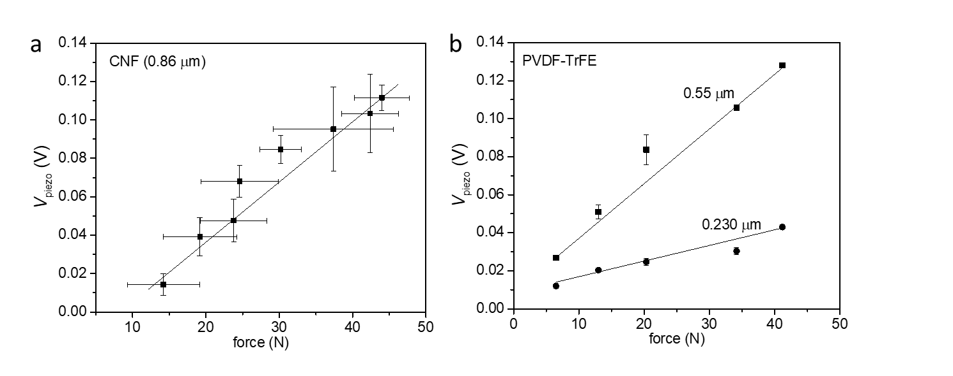
Supplementary Fig. 13: The piezoelectric output voltage with different applied force for (a) Poled CNF thin film (b) poled P(VDF-TrFE) thin films. The error bar in (a) and (b) is from 5 measurements of the same sample. The force was controlled through applying different amplitude to the shaker and measured by a force sensor synchronically together with the piezoelectric output voltage. The correlation between the amplitude and measured force in frequency of 3 Hz is shown in Supplementary Fig. 14.

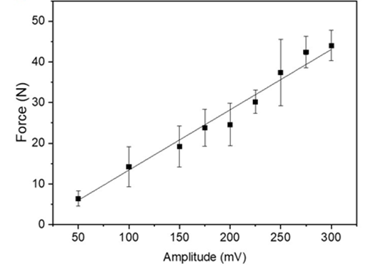
Supplementary Fig. 14: The measured force when different amplitude was applied to the shaker with frequency of 3 Hz.

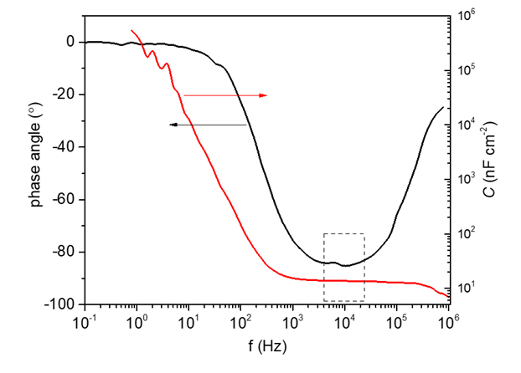
Supplementary Fig. 15: The frequency dependent phase angle and area capacitance of P(VDF-TrFE) film with the thickness of 550 nm.

Supplementary Note 4. The attempt of calculation of the d₃₃ of CNF thin films from impedance.
From Supplementary Fig. 8c, we can get the area capacitance of the CNF thin films is 0.016 nF cm⁻², which is far smaller than the value of P(VDF-TrFE) thin films (Supplementary Fig. 15). If we use the measured capacitance value to calculate the d₃₃ of CNF using:
$$V_{piezo}=\frac{d_{33}F}{C}$$
We obtain d₃₃ of 0.042 pC/N for CNF (thickness of 860 nm) after poling and 0.004 pC/N before poling. However, if we use the experimentally measured capacitance of CNF to calculate the relative dielectric constant (ε_{r}) from:
$$C=ε_{0}ε_{r}\frac{A}{d}$$
A surprisingly small dielectric constant of 0.016 was obtained, which is impossible. We believe the unexpected small capacitance of the CNF thin films measured from impedance is due to the uneven morphology. As illustrated in Supplementary Fig. 16a, during the impedance measurement, the small current can only pass through the thin area of the CNF films and lead to a dramatically decrease of the effective measured area. When a force is applied to the CNF film, the charge generated from piezoelectric effect distribute over the whole electrode (illustrated in Supplementary Fig. 16b). Hence, due to the mismatching of the effective area, it is not reasonable to use the measured capacitance to calculate the d₃₃ of the CNF thin films.
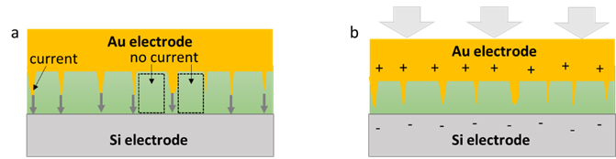
Supplementary Fig. 16 The illustration of the impact of morphology to the impedance measurement (a) and piezoelectric characterization (b) of CNF thin films.

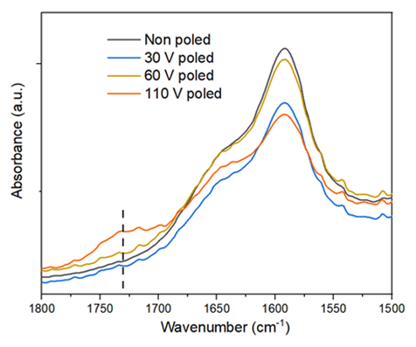
Supplementary Fig. 17: The increasing peak at 1730 cm⁻¹ of CNF poled at increasing voltage.

Supplementary Note 5. Grazing incidence small angle x-ray characterization of CNF thin films before and after poling
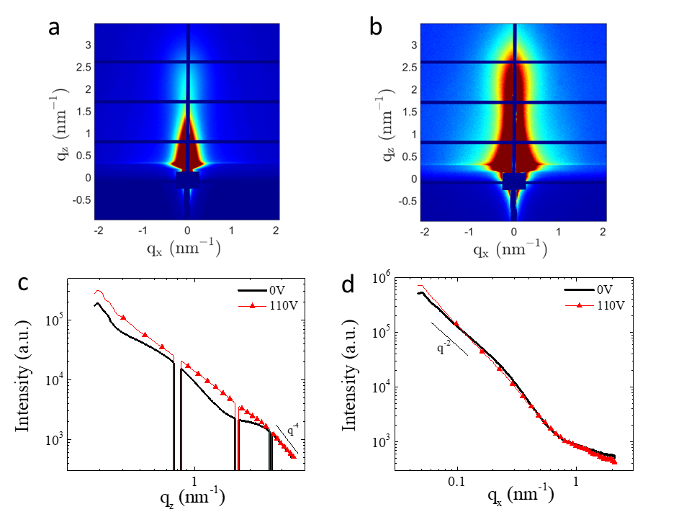
Supplementary Fig. 18: GISAXS characterization of CNF thin films before and after electrochemical poling. GISAXS images of a) a non-poled CNF solution-cast film and, b) a film poled at 110V. The corresponding c) out-of-plane and d) in-plane intensity linecuts were taken at q_{x} = 0.08 nm⁻¹ and q_{z} = 0.30 nm⁻¹. In c) and d) data are presented shifted along the y-axis in order to allow easier comparison of the scattering curves.
Grazing incidence small angle x-ray scattering (GISAXS) experiments were performed on several CNF solution cast films, before and after poling. The results observed on 6 non-poled and 6 poled film at 110 V clearly supports that poling does result in structural changes in these films, in the nm-scale. Representative data are presented in Supplementary Fig. 19. The shape of the scattering rod along the out-of-plane direction (q_{z}) changes considerably upon poling and the distribution of the scattered intensity alters, resulting in a more elongated rod (Supplementary Fig. 18a and 18b). The redistribution of the scattered intensity is also witnessed by the out-of-plane linecuts (Supplementary Fig. 18c). Note that the intensity redistribution concerns only the out-of-plane direction and not the in-plane one (Intensity versus q_{x}, Supplementary Fig. 18d). This suggests that structural changes take place only along the thickness direction. No scattering features appear in the in-plane linecuts. The q⁻² slope of the scattered intensity below 0.3 nm⁻¹ could be associated to the scattering from the flat interfaces formed by fibers that lie parallel to the substrate. The scattering feature changes observed in the q_{z} and q_{x} linecuts, in conjunction with the information derived by AFM, support the hypothesis of a re-orientation of lying-down fibers, with respect to the substrate, towards standing-up fibers upon poling. Because the piezoelectric coefficient along the nanofibers/nanocrystals is larger than the piezoelectric coefficient perpendicular to the direction of the fibers [7,8], the orientation of the nanofibers/nanocrystals perpendicular to the electrode upon electrochemical poling promotes high effective d₃₃ coefficient responsible of the high piezoelectric voltage observed in the cellulose films. Another way to see that is that the morphology change induced a non-centrosymmetric structure in the CNF film. Alignment of polymer chain that breaks center of symmetry inside biopolymer structure has previously been reported to enhance the piezoelectric performance of the materials [9].

References
1. Sultana, A. et al. An effective electrical throughput from PANI supplement ZnS nanorods and PDMS-based flexible piezoelectric nanogenerator for power up portable electronic devices: an alternative of MWCNT filler. ACS Appl. Mater. Interfaces 7, 19091−19097 (2015).
2. Roy, K. et al. A self-powered wearable pressure sensor and pyroelectric breathing sensor based on GO interfaced PVDF nanofibers. ACS Appl. Nano Mater. 2, 2013−2025 (2019).
3. Pinson, M. B. & Bazant, M. Z. Theory of SEI formation in rechargeable batteries: capacity fade, accelerated aging and lifetime prediction. J. Electrochem. Soc. 160, A243– A250 (2013).
4. Pradhan, D. K., Choudhary, R. N. P., Samantaray, B. K. Studies of structural, thermal and electrical behavior of polymer nanocomposite electrolytes. EXPRESS Polym. Lett. 2, 630–638 (2008).
5. Tschöpe, A., Kilassonia, S. & Birringer, R. The grain boundary effect in heavily doped cerium oxide. Solid State Ion. 173, 57–61 (2004).
6. F. Jiao, A. Naderi, D. Zhao, J. Schlueter, M. Shahi, J. Sundström, H. Granberg, J. Edberg, U. Ail, J. Brill, T. Lindström, M. Berggren, X. Crispin, J. Mater. Chem. A, 2017, 5, 16883–16888.
7.Wang, J. et al. Piezoelectric nanocellulose thin film with large-scale vertical crystal alignment. ACS Appl. Mater. Interfaces 12, 26399−26404 (2020).
8. Frka-Petesic, B., Jean, B. & Heux, L. First experimental evidence of a giant permanent electric-dipole moment in cellulose nanocrystals. EPL Europhysics Lett. 107, 28006 (2014).
9. Smith, M. & Narayan, S. K. Piezoelectric polymers: theory, challenges and opportunities, Int. Mater. Rev. 2021, DOI: 10.1080/09506608.2021.1915935.

