Extended Data
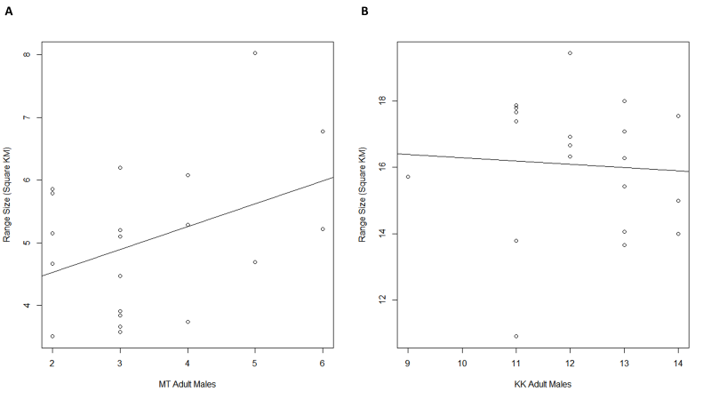
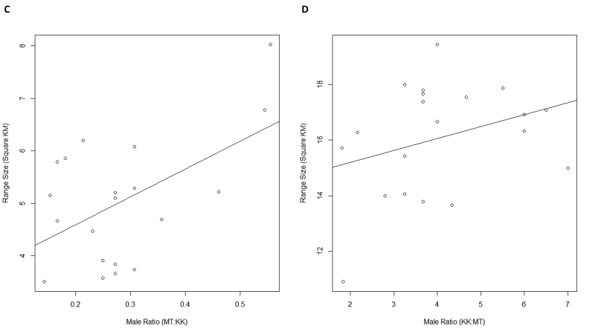
Figure S1 Relationship between adult males and annual range size. Range size did not correlate with raw number of males ≥12 years old in (A) Mitumba (Pearson correlation; t=1.8, df=18, n=20, p=0.09) or (B) Kasekela (Pearson correlation, t=-0.27, df=18, n=20, p=0.79). Home range size depended on the ratio of the number males with the rival community for (C) Mitumba (Pearson correlation; t=2.6, df=18, n=20, p=0.02) but not (D) Kasekela (t=1.42, df=18, n=20, p=0.17).
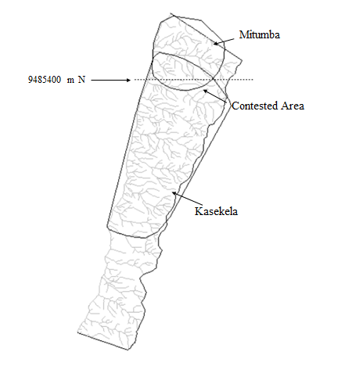
Figure S2. Contested Area shared by Mitumba and Kasekela. Range estimates are 99% minimum convex polygons created from location data of focal individuals taken at 15-minute intervals (1997-2016). Contested area is defined here as overlap between these two polygons. Latitude 9485400 m, an approximation of the boundary between the community ranges, is marked with a dotted line.
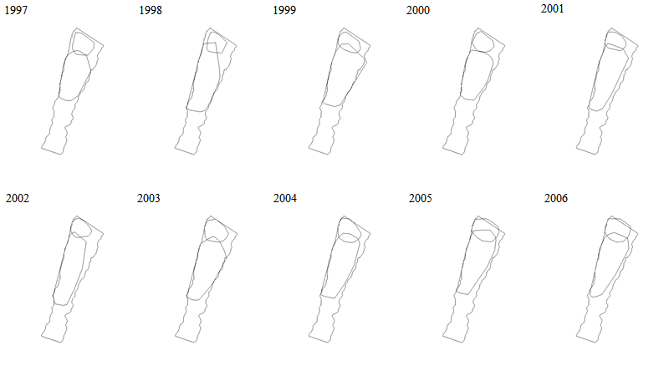
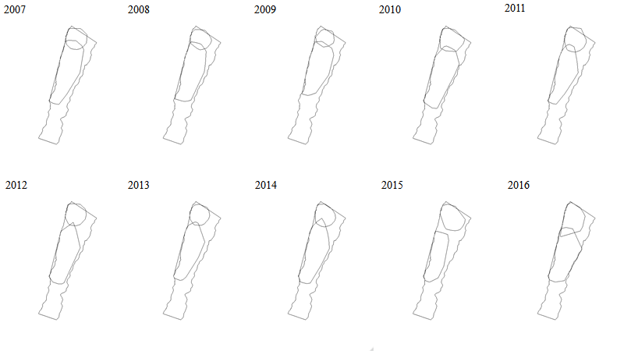
Figure S3. Home Range Estimates. Home Range estimates created using 99% minimum convex polygons between 1997-2016 for Gombe’s Kasekela and Mitumba communities. Location entries were collected at 15-minute intervals during focal follows.
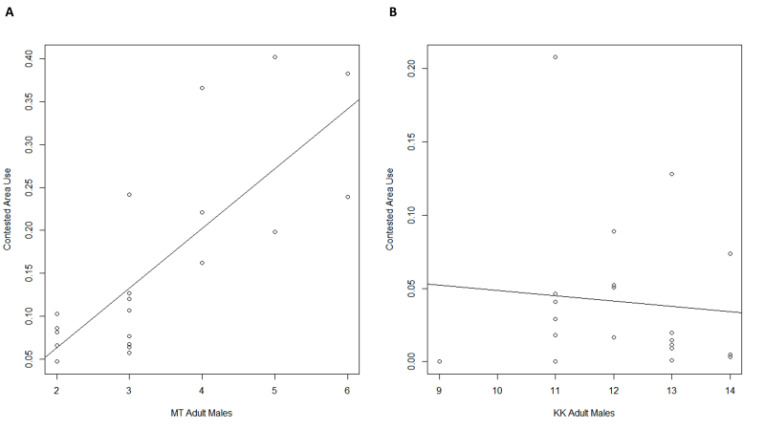
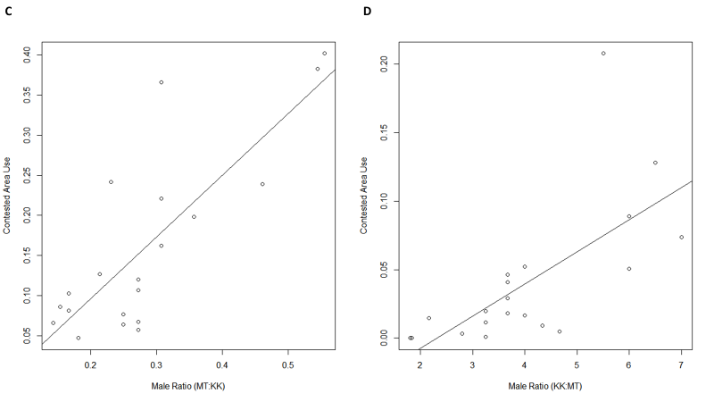
Figure S4 Relationship between adult males and contested area use, measured by the percent of location points located within contested area (the area of overlap in range used by each community over the study period, using 99% minimum convex polygons). (A) Mitumba chimpanzees spent a larger percentage of their time each year in the contested area when they had more males (Pearson correlation, t=5.3, df=18, n=20, p<0.01), however, (B) Kasekela did not follow this pattern (Pearson correlation, t=-0.4, df=18, n=20, p=0.70). Both (C) Mitumba and (D) Kasekela used the contested area more in years when they had a higher ratio of males in their community to males in the neighboring community (Pearson correlation; Mitumba, t=5.7, df=18, n=20, p<0.01; Kasekela, t=3.9, df=18, n=20, p<0.01).

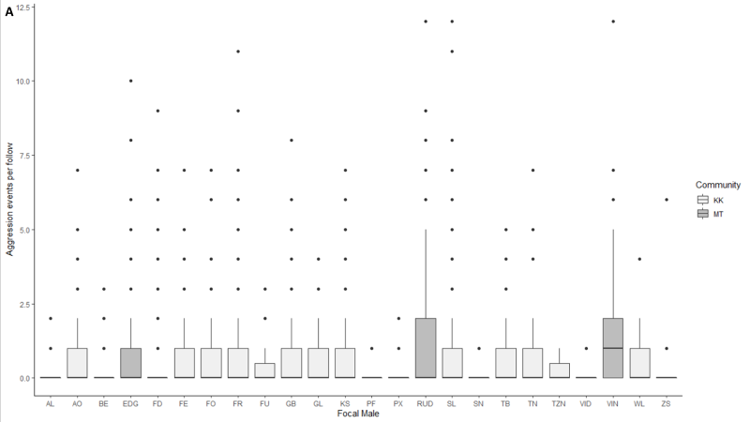
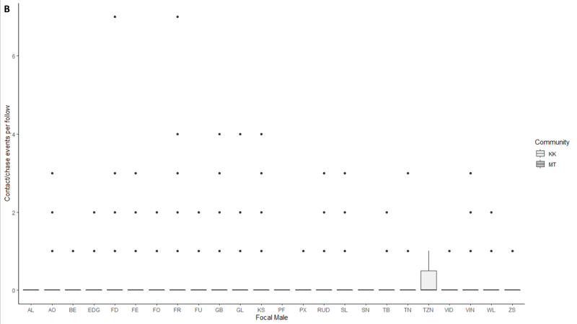
Figure S5. Rates of aggression during focal observations of male chimpanzees in Mitumba (2000-2008) and Kasekela (1997-2011). Boxes represent the distribution of aggression events documented during focal observation for males in the Mitumba (dark grey) and Kasekela (light gray) communities. Box and whisker plots represent 1st quartile, median, and third quartile values. (A) Kasekela and Mitumba males did not differ in their rate of aggression (mixed Poisson regression, β=0.64, z=1.43, p=0.152). (B) Kasekela and Mitumba males did not differ in their rate of aggression when considering only instances of higher-cost aggression involving chasing and/or physical contact (mixed Poisson regression, β=-0.30, z=-0.90, p=0.37)

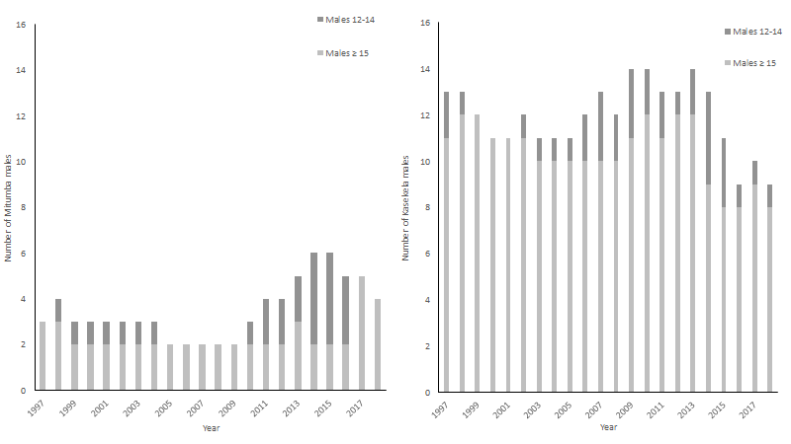
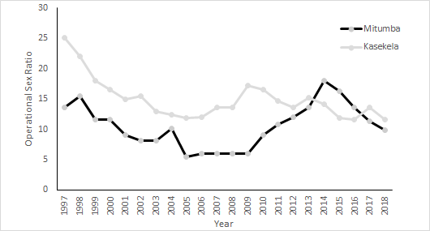
Figure S6. Mitumba and Kasekela Demographics (1994–2018). (Above) Kasekela consistently had more adult males (≥ 12 years old) than Mitumba (t-test, t = 21.6, n = 25 years, df = 47.6, p = 2.2*10⁻¹⁶). (Below) Mitumba had a less male-biased operational sex ratio (1997-2018; Mitumba mean=10.52; Kasekela mean=14.92; t-test, t=4.18, df=41.9, n_{KK}=n_{MT}=22, p<0.01).

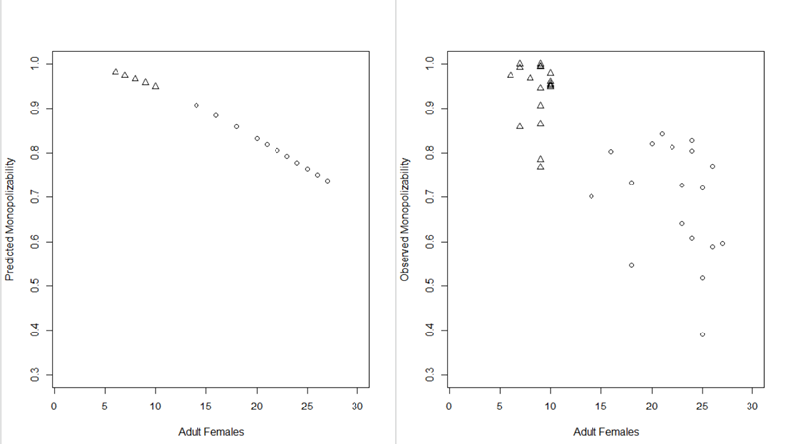
Figure S7. Predicted (left) and observed (right) monopolizability of females. Communities with more females feature less monopolizable mating opportunities. Annual values from 1997-2014 are presented for Mitumba (triangles) and Kasekela (circles). Predicted values are calculated following Nunn¹¹. Observed values are based on observations of maximal swellings. Monopolizability represents the proportion of days that either 0 or 1 female has a full sexual swelling.

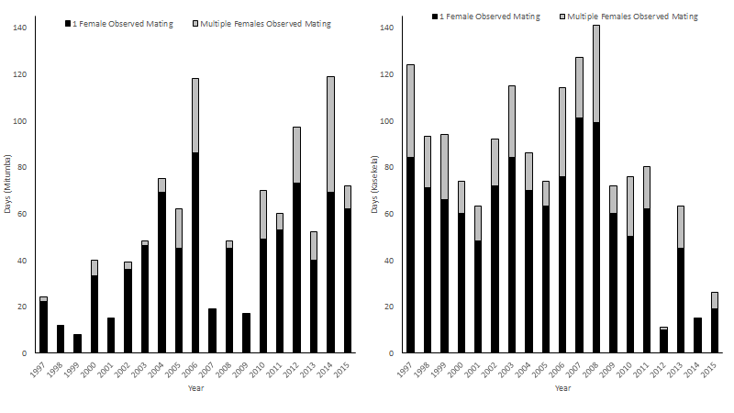
Figure S8. Distribution of the number of females observed mating on days of observation at Gombe communities. Clustered bar plots indicate the percent of days where females were observed mating that different numbers of females were mating concurrently for Mitumba (left) and Kasekela (right). Mitumba had a greater proportion days with only one female observed mating (𝛸²=23.59, df=1, p<0.01).

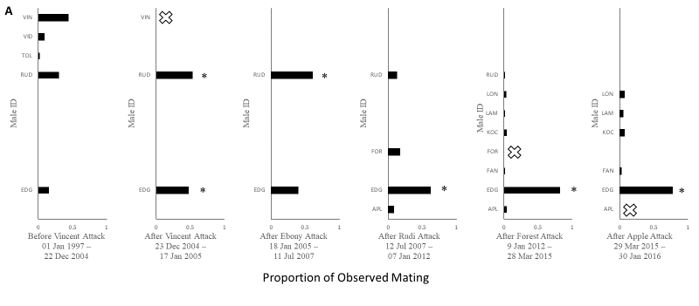
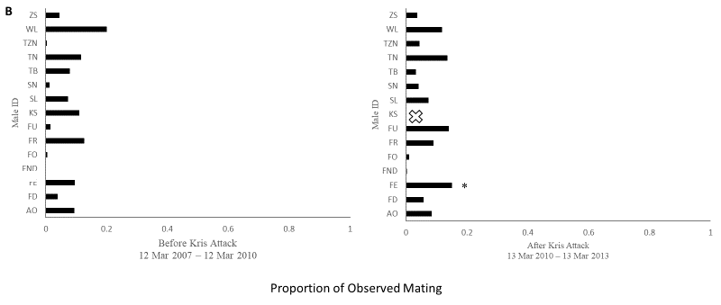
Figure S9. Observed mating of (A) Mitumba and (B) Kasekela males between instances of severe within-community attacks on males. Exes mark males killed following within-community attacks. Observer and suspected attackers are marked with asterisks. Attackers in both communities increased mating success after eliminating competitors.

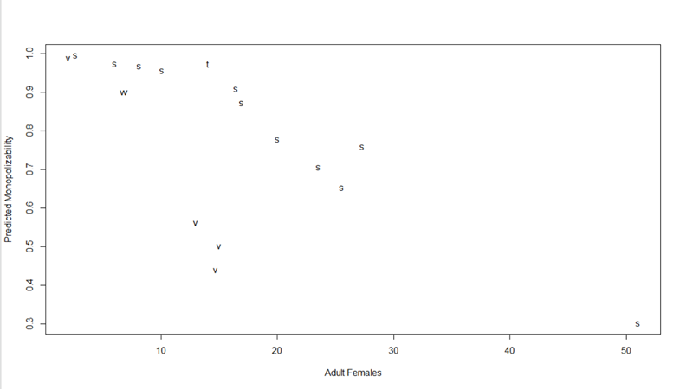
Figure S10. Relationship between predicted monopolizability and adult females. Predicted monopolizability calculated following Nunn¹¹ by average number of females ≥ 12 years old (data from Wilson et al.⁸). Subspecies are indicated by letter; s represents Eastern chimpanzees (Pan troglodytes schweinfurthii), v represents Western chimpanzees (Pan troglodytes verus), and t represents (Pan troglodytes troglodytes).

Supplementary Tables
Table S1. Attacks of weaned males at Gombe National Park inferred to result in death (1997-2018).
Individual | Date | Community | Evidence | Inferred/ObservedAttackers
Vincent | 22 Dec 2004 | Mitumba | Observed | Edgar, Rudi
Ebony | 17 Jan 2005 | Mitumba | Inferred | Rudi
Kris | 12 Mar 2010 | Kasekela | Inferred | Ferdinand
Forest | 07 Jan 2012 | Mitumba | Inferred | Edgar
Apple | 28 Mar 2015 | Mitumba | Inferred | Edgar
Fansi | 14 Jul 2017 | Mitumba | Inferred | Edgar

Table S2. Intra-community killing of weaned males during study period and across Long-term Chimpanzee study sites (Data from Wilson et al.⁸ with updated data from Gombe Stream Research Centre).
Site | Community | Years with Reported Demographic Data | Years of Data | Average Weaned Males per Year | Within-Community Kills of Weaned Males | Within-Community Weaned Male Killing Rate (per 100,000 individuals per year)
Gombe | Kasekela (Study Period) | 1997-2018 | 22 | 7.95 | 1 | 2859
Gombe | Mitumba (Study Period) | 1997-2018 | 22 | 18.78 | 5 | 242
Gombe | Kasekela | 1966-2018 | 53 | 18.1 | 3 | 313
Gombe | Mitumba | 1994-2018 | 25 | 8.4 | 5 | 2475
Gombe | Kahama | 1973-1977 | 5 | 5 | 0 | 0
Mahale | K-Group | 1968-1982 | 15 | 5.73 | 0 | 0
Mahale | M-Group | 1981-2011 | 31 | 20.42 | 1 | 158
Budongo | Sonso | 1996-2013 | 18 | 21.1 | 1 | 263
Kalinzu | M-Group | 2001-2011 | 11 | 19 | 0 | 0
Kibale | Kanyawara | 1988-2013 | 26 | 18 | 0 | 0
Kibale | Ngogo | 2002-2012 | 11 | 60 | 1 | 152
Kibale | Kanyantale | 2006-2007 | 2 | 38.5 | 0 | 0
Kyambura | Kyambura | 2005-2011 | 7 | 7 | 1 | 2041
Goualougo | Moto | 2008-2011 | 4 | 18 | 0 | 0
Taï | North | 1982-2013 | 32 | 9.86 | 0 | 0
Taï | South | 1993-2013 | 21 | 25.4 | 0 | 0
Taï | Middle | 1998-2013 | 16 | 2.53 | 0 | 0
Taï | East | 2005-2013 | 9 | 10.9 | 0 | 0
Bossou | Bossou | 1976-2011 | 36 | 4.8 | 0 | 0
Fongoli | Fongoli | 2006-2013 | 8 | 16.6 | 1 | 753
Mean |  |  |  |  | 0.72 | 308
Median |  |  |  |  | 0 | 0

Table S3. Aggression observations in Kasekela and Mitumba.
Focal Male | Community | Total follows | Hours per follow | Median aggression events per follow | Variance  aggression events per follow | Median contact/chase events per follow | Variance  contact/chase events per follow
AL | Kasekela | 25 | 10.57 | 0.000 | 0.160 | 0.000 | 0.000
AO | Kasekela | 191 | 9.78 | 0.000 | 0.628 | 0.000 | 0.188
BE | Kasekela | 66 | 10.70 | 0.000 | 0.212 | 0.000 | 0.045
EDG | Mitumba | 312 | 8.53 | 0.000 | 0.587 | 0.000 | 0.045
FD | Kasekela | 341 | 9.51 | 0.000 | 0.384 | 0.000 | 0.109
FE | Kasekela | 85 | 8.93 | 0.000 | 0.800 | 0.000 | 0.188
FO | Kasekela | 129 | 9.35 | 0.000 | 0.504 | 0.000 | 0.093
FR | Kasekela | 384 | 10.18 | 0.000 | 0.727 | 0.000 | 0.161
FU | Kasekela | 19 | 8.25 | 0.000 | 0.579 | 0.000 | 0.263
GB | Kasekela | 168 | 10.43 | 0.000 | 0.673 | 0.000 | 0.250
GL | Kasekela | 148 | 10.08 | 0.000 | 0.486 | 0.000 | 0.122
KS | Kasekela | 171 | 10.57 | 0.000 | 0.801 | 0.000 | 0.211
PF | Kasekela | 15 | 9.93 | 0.000 | 0.067 | 0.000 | 0.000
PX | Kasekela | 126 | 9.44 | 0.000 | 0.032 | 0.000 | 0.016
RUD | Mitumba | 314 | 8.19 | 0.000 | 1.204 | 0.000 | 0.076
SL | Kasekela | 172 | 10.23 | 0.000 | 0.942 | 0.000 | 0.140
SN | Kasekela | 15 | 8.98 | 0.000 | 0.067 | 0.000 | 0.000
TB | Kasekela | 169 | 9.82 | 0.000 | 0.527 | 0.000 | 0.136
TN | Kasekela | 55 | 8.31 | 0.000 | 0.582 | 0.000 | 0.200
TZN | Kasekela | 3 | 10.64 | 0.000 | 0.333 | 0.000 | 0.333
VID | Mitumba | 20 | 7.68 | 0.000 | 0.050 | 0.000 | 0.050
VIN | Mitumba | 131 | 8.57 | 1.000 | 1.336 | 0.000 | 0.137
WL | Kasekela | 218 | 10.07 | 0.000 | 0.362 | 0.000 | 0.288
ZS | Kasekela | 51 | 8.18 | 0.000 | 0.216 | 0.000 | 0.059

Table S4. Predicted and observed monopolizability at Gombe.
Year | Community | Females (≥12 years) | Predicted Monopolizability | Observed Monop- olizability (Mating) | Observed Monop- olizability (Swelling)
1997 | Kasekela | 14 | 0.907 | 0.877 | 0.702
1998 | Kasekela | 16 | 0.884 | 0.935 | 0.803
1999 | Kasekela | 18 | 0.859 | 0.889 | 0.545
2000 | Kasekela | 18 | 0.859 | 0.948 | 0.732
2001 | Kasekela | 20 | 0.832 | 0.954 | 0.820
2002 | Kasekela | 21 | 0.819 | 0.937 | 0.843
2003 | Kasekela | 23 | 0.792 | 0.907 | 0.642
2004 | Kasekela | 24 | 0.778 | 0.949 | 0.804
2005 | Kasekela | 25 | 0.764 | 0.964 | 0.518
2006 | Kasekela | 27 | 0.737 | 0.864 | 0.596
2007 | Kasekela | 26 | 0.751 | 0.915 | 0.770
2008 | Kasekela | 24 | 0.778 | 0.856 | 0.608
2009 | Kasekela | 22 | 0.806 | 0.945 | 0.813
2010 | Kasekela | 23 | 0.792 | 0.898 | 0.727
2011 | Kasekela | 24 | 0.778 | 0.942 | 0.827
2012 | Kasekela | 26 | 0.751 | 0.997 | 0.589
2013 | Kasekela | 25 | 0.764 | 0.945 | 0.722
2014 | Kasekela | 25 | 0.764 | 1.000 | 0.391
1997 | Mitumba | 6 | 0.981 | 0.990 | 0.975
1998 | Mitumba | 7 | 0.975 | 1.000 | 1.000
1999 | Mitumba | 7 | 0.975 | 1.000 | 0.992
2000 | Mitumba | 7 | 0.975 | 0.945 | 0.858
2001 | Mitumba | 9 | 0.959 | 1.000 | 0.994
2002 | Mitumba | 10 | 0.950 | 0.984 | 0.979
2003 | Mitumba | 10 | 0.950 | 0.992 | 0.952
2004 | Mitumba | 8 | 0.967 | 0.979 | 0.968
2005 | Mitumba | 10 | 0.950 | 0.946 | 0.950
2006 | Mitumba | 9 | 0.959 | 0.896 | 0.964
2007 | Mitumba | 9 | 0.959 | 1.000 | 1.000
2008 | Mitumba | 9 | 0.959 | 0.989 | 0.946
2009 | Mitumba | 9 | 0.959 | 1.000 | 0.995
2010 | Mitumba | 9 | 0.959 | 0.907 | 0.907
2011 | Mitumba | 10 | 0.950 | 0.974 | 0.956
2012 | Mitumba | 9 | 0.959 | 0.909 | 0.785
2013 | Mitumba | 10 | 0.950 | 0.953 | 0.961
2014 | Mitumba | 9 | 0.959 | 0.816 | 0.768

Table S5. Reported within-community killings of weaned males at long-term chimpanzee study sites. Previous reports are referenced below. Asterisks indicate previously unpublished data from Gombe Stream Research Centre.
Victim | Date | Evidence | Site | Community | References
Huxley | 21 Apr 1967 | Inferred | Gombe | Kasekela | ^{1, 8}
Mel | 09 Oct 1994 | Inferred | Gombe | Kasekela | ^{6, 8}
Zesta | 04 Nov 1998 | Inferred | Budongo | Sonso | ^{4, 8}
Grapelli | 19 Aug 2002 | Observed | Kibale | Ngogo | ^{5, 8}
Vincent | 22 Dec 2004 | Observed | Gombe | Mitumba | ^{6, 8}
Ebony | 17 Jan 2005 | Inferred | Gombe | Mitumba | ^{6, 8}
Kris | 12 Mar 2010 | Inferred | Gombe | Kasekela | ⁸
Hatari | 17 Feb 2011 | Inferred | Gombe | Kyambura | ⁸
Pimu | 02 Oct 2011 | Observed | Mahale | M-Group | ^{7, 8}
Forest | 07 Jan 2012 | Inferred | Gombe | Mitumba | *
Foudouko | 15 Jun 2013 | Inferred | Fongoli | Fongoli | ^{8, 9}
Apple | 28 Mar 2015 | Inferred | Gombe | Mitumba | *
Fansi | 14 Jul 2017 | Inferred | Gombe | Mitumba | *

Table S6. Summary of new paternities among the Gombe chimpanzees.
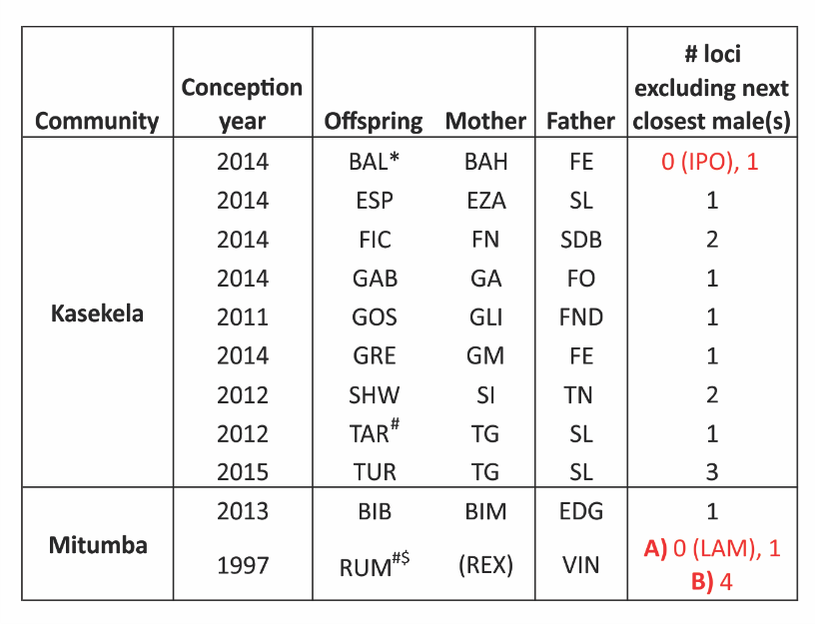
Eleven newly reported paternities of offspring are utilized in this study. For each offspring, the community and year in which the chimpanzee was conceived is given, as is the known mother. Parentheses around REX indicates that she was the only mother for which a genotype was not available. The genetically-identified father of each offspring is listed, all of which lacked allelic mismatches with the offspring, and were confirmed by likelihood analysis in Cervus³⁹ at the strict confidence level of 95% (see more below for detail about the specific case of RUM). Also given is the number of microsatellite loci excluding the next most similar male, when considering the genotypes of the offspring-mother-male trio. Fathers were the only males that did not have any loci excluding them for all but two offspring, BAL and RUM (noted by red font), but additional biological and/or demographic information resolved between two unexcluded males in both cases. Two males, FE and IPO, could not be genetically excluded as the father of BAL, however IPO was less than nine years old at the time of BAL’s conception, and therefore could not biologically be the sire. This is consistent with Cervus’ assignment of paternity of BAL to FE. $Paternity analysis for RUM did not include a maternal genotype, so dyadic comparisons between RUM and candidate males were done in two ways: A) including all genotyped males, and B) including only those males alive at the time of conception (of which 14 of 17 candidate males were sampled and genotyped: two of five Mitumba and all 12 Kasekela males). In both scenarios, VIN was a male that could not be excluded as the father, but in the former, a second male (LAM, son of VIN) also could not be excluded (and LAM was also assigned by Cervus as the father at the relaxed confidence level of 80%). However, VIN was assigned as the father by Cervus in the latter scenario at the strict 95% confidence level. LAM was not included in the latter scenario because he was not born until after RUM was conceived and cannot be the sire. *BAL’s genotype included seven, rather than the 8 microsatellite loci standardly genotyped by next-generation sequencing³⁵. #Genotyping was done using repeat size-based methods (described in Walker et al.³⁴, Wroblewski et al.³⁰).

Table S7. Life history parameter estimates for cross-site analysis.
Site | Community | Subspecies | B | c | n | Publications
Gombe | Kasekela | schweinfurthii | 4.88 | 14 | 4.7 | ^{37–39}
Gombe | Mitumba | schweinfurthii | 4.88 | 14 | 4.7 | ³⁷⁻³⁹
Gombe | Kahama | schweinfurthii | 4.88 | 14 | 4.7 | ^{37–39}
Mahale | K-Group | schweinfurthii | 5.80 | 12.5 | 5.9 | ^{17, 38}
Mahale | M-Group | schweinfurthii | 5.80 | 12.5 | 5.9 | ^{17, 38}
Budongo | Sonso | schweinfurthii | 5.00 | 14 | 6.125 | ^{17, 37–39}
Kalinzu | M-Group | schweinfurthii | 5.00 | 13.25 | 6.125 | ^{17, 37–39}
Kibale | Kanyawara | schweinfurthii | 6.00 | 14 | 5 | ^{37–38}
Kibale | Ngogo | schweinfurthii | 5.00 | 14 | 6.125 | ^{37–39}
Kibale | Kanyantale | schweinfurthii | 5.00 | 14 | 6.125 | ^{17, 37–38}
Kyambura | Kyambura | schweinfurthii | 5.00 | 13.25 | 6.125 | ^{17, 37-38}
Goualougo | Moto | troglodytes | 5.27 | 12.325 | 10.06 | ^{17, 37–39}
Taï | North | verus | 5.80 | 11.4 | 19.4 | ^{38–39}
Taï | South | verus | 5.30 | 11.4 | 19.4 | ^{38–39}
Taï | Middle | verus | 5.55 | 11.4 | 19.4 | ^{38–39}
Taï | East | verus | 5.55 | 11.4 | 19.4 | ^{38–39}
Bossou | Bossou | verus | 5.55 | 11.4 | 14 | ³⁸
Fongoli | Fongoli | verus | 5.55 | 11.4 | 14 | ³⁸

