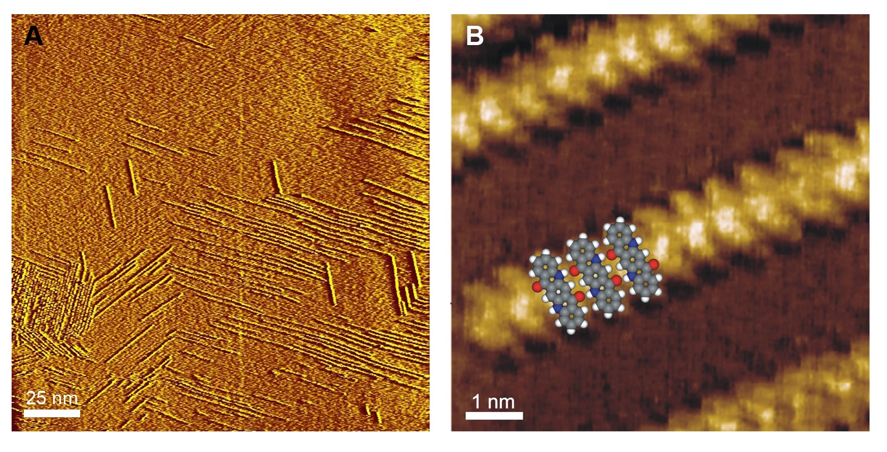
Extended Data Fig. 1 STM images of a graphite surface after OSWD processing. A, Chain-like supramolecular adsorbate structures formed via OSWD after the graphite surface contacts suspensions of QAC particles. B, Close-up view of a single supramolecular QAC adsorbate chain superimposed by a force field calculated assembly of three QAC molecules forming a linear chain via H-bonds.

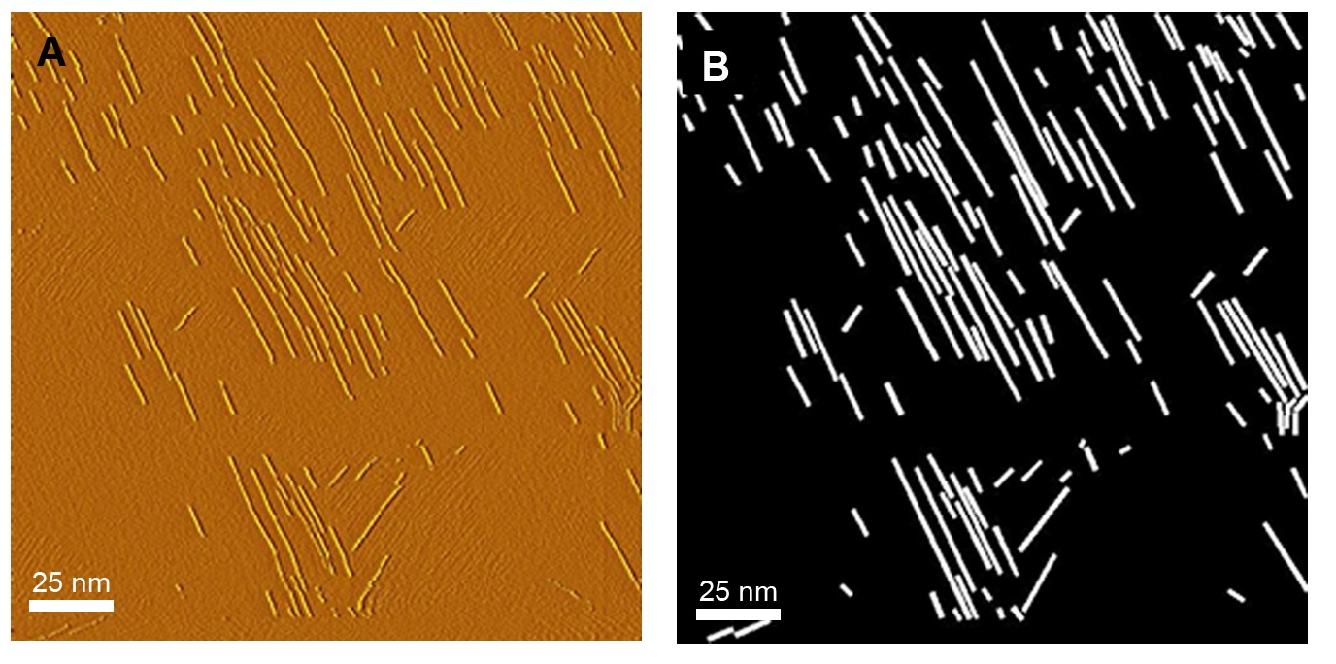
Extended Data Fig. 2 Example of a black/white conversion of STM images for coverage analysis. A, STM image of chain-like QAC assemblies on graphite. B, Black/white conversion of the STM image: QAC chains were masked out (white) and the background was set to black. The percentage of the white proportion (the QAC coverage) was subsequently calculated as described in the methods section.
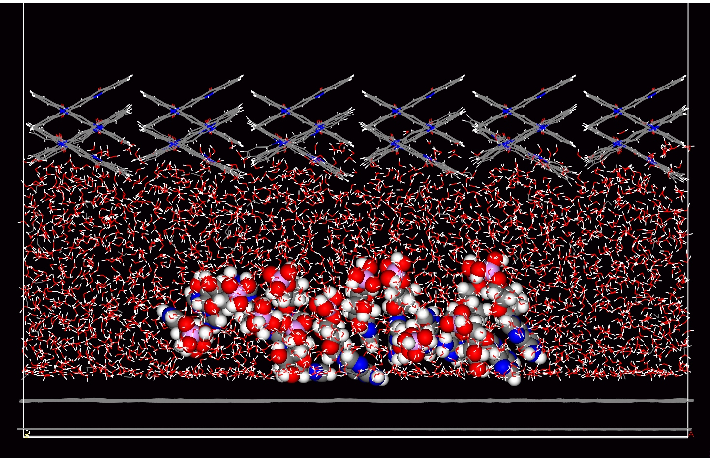
Extended Data Fig. 3 Dynamic force field calculation of an AMP stack within nanoconfined water. The simulation was modelled with a reduced confinement gap size of 2.6 nm between a QAC crystal (top) and a graphene layer (bottom). Displayed is the condition of the stack after a simulated time span of 60 ps, revealing a stack in destabilized, non-ordered condition.

