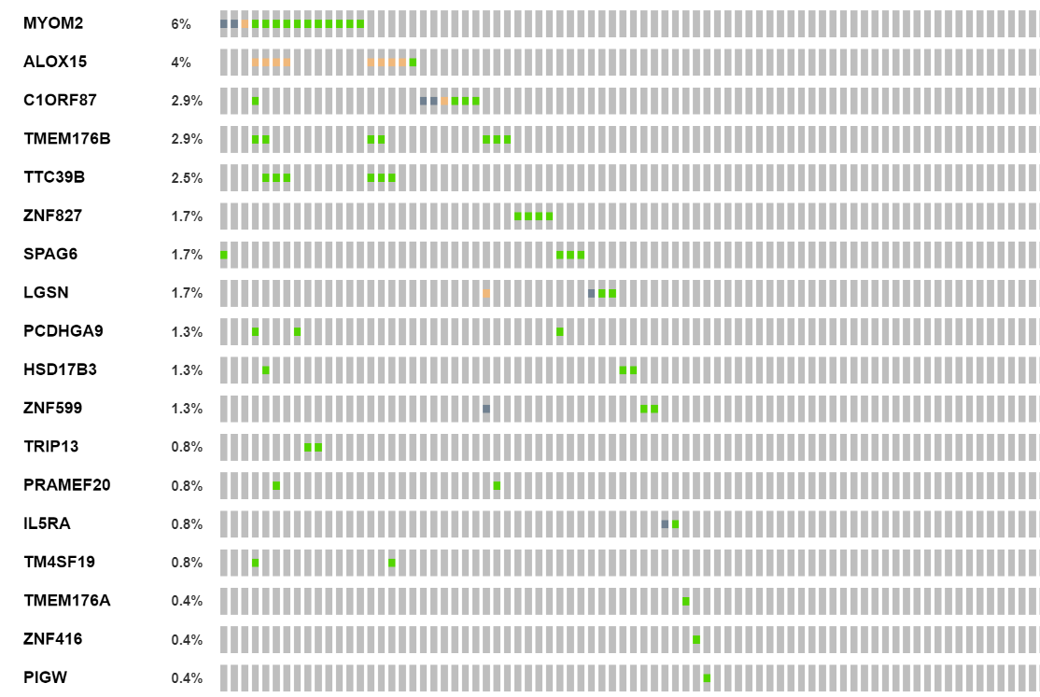
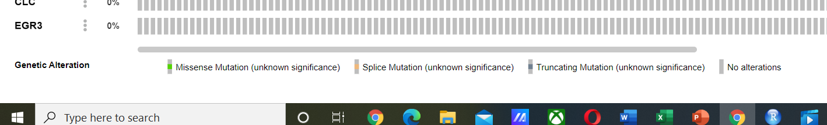

Figure S1. Mutations in up-regulated candidate genes in brain metastasis

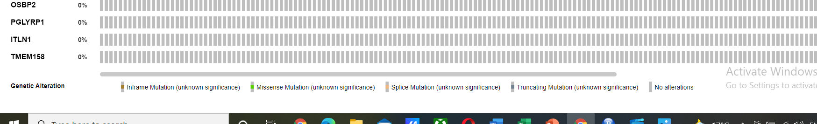
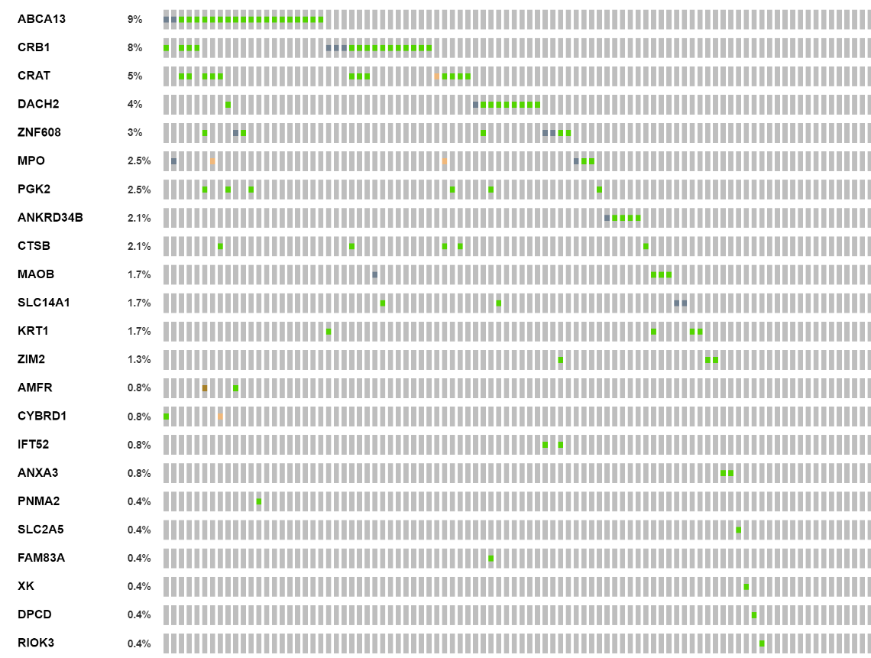

Figure S2. Mutations in down-regulated candidate genes in brain metastasis

