Supplemental information for:
Life history traits and biogeographic features shaped the complex evolutionary history of an iconic apex predator (Galeocerdo cuvier).

Pierre Lesturgie¹, Hugo Lainé¹, Arnaud Suwalski^{1,2}, Pascaline Chifflet-Belle^{1,2}, Pierpaolo Maisano Delser³, Eric Clua^{2,4}, Sébastien Jaquemet⁵, Hélène Magalon^{4,5,#}, Stefano Mona^{1,2, 4,#,*}

¹ Institut de Systématique, Evolution, Biodiversité, ISYEB (UMR 7205), Muséum National d'Histoire Naturelle, CNRS, Sorbonne Université, EPHE, Université des Antilles, Paris, France
² EPHE, PSL Research University, Paris, France
³ Department of Zoology, University of Cambridge, Cambridge, UK
⁴ Laboratoire d’Excellence CORAIL, Papetoai, French Polynesia
⁵ UMR ENTROPIE (Université de La Réunion/IRD/CNRS), Université de La Réunion, Saint Denis, France
# Jointly supervised this work
* Corresponding author. E-mail: stefano.mona@mnhn.fr

Supplementary tables
Table S1. Matrix of pairwise F_{ST} values (lower triangle) and significancy (upper triangle). F_{ST} values in bold are significantly different from 0 (P ≤ 0.001).
 | BRA | RUN | AUS_{N} | COR | AUS_{E} | NCA
BRA |  | P ≤ 0.001 | P ≤ 0.001 | P ≤ 0.001 | P ≤ 0.001 | P ≤ 0.001
RUN | 0.121857 |  | NS¹ | NS | NS | P ≤ 0.001
AUS_{N} | 0.117224 | 0.018064 |  | NS | NS | NS
COR | 0.128822 | 0.027691 | 0.022869 |  | NS | NS
AUS_{E} | 0.123757 | 0.019393 | 0.022254 | 0.023325 |  | P ≤ 0.001
NCA | 0.126444 | 0.026963 | 0.019532 | 0.022105 | 0.029433

¹NS: Not Significant

Table S2. Prior distribution of the parameters of the models FIM, SS and NS.
FIM | Nm* | T_{col}§ | N_{anc}
FIM | P*: 0.001 - 100 | U¶: 1 – 300,000 | U: 100 – 100,000
SS | Nm* | T_{col}§ | N_{anc}
SS | P: 0.001 - 100 | U: 1 – 300,000 | U: 100 – 100,000
NS | N_{mod} | T_{s}§ | N_{anc}
NS | U: 1 – 100,000 | U: 1 – 300,000 | U: 1 – 100,000

* P: the prior distribution of Nm is the product of two uniforms (one for N and one for m).
¶ U: uniform distribution.

Table S3. Confusion matrix of the model selection procedure and posterior probability for the most likely model explaining the structuring: rows indicate the simulated models and columns the votes (in %) attributed by the ABC-RF algorithm to each of them.
 |  | Attributed votes (%) |  |  | Class. error | Posterior Probability
 |  | FIM | NS | SS | Class. error | Posterior Probability
BRA | FIM | 75.848 | 4.438 | 19.714 | 0.24152
BRA | NS | 1.466 | 97.158 | 1.376 | 0.02842 | 0.63
BRA | SS | 20.584 | 4.088 | 75.328 | 0.24672
RUN | FIM | 44885 | 1376 | 3739 | 0.1023
RUN | NS | 466 | 49095 | 439 | 0.0181 | 0.79
RUN | SS | 4443 | 781 | 44776 | 0.10448
AUS_{N} | FIM | 40806 | 1867 | 7327 | 0.18388
AUS_{N} | NS | 598 | 48738 | 664 | 0.02524 | 0.48
AUS_{N} | SS | 7591 | 1466 | 40943 | 0.18114
COR | FIM | 37878 | 2121 | 10001 | 0.24244
COR | NS | 755 | 48450 | 795 | 0.031 | 0.69
COR | SS | 10344 | 1917 | 37739 | 0.24522
AUS_{E} | FIM | 40162 | 1849 | 7989 | 0.19676
AUS_{E} | NS | 623 | 48720 | 657 | 0.0256 | 0.86
AUS_{E} | SS | 8334 | 1562 | 40104 | 0.19792
NCA | FIM | 42620 | 1584 | 5796 | 0.1476
NCA | NS | 543 | 48872 | 585 | 0.02256 | 0.89
NCA | SS | 6123 | 1184 | 42693 | 0.14614

Supplementary figures
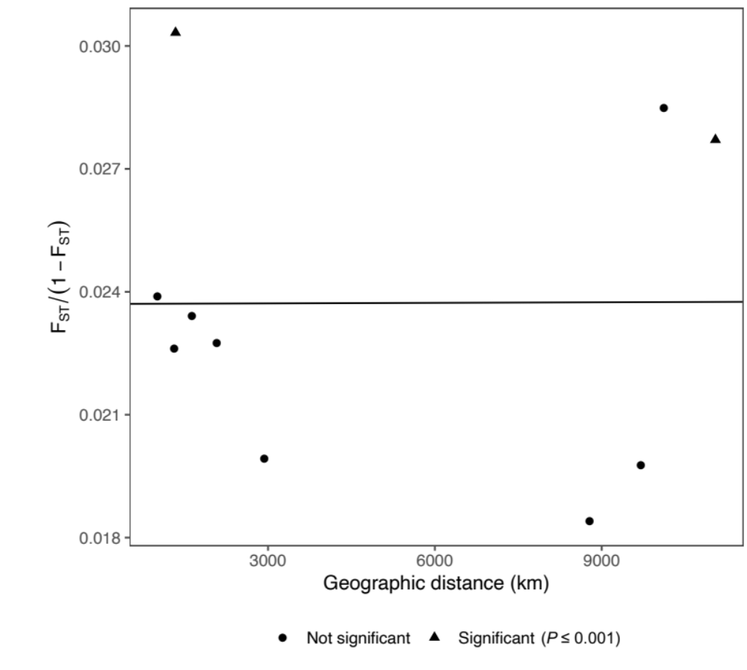
Figure S1. Isolation by distance (IBD) plot within the Indo-Pacific. Pairwise genetic distances (F_{ST}/(1-F_{ST})) are plotted against geographic distances between Indo-Pacific sampling sites.

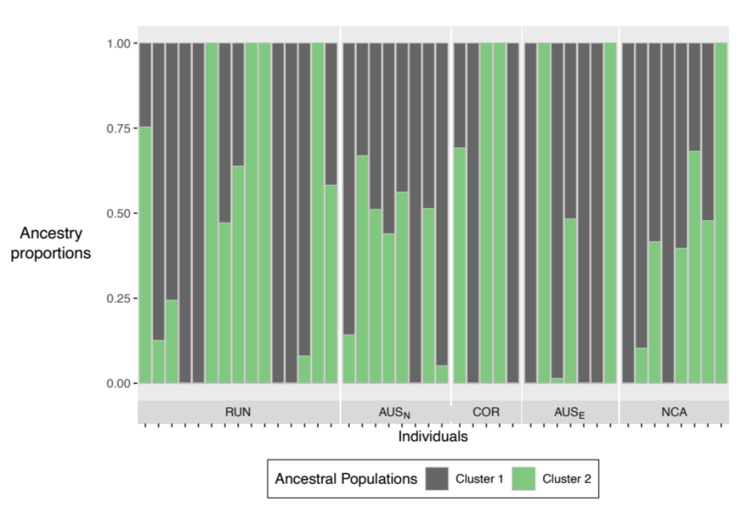
Figure S2. Ancestry proportions retrieved using the nmf algorithm with K=2 ancestral populations for Indo-Pacific samples performed with PCAngsd.

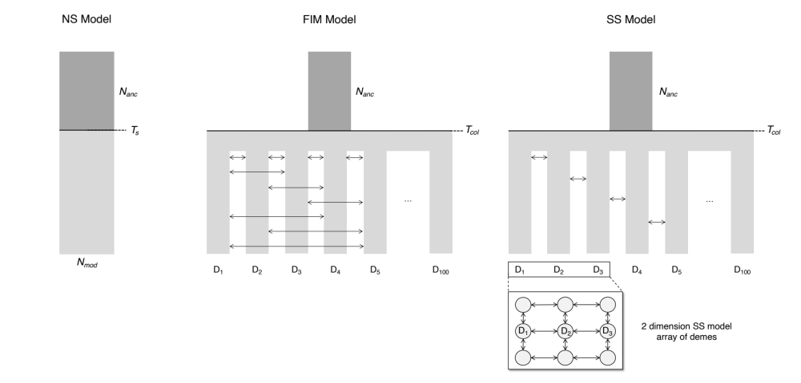
Figure S3. Evolutionary scenarios used to investigate the population structure of the Atlantic Ocean based on data from Brazil population through an Approximate Bayesian Computation (ABC) framework. NS (No Structure) is an unstructured model where the modern effective size ($N_{mod}$) instantaneously changes to $N_{anc}$, at time shift $T_{s}$ generations. FIM (Finite Island Meta-population) represents a finite island meta-population model with 100 demes that have been instantaneously colonised $T_{col}$ generations ago, from an ancestral population of size $N_{anc}$. Demes are allowed to exchange migrants with any other. SS (Stepping-Stone) is similar to FIM but the migrants are only exchanged between the four nearest neighbours in a two-dimensional grid.

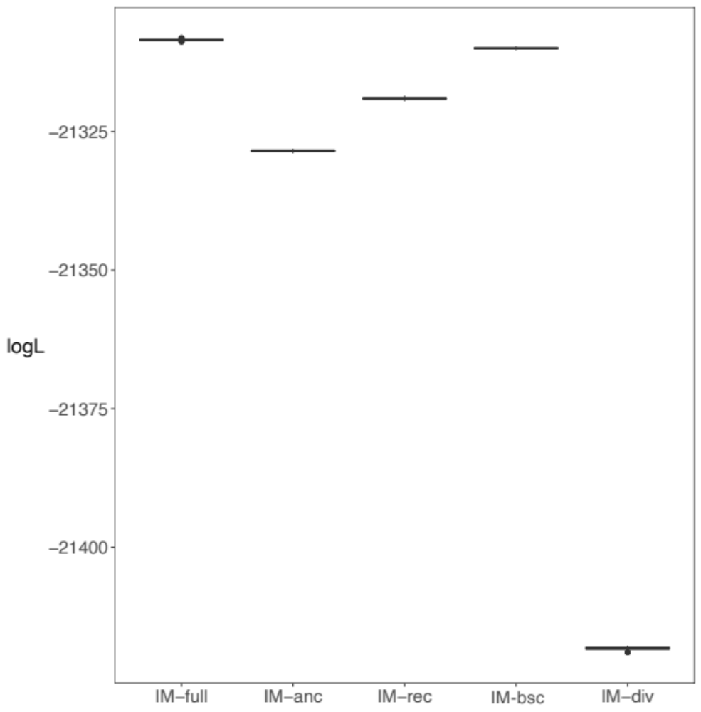
Figure S4. Akaike Information Criterion (AIC) values for the five isolation/migration models and the associated ranking on the x-axis. Boxplots represent the likelihood distribution of the data evaluated under the best parameter estimates for each of the five models (presented in Figure 2) after 100 replicates. The models are presented from the richest in parameters (IM-full, 13 parameters) to the poorest (IM-div, 8 parameters).

