Appendix 1
Figure A1. Latent-scale (single-pair ordinal response). Initial screen example, in Spanish.
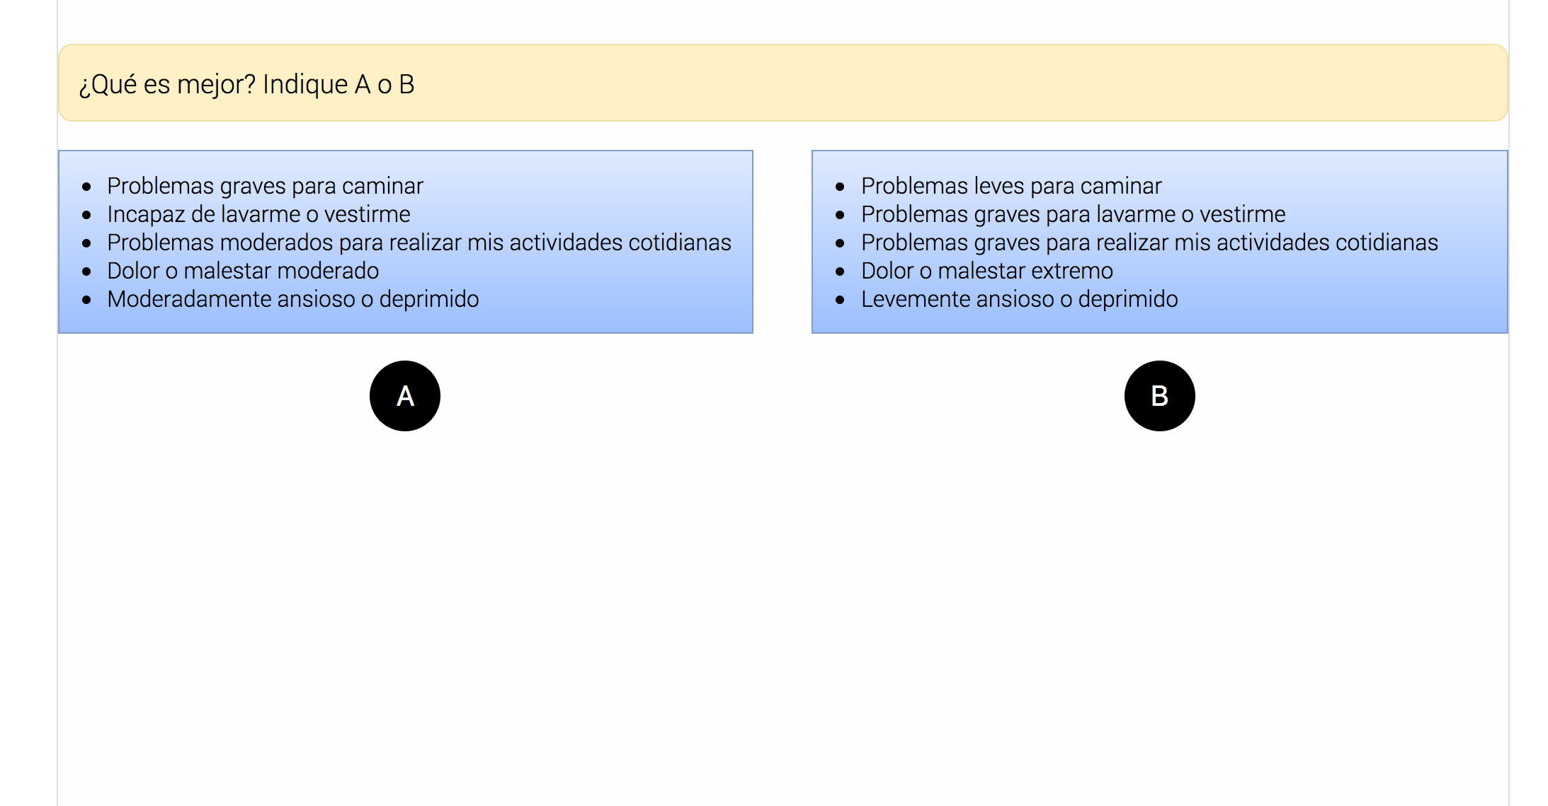
Ordinal response (matched pair) example (two screenshots [A vs B, then B vs. C], in Spanish).
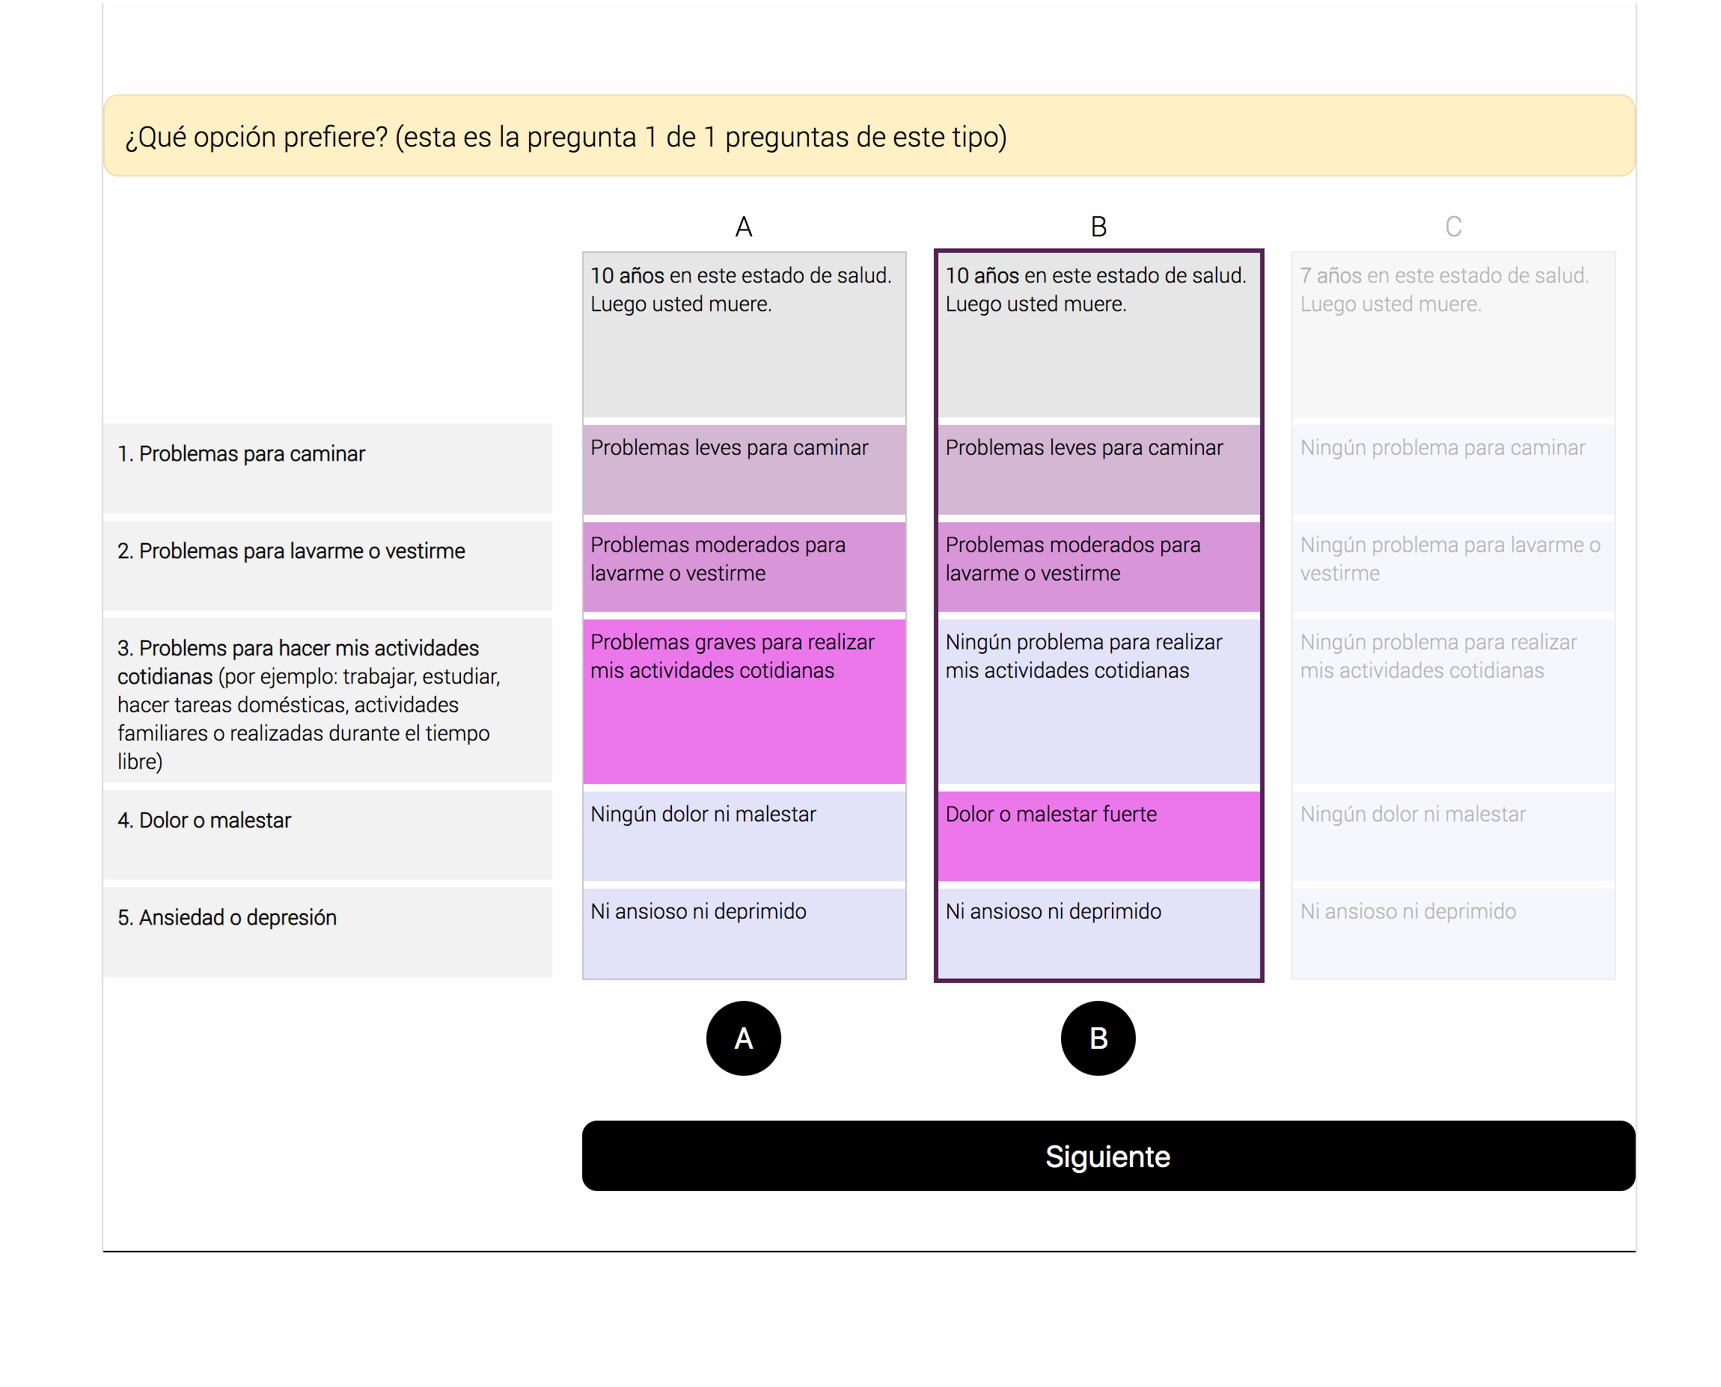
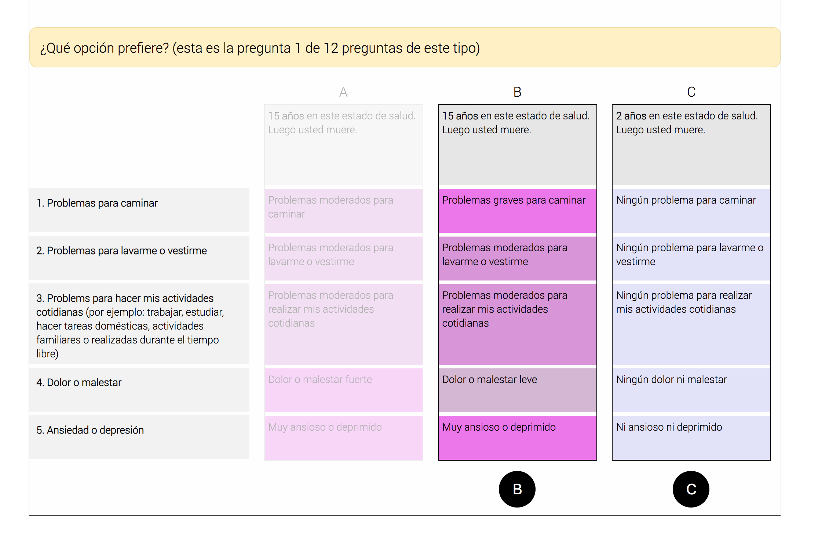

Table A1: Scale factors of heteroskedastic logit model
 | Coef. | S.E. | p-value | Coef. | S.E. | p-value
Intercept | 0.394 | 0.024 | <0.001 | 1.391 | 0.043 | <0.001
Task type
Latent pair |  |  |  | . | . | .
Matched pair |  |  |  | -1.318 | 0.057 | <0.001
Duration of each task (seconds)
Latent pair
1 to 14 |  |  |  | -0.193 | 0.080 | 0.016
15 to 29 |  |  |  | . | . | .
30 to 59 |  |  |  | -0.320 | 0.061 | <0.001
above 60 |  |  |  | -0.308 | 0.081 | 0.000
Matched pair
1 to 14 |  |  |  | 0.211 | 0.076 | 0.005
15 to 29 |  |  |  | -0.005 | 0.052 | 0.925
30 to 59 |  |  |  | . | . | .
above 60 |  |  |  | -0.025 | 0.063 | 0.693

*coefficients presented in log-scale term. '.' Represented the omitted category

Table A2: Summary of the converged estimated models
Model | Log-likelihood | Parameters | Bayesian Information Criterion (BIC)
Conditional logit | -19377.1 | 22 | 38981.67
Heteroskedastic logit | -19041.8 | 29 | 38383.63
Latent class logit (2 classes) | -17185.7 | 81 | 35209.13
Scale adjusted latent class logits
1 scale and 2 taste classes | -17359.2 | 66 | 35400.94
1 scale and 3 taste classes | -17068.9 | 103 | 35203.06
2 scale and 2 taste classes | -17208.5 | 87 | 35316.91
2 scale and 3 taste classes | -16914.7 | 124 | 35112.00
* models with more classes did not converge

Table A3: Heteroskedastic variables of the SALC model
 | scale class 1 (34.21 %) |  |  | scale class 2 (65.79 %)
 | Coef. | S.E. | p-value | Coef. | S.E. | p-value
Intercept | 0.945 | 0.072 | <0.001 | 2.208 | 0.171 | <0.001
Task type
Latent pair | . | . | . | . | . | .
Matched pair | -0.385 | 0.078 | <0.001 | -0.678 | 0.189 | <0.001
Duration of each task (seconds)
Latent pair
1 to 14 | -0.223 | 0.119 | 0.060 | -0.231 | 0.278 | 0.407
15 to 29 | . | . | . | . | . | .
30 to 59 | -0.357 | 0.104 | 0.001 | -0.584 | 0.214 | 0.006
above 60 | -0.389 | 0.149 | 0.009 | -0.399 | 0.252 | 0.113
Matched pair
1 to 14 | 0.215 | 0.090 | 0.017 | 0.451 | 0.255 | 0.076
15 to 29 | 0.041 | 0.059 | 0.481 | 0.026 | 0.109 | 0.815
30 to 59 | . | . | . | . | . | .
above 60 | -0.121 | 0.079 | 0.123 | -0.042 | 0.099 | 0.673
*Heteroskedastic coefficients presented in log-scale term. '.' Represented the omitted category

Table A4: Scale class grade-of-membership variables of the SALC model
 | Coef. | SE. | p-value
Intercept | 0.625 | 0.302 | 0.332
Age
15-29 | 0.861 | 0.230 | 0.576
30-44 | - | - | -
45-59 | 1.308 | 0.323 | 0.277
60-80 | 1.721 | 0.565 | 0.098
Gender
Female | 0.775 | 0.209 | 0.345
Difficulty level of questionnaire
Difficult | 1.263 | 0.462 | 0.524
Understanding of different health state
Easy/Moderate | 1.194 | 0.317 | 0.504
Difficulty to choose an answer
Difficult | 0.765 | 0.186 | 0.271
cTTO completed | 0.529 | 0.505 | 0.505
Interview time, excluding cTTO time (min)
0-10 | 0.636 | 0.193 | 0.136
10-15 | - | - | -
Above 15 | 1.280 | 0.731 | 0.666
Interview time - with cTTO (min)
0-30 | 0.537 | 0.766 | 0.663
30-40 | - | - | -
Above 40 | 0.850 | 0.559 | 0.805
*coefficients are in odd ratio

Figure A2: Distribution of Individual grade-of-membership of taste classes in 2scale-3taste class SALC model
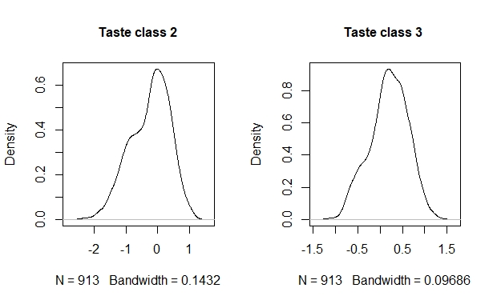

Figure A3: Distribution of Individual grade-of-membership of scale class 2 in 2scale-3taste class SALC model
