Supplementary information to the paper: Microbial biomass and enzyme activities determine dynamics of soil organic carbon stocks and fractions along an age-sequence of Mongolian pine plantations

Yansong Zhang^{1,2}, De-Hui Zeng^{1,}*, Zeyong Lei³, Xin Li^{1,2}, Guigang Lin^{1,}*
¹CAS Key Laboratory of Forest Ecology and Management, Institute of Applied Ecology, Chinese Academy of Sciences, Shenyang 110016, China
²College of Resources and Environment, University of Chinese Academy of Sciences, Beijing 100049, China
³College of Environmental Sciences and Engineering, Liaoning Technical University, Fuxin 123000, China
*Corresponding authors: De-Hui Zeng, E-mail: zengdh@iae.ac.cn; Guigang Lin, E-mail: linguigang@126.com

This Supplementary information contained one table and five figures. Table S1 showed the parameters used in calculating biomass and biomass carbon of Mongolian pine components. Fig. S1 showed a conceptual model depicting the direct and indirect effects of stand age, litter quality and quantity, soil acid-base chemistry, microbial properties, and C fractions on SOC stocks. Figs. S2–S5 separately revealed changes in SOC stocks, POC stocks, MAOC stocks and POC:MAOC ratio of 20–40, 40–60, 60–80, 80–100 and 0–100 cm soil layers along a chronosequence of Mongolian pine plantations.

Table S1 Parameters used in calculating biomass and biomass carbon of Mongolian pine components.
 | Biomass of tree components |  |  |  | Biomass carbon of tree components
 | a | b | c |  | m | n
Stem | 0.07 | 2.61 | -0.22 |  | 0.37 | 34.67
Branch | 0.78 | 2.94 | -1.44 |  | 0.28 | 38.62
Foliage | 2.27 | 2.22 | -1.35 |  | 0.36 | 37.33
Root | 0.59 | 2.32 | -0.74 |  | 0.36 | 34.77

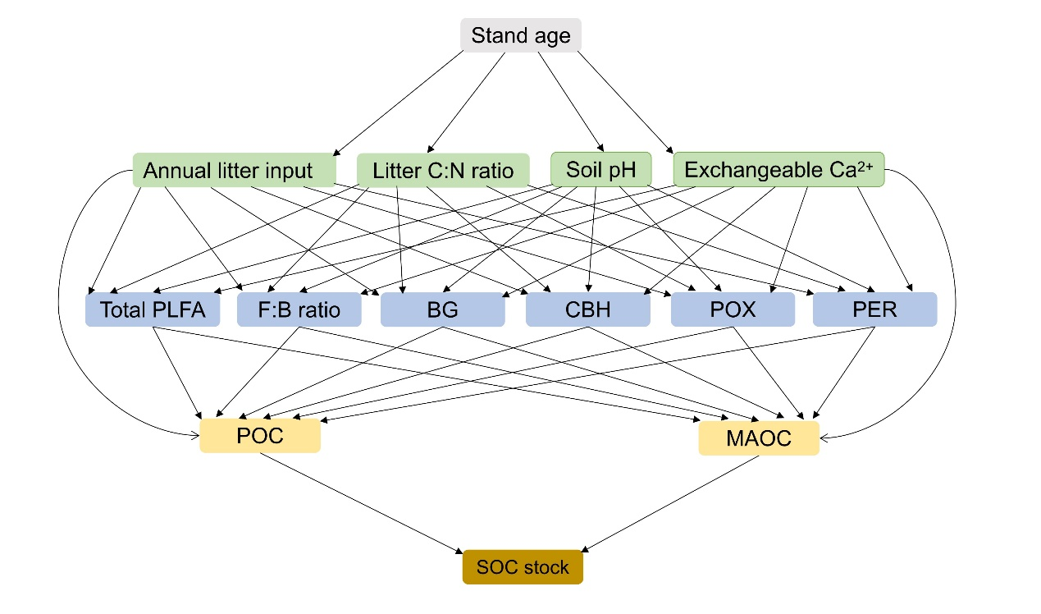
Fig. S1 Conceptual model depicting the direct and indirect effects of stand age, litter quality and quantity, soil acid-base chemistry, microbial properties, and C fractions on SOC stocks. PLFA, phospholipid fatty acid; F:B ratio, the ratio of fungal PLFAs to bacterial PLFAs; BG, β-1,4-glucosidase; CBH, cellobiohydrolase; POX, phenol oxidase; PER, peroxidase; POC, particulate organic C; MAOC, mineral-associated organic C
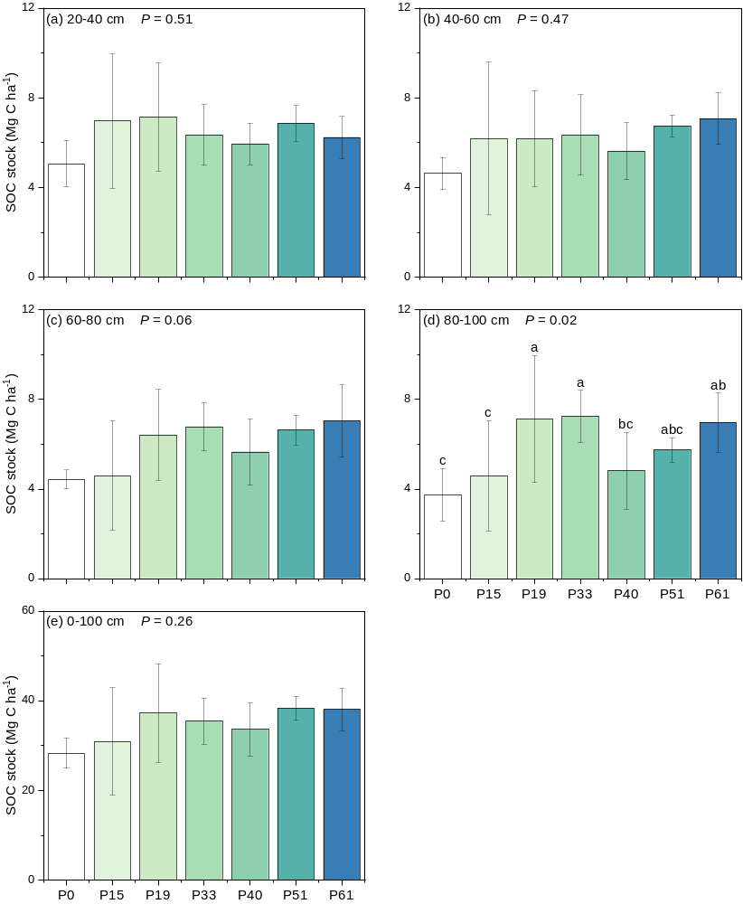
Fig. S2 Changes in soil organic C (SOC) stocks of 20–40 (a), 40–60 (b), 60–80 (c), 80–100 (d) and 0–100 cm (e) soil layers along a chronosequence of Mongolian pine plantations (mean ± SD, n = 5). Different lowercase letters indicate significant differences among stand ages. P0, P15, P19, P33, P40, P51 and P61 separately represent sandy grasslands, 15-, 19-, 33-, 40-, 51- and 61-year-old Mongolian pine plantations
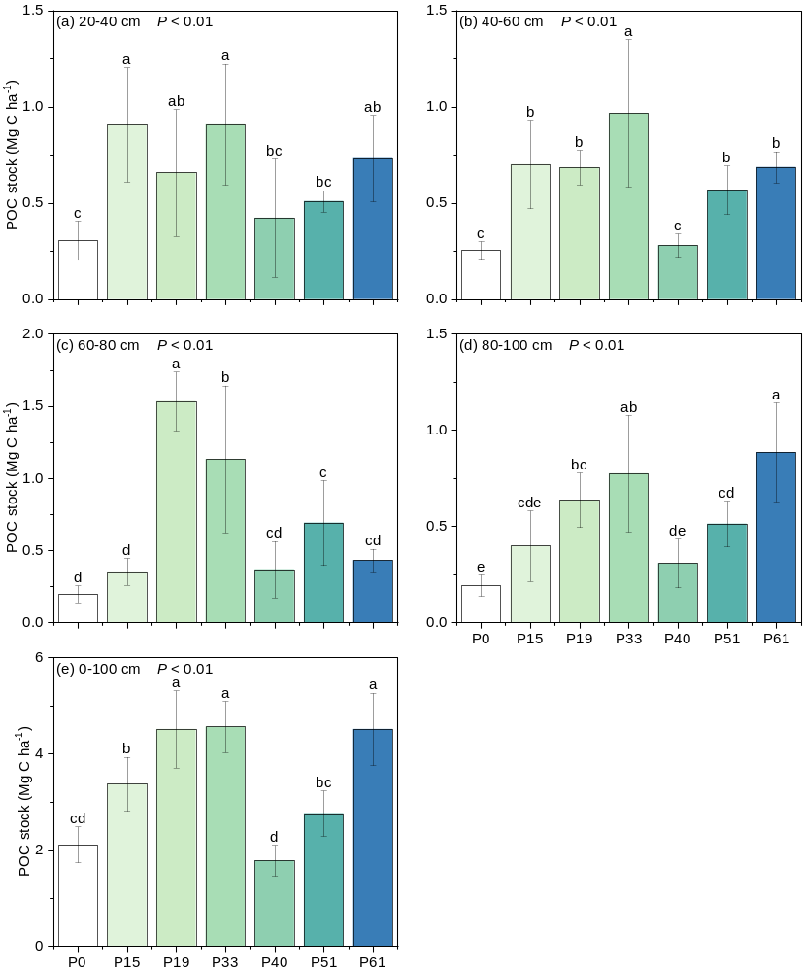
Fig. S3 Changes in particulate organic C (POC) stocks of 20–40 (a), 40–60 (b), 60–80 (c), 80–100 (d) and 0–100 cm (e) soil layers along a chronosequence of Mongolian pine plantations (mean ± SD, n = 5). Different lowercase letters indicate significant differences among stand ages. P0, P15, P19, P33, P40, P51 and P61 separately represent sandy grasslands, 15-, 19-, 33-, 40-, 51- and 61-year-old Mongolian pine plantations

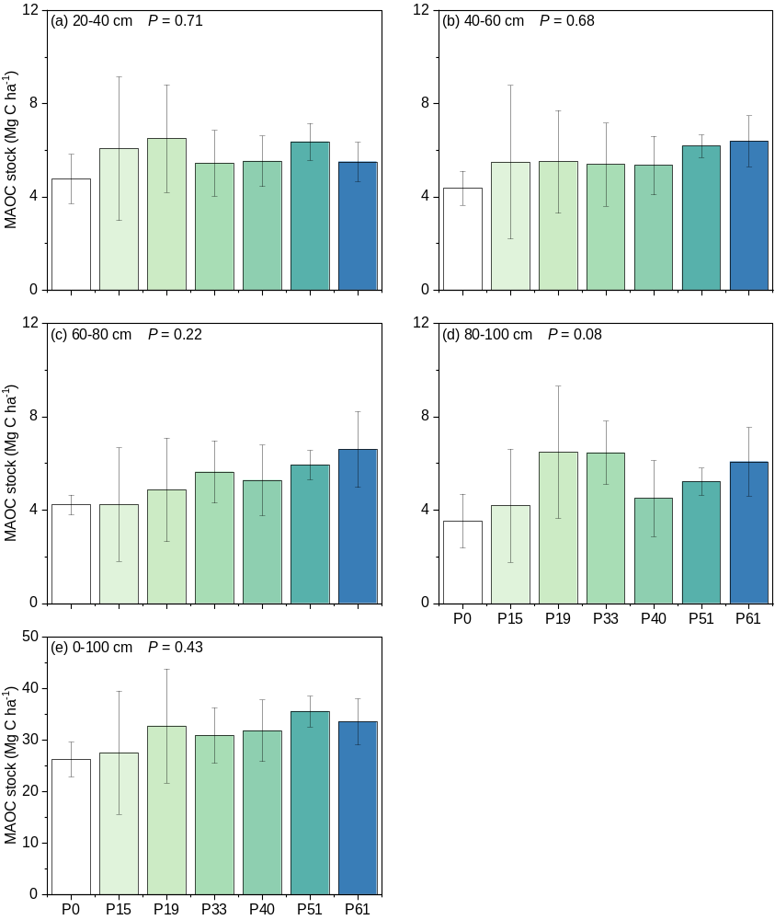Fig. S4 Changes in mineral-associated organic C (MAOC) stocks of 20–40 (a), 40–60 (b), 60–80 (c), 80–100 (d) and 0–100 cm (e) soil layers along a chronosequence of Mongolian pine plantations (mean ± SD, n = 5). Different lowercase letters indicate significant differences among stand ages. P0, P15, P19, P33, P40, P51 and P61 separately represent sandy grasslands, 15-, 19-, 33-, 40-, 51- and 61-year-old Mongolian pine plantations

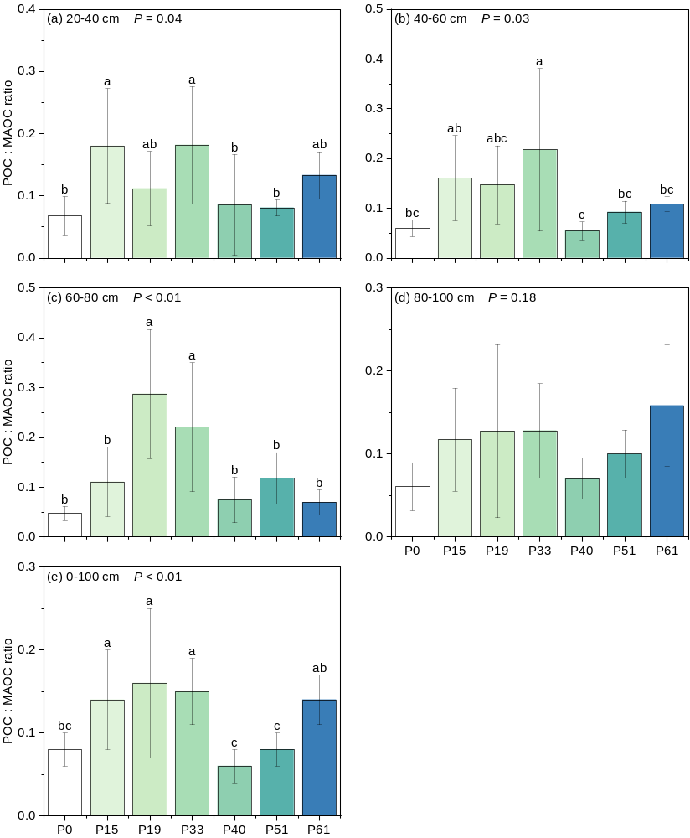
Fig. S5 Changes in the ratio of particulate organic C stocks to mineral-associated organic C stocks (POC:MAOC ratio) of 20–40 (a), 40–60 (b), 60–80 (c), 80–100 (d) and 0–100 cm (e) soil layers along a chronosequence of Mongolian pine plantations (mean ± SD, n = 5). Different lowercase letters indicate significant differences among stand ages. P0, P15, P19, P33, P40, P51 and P61 separately represent sandy grasslands, 15-, 19-, 33-, 40-, 51- and 61-year-old Mongolian pine plantations.

