Supporting information

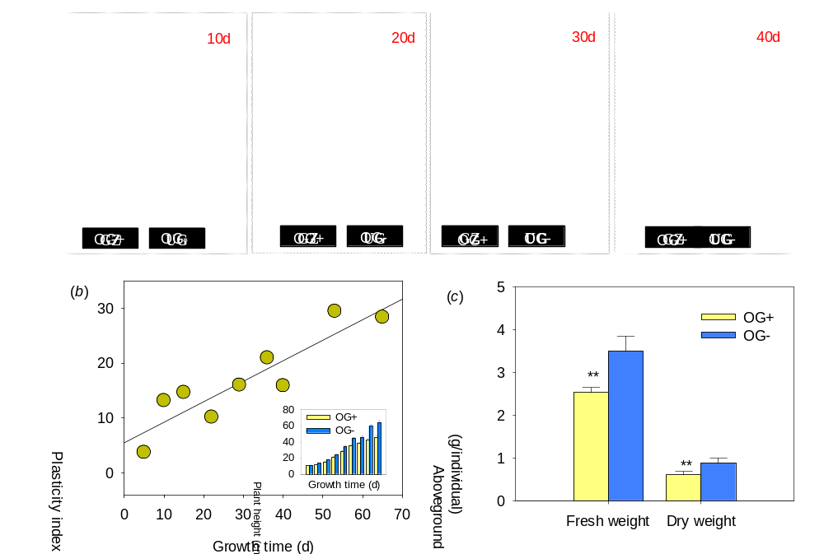
Fig. S1. Growth chamber test of clonal transgenerational plasticity of Leymus chinensis induced by long-term overgrazing. (a) Growth dynamics of L. chinensis individuals cultivated from rhizome buds from maternal plants in long-term overgrazed and fenced grasslands. (b) Plasticity index of dwarf L. chinensis over different growth times affected by transgenerational effects (P < 0.05). (c) Comparison in aboveground biomass of the clonal offspring of grazing and fenced L. chinensis. OG+, clonal offsping of plants that had experienced herbivore grazing; OG-, clonal offsping of plants that had not experienced grazing. **, P < 0.01.
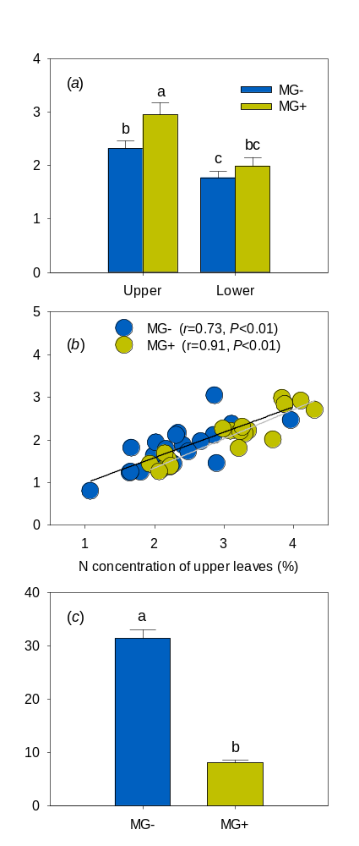
Fig. S2. Potential effects of leaf growth sequence on L. chinensis N dynamics. (a) Grazing effects on N concentrations in young (upper) and old (lower) leaves. (b) Relationship between upper and lower N concentrations. (c) Grazing effects on N accumulation at an individual scale. The same lowercase letters above bars in the same panel indicate non-significant differences (P > 0.05). Abbreviations: MG+, maternal plants from populations that had experienced herbivore grazing; MG+, maternal plants from populations that had not experienced grazing.
Table S1. The primers of the genes in Real-Time qPCR
Name | Forward primer (5′-3′) | Reverse primer (5′-3′)
NRT1.1 | GGATGAAGACTATGAGCACGG | AGAGGTAGACGATGAGGTTGG
NRT1.2 | AGAACACAAAGGGCTGGGA | ACTCGTCAGGGTTCTCAGG
NRT1.7 | CTCAAGCTTCCGCATCCTG | CACCATCCCTTACAATCGCA
Actin | ATTGTGCTCAGTGGTGGGTCA | CCAATCCAAACACTGTACTTCCTC

