Appendices
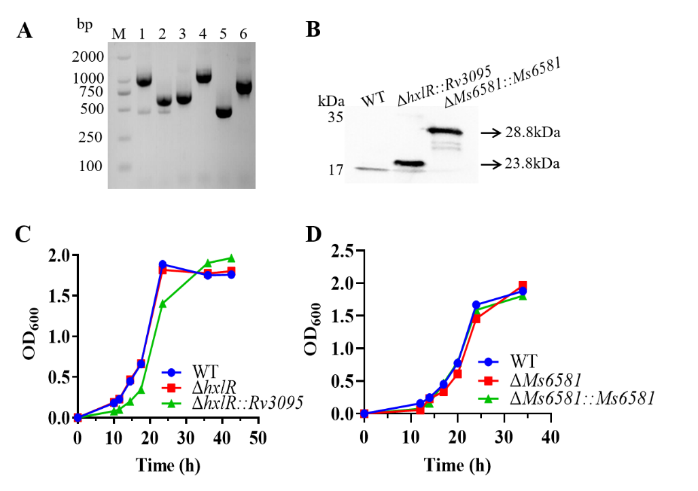
Fig. S1. The hxlR or MSMEG_6581 mutation did not affect the growth of M.smegmatis under control condition. (A) Confirmation of hxlR, MSMEG_6581 gene knockout by PCR amplification. M, Marker DL2000; 1, wild-type; 2, ΔhxlR; 3, ΔhxlR::Rv3095; 4, wild-type; 5, ΔMs6581; 6, ΔMs6581::Ms6581. (B) Acetamide-induced WT, ΔhxlR::Rv3095, ΔMs6581::Ms6581 were lysed and subjected to Western blotting to determine the level of fusion protein using anti-His antibody. (C) Growth curves of WT, ΔhxlR, ΔhxlR::Rv3095 in 7H9 medium supplemented with 0.05% Tween 80. (D) Growth curves of WT, ΔMs6581, ΔMs6581::Ms6581 in 7H9 medium supplemented with 0.05% Tween 80.
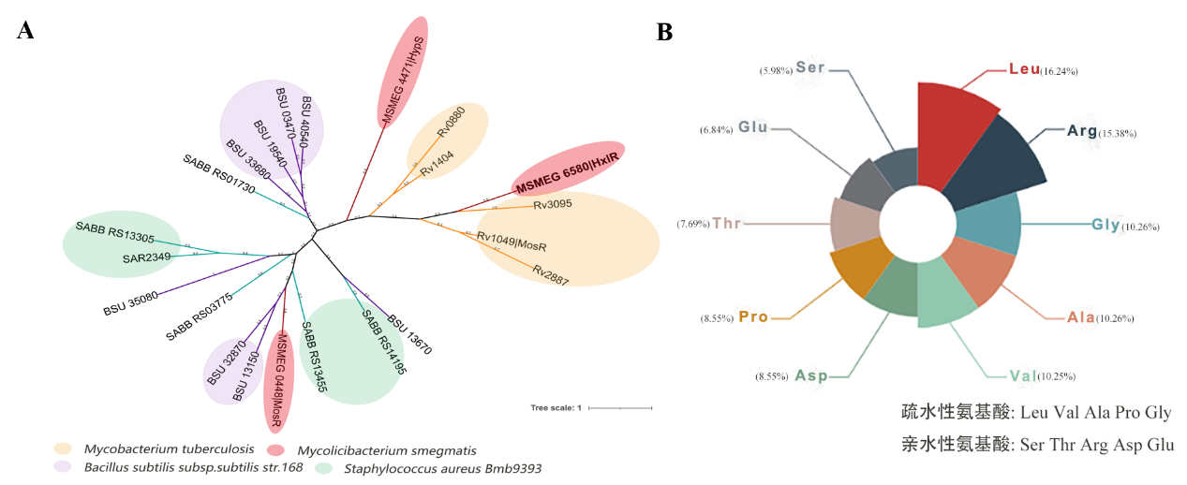
Fig. S2. Results of HxlR bioinformatics. (A) Phylogenetic analysis of the MarR family transcription factors of Mycobacterium tuberculosis, Mycolicibacterium smegmatis, Bacillus subtilis subsp.subtilis str.168 and Staphylococcus aureus Bmb9393. (B) HxlR amino acid features.
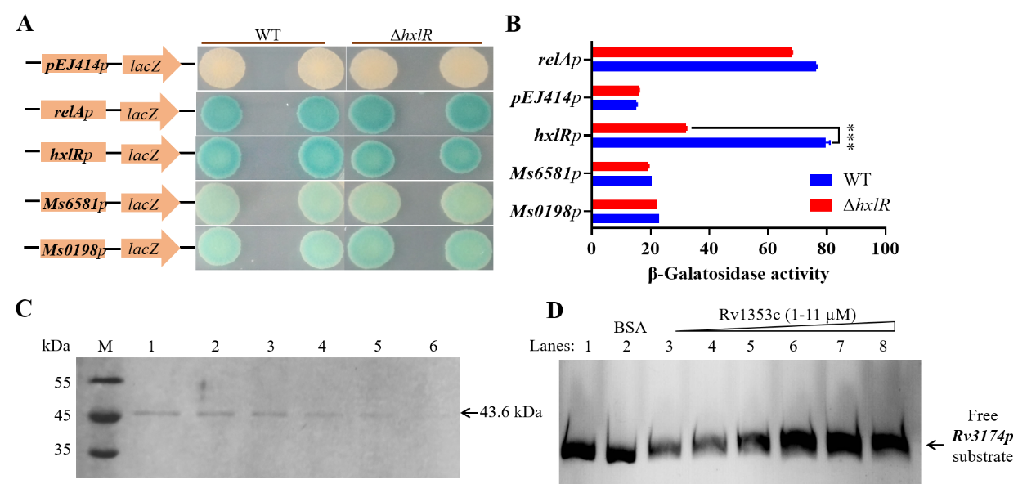
Fig. S3. Other transcription factors might be involved in transcription regulation of hxlR and MSMEG_6581. (A) (B)β-galactosidase activity detection plasmid was constructed using the reporter gene LacZ, which was transformed into hxlR knockout strains and wild-type M. smegmatis, respectively, to test the regulatory effect of HxlR on the genes in MSMEG_6581, MSMEG_0198 and itself. (C) Expression and purified of Rv1353c. (D) Electrophoretic mobility shift assay showing that Rv1353c would not combine with the promoter regions of Rv3174.
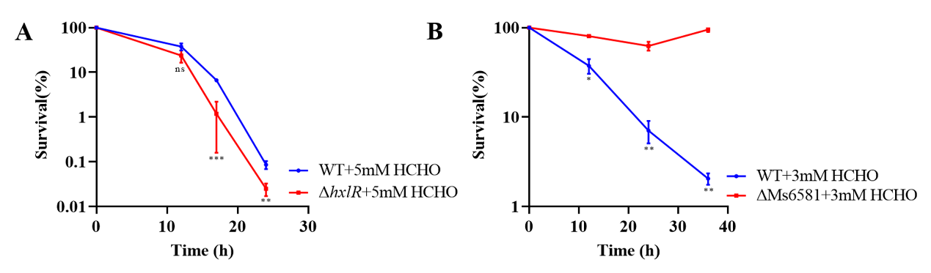
Fig. S4. Mycobacteria hxlR is involved in response to formaldehyde. (A) WT, ΔhxlR, ΔhxlR::Rv3095 were treated with 5 mM HCHO for indicated intervals; (B) WT, ΔMs6581, ΔMs6581::Ms6581 were treated with 3 mM HCHO for indicated intervals.

Table S1 Primers used for experiments
Primers | Sequence (5'-3')
hxlR-pET28a-F | CGGGATCCATGGGACGCAAGAAC
hxlR-pET28a-R | CCCAAGCTTTCAATTACCGGTCGGG
Rv3095-pET28a-F | TAATCGGGATCCATGGCCGTTTC
Rv3095-pET28a-R | CCCAAGCTTTTATGAGGACGCCA
Rv1353c-pET28a-F | GGAATTCATGCAGACAACCCCAGG
Rv1353c-pET28a-R | CCCAAGCTTTCAACGCGCCACCG
hxlRpro-F | CCGCGTACAACGAGTTCATGG
hxlRpro-R | AGGCTACGCGCGACGGAGCAG
MSMEG_6581pro-F | GAGGGAACAATTGCTGGATCATCCG
MSMEG_6581pro-R | GCCCCGCGGGCGAGCAGTTGTTCGG
MSMEG_0198pro-F | GATGACGCGGTCGATCGCTTCACGGGCAGA
MSMEG_0198pro-R | AAGGCGCCTGGGAGATCGAGAACATCATGC
Rv3094cpro-F | ATCGGTGGTCCTTCTGGGCGTGGCA
Rv3094cpro-R | CGGCGAGGATCTCGATCTCGGTTT
Rv3093cpro-F | GTCCACTCGGACCTTGGCGGAACG
Rv3093cpro-R | ACAGCGCAGCGAAACCCGTGTCA
Rv3092cpro-F | CCCGGCTATGGCGAAATGTTCAG
Rv3092cpro-R | GCGCCGATGTCGTCAATCGAGGC
HxlR point mutation P1 | TGGGCAGCAGCCATCATCATCATCA
HxlR point mutation P4 | GCTTTGTTAGCAGCCGGATCTCAGT
HxlR R15A P2 | GCGCTCGCCGAGGACAGCGAGGCTAGCCGCGACGGAGCAGTCGAGACTCTCG
HxlR R15A P3 | CGAGAGTCTCGACTGCTCCGTCGCGGCTAGCCTCGCTGTCCTCGGCGAGCGC
HxlR R30A P2 | CCGCCGTGTTCCCAGCAGGGCCTCGGCGAGGATGAGGATGGTCCAGCGCTCG
HxlR R30A P3 | CGAGCGCTGGACCATCCTCATCCTCGCCGAGGCCCTGCTGGGAACACGGCGG
HxlR R38A P2 | GAGCCGGGATTGGAAATCGGCGAACGCCCGTGTTCCCAGCAGGGCCTCGCGG
HxlR R38A P3 | CCGCGAGGCCCTGCTGGGAACACGGGCGTTCGCCGATTTCCAATCCCGGCTC
HxlR R56A P2 | GCCGTACTCCACGAGCGTCGAGAGCGCGTCGCTGAGCATGTCGGCCCCGATT
HxlR R56A P3 | AATCGGGGCCGACATGCTCAGCGACGCGCTCTCGACGCTCGTGGAGTACGGC
cr-hxlR-F | ACGCGCGACGGAGCAGTCGAGACTC
cr-hxlR-R | TCCCCATCAACGACGTTGTCAGCAT
cr-MSMEG_6581-F | ATGGCACCTTGAACGTCACGCGGGCATA
cr-MSMEG_6581-R | AGCTTATGCCCGCGTGACGTTCAAGGTGCCATCT
hxlR P1 | GCGCCTTAGCTGACCTTGATTGCA
hxlR P2 | AGCAATTGTTCCCTCAATTACCGGTTCTTGCGTCCCATCCGACCAGGATA
hxlR P3 | TATCCTGGTCGGATGGGACGCAAGAACCGGTAATTGAGGGAACAATTGCT
hxlR P4 | AATTCCTCACGGACAGCATCGGTTT
MSMEG_6581 P1 | TGCGACGTTGCGCGGTTACTTCACA
MSMEG_6581 P2 | CGATGCGGTCTCAGGCGGAAAGGCTCCTGGATCTTCACGGCTGACTCCTC
MSMEG_6581 P3 | GAGGAGTCAGCCGTGAAGATCCAGGAGCCTTTCCGCCTGAGACCGCATCG
MSMEG_6581 P4 | CCCGCGTCCTTCATCGCGAAGCCGA
hxlR-(-300) -(+800)-F | CGCTGTCACCCGAACTGT
hxlR-(-300) -(+800)-R | CACGAGATGCGGGACAAAT
MSMEG_6581-(-300) -(+1000)-F | CTGACCAAACAGCCTTATCAGGAAC
MSMEG_6581-(-300) -(+1000)-R | GGCTTCACATGGGCACGCTAACAA
Rv3095-pALACE-F | CGGGATCCATGGCCGTTTCC
Rv3095-pALACE-R | GGAATTCCATATGTTATGAGGACGCCAG
MSMEG_6581-pALACE-F | GGGAATTCCATATGGTGAAGATCCAGGGAT
MSMEG_6581- pALACE-R | CCATCGATTCAGGCGGAAAGGCTC
hxlR-RT-F | GCGTAGCCTCGCTGTCCT
hxlR-RT -R | TTCCTGATAAGGCTGTTTGGT
MSMEG_6581-RT -F | GGAATCCCACTTCTTCGGCACCT
MSMEG_6581-RT -R | TTCCTCACGGACAGCATCGGTTT
hxlRp-pEJ414-F | GCTCTAGACACATCCAACCCGCAGG
hxlRp-pEJ414-R | CCCAAGCTTAGGCTACGCGCGACGGA
MSMEG_6581p-pEJ414-F | GCTCTAGAGGGAACAATTGCTGG
MSMEG_6581p-pEJ414-R | CCCAAGCTTACGGATCCCTGGA
MSMEG_0198p-pEJ414-F | GCTCTAGAGGCCGTCGGTGGC
MSMEG_0198p-pEJ414-R | CCCAAGCTTAAGGCGCCTGGGAG

