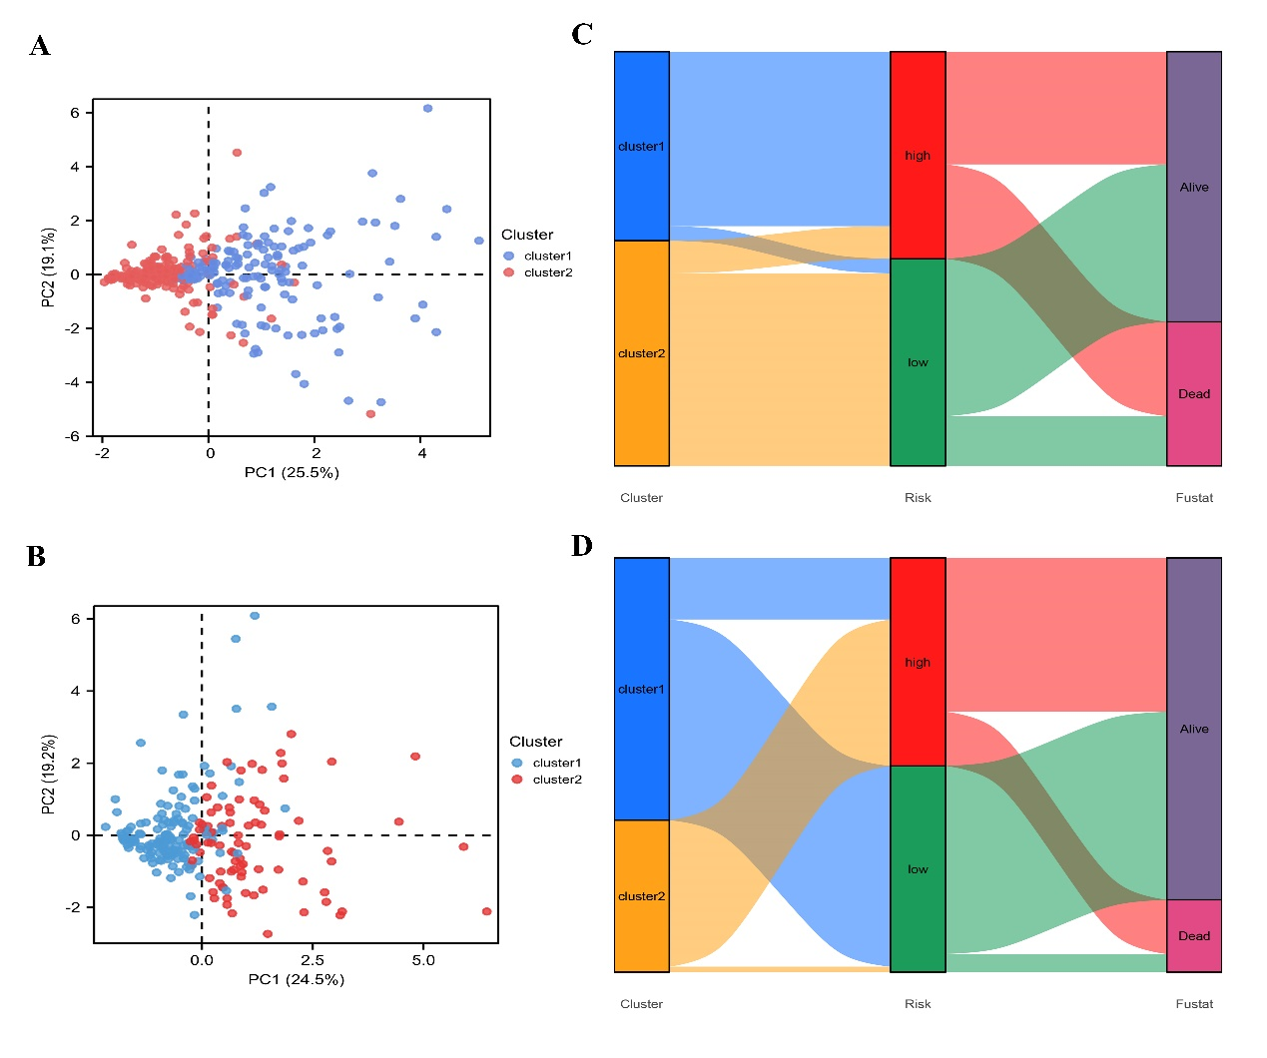
Figure S5 | Clustering analyses in TCGA and ICGC. (A) PCA results for two groups of patients in TCGA. (B) ggalluvial of two clusters in TCGA displayed the correlation between clusters, risk, and survival status. (C) PCA results for two groups of patients in ICGC. (D) ggalluvial of two clusters in ICGC displayed the correlation between clusters, risk, and survival status.

