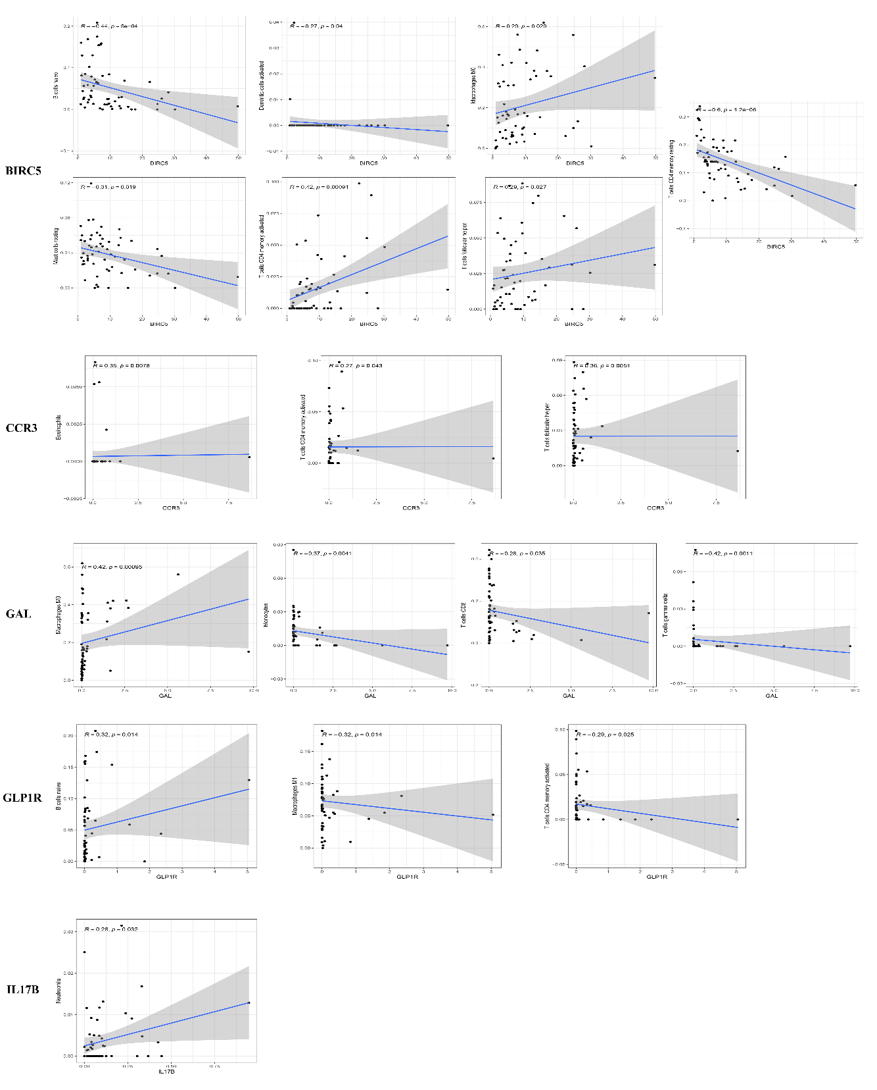
Figure S6 | Correlation between immune cells and seven genes in TCGA. MAPT and NROB1 have no Significant correlation wirh immune cells in TCGA.

