Supporting Information

Formation of Chlorate and Perchlorate during Electrochemical Oxidation by Magnéli Phase Ti₄O₇ Anode: Inhibitory Effects of Coexisting Constituents
Lu Wang^{a, b}, Yaye Wang^{c}, Yufei Sui^{c}, Junhe Lu^{b}, Baowei Huª, Qingguo Huang^{c,} *
ª School of Life Science, Shaoxing University, Shaoxing, 312000, China
^{b} Department of Environmental Science and Engineering, Nanjing Agricultural University, Nanjing, 210095, China
^{c} Department of Crop and Soil Sciences, University of Georgia, Griffin, GA 30223, USA

*Corresponding author:
E-mail: qhuang@uga.edu Telephone: +1-770-2293302

2 texts, 3 figures

Text S1

Electrode fabrication and characterization
The Magnéli phase Ti₄O₇ electrode was fabricated through a high temperature sintering process as described in our previous study (H. Lin et al. Chemical Engineering Journal, 2018, 354,1058-1067). In brief, TiO₂ powder was heated at 950 ◦C and reduced to Ti₄O₇ powder under controlled H₂ flow. The Ti₄O₇ powder was mixed (0.5%, m/m) with polyacrylamide/polyvinyl alcohol (95/5, m/m) to form a slurry that was then spray-dried to form ceramic granulates. The ceramic granulates were then pressed to make a ceramic preform that was dried and then sintered at 1350 °C in a vacuum for 11 h to form a bulk electrode.

The chemical composition of the Magnéli phase Ti₄O₇ electrode was characterized using an X’Pert PRO MRD X-ray diffractometer (XRD) (PANalytical, Netherlands) with CuKα1 radiation at 40 kV/40 mA. The surface morphology of Ti₄O₇ electrode was examined using scanning electron microscopy (SEM) on a Hitachi’s-4800 FE-SEM system (Hitachi, Japan). The porosimetry analysis of the anode was measured using a Micromeritics Autopore IV 9500 mercury porosimeter (Norcross, GA) according to method ISO 15901-1.

The XRD pattern confirmed Magnéli phase Ti₄O₇ as the dominant composition of the electrode material (Fig. S3 A and B). The SEM image (Fig. S3 C) shows fairly uniform interconnecting pores with diameters smaller than 10 µm on the surface of Magnéli phase Ti₄O₇ anode material. Mercury intrusion porosimetry analysis (Fig. S3 D) indicates a porosity of 21.6%, and a median pore diameter of 3.6 μm (based on volume) or 2.8 μm (based on area), and an average pore diameter of 2.6 μm.

Text S2
UPLC-MS/MS Analysis
Formation of ClO₃⁻ and ClO₄⁻ were quantified using the ultra-high performance liquid chromatography and mass spectrometry (UPLC-MS/MS, Waters ACQUITY, Milford, MA). An ACQUITY UPLC BEH 1.7-micron C18 column (Waters, Milford, MA) was used for UPLC separation. The mobile phase consists of 50% water (A) and 50% MeOH (B) running at 0.3 mL min⁻¹. Electrospray ionization was operated in negative mode with the capillary voltage at 3 kV and the source temperature at 400 °C. ClO₃⁻ and ClO₄⁻ were quantified using multiple reactions monitoring (MRM) based on the transition m/z = 83 > 67 for ClO₃⁻, and m/z = 99 > 83 for ClO₄⁻. Quantification was achieved using a five-point calibration curve. The detection limits for ClO₃⁻ and ClO₄⁻ were 50.0 μg L⁻¹ and 25.0 μg L⁻¹, respectively, with an injection volume of 10.0 μL.

Fig. S1 The anodic potential on Ti₄O₇ in Na₂SO₄ solution with MeOH (a) and KI (b) spiked during the oxidation of Cl⁻. [Cl⁻]₀= 1 mM, [Na₂HPO₄]= 100 mM, current density = 10 mA‧cm⁻².

Fig. S2 Formation of ClO₃⁻ and ClO₄⁻ during the electrochemical oxidation of Cl⁻ in the presence of H₂O₂ on Ti₄O₇ anodes. Conditions: [Cl⁻]₀= 1 mM, [Na₂HPO₄] = 100 mM, current density = 10 mA‧cm⁻².

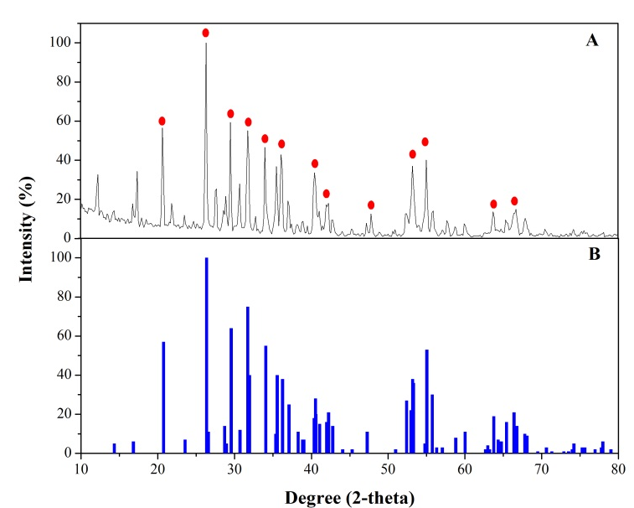
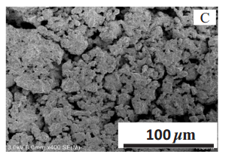
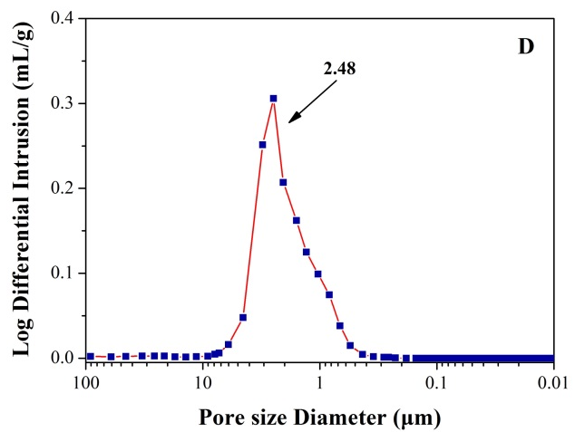
Fig. S3 XRD data of Magnéli phase Ti₄O₇ electrode material (A) and reference Ti₄O₇ powder (B); SEM image of Ti₄O₇ electrode material (C); Result of mercury intrusion analysis of pore size distribution (D).

