Nasal microbiome disruption and recovery after mupirocin treatment in Staphylococcus aureus carriers and noncarriers

Valérie O. Baede^{1#}, Anaïs Barray ^{2,3#}, Mehri Tavakol¹, Gérard Lina ^{2,3}, Margreet C. Vos ^{1¶}, Jean-Philippe Rasigade^{2,3¶*} on behalf of the MACOTRA study group

- Department of Medical Microbiology and Infectious Diseases, Erasmus MC University Medical Center Rotterdam, Rotterdam, the Netherlands
- CIRI, Centre International de Recherche en Infectiologie, Inserm U1111, Université Lyon 1, Ecole Normale Supérieure de Lyon, Lyon, France
- Centre National de Référence des Staphylocoques, Institut des Agents infectieux, Hôpital de la Croix Rousse, Hospices Civils de Lyon, Lyon, France

Supplementary information file

Supplementary table 1. Risk factors for S. aureus acquisition
 |  | Cohorts
 |  | Noncarrier | Carrier
Total |  | 8 | 8
Hormonal contraception |  | 1 | 4
Dairy consumption
 | Daily | 6 | 6
 | Weekly | 1 | 1
 | Monthly | 0 | 1
Disinfectants
 | Daily | 3 | 1
 | Weekly | 2 | 1
Smoking
 | Daily | 1 | 0
Alcohol consumption
 | Daily | 1 | 2
 | Weekly | 2 | 2
 | Monthly | 2 | 3
 | < 1x per month | 2 | 1
Nose picking
 | Daily | 5 | 2
 | Weekly | 2 | 5
 | Monthly |  | 1
 | < 1x per month | 1
Household size
 | 1 |  | 1
 | 2 | 5 | 5
 | 3 | 3 | 1
 | 4 |  | 1
Team sport or communal gym
 | Weekly | 2 | 2
 | Monthly |  | 1
Sauna visits
 | < 1x per month | 1 | 3
Healthcare or beauty practice
 | < 1x per month | 1 | 2
Public transport
 | Daily | 1 | 4
 | Weekly | 0 | 3
 | Monthly | 1 | 0
 | < 1x per month | 3 | 1

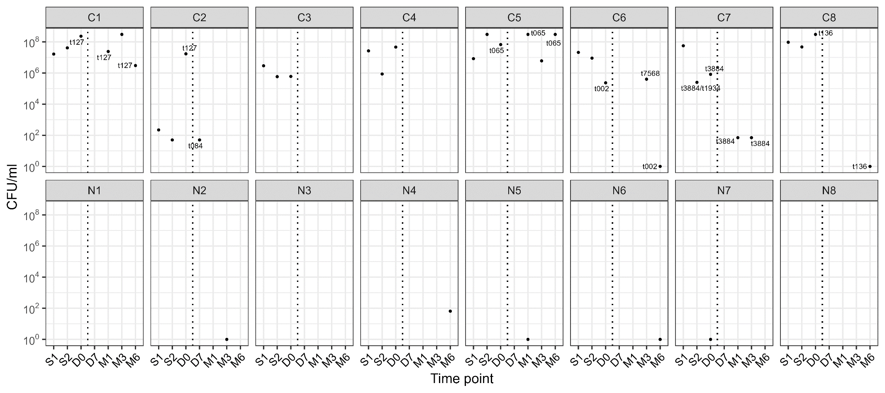
Supplementary Figure 1. S. aureus culture dynamics in carriers and noncarriers.
Sampling took place at screening time points S1 and S2. During the study phase, nasal samples were taken 1 day pre-treatment (D0) and 2 days (D7), 1 month (M1), 3 months (M3) and 6 months (M6) post-treatment. S. aureus-positive cultures are depicted as black dots, with bacterial load given on the y-axis. The vertical dotted line shows time of treatment. Spa-typing results are given as dot labels. Recolonization was defined as a S. aureus positive culture (>8 CFU/ml) post-decolonization
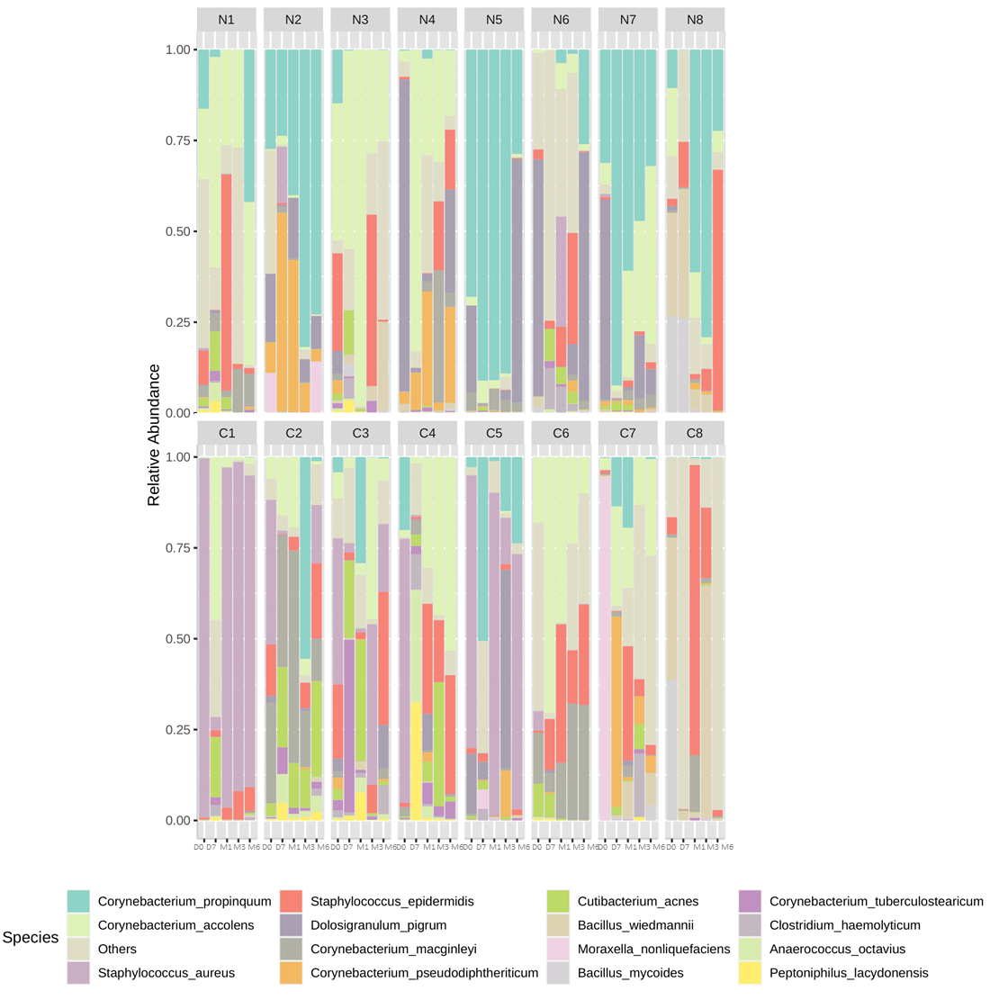
Supplementary Figure 2. Nasal microbiota of study participants in time.
A more detailed look at the nasal microbiota of the study participants. Samples were taken immediately before decolonization (D0) and after 7 days (D7) and 1 (M1), 3 (M3), and 6 (M6) months in 8 S. aureus carriers (down) and noncarriers (up).
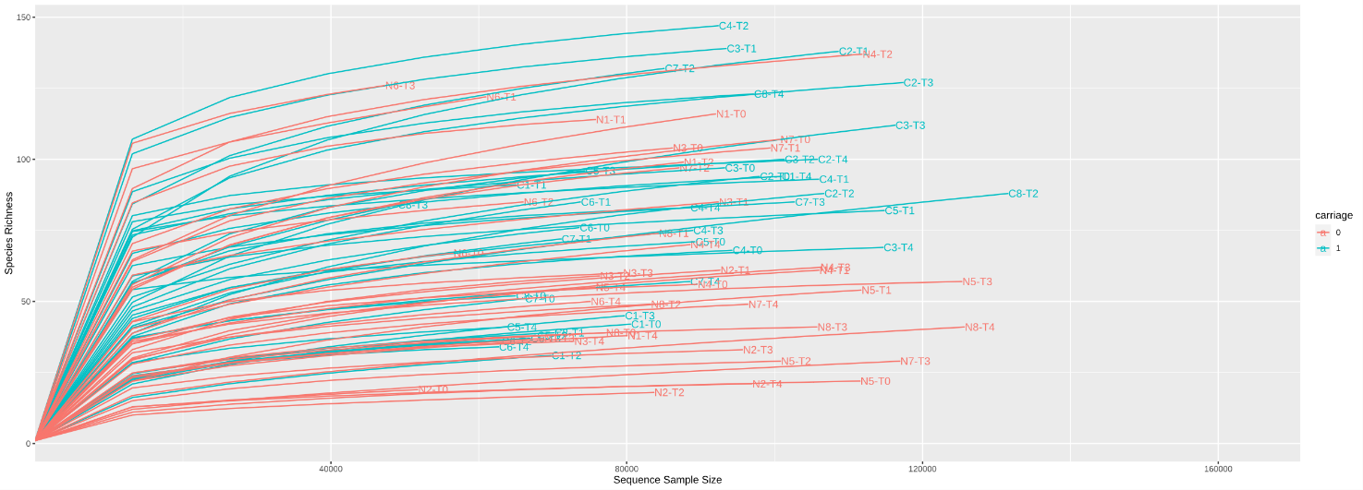
Supplementary Figure 3. Rarefaction plot
Rarefaction curves showing the number of sequences per sample and the belonging Species richness uncovered ; carriers in red, noncarriers in blue. Curves reaching a plateau mean that a deeper sequencing wouldn’t result in significant Species richness increase. Current sequencing have enough read depth to be analyzed.

