8. Appendix
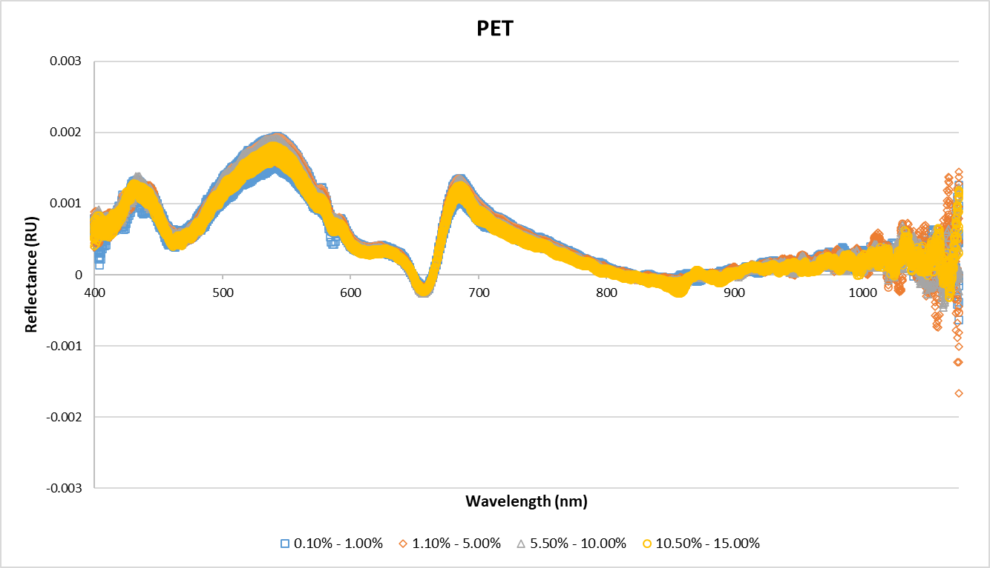
Fig. S1(a): vis-NIR spectra of PET (concentration from 0.1% to 15%) spiked beach sediment sample after preprocessing

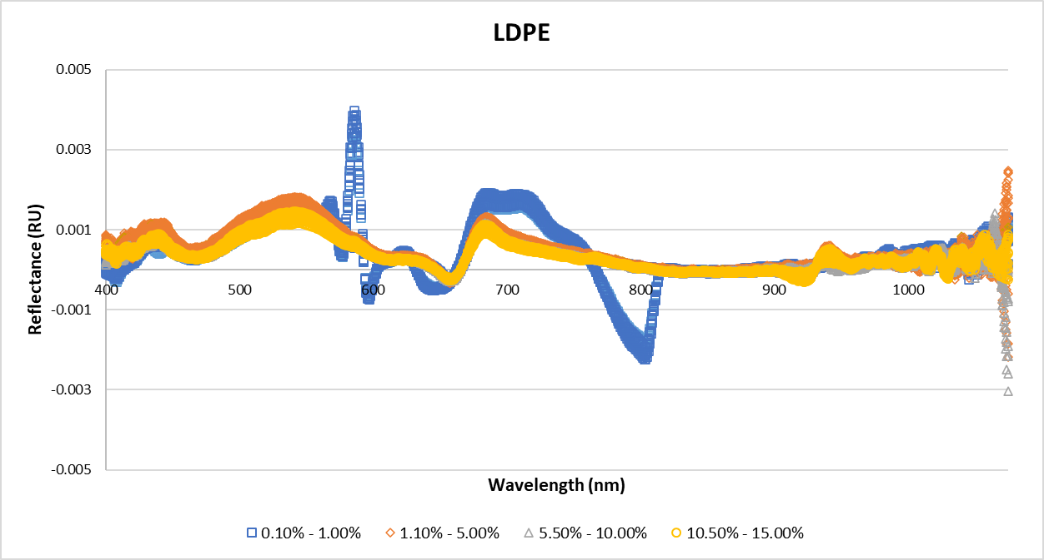
Fig. S1(b): vis-NIR spectra of LDPE (concentration from 0.1% to 15%) spiked beach sediment sample after preprocessing
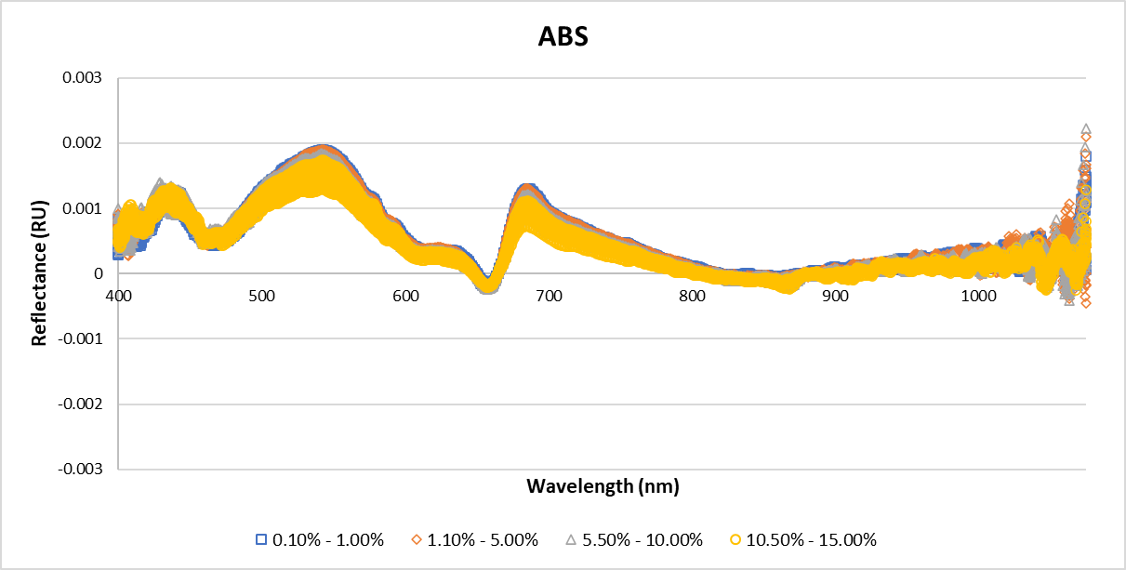
Fig. S1(c): vis-NIR spectra of ABS (concentration from 0.1% to 15%) spiked spiked beach sediment sample after preprocessing
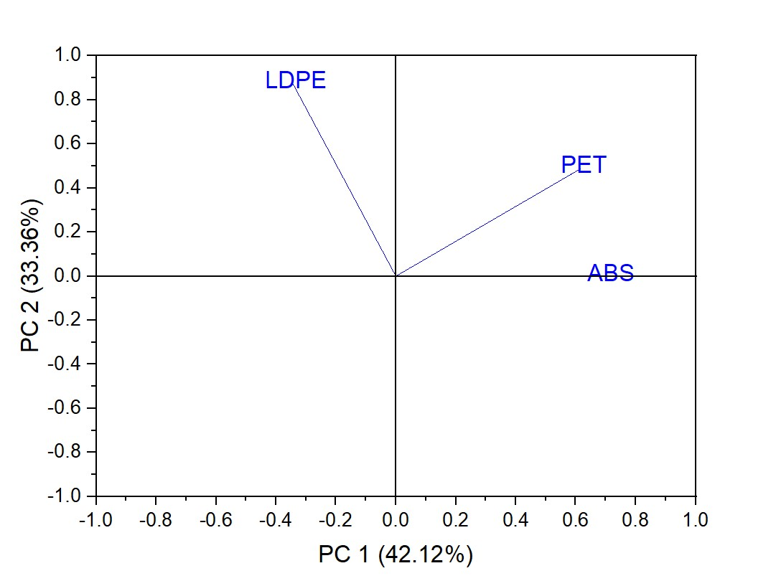
Fig. S2: PCA scores plot of LDPE, PET and ABS.

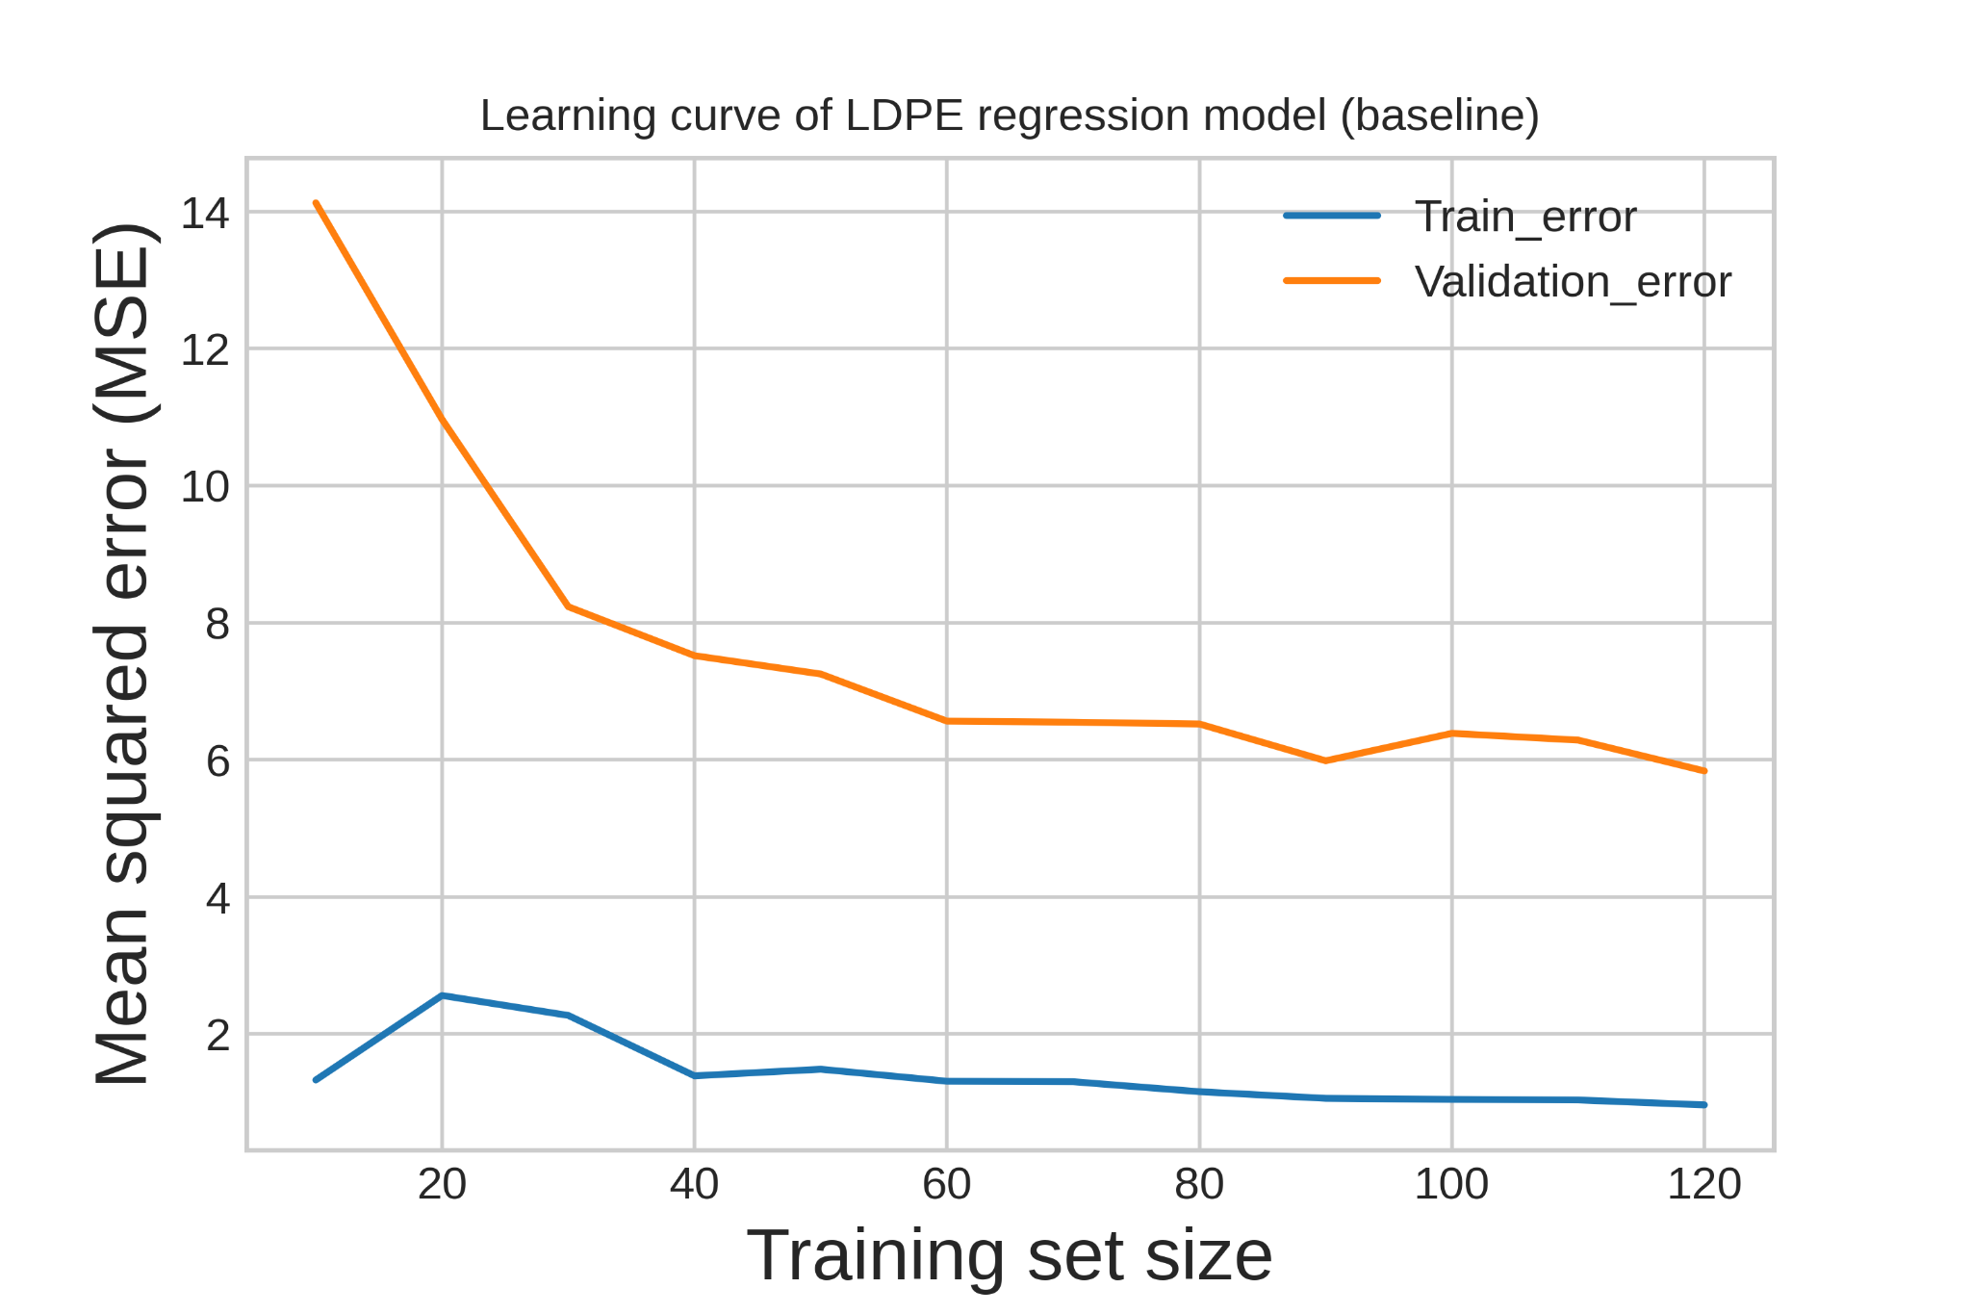
Fig. S3(a):Learning curve of LDPE regression model (baseline)
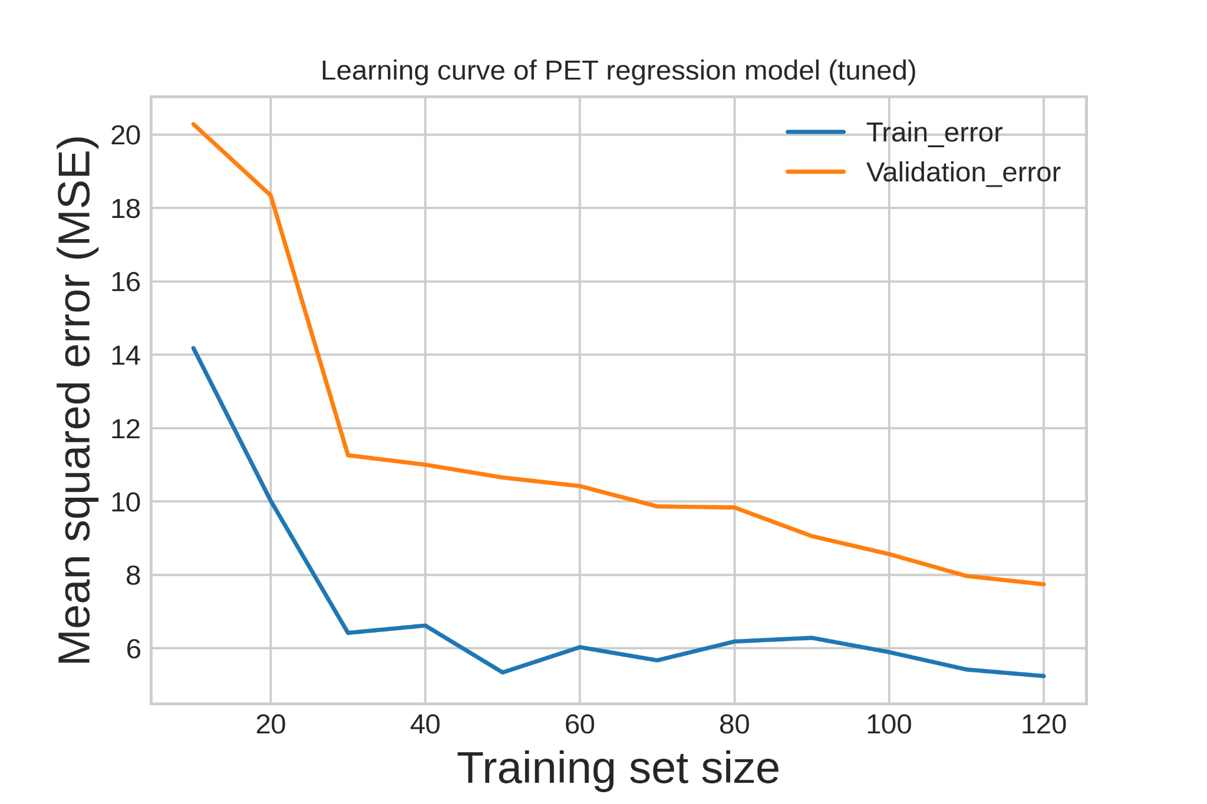
Fig. S3(b):Learning curve of PET regression model (tuned)
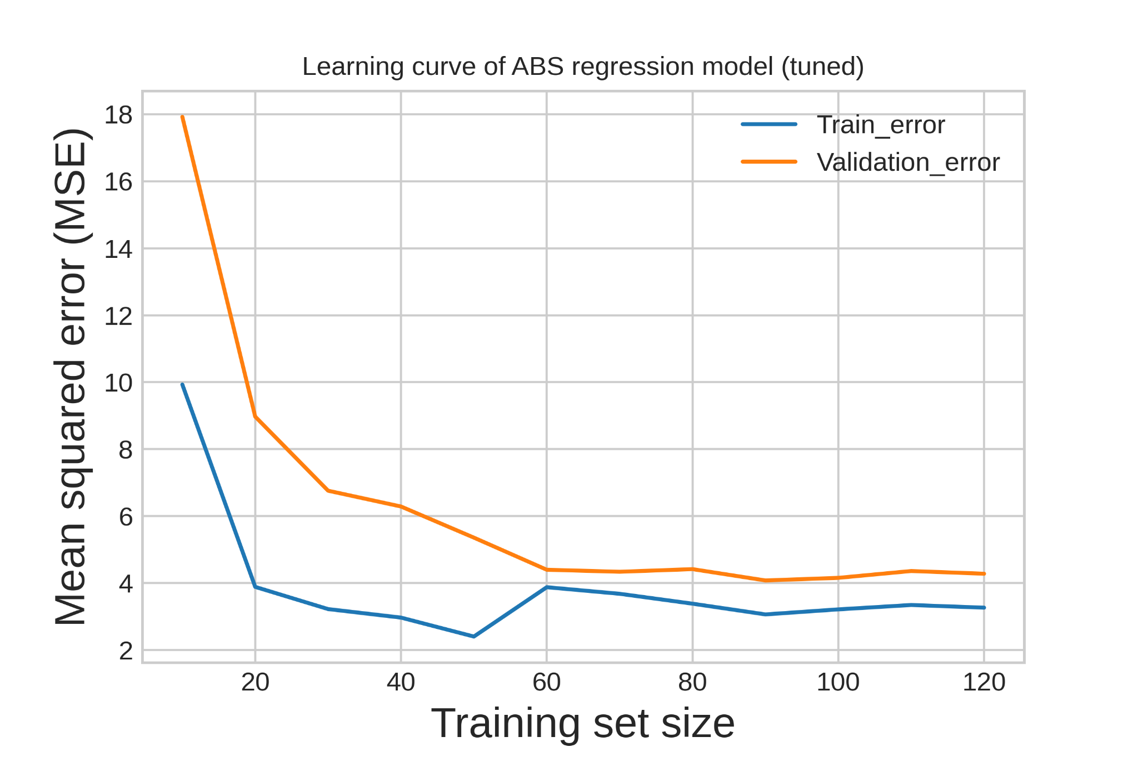
Fig. S3(c):Learning curve of ABS regression model (tuned)
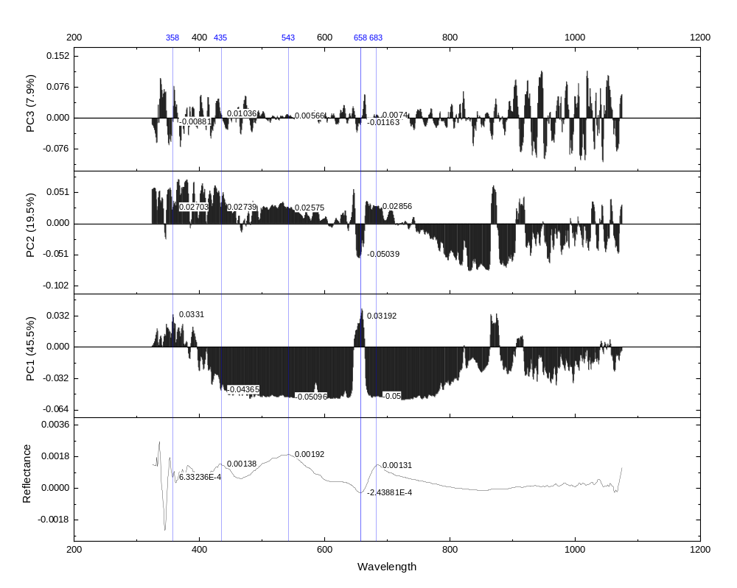
Fig. S4(a): Loading Score with a reference spectrum for PET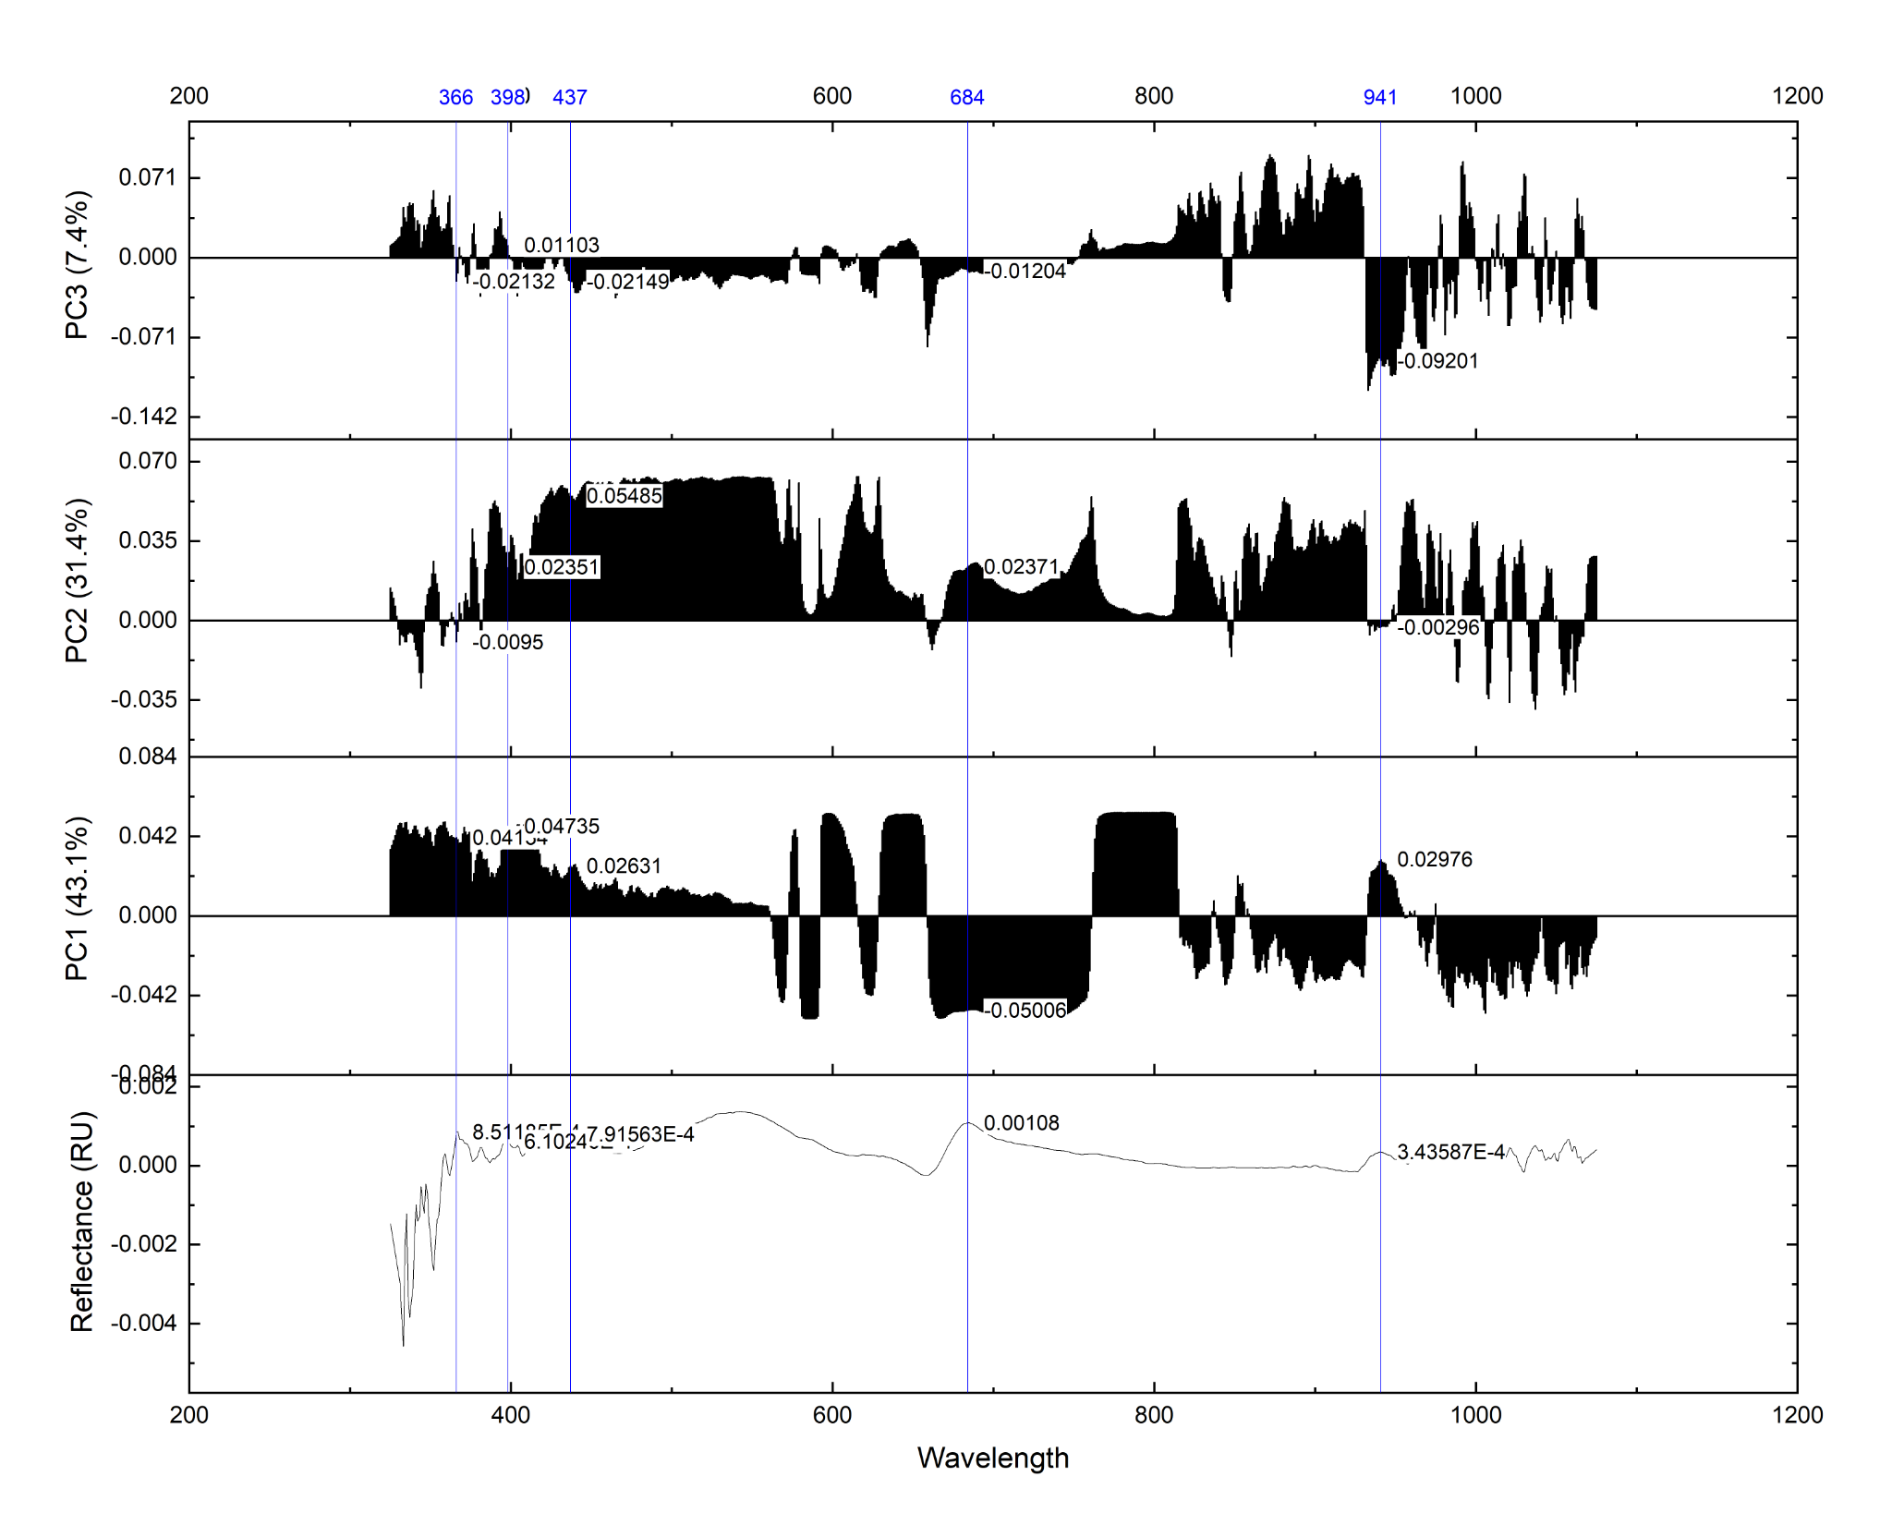Fig. S4(b): Loading Score with a reference spectrum for LDPE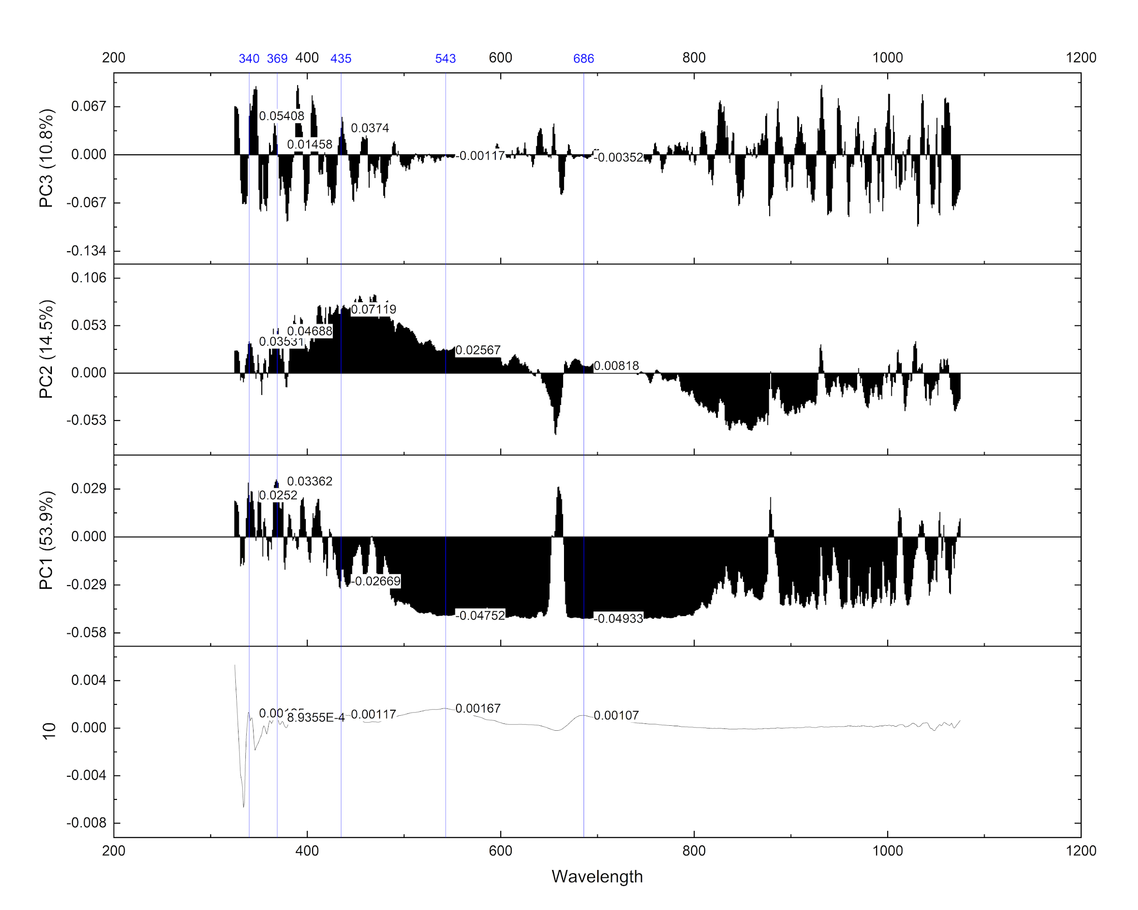
Fig. S4(c): Loading Score with a reference spectrum for ABS

- Feature selection
Table S1: Selected features and the importance values
LDPE |  | PET |  | ABS
Feature (wavelength) | Importance | Feature (wavelength) | Importance | Feature (wavelength) | Importance
1072 | 0.11 | 333 | 0.14 | 367 | 0.21
347 | 0.058 | 373 | 0.1 | 373 | 0.13
776 | 0.051 | 372 | 0.072 | 338 | 0.13
329 | 0.032 | 332 | 0.06 | 374 | 0.11
769 | 0.023 | 327 | 0.059 | 346 | 0.058
763 | 0.023 | 325 | 0.034 | 337 | 0.057
761 | 0.023 | 328 | 0.033 | 332 | 0.03
765 | 0.023 | 395 | 0.027 | 329 | 0.027
782 | 0.022 | 334 | 0.024 | 348 | 0.017
338 | 0.02 | 329 | 0.023 | 342 | 0.015
372 | 0.019 | 341 | 0.02 | 334 | 0.011
337 | 0.019 | 394 | 0.013 | 331 | 0.0087
1056 | 0.017 | 742 | 0.012 | 327 | 0.0086
783 | 0.017 | 580 | 0.012 | 349 | 0.0084
768 | 0.017 | 326 | 0.01 | 330 | 0.0076

- Algorithm selection
Table S2: Regression algorithm from Scikit-learn included in the algorithm selection pipeline.
Regression algorithm
Lasso
LGBMRegressor
LinearRegression
ElasticNet
DecisionTreeRegressor
KNeighborsRegressor
GradientBoostingRegressor
SVR
KernelRidge
SGDRegressor
RandomForestRegressor
BayesianRidge

Table S3: MSE and SD from the algorithm selection.
Algorithm | LDPE |  | PET |  | ABS
Algorithm | MSE | SD | MSE | SD | MSE | SD
LASSO | 23 | 1.7 | 16 | 1.2 | 27 | 26
LGBM | 6.1 | 1.6 | 8.2 | 2.4 | 23 | 20
LR | 960000 | 1800000 | 8.1 | 1 | 18 | 13
EN | 22 | 1.7 | 13 | 0.51 | 23 | 24
CART | 11 | 1.7 | 13 | 1.3 | 31 | 29
KNN | 8.7 | 2.5 | 6.9 | 2.5 | 15 | 11
GBM | 6.5 | 0.96 | 7.4 | 0.95 | 22 | 22
SVR | 24 | 4.8 | 8.8 | 2.4 | 16 | 15
KRidge | 51 | 7.3 | 37 | 3.3 | 35 | 25
SGD | 22 | 1.3 | 7.9 | 1.2 | 19 | 16
RF | 6 | 1.6 | 8.1 | 1.6 | 21 | 22
BRidge | 59 | 64 | 7.8 | 1.2 | 19 | 16

Table S4: Comparison of the baseline vs tuned regression models.
 | Baseline | Tuned
LDPE (RF)
MAE | 1.3 | 1.3
MSE | 3.5 | 3.8
RMSE | 1.9 | 1.9
R2 | 0.84 | 0.83
PET (KNN)
MAE | 1.8 | 1.8
MSE | 7.4 | 7.4
RMSE | 2.7 | 2.7
R2 | 0.66 | 0.66
ABS (KNN)
MAE | 1.1 | 1.1
MSE | 2.9 | 2.4
RMSE | 1.7 | 1.6
R2 | 0.86 | 0.88

Table S5(a): Eigenvalues of PET PCA
Principal Component Number | Eigenvalue | Percentage of Variance (%) | Cumulative (%)
1 | 340 | 46 | 46
2 | 150 | 20 | 65
3 | 59 | 7.9 | 73
4 | 43 | 5.8 | 79
5 | 36 | 4.7 | 83
6 | 27 | 3.6 | 87
7 | 16 | 2.1 | 89
8 | 11 | 1.5 | 91
9 | 7.9 | 1.1 | 92
10 | 5.4 | 0.72 | 92
11 | 5 | 0.66 | 93
12 | 3.9 | 0.52 | 94
13 | 3.6 | 0.48 | 94
14 | 3.3 | 0.44 | 95
15 | 3.2 | 0.43 | 95
16 | 2.8 | 0.38 | 95
17 | 2.8 | 0.37 | 96
18 | 2.5 | 0.33 | 96
19 | 2.3 | 0.31 | 96
20 | 2.2 | 0.3 | 97
21 | 2.1 | 0.27 | 97
22 | 2 | 0.27 | 97
23 | 1.8 | 0.24 | 97
24 | 1.6 | 0.22 | 98
25 | 1.6 | 0.21 | 98
26 | 1.5 | 0.19 | 98
27 | 1.4 | 0.18 | 98
28 | 1.2 | 0.16 | 98
29 | 1.2 | 0.15 | 99
30 | 1.1 | 0.14 | 99
31 | 1 | 0.13 | 99
32 | 0.93 | 0.12 | 99
33 | 0.87 | 0.12 | 99

Table S5(b): Eigenvalues of LDPE PCA
Principal Component Number | Eigenvalue | Percentage of Variance (%) | Cumulative (%)
1 | 320 | 43 | 43
2 | 240 | 31 | 75
3 | 55 | 7.4 | 82
4 | 31 | 4.1 | 86
5 | 23 | 3 | 89
6 | 16 | 2.1 | 91
7 | 14 | 1.9 | 93
8 | 10 | 1.3 | 94
9 | 7.7 | 1 | 95
10 | 6.8 | 0.91 | 96
11 | 3.1 | 0.41 | 97
12 | 2.5 | 0.34 | 97
13 | 2.1 | 0.28 | 97
14 | 1.8 | 0.24 | 98
15 | 1.7 | 0.23 | 98
16 | 1.6 | 0.22 | 98
17 | 1.5 | 0.2 | 98
18 | 1.3 | 0.17 | 98
19 | 1.1 | 0.15 | 99
20 | 1 | 0.14 | 99
21 | 1 | 0.13 | 99
22 | 0.83 | 0.11 | 99
23 | 0.77 | 0.1 | 99

Table S5(c): Eigenvalues of ABS PCA
Principal Component Number | Eigenvalue | Percentage of Variance (%) | Cumulative (%)
1 | 400 | 54 | 54
2 | 110 | 14 | 68
3 | 81 | 11 | 79
4 | 53 | 7 | 86
5 | 20 | 2.7 | 89
6 | 9 | 1.2 | 90
7 | 7.7 | 1 | 91
8 | 6 | 0.8 | 92
9 | 5.4 | 0.72 | 93
10 | 5.2 | 0.7 | 93
11 | 3.8 | 0.5 | 94
12 | 3.6 | 0.48 | 94
13 | 3.4 | 0.45 | 95
14 | 3.1 | 0.42 | 95
15 | 2.9 | 0.39 | 96
16 | 2.8 | 0.37 | 96
17 | 2.4 | 0.32 | 96
18 | 2.2 | 0.3 | 97
19 | 2.1 | 0.28 | 97
20 | 1.9 | 0.26 | 97
21 | 1.8 | 0.24 | 97
22 | 1.7 | 0.23 | 98
23 | 1.5 | 0.2 | 98
24 | 1.5 | 0.2 | 98
25 | 1.4 | 0.19 | 98
26 | 1.3 | 0.17 | 98
27 | 1.3 | 0.17 | 98
28 | 1.1 | 0.15 | 99
29 | 0.97 | 0.13 | 99
30 | 0.91 | 0.12 | 99
31 | 0.89 | 0.12 | 99
32 | 0.86 | 0.11 | 99

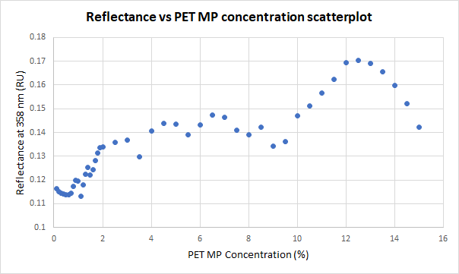
Fig. S5(a): Scatterplot of reflectance at significant wavelength vs PET MP concentration.

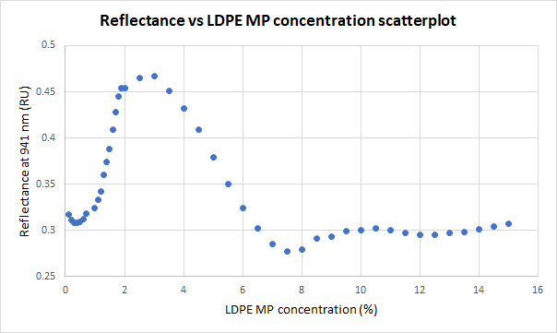
Fig. S5(b): Scatterplot of reflectance at significant wavelength vs LDPE MP concentration.

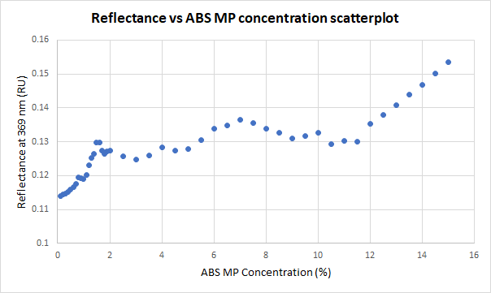
Fig. S5(c): Scatterplot of reflectance at significant wavelength vs ABS MP concentration.

Table S6(a): Summary of AIC and BIC scores of potential polynomial regression models for PET dataset
Functions | Status | AIC | BIC | Adj. R-Square
Poly9 | Succeeded(100) | -520 | -510 | 0.97
Poly5 | Succeeded(100) | -500 | -490 | 0.95
Poly4 | Succeeded(100) | -470 | -460 | 0.89
Cubic | Succeeded(100) | -450 | -440 | 0.81
Line | Succeeded(100) | -440 | -440 | 0.78
Constant | Succeeded(100) | -370 | -370 | 0.00

Table S6(b): Summary of AIC and BIC scores of potential polynomial regression models for LDPE dataset
Functions | Status | AIC | BIC | Adj. R-Square
Poly9 | Succeeded(100) | -390 | -380 | 0.98
Poly4 | Succeeded(100) | -320 | -310 | 0.83
Poly5 | Succeeded(100) | -310 | -300 | 0.82
Cubic | Succeeded(100) | -280 | -270 | 0.60
Line | Succeeded(100) | -250 | -250 | 0.23
Constant | Succeeded(100) | -240 | -240 | 0.00

Table S6(c): Summary of AIC and BIC scores of potential polynomial regression models for ABS dataset
Functions | Status | AIC | BIC | Adj. R-Square
Poly9 | Succeeded(100) | -580 | -570 | 0.97
Cubic | Succeeded(100) | -540 | -530 | 0.91
Poly4 | Succeeded(100) | -530 | -530 | 0.91
Poly5 | Succeeded(100) | -530 | -520 | 0.92
Line | Succeeded(100) | -490 | -490 | 0.76
Constant | Succeeded(100) | -430 | -420 | 0.00

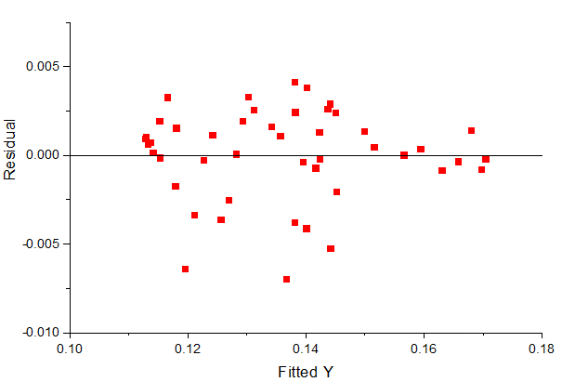Fig. S6(a): Residual plot of PET’s 9th order polynomial regression
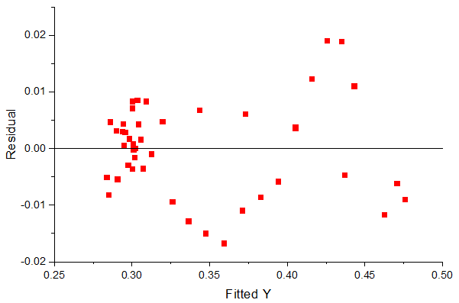Fig. S6(b): Residual plot of LDPE’s 9th order polynomial regression
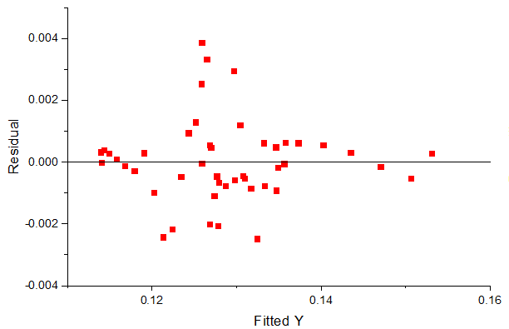Fig. S6(c): Residual plot of LDPE’s 9th order polynomial regression

Table S7(a): Summary of ANOVA for PET’s mean reflectance values at each concentration level
 |  | DF | Sum of Squares | Mean Square | F Value
Reflectance at 358 nm | Regression | 9 | 0.013 | 0.0014 | 170
Reflectance at 358 nm | Residual | 36 | 0.0003 | 0.0000083
Reflectance at 358 nm | Uncorrected Total | 46 | 0.86
Reflectance at 358 nm | Corrected Total | 45 | 0.013
*Reflectance at 358 nm: At the 0.05 level, the fitting function is significantly better than the function y=constant

Table S7(b): Summary of ANOVA for LDPE’s mean reflectance values at each concentration level
 |  | DF | Sum of Squares | Mean Square | F Value
Reflectance at 941 nm | Regression | 9 | 0.15179 | 0.01687 | 197.2931
Reflectance at 941 nm | Residual | 34 | 0.0029 | 0.000085
Reflectance at 941 nm | Uncorrected Total | 44 | 5.3355
Reflectance at 941 nm | Corrected Total | 43 | 0.15469
*Reflectance at 941 nm: At the 0.05 level, the fitting function is significantly better than the function y=constant

Table S7(c): Summary of ANOVA for ABS’s mean reflectance values at each concentration level
 |  | DF | Sum of Squares | Mean Square | F Value
Reflectance at 369 nm | Regression | 9 | 0.0037 | 0.00042 | 190
Reflectance at 369 nm | Residual | 36 | 0.00008 | 0.0000022
Reflectance at 369 nm | Uncorrected Total | 46 | 0.77
Reflectance at 369 nm | Corrected Total | 45 | 0.0038
*Reflectance at 358 nm: At the 0.05 level, the fitting function is significantly better than the function y=constant
Table S8: Regression algorithm with the MSE and its SD from cross validation score.
MP sample | Algorithm selected | MSE | SD
LDPE | RF regressor | 6.0 | 1.6
PET | KNN regressor | 7.0 | 2.6
ABS | KNN regressor | 15 | 11

