Extended Data

Extended Data Fig. S1. PCR validation for engineered cell lines by CRISPR/Cas9-knockin.
(a) Schematic representation of genotyping for CRISPR/Cas9 engineered cell lines used for the study. Primers are listed in Extended Data Table S1. (b) Genotyping results for the cell lines after PCR amplification for target regions. Lane numbers denote primer pairs represented in (a).

Extended Data Fig. S2. Super-resolution images of HaloTag-labeled SAF-A in hTERT-RPE1 and HCT116 cells.
(a and f) A conventional fluorescence image of JF646 labeled SAF-A in fixed hTERT-RPE1 cells (a) and HCT116 cells (f). (b and g) Super-resolution (dSTORM) image of SAF-A. (c to e) Representative super-resolved images of SAF-A in a hTERT-RPE1 cell. Successive images are magnified versions of the boxed area in the previous image. (h to j) Representative super-resolved images of SAF-A in a HCT116 cell. Successive images are magnified versions of the boxed area in the previous image. JF646 labeled SAF-A via HaloTag also show the nuclear matrix structures. Scale bars represent 5 µm for entire nuclei images and 1 µm or 500 nm for zoom-in images.

Extended Data Fig. S3. Exclusion of SAF-A from mitotic chromosomes.
(a to c) Conventional fluorescence images for SAF-A-Dendra2 (a), H2B-EBFP2 (b) and a merged image (c) in metaphase. (d to f) Conventional fluorescence images for SAF-A-Dendra2 (d), H2B-EBFP2 (e) and a merged image (f) in anaphase. (g to i) Conventional fluorescence images for SAF-A-mAID-Halo-JF646 (g), DAPI staining (h) and a merged image (i) in metaphase. (j to l) Conventional fluorescence images for SAF-A-mAID-Halo-JF646 (g), DAPI staining (h) and a merged image (i) in anaphase. Scale bars, 5μm.

Extended Data Fig. S4. Dynamic structure of the nuclear matrix in live nuclei.
Time-lapse super-resolved images of SAF-A-Dendra2 cells under DMSO treatment. Video available as Extended Data Movie S2. Scale bars, 5μm in overview, 1μm in zoom-in images.

Extended Data Fig. S5. The nuclear matrix is RNA-dependent.
Result of in situ fractionation followed by RNase or DNase treatment in HCT116 cells expressing H2B-EBFP2 and SAF-A-Dendra2. Results of (a) DNase I and (b) RNase A treatments. Scale bars, 5μm.

Extended Data Fig. S6. Capturing the nascent RNA enrichment near the nuclear matrix.
The intranuclear localization of the nuclear matrix and the nascent RNA. (a) A super-resolved image (dSTORM) of JF646-HaloTag labeled SAF-A in a fixed HCT116 cell nucleus. (b) A corresponding image of density rendering for nuclear nascent RNA by EU labelling with Alexa Fluor 488. (c) Each numbered panel correspond to boxed area in (a). (d) Each numbered panels correspond to boxed area in (b). (e) Saturated images of intensive areas in (d). (f) Merged images of the super-resolved images of SAF-A (c) and nascent RNA enriched regions (e). Scale bars represent 5 µm for entire nuclei images and 1 µm for zoom-in images.

Extended Data Fig. S7. Schematic representation of an experimental procedure for acute depletion of SAF-A followed by overexpressing SAF-A mutant constructs.
(a) Each SNAP-tagged SAF-A mutants were cloned in Tet-On expression vector and transiently transfected to the monoclonal homozygous SAF-A-mAID-Halo CMV-OsTIR cells. (b) The experimental time-line of the acute depletion of endogenous SAF-A followed by mutant rescue.

Extended Data Fig. S8. Dual-color fluorescence images of histone markers and SAF-A.
(a to c) Dual-color images of SAF-A and a euchromatin histone marker, H3K27ac in a cell nucleus. (d) A dot plot for colocalization analysis between SAF-A and H3K27ac signals. (e to g) Dual-color images of SAF-A and a heterochromatin histone marker, H3K27me3 in a cell nucleus. (h) A dot plot for colocalization analysis between SAF-A and H3K27me3 signals. (i) Distributions of Pearson’s R values for SAF-A vs. H3K27ac and SAF-A vs. H3K27me3 from N = 22 cells and 27 cells, respectively. All images are obtained using spinning disk confocal microscopy (Nikon CSU-W1). Scale bars, 5μm.

Extended Data Fig. S9. Dual-color imaging of SAF-A-Dendra2 and JF646-Halo Pol II in HCT116 cells after treatment of transcription inhibitors.
Dual-color imaging of SAF-A-Dendra2 and JF646-Halo-Pol II after treatment of (a) DMSO, (b) ActD and (c) DRB. Each numbered panel corresponds to boxed areas in each image. Scale bars, 5μm in (a), (b) and (c), 1μm in zoom-in box.

Extended Data Fig. S10. Schematic representation of quantitative measurement for the nuclear matrix and the transcriptional condensates.
(a) Skeletonization process for the super-resolved images of nuclear matrix. (b) A super-resolved image of transcriptional condensates. (c) Defining transcriptional condensates by DBSCAN analysis for clustering. (d) A rendered image shows skeletonized nuclear matrix and center points of transcriptional condensates together. Scale bars, 5μm.

Extended Data Fig. S11. The disruption of the nuclear matrix upon transcription inhibition is dynamic and reversible.
Disruption and restoration of the nuclear matrix and coordinated positioning of the transcriptional condensates upon DRB treatment and washout. Dual-color image of SAF-A-Dendra2 and JF646-Halo-Pol II in (a) untreated cell, (b) cell after 3 hours of DRB treatment, (c) cell after 6 hours of DRB treatment and (d) cell incubated without DRB for 6 hours, after 6 hours of DRB treatment. Scale bars, 5μm.

Extended Data Fig. S12. Radial distribution of SAF-A in a single nucleus changes upon transcription inhibition.
The radial average intensity in a single nucleus of (a) DMSO or (b) DRB treated cell, respectively. Each nucleus is sectioned into five segments relative to the center of the nucleus. (c) Distribution of average intensity of each segment in drug-treated cells. (N = 30 cells from two experimental replicates) Error bars show mean ± standard deviation of the mean (s.d.m.). *, **, ***, **** indicate statistical significance at P < 0.05, P < 0.01, P < 0.001 and P < 0.0001 unpaired two-tailed Student’s t-tests. Scale bars, 5μm.

Extended Data Fig. S13. Validation of 7SK depletion by RT-qPCR in scramble or 7SK ASO transfected cells.
Validation of 7SK depletion by RT-qPCR in scramble or 7SK ASO tranfected cells with (a) RNAiMAX or (b) nucleofection. (N = 3 for technical replicates) Error bars show mean ± standard deviation of the mean (s.d.m.). *, **, *** indicate statistical significance at P < 0.05, P < 0.01 and P < 0.001 unpaired two-tailed Student’s t-tests.

Extended Data Fig. S14. Disruption of the layered structure of transcriptional condensates and nuclear speckles relative to the nuclear matrix upon transcription inhibition by DRB treatment.
(a) Three-color imaging of SAF-A-Dendra2, JF646-Halo-Pol II, and immunofluorescence of SC35 in DRB treated HCT116. (b) Distribution of the number of nuclear speckles in a single nucleus. (c) Distribution of the average size of nuclear speckles in a single nucleus. (N = 30 from two experimental replicates) Scale bars, 5μm in (a), 1μm in zoom-in box. Error bars show mean ± standard deviation of the mean (s.d.m.). *, **, ***, **** indicate statistical significance at P < 0.05, P < 0.01, P < 0.001 and P < 0.0001 unpaired two-tailed Student’s t-tests.

Extended Data Fig. S15. Visualization of chromosome territories relative to the nuclear matrix.
(a) Multicolor image of chromosome 3, 9, and 19 visualized with whole chromosome painting, together with SAF-A-mAID-Halo-JF646. (b-e) Dual-color image of SAF-A-mAID-Halo-JF646 and (b) chromosome 3, (c) chromosome 6, (d) chromosome 9, (e) chromosome 19. Scale bars, 5μm.

Extended Data Fig. S16. Visualization of the nucleoli along with transcriptional condensates and nuclear matrix by immunofluorescence labeling.
Three-color image of SAF-A-Dendra2, JF646-Halo-Pol II and immunofluorescence of fibrillarin, nucleoli marker. Scale bar, 5μm.

Extended Data Table S1. Oligo sequences for cloning and PCR

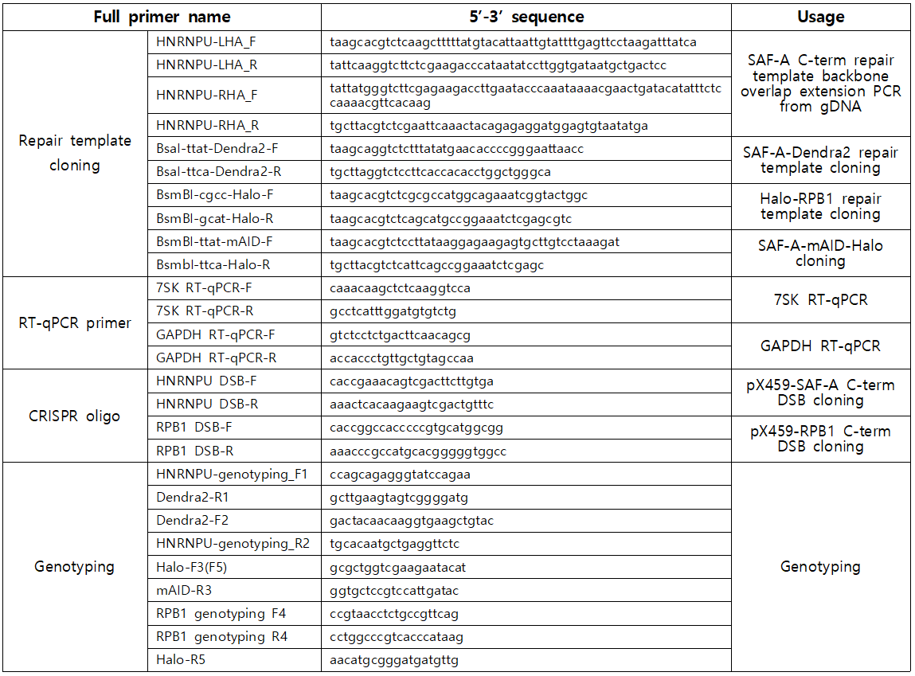

Extended Data Movie S1.
The z-stack images of intranuclear SAF-A framework. Each image sequence was rendered from 500 frame images by ThunderSTORM with z-step size of 0.2μm. Scale bar, 5μm. The z-stack movements are repeated three times in the movie. The movie shows the structural network of the nuclear matrix extends throughout the entire nucleus.

Extended Data Movie S2.
The time-lapse movie of transformable structure of intranuclear SAF-A framework. Each image sequence was rendered from 500 frame images by ThunderSTORM with 20 min time interval. Scale bar, 10μm. The movie shows the nuclear matrix is dynamic in live cells.

