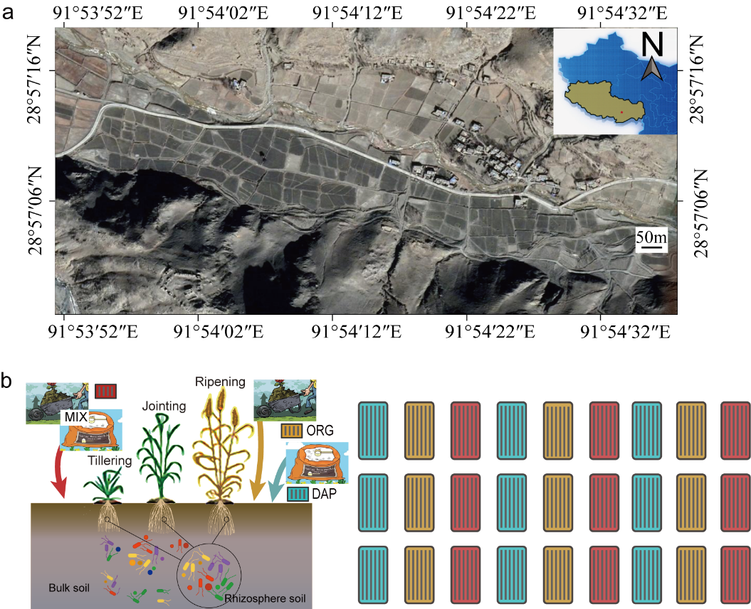
Figure S1. The location of Tibetan hulless barley field area (a) and experimental design (b) in Shannan city, Tibet.

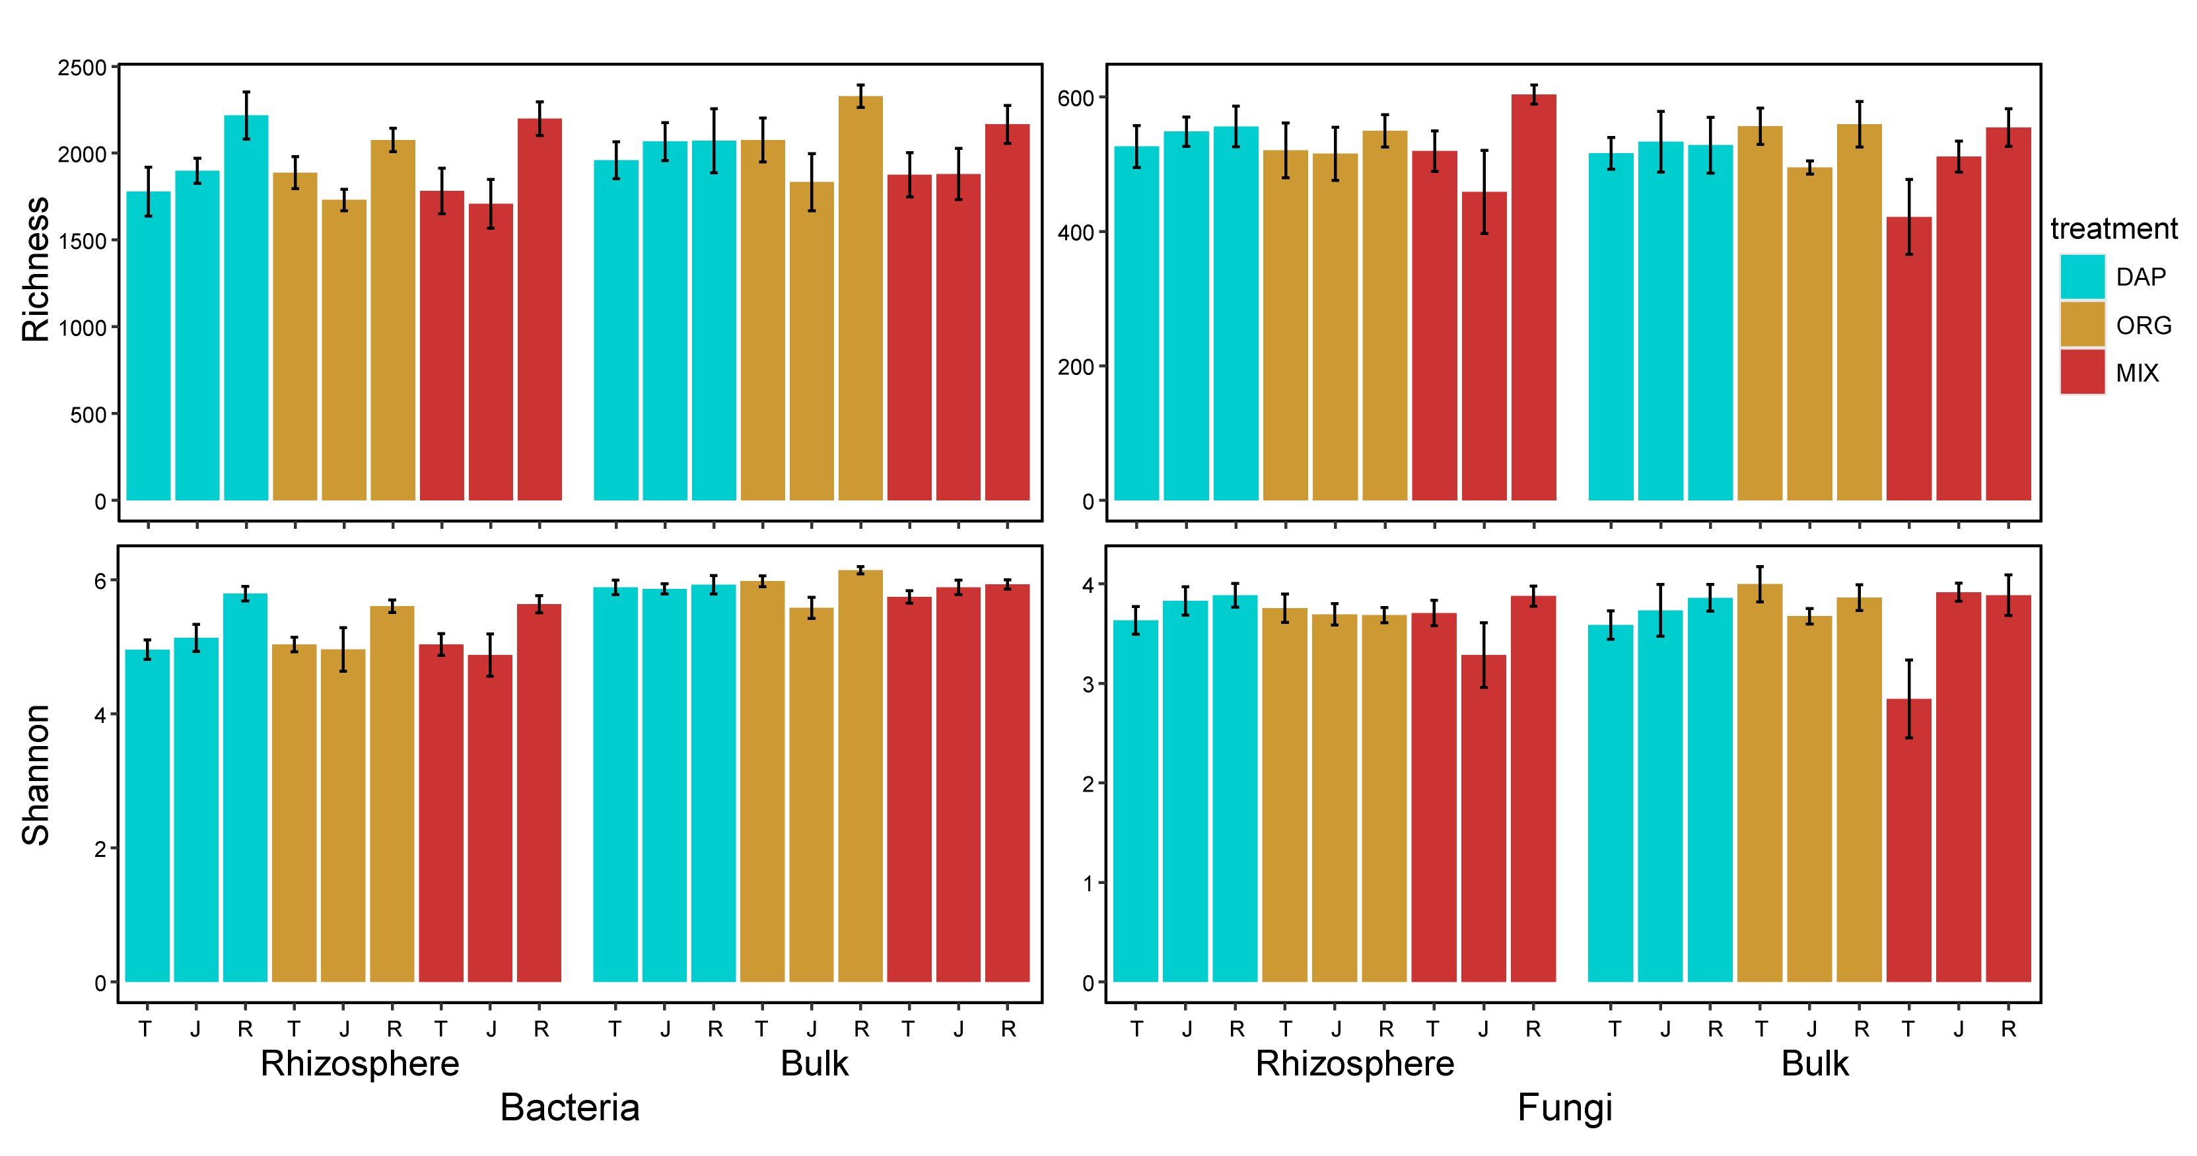
Figure S2. Alpha diversity of rhizosphere and bulk soil microbial communities under inorganic (DAP), organic (ORG), and inorganic and organic mixed (MIX) soil amendment treatments in tillering (T), jointing (J) and ripening (R) hulless barley growth stages.

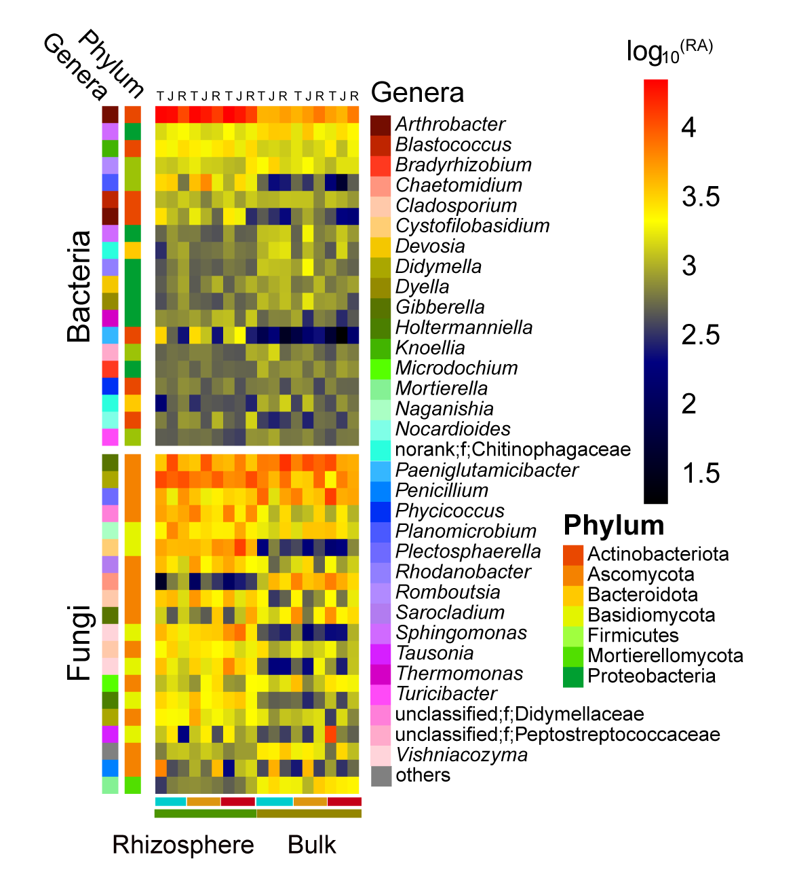
Figure S3. The top 20 abundant bacterial and fungal genera in Tibetan hulless barley farmland soil. The color bars on the left side of each heat map represent the differential enrichment of phylum and genera. T (tillering), J (jointing) and R (ripening) in the upper line of the heatmap represents three plant development stages, respectively.

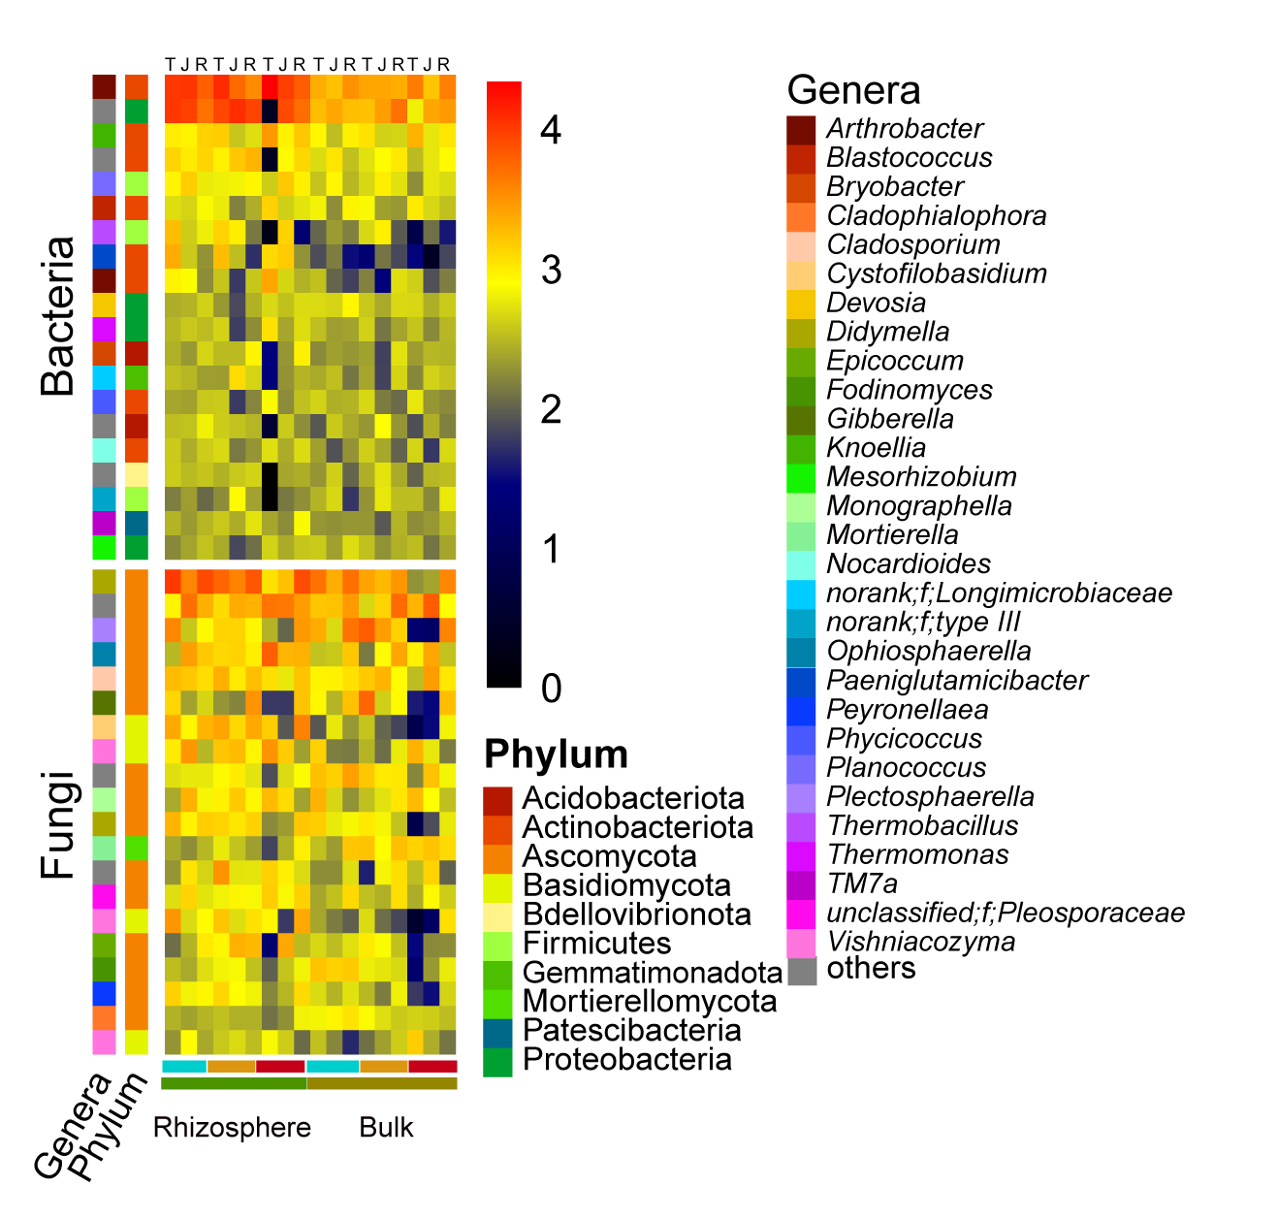
Figure S4. Plant development stage indicator genera in Tibetan hulless barley farmland soil. The color bars on the left side of each heat map represent the differential enrichment of phylum and genera. T (tillering), J (jointing) and R (ripening) in the upper line of the heatmap represents three plant development stages, respectively.

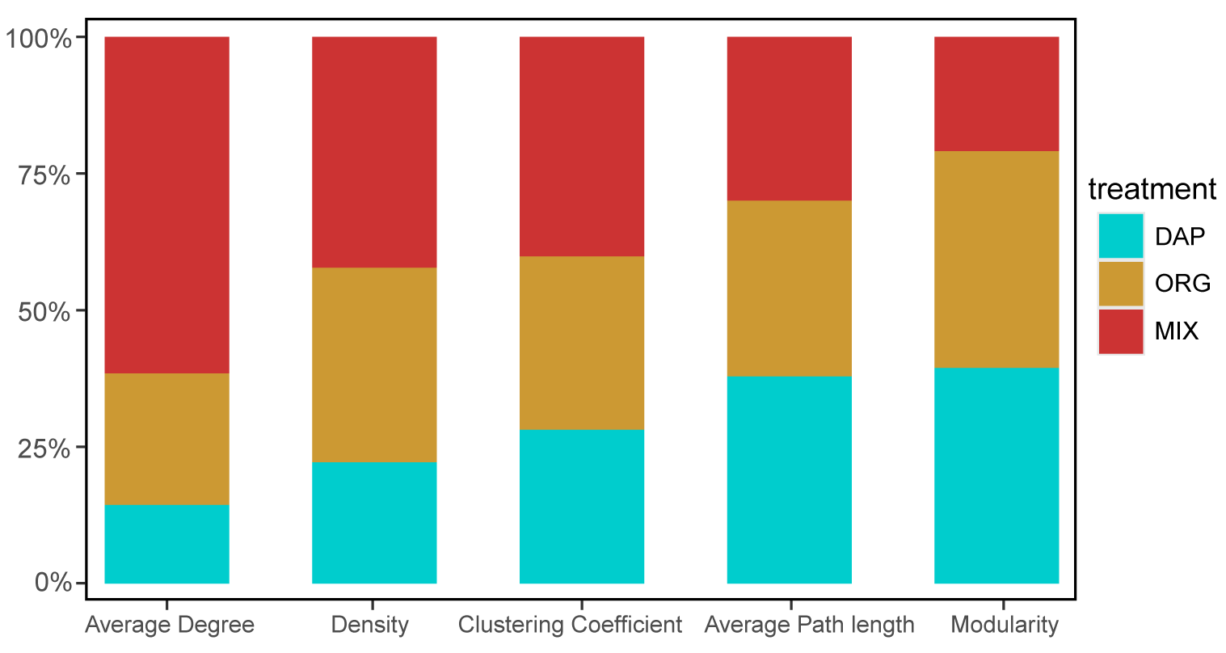
Figure S5. Topological properties of co-occurrence patterns network of rhizosphere microbial communities across different soil amendment treatments.

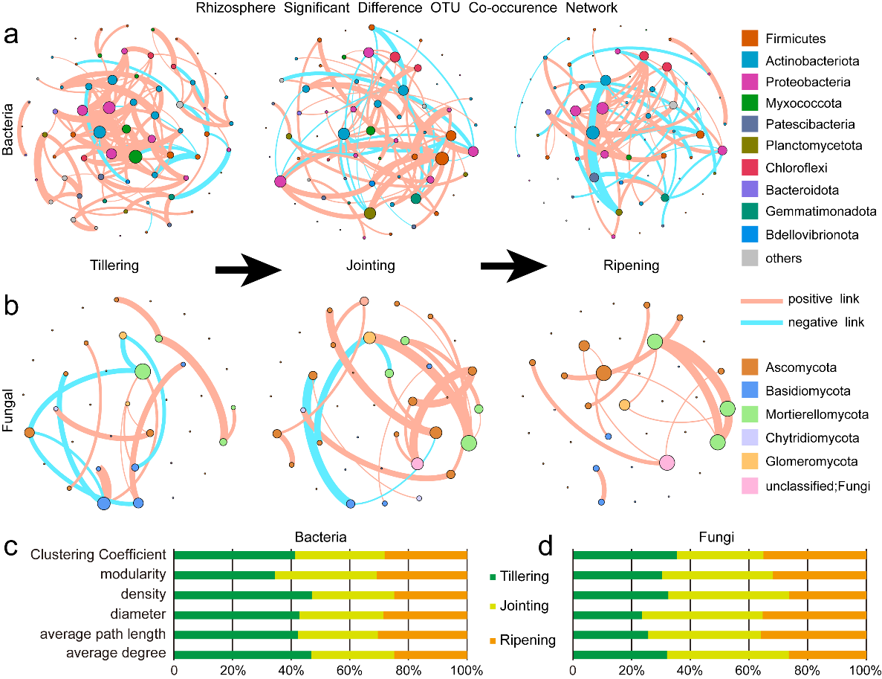
Figure S6. The co-occurrence patterns of bacterial and fungal community of Tibetan hulless barley farmland soil during tillering (T), jointing (J), and ripening (R) growth stages. a. Co-occurrence network of soil amendment-indicating OTUs in rhizosphere bacteria communities (r > 0.6, p < 0.05). b. Co-occurrence network of soil amendment-indicating OTUs in rhizosphere fungi communities (r > 0.6, p < 0.05). c. Topological properties of networks in a. d. Topological properties of networks in b. Positive correlation indicated with orange lines, negative with cyan), node colors represent different phyla, and size represents connectivity.

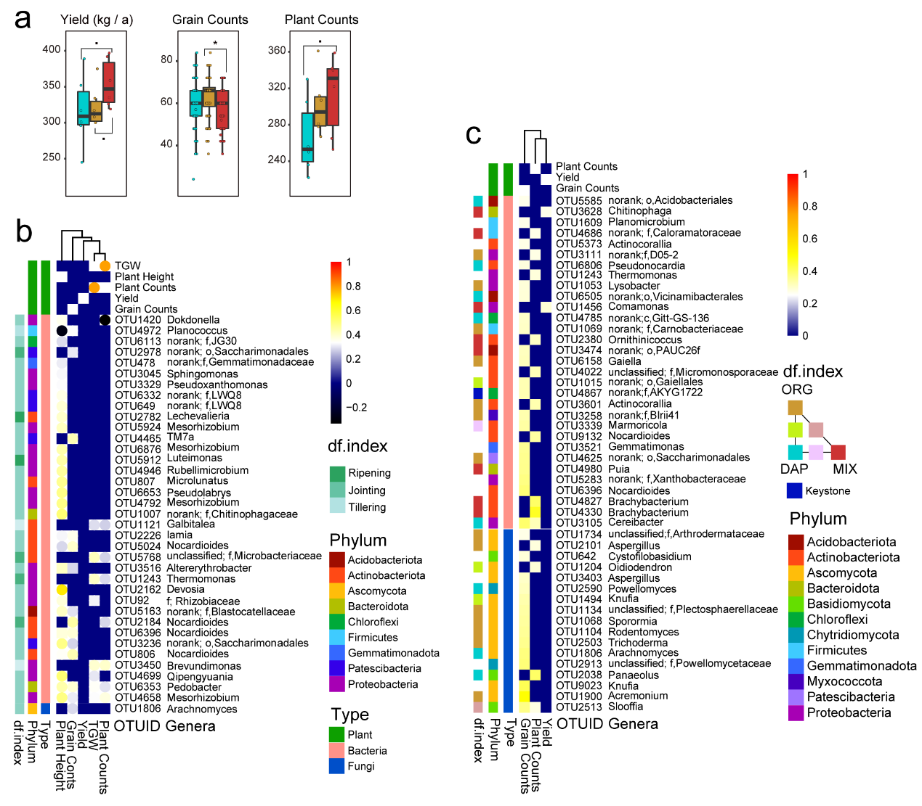
Figure S7. Plant traits of Tibetan hulless barley and their correlated indicator species during the tillage growth stage. a. Hulless barley yield, grain counts and plant counts b. The heat map of significant correlation coefficient between planting stage indicator species (top 50 of bacteria and fungi, respectively) and hulless barley plant traits (P < 0.05) in tillering (T), jointing (J), and ripening (R) stages. c. The heat map of correlation coefficient between fertilizer indicator species and hulless barley plant traits under inorganic (DAP), organic (ORG), and inorganic and organic mixed (MIX) fertilization treatments. The color block on the left explained the differential enrichment of indicator species (df. index, blank indicated abundant species), phylum level classificati
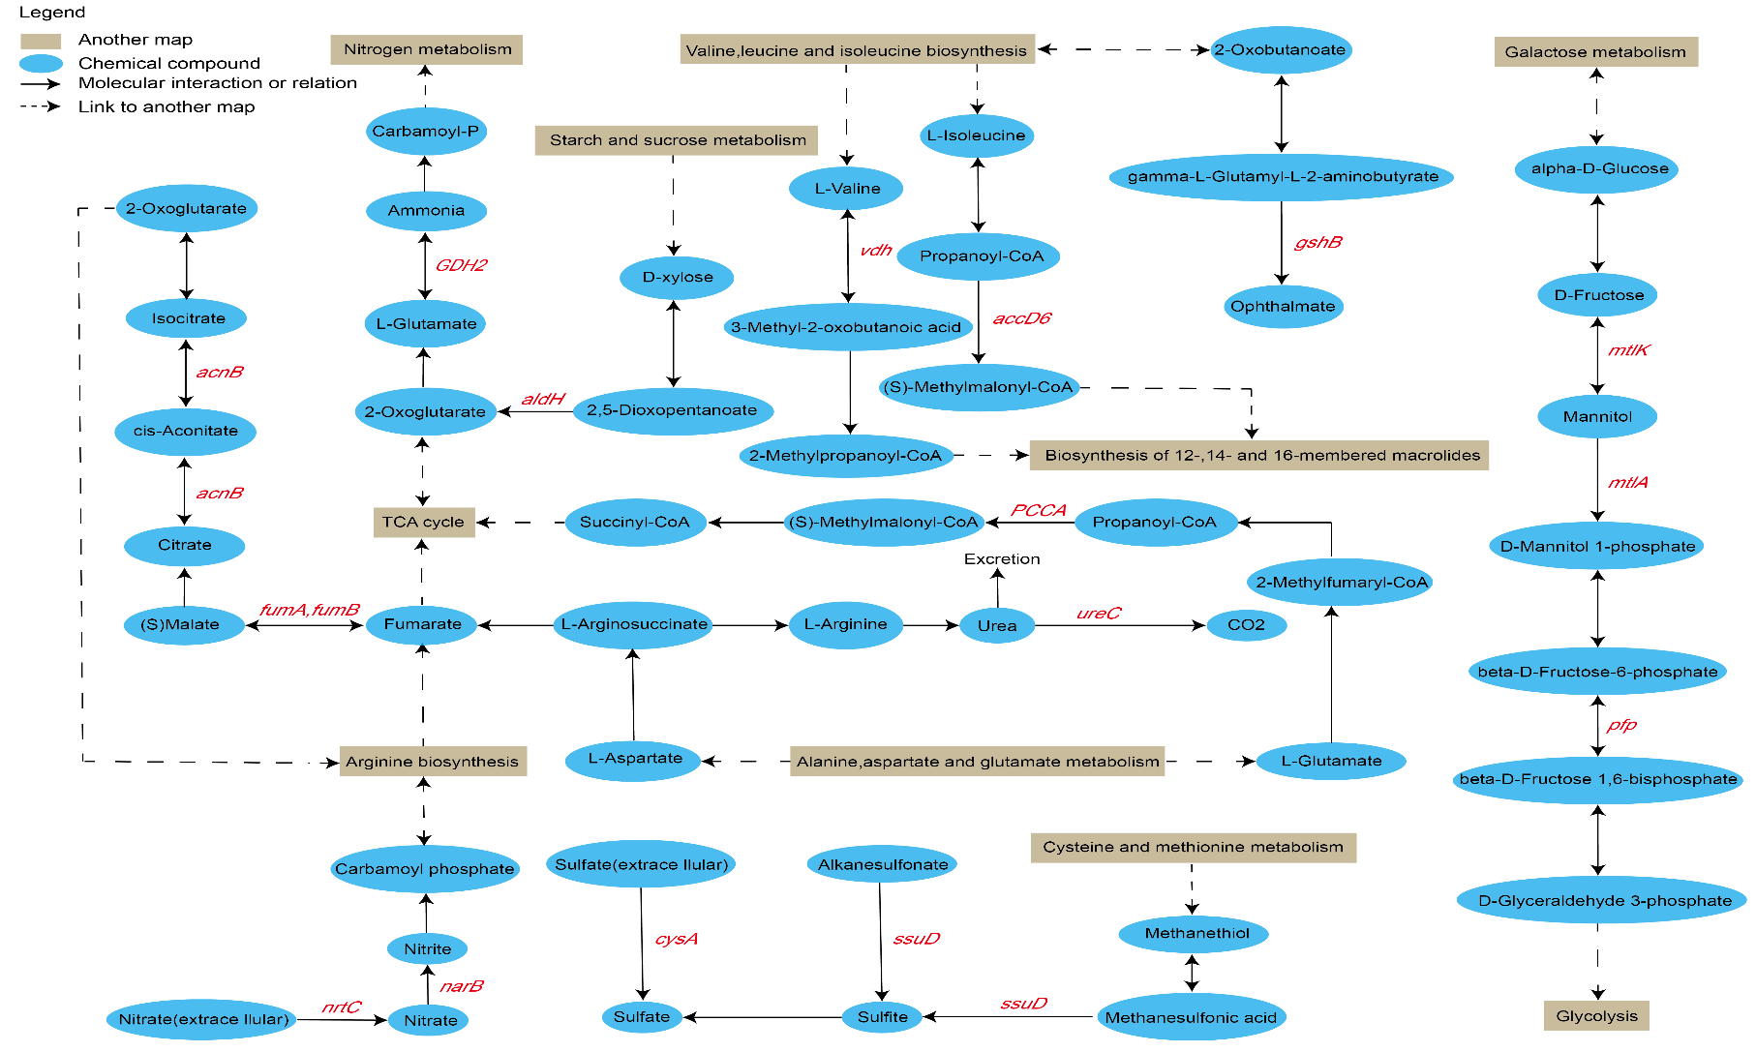
Figure S8. Metabolic pathways with the higher genes abundance in organic mixed (MIX) soil amendment than inorganic (DAP) and organic (ORG) soil amendments in Tibetan hulless barley farmland soil.
Table S1 Rhizosphere-related literature statistics
Keywords | Search result | The proportion | Years | Data base
Rhizosphere | 9440 | 1 | The last five years | From Web of Science Core Collection
Tibet barley rhizosphere | 1 | <0.1% | The last five years | From Web of Science Core Collection
Tibetan barley rhizosphere | 4 | <0.1% | The last five years | From Web of Science Core Collection
Barley rhizosphere | 177 | 1.88% | The last five years | From Web of Science Core Collection
Arabidopsis rhizosphere | 540 | 5.7% | The last five years | From Web of Science Core Collection
Rice rhizosphere | 878 | 9.3% | The last five years | From Web of Science Core Collection
wheat rhizosphere | 1005 | 10.6% | The last five years | From Web of Science Core Collection
Maize rhizosphere | 858 | 9.1% | The last five years | From Web of Science Core Collection
The statistics data of Rhizosphere-related literature was based on the web of science core collection database (www.webofknowledge.com) in the past five years
Table S2 Soil physicochemical factors in different amendments soil of Tibetan hulless barley farmland
 | pH | TOC | SM  % | NO₃⁻  mg/kg | NO₂⁻  mg/kg | NH₄⁺  mg/kg | TN  g/kg | TDN  mg/kg | TP  g/kg | AP  mg/kg | TK  g/kg | Ak  mg/kg | Fe  mg/kg | Na  mg/kg | Ca  mg/kg | Mn  mg/kg | SON  mg/kg | Mg  mg/kg | Zn  mg/kg | Si  mg/kg | Al  mg/kg | As  mg/kg | Cr  mg/kg | Cu  mg/kg
Rhizosphere
Tillering
control | 5.1 | 1.2 | 13.1 | 80.8 | 0.3 | 73.9 | 1,350.0 | 263.1 | 1,020.8 | 53.6 | 21,446.4 | 780.8 | 4,271.0 | 114.8 | 5,605.3 | 460.6 | 108.2 | 1,550.2 | 35.3 | 1,368.3 | 2,561.8 | 10.9 | 9.8 | 28.9
org1 | 6.4 | 2.6 | 14.8 | 80.8 | 0.8 | 124.2 | 1,396.7 | 283.5 | 1,039.8 | 33.8 | 21,951.4 | 717.7 | 4,789.3 | 39.0 | 5,196.2 | 663.8 | 77.7 | 1,062.9 | 38.0 | 1,364.2 | 2,588.6 | 9.3 | 11.8 | 29.5
org2 | 6.1 | 1.7 | 15.3 | 71.5 | 0.8 | 118.6 | 1,521.7 | 259.4 | 1,073.0 | 35.0 | 21,426.5 | 790.1 | 4,088.2 | 57.8 | 5,648.6 | 631.3 | 68.5 | 987.4 | 34.4 | 1,125.2 | 2,289.9 | 10.2 | 10.8 | 28.8
Jointing
control | 5.5 | 1.2 | 13.8 | 76.8 | 1.0 | 125.1 | 1,108.3 | 284.1 | 1,022.8 | 48.6 | 21,323.8 | 713.2 | 5,192.5 | 80.1 | 5,833.9 | 671.6 | 81.2 | 1,090.6 | 41.9 | 1,526.1 | 2,666.6 | 9.5 | 11.7 | 29.8
org1 | 6.1 | 2.2 | 14.0 | 92.0 | 0.5 | 85.1 | 1,514.7 | 276.5 | 1,034.1 | 28.3 | 21,592.2 | 883.4 | 4,227.7 | 176.5 | 6,608.1 | 591.0 | 98.9 | 1,391.6 | 34.4 | 1,245.3 | 2,431.0 | 10.8 | 9.6 | 29.4
org2 | 6.2 | 2.1 | 15.0 | 99.8 | 0.5 | 118.5 | 1,676.7 | 278.1 | 984.7 | 31.1 | 21,842.3 | 836.4 | 4,130.8 | 126.0 | 7,034.0 | 613.2 | 59.3 | 1,363.8 | 33.7 | 1,286.6 | 2,403.5 | 10.9 | 10.0 | 28.8
Ripening
control | 5.6 | 1.7 | 17.0 | 98.2 | 0.5 | 73.0 | 1,581.7 | 258.6 | 1,093.2 | 35.1 | 21,276.0 | 952.0 | 4,790.8 | 137.4 | 7,200.9 | 537.2 | 87.0 | 1,893.5 | 34.0 | 1,358.1 | 2,602.0 | 9.7 | 13.8 | 30.3
org1 | 5.8 | 1.5 | 16.1 | 70.9 | 0.3 | 83.9 | 1,196.7 | 238.4 | 975.3 | 34.5 | 21,381.2 | 639.3 | 4,491.4 | 67.5 | 7,639.7 | 549.2 | 83.3 | 2,011.4 | 36.2 | 1,202.3 | 2,715.8 | 10.3 | 10.7 | 30.5
org2 | 5.7 | 1.3 | 12.1 | 90.0 | 0.5 | 85.1 | 1,598.3 | 245.4 | 1,017.7 | 39.9 | 20,095.9 | 844.5 | 4,709.6 | 47.6 | 6,114.7 | 591.7 | 69.8 | 1,640.7 | 39.7 | 1,484.8 | 2,744.5 | 10.0 | 10.7 | 31.4
Bulk
Tillering
control | 5.9 | 1.9 | 14.5 | 91.6 | 0.2 | 87.1 | 1,155.0 | 248.3 | 968.2 | 40.4 | 22,931.8 | 792.1 | 4,399.8 | 75.1 | 6,534.4 | 549.1 | 69.4 | 1,499.0 | 37.3 | 1,455.1 | 2,667.2 | 10.6 | 9.8 | 28.8
org1 | 5.8 | 1.6 | 14.9 | 97.4 | 0.2 | 86.8 | 1,473.3 | 248.4 | 1,135.0 | 41.5 | 21,314.0 | 505.3 | 4,230.4 | 94.9 | 6,267.6 | 583.4 | 64.1 | 1,650.0 | 35.2 | 1,394.1 | 2,604.4 | 10.9 | 10.2 | 28.7
org2 | 5.4 | 1.6 | 15.6 | 104.4 | 0.2 | 86.7 | 1,216.7 | 274.2 | 1,107.0 | 44.3 | 21,156.0 | 827.7 | 4,524.0 | 133.0 | 6,165.3 | 498.5 | 82.9 | 1,110.6 | 31.5 | 1,010.9 | 2,288.3 | 10.6 | 12.5 | 29.3
Jointing
control | 5.5 | 1.2 | 17.5 | 71.3 | 0.1 | 81.4 | 1,321.7 | 256.1 | 1,014.0 | 45.1 | 21,866.3 | 1,105.2 | 4,777.8 | 123.1 | 7,037.8 | 491.9 | 103.3 | 2,143.7 | 34.9 | 1,243.0 | 2,195.4 | 7.8 | 14.3 | 27.7
org1 | 6.3 | 2.1 | 13.6 | 87.3 | 1.0 | 94.1 | 1,246.7 | 269.6 | 1,063.5 | 33.1 | 21,317.3 | 607.5 | 5,199.0 | 50.3 | 5,781.0 | 560.6 | 87.2 | 1,369.7 | 37.5 | 1,235.4 | 2,516.8 | 8.6 | 12.4 | 29.2
org2 | 6.4 | 1.8 | 16.2 | 74.1 | 0.8 | 82.4 | 1,408.3 | 271.4 | 1,028.7 | 38.7 | 21,994.0 | 823.0 | 4,712.0 | 79.7 | 6,251.1 | 562.8 | 114.1 | 1,381.2 | 37.1 | 1,166.6 | 2,406.0 | 8.3 | 12.4 | 29.1
Ripening
control | 5.6 | 1.1 | 12.6 | 74.1 | 1.0 | 143.8 | 1,476.7 | 311.3 | 1,049.7 | 43.8 | 21,509.1 | 558.5 | 5,364.8 | 36.6 | 6,829.7 | 581.4 | 92.5 | 1,427.1 | 39.6 | 1,390.1 | 2,603.1 | 8.7 | 12.5 | 29.3
org1 | 6.4 | 2.1 | 9.8 | 60.4 | 0.5 | 78.5 | 1,263.0 | 201.9 | 1,076.0 | 29.4 | 23,131.2 | 544.4 | 3,815.5 | 36.3 | 6,775.0 | 470.1 | 62.5 | 1,507.6 | 31.0 | 1,169.0 | 2,074.9 | 10.3 | 10.6 | 28.3
org2 | 5.9 | 2.1 | 10.8 | 75.0 | 0.5 | 95.9 | 1,357.5 | 257.0 | 1,009.8 | 32.9 | 23,000.3 | 681.3 | 4,594.1 | 86.0 | 5,694.1 | 498.0 | 85.5 | 1,251.9 | 36.9 | 1,338.9 | 2,325.7 | 9.2 | 12.4 | 31.6

Table S3 Physiochemical soil factors of significant difference at different growth stages in different amendments
Different soil amendments | Soil physicochemical factors | P-value  (Welch's t-test)
Inorganic (DAP) | NH₄⁺ | 2.20E-05
Inorganic (DAP) | NO₂⁻ | 3.94E-05
Inorganic (DAP) | Fe | 4.99E-04
Inorganic (DAP) | TOC | 1.28E-03
Inorganic (DAP) | TDN | 5.42E-03
Inorganic (DAP) | Mn | 1.30E-02
Organic (ORG) | NO₂⁻ | 4.40E-02
Mixed inorganic-organic (MIX) | NO₂⁻ | 9.27E-05
Mixed inorganic-organic (MIX) | Zn | 1.94E-04
Mixed inorganic-organic (MIX) | Fe | 1.95E-04
Mixed inorganic-organic (MIX) | TOC | 3.85E-03
Mixed inorganic-organic (MIX) | Al | 5.06E-03

Table S4 Physicochemical factors with significant difference between bulk soil and rhizosphere soil
Sites | Soil physicochemical factors | P-value  (Welch's t-test)
Higher in Rhizosphere soil than bulk soil | As | 8.91E-04
Higher in Rhizosphere soil than bulk soil | NO₃⁻ | 3.47E-03
Higher in Rhizosphere soil than bulk soil | Mn | 1.70E-02
Higher in Rhizosphere soil than bulk soil | TDN | 3.30E-02
Higher in Rhizosphere soil than bulk soil | NH₄⁺ | 4.60E-02
Higher in Bulk soil than rhizosphere soil | Mg | 2.20E-02

