Methods

Human samples
Healthy human tissue array sections were purchased from US Biomax, Inc (Cat#: FBN406et). Tumor tissue sections from patients newly diagnosed with primary GBM were kindly provided by Dr. Amy B. Heimberger (The University of Texas MD Anderson Cancer Center). Blood buffy coat was purchased from Gulf Coast Regional Blood Center. These studies were conducted under protocol #LAB03-0687, which was approved by the Institutional Review Board of The University of Texas MD Anderson Cancer Center. Informed consent was obtained for the use of human samples.
Animals
We purchased Balb/c, C57BL/6 (5–8 weeks of age), B6.129P2-Cxcr3^{tm1Dgen}/J mice, and Thy1.1 (CD90.1⁺) mice from The Jackson Laboratory. FcƴRIIB^{-/-} mice (Fcgr2b-Model 579) were purchased from Taconic. We performed all animal experiments in accordance with the guidelines approved by the Institutional Animal Care and Use Committee (IACUC) at MD Anderson.

Cells
DBT mouse glioma cells were kindly provided by Dr. Leonid Metelitsa (Baylor College of Medicine). GL261 cells were obtained from the National Cancer Institute. DBT-FGL2^{-/-} cells and GL261-FGL2^{-/-} cells were constructed as described previously¹. 4T1 cells were purchased from ATCC (USA). All cells were cultured as described previously^{1,2} and treated with a mycoplasma removal agent (BUF035, BIO-RAD) before experiments.

Mouse models

For the orthotopic mouse models, DBT cells, GL261 cells, and 4T1 cells were treated with mycoplasma removal agent and collected in the logarithmic growth phase. Next, 5 × 10⁴ DBT cells, 5 × 10⁴ GL261 cells, or 5 × 10⁴ 4T1 cells in a total volume of 5 μL phosphate-buffered saline (PBS) were injected intracerebrally into Balb/c, C57BL/6, Balb/c mice respectively. For co-inoculations with T cells and DBT cells, 3 × 10³ DBT cells and 3 × 10³ T cells that had been sorted by flow cytometry were mixed and inoculated intracerebrally into naïve Balb/c mice. For co-inoculation of DBT cells with T_{RM}-BILs, 3 × 10³ DBT cells and 3 × 10⁴ BILs cells that had been isolated as previously¹ were inoculated intracerebrally into naïve SCID mice. The mice were observed daily. When the mice showed signs of neurological compromise, they were euthanized by CO₂ inhalation.
For the subcutaneous tumor model, 2 × 10⁵ DBT cells were suspended in 30 μL PBS and injected subcutaneously into 1 flank of each mouse. Tumors were measured twice per week. Mice that showed signs of morbidity, high tumor burden, or skin necrosis were immediately euthanized according to IACUC guidelines. Tumor volumes were calculated using the formula (length × width²)/2, with the length representing the longest axis, and the width at right angles to the length. All animal experiments were repeated at least twice.
For in vivo blocking assay, the antibodies used in extended data table 1 were injected i.p. at designed time to depleting or blocking the targets in vivo.
Extended Data Table 1. Antibodies used for in vivo blocking.
Target | Source | Cat #
Rat IgG (clone: 2A3) | BioXcell | BE0089
CD8 (clone: 2.43) | BioXcell | BE0061
CD4 (clone: GK1.5) | Leinco Techonologies | 25-0032-U100
Asialo GM1 | Fujifilm wako chemical U.S.A. corporation | 986-10001
CD69 (clone: H1.2F3) | Thermo Fisher scientific | 14-0691-82
MHC-I (clone: M1/42.3.9.8) | BioXcell | BE0077
CXCL9 (clone: MIG-2F5.5) | BioXcell | BE0309
CXCL10 (clone: 134013) | Thermo Fisher scientific | MA5-23774

Treatments
Starting on day 3 after tumor-cell inoculation, temozolomide (TMZ) from Accord Healthhcare, Inc was injected intraperitoneally at a dose of 25 mg/kg (3 daily injections). On days 6 and 13 after tumor-cell inoculation, 2.5 million T cells transfected with either virus bearing a control vector or one bearing an FGL2-blocking scFv vector were injected intravenously.

In vivo bioluminescence imaging
On a designated day after DBT tumor-cell implantation, mice were injected intraperitoneally with 150 mg/kg of D-luciferin in PBS. After 10 minutes, the mice were imaged with a charge-coupled device camera (IVIS 100; Xenogen-Caliper). Total photon flux (photons/s) was measured from a fixed region of interest over the skull using Living Image and IgorPro software (Wavemetrics).

T cell preparation

Mouse T cells were isolated from the spleens and lymph nodes of Balb/c, C57BL/6, FGL2^{-/-}, and LAG3^{-/-} mice and purified with a Mouse CD3 T cell Isolation Kit (480031; BioLegend). Human peripheral blood mononuclear cells (PBMCs) were isolated using Ficoll-Paque PLUS (GE Healthcare Biosciences AB) and SepMate-50 (Stemcell Technologies, Inc.) according to the manufacturers’ protocols. Human T cells were purified from PBMCs with a Human CD3 T Cell Isolation Kit (19051; BioLegend). Mouse T cells and human T cells were activated with Dynabeads Mouse T-Activator CD3/CD28 (0077118, Gibco) or Dynabeads Human T-Activator CD3/CD28 (00805147, Gibco) per the manufacturer’s instructions and then cultured in RPMI-1640 (Gibco), 10% fetal bovine serum (Hyclone), 2 mM GlutaMAX (Gibco), 100 μM β-mercaptoethanol (Gibco), 100 U/mL penicillin, and 100 μg/mL streptomycin (Corning) with 100 U interleukin (IL)-2 (Biolegend) and IL-15 (5 ng/mL) (Fisher). Twenty-four hours after activation, T cells were transfected with a lentivirus containing a control vector or an FGL2-blocking scFv vector. Cells were spun down at 1500×g for 2 h with 8 μg/mL polybrene (MilliporeSigma) in RPMI medium in a retronectin (T100B; Takara)-coated 24-well plate. T cells were used for in vivo or in vitro experiments 2 to 4 days after transfection.

In vitro cytotoxic T lymphocyte assay
For direct tumor cells killing assay, effector CD3⁺ T cells (2 days after activation) and target DBT-GFP⁺ tumor cells were cocultured at a E:T ratio of 4:1 for 72 h. For cytokines detection, target DBT tumor cells and effector CD3⁺ T cells (2 days after activation) were cocultured at a E:T ratio of 1:1 for 24 h. 4h before cytokines detection, 10ug/ml GolgiPlug (BD Biosciences) was added to T cells medium.

Flow cytometry
Mouse brain tissues and dLNs were minced and enzymatically digested to obtain single-cell suspensions. BILs were isolated per a previous protocol³. Briefly, each single-cell suspension was centrifuged through a 30% Percoll gradient at 7800×g for 30 minutes. The leukocyte layer was collected and centrifuged on a discontinuous Ficoll-Paque Plus gradient to select and purify leukocytes. Leukocytes from mouse PB were collected as previously described⁴. Fc receptors were blocked using a rat anti-mouse anti-CD16/CD32 antibody (clone: 2.4G2, BD Biosciences). The antibodies used for flow cytometry are listed in Extended Data Table 1. The cell surfaces were stained by using a standard protocol. For intracellular cytokines staining, 4h before assay, Brefeldin A (1,000× solution, Biolegend) were added 1:1000 dilution to in vitro cultured cells medium, and 250ug Brefeldin A (AdipoGen Life Sciences) were injected per mouse i.p for in vivo experiment. After cell surface staining, cells were fixed, permeabilized, and incubated with antibodies against IFNγ, TNFα, and granzyme B. For apoptosis assay, 7-AAD (Tonbo Biosciences, #13-6993-T500), and Annexin V antibody was used to stain cells in Annexin V binding buffer (BioLegend, #422201) for 15 min before detecting. Stained cells were isolated by flow cytometry and the results analyzed by FlowJo software (version 10).
Extended Data Table 2. Antibodies used for flow cytometry analysis.
 |  |  | Target |  | Source | Cat #
 |  |  | CD4-PE-CY7 (clone: RM4-5) |  | Tonbo Biosciences | 60-0042-U100
 |  |  | CD49b-PE (clone: DX5) |  | ThermoFisher | 14-0491-82
 |  |  | CD8α-VF450 (clone: 53-6.7) |  | Tonbo Biosciences | 75-0081-U100
 |  |  | CD3-APC/CY7 (clone: 17A2) |  | Tonbo Biosciences | 25-0032-U100
 |  |  | CD8α-APC/CY7 (clone: 53-6.7) |  | Tonbo Biosciences | 25-0081-U100
 |  |  | CD8α-FITC (clone: 53-6.7) |  | BioLegend | 100706
 |  |  | CD8α-PE (clone: 53-6.7) |  | Tonbo Biosciences | 50-0081-U100
 |  |  | CD8β-PE (clone: YTS156.7.7) |  | BioLegend | 126607
 |  |  | CD11b-PE (clone: M1/70) |  | Tonbo Biosciences | 50-0112-U100
 |  |  | CD11c-FITC (clone: N418) |  | BioLegend | 117305
 |  |  | Ly6G-APC/CY7 (clone: 1A8) |  | BioLegend | 127623
 |  |  | CD19-FITC (clone: 1D3) |  | Tonbo Biosciences | 35-0193-U025
 |  |  | CD45-Pacific blue (clone: 30-F11) |  | BioLegend | 103125
 |  |  | TNFα-PE (clone: MP6-XT22) |  | BioLegend | 506306
 |  |  | Granzyme B-PE (clone: QA16A02) |  | BioLegend | 372208
 |  |  | IFNγ-VF450 (clone: XMG1.2) |  | Tonbo Biosciences | 75-7311-U100
 |  |  | CD69-FITC (clone: H1.2F3) | BioLegend |  | 104506
 |  |  | CD103-PE (clone: 2E7) | BioLegend |  | 121406
 |  |  | CD44-FITC (clone: 1M7) | BioLegend |  | 103021
 |  |  | CD62L-APC (clone: MEL-14) | BioLegend |  | 104412
 |  |  | CD183-PE (clone: CXCR3-173) | BioLegend |  | 126511
 |  |  | CD183-APC (clone: CXCR3-173) | BioLegend |  | 126505
 |  |  | PD-1-PE (clone: 29F.1A12) | BioLegend |  | 135205
 |  |  | B220-PE/CY7 (clone:RA3-6B2) | BioLegend |  | 103221
 |  |  | Annexin V-Pacific blue | BioLegend |  | 640918
 |  |  | S1P1-AF488 (clone:713412) | R&D systems |  | FAB7089G
 |  |  | Fixable Viability Dye eFluor™ 780 | ThermoFisher |  | 65-0865-14

FGL2 mAb screening
FGL2 mAbs were generated by the MD Anderson Monoclonal Antibody Core Facility. We performed ELISA to assay the binding reactivity of 75 clones of anti-FGL2 antibody and identify the clones that showed a high capacity to bind to recombinant mouse FGL2 protein. After that, 13 clones were left for subsequent screening. Next, diluted antibodies of these 13 clones were used to test their binding affinity to recombinant mouse FGL2 protein. Finally, the binding capacity to recombinant human FGL2 protein was measured to identify clones that reacted to both mouse and human FGL2.
Plasmid construction and lentivirus production
Variable regions of a monoclonal antibody against FGL2 (clone #4) were sequenced by Genscript. FGL2 ScFV-mIgG2aFC-P2A-TM (transmembrane domain) was synthesized by Genscript and cloned into a third-generation self-inactivating lentiviral expression vector, pCDH (System Biosciences), with a cytomegalovirus promoter. The control virus was the same vector without the gene insert. High-titer replication-defective lentiviral vectors were produced and concentrated by the MD Anderson Functional Genomics Core and VectorBuilder, Inc..
CyTOF
All mass cytometry reagents were purchased from Fluidigm, Inc.. BILs were isolated from tumor-bearing brains and then washed with PBS containing 0.1% bovine serum albumin and blocked with a commercial Fc-blocking reagent (BD Biosciences) to minimize nonspecific antibody binding. The cells were then stained with a panel of metal-labeled antibodies against cell surface markers for 30 minutes on ice and washed in PBS. After antibody staining, the cells were incubated for 5 minutes at room temperature (RT) with cisplatin as a viability dye for dead cell exclusion. The cells were then fixed and permeabilized with a FoxP3/Transcription Factor Staining Kit (eBioscience) according to the manufacturer’s protocol and stained with metal-labeled antibodies against intracellular cytokines and transcription factors. The cells were then washed and incubated overnight at 4 °C in PBS containing 1.6% formaldehyde and 125 nM Ir nucleic acid intercalator to label all nucleated cells. Immediately prior to acquisition, the cells were washed in diH₂O, then resuspended in diH₂O containing a 1/10 dilution of EQ 4 Element Calibration beads. The samples were acquired on a CyTOF2 mass cytometer. The resulting FCS files were concatenated and normalized using a bead-based normalization algorithm in the CyTOF acquisition software. FCS files were manually pre-gated on ¹⁹³Ir DNA⁺CD45⁺ events, excluding cisplatin-positive dead cells, doublets, and DNA-negative debris.
The subsequent data processing and data transformation were done by using the flowCore⁵, by which the raw marker intensities were arcsinh-transformed (with cofactor 5) for cell clustering and further quantile-transformed (with 1st and 99th percentiles as the boundaries) for heatmap visualization. The clustering and cell population identification were conducted by using the FlowSOM⁶ and ConsensusClusterPlus⁷ packages for Bioconductor. The initially identified 15 cell clusters were visually represented by t-distributed stochastic neighbor embedding with a downsampling of 2,000 cells per sample. Based on this, the delta area plot, and the heatmap of markers’ median expression level for each cluster, we merged and annotated homogeneous clusters: neutrophils (CD11b⁺LY6G⁺), MDSC cells (CD11b⁺Gr.1⁺), B cells (CD19+), MHCII⁻ macrophages (CD11b⁺F4/80⁺MHCII⁻), MHCII⁺ macrophages (CD11b⁺F4/80⁺MHCII⁺), monocytes (CD11b⁺LY6C⁺LY6G⁻), CD11b⁺ DCs (CD11c⁺MHCII⁺CD11b⁺), Ly6C⁺ DCs (CD11c⁺MHCII⁺Ly6C⁺), CD8⁺ proliferating T_{EM} cells (CD3⁺CD8⁺CD44⁺CD62L⁻Ki67⁺), CD8⁺ resting T_{EM} cells (CD3⁺CD8⁺CD44⁺CD62L⁻Ki67⁻), regulatory T cells (CD3⁺CD4⁺CD25⁺FoxP3⁺), helper T cells (CD3⁺CD4⁺CD25⁻FoxP3⁻), natural killer T cells (CD49b⁺CD3⁺), natural killer T cells (CD49b⁺CD3⁻), and CD4⁻CD8⁻ T cells (CD3⁺CD4⁻CD8⁻). The differential analysis of cell population abundance was conducted by fitting a generalized linear mixed model based on the binomial distribution, and a linear model was used for the differential analysis of marker expression.
Extended Data Table 3. Antibodies used for CyTOF analysis in vivo.
Target | Label | Clone | Specificities | Source | Cat #
CD45 (Ms) | ⁸⁹Y | 30-F11 | Ms | DVS-Fluidigm | 3089005B
CD4 (Ms) | ¹¹⁵In | RM4-5 | Ms | BioLegend | 100506
Ly-6G/Ly-6C, Gr-1 | ¹³⁹La | RB6-8C5 | Ms | BioLegend | 108402
Ly-6G | ¹⁴¹Pr | 1A8 | Ms | DVS-Fluidigm | 3141008B
CD39 | ¹⁴²Nd | 24DMS1 | Ms | DVS-Fluidigm | 3142005B
CCR2 | ¹⁴³Nd | 475301 | Ms | R&D Systems | MAB55381
CD115 | ¹⁴⁴Nd | AFS98 | Ms | DVS-Fluidigm | 3144012B
CD68 | ¹⁴⁵Nd | FA-11 | Ms | BioLegend | 137002
CD8a (Ms) | ¹⁴⁶Nd | 53-6.7 | Ms | DVS-Fluidigm | 3146003B
CD223, LAG-3 | ¹⁴⁷Sm | C9B7W | Ms | BioLegend | 125202
CD11b (Ms) | ¹⁴⁸Nd | M1/70 | Ms | DVS-Fluidigm | 3148003B
CD19 (Ms) | ¹⁴⁹Sm | 6D5 | Ms | DVS-Fluidigm | 3149002B
CD25 | ¹⁵⁰Nd | 3C7 | Ms | BioLegend | 101902
TIGiT, Vstm3 | ¹⁵¹Eu | 1G9 | Ms | BioLegend | 142102
CD3, CD3e | ¹⁵²Sm | 145-2C11 | Ms | BioLegend | 100302
CD182, CXCR2 | ¹⁵³Eu | SA044G4 | Ms | BioLegend | 149302
CD274, PD-L1 | ¹⁵⁴Sm | 10F.9G2 | Ms | BioLegend | 124303
CD69 | ¹⁵⁶Gd | H1.2F3 | Ms | BioLegend | 104533
Foxp3 | ¹⁵⁸Gd | FJK-16s | Ms, Rt, Bv, Cn, Po, Fe | DVS-Fluidigm | 3158003A
CD279, PD-1 | ¹⁵⁹Tb | 29F.1A12 | Ms | BioLegend | 135202
CD62L | ¹⁶⁰Gd | MEL-14 | Ms | DVS-Fluidigm | 3160008B
CD183, CXCR3 | ¹⁶¹Dy | CXCR3-173 | Ms | BioLegend | 126502
Ly-6C | ¹⁶²Dy | HK1.4 | Ms | DVS-Fluidigm | 3162014B
CD152, CTLA-4 | ¹⁶³Dy | 9H10 | Ms | BioLegend | 106202
CD49b | ¹⁶⁴Dy | HMa2 | Ms | DVS-Fluidigm | 3164011B
IFNg | ¹⁶⁵Ho | XMG1.2 | Ms | DVS-Fluidigm | 3165003B
CD44 | ¹⁶⁶Er | IM7 | Hu, Ms, Ch, Rh | BioLegend | 103002
Ki67 | ¹⁶⁸Er | B56 | Ms, Hu | BD | 556003
CD206, MMR | ¹⁶⁹Tm | C068C2 | Ms | DVS-Fluidigm | 3169021B
CD127, IL-7Ra | ¹⁷⁰Er | A7R34 | Ms | BioLegend | 135029
CD80 | ¹⁷¹Yb | 16-10A10 | Ms, Cn | DVS-Fluidigm | 3171008B
CD86 | ¹⁷²Yb | GL1 | Ms | DVS-Fluidigm | 3172016B
F4/80 | ¹⁷³Yb | BM8 | Ms | BioLegend | 123102
I-A/I-E MHC-II | ¹⁷⁴Yb | M5/114.15.2 | Ms | DVS-Fluidigm | 3174003B
CD28 | ¹⁷⁵Lu | 37.51 | Ms | BioLegend | 102119
CX3CR1 | ¹⁷⁶Yb | SA011F11 | Ms | BioLegend | 149002
CD11c | ²⁰⁹Bi | N418 | Ms | DVS-Fluidigm | 3209005B
Abbreviations: Ms, mouse; Rt, rat; Bv, bovine; Cn, canine; Po, porcine; Fe, feline; Hu, human; Ch, Chicken; Rh, rhesus
TCR sequencing
BILs were stained with anti-CD3, anti-CD4, and anti-CD8 antibodies for 30 minutes at RT and washed twice. Then, live CD3⁺CD8⁺ T cells were sorted by using a FACSAria III flow cytometer (BD Biosciences) into 15-mL sterilized tubes containing 2 mL RPMI 1640 medium. After the samples were spun down, the supernatant was discarded. Next, the CD3⁺CD8⁺ T cells were resuspended in 1 mL RNAprotect Cell Reagent (Qiagen Inc.) and shipped on dry ice to iRepertoire, Inc. for RNA isolation and NGS of the TCRα and TCRβ immune repertoire. Sequences were analyzed by using the IMGT/V-QUEST web-based tool.
Digital PCR assay
RNA was isolated from CD8⁺T cells (sorted from T_{RM} bearing brains), T-Ctr cells (negative control of FGL2-scFv transfected T cells), and T-aFGL2 cells (positive control of FGL2-scFv transfected T cells) using Trizol reagent (Thermo Fisher Scientific). Total RNA was isolated from cells using RNeasy Mini Kit (Qiagen, Germantown, MD). RNA was converted to cDNA using the IScript cDNA Synthesis Kit (Biorad, Herculrs, CA). Droplet Digital PCR (ddPCR) was performed using QX200™ ddPCR™ EvaGreen Supermix in the Bio-Rad QX200 system in MDA DNA Analysis Core Facility. Absolute Quantification (ABS) was done using gene specific primers and input CDNA from known cell numbers. Serial dilution of the #F4 containing plasmid was used as reference. The primer sequences for the #F4 are: GCAACCTGGAGCAAGAAGAT; TCCACGGAGGAAGCGTATTA.
Microfluidics slide chip assay
A PDMS microfluidics slide chip (Abnova) was coated with 1 mg/mL streptavidin (Agilent). The chip was then washed and coated with 4 mg/mL rmFGL2 (5257-FL, R&D system) conjugated with biotin for 1 hour. Following this, 1.5 million T-Ctr cells (dyed green) and 1.5 million T-αFGL2 cells (dyed red) were loaded into a spiral chamber (Abnova) and passed through the slide chip at a flow rate of 1.8 mL per hour using the Cytoquest microfluidics pump (Abnova). The slide chip was then imaged on a fluorescent microscope (Keyence).
T-αFGL2 toxicity studies in Balb/c immunocompetent mice
Six-week-old Balb/c mice were infused intravenously with syngeneic T cells transfected with control virus (T-Ctr) or FGL2-blocking scFv virus (T-αFGL2). Balb/c mice without T cell infusion were used as controls. Five days after T cell infusion, mice were euthanized, and their blood chemistry was assessed at VetMed LIMS. The immune cell composition of the spleen and bone marrow was assessed by flow cytometry. Tissues were also collected and subjected to hematoxylin and eosin (H&E) staining. A board-certified veterinary anatomic pathologist analyzed the stained slides at the Department of Veterinary Medicine and Surgery at MD Anderson.

Western blotting

Cells were subjected to lysis in RIPA buffer (50 mM Tris-HCl, pH 7.4; 1% NP-40, 0.25% sodium deoxycholate, 150 mM NaCl, 1 mM EDTA) supplemented with 50 mM NaF, 20 mM β-glycerophosphate, and a complete protease inhibitor cocktail (Roche Diagnostics). Protein concentrations were determined using a bicinchoninic acid reagent (Thermo Fisher Scientific). Proteins were separated by sodium dodecyl sulfate-10% polyacrylamide gel electrophoresis and transferred to polyvinylidene fluoride membranes. Membranes were incubated overnight at 4 °C with primary antibodies. After washing, the blots were incubated with the appropriate horseradish peroxidase-conjugated secondary antibody and processed to detect electrochemiluminescence signals. Anti-FGL2 mAb-clone #4 was then applied for immunoblotting (1:500). The anti-FGL2 mAb-clone #4 was purchased from the MD Anderson Monoclonal Antibody Core Facility. α-β-Actin (13E5) and α-GAPDH (D16H11) antibodies were purchased from Santa Cruz Biotechnology. α-PIDD (Anto-1) antibodies were purchased from Novus Biologicals, Inc.

Immunohistochemistry
Mouse brains were fixed in formalin and embedded in paraffin, and 8-µm sections were cut for H&E staining. For anti-FGL2 antibody staining, mouse brain tissues were embedded in OCT compound and frozen in dry ice. After that, 8-µm sections were cut at −20 °C, fixed with cold acetone, acetone/chloroform 1:1, and acetone for 5 minutes each, blocked with 3% H₂O₂ (Sigma) in distilled water for 20 minutes, then blocked with 1% BSA and 10% normal goat serum (Sigma) in PBS for 1 h at RT. Slides were stained with mouse anti-FGL2 antibody (1∶250, anti-FGL2 mAb-clone #4) overnight at 4 °C, followed by 1 h incubation with an anti-mouse biotin-conjugated antibody. Next, the sections were stained with a peroxidase-labeled anti-biotin antibody for 30 minutes and incubated with DAB for 5 minutes and Gill’s #3 hematoxylin for 30 s. Slides were dried in 75%, 95%, 100% ethanol and xylene for 2 minutes each and further processed for imaging analysis using a Keyence BZ-X800 microscope.
Immunofluorescence
For immunofluorescence analyses of tumor cells, 2,000 GL261 or GL261-FGL2^{-/-} cells were spun down onto slides separately, and then the slides were fixed with 4% paraformaldehyde for 10 minutes and permeabilized with 0.25% NP40 for 30 minutes at RT. After blocking with 5% horse serum and 1% goat serum in PBS for 1 h, slides were incubated with anti-FGL2 mAb-clone #4 at 4 °C overnight. The slides were washed 3 times with PBS, followed by 1 h incubation with anti-mouse Alexa Fluor 647-conjugated antibody. ProLong Gold Antifade Mountant with 4′-diamidino-2-phenylindole (DAPI; Thermo Fisher Scientific) was used as the mounting medium. Leica SP8 Confocal Microscope were used for imaging analysis.

Statistical analysis

Statistical analyses were performed using GraphPad Prism 8 software. Each figure legend indicates methods used for comparisons and corrections.

List of Abbreviations
TMZ | Temozolomide
T-Ctr | T cells transfected with control vector
T-αFGL2 | T cells transfected with FGL2-blocking single-chain variable fragment
scFv | Single-chain variable fragment
TM | Transmembrane domain
CTL | Cytotoxic T lymphocyte
T_{RM} | Tissue-resident memory T cells
T_{M} | Memory T cells
Tregs | Regulatory T cells
BIL | Brain-infiltrating lymphocytes
dLN | Draining lymph node
PB | Peripheral blood
PD-1 | Programmed death 1 receptor
PBMCs | Peripheral blood mononuclear cells
CyTOF | Mass cytometry
NGS | Next-generation sequencing
DC | Dendritic cells
References:
1 Yan, J. et al. FGL2 as a multimodality regulator of tumor-mediated immune suppression and therapeutic target in gliomas. Journal of the National Cancer Institute 107, djv137 (2015).
2 Yan, J. et al. FGL2 promotes tumor progression in the CNS by suppressing CD103+ dendritic cell differentiation. Nature communications 10, 1-15 (2019).
3 LaFrance-Corey, R. G. & Howe, C. L. Isolation of brain-infiltrating leukocytes. JoVE (Journal of Visualized Experiments), e2747 (2011).
4 Mendez-David, I. et al. A method for biomarker measurements in peripheral blood mononuclear cells isolated from anxious and depressed mice: β-arrestin 1 protein levels in depression and treatment. Frontiers in pharmacology 4, 124 (2013).
5 Hahne, F. et al. flowCore: a Bioconductor package for high throughput flow cytometry. BMC bioinformatics 10, 106 (2009).
6 Van Gassen, S. et al. FlowSOM: Using self‐organizing maps for visualization and interpretation of cytometry data. Cytometry Part A 87, 636-645 (2015).
7 Wilkerson, M. D. & Hayes, D. N. ConsensusClusterPlus: a class discovery tool with confidence assessments and item tracking. Bioinformatics 26, 1572-1573 (2010).

Supplementary data
Supplementary Table 1. Histopathologic characteristics and diagnoses for mice treated with T-Ctr, T-αFGL2, or no treatment (NT).
Organ Morphologic Diagnosis | NT | T-Ctr | T-αFGL2 | P value  NT v.s. T-Ctr | P value  NT v.s. T-αFGL2
Liver | N (100%) | N (100%) | N (100%) | >0.99 | >0.99
Increased mitoses | P (20%) | P (0%) | P (0%) | >0.99 | >0.99
Mononuclear infiltrate portal area, focal | 1 (60%) | 1 (20%) | 1 (20%) | 0.5238 | 0.5238
Kidney | N (100%) | N (100%) | N (100%) | >0.99 | >0.99
Lung | N (100%) | A (40%) | N (100%) | 0.4444 | >0.99
Mononuclear infiltrate | 0 (100%) | 1 (20%) | 0 (100%) | >0.99 | >0.99
Inflammation, vessel wall | 0 (100%) | P (20%) | 0 (100%) | >0.99 | >0.99
Heart | N (100%) | A (20%) | A (20%) | >0.99 | >0.99
Inflammation, vessel wall | 0 (100%) | P (20%) | 0 (100%) | >0.99 | >0.99
Inflammation, myocardium | 0 (100%) | 1 (20%) | 1 (20%) | >0.99 | >0.99
Brain | N (100%) | N (100%) | N (100%) | >0.99 | >0.99
Skeletal muscle | N (100%) | N (100%) | N (100%) | >0.99 | >0.99
Duodenum, Jejunum, lleum | N (100%) | N (100%) | N (100%) | >0.99 | >0.99
Mesenteric Lymph Node and Mesentery | N (100%) | N (100%) | N (100%) | >0.99 | >0.99
Spleen | N (100%) | N (100%) | N (100%) | >0.99 | >0.99
Salivary Gland | N (100%) | N (100%) | N (100%) | >0.99 | >0.99
Trachea | N (100%) | N (100%) | N (100%) | >0.99 | >0.99
Esophagus | N (100%) | N (100%) | N (100%) | >0.99 | >0.99
Skin | N (100%) | N (100%) | N (100%) | >0.99 | >0.99
Colon | N (100%) | N (100%) | N (100%) | >0.99 | >0.99
Stomach | N (100%) | N (100%) | N (100%) | >0.99 | >0.99
Pancreas | N (100%) | N (100%) | N (100%) | >0.99 | >0.99
Legend: N= Normal tissue or No significant lesion observed; A= Abnormal tissue (Lesion present); P= The lesion is present, but not graded. Grading/Scoring of histological lesions; Grade 0=no histologic lesion (or normal tissue); Grade1=minimal, minor, rare, infrequent, barely noticeable tissue change (lesion affects 1-10% of the tissue)

Supplementary Fig. 1. Screening of anti-FGL2 monoclonal antibodies.
a, Initial screen of the binding capability of anti-FGL2 monoclonal antibodies (mAbs) to recombinant mFGL2 protein with a His tag or His tag alone via ELISA.b, Screening of the top 13 anti-FGL2 mAb clones from a. Binding affinity of the diluted mAbs to recombinant mFGL2 protein with a His tag was determined using ELISA. c, Screening of binding capability of anti-FGL2 mAbs to recombinant hFGL2 protein. Clone #4 bound to both mouse and human FGL2. Western blotting (d) and immunofluorescence staining (e) were used to validate the binding reactivity of anti-FGL2 mAb-clone #4 to mFGL2. f, ELISA was used to confirm the binding affinity of clone #4 to hFGL2 and mFGL2. g, 1.5 million T-Ctr cells (dyed green) and 1.5 million T-αFGL2 cells (dyed red) were loaded into a FGL2 coated chamber and passed through the slide chip using the Cytoquest microfluidics pump. The slide chip was then imaged on a fluorescent microscope. ****p<0.0001, two-way t-test.

Supplementary Fig. 2. T-αFGL2 therapy does not cause toxicity in vivo.
Balb/c mice were infused intravenously with 5 × 10⁶ T-αFGL2 cells or T-Ctr cells, or no treatment (NT) (5 mice/group). Five days later, mice were euthanized for flow cytometry analysis of the immune cell composition of the spleen (a) and bone marrow (b). Blood was collected to assess blood chemistry (c). n.s., not significant, *P < 0.05, two-way t-test. DCs, dendritic cells, ALT, alanine transaminase; AST, aspartate aminotransferase.

Supplementary Fig. 3. T-αFGL2 does not cause obvious abnormal changes in tissues.
Representative micrographs showing hematoxylin and eosin staining of the indicated tissues collected from Balb/c mice 5 days after intravenous infusion with 5 × 106 T-Ctr or T-αFGL2 cells. LN, lymph nodes; NT, no treatment.Supplementary Fig. 4. T-αFGL2 treatment induced TRM cells are transplantable and tumor specific
a, Kaplan-Meier survival curves for DBT tumor–rejecting mice inoculated (i.c.) with 1 × 10⁴ 4T1 cells (n = 3 mice/group). b, Representative bioluminescence images of naïve mice coinoculated i.c. with 3 × 10³ DBT glioma cells and 3 × 10³ CD44+ memory CD8T cells. Images show gliomas in mice coinoculated with CD44+ memory CD8 T cells in the brain (BIL-CD44+CD8T), PB (PB-CD44+CD8T), dLNs (dLN-CD44+CD8T), and pLNs (pLN-CD44+CD8T). CD8+ T cells and CD4+ T cells were sorted by flow cytometry on day 7 after the third challenge in T-αFGL2 survivors. c, Kaplan-Meier survival curves of mice in d (n = 5 mice/group). ****P < 0.0001, log-rank test. dLNs: draining LNs (cervical LNs); pLNs: pooled peripheral LNs (mediastinal LNs, Axillary LNs, brachial LNs, and inguinal LNs); PB: peripheral blood. d, Kaplan-Meier survival curves for C57 mice co-inoculated with 1 × 10³ GL261 and 3 × 10³ CD44+CD8+ T cells from the brain (BIL-CD44+CD8T) and peripheral blood (PB-CD44+CD8T). Cells were sorted by flow cytometry on day 6 after the second GL261 challenge in T-αFGL2 survivors. *P < 0.05, n.s. not significant, log-rank test.

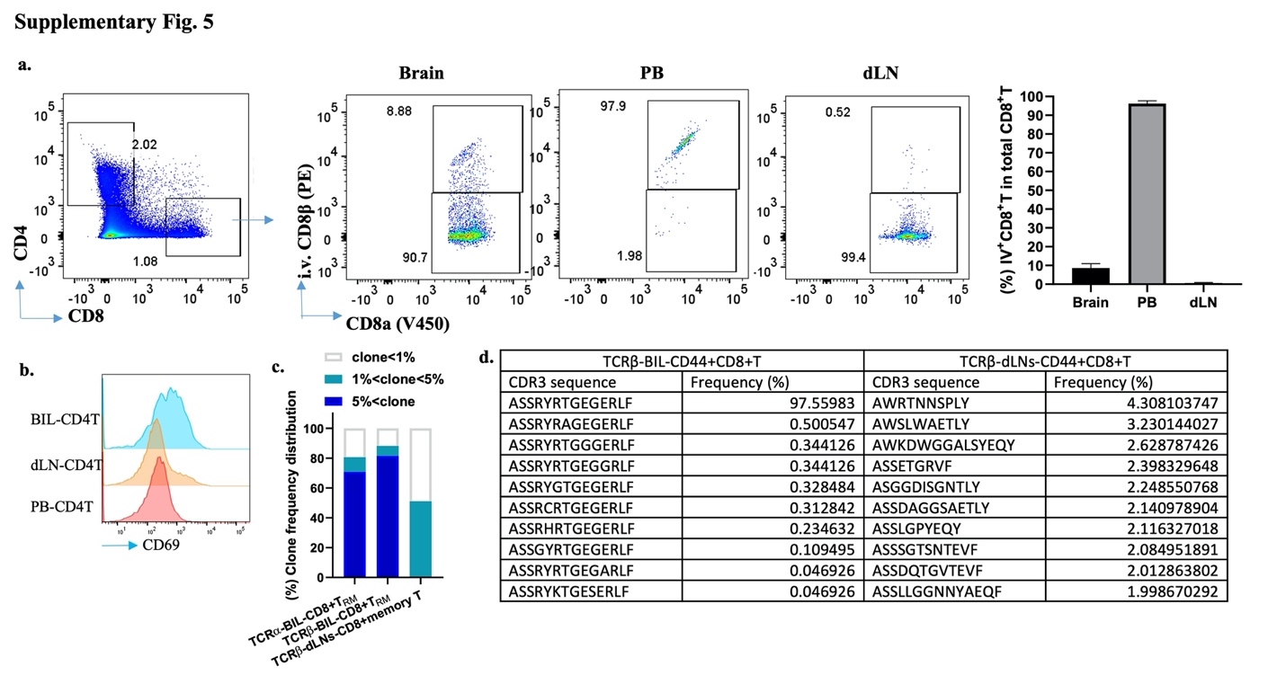
Supplementary Fig. 5. BIL-T cells were mainly brain resident T cells
a, Intravital (IV) staining CD8⁺T cells showing CD8⁺ T cells from brain, blood, and LNs (n = 8, representing three experiments). b, Representative flow cytometry plots and graphs showing CD69 expression on CD4⁺ T cells in the brain, dLN, and PB of T-αFgl2–treated survivors of DBT model. c, Clone frequency distributions of TCRα-BIL-CD8+T_{RM}, TCRβ-BIL-CD8+T_{RM}, TCRβ-dLNs-CD44+CD8+T clones based on CDR3 sequences of DBT model. Highly expanded TCRα/β clones (frequency > 5%) constituted more than 60% of BIL-CD8+T_{RM} population. d, Top 10 CDR3 sequences of TCRβ-BIL-CD44+CD8+T and TCRβ-dLNs-CD44+CD8+T of DBT model.

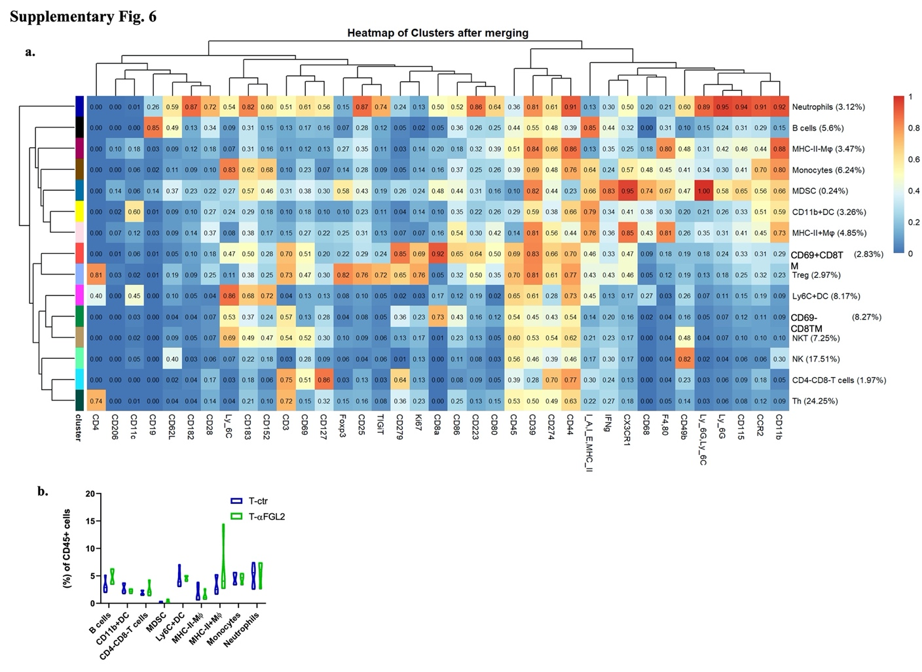

Supplementary Fig. 6. Immune cell clusters and cluster frequency in brain of CyTOF data
a, Heatmap of different markers’ expression on 15 clusters of CD45⁺ cells in brain of CyTOF data in Fig. 6; b, frequency of different cells populations in brains with T-Ctr treated and brains with T-αFGL2 treatment (n = 4~5, P values from one-way t-test).

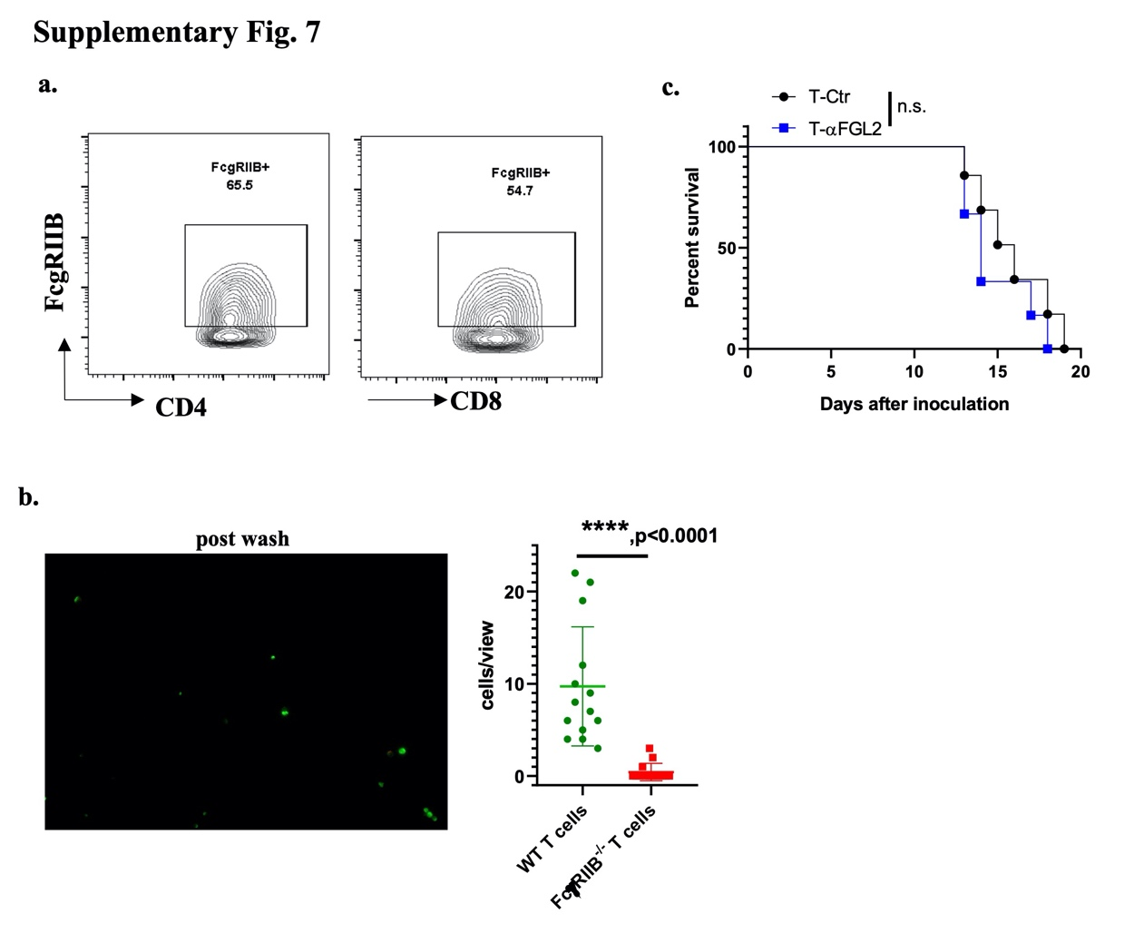
Supplementary Fig. 7. FcƴRIIb expressed on the T cells and responded to FGL2
a, representative CYTOF data of FcƴRIIb expression on CD4T cells and CD8T cells in tumor bearing brains. b, 1.5 million WT T cells (dyed green) and 1.5 million FcƴRIIb^{-/-} T cells (dyed red) were loaded into a FGL2 coated chamber and passed through the slide chip using the Cytoquest microfluidics pump. The slide chip was then imaged on a fluorescent microscope. ****p<0.000, two-way t-test. c, Kaplan-Meier survival curves for DBT bearing FcƴRIIb^{-/-} mice treated with T-Ctr or T-αFGL2, n.s. not significant, log-rank test.

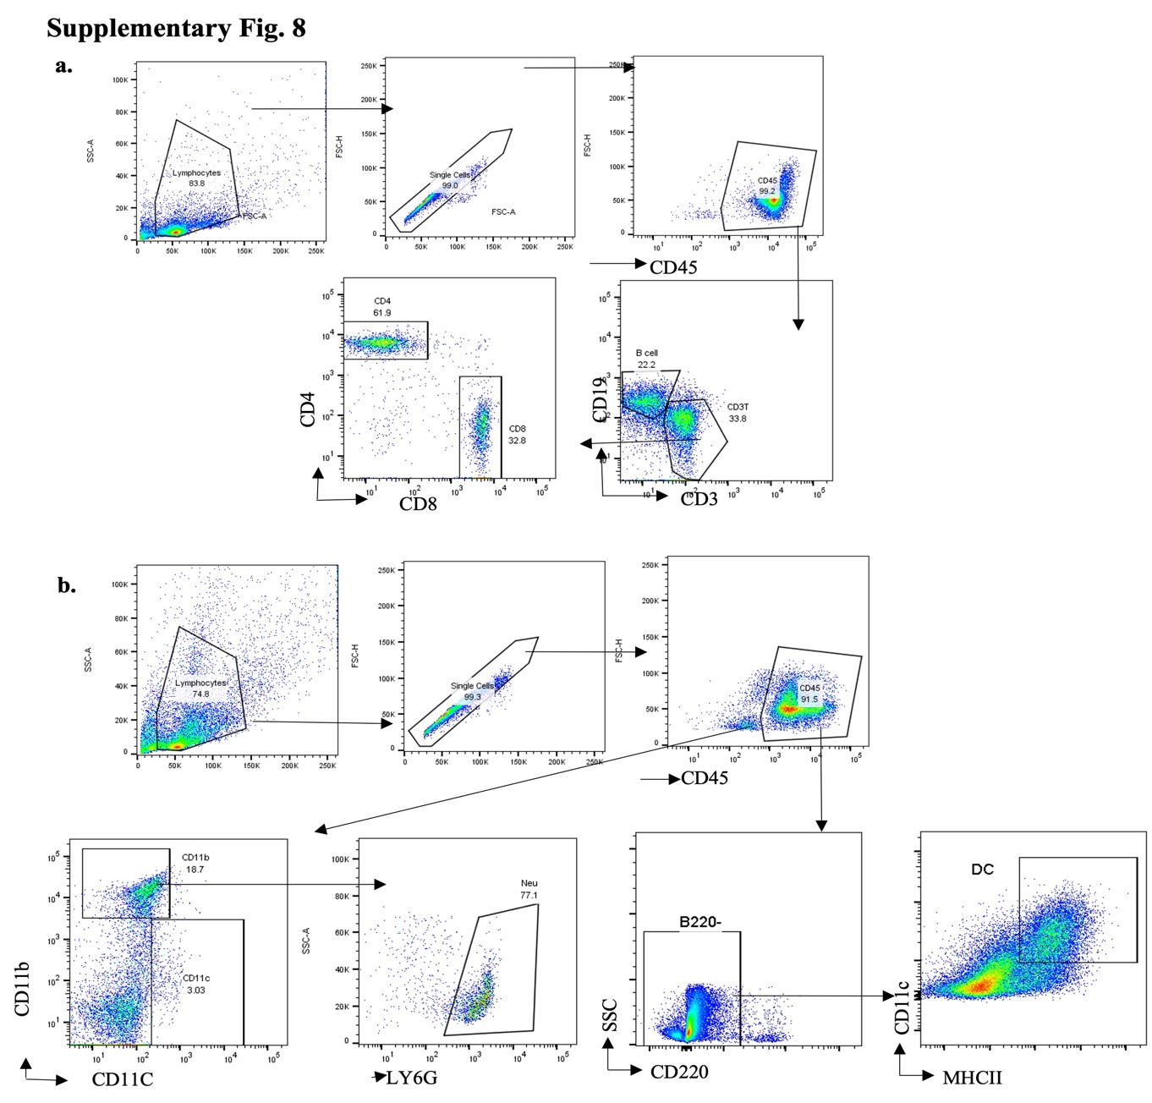
Supplementary Fig. 8. Flow gating strategy of different cell populations.
a, Gating strategy of B cells, T cells, CD8⁺T cells, and CD4⁺T cells; b, Gating strategy of dendritic cells (DCs), neutrophils.

