Supplementary information

In situ 3D printing of liquid metal-hydrogel hybrid for multifunctional soft bioelectronics and devices

Caicai Jiao¹, Liangtao Li¹, Qian Wang¹, Weili Hong¹, Xing Chen¹, Lingqian Chang¹, Xinpeng Wang¹, Yang Wang¹, Kang Sun¹, Liang Hu^{1*}, Yubo Fan^{1*}

¹Beijing Advanced Innovation Center for Biomedical Engineering, School of Biological Science and Medical Engineering, Beihang University, Beijing 100191, China
* Corresponding author: cnhuliang@buaa.edu.cn
yubofan@buaa.edu.cn

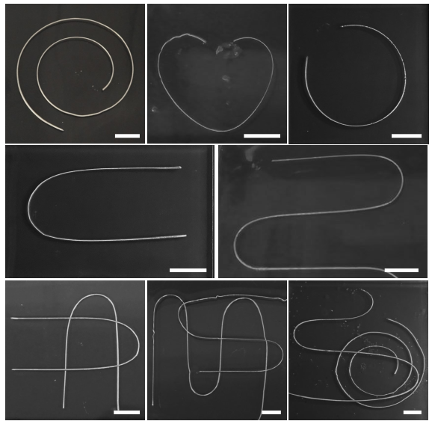
Fig. S1 Images of different printing patterns by in-situ 3D printing method. Scale bar: 1 cm.
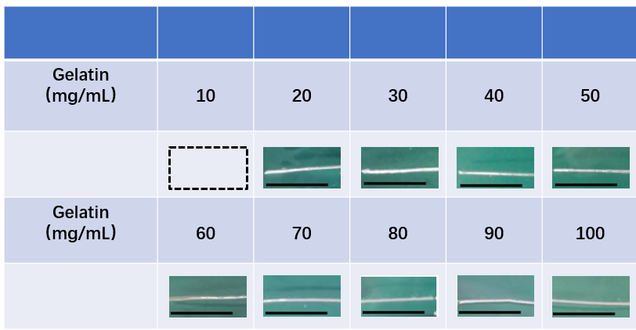
Fig. S2 Effect of gelatin concentration on printing smooth LM wire. Scale bar: 2 cm.
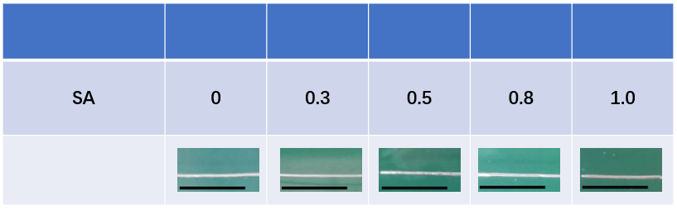
Fig. S3 Effect of SA concentration on printing smooth LM wire. Scale bar: 2 cm.
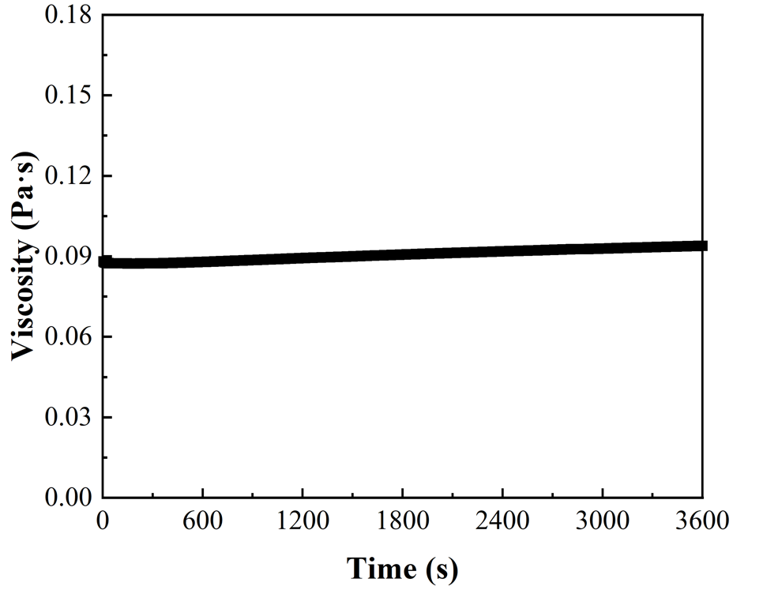
Fig. S4 The viscosity as a function of time.
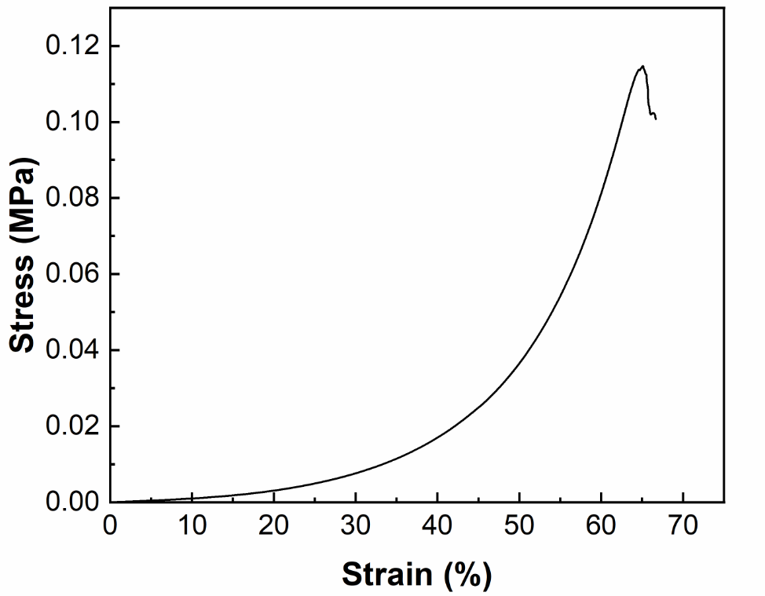
Fig. S5 Stress–strain curve of GSP hydrogel.
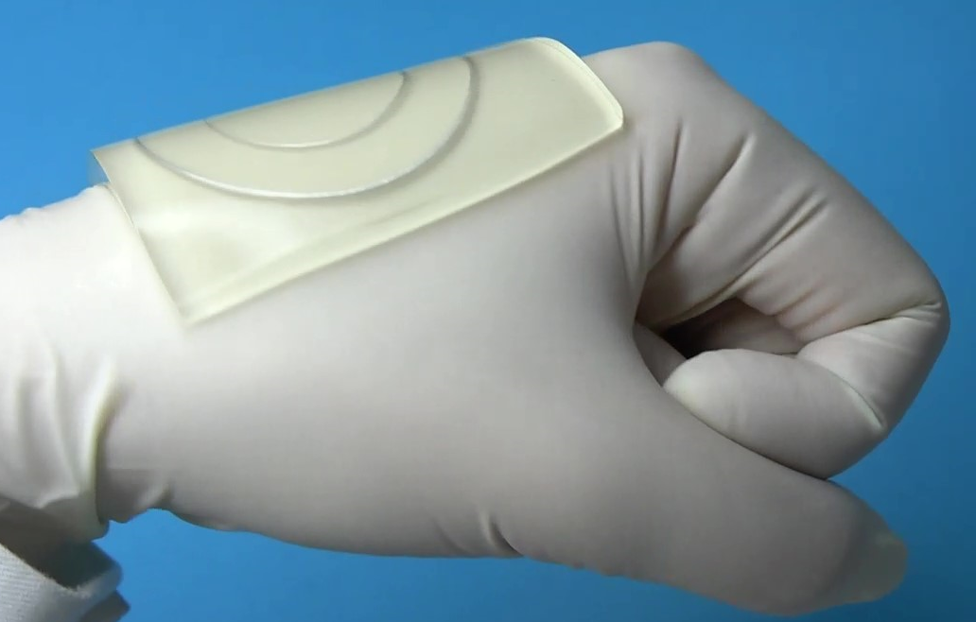
Fig. S6 Demonstration showing that the LM-hydrogel hybrid fits well on the hand under bending conditions.

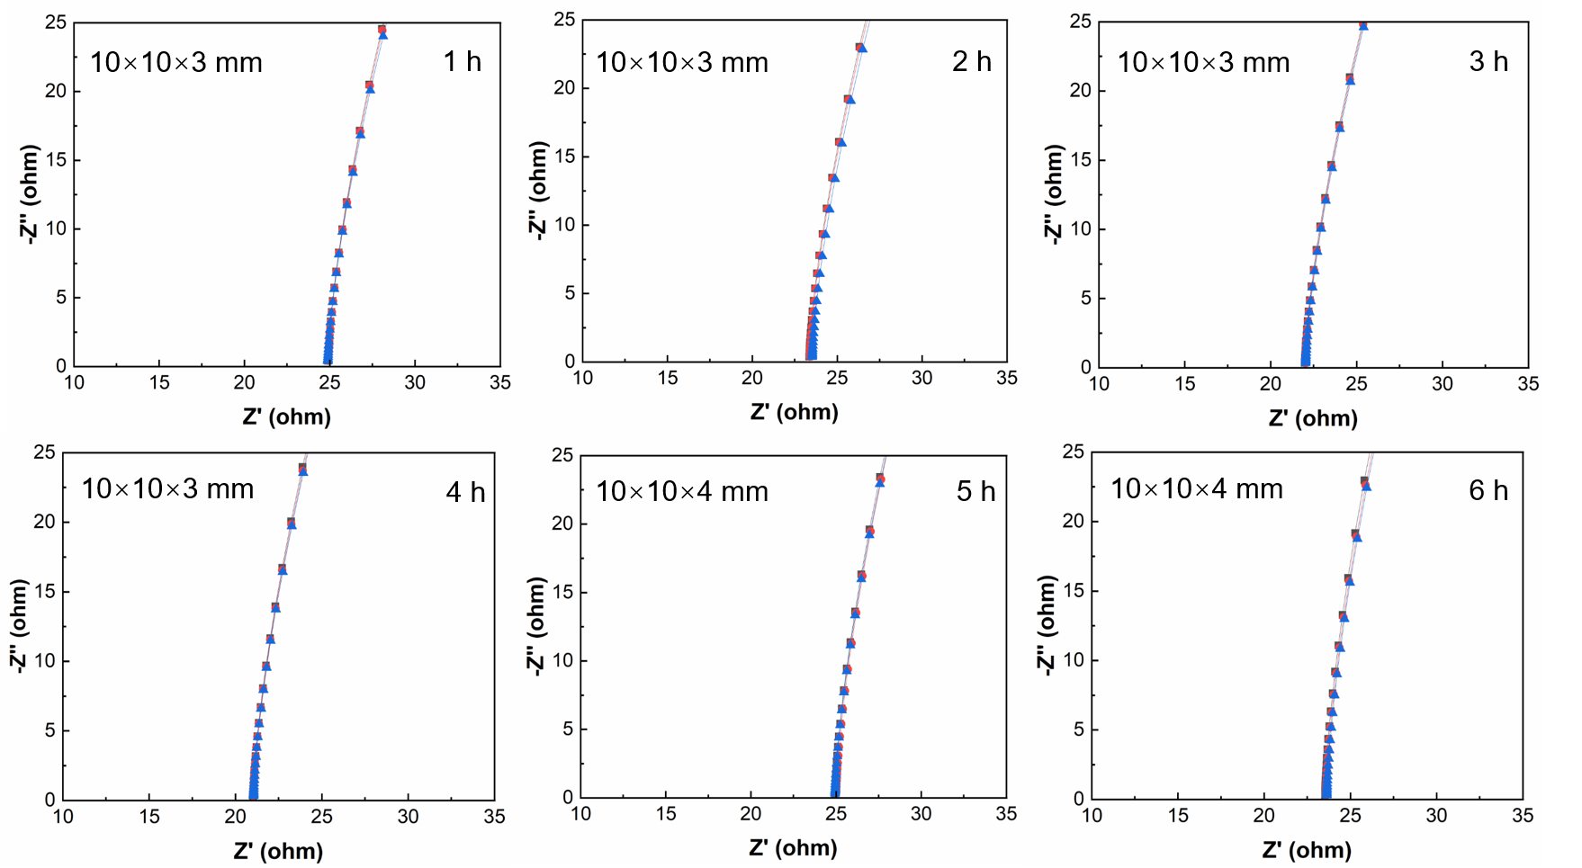
Fig. S7 Nyquist plots of GSP hydrogel with different CaCl₂ soaking time.
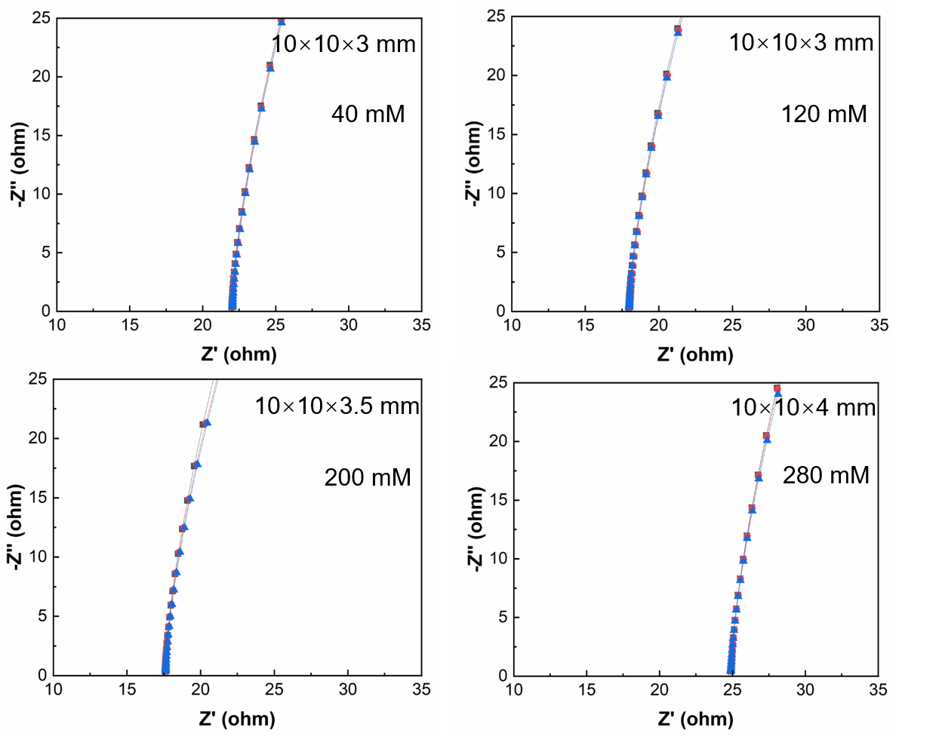
Fig. S8 Nyquist plots of GSP hydrogel with different electrolyte KCl concentration.
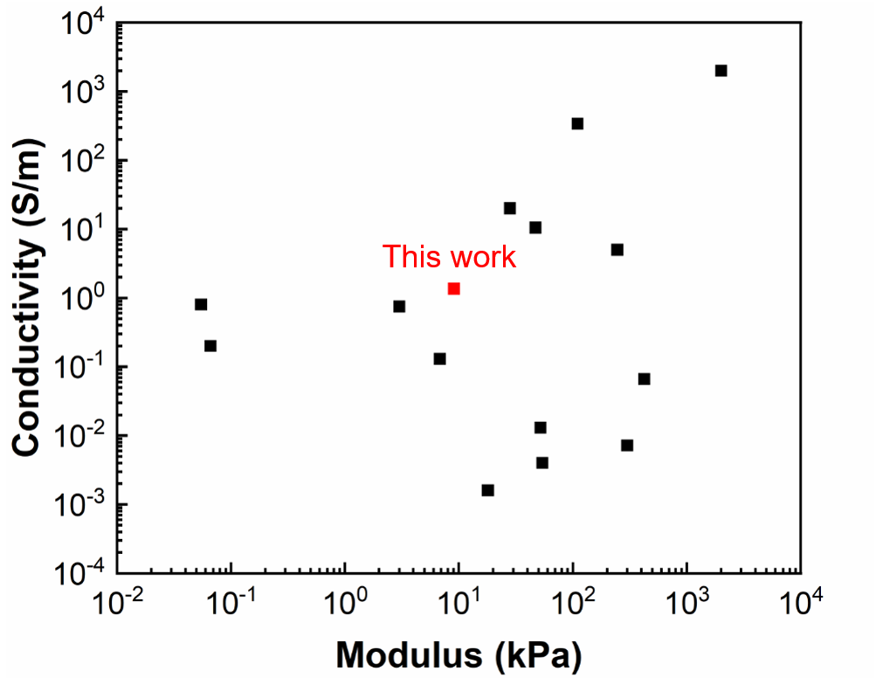
Fig. S9 An Ashby-style plot comparing conductivity and modulus of the GSP hydrogel with other conductive hydrogels (data points are from references mentioned in Table S1).
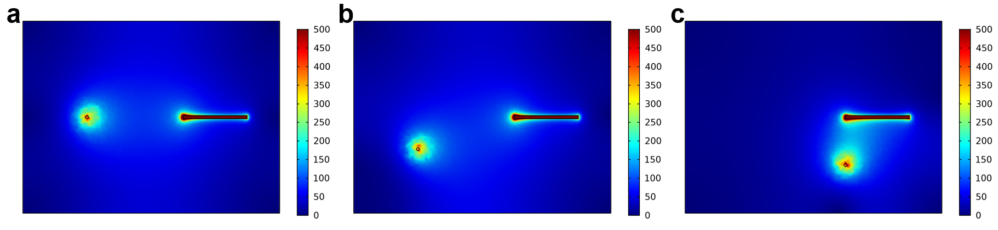
Fig. S10 Setting 1 COMSOL simulation of current distribution in LM-hydrogel hybrid electronics in different positions.
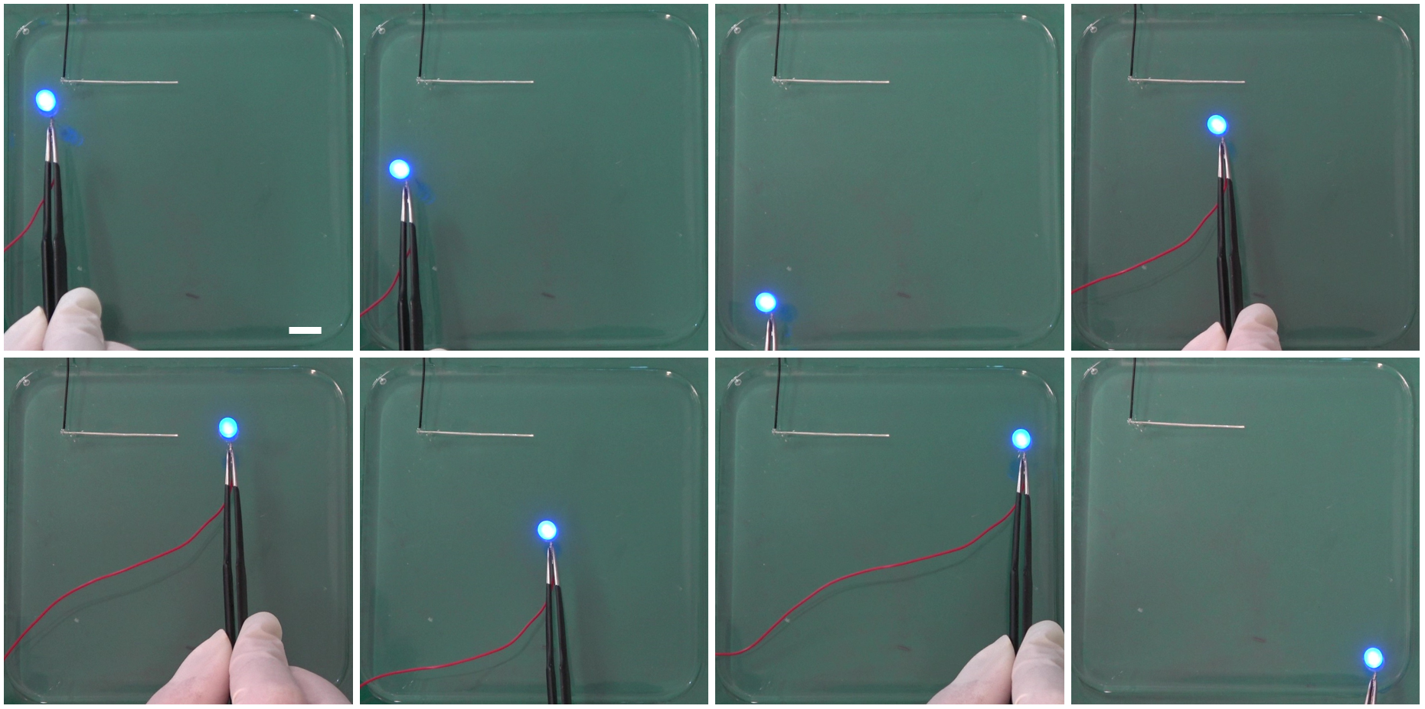
Fig. S11 Photos containing the LM-hydrogel hybrid electronic with a LM wire and a connected LED in different positions in Setting 1. Scale bar: 1 cm.
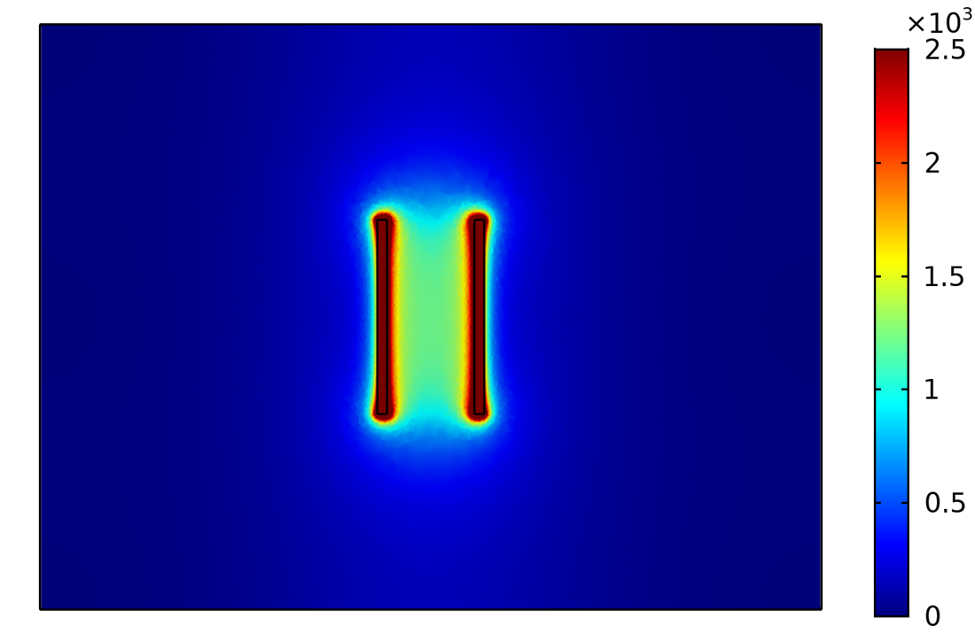
Fig. S12 Setting 2 COMSOL simulation of current distribution in LM-hydrogel hybrid electronics.
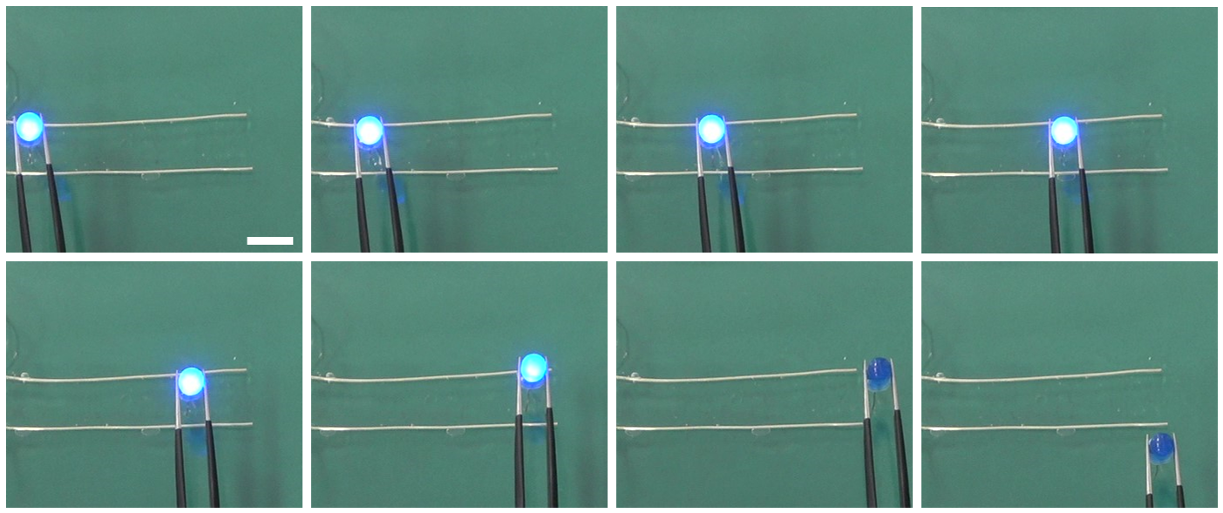
Fig. S13 Photos containing the LM-hydrogel hybrid electronic with two parallel LM wires and an LED placed on the two parallel LM wires in different positions in Setting 2. Scale bar: 1 cm.
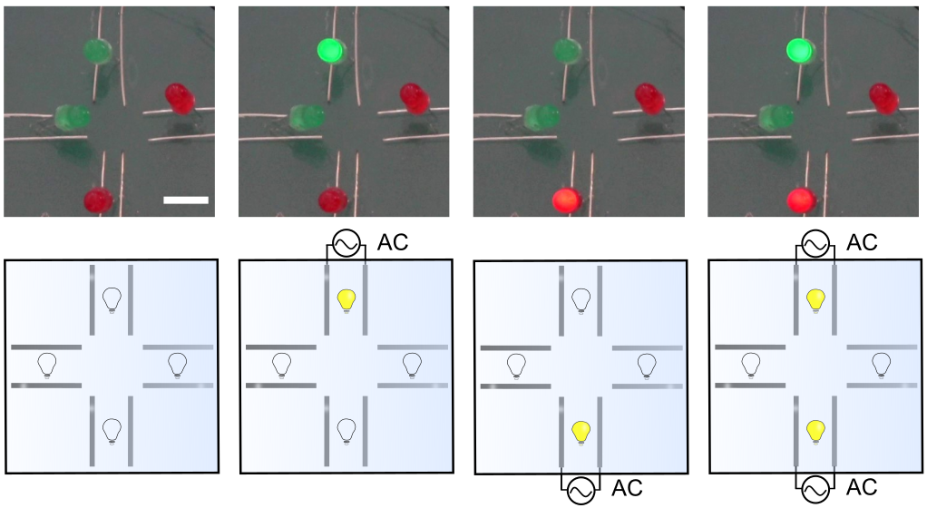
Fig. S14 Photos and schematic diagrams of a programmable ionic hydrogel circuit display device. Scale bar: 1 cm.

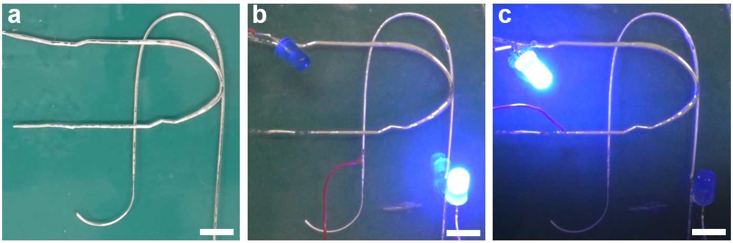
Fig. S15 Demonstration of multilayer LM-hydrogel hybrid circuits. (a) The circuits are not connected. (b) Connect one circuit. (c) Connect the other circuit. Scale bar: 1 cm.

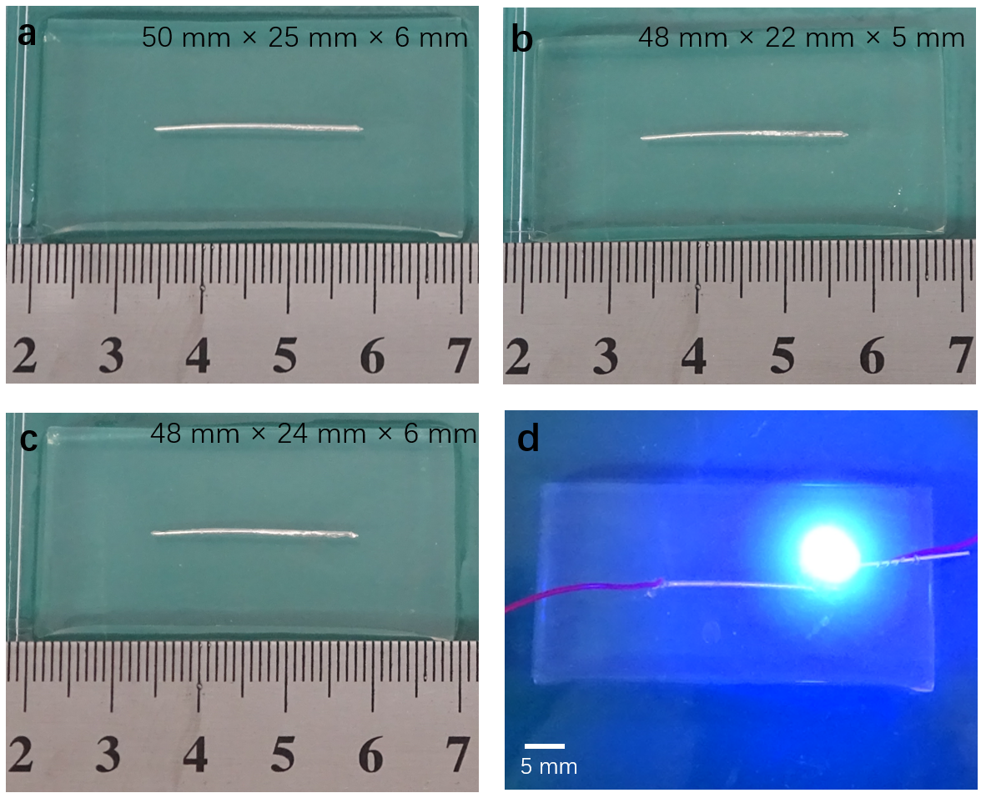
Fig. S16 Reusability of the LM-hydrogel hybrid circuit. Digital photos of LM-hydrogel hybrid circuit in different conditions: (a) initial, (b) directly placing at room temperature (26 ℃) for 3 h, and (c) after re-immersed in water for 3 h. (d) LM-hydrogel hybrid circuit can still light LED after dehydration-hydration process.

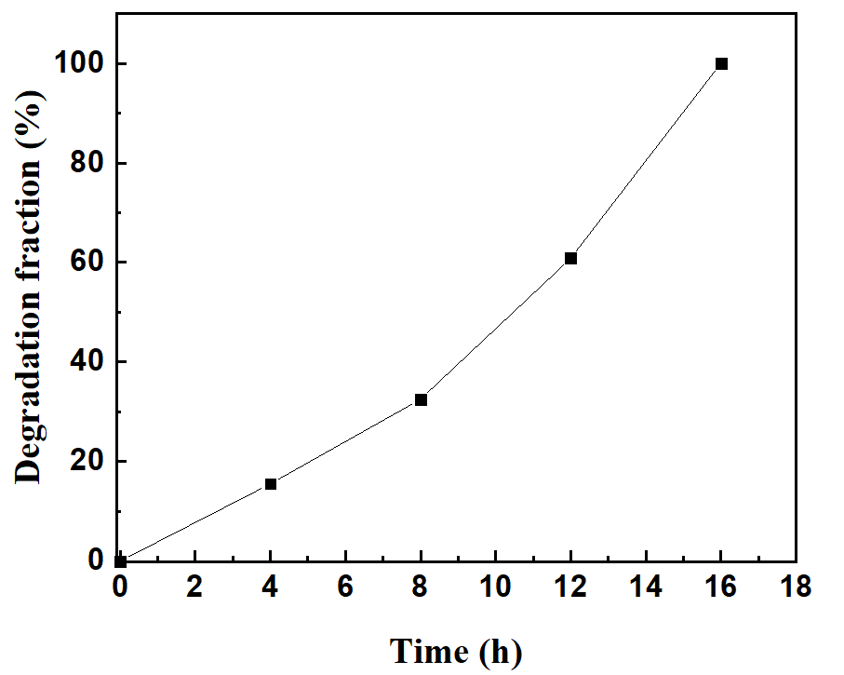
Fig. S17 Degradation fraction of the LM-hydrogel hybrid as a function of time.

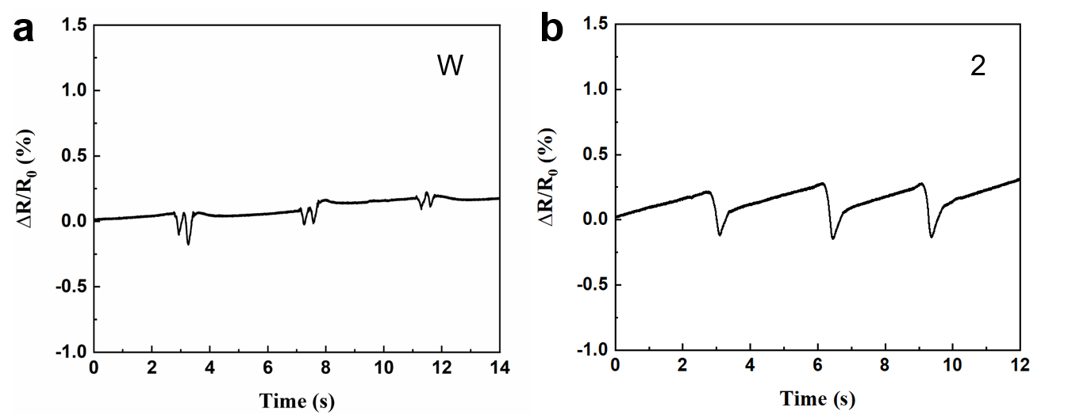
Fig. S18 Resistive change on writing the letter “W” and the number “2”, each was written three times to exhibit the repeatability.

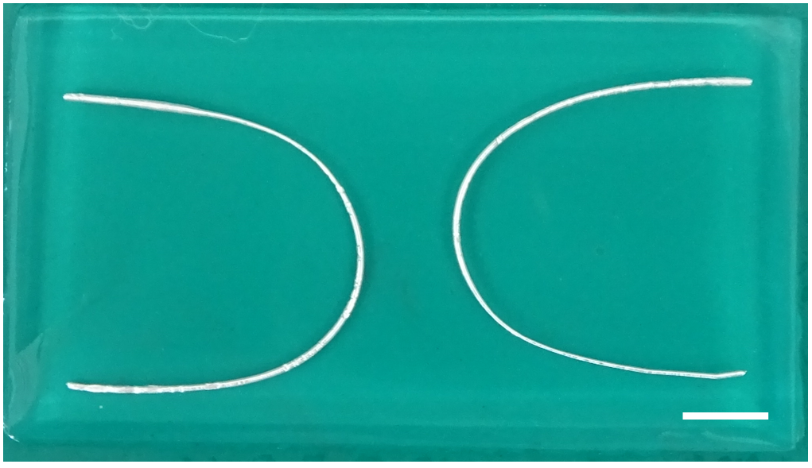
Fig. S19 The LM-hydrogel hybrid electrodes for electrical stimulation. Scale bar: 5 mm.

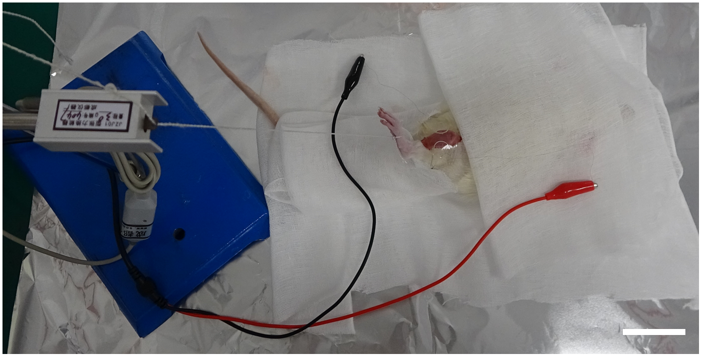
Fig. S20 Image of in vivo TA muscle electrical stimulation. Scale bar: 5 cm.

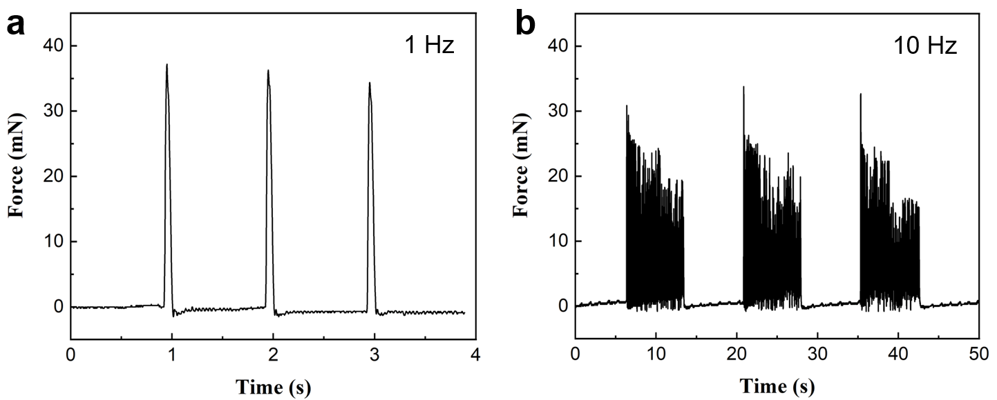
Fig. S21 Force changes under different stimulation frequencies of (a) 1 Hz and (b) 10 Hz.

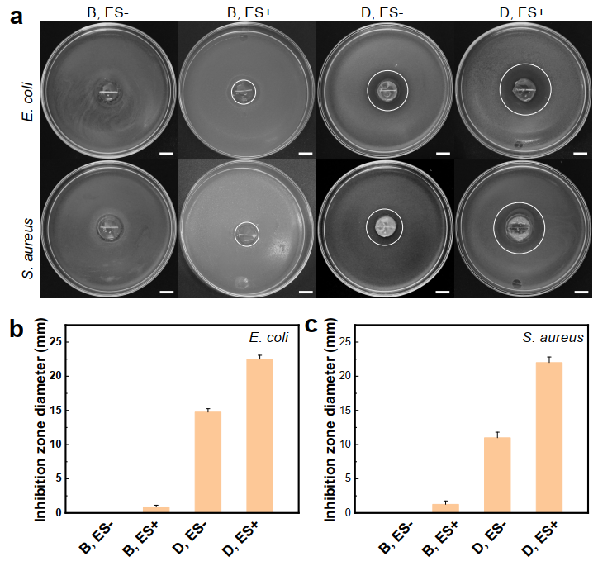
Fig. S22 (a) Optical images of antibacterial test results against E. coli and S. aureus. The inhibition zone diameter of different groups for (b) E. coli and (c) S. aureus. Scale bar: 1 cm.

Table S1. Comparison of conductivity and modulus of different conductive hydrogels.
hydrogel network | Conductivity  (S/m) | Modulus  (kPa) | Ref
PAAm | 0.0016 | 18 | 1
GO/PAAm | 0.004 | 54 | 1
r(GO/PAAm)_{3h} | 0.013 | 52 | 1
CS-2GNP | 0.13 | 6.8 | 2
PANI/PVA cryogels | 10.5 | 47 | 3
PVA/SA composite hydrogels | 0.0664 | 423 | 4
PNIPAM/PPy | 0.8 | 0.0545 | 5
PNIPAM/PANI | 0.2 | 0.0661 | 5
DOPA-based cryogels (2mg/mL) | 0.0072 | 300 | 6
MC-Gel (c_{aniline} = 0.1 M) | 5 | 245 | 7
DN-PEDOT(PSS)-II | 340 | 110 | 8
APY gel | 20 | 28 | 9
Pure PEDOT:PSS hydrogels | 2000 | 2000 | 10
PyHA-PPy 50 | 0.75 | 3 | 11
GSP hydrogel | 1.36 | 9.069 | This work

Reference
1 Jo, H. et al. Electrically conductive graphene/polyacrylamide hydrogels produced by mild chemical reduction for enhanced myoblast growth and differentiation. Acta Biomaterialia 48, 100-109 (2017).
2 Baei, P. et al. Electrically conductive gold nanoparticle-chitosan thermosensitive hydrogels for cardiac tissue engineering. Materials Science and Engineering C 63, 131-141 (2016).
3 Stejskal, J. et al. Polyaniline cryogels supported with poly(vinyl alcohol): soft and conducting. Macromolecules 50, 972-978 (2017).
4 Kweon, O. Y., Samanta, S. K., Won, Y., Yoo, J. H. & Oh, J. H. Stretchable and self-healable conductive hydrogels for wearable multimodal touch sensors with thermoresponsive behavior. ACS Appl. Mater. Interfaces 11, 26134-26143 (2019).
5 Shi, Y., Ma, C., Peng, L. & Yu, G. Conductive “smart” hybrid hydrogels with PNIPAM and nanostructured conductive polymers. Adv. Funct. Mater. 25, 1219-1225 (2015).
6 Wang, L. et al. Mussel-inspired conductive cryogel as cardiac tissue patch to repair myocardial infarction by migration of conductive nanoparticles. Adv. Funct. Mater. 26, 4293-4305 (2016).
7 Duan, J., Liang, X., Guo, J., Zhu, K. & Zhang, L. Ultra-stretchable and force-sensitive hydrogels reinforced with chitosan microspheres embedded in polymer networks. Adv. Mater. 28, 8037-8044 (2016).
8 Naficy, S., Razal, J. M., Spinks, G. M., Wallace, G. G. & Whitten, P. G. Electrically conductive, tough hydrogels with pH sensitivity. Chem. Mater. 24, 3425-3433 (2012).
9 Hur, J. et al. Polypyrrole/agarose-based electronically conductive and reversibly restorable hydrogel. ACS Nano 8, 10066-10076 (2014).
10 Lu, B. et al. Pure PEDOT:PSS hydrogels. Nat Commun 10, 1043 (2019).
11 Yang, J., Choe, G., Yang, S., Jo, H. & Lee, J. Y. Polypyrrole-incorporated conductive hyaluronic acid hydrogels. Biomaterials Research 20, 31 (2016).

