Supplementary Figures
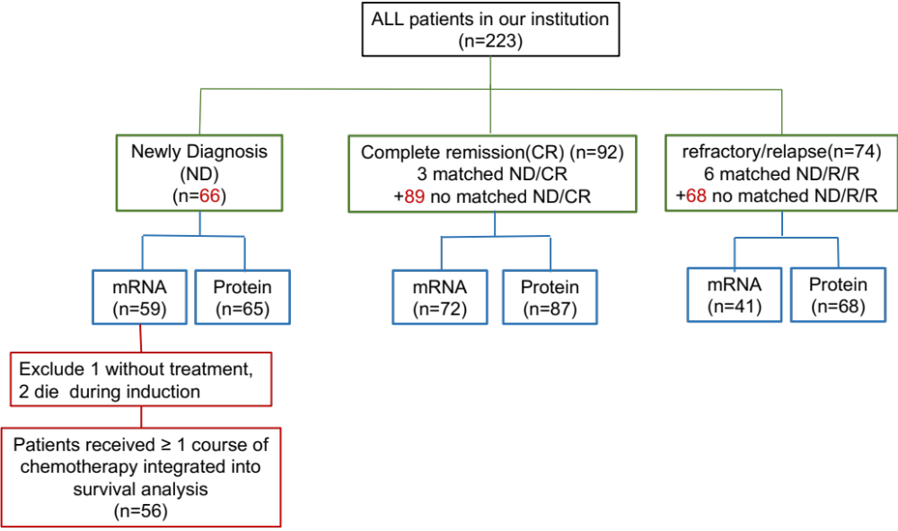
Supplementary Figure S1. Flowchart of the ALL patients samples collection and clinical data follow up. For NCL expression test, clinical samples were collected from 223 patients of ALL. There were 59 mRNA sample and 65 protein samples collected from 66 patients before treatment (de novo); 72 mRNA samples and 87 protein samples collected from 89 patients with complete remission; 41 mRNA samples and 68 protein samples collected from 74 patients with refractory/relapse. Of the 74 refractory/relapse patients, only 6 were with corresponding samples at newly diagnosis (matched samples), and another 68 were without corresponding samples at newly diagnosis (not matched samples).

Supplementary Figure S2. Constructed of Nucleolin overexpression and knock down cells. Molt-4, Jurkat and Nalm-6 cells were transfected with lentiviral vectors for the NCL cDNA (OE) or empty control (NC), and NCL-shRNA (KD) or Scramble-shRNA(Scr). MAR cells were transfected with lentiviral vectors for NCL-shRNA (KD) or Scramble-shRNA(Scr). (A) Relative mRNA expression of nucleolin was detected by qRT-PCR, NCL mRNA level increased in the three tested lines. (B) Molt-4, Jurkat, and Nalm-6 cell lysates were extracted and subjected to western blot analysis to detect the NCL protein expression. β-actin and GADPH was utilized to monitor equal loading of proteins. (C) Relative mRNA expression of NCL was detected by qRT-PCR, NCL mRNA level increased in the three tested lines. (D) MAR, Molt-4, Jurkat, and Nalm-6 cell lysates were extracted and subjected to western blot analysis to detect the NCL protein expression. β-Tublin and GADPH was utilized to monitor equal loading of proteins. *, P < 0.05.
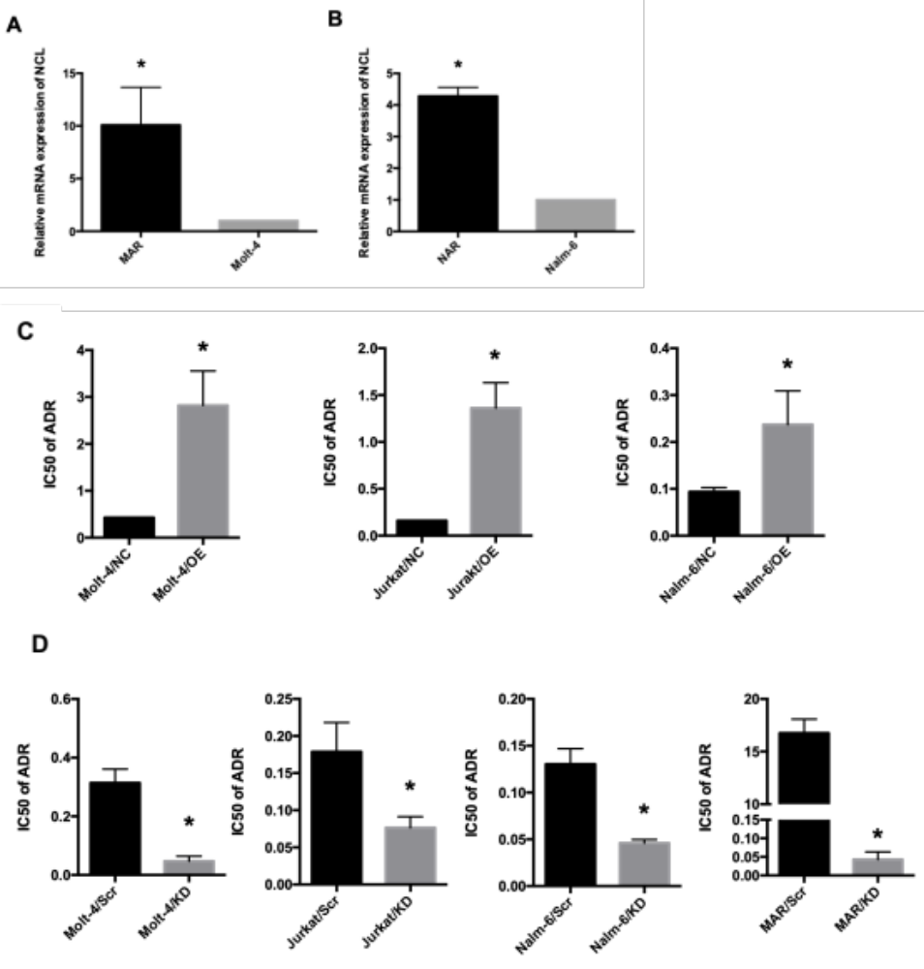
Supplementary Figure S3. Expression of NCL increased in MAR and NAR cells. Increased nucleolin levels are inversely correlated with sensitivity to the chemotherapy agent Adriamycin in ALL cell line. (A) The NCL mRNA expression in Molt-4 cells was compared with the levels in MAR cells. (B) The NCL mRNA expression in Nalm-6 cells was compared with the levels in NAR cells. Relative NCL mRNA expression was detected by qRT-PCR. Molt-4, Jurkat and Nalm-6 cells were transfected with lentiviral vectors for the NCL cDNA (OE) or empty control (NC), and NCL-shRNA (KD) or Scramble-shRNA(Scr). MAR cells were transfected with lentiviral vectors for NCL-shRNA (KD) or Scramble-shRNA(Scr). (C) Effect of increased NCL expression on cell drug sensitivity was evaluated by ADR IC50 analysis. (D) Effect of decreased NCL expression on cells drug sensitivity was evaluated by ADR IC50 analysis. *, P < 0.05.
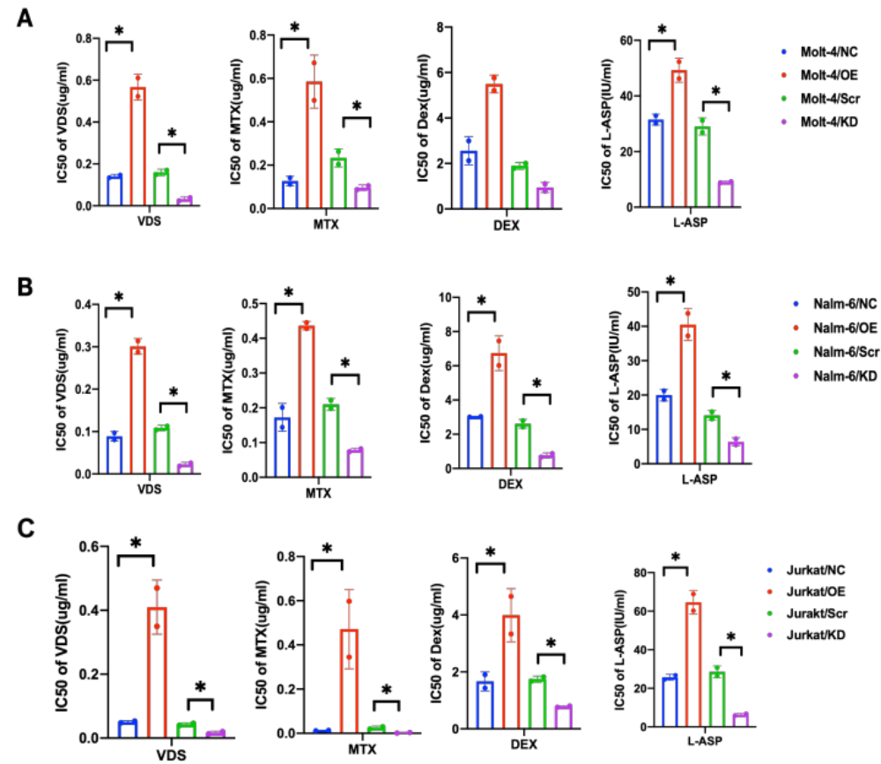
Supplementary Figure S4. Increased nucleolin levels are inversely correlated with sensitivity to the chemotherapy agent VDS, MTX, DEX and L-ASP in ALL cell line. MTT assay was used to detect the IC50 of above agents on (A) Molt-4/OE and Molt-4/KD cells, (B) Nalm-6/OE and Nalm-6/KD cells, (C) Jurkat/OE and Jurkat/KD cells. *, P < 0.05.

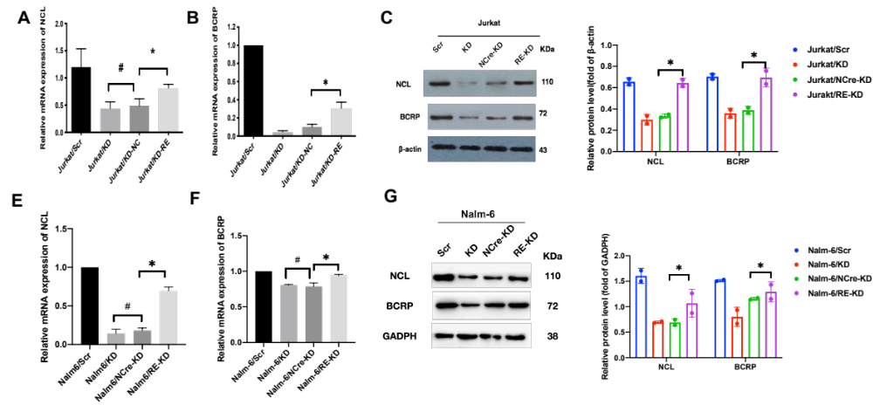
Supplementary Figure S5. Effect of rescue experiment. Jurkat/KD and Nalm-6/KD cells were transfected with lentivirus vector carrying NCL full-length ORF with a C-terminal FLAG tag but lacking the UTR sequence (RE-KD) or empty vector (NCre-KD). (A-C) Expression of NCL and BCRP mRNA (A, B) and protein level(C) after re-expression NCL in Jurkat/KD cells were detected use RT-qPCR and western blot. (E-G) Expression of NCL and BCRP mRNA (E, F) and protein level(G) after re-expression NCL in Nalm-6/KD cells were detected use RT-qPCR and western blot. #, P>0.05, *, P < 0.05.

Supplementary Figure S6. Effect of nucleolin on ERK pathway. Western blot analysis of the protein levels of ERK pathway in response to overexpressed NCL expression in Molt-4 cells.

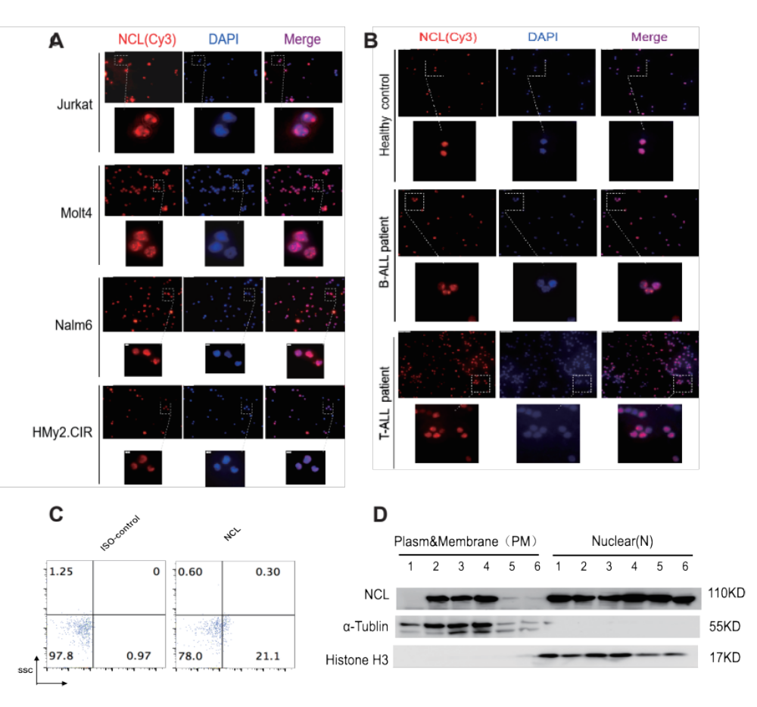
Supplementary Figure S7. Intracellular localization and expression of nucleolin. (A, B) The localization of nucleolin was determined by indirect immunofluorescence using a primary antibody against nucleolin and PE-conjugated anti-mouse secondary antibody. DNA was stained with DAPI. Nucleolin was presented mainly in the cytoplasm and membrane of ALL cells, especially in membrane. Whereas in normal cells nucleolin was concentrated in nucleus. (C) Representative images of Detection of membrane NCL expression of primary ALL cells from relapse-refractory ALL patients by flow cytometry. (D) The intracellular localization of nucleolin in was determined by western blotting. NCL protein was mainly in the cytoplasm and membrane in ALL cells compared with cell nuclei of normal and in a human B-lymphoblast cell line Hmy2.CIR cells. 1: Healthy Donor; 2: Jurkat; 3: BALL-1; 4: Nalm6; 5: Molt4; 6: Hmy2.CIR.
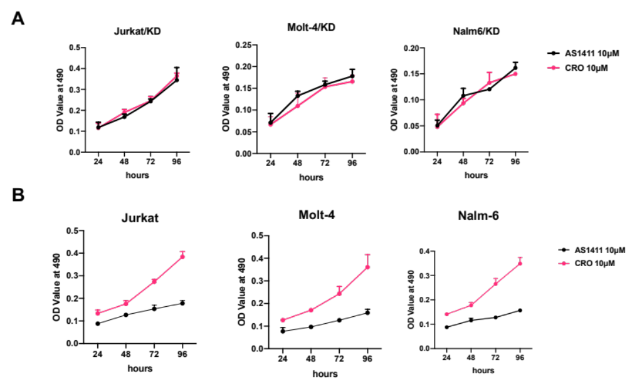
Supplementary Figure S8. AS1411 and CRO had no effect on the proliferation of the KD cells. (A) Jurkat/KD, Molt-4/KD and Nalm-6/KD cells were treated with AS1411(10 μmol/L) or CRO (10 μmol/L). Effect on cells growth of AS1411 was examined by MTT assay after 24, 48, 72 and 96 hours. (B) Jurkat, Molt-4 and Nalm-6 cells were treated with AS1411(10 μmol/L) or CRO (10 μmol/L). Effect on cells growth of AS1411 was examined by MTT assay after 24, 48, 72 and 96 hours.

Name | Sequences
NCL-P1 | 5’GAGGATCCCCGGGTACCGGTCGCCACCATGGTGAAGCTCGCGAGGCAG-3
NCL-P2 | 5’-TCCTTGTAGTCCATACCTTCAAACTTCGTCTTCTTTCC-3’.
NCL shRNA oligos | F:5’CCGGCGGTGAAATTGATGGAAATAACTCGAGTTATTTCCATCAATTTCACCGTTTTTg-3’,  R:5’AATTCAAAAACGGTGAAATTGATGGAAATAACTCAGTTATTTCCATCAATTTCACCG-3’.
Scramble sequences | 5’-TTCTCCGAACGTGTCACGT-3’.
18S | F: 5′-GACACGGACAGGATTGACAGATTG-3′  R:5′-TGCCAGAGTCTCGTTCGTTATCG-3′
NCL | F:5′-CTTGCTGTTGTGGATGTC-3′  R: 5′-CATGGCGTCTTCAAACAC-3′
BCRP | F: 5′-GATATGGATTTACGGCTTTGC-3′  R: 5′-CGATGCCCTGCTTTACCA-3′
LRP | F: 5′-CAGCTGGCCATCGAGATCA-3'  R: 5′-TCCAGTCTCTGAGCCTCATGC-3′
MRP1 | F: 5′-GCGGTGTCTCCCTCAAACG-3′  R: 5′-TCCTCACGGTGATGCTGTTC-3′
mdr-1 | F: 5′-CCCATCATTGCAATAGCAGG-3′  R: 5′-GTTCAAACTTCTGCTCCTGA-3′

Supplementary Table 1: The primers used in this study

Supplement Table 2. Clinical characteristics of ALL patients according to NCL expression (data set from our clinical site)
Characteristics | Low NCL expression  (N=29) | High NCL expression  (N=30) | P value
Age(Y)
≥60 | 16(55.2) | 13(43.3) | 0.9094
<60 | 13(44.8) | 17(56.7)
Gender
Female | 15(51.7) | 18(53.3) | 0.5221
Male | 14(48.3) | 12(46.7)
WBC at diagnose(10^9/L)
≥50 | 13(44.8) | 10(33.3) | 0.3655
<50 | 16(55.2) | 20(66.7)
Immuno-type
B-ALL | 27(93.1) | 29(96.7) | 0.5334
T-ALL | 2(6.9) | 1(3.3)
Cytogenetics
BCR-ABL | 3(10.3) | 6(20) | 0.2926
MLL rearranged | 2(6.9) | 3(10)
Hyperdiploidy | 2(6.9) | 1(3.3)
others | 16(55.2) | 10(30)
unkown | 6(20.7) | 10(36.7)
CRª
Yes | 25(89.3) | 21(75) | 0.2928
No | 3(10.7) | 7(25)
Values are reported as N (%) of patients unless indicated otherwise.
a: The calculation was based on 56 patients with available data.

Supplement Table 3. Clinical characteristics of B-ALL patients according to NCL expression (data set from TARGET database)
Characteristics | Low NCL expression  (N=182) | High NCL expression  (N=180) | P value
Age | 10.8(3.3-14.7) | 11.0(3.92-15.14) | 0.4247
Gender |  |  | 0.5918
Female | 74(40.7) | 68(37.8)
Male | 108(59.3) | 112(62.2)
WBC at diagnose(10⁹/L) |  |  | 0.0077
>=50 | 87(47.8) | 61(33.9)
<50 | 95(52.1) | 119(66.1)
CNSL at diagnose |  |  | 0.5235
No | 140(76.9) | 144(80)
Yes | 42(23.1) | 36(20)
Cytogenetics |  |  | 0.85
BCR-ABL | 2(1.1) | 0(0)
MLL rearranged | 13(7.1) | 15(8.3)
ETV6-RUNX1 | 8(4.4) | 10(5.6)
TCF3-PBX1 | 21(11.5) | 18(10)
Trisomy4/10 | 8(4.4) | 9(5)
Hyperdiploidy | 16(8.8) | 16(8.9)
others | 114(62.7) | 112(62.2)
MRD D29
>=0.01% | 89(48.9) | 95(52.8) | 0.4607
<0.01% | 93(51.1) | 85(47.2)
Values are reported as N (%) of patients unless indicated otherwise.

Supplement Table 4. Clinical co-variates
Patient NO. | Sex | Age | Response to  induction  therapy | Relapsed  or Not | T or B ALL | BCR-ABL
1 | Male | 49 | CR | YES | B-ALL | negative
2 | Male | 20 | CR | YES | B-ALL | negative

