Meteorological Factors Facilitated Increased Legionnaires’ Disease Notifications and Mortality Pre-COVID-19 and COVID-19 in Hong Kong
¹Yin Zhang, ¹*Frank Y. Chen, ¹Geoffrey K.F. Tso, ²Lin Yang
¹Department of Management Sciences, College of Business, City University of Hong Kong, Hong Kong, P.R.China
²Faculty of Health and Social Sciences, School of Nursing, The Hong Kong Polytechnic University, Hong Kong, P.R.China
^{2*}Corresponding Email: youhchen@cityu.edu.hk,
^{2*}Corresponding ORCID : 0000-0003-4707-9361,
^{2*}Corresponding postal address: 7-251, Lau Ming Wai Academic Building, City University of Hong Kong, Hong Kong, P.R. China.
Running Title: Meteorological Factors Facilitated LD Pre-COVID-19 and COVID-19 HK

Appendix A Figures
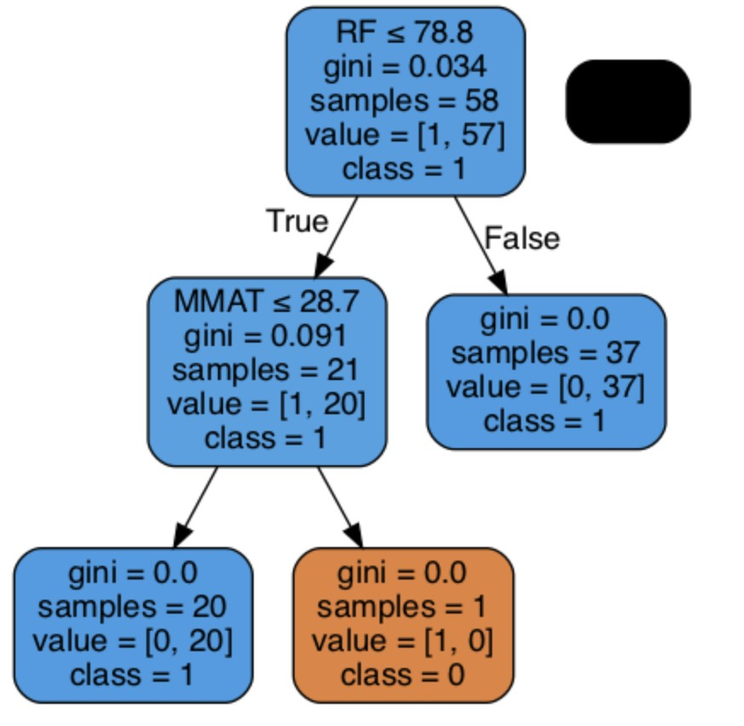
Figure S1. Decision tree classification for public policy shows rainfall greater than 78.8 with Gini score 3.4 has a higher likelihood for new LD incidence

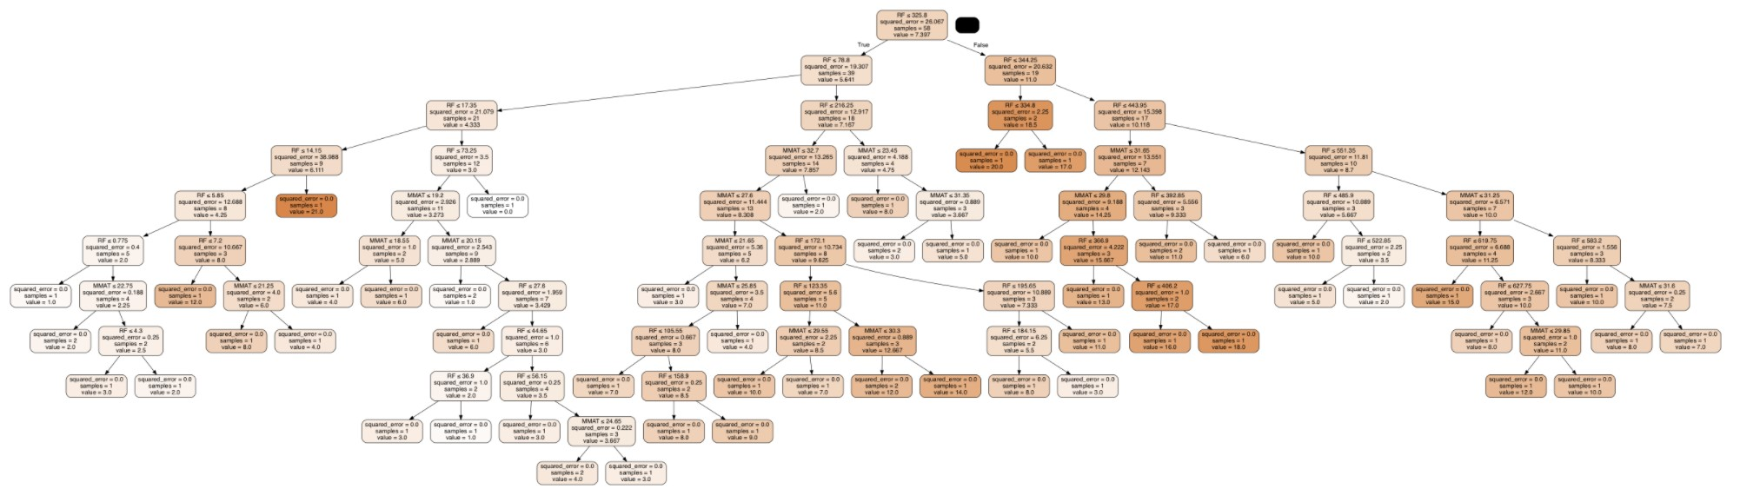
Figure S2. Decision tree regression for public policy shows rainfall greater than 334.8(mm) is dangerous to have more number of LD confirmed cases

Appendix B Equations
2.1 Annual change in case fatality rate
We calculate the annual change in LD case fatality rate (CFR) using the following equation:
Change in LD CFR = $\frac{{CFR}_{LD, y }- {CFR}_{LD, y-1}}{{CFR}_{LD, y-1}}$ (1)
where ${CFR}_{LD, y }$ denotes the LD CFR in year y and ${CFR}_{LD, y -1}$ denotes LD CFR in year y-1 such that
${CFR}_{lLD y }=\frac{Number of LD-related deaths in year y}{Number of LD confirmed cases in year y} x 100\%$ (2)
2.3 | Negative binomial regression equation  $$Y_{i}=e^{ln\left(\ln\left(c_{i}\right)+β_{1}x_{1i}+β_{2}x_{2i}+…+β_{k}x_{ki}\right)}$$  = $e^{ln\left(\ln\left(c_{i}\right)+β_{1}{MMAT}_{\left(m,y\right)i}+β_{2}{MAT}_{\left(m,y\right)i}+β_{3}{RH}_{\left(m,y\right)i}+β_{4}{RH}_{\left(m,y\right)I}\right)}$ (11)
where Y_{i} is the expected mean of Y_{c} determined by the exposure counts, c, of the confirmed LD cases and a set of k regressors, MMAT₍m,y)i, MAT₍m,y)i, RH₍m,y)i and RF₍m,y)i are monthly data for maximum air temperature, average air temperature, relative humidity and amount of rainfall, in month m in year y respectively.
2.4 Poisson regression equation
$${ Y}_{i}=log\left(λ_{i}\right)$$
$$=log\left(E\left[{LD}_{mortality} | x_{ik}\right]\right)$$
= ${β_{0}Intercept + β}_{1}{MMAT}_{\left(m,y\right)i}$ + $β_{2}{MAT}_{\left(m,y\right)i}+β_{3}{RH}_{\left(m,y\right)i}+β_{4}{RH}_{\left(m,y\right)i}$ (10)

where the observed values Y_{i} „ Poisson with λ “ λ_{i} for a given x_{i} is the expected LD-related deaths in month m in year y, MMAT_{m,y}, MAT_{m,y}, RH_{m,y} and RF_{m,y} are monthly data for maximum air temperature, average air temperature, relative humidity and amount of rainfall, in month m in year y respectively.

Appendix C Tables
Table S1. All other causes (AOC) of death in Hong Kong in 2020¹ with number of deaths, number of notification and case fatality rate (CFR).
Disease | Death | Notification | CFR
Tuberculosis | 200 | 3699 | 5.4%
Coronavirus disease 2019(COVID-19) | 125 | 8889 | 1.4%
Legionnaires’ disease | 18 | 104 | 17.3%
Invasive pneumococcal disease | 15 | 47 | 31.9%
Creutzfeldt-Jakob disease | 12 | 12 | 100%
Viral hepatitis | 3 | 161 | 1.9%
Amoebic dysentery | 1 | 8 | 12.5%
Community-associated methicillin-resistant Staphylococcus aureus | 1 | 813 | 0.1%
Listeriosis | 1 | 15 | 6.7%
Psittacosis | 1 | 11 | 9.1%
Rubella and congenital rubella syndrome | 1 | 4 | 25.0%
Typhus and other rickettsial disease | 1 | 49 | 2.0%
Whooping cough | 1 | 22 | 4.5%

Table S2. Negative binomial model for LD monthly incidence with July effect
Variable | Coefficient | S.E. | Pr(>z) |  | RR | 95%CI
(intercept) | 1.88 | 0.08 | 0.000 |  | 6.53 | 5.6-7.6
July | 0.59 | 0.26 | 0.025** |  | 1.81 | 1.08-3.03
N | 591
t-statistics α | 3.96
df = 69 with 1 dispersion of α | 2.381
Log-likelihood (negative binomial) | -196.97
Log-likelihood (Poisson) | -222.32
Log-likelihood ratio | 50.7
χ2 | 74.5
χ² (df residuals=68) | 88.25
***p < 0.01, **p < 0.05, *p < 0.1 ;
S.E.: Standard error; RR: Relative risk; 95% CI: 95% CI of RR; CI: Confidence interval.
Table S3. Negative binomial model for monthly confirmed LD cases with February 2020 spike with relative risk and 95% confidence intervals.
Variable | Coefficient | S.E. | Pr(>z) | RR | 95%CI
(intercept) | 1.86 | 0.07 | 0.000 | 6.43 | 5.59-7.39
February 2020 | 1.1841 | 0.49 | 0.016** | 3.27 | 1.24-8.58
N | 591
t-statistics α | 3.48
df = 69 with 1 dispersion of α | 2.382
Log-likelihood (negative binomial) | -190.97
Log-likelihood  (Poisson) | -209.86
Log-likelihood ratio | 38.78
χ2 | 75.3
χ² (df residuals=67) | 87.11
***p < 0.01, **p < 0.05, *p < 0.1.

Table S4. Demographics results of LD-related deaths in current study vs. confirmed LD cases in the main reference³¹.
 | Current Study |  | Main Reference³¹
Objective of study |  | LD-related deaths | Confirmed LD cases
Region of study |  | Hong Kong | Hong Kong
Period of study |  | 2015-2020 | 2005-2015
Total cases |  | N=53 | N=288
Age
Median |  | 71 years | 64 years
Range |  | 9-94 years | 25-96 years
Interquartile |  | 60-81 years | 56-74 years
>=50 years |  | 87% | 88%
Gender
Male |  | 85% | 86%
Female |  | 15% | 14%
Occupation
Economically inactive |  | 74% | 58%
Residential institution/ security guards |  | 9% | 9%
Drivers |  | None is found | 12%
Unknown |  | 6 cases | 3 cases

Appendix D Hypothesis Testing of Poisson Distribution for monthly confirmed LD cases
We want to fit the Poisson distribution for the monthly confirmed LD cases and test the goodness of fit. Does the assumption of Poisson distribution seem appropriate as a model for the monthly confirmed LD cases in Hong Kong?
Null Hypothesis 1 H₀: X follows Poisson distribution.
Hypothesis 1 H₁: X does not follow Poisson distribution.
We have the following observed counts of monthly confirmed LD cases and the frequency for each count for our dataset from January 1, 2015 to November 30, 2021.
Table S5. Confirmed LD cases and frequency count
Observed cases | 0 | 1 | 2 | 3 | 4 | 5 | 6 | 7 | 8 9
Frequency | 3 | 4 | 7 | 11 | 7 | 5 | 8 | 5 | 6 1
Observed cases | 10 | 11 | 12 | 13 | 14 | 15 | 16 | 17 | 18 19
Frequency | 8 | 3 | 5 | 2 | 2 | 1 | 1 | 2 | 1 0
Observed cases | 20 | 21
Frequency 1 1
ªNote: N=591 confirmed LD cases.
The frequency of Poisson distribution is given by equation (1):
Pr(x_{i} ) = N $\frac{e^{-λ}λ^{x_{i}}}{x_{i}!}$ (11)
Where x_{i} is the confirmed LD cases and x_{i} = 0,1,2,...,21 in our dataset from January 1, 2015, to November 30, 2021.
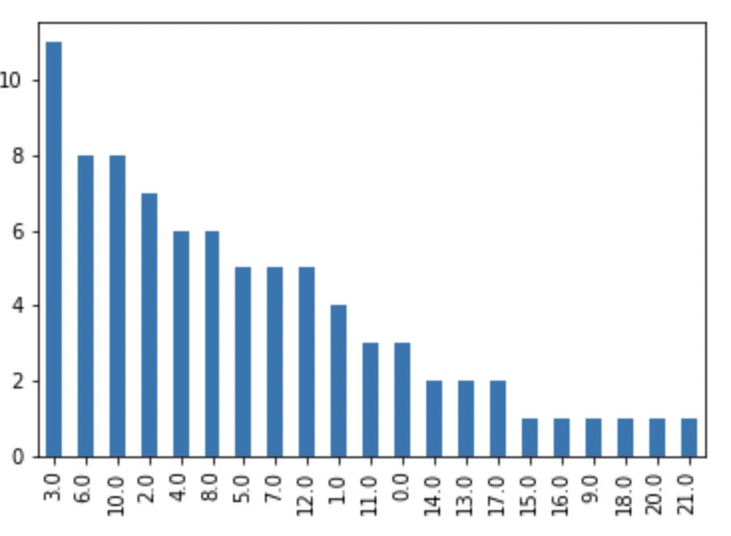
Figure S3. LD-related death cases and frequency count
We calculate the mean of the monthly confirmed LD cases which equals to the λ,poisson
mean = $\overline{x}$ = λ = 7.21 (12)
By substituting the observed cases number x into Poisson distribution equation (11), we have the following equations (13)-(34):
Pr(x_{i} = 0)= 591$\frac{e^{-7.21}{7.21}^{0}}{0!}$= 0.5 (13)
Pr(x_{i} = 1)= 591$\frac{e^{-7.21}{7.21}^{1}}{1!}$= 3.4 (14)
Pr(x_{i} = 2)= 591$\frac{e^{-7.21}{7.21}^{2}}{2!}$= 12 (15)
Pr(x_{i} = 3)= 591$\frac{e^{-7.21}{7.21}^{3}}{3!}$= 29 (16)
Pr(x_{i} = 4)= 591$\frac{e^{-7.21}{7.21}^{4}}{4!}$= 51.2 (17)
Pr(x_{i} = 5)= 591$\frac{e^{-7.21}{7.21}^{5}}{5!}$= 72.9 (18)
Pr(x_{i} = 6)= 591$\frac{e^{-7.21}{7.21}^{6}}{6!}$= 86.5 (19)
Pr(x_{i} = 7)= 591$\frac{e^{-7.21}{7.21}^{7}}{7!}$= 88 (20)
Pr(x_{i} = 8)= 591$\frac{e^{-7.21}{7.21}^{8}}{8!}$= 78.3 (21)
Pr(x_{i} = 9)= 591$\frac{e^{-7.21}{7.21}^{9}}{9!}$= 62 (22)
Pr(x_{i} = 10)= 591$\frac{e^{-7.21}{7.21}^{10}}{10!}$= 44.1 (23)
Pr(x_{i} = 11)= 591$\frac{e^{-7.21}{7.21}^{11}}{11!}$= 28.6 (24)
Pr(x_{i} = 12)= 591$\frac{e^{-7.21}{7.21}^{12}}{12!}$= 16.9 (25)
Pr(x_{i} = 13)= 591$\frac{e^{-7.21}{7.21}^{13}}{13!}$= 9.3 (26)
Pr(x_{i} = 14)= 591$\frac{e^{-7.21}{7.21}^{14}}{14!}$= 4.7 (27)
Pr(x_{i} = 15)= 591$\frac{e^{-7.21}{7.21}^{15}}{15!}$= 2.2 (28)
Pr(x_{i} = 16)= 591$\frac{e^{-7.21}{7.21}^{16}}{16!}$= 0.99 (29)
Pr(x_{i} = 17)= 591$\frac{e^{-7.21}{7.21}^{17}}{17!}$= 0.42 (30)
Pr(x_{i} = 18)= 591$\frac{e^{-7.21}{7.21}^{18}}{18!}$= 0.17 (31)
Pr(x_{i} = 19)= 591$\frac{e^{-7.21}{7.21}^{19}}{19!}$= 0.06 (32)
Pr(x_{i} = 20)= 591$\frac{e^{-7.21}{7.21}^{20}}{20!}$= 0.02 (33)
Pr(x_{i} = 21)= 591$\frac{e^{-7.21}{7.21}^{21}}{21!}$= 0.007 (34)
Using chi-square test (aka. dispersion test), since no frequency less than 5 is considered, the above table becomes the following, where O_{i} denotes the frequency of observed counts of confirmed LD cases under each frequency-bin and E_{i} denotes the expected frequency of counts of confirmed LD cases in Poisson distribution under the same frequency-bin (Table S5).
Table S6. Confirmed LD cases and frequency count

Observed cases 0-1 2 3 4 5 6 7 8 9-10 11-12 13-21

The number of degree of freedom is k-p-1. Here we have k =11 classes and we have p=1 because we had to estimate one parameter (the mean), so our chi-squared statistic has:
Degree of freedom (df) = 11 - 1 - 1 = 9
The chi-squared goodness of fit test statistics
$$X^{2}=\frac{\sum{{\left(O_{i}-e_{i}\right)}^{2}}}{e_{i}}$$
$$=\frac{{\left(7-4\right)}^{2}}{4}+\frac{{\left(7-12\right)}^{2}}{12}+\frac{{\left(11-29\right)}^{2}}{29}+\frac{{\left(7-51\right)}^{2}}{51}+ \frac{{\left(5-73\right)}^{2}}{73}+\frac{{\left(8-87\right)}^{2}}{87}$$
$+\frac{{\left(5-88\right)}^{2}}{88}+\frac{{\left(6-78\right)}^{2}}{78}+\frac{{\left(9-86\right)}^{2}}{86}+\frac{{\left(8-46\right)}^{2}}{46}+\frac{{\left(11-17.7\right)}^{2}}{17.7}$=436.2
If we look up the table value for χ² with df =9 with 1% and 5% significance is 16.919. The calculated value 436.2 >16.919. Therefore, H₀ is rejected. Poisson distribution is not a good fit for our monthly confirmed LD cases data. $∎$

Appendix E Hypothesis Testing of Negative Binomial Regression on monthly confirmed LD cases t test, log-likelihood ratio and goodness of fit
After relaxing the assumption of Poisson distribution that mean equals variance, we adopted the negative binomial regression model that mean does not have to be equal to variance. Negative binomial regression model is usually for modelling over-dispersed counts variables by introducing an unobserved heterogeneity, a gamma noise variable. The negative binomial regression model considered here is (35):
$\operatorname{Pr}\left(Y=y_{i} \right|x )= \frac{Γ \left(y_{i }+α^{-1}\right)}{Γ \left(y_{i}+1\right)Γ\left(α^{-1}\right)} {\left(\frac{α^{-1}}{α^{-1}+{ μ}_{i}\left(x\right)}\right)}^{α^{-1}}{\left(\frac{{ μ}_{i}\left(x\right)}{α^{-1}+{ μ}_{i}\left(x\right)} \right)}^{y_{i}}$ (35)
Where α > 0 is referred to as the dispersion parameter. The mean and variance of Y are
E(Y |x)= µ_{i}(x) (36)
V(Y ) = µ_{i}(x) + αµ_{i}(x)² (37)
Since Poisson distribution is a special case of the negative binomial distribution when α equals 0. We wanted to understand when the α dispersion parameter greater than 0 is employed in the negative binomial distribution, is there any true difference in the estimated mean of the Poisson regression model on our monthly LD confirmed cases and the estimated mean of the negative binomial regression model on our monthly LD confirmed cases?
Null Hypothesis 2 H0: $\overline{µ}$Poisson - $\overline{µ}$Negativebinomial = 0.
Hypothesis 2 H1: $\overline{µ}$Poisson - $\overline{µ}$Negativebinomial $≠$ 0.
The t-statistic is as follows:
$$t=\frac{\overline{x_{1}}-\overline{x_{2}}}{\sqrt{s^{2}\left(\frac{1}{n_{1}}+\frac{1}{n_{2}}\right)}}$$
(38)

where ¯x₁ and ¯x₂ are the means of the Poisson distribution and negative binomial distribution being compared, s² is the pooled standard error of the two distributions, and n₁ and n₂ are the number of observations in each of the two distributions.
Furthermore, equation (35) is derived from the definition of the gamma function, equation (35) becomes (39):
$$\ln\left(\frac{Γ\left(y_{i}+α^{-1}\right)}{Γ\left(α^{-1}\right)}\right)=\sum_{j=1}^{y_{i}-1}{\ln\left(j+α^{-1}\right)}$$
(39)
The regression coefficients are estimated using the method of maximum likelihood in equation (40):¹

$$L\left(θ\right)=\sum_{i=1}^{n}{\{}\ln\left(Γ\left(y_{i}+α^{-1}\right)\right)-\ln\left(Γ\left(α^{-1}\right)\right)-\ln\left(Γ\left(y_{i}+1\right)\right)-α^{-1}\ln\left(1+αμ_{i}\right)$$
$$-y_{i}\ln\left(1+αμ_{i}\right)+y_{i}\ln\left(α\right)+y_{i}\ln\left(μ_{i}\right)\}$$

(40)
Rearranging equation (40) gives (41):
$$L\left(θ\right)=\sum_{i=1}^{n}{\{\left(\sum_{j=0}^{y_{i}-1}{\ln\left(j+α^{-1}\right)}\right)}-\ln\left(Γ\left(y_{i}+1\right)\right)-\left(y_{i}+α^{-1}\right)\ln\left(1+αμ_{i}\right)$$
$$+y_{i}\ln\left(μ_{i}\right)+y_{i}\ln\left(α\right)\}$$
(41)
Taking the first derivative of L(θ) with respect to α given by Cameron² and Lawless³:
$$\frac{∂L\left(θ\right)}{∂α}=\sum_{i=1}^{n}{\{\sum_{j=0}^{y_{i}-1}{\left(\frac{j}{1+αj}\right)}}+α^{-2}\ln\left(1+αμ_{i}\right)-\frac{\left(y_{i}+α^{-1}\right)μ_{i}}{1+αμ_{i}}\}$$
(42)
Equating the gradient to zero in equation (42) yields the following:
$\frac{∂L\left(θ\right)}{∂α}=\sum_{i=1}^{n}{\{\sum_{j=0}^{y_{i}-1}{\left(\frac{j}{1+αj}\right)}}+α^{-2}\ln\left(1+αμ_{i}\right)-\frac{\left(y_{i}+α^{-1}\right)μ_{i}}{1+αμ_{i}}\} = 0$ (43)

Table S7 Negative binomial model for Legionnaire’s disease monthly incidence with weather variables
Variable | Coefficient S.E. Pr(ąz) RR |  |  |  |  | 95%CI
(intercept) | 0.478 | 1.625 | 0.769 | 1.61 | 0.07-39
Maximum AT | 0.264 | 0.151 | 0.081* | 1.3 | 0.97-1.75
Average AT | -0.231 | 0.154 | 0.135 | 0.79 | 0.6-1.075
RH | 0.493 | 1.871 | 0.792 | 0.61 | 0.02-23
Rainfall | 0.002 | 0.001 0.009*** 1.02 1.0004-1.003
N | 591
t-statistics α | 4.25
df =67  with 1 dispersion of α | 2.38
Log-likelihood (negative binomial) | -197.95
Log-likelihood  (poisson) | -219.41
Log-likelihood ratio | 42.92
χ2 | 75.9
χ² (df residuals=64) | 81.381
Note.***p > 0.01, **p > 0.05, *p > 0.1,
AT: Air temperature,
RH: Relative humidity,
S.E.: Standard error,
RR: Relative risk,
95%CI: 95% CI of RR,
CI: Confidence interval.

Our result in Table S6 showed that the estimation of dispersion α parameter to be 4.25 in equation (35) and (39) - (42) at 1% statistical significance level. We looked up the t-statics table for df equals 67 and one dispersion of α equals 2.38, which is less than α being 4.25. We rejected H₀ in the t-statistics testing and confirms that true difference in the estimated means of Poisson and negative binomial distribution on our monthly LD confirmed cases does not equal to 0. Therefore, the dispersion α parameter is statically significant to suggest fitting a negative binomial regression can be better than Poisson regression model.
Since Poisson regression model is a nested model of the negative binomial regression model when limit of α approaches 0. If Poisson regression model is supported by our LD monthly confirmed cases data, the two likelihoods should not differ by more than the sampling error. Thus we conducted the following likelihood-ratio test to compare the two models.
Null Hypothesis 3 H₀: θ₀ = θ_{Poisson}.
Hypothesis 3 H1: θ1 = θNegativebinomial.
where the likelihood-ratio test statistic is expressed as follows:
$$λ_{L}R=-2\ln\left[\frac{sup_{θ_{0}∈ΘL}\left(θ_{0}\right)}{sup_{θ_{1}∈ΘL}\left(θ_{1}\right)}\right]$$
(44)

Obtained from our results in Table VI, the L(θ_{Poisson}) log-likelihood for Poisson model is -219.41.The L(θ_{Negativebinomial}), the log-likelihood for negative binomial regression model is -197.95.

So the log-likelihood ratio test statistic is
$$λ_{LR}=-2\left[l\left(θ_{Poisson}\right)-l\left(θ_{Negativebinomial}\right)\right]$$
$$=-2\left(-219.41-\left(-197.95\right)\right)$$
$$=2\left(219.41-197.95\right)$$
$$=42.92$$
(45)
The value in the log-likelihood ratio test in equation (44) and (45) by multiplying -2 ensures mathematically that by Wilks’ theorem converges asymptotically to be χ²-distributed. This value 42.92 calculated from equation (7) is vastly greater than the χ²(df “ 1) at the 1% significance level which is 5.412. We rejected H₀ in the likelihood ratio test, that is to reject the Poisson. This further confirmed that negative binomial regression model is a better fit model than Poisson regression model for our LD monthly confirmed cases.
Finally, we want to fit the negative Poisson distribution for the monthly LD confirmed cases data and test the χ² goodness of fit.
Null Hypothesis 4 H₀: X follows the Negative binomial distribution.
Hypothesis 4 H₁: X does not follow the Negative binomial distribution.
The chi-squared goodness of fit test statistics:
$$X^{2}=\frac{\sum{{\left(O_{i}-e_{i}\right)}^{2}}}{e_{i}}$$

In Table S6, we found the Pearson chi-squared ˜χ² for the negative binomial model is 75.9. To make a quantitative determination of the goodness-of-fit at 95% confidence interval where χ² value for 95% confidence interval and degrees of freedom of residuals equals to 62. We compare this chi-squared test with the observed statistic. That is the Pearson’s chi-squared value. We found that at 95% confidence interval and degree of freedom residuals equals 62, the chi-squared value from a standard chi-squared table equals 81.381 which is higher than the calculated value 75.9. We rejected H₁ in the goodness of fit test. We concluded that our counts of LD monthly confirmed cases followed the negative binomial distribution.
All three hypothesis tests, namely the t-statistics test, likelihood-ratio test and χ² goodness of fit test demonstrated that negative binomial regression model is a much better fit than the Poisson regression model on our LD monthly confirmed cases. Negative binomial regression model is also optimal based on the goodness of fit test. $∎$

Appendix F Hypothesis Testing of Poisson Distribution for LD mortality cases
We want to fit the Poisson distribution for the monthly LD mortality and test the goodness of fit. Does the assumption of Poisson distribution seem appropriate as a model for the monthly LD mortality in Hong Kong?
Null Hypothesis 1 H₀: X follows Poisson distribution.
Hypothesis 1 H₁: X does not follow Poisson distribution.
We have the following observed counts of monthly LD mortality cases and the frequency for each count for our dataset from January 1, 2015 to December 31, 2020.
Observed Cases | 0 |  | 1 | 2 | 3 | 4
Frequency 34 |  |  | 28 | 6 | 3 | 1
Note: N=53 LD mortality cases from January 1 2015 to December 31 2020.
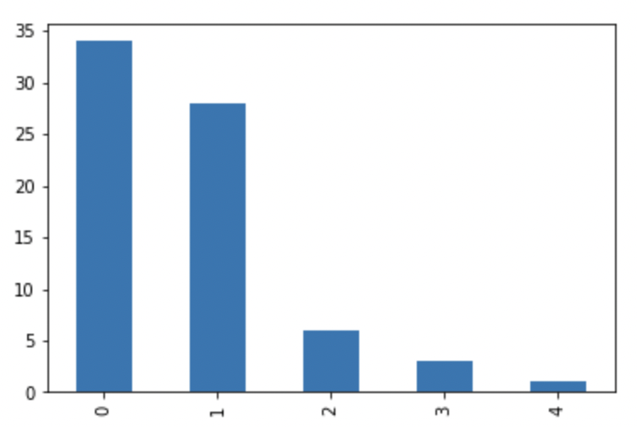
The frequency of Poisson distribution is given by equation (1):
Pr(x_{i} ) = N $\frac{e^{-λ}λ^{x_{i}}}{x_{i}!}$ (46)
Where x_{i} is the LD mortality cases and x_{i} = 0,1,2,...,21 in our dataset from January 1, 2015, to December 31, 2020.

We calculate the mean of the monthly LD mortality cases which equals to the λ,poisson
mean = $\overline{x}$ = λ = 0.736 (47)

By substituting the observed cases number x into Poisson distribution equation (46), we have the following equations (48)-(52):
Pr(x_{i} = 0)= 53$\frac{e^{-0.736}{0.736}^{0}}{0!}$= 25 (48)
Pr(x_{i} = 1)= 53$\frac{e^{-0.736}{0.736}^{1}}{1!}$= 19 (49)
Pr(x_{i} = 2)= 53$\frac{e^{-0.736}{0.736}^{2}}{2!}$= 7 (50)
Pr(x_{i} = 3)= 53$\frac{e^{-0.736}{0.736}^{3}}{3!}$= 1.68 (51)
Pr(x_{i} = 4)= 53$\frac{e^{-0.736}{0.736}^{4}}{4!}$= 0.31 (52)
Using chi-square test (aka. dispersion test), since no frequency less than 5 is considered, the above table becomes the following, where O_{i} denotes the frequency of observed counts of confirmed LD cases under each frequency-bin and E_{i} denotes the expected frequency of counts of confirmed LD cases in Poisson distribution under the same frequency-bin.
 | 0 |  | 1 |  | 2 | 3-4
$O_{i}$ 34 |  |  | 28 |  | 6 | 4
$e_{i}$ 25 |  | 19 |  |  | 7 | 2

The number of degree of freedom is k-p-1. Here we have k =4 classes and we have p=1 because we had to estimate one parameter (the mean), so our chi-squared statistic has:
Degree of freedom (df) = 4 - 1 - 1 = 2
The chi-squared goodness of fit test statistics

$X^{2}=\frac{\sum{{\left(O_{i}-e_{i}\right)}^{2}}}{e_{i}}$ $=\frac{{\left(34-25\right)}^{2}}{25}+\frac{{\left(28-19\right)}^{2}}{19}+\frac{{\left(6-7\right)}^{2}}{7}+\frac{{\left(4-2\right)}^{2}}{2}$ = 7.1

If we look up the table value for χ² with df =2 with 1% significance is 9.21. The calculated value 7.1 < 9.21. Therefore, H₀ is not rejected. Poisson distribution is a good fit for our monthly LD mortality cases data. $∎$

Appendix G: Python
Listing 1: Kernel density⁶

# Use Kernel Density Estimation (KDE) import pandas as pd import matplotlib . pyplot as plot
# Load daily LD mortality data HK January 2015− December 2020 daily data = pd. read csv (”./ data/[ZHANG]Kernel Daily LD mortality 2015 2020 . csv”) dailydata . head () daily mortality data = daily data [ [ ’ LD Mortality Case ’ , ’Day ’ ] ]
# Plot PDF using KDE with different bandwidth values daily mortality data . plot . kde(
t i t l e=”PDF using Kernel Density Estimation −Bandwidth method : scott ”
);
plot . show( block=True );

Listing 2: Relative risk and confidence intervals⁴

import pandas as pd import numpy as np from matplotlib import pyplot as plt
def calculate rr (data , exposure , outcome ):
###
#A relative risk or odds ratio greater
#than one indicates an exposure to be harmful , while
#a value less than one indicates a protective e f f e c t .
from scipy . stats import norm from zepid import RiskRatio
rr = RiskRatio () rr . f i t (data , exposure=exposure , outcome=outcome)
# calculating p−value est = rr . results [ ’ RiskRatio ’ ] [ 1 ] std = rr . results [ ’SD(RR) ’ ] [ 1 ] z score = np. log ( est ) / std p value = norm. sf (abs( z score )) ∗ 2 lower CI = rr . results [ ’RR LCL’ ] upper CI = rr . results [ ’RR UCL’ ]
print | ( ’ est : ’ , est )
print | ( ’ p value : ’ , p value )
print ( ’ lower CI : ’ , lower CI ) print ( ’ uppder CI : ’ , upper CI ) print ( rr .summary()) return est , p value , lower CI , upper CI
#Load monthly LD confirmed and weather data HK 2015−2020 ld confirmed weather=pd. readcsv (
’ ./ data/[ZHANG]monthly LD confirmedweather 2015 2020 . csv ’
)
ld confirmed weather . head ()
#Calculate RR:
#probability of | an individual becoming diseased
#in the risk of | being exposed to maximum air temperature that
#is higher than | monthly maximum air temperature of 2015−2020 HK
calculate rr ( ld confirmed weather ,
’Mean monthly max AT’ , ’ LD monthly confirmed cat ’ )
#Calculate RR:
#probability of | an individual becoming diseased
#in the risk of | being exposed average air temperature that
#is higher than | monthly average air temperature of 2015−2020 HK
calculate rr ( ld confirmed weather ,
’Mean monthly AT’ , ’ LD monthly confirmed cat ’ )
#Calculate RR:
#probability of | an individual becoming diseased
#in the risk of | being exposed to relative humidity that
#is higher than | monthly relative humidity of 2015−2020 HK
calculate rr ( ld confirmed weather ,
’Monthly RH’ ,
’ LD monthly confirmed cat ’ )
#Calculate RR:
#probability of an individual becoming diseased
#in the risk of being exposed to monthly r a i n f a l l that
#is higher than monthly r a i n f a l l of 2015−2020 HK calculate rr ( ld confirmed weather ,
’Monthly
RF’,
’LD
monthly
confirmed
cat’)
Listing 3: Negative binomial regression⁷

import matplotlib . pyplot as plt
%matplotlib inline
import numpy as np import pandas as pd import statsmodels . api as sm
from statsmodels .genmod. generalized estimating equations import GEE from statsmodels .genmod. cov struct import (Exchangeable ,
Independence , Autoregressive ) from statsmodels .genmod. families import Poisson from patsy import dmatrices import math
#load data f i l e monthly LD confirmed cases HK 2015−2021 in csv format df = pd. read csv (”./ data/[ZHANG]Monthly LD Confirmed 2015 2021 . csv”) print( df . head ())
mask=np. random . rand(len( df ))<0.8
dftrain = df [mask] dftest = df [˜mask] df train=df train . dropna () dftrain dftest
print ( ’ Training data set length = ’+str (len( dftrain ))) print ( ’ Testing data set length = ’+str (len( dftest )))
#Step 1 we w i l l now configure and f i t the Poisson regression model
#on the training data set : expr = ”””confirmed ˜ MMAT + MAT + RH + RF ””” expr = ”””confirmed ˜ MMAT + MAT + RH + RF ”””
ytrain2 , Xtrain = dmatrices (expr , df train , return type=’ dataframe ’ ) ytest2 , X test = dmatrices (expr , df test , return type=’ dataframe ’ )
#Using the statsmodels GLM class ,
#train the Poisson regresion model on training data set poisson training results=sm.GLM( y train , X train , family=sm. families . Poisson ()). f i t () print ( poisson training results .summary())
#We are interested in the vector of f i t t e d rates #lambda produced by the training .
#This rate vector is contained in the parameter #poisson training results .mu.
print ( poisson training results .mu)
#printing the length of the rate vector print(len( poisson training results .mu))
# Step 2: We f i t the auxiliary OLS regression model on the data set #and use the f i t t e d model to get the value of alpha . import statsmodels . formula . api as smf
#add a lambda vector as a new column called ”BB LAMBDA”
#to the data frame of the training data set df train [ ’confirmed LAMBDA ’ ] = poisson training results .mu
#add a derived column called ’AUX OLS DEP’ to the pandas Data Frame.
#This new column w i l l store the values
#of the dependent variable of the OLS regression . df train [ ’AUX OLS DEP’ ] = df train . apply(lambda x : ((x [ ’ confirmed ’ ] − x [ ’confirmed LAMBDA ’ ])∗∗2 − x [ ’confirmed LAMBDA ’ ]) / x [ ’confirmed LAMBDA ’ ] , axis=1)
#use patsy to form the model specification for the OLSR ols expr = ”””AUX OLS DEP ˜ confirmed LAMBDA − 1”””
#Configure and f i t the OLSR model aux olsr results = smf . ols ( ols expr , df train ). f i t ()
#Print the regression params print( ’ alpha=’ , aux olsr results . params)
#Print the auxiliary OLS results student t−s t a t i s t i c s value print( ’t−s t a t i s t i c s value for alpha : ’ , aux olsr results . tvalues )
#If the value of is s t a t i s t i c a l l y not significant ,
#then the Negative Binomial regression model cannot do a better job #of f i t t i n g the training data set than a Poisson regression model .
#train the NB2 model on the training data set nb2 training results = sm.GLM( y train , X train ,
family=sm. families . NegativeBinomial ( alpha=aux olsr results . params [ 0 ] ) ) . f i t ()
#print the training summary print( nb2 training results .summary())
#make some predictions using our trained NB2 model nb2 predictions = nb2 training results . get prediction ( X test )
#print out the predictions predictions summary frame = nb2 predictions . summary frame () print( predictions summary frame )
# STEP 5: Measuring the likelihood ratio test and
# goodness−of−f i t of the NB2 model
# In our case , the Log−likelihood for NB2 is −197.95,
# while for the Poisson regression model i t is −219.41.
# So the LR #test s t a t i s t i c is 2 ∗ (219.41 197 .95) = 42.92.
# This value is vastly greater than the c r i t i c a l value of
# chi−squared value at the 1\% #significance l e v e l which is 5.412.
# The Pearson chi−squared s t a t i s t i c s
# The reported values of Pearson chi−squared for the NB2 model is 75.9 respectively .
# To make a quantitative #determination of the goodness−of−f i t at some confidence level , # say 95\% (p=0.05) , we look up the value in the chi−squared table for p=0.05 and # degrees of freedom of residuals =62.
# We compare this Chi−Squared value with the observed s t a t i s t i c , # in this case i t is P e a r s o n s chi−squared value reported in GLMResults .
# We find that at p=0.05 and DF Residuals = 64 , the chi−squared value # from a standard Chi−Squared table is 81.381 which is higher than 75.9.
# Hence as per this test , the NB2 regression model ,
# demonstrating a much better f i t than the Poisson regression model , # is also optimal based on the goodness of f i t test .
# STEP 6: Calculate the relative risk and 95\%CI of
# negative binomial model = ”””confirmed ˜ MMAT + MAT + RH + RF ””” import math
#retreive c oef fic ie nts
#of MMAT, MAT, RH and RF
#from negative binomial regression model results model1 coef intercept = nb2 training results . params . Intercept
model1 coef MMAT = nb2 training results . params .MMAT model1 coef MAT = nb2 training results . params .MAT model1 coef RH = nb2 training results . params .RH model1 coef RF = nb2 training results . params .RF print ( ’ model1 coef intercept=’ , model1 coef intercept ) print ( ’model1 coef MMAT ’ ,model1 coef MMAT) print ( ’model1 coef MAT ’ ,model1 coef MAT) print ( ’ model1 coef RH ’ , model1 coef RH ) print ( ’ model1 coef RF ’ , model1 coef RF )
#retreive 95\% confidence interval results
#for intercept and MMAT from negative binomial regression model results model1intercept LCI = nb2 training results . conf int (). iloc [ 0 ] . iloc [0] print( ’ model1 intercept LCI=’ , model1intercept LCI )
model1intercept UCI = nb2 training results . conf int (). iloc [ 0 ] . iloc [1] print ( ’ model1 intercept UCI=’ , model1 intercept UCI )
model1MMAT LCI = nb2 training results . conf int (). iloc [ 1 ] . iloc [0] print(’model1 MMAT LCI=’ ,model1 MMATLCI)
model1MMAT UCI = nb2 training results . conf int (). iloc [ 1 ] . iloc [1] print( ’model1 MMAT UCI=’ ,model1 MMATUCI)
model1 MAT LCI = nb2 training results . confint (). iloc [ 2 ] . iloc [0] print( ’model1 MAT LCI=’ ,model1 MAT LCI)
model1 MAT UCI = nb2 training results . confint (). iloc [ 2 ] . iloc [1] print( ’model1 MAT UCI=’ ,model1 MAT UCI)
model1 RH LCI = nb2 training results . confint (). iloc [ 3 ] . iloc [0] print( ’model1 RH LCI=’ ,model1 RH LCI) model1 RH UCI = nb2 training results . confint (). iloc [ 3 ] . iloc [1] print( ’model1 RH UCI=’ ,model1 RH UCI)
model1 RF LCI = nb2 training results . confint (). iloc [ 4 ] . iloc [0] print( ’model1 RF LCI=’ ,model1 RF LCI) model1 RF UCI = nb2 training results . confint (). iloc [ 4 ] . iloc [1] print( ’model1 RF UCI=’ ,model1 RF UCI)
#Calculate the relative risk print ( ’ effects of intercept is exp( model1 coef intercept ) for monthly LD confirmed cases . ’ math. exp( model1 coef intercept ))
print ( ’ effects of MMAT is exp(model1 coef MMAT) for monthly LD confirmed cases . ’ , math. exp(model1 coef MMAT))
print ( ’ effects of MAT is exp(model1 coef MAT) for monthly LD confirmed cases . ’ , math. exp(model1 coef MAT ))
print ( ’ effects of RH is exp( model1 coef RH ) for monthly LD confirmed cases . ’ , math. exp( model1 coef RH ))
print ( ’ effects of RF is exp( model1 coef RF ) for monthly LD confirmed cases . ’ , math. exp( model1 coef RF ))
print ( ’NB2 Model 1 intercept 95\% CI : ’ ,
math. exp( model1 intercept LCI ) , math. exp( model1 intercept UCI ) )
print ( ’NB2 Model 1 MMAT 95\% CI : ’ ,
math. exp(model1 MMAT LCI) , math. exp(model1 MMAT UCI) ) print ( ’NB2 Model 1 MAT 95\% CI : ’ ,
math. exp(model1 MAT LCI) , math. exp(model1 MAT UCI) ) print ( ’NB2 Model 1 RH 95\% CI : ’ ,
math. exp(model1 RH LCI) , math. exp(model1 RH UCI) ) print ( ’NB2 Model 1 RF 95\% CI : ’ ,
math. exp(model1 RF LCI ) , math. exp(model1 RF UCI) )

Listing 4: Poisson regression⁸

import matplotlib . pyplot as plt
%matplotlib inline
import numpy as np import pandas as pd
from statsmodels .genmod. generalized estimating equations import GEE from statsmodels .genmod. cov struct import (Exchangeable ,
Independence , Autoregressive ) from statsmodels .genmod. families import Poisson import math
data = pd. read csv (”./ data/[ZHANG]poisson LD confirmed mortality weather . csv”) print( data . head ())
#Descriptive S t a t i s t i c s data . describe ()
data [ [ ’y ’ ] ] = data [ [ ’ count monthly LD mortality ’ ] ] data . head ()
# Fit the Multiple Poisson Regression
# y = poisson ˜(b0+ b1MMAT + b2MAT + b3RH + b4RF)
data . head ()
fam = Poisson ()
ind = Independence () model = GEE. from formula (”y ˜ MMAT + MAT + RH + RF” ,
”Month” , data , cov struct=ind , family=fam)
result = model . f i t ()
print( result .summary())
#retreive c oef fi cie nts
#of MMAT, MAT, RH and RF
#from negative binomial regression model results model coef intercept = result . params . Intercept
model coef MMAT = result . params .MMAT model coef MAT = result . params .MAT model coef RH = result . params .RH model coef RF = result . params .RF print ( ’ model coef intercept=’ , model coef intercept ) print ( ’model coef MMAT ’ ,model coef MMAT) print ( ’model coef MAT ’ ,model coef MAT) print ( ’ model coef RH ’ , model coef RH ) print ( ’ model coef RF ’ , model coef RF )
#retreive 95\% confidence interval results for :
#Intercept , MMAT, MAT, RH, RF from Poisson regression model results modelintercept LCI = result . conf int (). iloc [ 0 ] . iloc [0] print(’ model interceptLCI=’ , model interceptLCI ) modelintercept UCI = result . conf int (). iloc [ 0 ] . iloc [1] print ( ’ model interceptUCI=’ , model interceptUCI )
model MMAT LCI = result . conf int (). iloc [ 1 ] . iloc [0] print( ’model MMAT LCI=’ ,model MMAT LCI)
model MMAT UCI = result . confint (). iloc [ 1 ] . iloc [1] print( ’model MMAT UCI=’ ,model MMAT UCI)
model MAT LCI = result . conf int (). iloc [ 2 ] . iloc [0] print( ’model MAT LCI=’ ,model MAT LCI)
model MAT UCI = result . conf int (). iloc [ 2 ] . iloc [1] print( ’model MAT UCI=’ ,model MAT UCI)
model RH LCI = result . conf int (). iloc [ 3 ] . iloc [0] print( ’model RH LCI=’ ,model RH LCI) model RH UCI = result . conf int (). iloc [ 3 ] . iloc [1] print( ’model RH UCI=’ ,model RH UCI)
model RF LCI = result . conf int (). iloc [ 4 ] . iloc [0] print( ’model RF LCI=’ ,model RF LCI) model RF UCI = result . conf int (). iloc [ 4 ] . iloc [1] print( ’model RF UCI=’ ,model RF UCI)
#Calculate RR print ( ’ effects of intercept is exp( model1 coef intercept ) ’ , math. exp( model coef intercept ))
print ( ’ effects of MMAT is exp(model1 coef MMAT) ’ , math. exp(model coef MMAT))
print ( ’ effects of MAT is exp(model1 coef MAT) ’ , math. exp(model coef MAT ))
print ( ’ effects of RH is exp( model1coef RH ) ’ , math. exp( model coef RH ))
#Calculate the 95\%CI of RR
print ( ’ Poisson regression intercept | 95\% CI : ’ ,
print ( ’ effects of RF is exp( model1coef RF ) ’ , math. exp( model coef RF ))
math. exp( model intercept LCI ) , math. exp( model intercept UCI ) )
print ( ’ Poisson regression MMAT 95\%CI : ’ ,
math. exp(model MMAT LCI) , math. exp(model MMAT UCI) ) print ( ’ Poisson regression MAT 95\% CI : ’ ,
math. exp(model MAT LCI) , math. exp(model MAT UCI) ) print ( ’ Poisson regression RH 95\% CI : ’ ,
math. exp(model RH LCI) , math. exp(model RH UCI) ) print ( ’ Poisson regression RF 95\% CI : ’ ,
math. exp(model RF LCI) , math. exp(model RF UCI) )

Listing 5: Decision tree⁵

# Load l i b r a r i e s import pandas as pd
from sklearn . tree import DecisionTreeClassifier # Import Decision Tree Classifier from sklearn . tree import DecisionTreeRegressor # Import Decision Tree Regressor from sklearn . model selection import train test split # Import t r a i n t e s t s p l i t function from sklearn import metrics #Import scikit −learn metrics module for accuracy calculation
#Load the monthly LD confirmed data in HK 2015−2021 data = pd. read csv (”./ data/[ZHANG]Monthly LD Confirmed 2015 2021 . csv”) print( data . head ()) data . dropna( inplace=True)
data . loc [ data [ ’ confirmed ’]>=1, ’ confirmedlable ’ ] = 1 data . loc [ data [ ’ confirmed ’]<1, ’ confirmedlable ’ ] = 0
data . loc [ data [ ’ confirmed ’]>=1, ’ confirmedlable ’ ] = 1 data . loc [ data [ ’ confirmed ’]<1, ’ confirmedlable ’ ] = 0 #s p l i t dataset in features and target variable feature cols = [ ’MMAT’ , ’RF’ ]
X = data [ feature cols ] # Features ( independent variables ) y = data . confirmed lable # Target variable ( dependent variable )
# Split dataset into training set and test set
X train , X test , y train , y test = train test split (X,
y ,
test size =0.3, random state=1)
# Create Decision Tree c l a s s i f e r object clf = DecisionTreeClassifier ()
# Train Decision Tree Classifer clf = clf . f i t ( X train , y train )
#Predict the response for test dataset y pred = clf . predict ( X test )
# Model Accuracy , how often is the c l a s s i f i e r correct ? print(”Accuracy : ” , metrics . accuracy score ( y test , y pred ))
from sklearn . tree import export graphviz #from sklearn . externals . six import StringIO from six import StringIO from IPython . display import Image import pydotplus
dot data = StringIO () export graphviz ( clf ,
out file=dot data , f i l l e d=True ,
rounded=True ,
special characters=True , feature names = feature cols , class names=[ ’0 ’ , ’1 ’ ])
graph = pydotplus . graph from dot data ( dot data . getvalue ()) graph . write png ( ’ DTClassification monthly LD confirmed . png ’ ) Image(graph . create png ())

Appendix H: Relative risks of meteorology-related LD confirmed cases and mortality

In the very early phase of the investigation, we used the indicator function to transform the time series data to minimize the impact of autocorrelation. We transformed monthly meteorological variables using indicator functions to: 0 if the monthly variable is below the corresponding variable’s N-month-average or 1 if the monthly variable is above the corresponding variable’s N-month-average for the LD deaths. We then calculated the relative risk for the probability of LD cases and deaths exposed to the meteorological risk factors.
Indicator function
We defined: confirmed LD cases, L_{confirmed,m,y} that denotes there is a confirmed LD case. LD-related death L_{mortality,m,y} denotes there is a LD-related death in month m in year y. We define monthly variables: maximum air temperature as MMAT_{m,y}, average air temperature as MAT_{m,y}, relative humidity as RH_{m,y} and rainfall as RF_{m,y}.

$I{LD}_{confirmed, m, y}=\left\{\begin{aligned}1, if {LD}_{confirmed, m,y }≥1 \\ 0, otherwise\end{aligned}\right.$ (9.1)

$I{LD}_{cmortality, m, y}=\left\{\begin{aligned}1, if {LD}_{mortality, m,y }≥1 \\ 0, otherwise\end{aligned}\right.$ (9.2)

$I{MMAT}_{ m, y}=\left\{\begin{aligned}1, {MMAT}_{m,y }≥Averagemaximumairtemperature \\ 0, otherwise\end{aligned}\right.$ (9.3)

$I{MAT}_{ m, y}=\left\{\begin{aligned}1, {MAT}_{m,y }≥Averagemaximumairtemperature \\ 0, otherwise\end{aligned}\right.$ (9.4)

${IRH}_{ m, y}=\left\{\begin{aligned}1, {RH}_{m,y }≥Averagemaximumairtemperature \\ 0, otherwise\end{aligned}\right.$ (9.5)

${ IRF}_{ m, y}=\left\{\begin{aligned}1, {RF}_{m,y }≥Averagemaximumairtemperature \\ 0, otherwise\end{aligned}\right.$ (9.6)

Relative risks of meteorology-related confirmed LD cases and mortality
In the calculation, A = 1 for our meteorological variables such as
MMAT_{m,y}, for which MMAT_{m,y} = 1 represents a temperature above the maximum air temperature, and MMAT_{m,y} = 0 represents a temperature below the maximum air temperature; likewise for MAT_{m,y}, RH_{m,y} and RF_{m,y} which represent average air temperature, relative humidity and rainfall. Y = 1 if there was LD-related mortality in month m in year y, likewise Y = 0 if no LD mortality was reported in month m in year y. Pr(.) denotes the probability function, with Pr(Y |A) as the conditional probability of Y given A, and Pr^{ˆ}(.) is the estimated probability.
$Relative Risk=\frac{\hat{Pr} \left(Y=1 \right|A=1)}{\hat{Pr} \left(Y=1 \right|A=0)}$ (9.7)

${ CI}_{1-α}=\log\left(Relative Risk\right)±SD (\log\left(Relative Risk\right)× z_{α}$ (9.8)

We applied equations (9.1)-(9.8) to all the monthly data for the meteorological variables, monthly confirmed LD cases from 2015 to 2021, and monthly LD deaths from 2015 to 2020 in HK. However, we found that the relative risks associated with the weather variables were inconclusive in this simple analysis of monthly confirmed LD cases; (1) the maximum air temperature was inconclusive, as the 95% CI of the maximum air temperature was 0.888-1.073; (2) the average temperature was inconclusive; and (3) the relative humidity was inconclusive, as the 95% CI for relative humidity was 0.88-1.07 for monthly confirmed LD cases. The same pattern was observed for monthly confirmed LD cases in the 83-month dataset. Therefore, we subsequently employed more advanced models to analyze the raw weather variables with raw numbers of monthly confirmed LD cases and monthly LD-related deaths in HK in the main text.

References
1. Health facts of Hong Kong 2021 Edition. https://www.dh.gov.hk/english/statistics/statistics_hs/files/2021.pdf (2021).
2. Cameron, A. C., & Trivedi, P. K. Regression analysis of count data. Cambridge university press. 53, (2013).
3. Lawless, J. F. Negative binomial and mixed Poisson regression. The Canadian Journal of Statistics/La Revue Canadienne de Statistique, 209–225. (1987).
4. Python library to calculate relative risks and confidence intervals. https://zepid.readthedocs.io/en/latest/Reference/Measures.html# id1andhttps://github.com/pzivich/zEpid (2018).
5. Python library for decision tree. https://scikit-learn.org/ stable/modules/tree.html (2021).
6. Python library for kernel density plot. https://pandas.pydata.org/ docs/reference/api/pandas.DataFrame.plot.density.html (2022).
7. Python library for negative binomial regression. https:// www.statsmodels.org/stable/generated/statsmodels.genmod.families.family .NegativeBinomial.html (2021).
[8]Python library for Poisson regression. 2022. Accessed March 15, 2022. https://www.statsmodels .org/dev/generated/statsmodels.genmod.families.family.Poisson.html

