Supporting Information
S1. Confirmation of the performance of the microphones in the laboratory
Before the field experiment, we confirmed the microphone performance by the laboratory experiment. The microphones were put together in a box. As the incident wave, we generated the infrasonic signals by opening and closing a door in the laboratory and recorded data for 1 minute. The waveforms and the power spectra are shown in Figure S1. The detrended waveforms were not exactly the same (Fig. S1.1a1 and a2) because the MEMS and ACO microphones were adjusted above 1 Hz and 0.1 Hz, respectively. As expected, the high-pass filtered waveforms and the power spectra were consistent among all the microphones above 1 Hz (Fig. S1.1b1, b2, c1, and c2).
We examined the power spectral ratio and the phase difference in detail. We calculated the spectra using the 10-second-long running time windows with 90 % overlapping. Then, we divided each spectrum by that of the reference microphone in the same time window. Finally, we averaged the spectral ratios in all time windows. The results are shown in Figure S1.2. All ACO microphone pairs showed the power ratio close to unity and the relative phase close to zero in 0.1–50 Hz (Fig. S1.2a1 and b1). The relative phase of each MEMS microphone to the reference ACO sensor deviated from zero below 1 Hz. In addition, the power ratio and relative phases of the MEMS microphones to the ACO were perturbed above 5 Hz due to the lower SN ratio of the MEMS than the ACO (Fig. S1.2a2 and b2). We may suppress the perturbation by stacking for a longer time as for the field experiment. Nevertheless, they tended to be around the expected values (unity for the power spectral ratio and zero for the relative phase) above 1 Hz, indicating that these microphones’ responses were consistent.

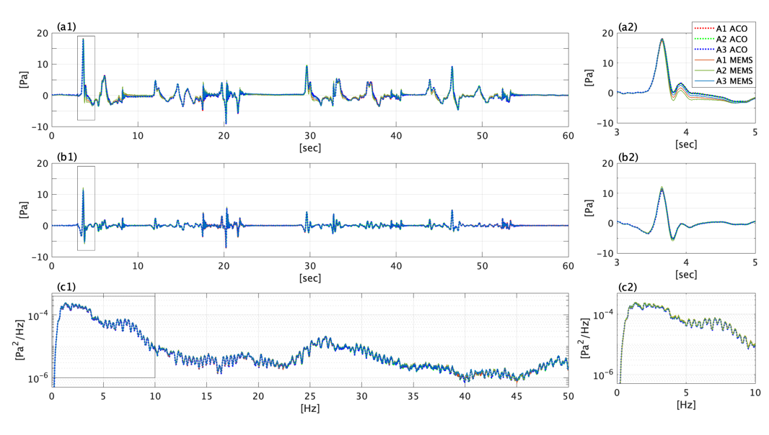
Figure S1.1. The 1-min-long test waveforms (a1) detrended, (b1) high-pass filtered above 1 Hz, and (c1) the power spectra for each microphone in the field experiment. (a2), (b2), and (c2) show the enlarged view of each black rectangle in (a1), (b1), and (c1), respectively. For visibility, the power spectra shown here were running-averaged in the frequency axis with the 0.2-Hz running-window lengths.
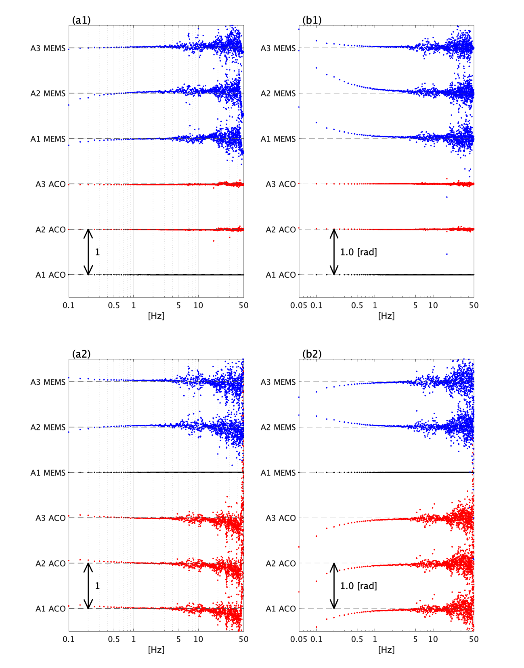
Figure S1.2. The power spectral ratios (a) and the relative phases (b) for the ACO microphones (red) and the MEMS microphones (blue) with the reference of A1 ACO (a1, b1) and A1 MEMS (a2, b2). The horizontal dashed lines indicate unity in (a) and zero radian in (b), and the vertical arrows indicate the amplitudes of unity in (a) and 1.0 radian in (b).
S2. Microphones in the array observation
Both ACO and MEMS microphones were used in the field experiment. In each array element, an ACO microphone and a MEMS microphone were put in the same box (Fig. S2.1). As expected from the laboratory test (Supporting Information S1), the microphones in the same box showed almost the same waveforms (Fig. 2a1-a3), power spectra, and phase (Fig. S2.2) above 1 Hz.
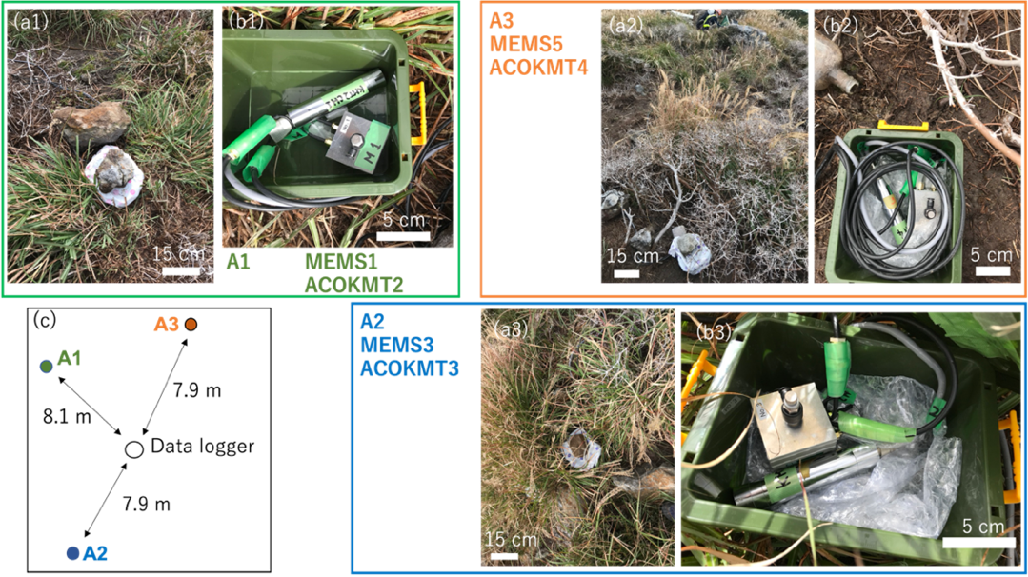
Figure S2.1. The images of the field experiment and the microphones. (a) The image of the rain-proof box and (b) the microphones in the box. (c) The schematic image of the locations of the array elements.
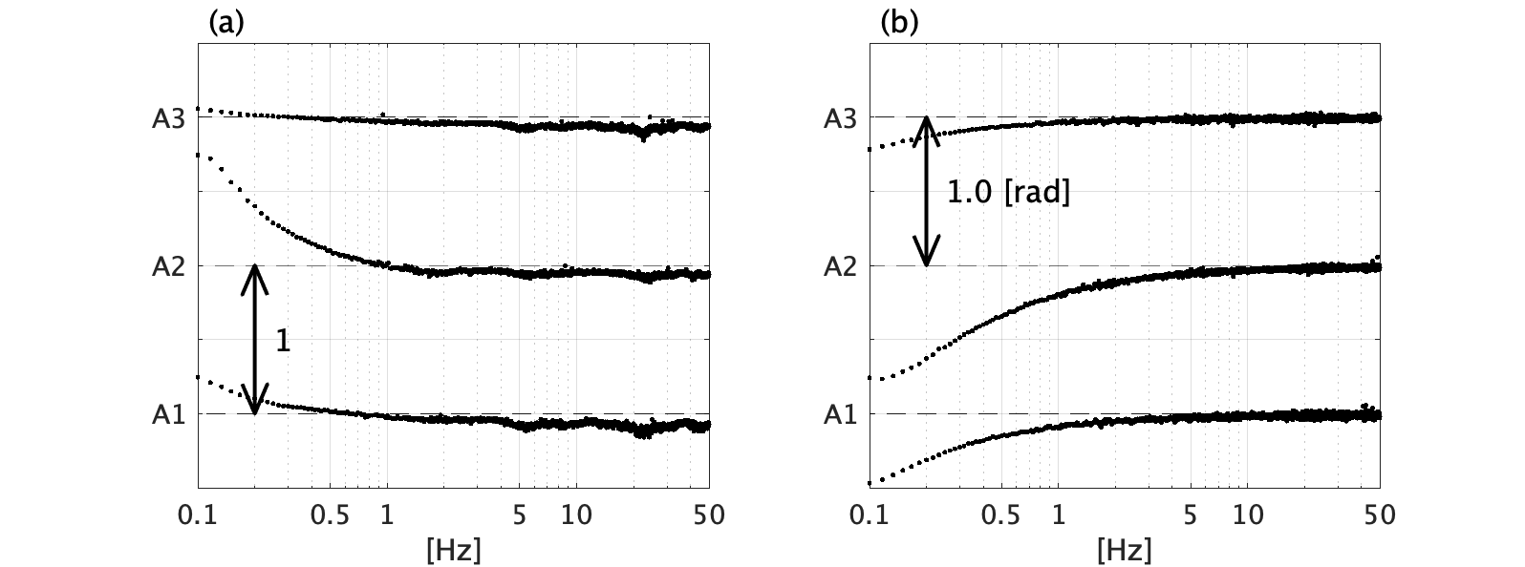
Figure S2.2. The power spectral ratio (a) and the relative phases (b) of the ACO to the collocated MEMS microphones. The horizontal dashed lines indicate unity for (a) and zero radian for (b). The power spectral ratio and relative phase were calculated for every 1 minute from 17:30 on 19 Oct to 12:30 on 20 Oct 2020 and averaged.
S3. Spectrograms and correlation coefficients of the microphones
In Figure 2, we mainly showed the results of the A1 microphone. Here, we show the results of all the microphones. Figure S5 shows the spectrograms and power spectra for the microphones. Although the A3 microphone tended to be a bit large power than the other microphones (Fig. S3.1d1), the general spectral shapes were consistent among the array microphones (Figs. S3.1a–d). The spectral shape of the SI microphone, which was distant from the array (Fig. 1c1), was different. Figures S6 and S7 show the correlation coefficients (CCs) as functions of time using the waveforms detrended and high-pass filtered above 5 Hz, respectively. The low-frequency noise below 5 Hz (Figs. S3.1a1-c1 and S3.2a1) lowers the CCs (Fig. S3.2b and c), but the CCs above 5 Hz were close to 1 (Fig. S3.3b and c). The array CCs for several high frequency bands, such as 5–10, 10–15, 15–20, 20–30, 30–40, 40–50, and 50–90 Hz, held the peaks at almost the same lag times (Fig. S3.4a), indicating that the array CCs represent the same signal in all frequency bands. On the other hand, the SI-array CCs for several bands are not consistent, particularly for the small peak around -0.8 sec (Fig. S3.4b). It might be because of the insufficient signal-to-noise ratio of the signal corresponding to this small peak.

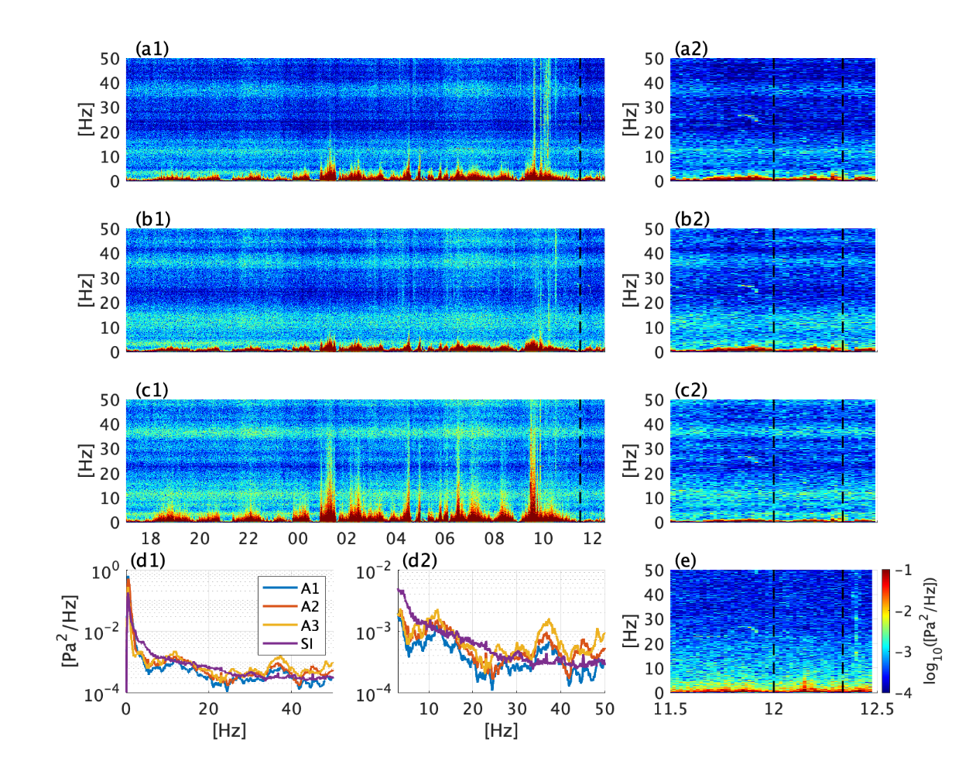
Figure S3.1. Spectrograms of (a) A1, (b) A2, (c) A3, and (e) SI microphones for all the observation time (a1–c1) and for the operation time of the SI (a2–c2, e) (the time after the black lines shown in a1–c1). (d1) Power spectra of A1, A2, A3, and SI during the time enclosed by dashed lines in the right panels. (d2) An enlargement of (d1). The color scales are common among (a) – (c) and (e).

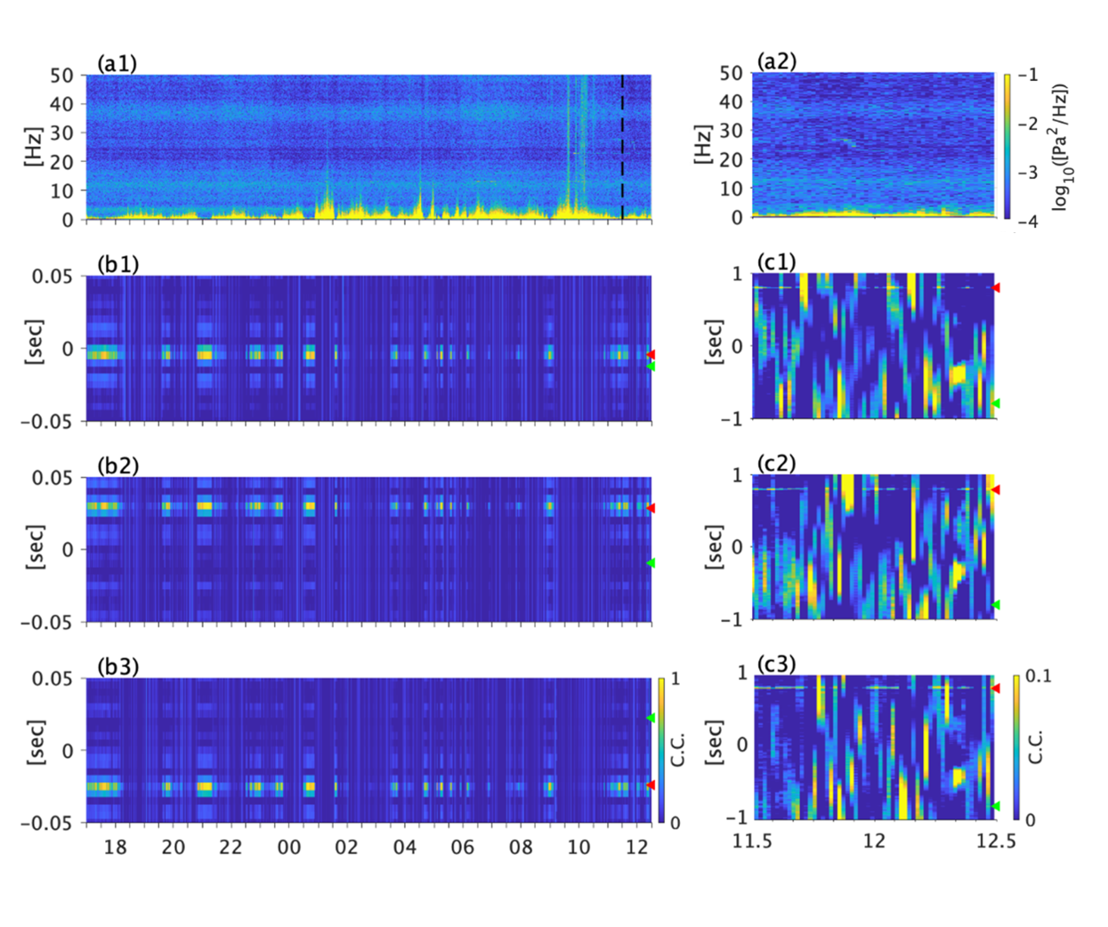
Figure S3.2. The cross-correlation coefficients as functions of time using the waveforms filtered from 0.3 to 90 Hz. The left panels (a1, b1–b3) show the whole period of the array observation, and values during the SI observation are displayed on the right (a1, c1–c3). The spectrogram of A1 (a1,a2), and 2-min stacked correlation coefficients between (b1) A1–A2, (b2) A2–A3, (b3) A3–A1, (c1) SI–A1, (c2) SI–A2, and (c3) SI–A3. The colorbar of (a2) and (c3) shares with (a1) and (b1-b3, c1-c2), respectively. The arrowheads on the right axis indicate the lag times between the microphones assuming the ISC source (red) and IWC source (green). The color scales are commong for (b1)-(b3) and (c1)-(c3), respectively.
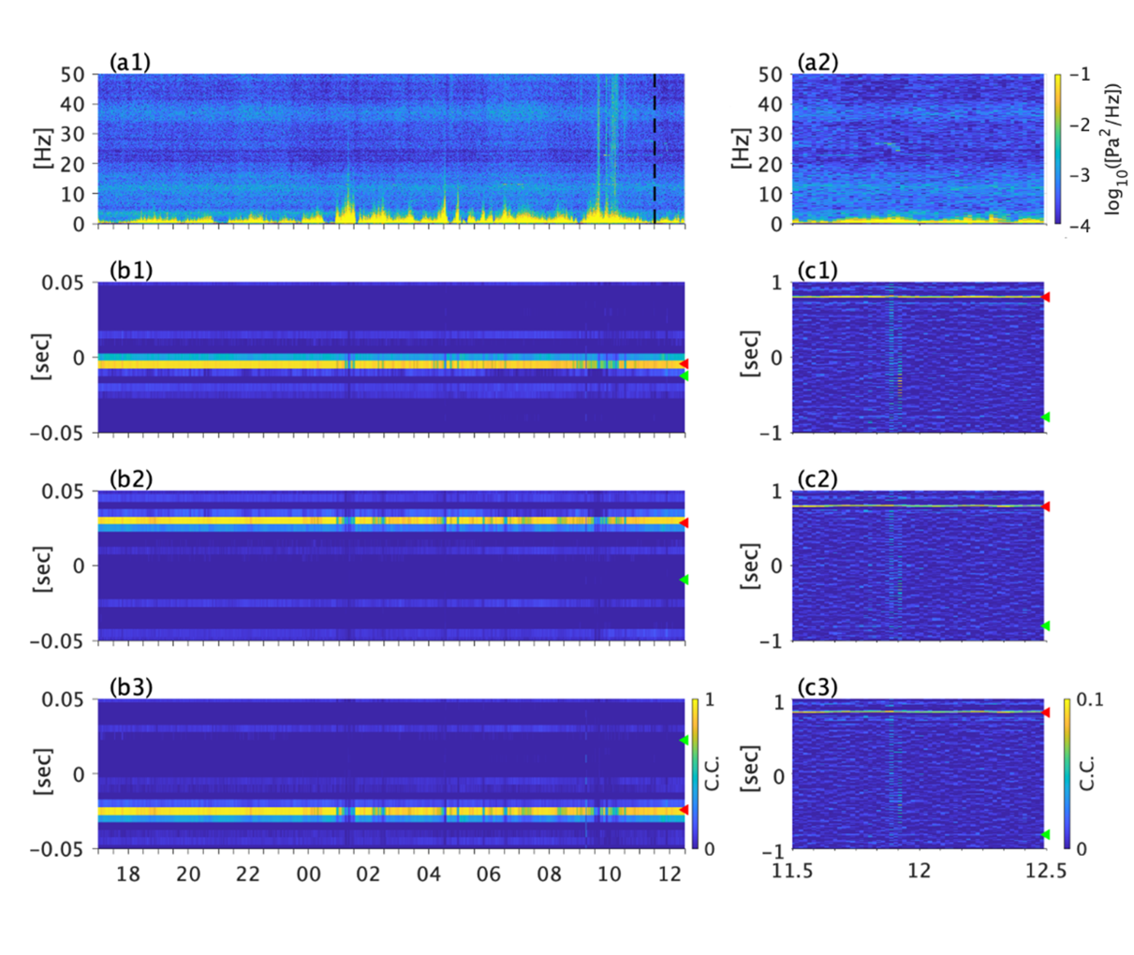
Figure S3.3. The same as Figure S6, but using the waveforms filtered from 5 to 90 Hz.

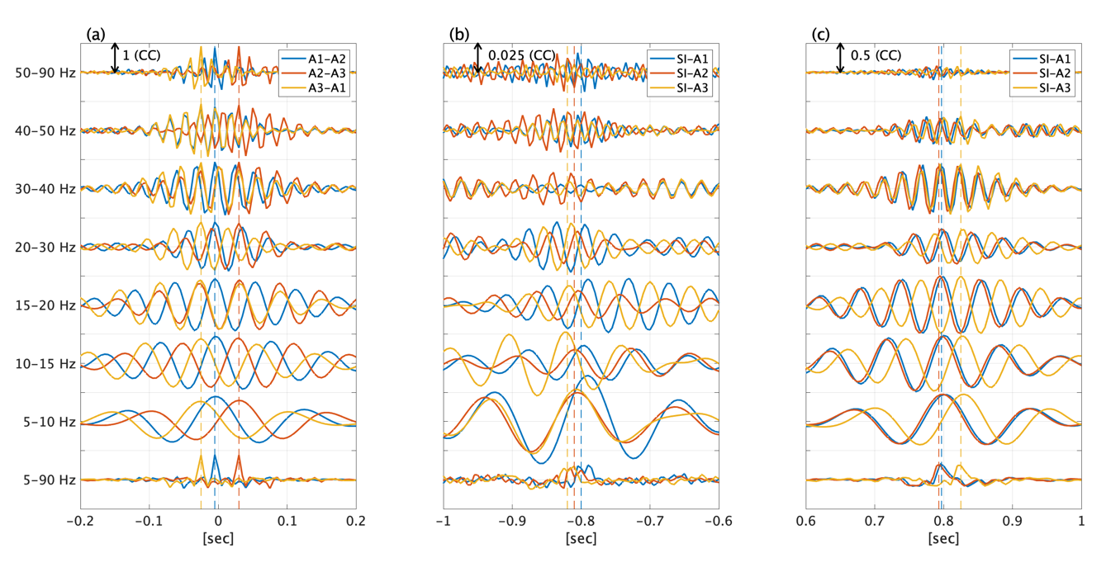
Figure S3.4. The cross-correlation coefficients for several bands. (a) Array CC, (b) SI-array CC focusing on the peak around -0.8 sec, and (c) that focusing on the peak around +0.8 sec. The bands are shown in the vertical axis of (a). The color indicates the microphone pair shown in the legends. The vertical dashed lines show the peaks of CCs in 5–90 Hz.

S4. Results of several array analyses
We tried to resolve multiple sources simultaneously using the standard and CLEAN beamformings (den Ouden, 2020; Yamakawa et al., 2022), and the MUSIC (MUltiple Signal Classification) algorithm (Schmidt, 1978; Yamakawa et al., 2022). In principle, all of these methods can resolve multiple independent sources. We expected two sources: one in the direction of the ISC fumarole (red line in Fig. S4a) and the other in the direction of the IWC fumarole (green line in Fig. S4a). Signals from both sources should propagate by the acoustic slowness (white circle in Fig. S4a). However, a single signal from ISC fumarole was apparent. The beamforming showed only a single prominent peak (Fig. S4b1). The CLEAN beamforming revealed weak peaks hidden by the prominent peak, but it found no meaningful peak in the IWC fumarole direction (Fig. S4b2). The MUSIC algorithm could not resolve the IWC fumarole source, either. When we assumed the signal number to be one in the MUSIC analysis, the result showed two sources to the east: one is the ISC fumarole source, and the other should be the artifact generated by the symmetricity of the array (Fig. S4c1). When we assumed the signal number to be two, the MUSIC algorithm did not produce any meaningful result (Fig. S4c2).

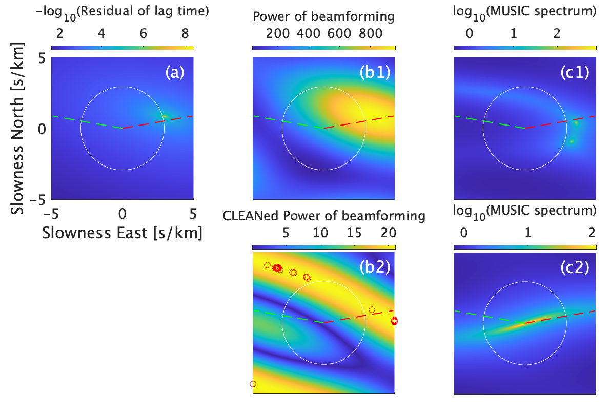
Figure S4. Array analyses results of the waveforms A1–A3. The white circle indicates the acoustic slowness (1/340 m s⁻¹). The red and green dashed lines indicate the directions of the ISC and IWC fumaroles, respectively. The horizontal and vertical axes are common among all panels, as labeled in (a). (a) Lag time fitting using the waveforms above 5 Hz in 11:30–12:30 on 20 Oct (Fig. 3.3b2). The beamforming (b1) and the CLEAN beamforming (b2) using the waveforms at 12 ± 1.2 Hz. The red circles in (b2) indicate the meaningful peaks. (c) The MUSIC spectra obtained with a single-source assumption (c1) and a two-source assumption (c2) using the same waveforms as (b1) and (b2).

S5. Correlation coefficients and the stacking number of the time windows
Because of the low correlation coefficient (CC) value, we need stacking the CCs sufficiently to find the weak CC peak around -0.8 sec (Figs. 3b1 and b2, Fig. S5a). Figure S5b shows the CCs calculated using the 1 min data with different stacking numbers. It clearly shows that the stacking of the CCs is vital to find the weak peak. In this case, the 30 min stacking, namely, averaging thirty of 1-min CCs is enough to resolve the weak peak, indicating that the time resolution of this analysis should be 30 minutes.
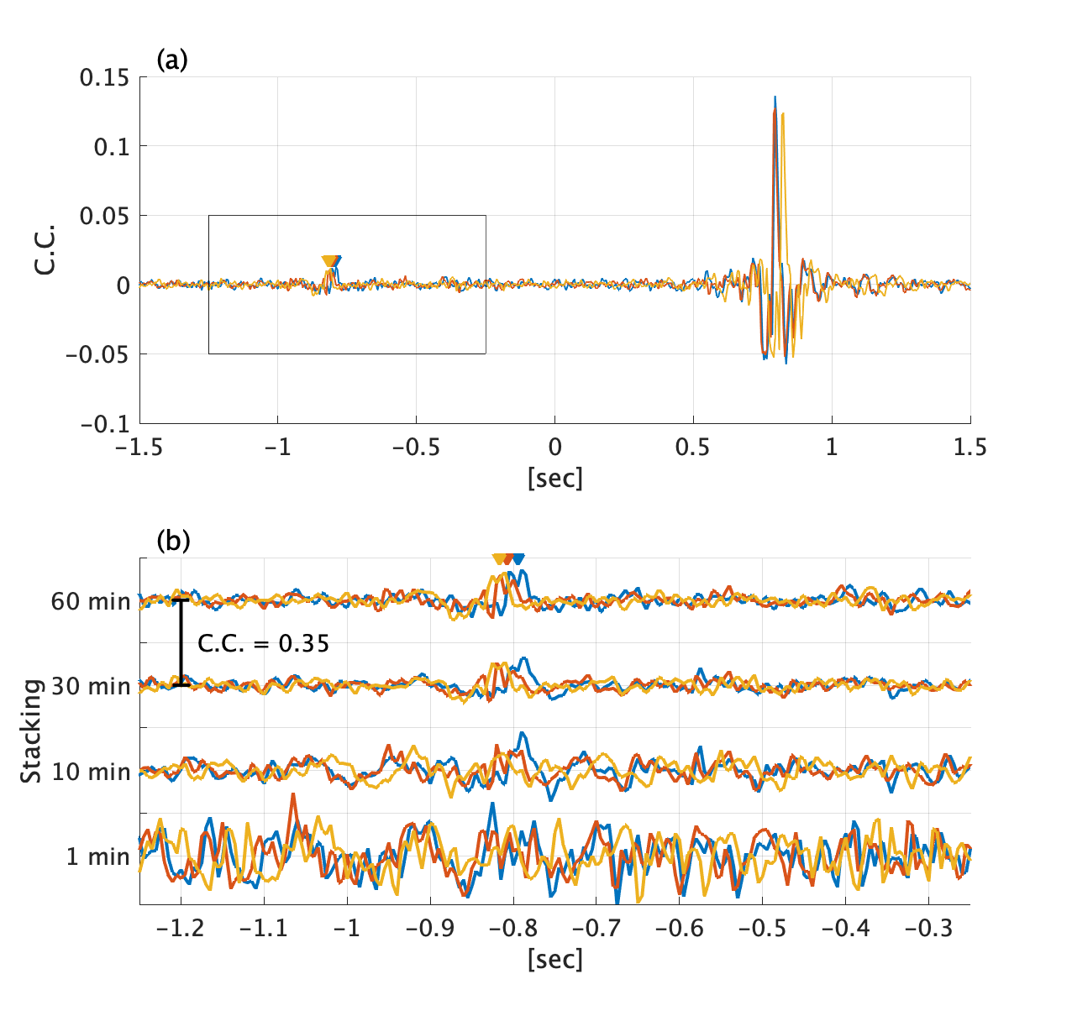
Figure S5. (a) The 60-min stacked SI-array CC in 5–90 Hz, revealing the minor peak enclosed by a black rectangle. (b) The SI-array CC with various stacking time lengths from 1 min to 60 min. The colors indicate the pairs: SI–A1 (blue), SI–A2 (red), and SI–A3 (yellow). The inverted triangles indicate the theoretical lag times between the corresponding pairs, assuming the source at the IWC fumarole and the propagation velocity of 340 m s⁻¹.
S6. Power spectrum and synthetic test
At the array, the contribution of the ISC fumarole is significant. Thus, the power spectrum of the array elements (Fig. 3e1 and e2) is expected be the character of the infrasound from the ISC fumarole. The distinct feature is the persistent power in ~10 Hz and ~35 Hz. However, both ISC and IWC signals are estimated to have significant power in ~35 Hz (the red line in Fig. 3e1 and the blue line in Fig. 3e2). To check it, the numerical tests using synthetic waveforms are conducted.
The synthetic waveforms are constructed using gaussian noise: (1) obtain $G(f)$, the Fourier transformation of the gaussian noise as a function of frequency, $f$, (2) multiply $G(f)$ by an arbitrary function $A_{m}\left(f\right)$, which represents the PSD of the $m$-th source, (3) calculate the inverse Fourier transformation of $A_{m}\left(f\right)G\left(f\right)$ to get the time domain source waveform $S_{m}\left(t\right)$, (4) repeat (1)–(3) for two sources ($m=1$ and 2). (5) make synthetic data at the $n$-th element using the source-receiver distance, $f^{n}\left(t\right)=\frac{S_{1}\left(t+\left|y_{1}-x_{ }^{n}\right|/c\right)}{\left|y_{1}-x_{ }^{n}\right|}+\frac{S_{2}\left(t+\left|y_{2}-x_{ }^{n}\right|/c\right)}{\left|y_{2}-x_{ }^{n}\right|}+N^{n}\left(t\right)$. In the step (4), a common amplitude function is used: $A_{m}\left(f\right)=\frac{1}{1+{\left(0.05f\right)}^{2}}$. In addition, some fluctuations made by sinusoidal waves are given to $S_{1}$ and $S_{2}$ to distinguish them (the blue and red lines in Fig. S6.1a1 and a2). The analysis of the synthetic waveforms showed the correlation coefficients similar to the observation (Fig. S6.1b–d), indicating that this synthetic test was comparable with the observation.
Since the observed waveforms had a significant power in ~35 Hz, three hypotheses are tested: (1) the ISC fumarole had a significant peak in 35 Hz, (2) the IWC fumarole had a significant peak in 35 Hz, and (3) background noise had a significant peak in 35 Hz. The results are shown in Figure S6.2–S6.4. The reconstructed ISC power spectrum has the prominent power in 35 Hz only in the case (1), indicating that the peak in ~35 Hz is originated from the ISC fumarole. On the other hand, the restored IWC signals has a prominent peak in 35 Hz in all cases (Figs. S6.2c1–S6.4c1), due to the poor S/N ratio. To improve the estimation of the IWC fumarole’s power spectrum, the array or network observation around the IWC fumarole or long-term observation would be helpful.
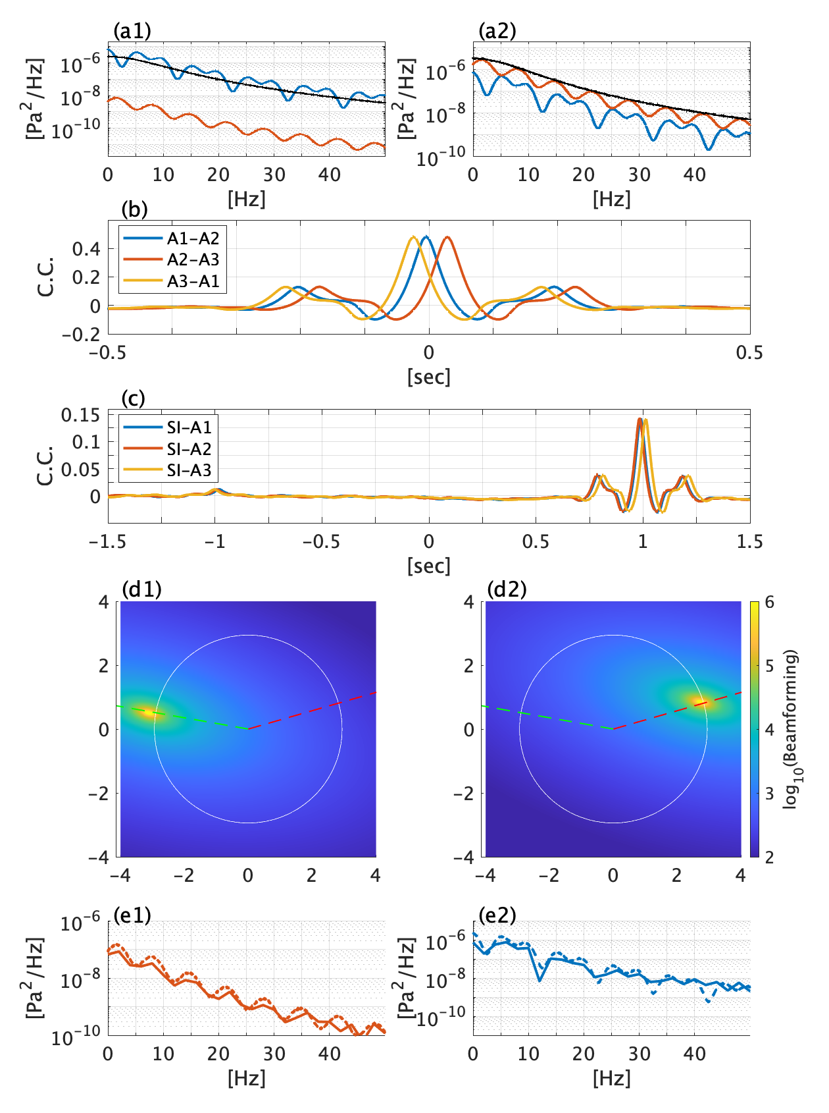
Figure S6.1. The synthetic test results. (a) The power spectra of the synthetic waveforms, $S_{1}$ and $S_{2}$, created for the two sources (red, IWC source; blue, ISC source）and noise (black). The array CC (b) and the SI-array CC (c) of the synthetic waveforms. (d) The results of the lag time fitting for the IWC peak around -1 sec (d1) and the ISC peak around 1 sec (d2). (e) The PSDs for IWC source (e1) and ISC source (e2). The solid lines are calculated from the correlation coefficients shown in (c), and the dashed lines are the given PSDs of the synthetic source.
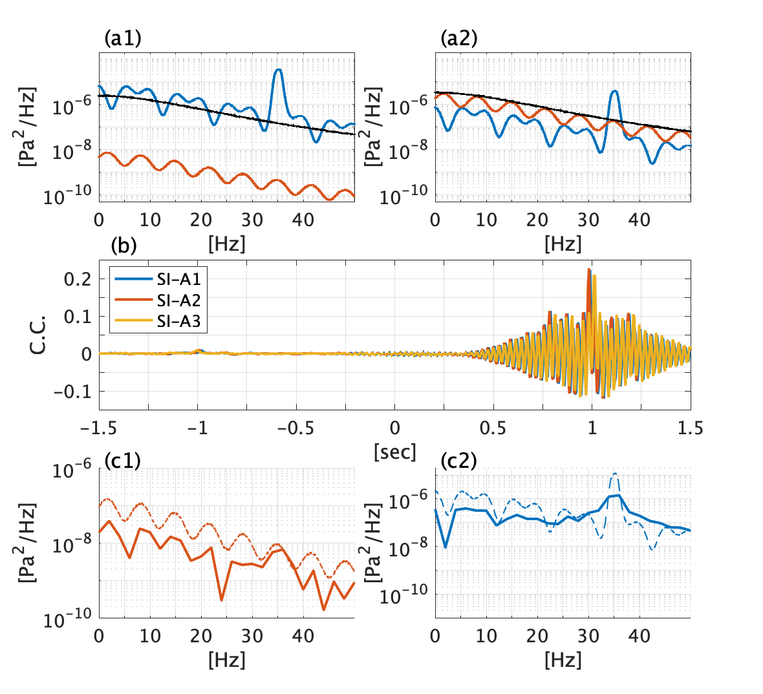
Figure S6.2. A synthetic test, assuming that the ISC signal had a significant power in 35 Hz. (a) The power spectra of the synthetic waveforms created for the two sources (red, IWC source; blue, ISC source）and noise (black). (b) The SI-array CC of the synthetic waveforms. (c) The power spectral densities for IWC source (c1) and ISC source (c2). The solid lines are calculated from the correlation coefficients shown in (c), and the dashed lines are the assumed power spectral densities of the synthetic source.
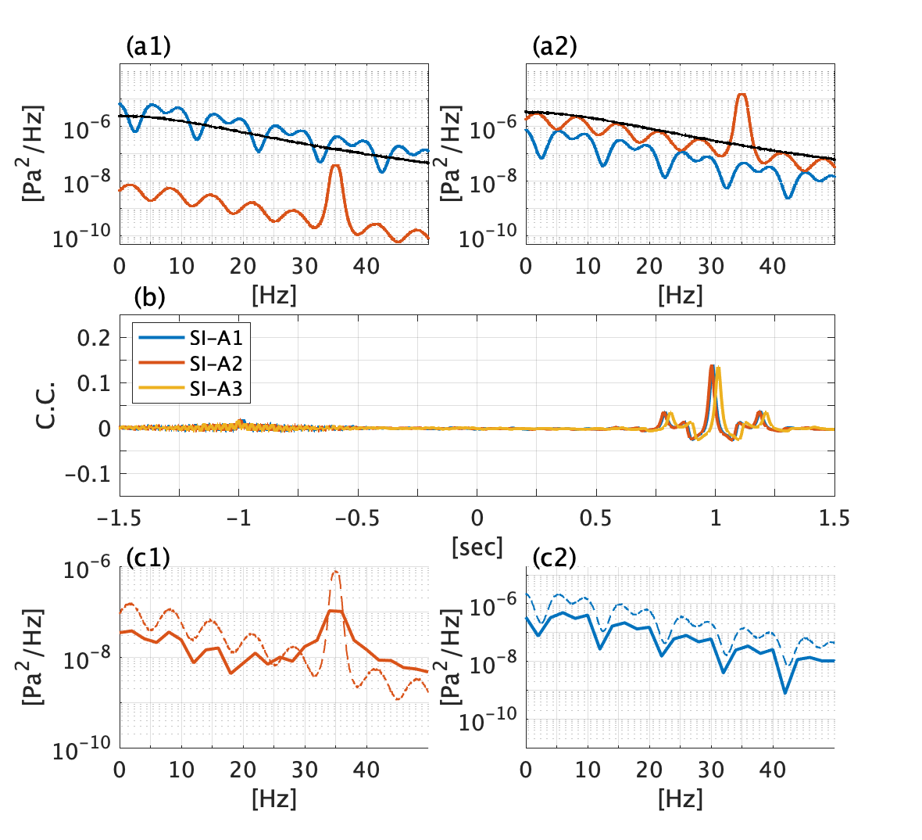
Figure S6.3. A synthetic test, assuming that IWC signal had a significant power in 35 Hz. The presentation format follows Figure S6.2.
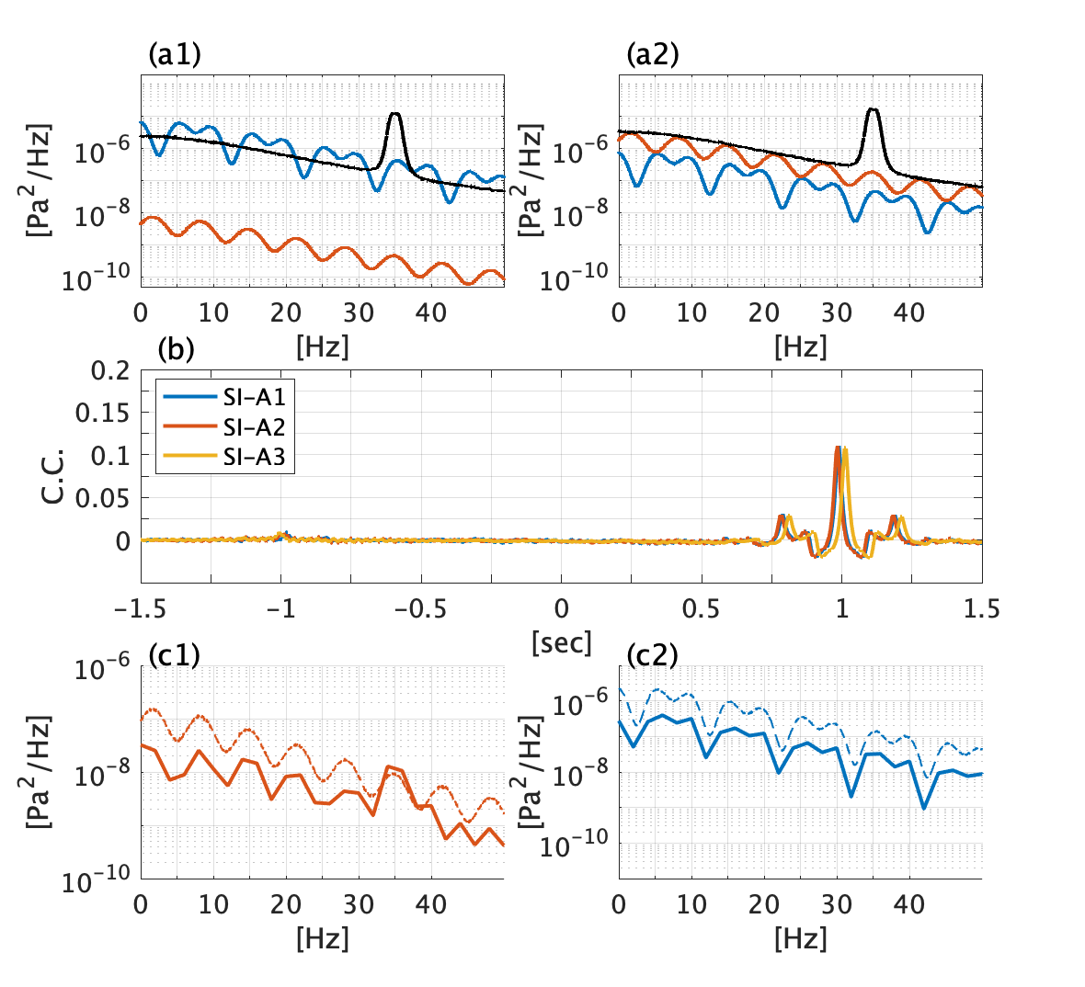
Figure S6.4. A synthetic test, assuming that the background signal had a significant power in 35 Hz. The presentation format follows Figure S6.2.

