Supplementary material
Description of Sandaracinobacter hominis sp. nov., isolated from human skin

Ping-Hua Qu . Hai-Min Luo . Jun-Hui Feng . Lei Dong . Song Li . Yu-Zhen Ming . Wen-Jun Li . Ying Lin . Cha Chen

P.-H Qu . H.-M. Luo . J.-H. Feng . S. Li . C. Chen ()
Department of Clinical Laboratory, the Second Clinical College of Guangzhou University of Chinese Medicine, Guangdong Provincial Hospital of Traditional Chinese Medicine, Guangzhou 510006, People’s Republic of China.
E-mail: chencha906@163.com

L. Dong . Y.-Z.Ming . W.-J. Li
State Key Laboratory of Biocontrol and Guangdong Provincial Key Laboratory of Plant Resources, School of Life Sciences, Sun Yat-Sen University, Guangzhou, 510275, People’s Republic of China

Y. Lin ()
Department of dermatology, Guangdong Provincial Hospital of Traditional Chinese Medicine, Guangdong Provincial Key Laboratory of Chinese Medicine for Prevention and Treatment of Refractory Chronic Diseases, Guangzhou 510006, People’s Republic of China.
E-mail: 13725137126@163.com
Ping-Hua Qu and Hai-Min Luo have contributed equally to this work

Fig. S1. Neighbour-joining phylogenetic tree based on 16S rRNA gene sequences showing the relationship between the strain SZY PN-1^{T} and its closest relatives. Only bootstrap values (expressed as percentages of 1000 replications) above 50% are shown at the branch points. Bar, 0.01 substitutions per nucleotide position.

Fig. S2. Maximum parsimony tree based on 16S rRNA gene sequences of the strain SZY PN-1^{T} and its related taxa. Only bootstrap values (expressed as percentages of 1000 replications) above 50% are shown at the branch points. Rhodospirillum rubrum ATCC 11170^{T} (D30778) was used as an outgroup.

Fig. S3. Absorption spectra of whole cells of isolate SZY PN-1^{T} (solid line) and P. fuscus CGMCC 1.12714^{T} (dashed line) in the acetone-methanol extract.

Fig. S4. Polar lipids profile of strain SZY PN-1^{T}, stained with 5 % molybdophosphoric acid after separation by two-dimensional TLC.
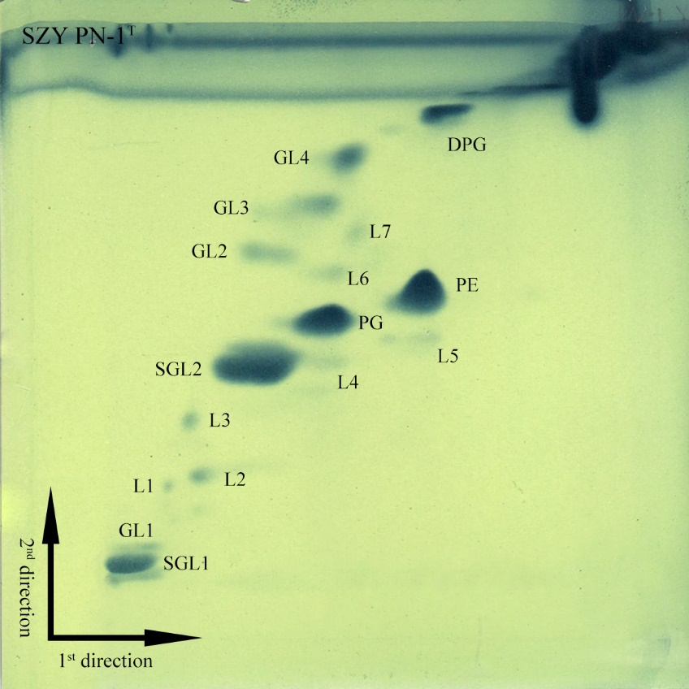
Abbreviations: DPG, diphosphatidylglycerol; PE, phosphatidylethanolamine; PG, phosphatidylglycerol; SGL, sphingoglycolipid; GL, unidentified glycolipid; L, unidentified lipid.

Table S1. ANI and AAI values between genomes of strain Sandaracinobacter hominis SZY PN-1^{T} (JADCUC000000000) and that of related species of the family Sphingosinicellaceae.
Strain (accession number) | Size (×10⁶) | G+C content (%) | ANIb value (%) | ANIm value (%) | AAI value (%)
Sandaracinobacter hominis SZY PN-1^{T} (JADCUC000000000) | 3.53 | 65.0 | − | − | −
Sandaracinobacter neustonicus JCM 30734^{T} (VFSU00000000) | 3.65 | 65.3 | 76.46 | 84.75 | 75.93
Polymorphobacter arshaanensis KCTC 72014^{T} (SIHO00000000) | 3.26 | 65.0 | 69.42 | 83.05 | 61.96
Sandarakinorhabdus limnophila DSM 17366^{T} (ATVO00000000) | 2.61 | 64.5 | 69.36 | 83.38 | 61.43
Polymorphobacter fuscus JCM 19740^{T} (WIOL00000000) | 3.37 | 66.8 | 69.71 | 83.31 | 61.11
Sandarakinorhabdus cyanobacteriorum LMG 30294^{T} (NOXT00000000) | 3.53 | 66.2 | 69.87 | 83.06 | 60.95
Polymorphobacter multimanifer JCM 18140^{T} (JACIIV000000000) | 3.92 | 65.9 | 69.14 | 82.73 | 60.41
Sphingomonas jatrophae DSM 27345^{T} (FOZG00000000) | 4.06 | 68.5 | 69.46 | 83.18 | 59.54
Sphingomonas adhaesiva DSM 7418^{T} (NWVC00000000) | 3.76 | 69.8 | 70.07 | 84.14 | 59.23
Sphingomonas paeninsulae LMG 31027^{T} (CP032829) | 3.99 | 58.9 | 67.44 | 84.10 | 58.85
Sphingomonas sediminicola DSM 18106^{T} (CP060782) | 2.76 | 62.9 | 68.03 | 83.53 | 58.62
Sphingomonas oligophenolica DSM 17107^{T} (RCZK00000000) | 3.09 | 65.8 | 68.86 | 82.76 | 58.60
Sphingomonas lenta DSM 27572^{T} (NSLI00000000) | 3.76 | 69.1 | 69.10 | 83.03 | 58.60
Sphingomonas jejuensis DSM 27651^{T} (JAATJE000000000) | 2.96 | 68.6 | 69.21 | 83.43 | 58.60
Sphingomonas jaspsi DSM 18422^{T} (JFBW00000000) | 2.55 | 64.7 | 68.51 | 83.32 | 58.54
Novosphingobium acidiphilum DSM 19966^{T} (AUBA00000000) | 3.71 | 64.2 | 68.38 | 83.34 | 58.06
Novosphingobium kunmingense DSM 25975^{T} (PHUF00000000) | 3.50 | 65.7 | 68.40 | 83.28 | 58.03
Rhodospirillum rubrum ATCC 11170^{T} (CP000230) | 4.41 | 65.4 | 66.60 | 82.62 | 53.52

