Comparison of Canonical Correlation and Partial Least Squares analyses of simulated and empirical data.

Supplementary Material

S1. Reproducibility Assessments

We compared the train-test and split-half assessments on data using a permuted version of one block, which essentially creates a null model to compare with the unpermuted (original) data. We performed this null assessment for all data sets and the z-scores for the null models seldom were above 1.96. However, in cases where it does, the null model provides an idea of expected value of the reproducibility metrics under the null. This is depicted in the two examples below. These data are from the PLS analysis of the second COSMO sample, which has two strong LVs and two that are unreliable. The z-values for the reproducibility distributions show this, where both the singular values for train-test and singular vectors from split-half (for matrix X only in this example). The pattern was essentially the same for CCA.

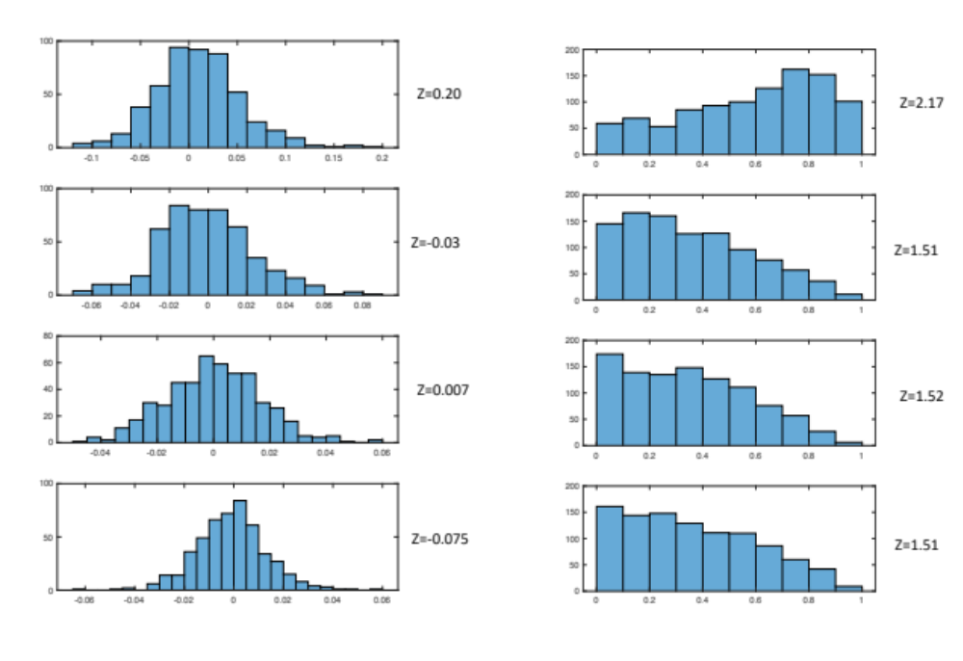
Figure S1. Distributions for reproducibility metrics for singular values (left) and the X singular vector (U). Z-values are the ratio of the distribution mean over its standard deviation. The data come from the second COSMO dataset. Each row corresponds to a Latent Variable from the PLS analysis.
For the null model, the distributions had substantially lower z-values for the first two LVs, especially for the singular values. The utility of the null model is shown for singular vector for the first LV - 2.17 – which by some criteria would be considered “significant”. This expected value under the null can be compared with the obtained value, which in this case is tremendously larger at 933.5. However, the z-values for the lower order LVs in both the null and original model are essentially the same (~1.5) confirming the lack of reliability for these LVs

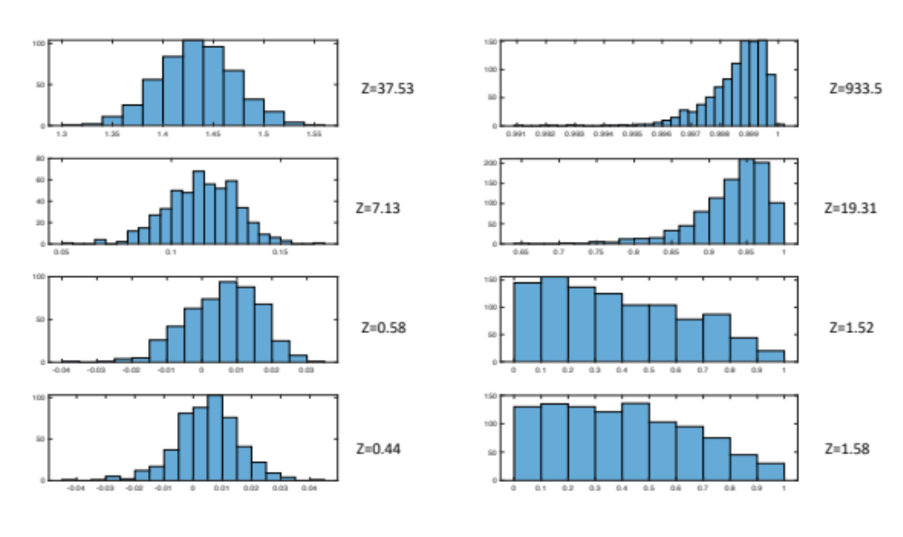
Figure S2. Distributions for reproducibility metrics for singular values (left) and the X singular vector (U) for permuted data to give a null distribution. The data come from the second COSMO dataset, where the rows for the Y matrix were permuted for iteration. Z-values are the ratio of the distribution mean over its standard deviation. Each row corresponds to a Latent Variable from the PLS analysis.

S2. PCA stability
Using the PCA scores as input to PLS and CCA is a common practice, but is not without its issues. In the situation where the components are meant to reflect an underlying latent structure in the population, the stability of the component weights with the given sample needs to be evaluated. In addition, the interpretation of the PLS or CCA output requires the secondary step where the contributions of the original variables are filtered through the eigenvectors and then the singular vectors from CCA/PLS.

For the SIMREL data (Data Set 4), the eigenspectrum had a steep drop (Fig S3), indicating that most of the variance is captured in the first few components. The steep drop also suggests that the component structure would likely be preserved across different resampling regimes, especially with smaller sample sizes.

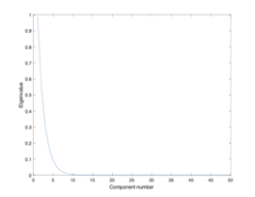
Figure S3. Eigenspectrum for SIMREL data.

This is indeed the case where the cosine of the first seven eigenvectors from the full sample with the eigenvectors from the smaller sample sizes all showed strong reproducibility as indicated by the z-score for the cosine distribution (Table S1). Arbitrary reflections of the eigenvector can affect the similarity we test reproducibility with and without correction (z-score for distribution without correct are in parenthesis in the tables). For all sample sizes, the first and second PCs were reproduced well regardless of correction. Without correction, the z-score for PC2 dropped to near zero for all sample sizes.

Table S1. z-score value from distribution of cosine angle between population components and subsamples. Values in parentheses from distribution with no correction for eigenvector reflections
Sample Size | PC1 - z-score | PC2 - z-score
500 | 234.6 (234.6) | 179.75 (0.138)
250 | 110.5 (110.5) | 87.7 (0.02)
100 | 23.8 (23.8) | 20.5 (0.01)
50 | 9.9 (9.9) | 8.1 (-0.03)
20 | 4.7 (4.4) | 3.2 (0.07

In a situation where the eigenspectrum is flatter, the reproducibility drops. Here we generate a dataset with 15 X variables with SIMREL, with a more gradual change in the eigenvalue spectrum (Figure S4).

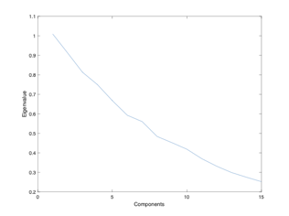
Figure S4. Eigenspectrum for SIMREL data with variance spread across more componoents.

The reproducibility of the PCA solution relative to the full sample was extremely low without correction for reflections. Even with such a correction, the z-score for reproducibility was only high for N=500 and N=250, and only for the first two components.

Table S2. z-score value from distribution of cosine angle between population components and subsamples. Values in parentheses from distribution with no correction for eigenvector reflections
Sample Size | PC1 - z-score | PC2 - z-score
500 | 4.5 (0.28) | 3.1 (-0.18)
250 | 3.3 (0.25) | 2.2 (-0.24)
100 | 2.4 (0.19) | 1.73 (-0.15)
50 | 2.02 (0.19) | 1.57 (-0.23)
20 | 1.8 (0.07) | 1.5 (-0.11)

