Understanding Variation in Oleic Acid Content of High-Oleic Virginia-type Peanut
R.J. Andres and J.C. Dunne (jcdunne@ncsu.edu Orchid ID), North Carolina State University, Department of Crop and Soil Sciences, Raleigh, NC, United States of America
Supplementary File 1: Detailed Overview of the Seed Chipper and its Operation
Overview: The seed chipper consists of a standard arbor press with 24 biopsy punches mounted in fixed positions (4 x 6 layout) within a stainless steel bracket. The bracket also includes the ejector plate and is mounted at the base of the arbor press ram. The base at the bottom starts in the grooved state to accept the 24-well plate. The handle is used to place the flat sheet over the grooved state to accommodate the 96-well plate.
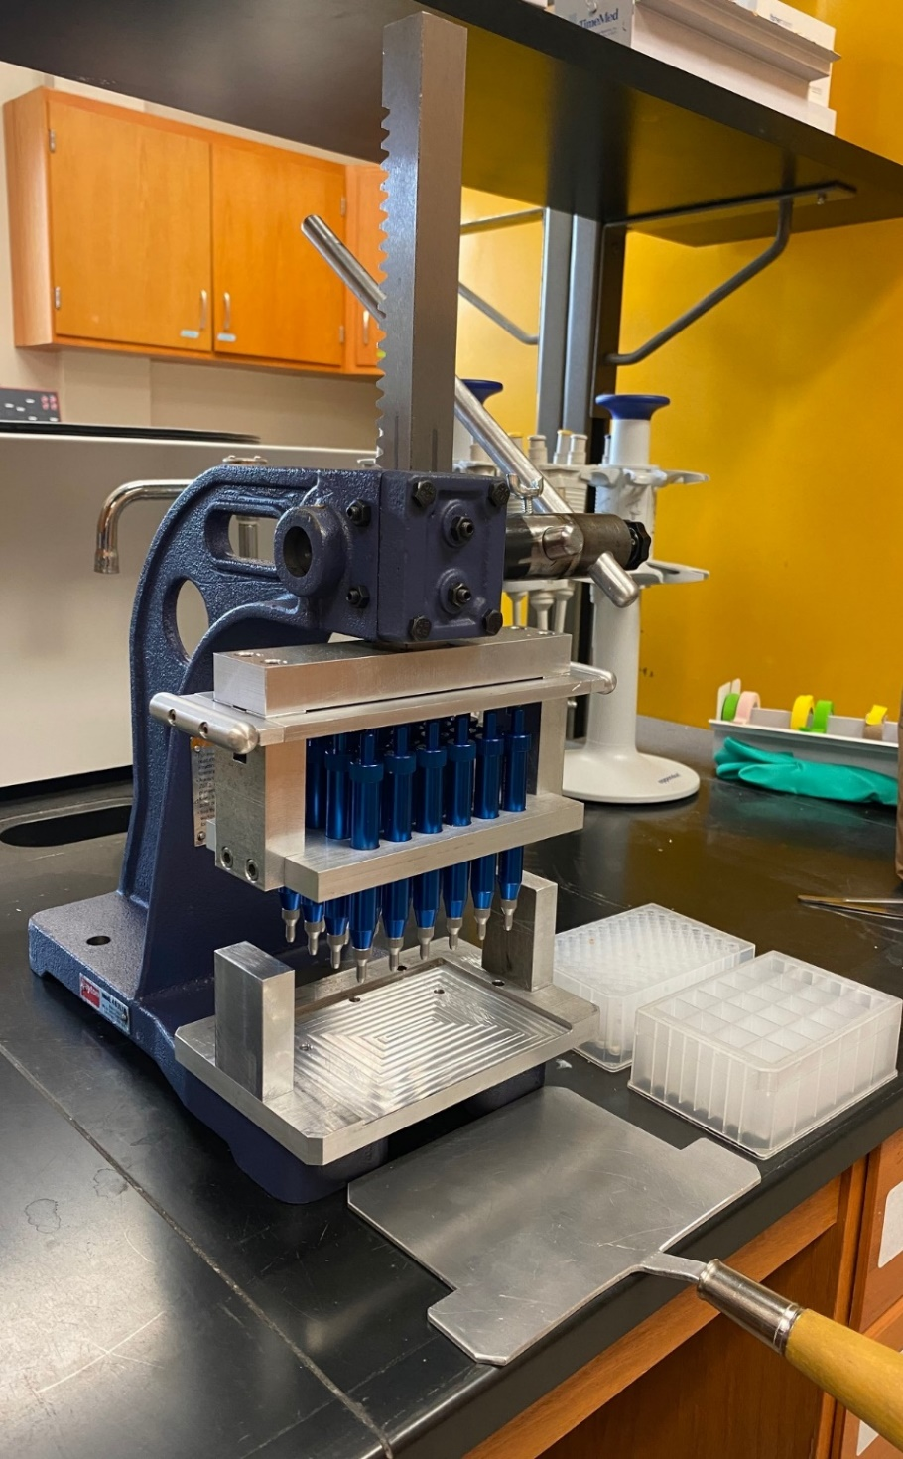

Step 1: Seeds to be sampled are placed in 24-square well plates. The left image below shows an empty plate while the right image below shows a fully loaded plate.

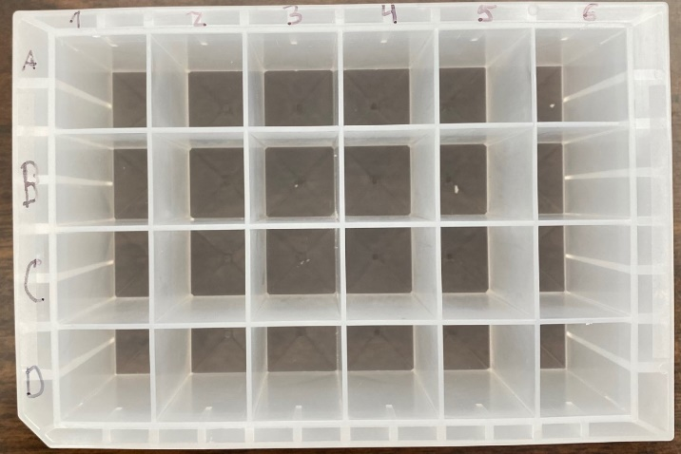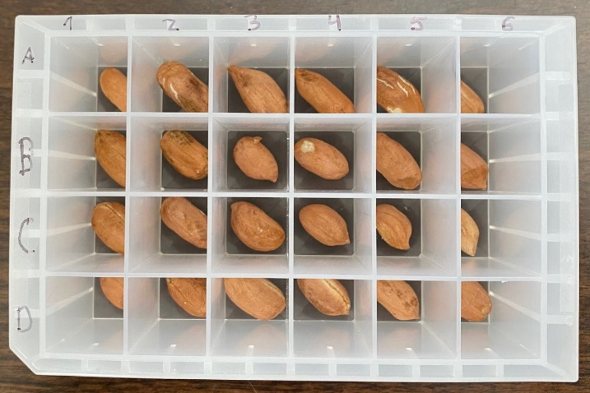

Step 2: The full 24-well plate slides into the grooved portion of the base. This ensure each biopsy punch is centered over its respective seed. Therefore, samples will only be taken from the middle of the seed, the germ will be missed, and seed viability maintained. The left image below shows the grooved base of the seed chipper while empty and the right image below shows the fully loaded 24-well plate in position.

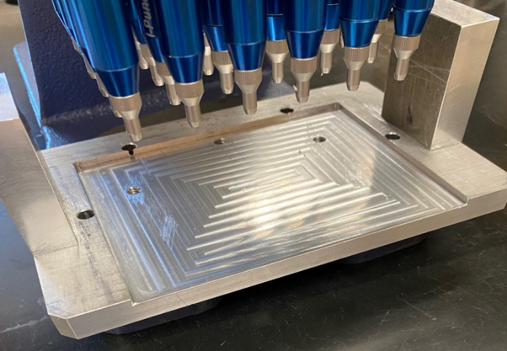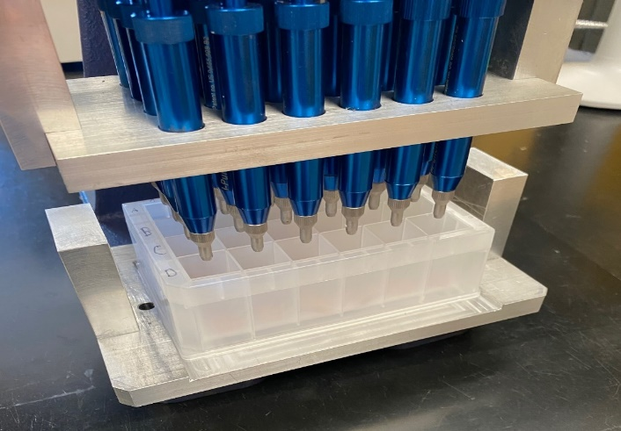

Step 3: When the arbor press handle is pulled forward, the 24 biopsy punches move down simultaneously to collect the sample. The left image below shows the handle in the upright position. The right image below shows the handle fully depressed with all 24 biopsy punches inside the wells to collect the seed chips.
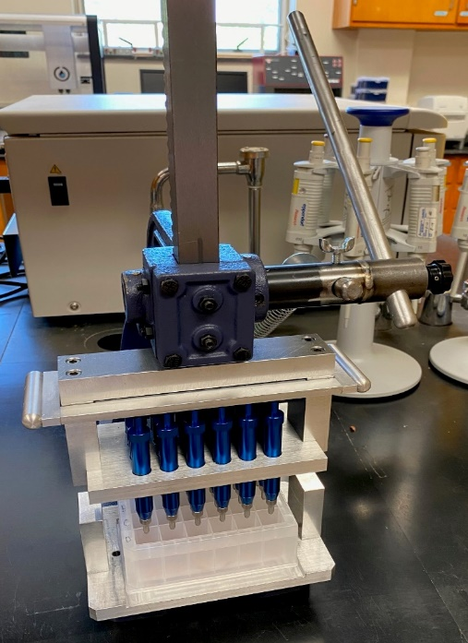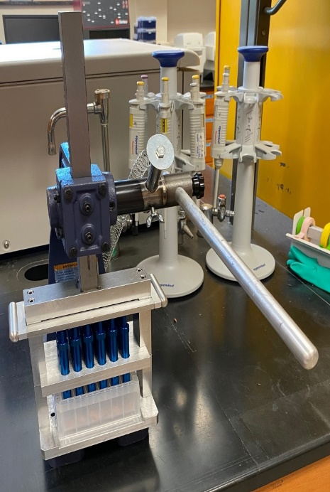

Step 4: The handle is then pushed back to the upright position. The seed remains in the well while the seed chips are within the tips of the biopsy punches (top picture below). While most seeds have a small seed chip removed perfectly, some seeds are split (wells A2, A5, C4, D2, and D4 in the bottom image below). However, viability is not compromised in either case.
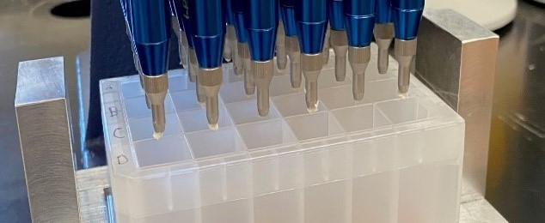
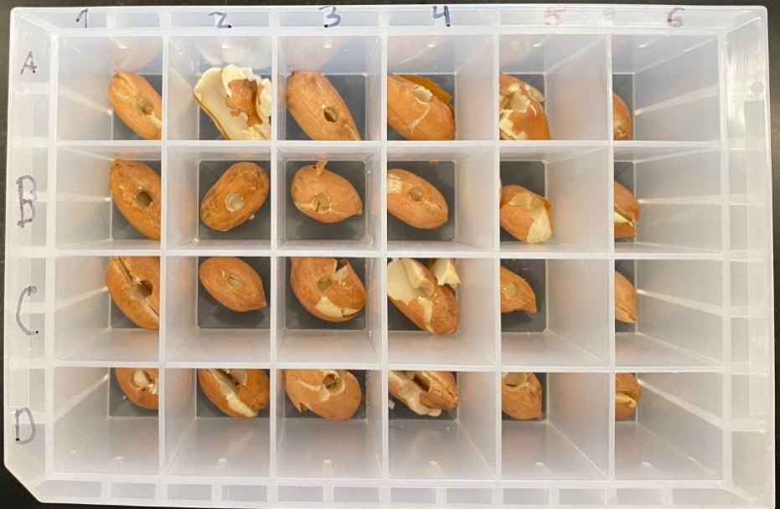

Step 5: The flat metal sheet is then used to cover the grooved base (top left image below). The 96-well plate goes on top of the flat metal sheet and is positioned underneath the biopsy punches (top right image below). The ejector plate above the biopsy punch plungers is then pushed down using the two side handles to eject the seed chips into the corresponding wells below. The process is repeated three times until each 96-well plate is full. The bottom left images shows the 96-well plate with just the northwest quadrant full while the bottom right image shows the 96-well plate with all four quadrants full.
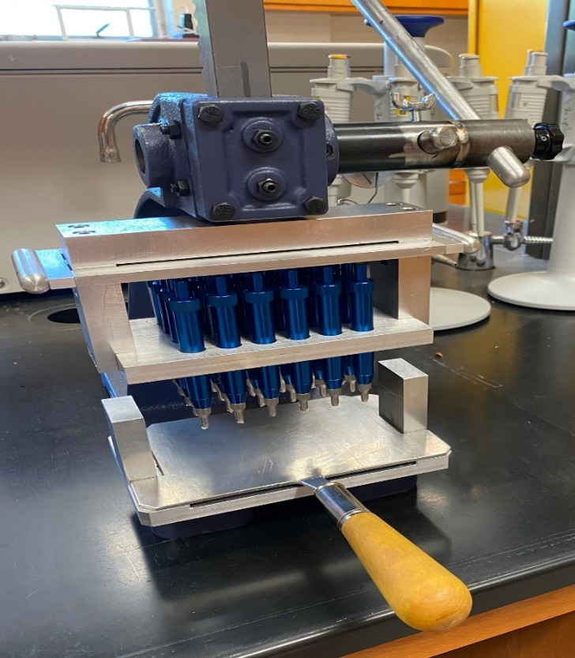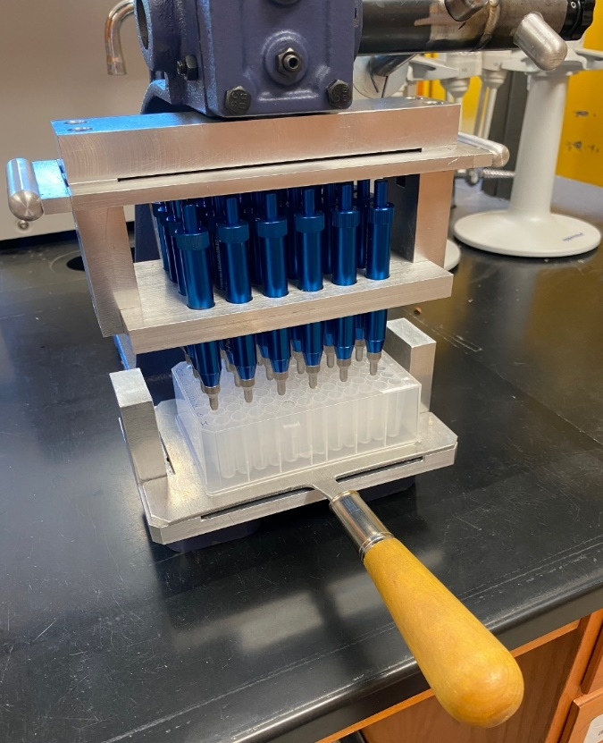
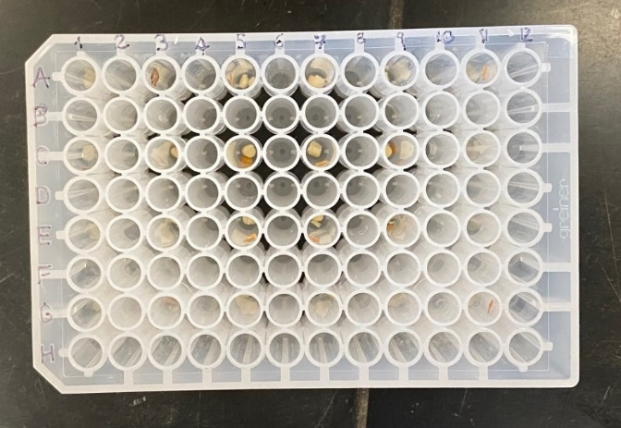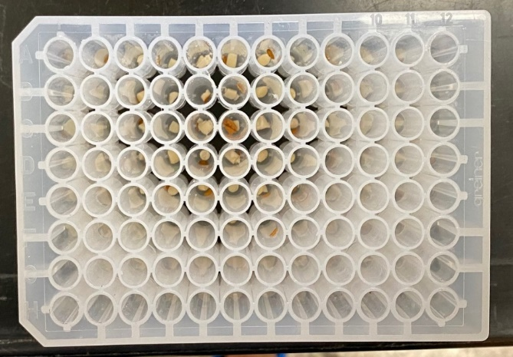
Schematic of how the four 24-well plates fit into a single 96-well plate. The arragenment is analgous to how four 96-well plates fit into a 384-well plate.
