Additional File 1
Title
Evidence for cross-feeding, metabolic specialization, and niche partitioning in the octocoral holobiont

Authors
Tina Keller-Costa^{1,2*}, Lydia Kozma^{1,3}, Sandra G. Silva^{1,2}, Rodolfo Toscan⁴, Jorge Gonçalves⁵, Asunción Lago-Lestón⁶, Nikos C. Kyrpides⁷, Ulisses Nunes da Rocha⁴ & Rodrigo Costa^{1,2,5*}

Affiliations
¹Institute for Bioengineering and Biosciences, Department of Bioengineering, Instituto Superior Técnico, University of Lisbon, Lisbon, Portugal
²Associate Laboratory i4HB, Institute for Health and Bioeconomy, Instituto Superior Técnico, University of Lisbon, Lisbon, Portugal
³École Polytechnique Fédérale de Lausanne, Switzerland
⁴Helmholtz Centre for Environmental Research - UFZ, Leipzig, Germany
⁵Centro de Ciências do Mar (CCMAR), Universidade do Algarve, Faro, Portugal
⁶Centro de Investigación Científica y de Educación Superior de Ensenada, Ensenada, Mexico
⁷Department of Energy, Joint Genome Institute, Lawrence Berkeley National Laboratory, Berkeley, California, USA.

*Corresponding authors

Institute for Bioengineering and Biosciences, Instituto Superior Técnico, University of Lisbon, Av. Rovisco Pais 1, Torre Sul, Office 11.6.11b, 1049-001 Lisbon, Portugal, Tel: (+351) 21 841 3167,

E-mail: tinakellercosta@tecnico.ulisboa.pt; rodrigoscosta@tecnico.ulisboa.pt

Detailed Methodology
Phylogenomics of the Endozoicomonadaceae and Ca. Thioglabaceae families

The Endozoicomonadaceae phylogenomics assessment (Figure 2) included all (N = 29) genome assemblies publicly available on NCBI (National Center for Biotechnology Information, https: //www.ncbi.nlm.nih.gov), IMG/M (Integrated Microbial Genomes, [1]) and RAST (Rapid Annotation using Subsystem Technology, [2, 3]) by March 2021. The 29 genomes derived from cultured (i.e., isolates) and uncultured (MAGs and those obtained by single cell genomics - SAGs) bacteria. To root the tree, the genomes of five species of the closely related family Hahellaceae were included as an outgroup. The Thioglobaceae phylogenomics inference (Figure S1) included, next to the six octocoral-derived MAGs from this study, 33 publicly available genomes, MAGs and SAGs of the sulfur-oxidizing Thioglobaceae Arctic96 and SUP5 clades (three Thioglobus species, 16 Thiomultimodus species and divSUP05-5, as described in [4]). As an outgroup, 13 genomes of the Piscirickettsiaceae family (order Thiotrichales) with representative type genomes of the genera Thiomicrospira (N=2), Thiomicrorhabdus (N=2), Sulfurivirga (N=1), Methylophaga (N=5), Hydrogenovibrio (N=2) and Cycloclasticus (N=1) were used. The Piscirickettsiaceae family was chosen as the outgroup since several Piscirickettsiaceae genomes were indeed identified by MiGA as the closest type species to our Thioglobaceae MAGs, albeit with low AAI values (see Table S1, Additional File 2 for details).

Analysis of the chitinase gene sequence present on the Endozociomonadaceae MAGs
Complete chitinase coding sequences (CDS) present on our MAGs were retrieved from RAST and translated into amino acid sequences, followed by Pfam annotations using the EMBOSS Transeq (https://www.ebi.ac.uk/Tools/st/emboss_transeq) and hmmscan (https://www.ebi.ac.uk/Tools/hmmer/search/hmmscan) algorithms of EMBL-EB. Phylogenetic inference of complete chitinase gene sequences was then performed following the methodology detailed in Raimundo et al., 2021 [5].

Supplementary Figures

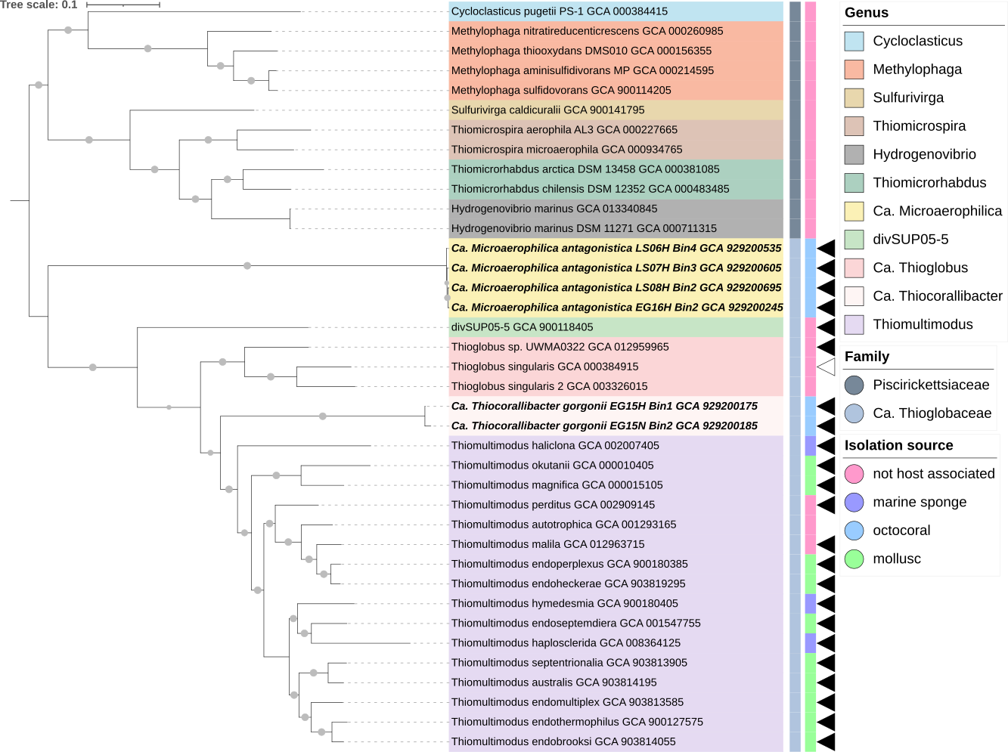

Figure S1. Phylogenomic analysis of the Ca. Thioglobaceae family using SpeciesTreeBuilder v.01.0. Evolutionary history was inferred by using a Maximum likelihood method (FastTree2) based on alignment similarity of a set of 49 core, universal genes defined by COG (Clusters of Orthologous Groups of proteins) gene families. Grey dots on the branches indicate bootstrap support of >70%. Black triangles indicate a MAG, white triangles a SAG, the remaining genomes derived from isolates. The six Ca. Thioglobaceae MAGs (Ca. Thiocorallibacter gorgonii and Ca. Microaerophilica antagonistica) of this study are highlighted in bold-italics. All other Ca. Thioglobaceae genomes (N=20) were publicly available on NCBI. Assembly accession numbers are given next to the strain names. Twelve genomes of the related Piscirickettsiaceae family (Thiotrichales, Gammaproteobacteria) were used as an outgroup to root the tree. The inner coloured bar next to the tree shows family-level affiliation and the outer coloured bar the isolation source of the genomes. The tree is drawn to scale and was style-edited in iTOL.

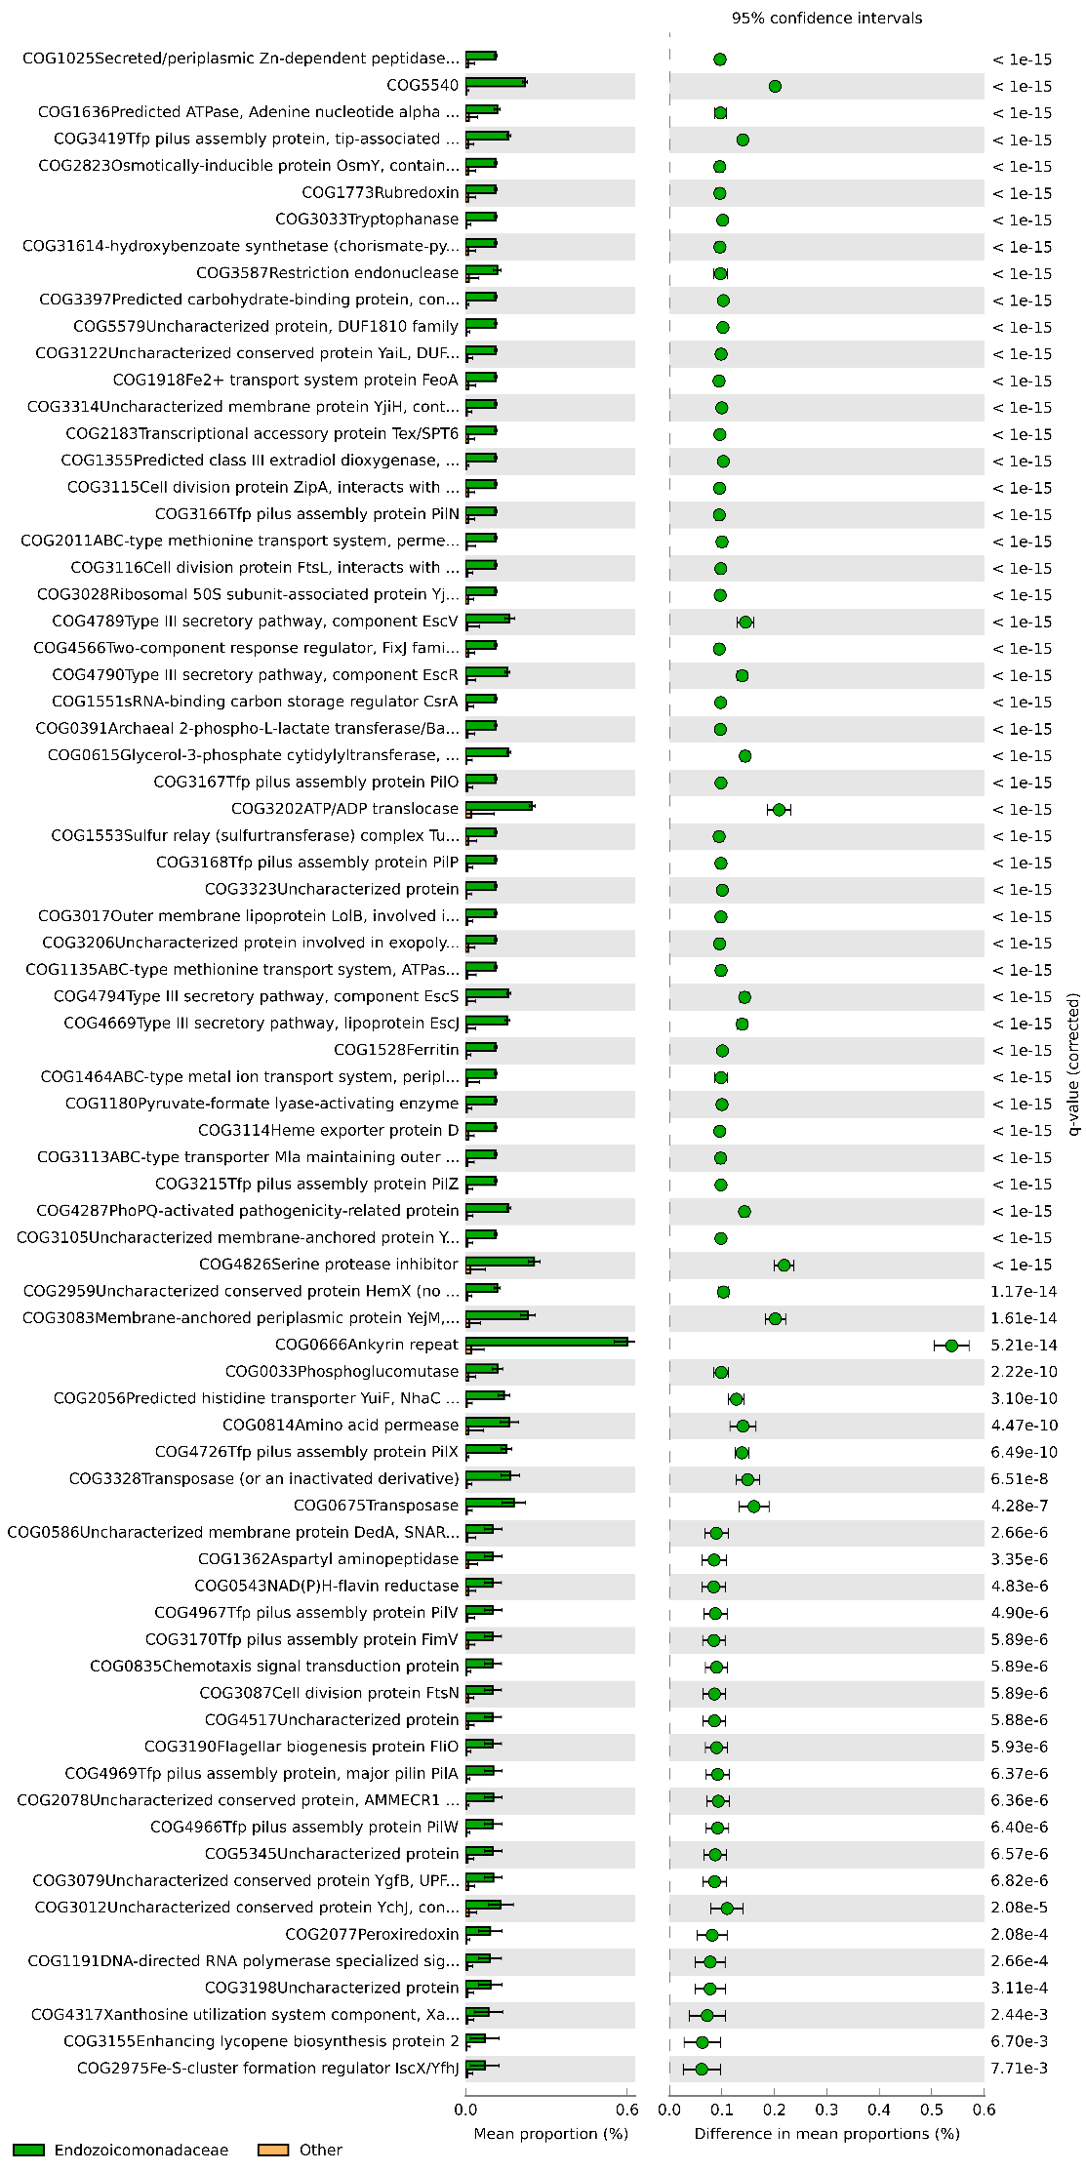
Figure S2.
COG functions (N=76) significantly enriched (q-value > 0.05) in the octocoral-derived Gorgonimonas (Endozoico-monadaceae) MAGs (N= 11, green), compared with all other MAGs (N=55) of this dataset. An one-sided, Welch’s t-test for unequal variances was performed with the STAMP (Statistical Analysis of Metagenomic Profiles) v.2.1.3 software. Multiple test correction was performed using the Benjamini-Hochberg correction (FDR). To further limit the displayed number of significant entries, an effect size filter was also applied, setting the “ratio of proportions” to 10.00.
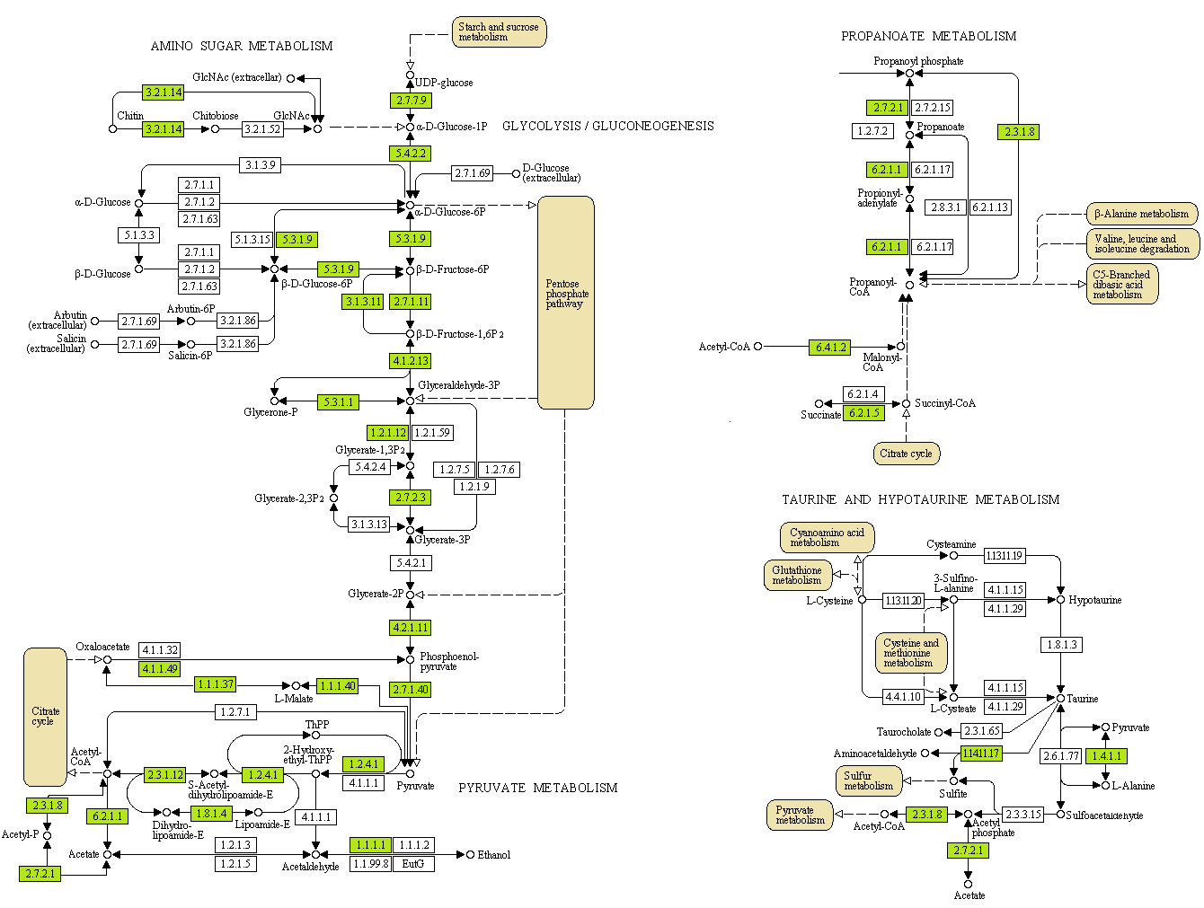

Figure S3. KEGG metabolic pathway map of the Gorgonimonas (Endozoicomonadaceae) MAGs of this study. The metabolic map features glycolysis, amino-sugar, pyruvate, propanoate, and taurine metabolism in these symbionts. EC numbers of enzymes catalysing the reactions are given in rectangular boxes. EC numbers highlighted in green represent enzymes encoded on the Gorgonimonas MAGs. Beige boxes indicate connections to other metabolic pathways active in these MAGs.

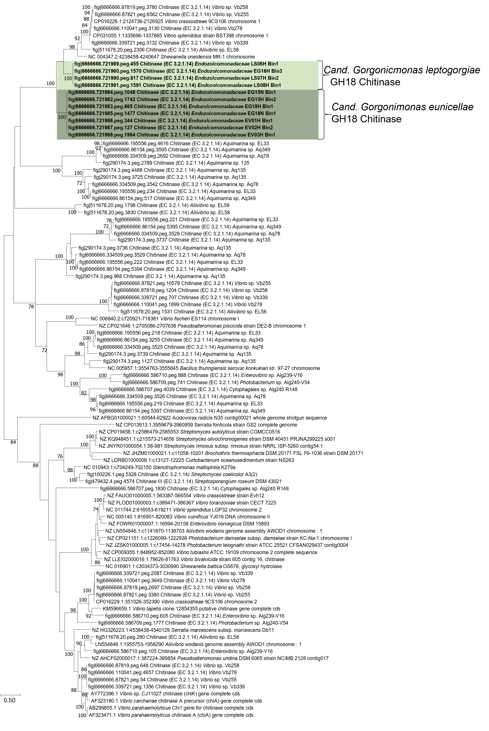

Figure S4. Phylogeny of 101 full-length, bacterial endo-chitinase (EC 3.2.1.14) encoding genes, including the 11 endo-chitinase (GH18-family) genes from Endozoicomonadaceae MAGs (grey shadings) of this study. These 11 Endozoicomonadaceae chitinases form two distinct, species-specific clusters, whereby four genes belonged to the four MAGs of Ca. species Gorgonimonas leptogorgiae and were each 1731 bp (577 AA) long, carrying, besides a GH18 domain, two other domains of unknown function (DUF5011). The other seven genes belonged to the seven MAGs of Ca. species G. eunicellae and were each 1572 bp (524 AA) long, carrying the GH18 domain only. Closest neighbours are GH18-type chitinases of Vibrionaceae and Shewanellaceae (Gammaproteobacteria) isolates. The phylogeny was based on the Maximum Likelihood method and the General Time Reversible model (GTR+G+I). The tree with the highest log likelihood (-72263.15) is shown. The percentage of trees in which the associated taxa clustered together is shown next to the branches (50 repetitions). Codon positions included were 1st+2nd+3rd+Noncoding. All positions with less than 85% site coverage were eliminated. There were a total of 1206 nucleotide positions in the final dataset. More information about the other 90 bacterial chitinase sequences shown in this tree is available in the article of Raimundo et al. [5].

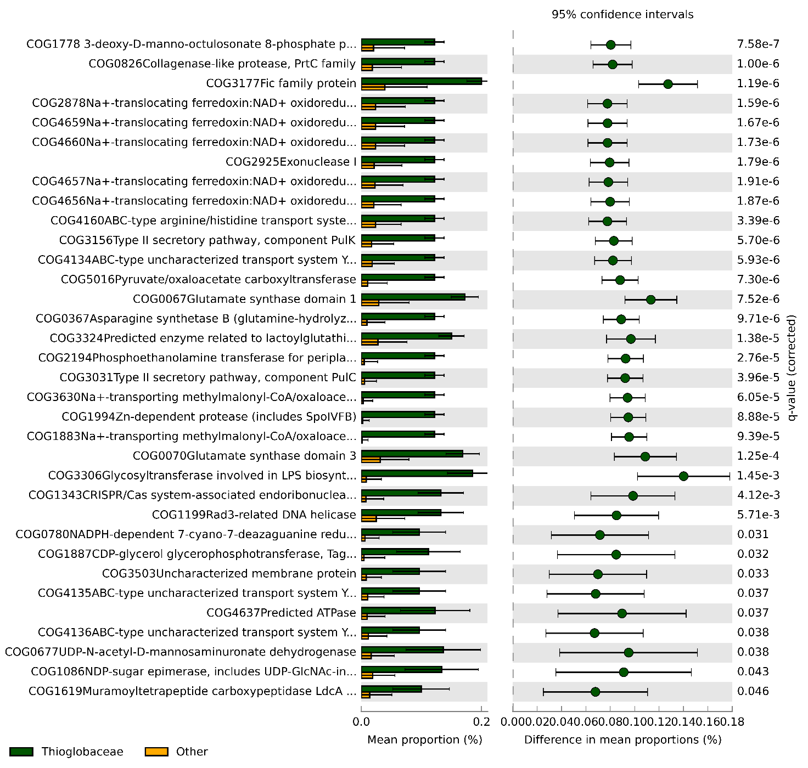

Figure S5. COG functions (N=34) significantly enriched (p-value > 0.05) in the Ca. Thioglobaceae MAGs (N= 6, dark green), compared with all other MAGs (N=60) of this dataset. An one-sided, Welch’s t-test for unequal variances was performed in STAMP v.2.1.3. Multiple test correction was performed using the Benjamini-Hochberg correction (FDR). To further limit the displayed number of significant entries, an effect size filter was also applied, setting the “ratio of proportions” to 5.00.

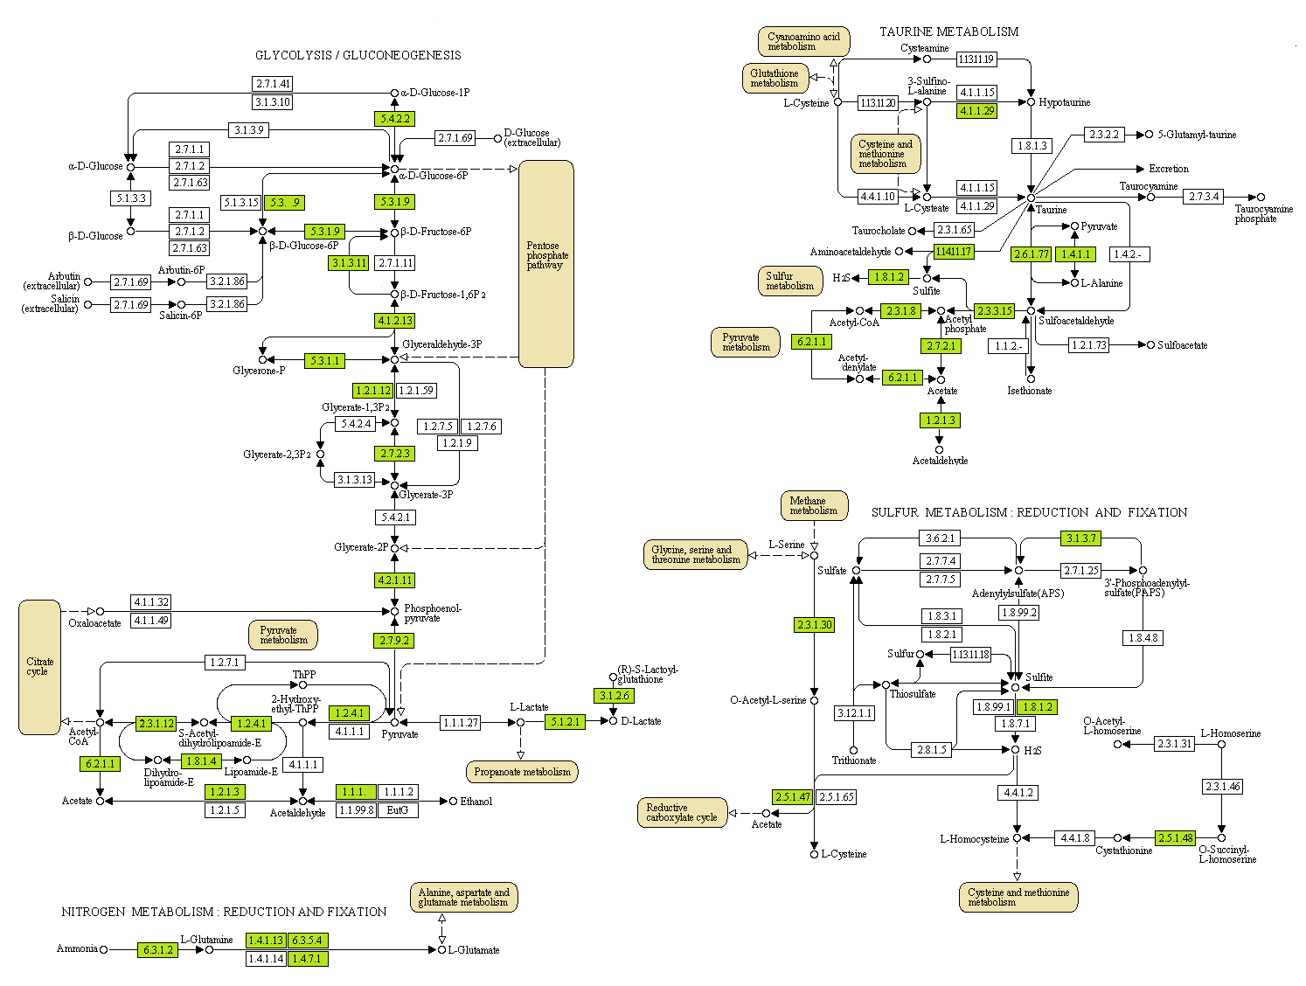

Figure S6. KEGG metabolic pathway map of the Ca. Thioglobaceae MAGs of this study. The metabolic map features glycolysis, pyruvate, nitrogen, sulfur and taurine metabolism. EC numbers of enzymes catalysing the reactions are given in rectangular boxes. EC numbers highlighted in green represent enzymes encoded on Ca. Thioglobaceae MAGs. Beige boxes indicate connections to other metabolic pathways active in these MAGs.

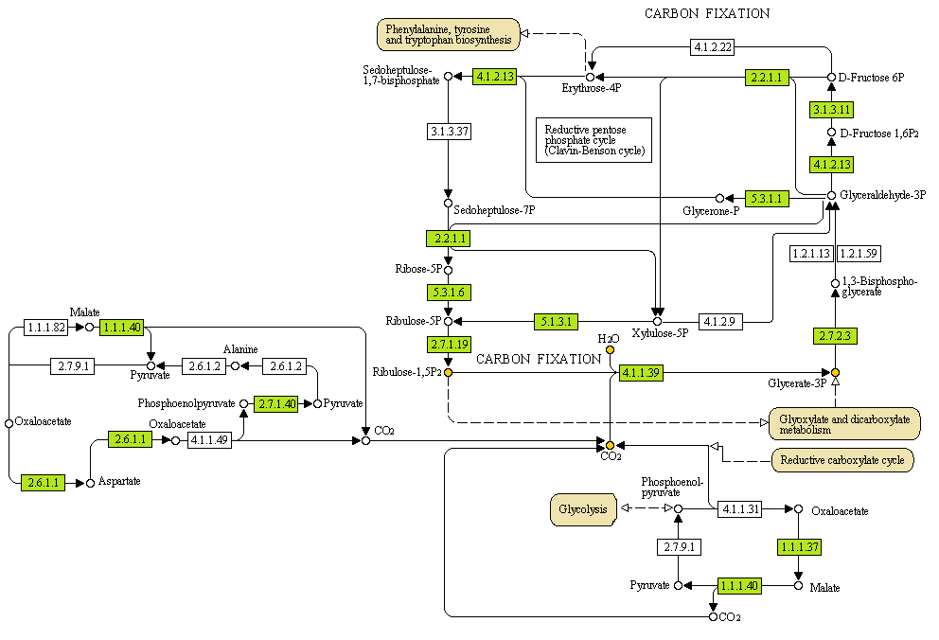

Figure S7. KEGG carbon fixation map of Ca. Thiocorallibacter gorgonii MAG EG15H_Bin1 (Ca. Thioglobaceae). EC numbers of enzymes catalysing the reactions are given in rectangular boxes. EC numbers highlighted in green represent enzymes encoded on this MAG. Beige boxes indicate connections to other metabolic pathways active in these MAGs. Orange dots highlight the substrates (Ribulose-1,5-bisphosphate, CO₂, and H₂O) and product (2 Glycerate-3-phosphate, 2 H⁺) of Rubisco (EC 4.1.1.39).

References

1. Chen IA, Chu K, Palaniappan K, Pillay M, Ratner A, Huang JH, Huntemann M, Varghese N, White JR, Seshadri R et al: IMG/M v.5.0: an integrated data management and comparative analysis system for microbial genomes and microbiomes. Nucleic Acids Research 2019, 8(47(D1)):D666-D677.
2. Overbeek R, Olson R, Pusch GD, Olsen GJ, Davis JJ, Disz T, Edwards RA, Gerdes S, Parrello B, Shukla M et al: The SEED and the rapid annotation of microbial genomes using subsystems technology (RAST). Nucleic Acids Research 2014, 42:D206–D214.
3. Aziz RK, Bartels D, Best AA, DeJongh M, Disz T, Edwards RA, Formsma K, Gerdes S, Glass EM, Kubal M et al: The RAST Server: rapid annotations using subsystems technology. BMC Genomics 2008, 9(75).
4. Ansorge R, Romano S, Sayavedra L, Rubin-Blum M, Gruber-Vodicka H, Scilipoti S, Molari M, Dubilier N, Petersen J: The hidden pangenome: comparative genomics reveals pervasive diversity in symbiotic and free-living sulfur-oxidizing bacteria. bioRxiv 2020, 12.11.421487.
5. Raimundo I, Silva R, Meunier L, Valente S, Keller-Costa T, Costa R: Functional metagenomics reveals differential chitin degradation and utilization features across free-living and host-associated marine microbiomes. Microbiome 2021, 9:43.

