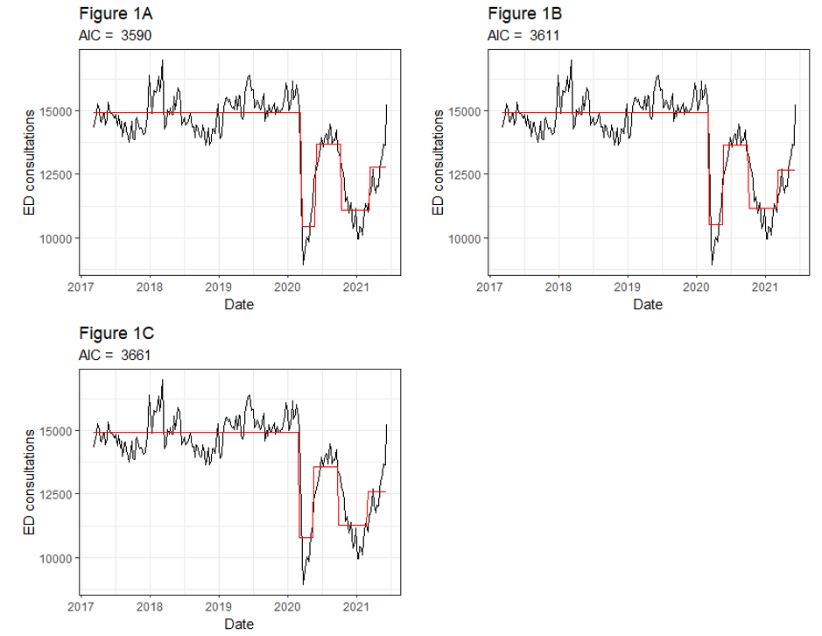
Supplemental Figures
Figure 1 - Model fit for overall consultations showing number of cases per week (black) and fitted values (red) for A): a two-week delay, B): a one-week delay and C): no delay

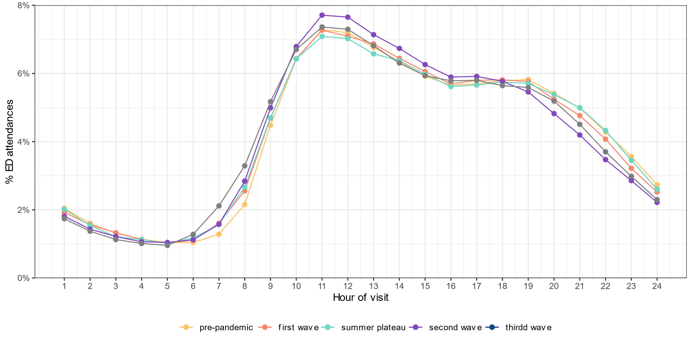
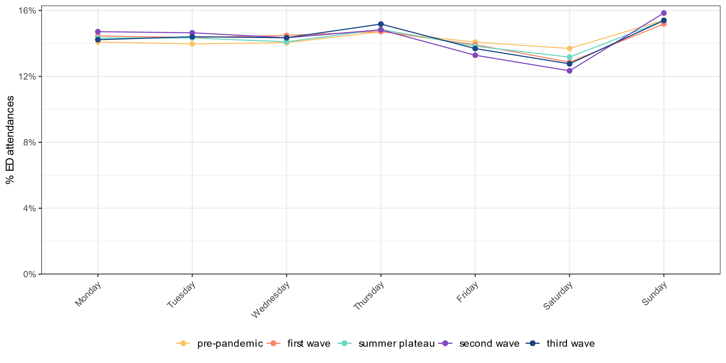
Figure 3 Relative number of emergency department consultations stratified by hour of consultation comparing the pandemic phases
Figure 2 - Relative number of emergency department consultations stratified by weekday of consultation comparing the pandemic phases
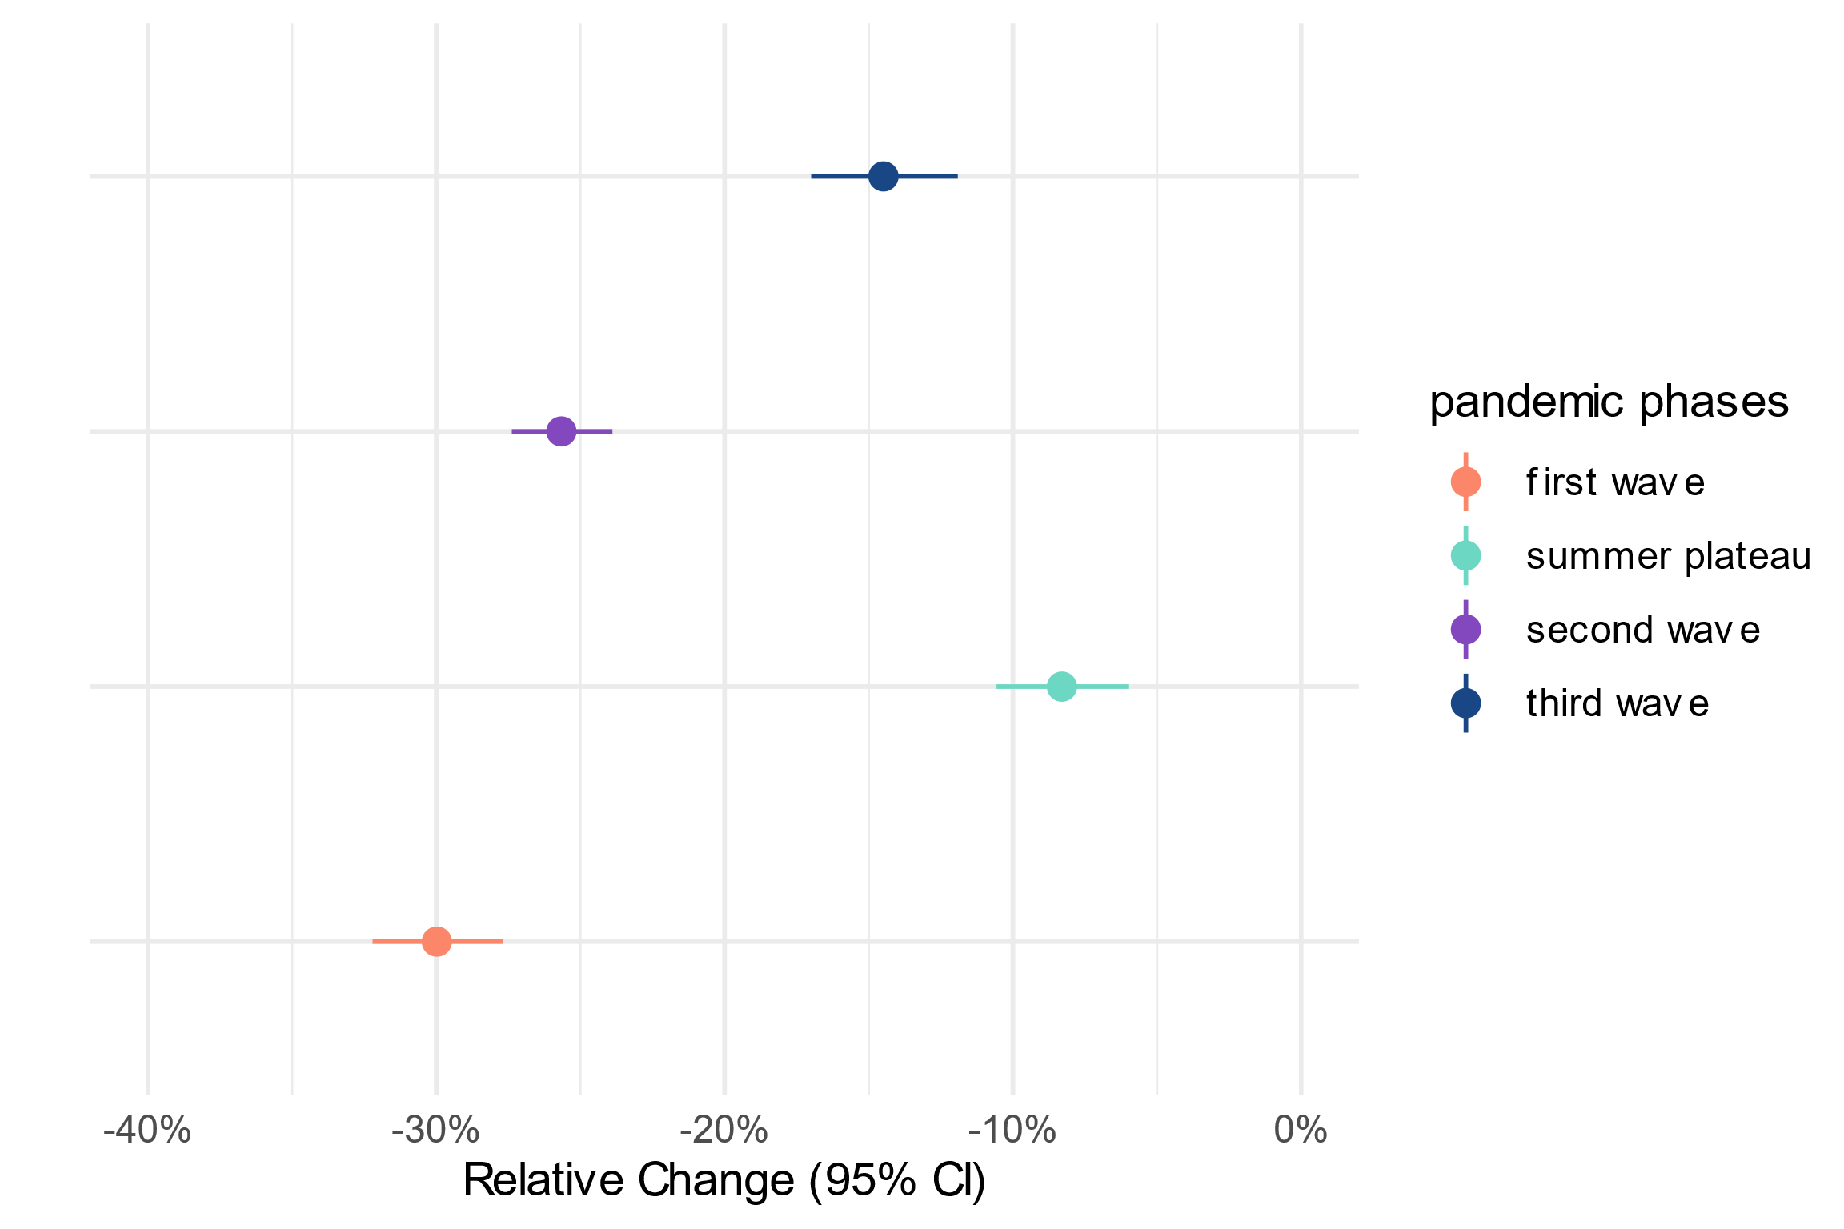

Figure 4 - Relative change in % and 95% confidence interval for all emergency department consultations, comparing every pandemic phase with the pre-pandemic reference period
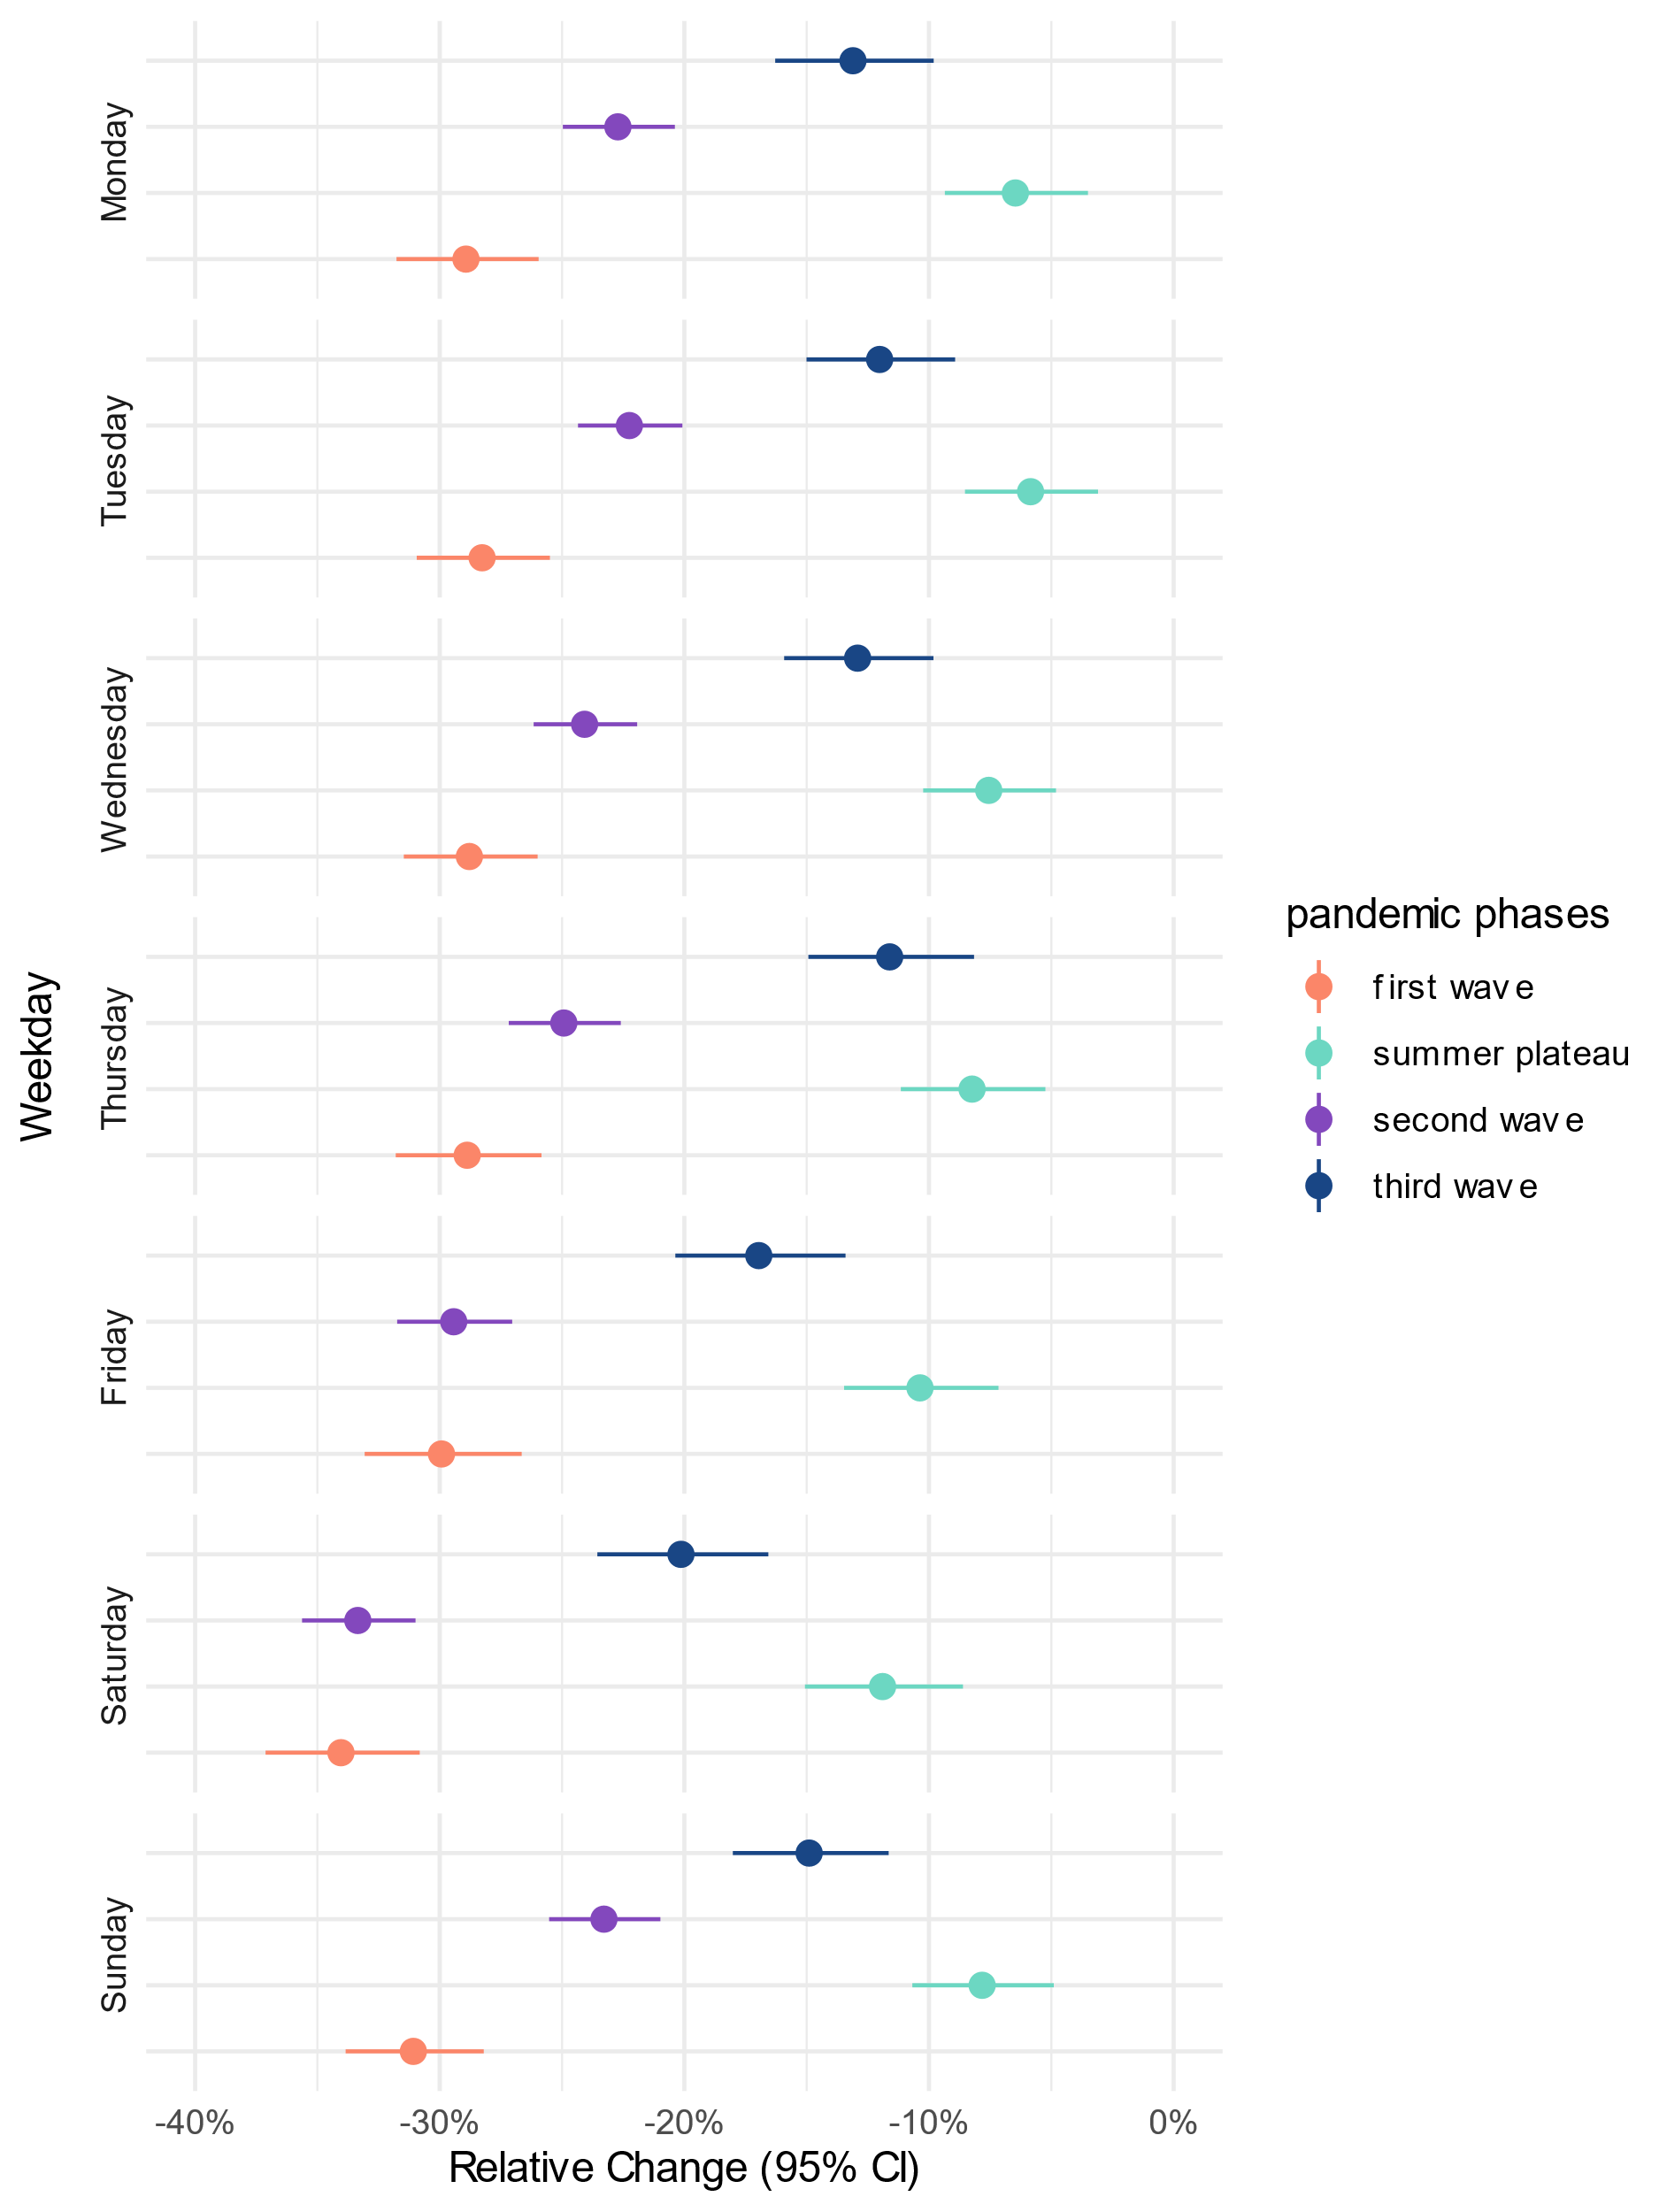
Figure 5 - Relative change in % and 95% confidence interval for all emergency department consultations by weekday, comparing every pandemic phase with the pre-pandemic reference period
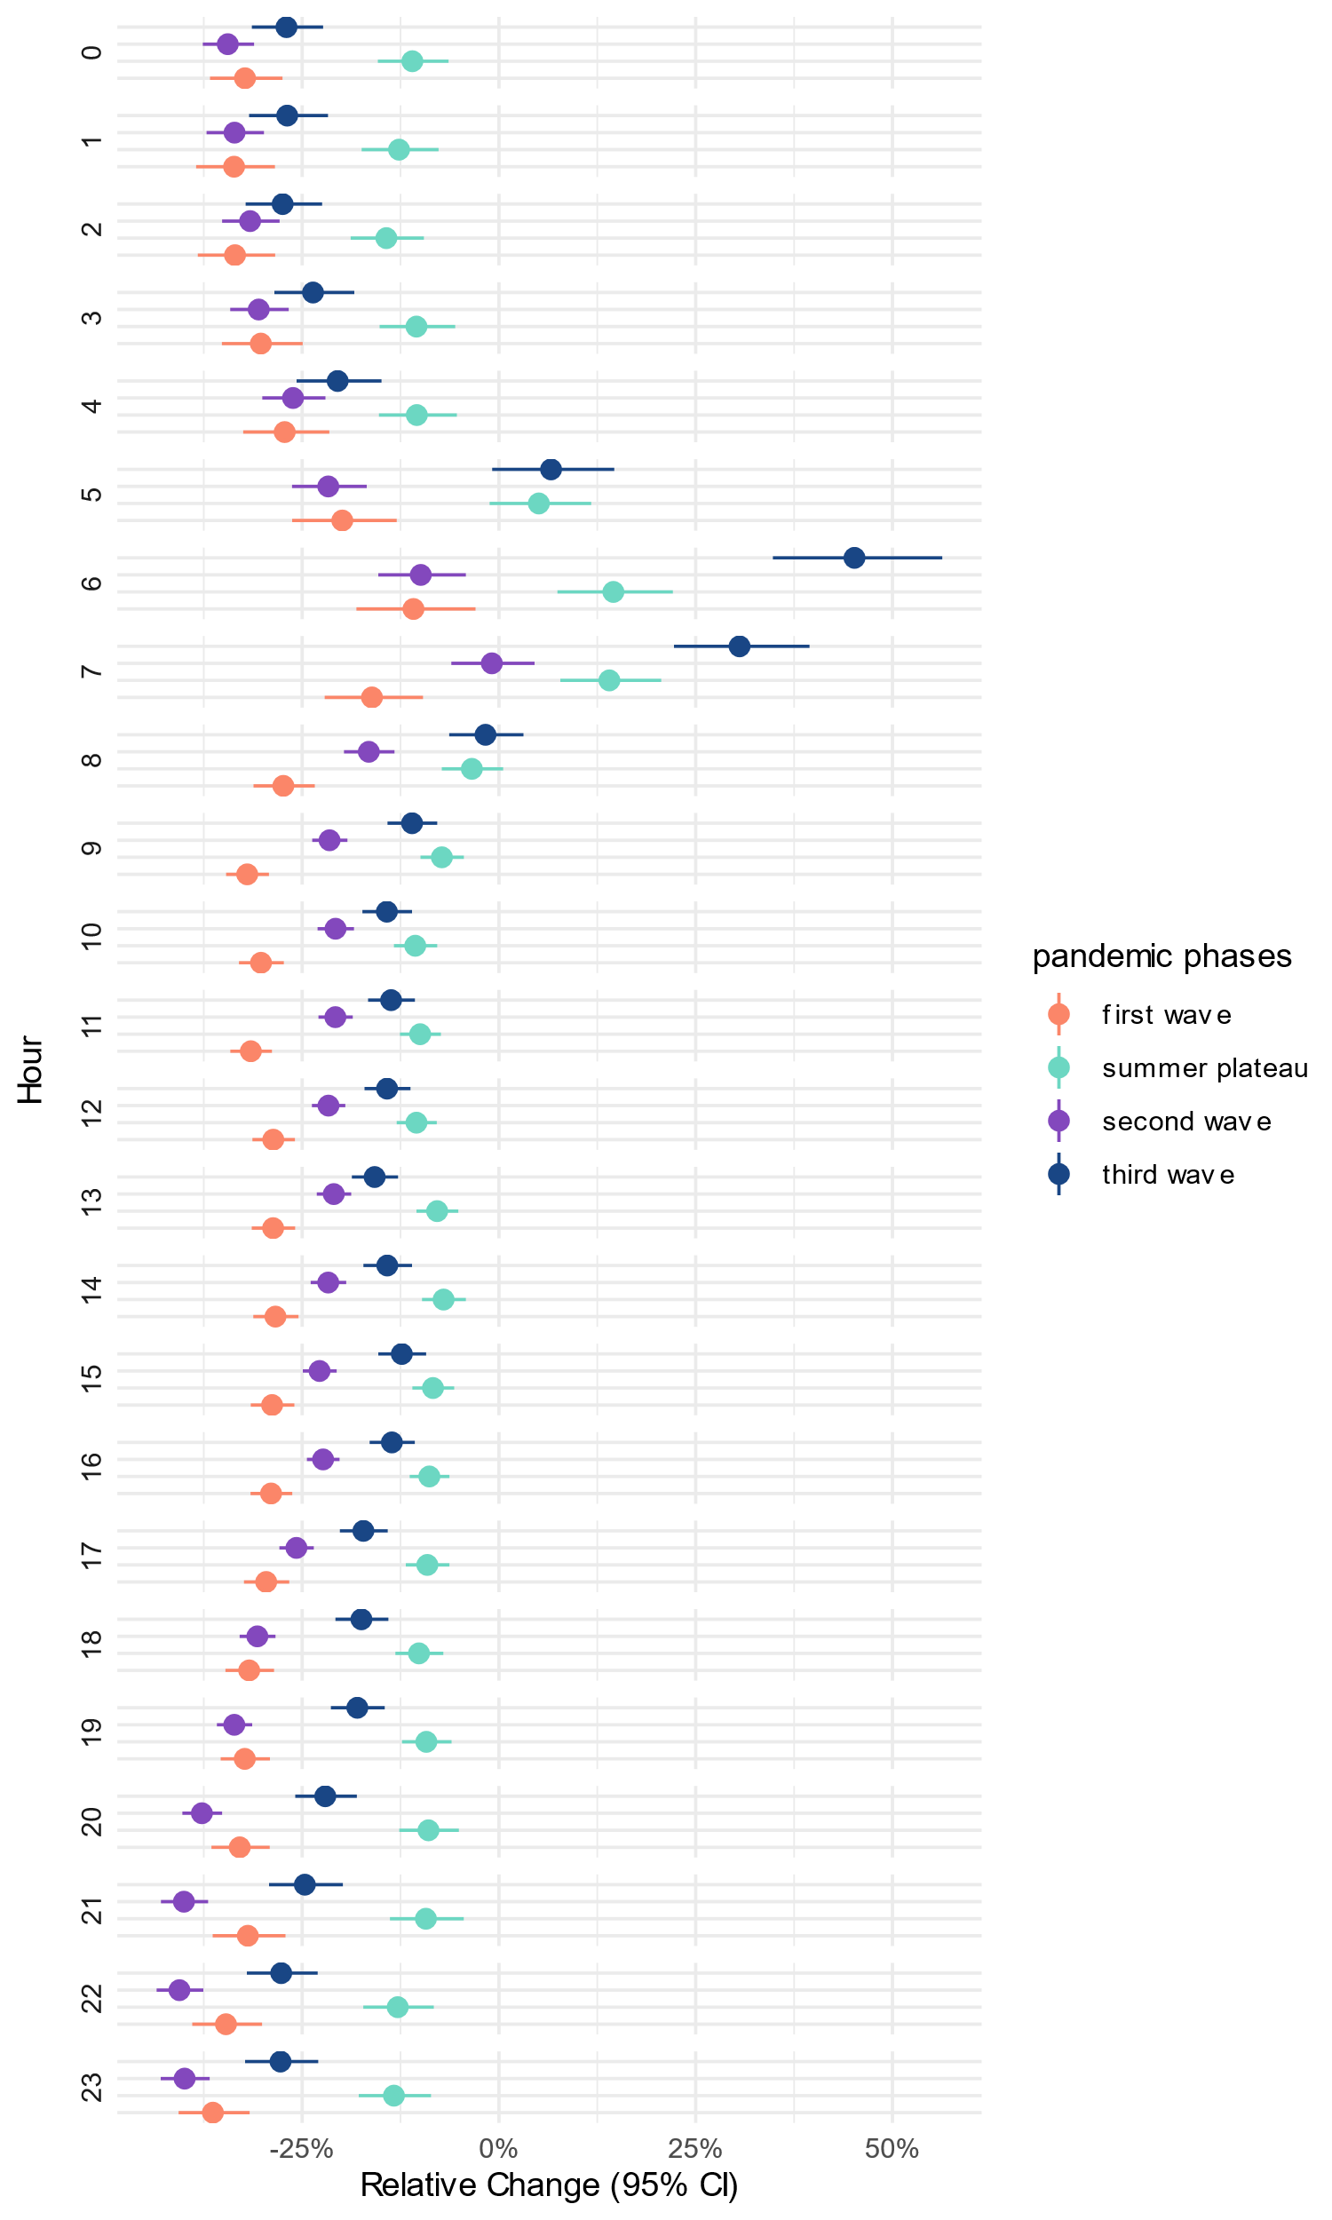
Figure 6 - Relative change in % and 95% confidence interval for all emergency department consultations by hour of day, comparing every pandemic phase with the pre-pandemic reference period

Supplemental Tables
Table 1 - Relative percentage change, 95% confidence interval and p-value for the pre-pandemic trend (i.e. linear time from start of study period until start of first interruption)
 | % Change | 2.5% | 97.5%
All consultations
 | 0.03 | 0.01 | 0.05
Age group
0-19 | 0.04 | 0.03 | 0.04
20-39 | -0.01 | -0.01 | -0.00
40-59 | -0.00 | -0.00 | 0.00
60-79 | 0.01 | 0.00 | 0.01
80+ | -0.00 | -0.01 | -0.00
Acuity level
1 (immediate) | -0.01 | -0.02 | -0.00
2 (very urgent) | 0.00 | -0.00 | 0.01
3 (urgent) | 0.01 | 0.01 | 0.01
4 (standard) | 0.00 | -0.00 | 0.01
5 (non urgent) | 0.02 | 0.01 | 0.02
Missing | -0.01 | -0.02 | -0.01
Weekday
Monday | 0.01 | 0.00 | 0.01
Tuesday | 0.01 | 0.00 | 0.01
Wednesday | 0.01 | 0.00 | 0.01
Thursday | 0.01 | 0.00 | 0.01
Friday | -0.00 | -0.00 | 0.00
Saturday | -0.00 | -0.00 | 0.00
Sunday | 0.01 | 0.00 | 0.01
Hour
0 | 0.00 | 0.00 | 0.00
1 | 0.00 | 0.00 | 0.01
2 | 0.00 | 0.00 | 0.00
3 | 0.00 | 0.00 | 0.00
4 | 0.00 | 0.00 | 0.01
5 | 0.00 | 0.00 | 0.01
6 | 0.01 | 0.00 | 0.01
7 | 0.01 | 0.01 | 0.01
8 | 0.00 | 0.00 | 0.00
9 | 0.00 | 0.00 | 0.00
10 | 0.00 | 0.00 | 0.00
11 | 0.00 | 0.00 | 0.00
12 | 0.00 | 0.00 | 0.00
13 | 0.00 | 0.00 | 0.00
14 | 0.00 | 0.00 | 0.00
15 | 0.00 | 0.00 | 0.00
16 | 0.00 | 0.00 | 0.00
17 | 0.00 | -0.00 | 0.00
18 | -0.00 | -0.00 | 0.00
19 | -0.00 | -0.00 | 0.00
20 | -0.00 | -0.00 | 0.00
21 | -0.00 | -0.00 | 0.00
22 | -0.00 | -0.00 | 0.00
23 | 0.00 | -0.00 | 0.00

Table 2 - Absolute and relative number of all emergency department consultations, consultations by age group, acuity level, weekday, and hour of day, stratified by pandemic phases
 | N (%)
 | Pre-Pandemic | Wave 1 | Summerbreak | Wave 2 | Wave 3
Weeks per phase | 156 | 19 | 11 | 22 | 15
Ø attendances per week | 14,935.53 | 13,586.26 | 10,783.55 | 11,271.64 | 12,573.07
All attendances
 | 2,329,943 (100%) | 258,139 (100%) | 118,619 (100%) | 247,976 (100%) | 188,596 (100%)
Age group
0-19 | 432,090 (18.5%) | 47,879 (18.5%) | 20,420 (17.2%) | 41,000 (16.5%) | 33,995 (18.0%)
20-39 | 530,985 (22.8%) | 56,769 (22.0%) | 25,904 (21.8%) | 52,101 (21.0%) | 40,562 (21.5%)
40-59 | 480,819 (20.6%) | 54,098 (21.0%) | 25,291 (21.3%) | 51,765 (20.9%) | 39,464 (20.9%)
60-79 | 514,119 (22.1%) | 59,083 (22.9%) | 27,812 (23.4%) | 59,570 (24.0%) | 44,104 (23.4%)
80+ | 371,930 (16.0%) | 40,310 (15.6%) | 19,192 (16.2%) | 43,540 (17.6%) | 30,471 (16.2%)
Severity level
1 (immediate) | 26,624 (1.1%) | 3,048 (1.2%) | 1,458 (1.2%) | 3,366 (1.4%) | 2,503 (1.3%)
2 (very urgent) | 267,807 (11.5%) | 30,095 (11.7%) | 14,551 (12.3%) | 32,975 (13.3%) | 23,437 (12.4%)
3 (urgent) | 866,551 (37.2%) | 100,352 (38.9%) | 46,105 (38.9%) | 100,713 (40.6%) | 76,055 (40.3%)
4 (standard) | 944,203 (40.5%) | 100,611 (39.0%) | 43,345 (36.5%) | 87,896 (35.4%) | 69,972 (37.1%)
5 (non urgent) | 92,667 (4.0%) | 10,937 (4.2%) | 4,617 (3.9%) | 9,439 (3.8%) | 7,199 (3.8%)
Missing | 132,091 (5.7%) | 13,096 (5.1%) | 8,543 (7.2%) | 13,587 (5.5%) | 9,430 (5.0%)
Weekday
Monday | 328,166 (14.1%) | 36,994 (14.3%) | 17,148 (14.5%) | 36,487 (14.7%) | 26,832 (14.2%)
Tuesday | 325,575 (14.0%) | 36,997 (14.3%) | 17,031 (14.4%) | 36,319 (14.6%) | 27,172 (14.4%)
Wednesday | 327,168 (14.0%) | 36,396 (14.1%) | 17,185 (14.5%) | 35,567 (14.3%) | 27,052 (14.3%)
Thursday | 342,753 (14.7%) | 38,335 (14.9%) | 17,466 (14.7%) | 36,771 (14.8%) | 28,619 (15.2%)
Friday | 328,159 (14.1%) | 35,700 (13.8%) | 16,521 (13.9%) | 32,941 (13.3%) | 25,815 (13.7%)
Saturday | 319,062 (13.7%) | 34,004 (13.2%) | 15,259 (12.9%) | 30,599 (12.3%) | 24,073 (12.8%)
Sunday | 359,060 (15.4%) | 39,713 (15.4%) | 18,009 (15.2%) | 39,292 (15.8%) | 29,033 (15.4%)
Hour
0 | 47,639 (2.0%) | 5,214 (2.0%) | 2,289 (1.9%) | 4,495 (1.8%) | 3,283 (1.7%)
1 | 37,369 (1.6%) | 3,977 (1.5%) | 1,849 (1.6%) | 3,553 (1.4%) | 2,589 (1.4%)
2 | 30,665 (1.3%) | 3,131 (1.2%) | 1,578 (1.3%) | 3,021 (1.2%) | 2,130 (1.1%)
3 | 26,565 (1.1%) | 2,908 (1.1%) | 1,338 (1.1%) | 2,638 (1.1%) | 1,913 (1.0%)
4 | 24,219 (1.0%) | 2,631 (1.0%) | 1,216 (1.0%) | 2,590 (1.0%) | 1,809 (1.0%)
5 | 24,323 (1.0%) | 3,028 (1.2%) | 1,324 (1.1%) | 2,783 (1.1%) | 2,416 (1.3%)
6 | 29,963 (1.3%) | 4,056 (1.6%) | 1,909 (1.6%) | 3,913 (1.6%) | 3,991 (2.1%)
7 | 50,278 (2.2%) | 6,892 (2.7%) | 3,035 (2.6%) | 7,050 (2.8%) | 6,208 (3.3%)
8 | 104,405 (4.5%) | 12,140 (4.7%) | 5,562 (4.7%) | 12,381 (5.0%) | 9,759 (5.2%)
9 | 149,740 (6.4%) | 16,597 (6.4%) | 7,632 (6.4%) | 16,832 (6.8%) | 12,641 (6.7%)
10 | 169,646 (7.3%) | 18,294 (7.1%) | 8,622 (7.3%) | 19,121 (7.7%) | 13,890 (7.4%)
11 | 167,706 (7.2%) | 18,124 (7.0%) | 8,412 (7.1%) | 18,976 (7.7%) | 13,760 (7.3%)
12 | 157,565 (6.8%) | 16,972 (6.6%) | 8,146 (6.9%) | 17,699 (7.1%) | 12,852 (6.8%)
13 | 148,070 (6.4%) | 16,459 (6.4%) | 7,643 (6.4%) | 16,702 (6.7%) | 11,890 (6.3%)
14 | 137,867 (5.9%) | 15,431 (6.0%) | 7,185 (6.1%) | 15,526 (6.3%) | 11,194 (5.9%)
15 | 131,759 (5.7%) | 14,500 (5.6%) | 6,751 (5.7%) | 14,616 (5.9%) | 10,909 (5.8%)
16 | 132,678 (5.7%) | 14,611 (5.7%) | 6,881 (5.8%) | 14,666 (5.9%) | 10,939 (5.8%)
17 | 134,792 (5.8%) | 14,843 (5.8%) | 6,896 (5.8%) | 14,308 (5.8%) | 10,643 (5.6%)
18 | 135,677 (5.8%) | 14,734 (5.7%) | 6,835 (5.8%) | 13,536 (5.5%) | 10,537 (5.6%)
19 | 126,143 (5.4%) | 13,883 (5.4%) | 6,221 (5.2%) | 11,961 (4.8%) | 9,789 (5.2%)
20 | 116,228 (5.0%) | 12,899 (5.0%) | 5,652 (4.8%) | 10,406 (4.2%) | 8,503 (4.5%)
21 | 99,800 (4.3%) | 11,172 (4.3%) | 4,834 (4.1%) | 8,612 (3.5%) | 6,983 (3.7%)
22 | 83,061 (3.6%) | 8,916 (3.5%) | 3,817 (3.2%) | 7,088 (2.9%) | 5,628 (3.0%)
23 | 63,785 (2.7%) | 6,727 (2.6%) | 2,992 (2.5%) | 5,503 (2.2%) | 4,340 (2.3%)

