Supplementary Information:

ToxTree: Descriptor-based machine learning models to predict hERG and Nav1.5 cardiotoxicity

Issar Arab*^{1,2}, Daniela Wonneberger^{2,3} and Khaled Barakat*³

¹Department of Informatics, Technical University of Munich, Garching, Bavaria 85748, Germany
²Department of Bioinformatics, Technical University of Munich, Garching, Bavaria 85748, Germany
³Faculty of Pharmacy and Pharmaceutical Sciences, University of Alberta, Edmonton, Alberta 8613, Canada
*Corresponding Authors: kbarakat@ualberta.ca and issar.arab@tum.de

hERG Data Collection and Curation
As a first step to further clean the data, an exact duplicate analysis of the SMILE strings showed that a subset of 23 unique molecular compounds had exact duplicate matches. All of these duplicates were in the training set as mentioned by Kumar et al. [6], used to train their published model. Most of the time, those duplicates had different potencies leading to the assignment of the same compound to different classes, which introduced noise to the data. For duplicates falling in the same class, we kept a unique SMILE string and reassigned the potency to the average among its duplicates. In case the potencies were too far, i.e. they map to different classes, we discarded the compound. This led to a reduced set of 9178 instances. Furthermore, and using the PubChem’s ID exchange service, we fed the entire cleaned set of SMILE strings to the server. The output results showed that a subset of 596 compounds contained duplicate entries mapping to the same CID. Out of the 277 compounds retrieved from PubChem and used for evaluation purposes by Kumar and his colleagues, 226 compounds were identified having duplicates in the training set. Second, out of the 222 compounds fetched from the literature and used as well in the test set, 7 were identified having duplicates in the training set. Third, 67 compounds in the training set had duplicate entries in the same set. In our second curation process, we removed all the duplicates from the training set (i.e. compounds retrieved from ChEMBL) and kept their corresponding unique ones in the test set. Concerning the duplicates within the training set, we followed the same manual curation procedure done in the first investigation step. The final dataset includes 8380 instances for development (${PIC}_{50}$ distribution is visualized Fig, S1.a), and 499 instances used for testing (${PIC}_{50}$ distribution is visualized Fig, S1.b) [68].
(a) (b)
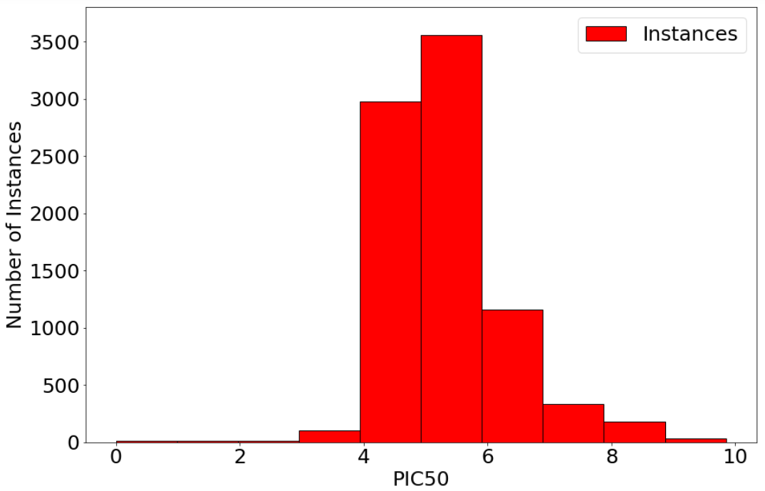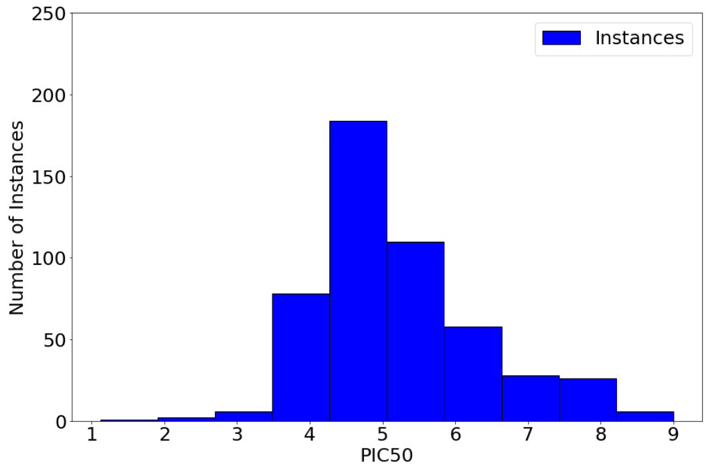
Figure S1: ${PIC}_{50}$ distribution of the (a) training and (b) test hERG liability dataset

Nav1.5 Data Collection and Curation
For redundancy reduction, we noticed that many redundant molecular compounds were reporting assays conducted on 2 cell types: Chinese Hamster Ovary (CHO) K1 and HEK293 cells. Since potency values on the two cells were too different from each other, we performed a count analysis of the most dominant cells used in the Nav1.5 inhibition assays to choose which one to consider. On the original retrieved dataset, the count represented 1078 for HEK293 and 181 for CHO. Hence, only assays on HEK293 cells were considered in case of redundancy. If we still have more than one potency value reported on the same compound, we discarded the compound from any further analysis if the values difference is greater by more than one order of magnitude. Otherwise, the mean was computed and assigned. At the end of the curation process, we ended up with 1463 unique records with reported ${IC}_{50}$ value through assays. Furthermore, we compared the final set we obtained with the curated ChEMBL v25 set based on 100% similarity of the compounds’ SMILE strings. We compiled 18 exact similar compounds in both sets. Since we believe that ChEMBL database is better maintained, we wanted to keep entries retrieved from this database and discard the others. Therefore, we removed those 18 duplicates from PubChem curated set and kept them in ChEMBL v25 one. The final sets represent 1646 (Fig. S2) and 1437 (Fig. S3) unique compounds for ChEMBL v25 and PubChem respectively. All ${IC}_{50}$ values were normalized to ${PIC}_{50}$ values.

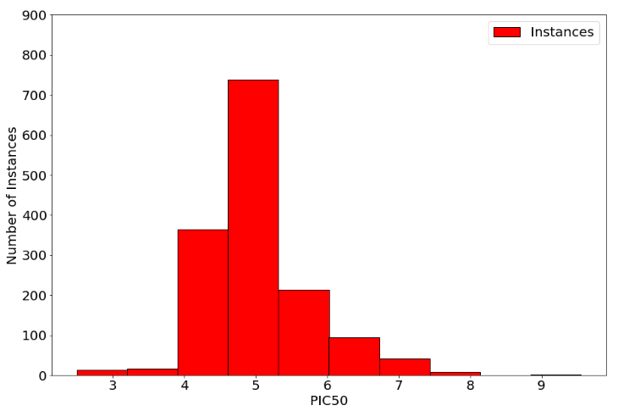Figure S2: ${PIC}_{50}$ distribution of ChEMBL v25 curated Nav1.5 liability dataset
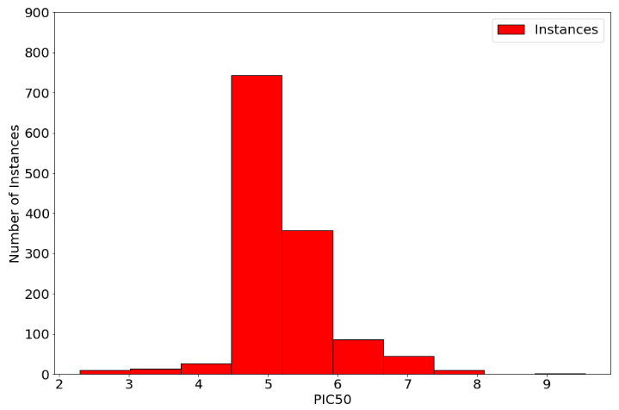Figure S3: ${PIC}_{50}$ distribution in PubChem curated Nav1.5 liability dataset
The final goal of this work was to be able to classify Nav1.5 blockers and non-blockers. For the blocking molecular compounds, we wanted to achieve a multiclass classification at three intensity levels: strong, moderate, and weak blockers at three potency thresholds, namely at a ${PIC}_{50}$ value of 6, 5, and 4.5 respectively. An analysis of the ChEMBL retrieved set conveyed that out of 1646 instances, only 86 compounds had ${PIC}_{50}<$ 4.5 (for non-blockers) and 170 compounds with ${PIC}_{50}≥$ 6 (for strong blockers). Whereas, the 1437 PubChem curated set comprised of 88 compounds with ${PIC}_{50}<$ 4.5 (for non-blockers) and 145 compounds with ${PIC}_{50}≥$ 6 (for strong blockers).
To augment our dataset, especially for the minority classes, we appended all the 88 non-blockers and the 145 strong blockers from PubChem to the cleaned ChEMBL set. Before moving to the model development phase, we fed the gathered set of SMILE strings to the PubChem’s ID exchange service, in order to check for potential duplicate compounds that have different SMILE representations, yet similar in structure. The redundancy reduction procedure reduced the gathered data by 156 instances, to leave us with a final high-quality set of 1723 compounds. We then applied a stratified split based on the 4 classes previously explained to select 10% (173 molecular compounds) for evaluation and 90% (1550 molecular compounds) for development. The final dataset includes 1550 instances for development (${PIC}_{50}$ distribution is visualized Fig, S4.a), and 173 instances used for testing (${PIC}_{50}$ distribution is visualized Fig, S4.b) [69].
(a) (b)
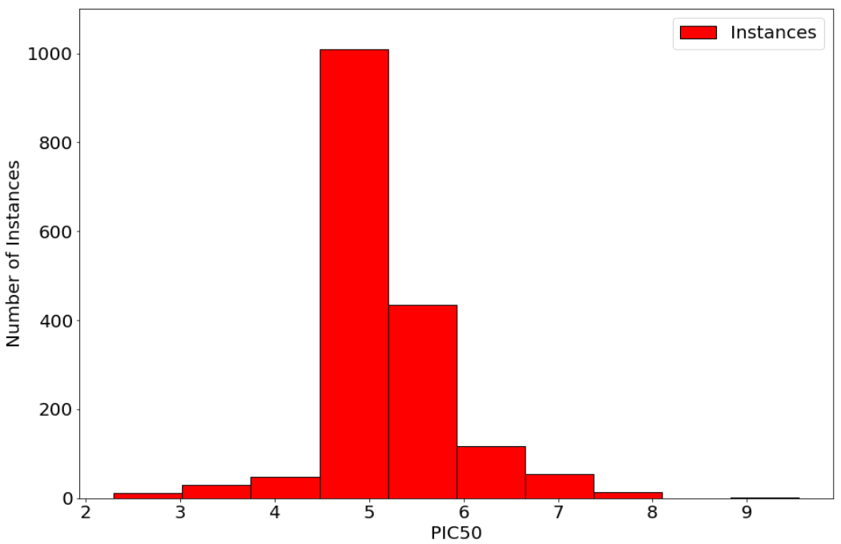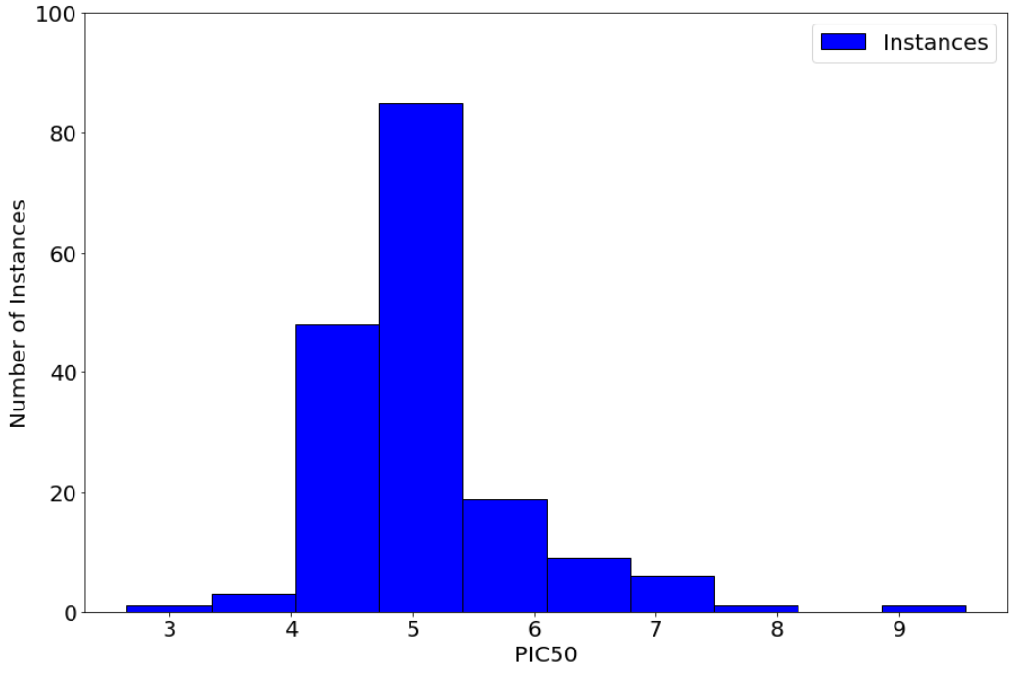
Figure S4: ${PIC}_{50}$ distribution of the (a) training and (b) test Nav1.5 liability dataset

Nav1.5 feature selection – percent missing value and information analysis
Through a single feature analysis of the data, we noticed that many columns had most (~71%) of their values as the same constant, namely a value of zero. Such features contain no information and will just add noise to our model. Therefore, features with a threshold of more than 1300 zero values were discarded from any further analysis, resulting in a reduction of 386 features to be removed. Additionally, we noticed that many features had Nan values, some features with more than 600 Nan values and many with more than 210 Nans. Assigning a value of zero or a mean value to those statistics will lead to biased models. A threshold of more than 200 Nan values per column was set to discard those features. This feature reduction procedure resulted in 551 features to be considered for model building.
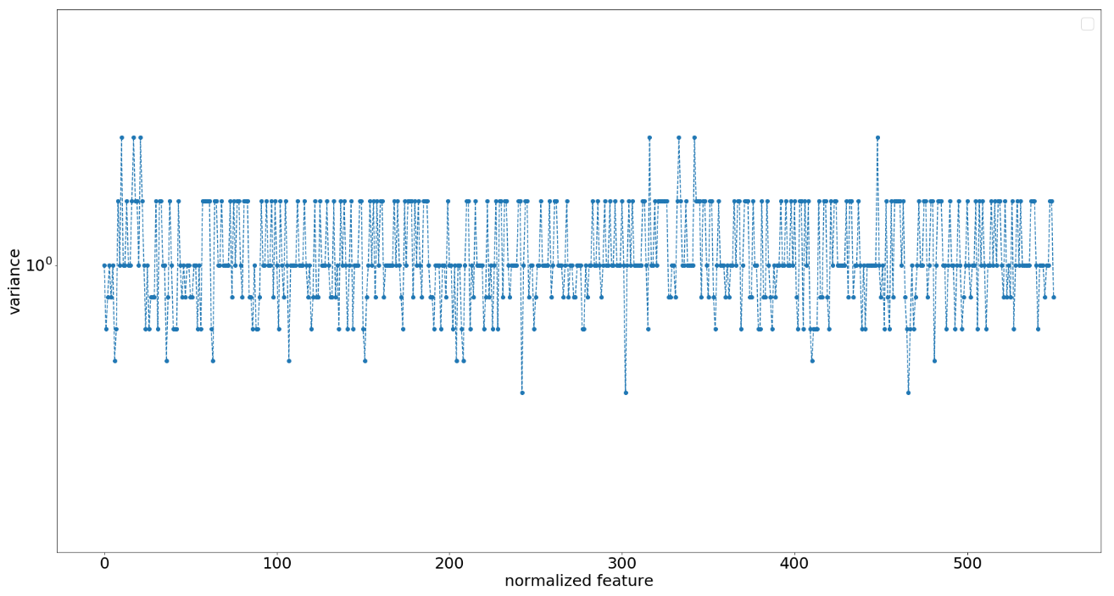
Figure S5: Dev-Set-Nav variance-based analysis of the normalized 551 features
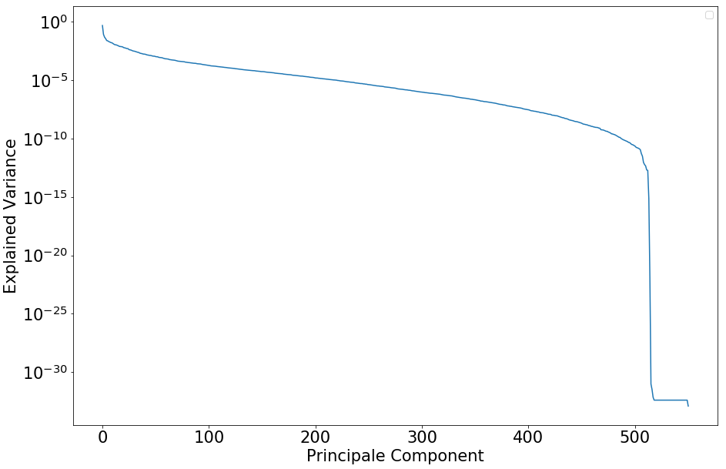
Figure S6: Principal component analysis of the 551 features of the entire normalized
Dev-Set-Nav where x-axis represents the principal components and the y-axis their corresponding variance

Table S1: Number of estimators’ selection based on the performance of each random forest with an ensemble of decision trees using 10-fold stratified cross-validation. The optimal number of estimators is highlighted in bold.
Number of estimators | Multiclass ${AC}_{cv}$ | Binary ${AC}_{cv}$ | $${F1}_{cv}$$
10 | 69.7 | 81.8 | 81.5
20 | 71.2 | 82.3 | 80.9
30 | 71.5 | 82.4 | 81
40 | 71.8 | 82.6 | 81
50 | 71.8 | 82.4 | 80.9
60 | 71.9 | 82.5 | 81
70 | 71.9 | 82.5 | 81
80 | 72.1 | 82.5 | 81
90 | 72.1 | 82.5 | 81
100 | 72.1 | 82.4 | 81

Table S2: Max depth selection based on the performance of each random forest with the same best ensemble of decision trees using 10-fold stratified cross-validation. The optimal max depth is highlighted in bold.
Model number | Number of estimators | Max depth | Fold multiclass-accuracy | Fold binary-accuracy | Fold F1-score
RF_1 | 30 | 23 | 70.4 | 82.7 | 81.1
RF_2 | 30 | 23 | 72.3 | 82.9 | 81.3
RF_3 | 30 | 24 | 70 | 82.7 | 81
RF_4 | 30 | 25 | 70.9 | 82.9 | 81.3
RF_5 | 30 | 26 | 71.9 | 82.4 | 80.9
RF_6 | 30 | 27 | 71.1 | 82.7 | 81.1
RF_7 | 30 | 22 | 71.9 | 82.1 | 80.7
RF_8 | 30 | 25 | 70.9 | 81.6 | 80.3
RF_9 | 30 | 24 | 70.6 | 81.3 | 80.2
RF_10 | 30 | 24 | 75.2 | 83.2 | 81.5

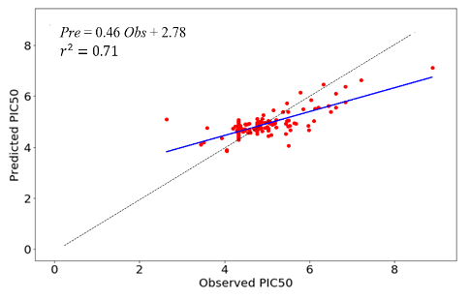
Figure S7: Regression scatter plot of the Predicted vs. Observed ${PIC}_{50}$ of our ToxTree-Nav1.5 Regressor
model on the evaluation dataset (EV-Set-Nav) of N=173 unique molecular compound

https://pubchem.ncbi.nlm.nih.gov/idexchange/idexchange.cgi

