Table 1 Cost and Its Contributing Factors of the Mental Health Episodes in the 3/2020-2/2021 Period
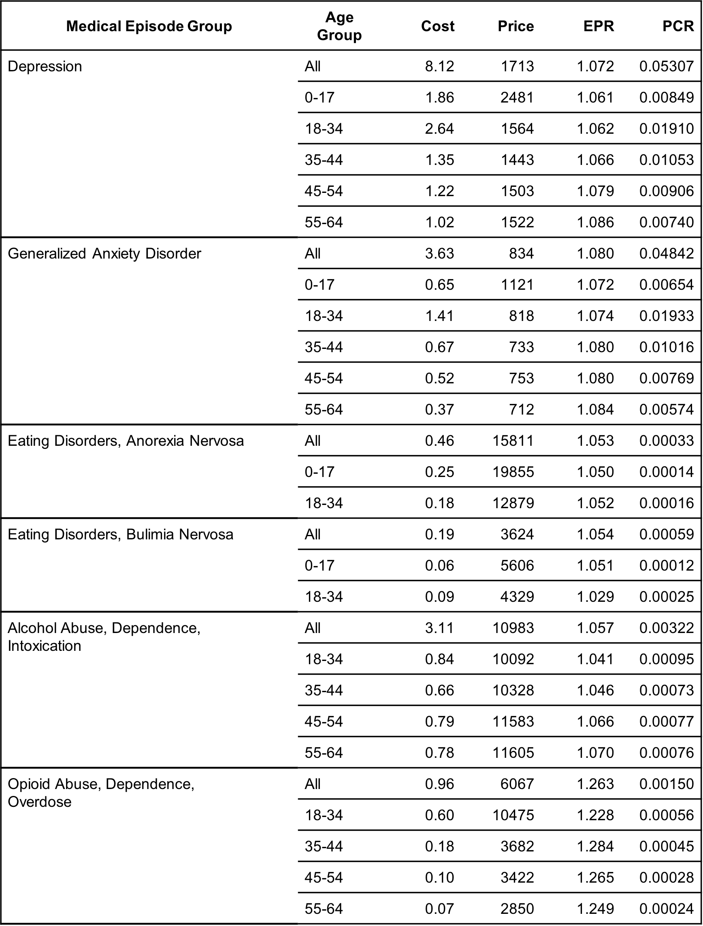
Cost: allowed amount per claimant (per month). Price: allowed amount per episode. EPR: number of episodes per patient. PCR: proportion of patients among claimants.

Table 2. Changes of the Mental Health Episodes in Twelve-Month Target Periods
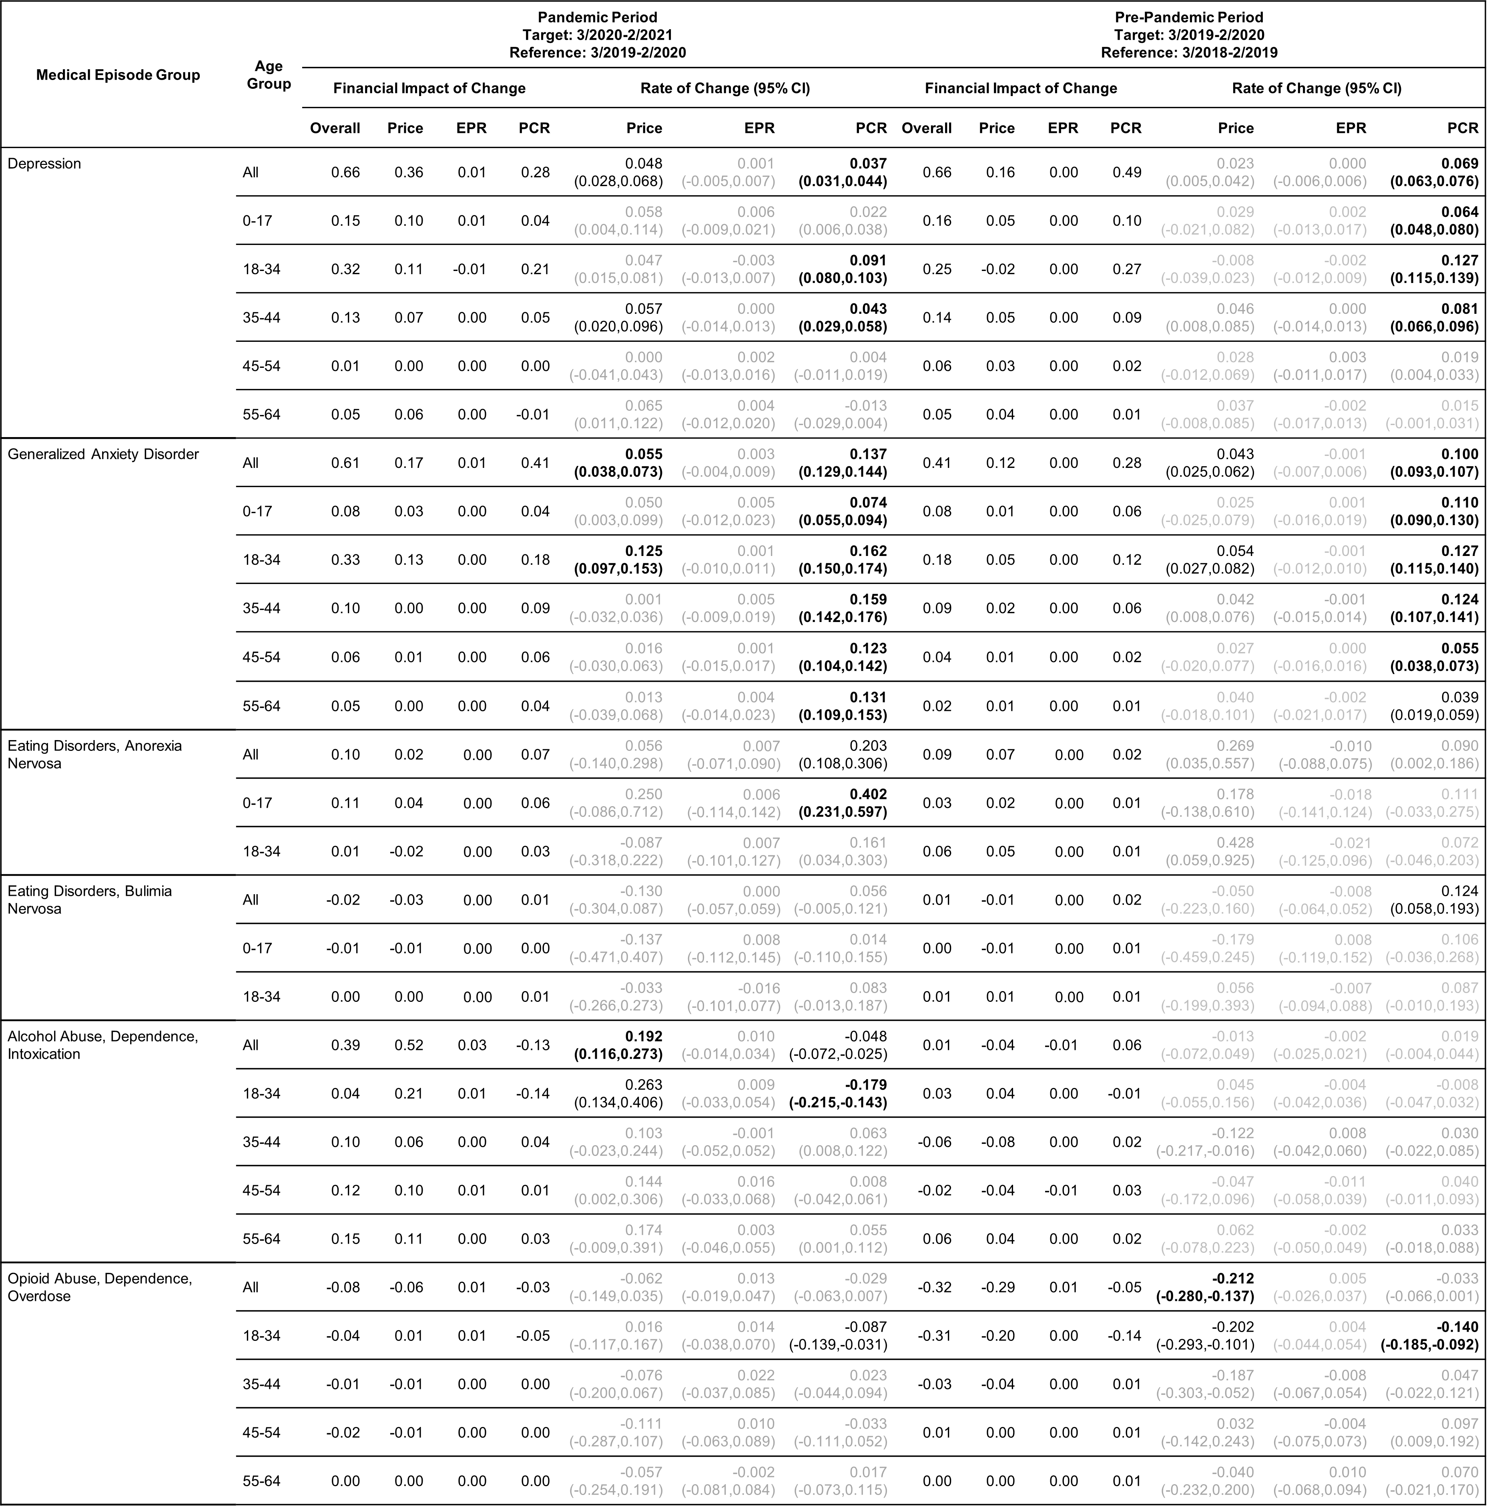Rate of change in Price, EPR, and PCR: boldface, strong statistical significance (absolute value of Z score greater than 5, or p-value < 5.7e-7); lightface, weak or no statistical significance (absolute value of Z score less than or equal to 3, or p-value > 0.0027).

Table 3. Summary of Changes Detected in the Twelve-Month Periods before and after the pandemic started (Table 2) for Patients in All Age Groups Combined
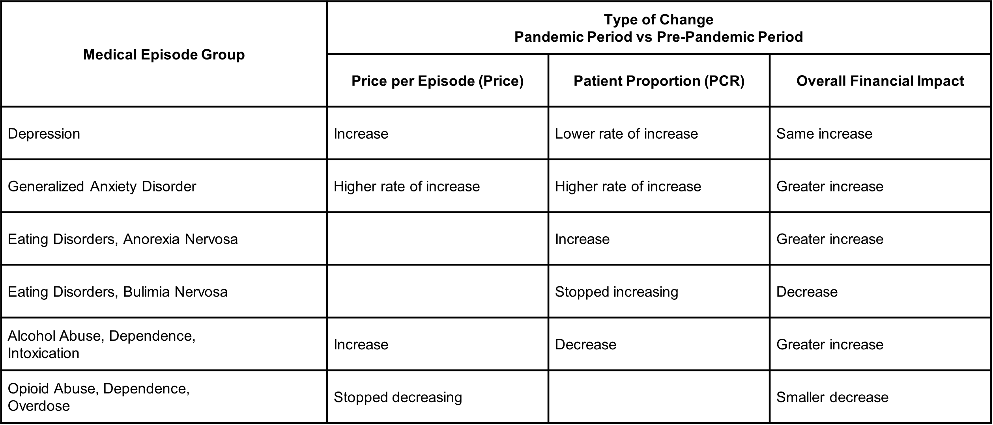
Table 4. Changes of the Mental Health Episodes in Three-Month Target Periods
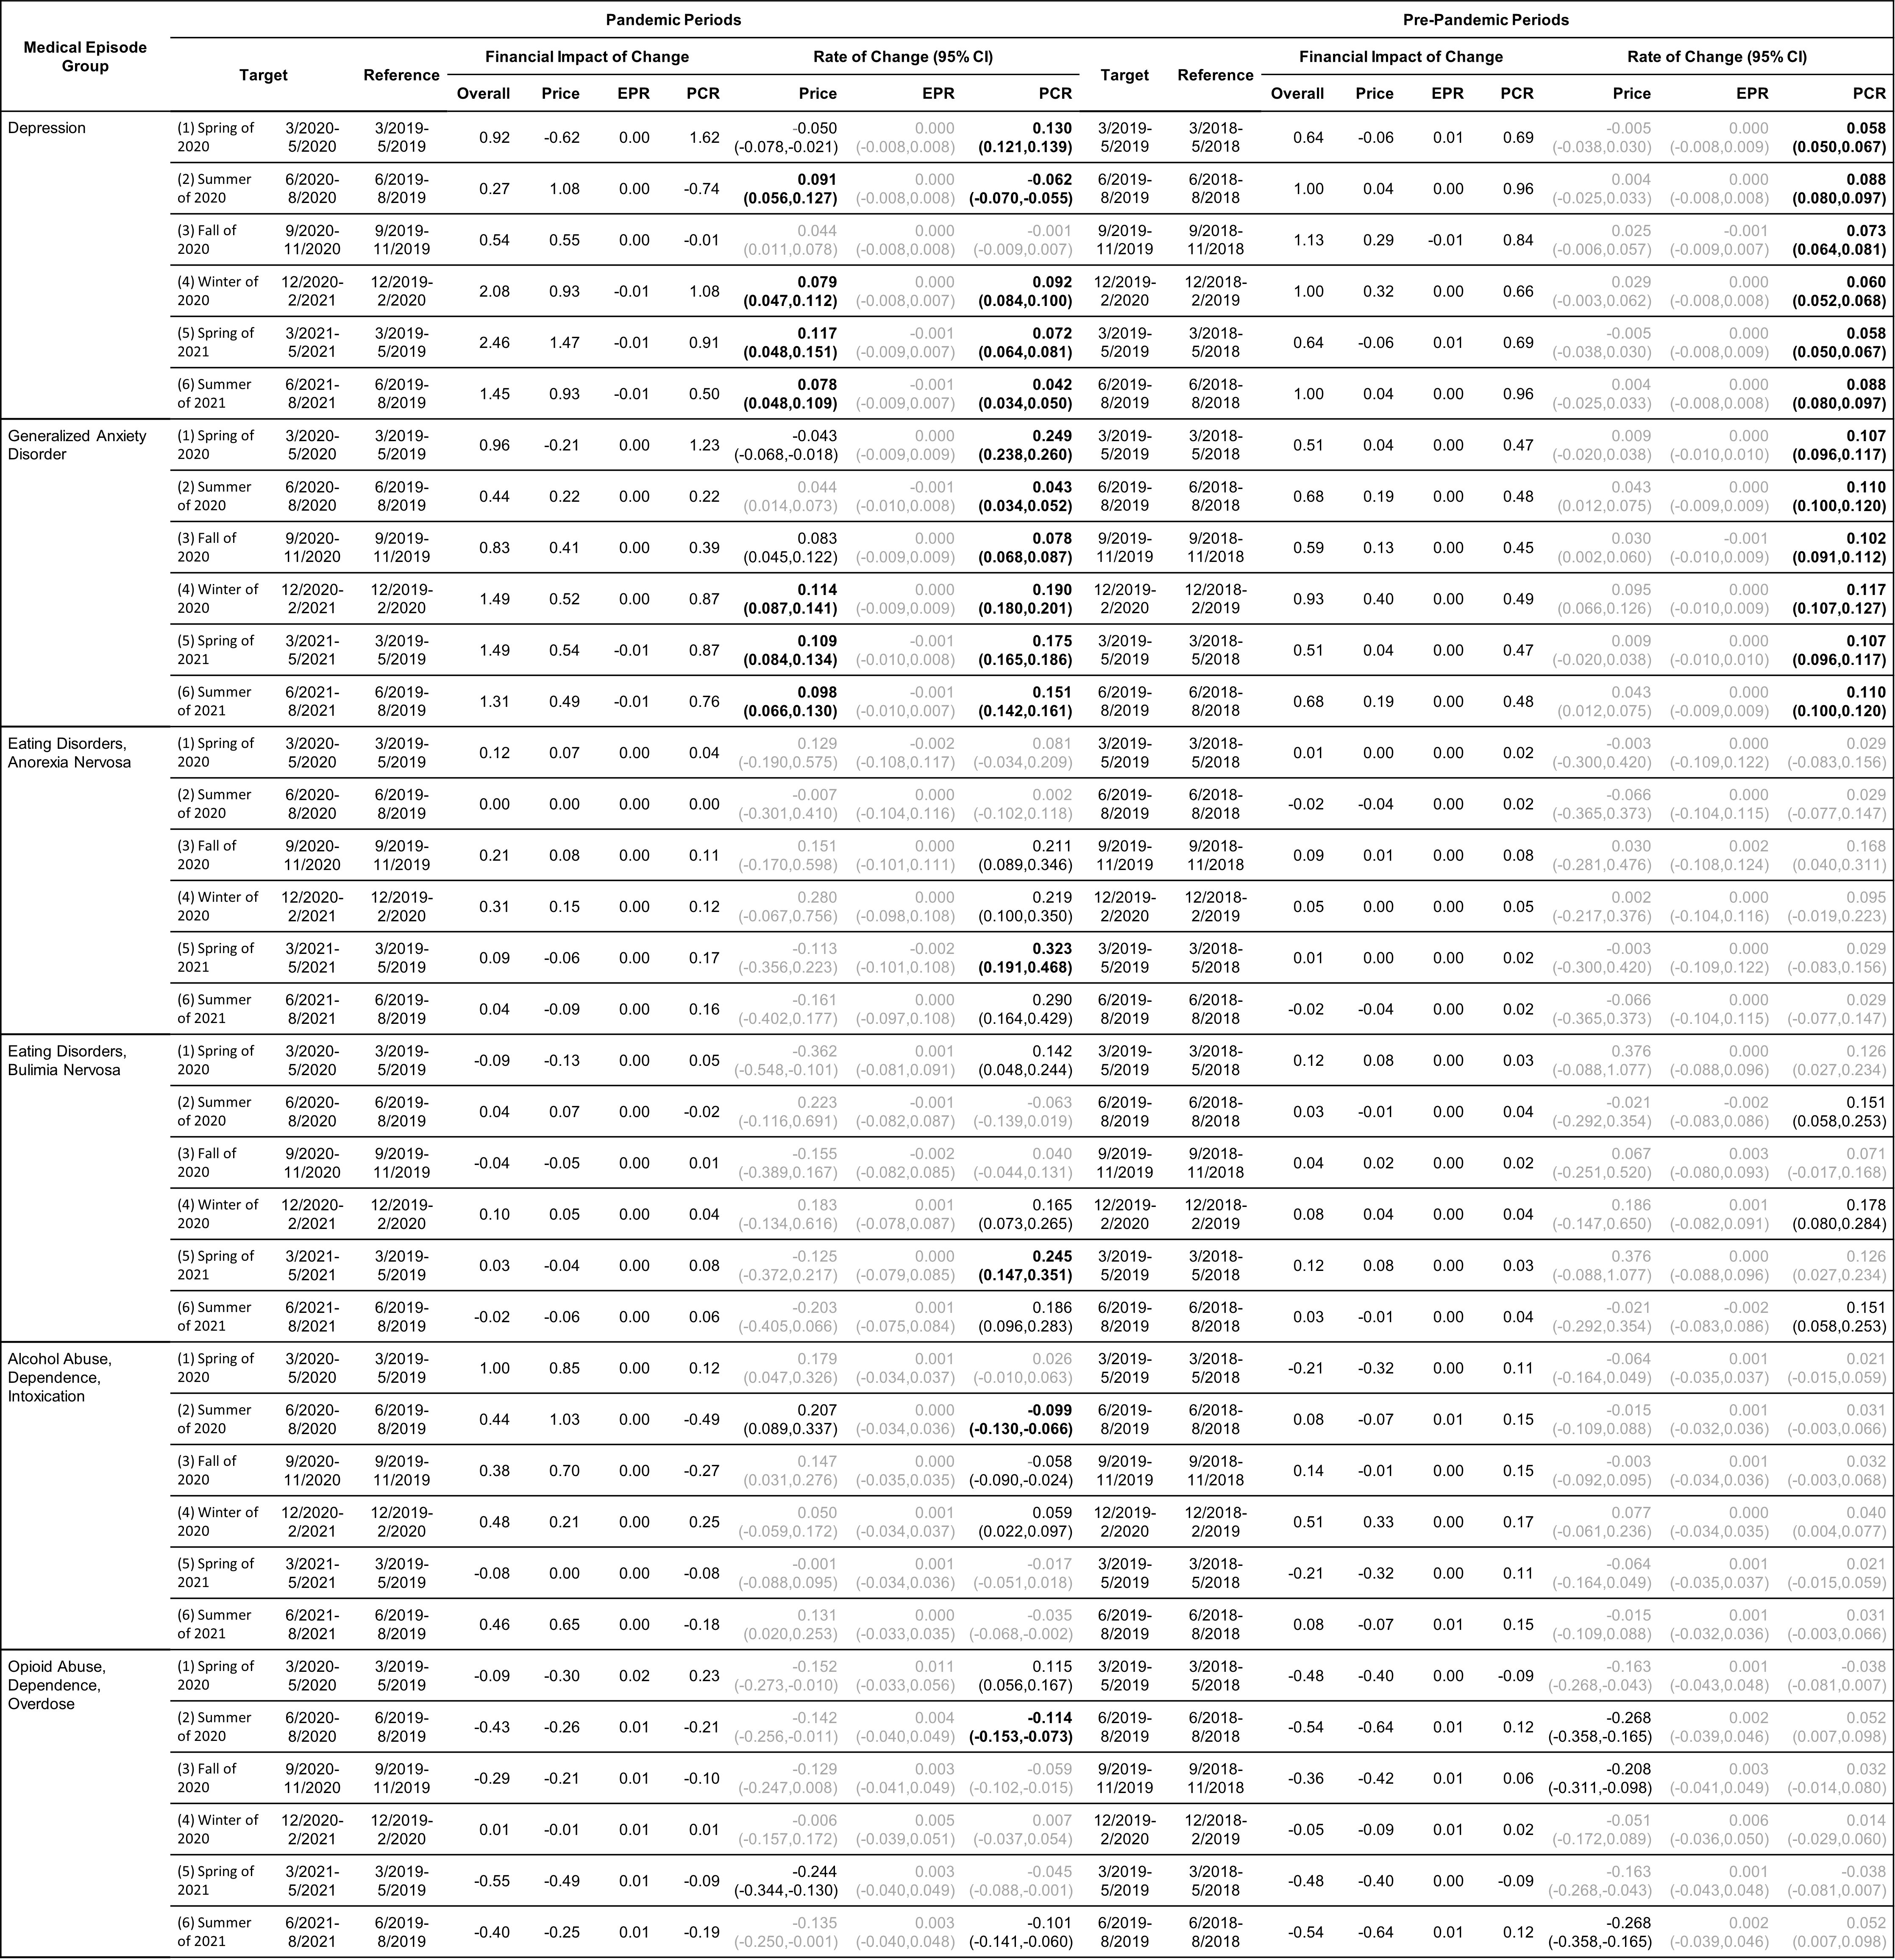Rate of change in Price, EPR, and PCR: boldface, strong statistical significance (absolute value of Z score greater than 5, or p-value < 5.7e-7); lightface, weak or no statistical significance (absolute value of Z score less than

