Table 1. Prioritized barriers and solutions proposed by Citizen Scientists during the Participatory mapping workshop
Barriers | Solutions proposed by Citizen Scientists | Pictures taken by Citizen Scientists
Danger and risk of personal injury from debris, broken walls, trash, damaged fans, damaged chairs and tables | - Clean and organize the school facilities, such as the classrooms, to increase safety  - Move debris that could be a tripping hazard, with students helping to organize and move the debris | 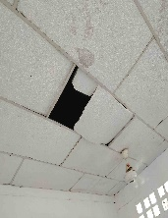  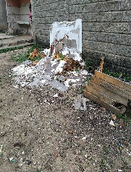
Insufficient or poorly maintained urinals | - Replace the boys’ bathroom urinals and repair the problem of stagnant water  - The students potentially contributing to this activity with their labor | 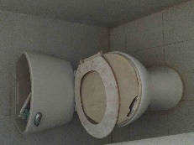
Poor condition of the eating area chairs and tables | - Provide feedback and guidance to students who damage chairs and tables during fights | 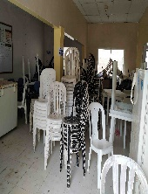
Low-rise wall, which can lead to falls and injury | - Raise the wall to prevent students from climbing on or over them  - Have more guards in the area so that students do not try to leave the school grounds in that manner | 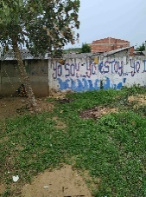

Table 2. Action plan agreed between citizen scientists and the school decision-makers during School Community Meeting 2.
Barriers | Agreements and actions plan
Diminished sense of belonging that leads to the destruction of school facilities | - Teachers committed to discussing with students the importance of taking care of things in the school environment  - The school will provide psychological support to students for anger management to reduce the destruction of school property  - The school will develop appropriate signage and messages promoting a greater sense of belonging  - The school will explore the creation of a system of fines to be used as a sanction to discourage destructive behavior and promote a sense of belonging
Danger and risk of personal injury on the school grounds due to debris, etc., and insufficient or poorly maintained urinals | - Cleaning days will be organized by the school staff, and students will be encouraged to participate  - During cleaning days, school staff will give talks to students to raise awareness about taking care of school grounds
The poor condition of the eating area chairs and tables | - To reduce the destruction of facilities, the school administrators committed to provide psychological support to students for anger management
Low-rise wall | - The school principal stated that the law does not allow increasing the height of the wall  - Teachers agreed to comply with the surveillance schedules that have been assigned to them  - Students will participate in surveillance activities at appropriate times during the day  - The school administration committed to explain the consequences of school non-attendance and dropout to the student body to diminish the frequency of students’ attempts to leave school by climbing over the wall
High traffic speed on the main street near the school | - The school will ask for support from the general community to reduce the speed of vehicles on this street  - The school will install caution signs to raise awareness among community members related to respecting speed regulations  - Students will draft a letter asking the traffic police for help
There is not support among people in the community to influence the decisions that affect the community: Communication of project findings and future meetings | - The school believes that students should show their findings to the whole school  - Citizen scientists also should present their findings to the greater community and the Santa Ana assembly  - Citizen scientists need to become leaders to bring change to the entire Santa Ana community  - The director of the Amor Por Barú Foundation will take these findings to other community stakeholders

Table 3. Verified actions taken as a result of plans agreed upon citizen scientists and school decision-makers.
Barriers | Actions taken
Diminished sense of belonging that leads to the destruction of school facilities | - The student council organized care groups at recess and in the afternoon to improve feelings of student belonging
Danger and risk of personal injury and Insufficient or poorly maintained urinals and bathrooms | - The students scheduled cleaning campaigns in the areas that generated problems  - An architect worked on solving the stagnant water issue  - The parking lot was organized to minimize the risk of personal injury  - Restroom damage was fixed and a new adult restroom was built
The poor condition of the eating area chairs and tables | - No action was reported
Low-rise wall | - No action was reported
High traffic speed on the main street near the school | - The police promised to assign a traffic policeman to provide education related to road behavior
There is not support among people in the community to influence the decisions that affect the community: Communication of project findings and future meetings | - The findings were presented to the Youth Social Forum. This is a school event where students present different situations and problems to the entire Santa Ana community
Additional actions/effects | - The students’ group for ecological expeditions was strengthened based on the findings. Students and teachers began to use aspects of the Our Voice methodology to collect information and present the findings of the expeditions  - The Our Voice methodology was brought to school courses as a learning methodology  - The students spoke with the group of local fishermen about the importance of the garden in the school as a facilitator of student well-being and got the most important hotel in the area to give them plants and fertilized soil for the garden  - Now there are more applications to the student council  - There are more collective actions and cooperation, as described above  - The activity "let's talk with my principal" was created to increase trust between students and school directors

