Fig. S1 Rarefaction curves (a) and Shannon curves (b) of all samples.
The rarefaction curves are plots of the number of OTUs as a function of the number of sequences. The Shannon curves reflect the microdiversity of the samples.

Fig. S2 Community bar plot of bacteria at the phylum level.

Fig. S3 Heatmap of the top 50 dominant bacteria at the genus level with respect to abundance. Cluster analysis was performed using Bray-Curtis distances and the average-linkage method. Each bar or column corresponds to a specimen. The data are calculated in terms of relative abundance, and the colours represent lg values.

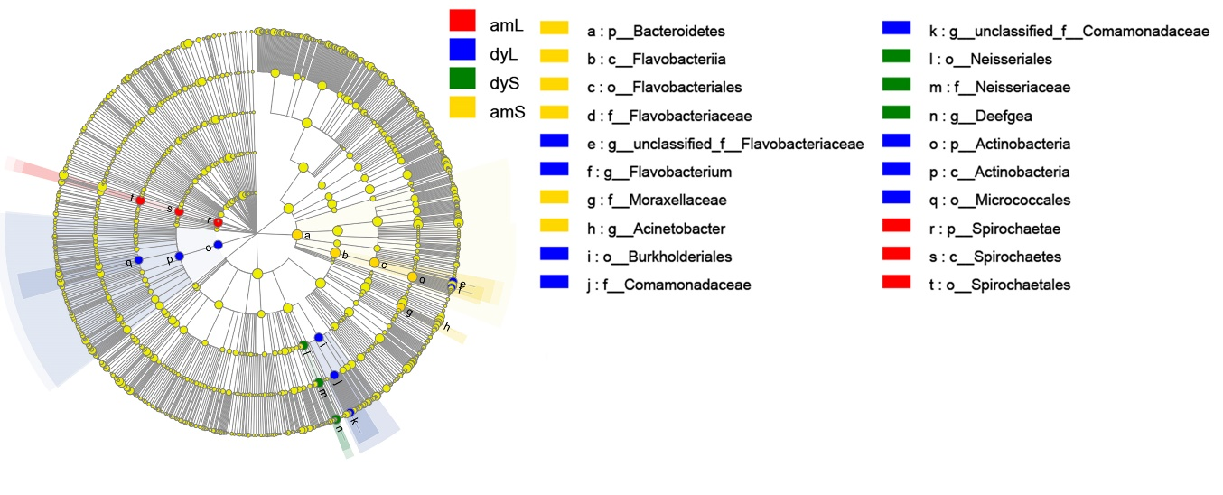
Fig. S4 Linear discriminant analysis (LDA) effect size (LEfSe) analysis identifying taxonomic differences in the gut microbiota of R. amurensis and R. dybowskii responding to the captive and wild environments.
Taxonomic differences in the gut microbiota of R. amurensis and R. dybowskii responding to the captive and wild environments (red indicates amL; yellow, amS; blue, dyL; and green, dyS). Each circle diameter is proportional to the taxon abundance. The strategy of the multiclass analysis is non-strict (at least one class differential). Circles represent taxonomic ranks from domain to genus from inside to out. Labels are shown at the class, order, family and genus levels. The scores are shown for all the taxa with an LDA score > 4.

