Table S1 The specific mutation for each osnia1 and osnia3 knockout mutant line
Lines | Original sequence | Mutated sequence
osnia1-1 | 579GGGCAACCGCCGCAAGGAGCA599 | 579GGGCG------GCAAGGAGCA599
osnia1-2 | 579GGGCAACCGCCGCAAGGAGCA599 | 579GGGCAACCGC-GCAAGGAGCA599
osnia1-3 | 579GGGCAACCGCCGCAAGGAGCA599 | 579GGGCAAC----GCAAGGAGCA599
osnia3-1 | 566CGCTGGCCTGCTCGGGGAACC586 | 566CGCTGGCCTGCTGCGGGGAACC587
osnia3-2 | 566CGCTGGCCTGCTCGGGGAACC586 | 566CGCTGGCCTGCTTCGGGGAACC587
osnia3-3 | 566CGCTGGCCTGCTCGGGGAACC586 | 566CGCTGGCCTGCTC---GAACC586

Table S2 Nutrient solution for culture with different nitrogen types
Type | Reagent | Preparation (g/10 L of distilled water)
Type | Reagent | NO₃⁻: NH₄⁺ = 100:0 | NO₃⁻: NH₄⁺ = 50:50 | NO₃⁻: NH₄⁺ = 0:100
Macroelement | KNO₃ | 697 | 0 | 0
Macroelement | NH₄NO₃ | 0 | 914 | 0
Macroelement | (NH₄)₂SO₄ | 0 | 0 | 1509
Macroelement | NaH₂PO₄∙2H₂O | 403 | 403 | 403
Macroelement | K₂SO₄ | 96 | 714 | 714
Macroelement | Ca(NO₃)₂∙4H₂O | 1884 | 0 | 0
Macroelement | CaCl₂ | 0 | 886 | 886
Macroelement | MgSO₄∙7H₂O | 3240 | 3240 | 3240
Microelement | MnCl₂∙4H₂O | 15 | 15 | 15
Microelement | (NH₄)₆∙MO₇O₂₄∙4H₂O | 0.74 | 0.74 | 0.74
Microelement | H₃BO₃ | 9.34 | 9.34 | 9.34
Microelement | ZnSO₄∙7H₂O | 0.35 | 0.35 | 0.35
Microelement | CuSO₄.5H₂O | 0.31 | 0.31 | 0.31
Microelement | FeCl₃.6H₂O | 77 | 77 | 77
Microelement | Citric acid (monohydrate) | 119 | 119 | 119
Note: The ratios of the different nitrogen types were adjusted according to the formula of the hydroponic nutrient solution provided by the International Rice Research Institute.

Table S3 Sequences of the primers used for qPCR
Primer name | Primer sequence (5′–3′) | Gene
AtNia1-DNA-F | TGTGACATGAGTCCTGACATGC | AtNia1
AtNia1-DNA-R | TCATCTCTGTAACGCCCCCTA | AtNia1
AtNia2-DNA-F | ACGTGTGATTCGGCACGATA | AtNia2
AtNia2-DNA-R | AACGCAGAAAATTCAATGTACGA | AtNia2
OsNia1-DNA-F | ACGCTAGAACCGAGCACTA | OsNia1
OsNia1-DNA-R | CGGTGCGTATAATTTAGTAGTAGGA | OsNia1
OsNia2-DNA-F | GGAGTGAGTTTTGCCGACAG | OsNia2
OsNia2-DNA-R | CTACTACGACCTCGCGTTCC | OsNia2
OsNia3-DNA-F | TGAACGCAGAACCGAACAC | OsNia3
OsNia3-DNA-R | TCCACGGGCCACCATAC | OsNia3
OsNia1-F | TTTGGCGCCGCCGCCGTGTCC | OsNia1
OsNia1-R | CGTGTGATGCTGGTGCCGTAC | OsNia1
OsNia2-F | CTTGGTGGTACAAGCCGGAG | OsNia2
OsNia2-R | AGCACCAGCACCAGTACTTT | OsNia2
OsNia3-F | TGGGGCGCCGCTGGCGTGTCT | OsNia3
OsNia3-R | CGTGTGATGCTGGTGCCGTAC | OsNia3
OsNiR-F | GACATCGACGTGCGTCTCA | OsNiR
OsNiR-R | CTTGCCGTACGCCTCGATCA | OsNiR
OsNRT2.3a-F | CGCTGCTGCCGCTCATCCG | OsNRT2.3a
OsNRT2.3a-R | CCGTGCCCATGGCCAGAC | OsNRT2.3a
OsNRT2.1-F1 | CACGGTGCAAGTCTCAAG | OsNRT2.1
OsNRT2.1-R1 | GGTATAAATGCCTCTCCC | OsNRT2.1
OsGS-F | AAATGGAGAGGTCATGCCTGG | OsGS
OsGS-R | GCAAGTCATGGCGAAGTGAT | OsGS
OsFDGS-F | TGGTTGCAGCAAAGTACACG | OsFDGS
OsFDGS-F | GCTTTTGTGACAACACAGCT | OsFDGS
OsAMT1.1-F | GGTTTCTCTCCCTCTCCGAT | OsAMT1.1
OsAMT1.1-R | CCACCTTCACACCACACATT | OsAMT1.1
OsNGS1-F | CTGACATGATTTCTGTGGACG | OsNGS1
OsNGS1-R | ACGAGAAGGCTGTTCCCCTC | OsNGS1
OsNGS2-F | ACTCTGCGTGGCATGCTGAA | OsNGS2
OsNGS2-R | ATACGGCAAGGTTGTTCCCC | OsNGS2
OsRFT1-F | ACCCTAACCTTAGGGAGTATCTACAC | OsRFT1
OsRFT1-R | GCCTGCATGCATATACAGCTAGGCAG | OsRFT1
OsEhd1-F | GAGCAAGTTGCCAGTC | OsEhd1
OsEhd1-R | CATGCACTCTGAGCCA | OsEhd1
OsHd3a-F | AGCCCAAGTGACCCTAACCT | OsHd3a
OsHd3a-R | GTTGTAGAGCTCGGCGAAGT | OsHd3a
OsGhd7-F | ATATTGTGGGAGCACGTT | OsGhd7
OsGhd7-R | ATCTGAACCATTGTCCAAGC | OsGhd7
OsMADS51-F | GTTTGCTCTGCTCCTACTC | OsMADS51
OsMADS51-R | ACTCCTCCTCCAGCATTGAA | OsMADS51
OsGI-F | TGGAGAAAGGTTGTGGATGC | OsGI
OsGI-R | GATAGACGGCACTTCAGCAGAT | OsGI
OsHd1-F | AACCAAGATCGGCAGTATGG | OsHd1
OsHd1-R | GATTGATTGCTCCAGCAGGT | OsHd1
Ubiquitin1-F | AACCAGCTGAGGCCCAAGA | Ubiquitin1
Ubiquitin1-R | ACGATTGATTTAACCAGTCCATGA | Ubiquitin1

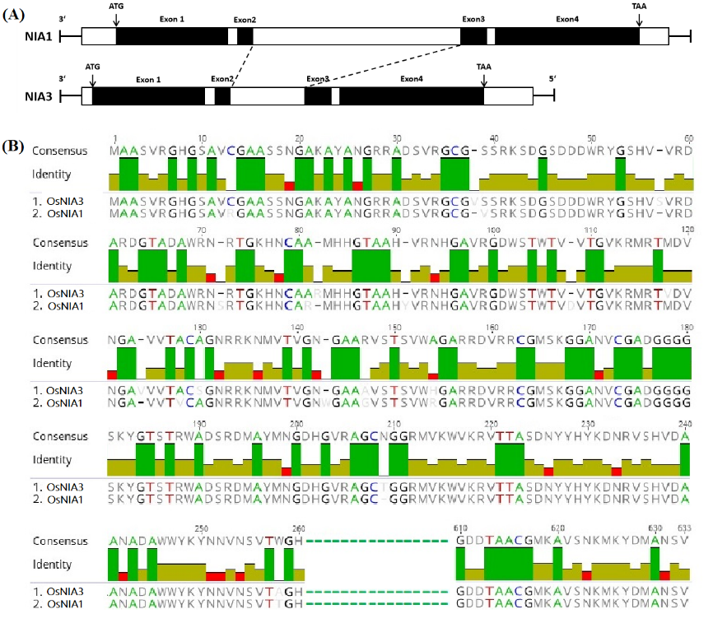
Figure S1. Comparison of OsNia1 and OsNia3 gene structures and protein sequences. (A) Comparison of OsNia1 and OsNia3 gene structures. The structural difference between the two genes is mainly due to the size of the second intron. (B) Comparison of OsNIA1 and OsNIA3 protein sequences using Geneious software (Biomatters Ltd, Auckland, New Zealand). The coding regions of the OsNia1 and OsNia3 genes in rice have 18 different amino acid residues.

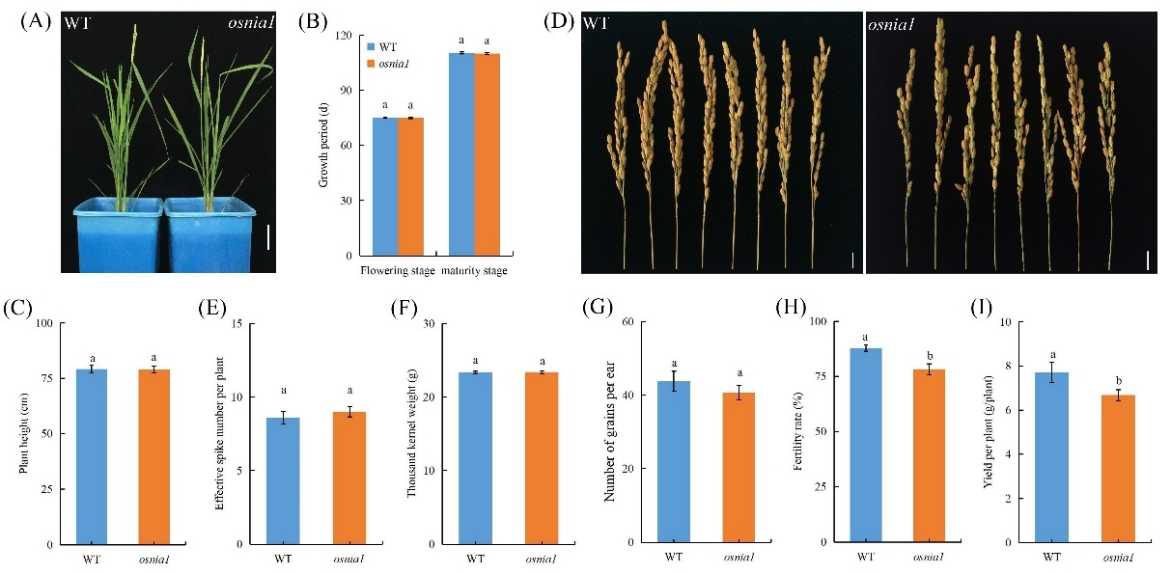
Figure S2. The loss of function of OsNia1 leads to low rice yield. (A, D) Gross morphological phenotypes of wild-type Kitaake (WT) and osnia1 mutant plants grown in the field. Scale bars = 10 cm (A) and 1 cm (D).
(B) Days to flowering in WT and osnia1 mutant plants. (C) Height of WT and osnia1 mutant plants. (E) Effective panicles per plant in WT and osnia1 mutant plants. (F) Thousand kernel weight in WT and osnia1 mutant plants. (G) The number of grains per ear in WT and osnia1 mutant plants. (H) The fertility rate of WT and osnia1 mutant plants. (I) Yield per plant in WT and osnia1 mutant plants. Five replicates were used for the determination of the growth period, plant height, effective panicles per plant, thousand kernel weight, number of grains per ear, fertility rate, and yield per plant. Different lowercase letters indicate significant differences between WT and osnia1 mutant plants as evaluated by LSD tests, P<0.05.
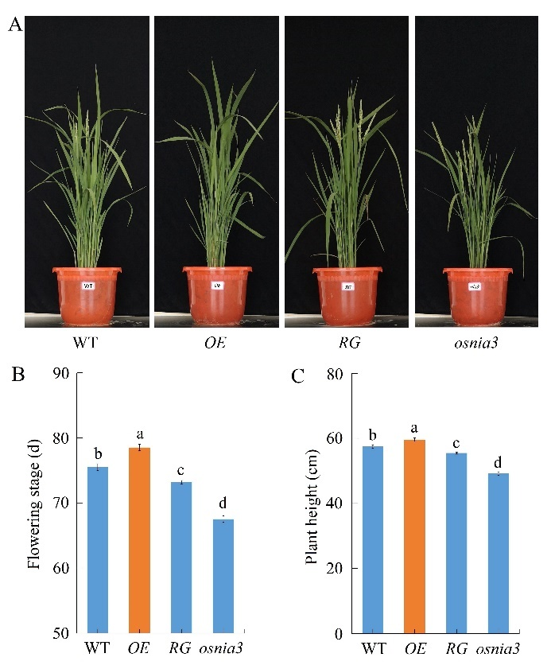
Figure S3. OsNia3 overexpression resulted in late flowering and an increase in the height of rice plants. (A) Growth of wild-type Kitaake (WT) plants, OsNia3-overexpressing plants (OE), plants with restored OsNia3 expression (RG), and OsNia3 mutant plants (osnia3) in the field at flowering. Scale bars = 20 cm. (B) Flowing stage of WT, OE, RG, and osnia3 mutant plants. (C) Height of WT, OE, RG, and osnia3 mutant plants. Values in (B) and (C) are presented as means ± SD (10 replicates for flowering stage and plant height). Different lowercase letters indicate significant differences between WT and osnia3 mutant plants as evaluated by LSD tests, P<0.05.
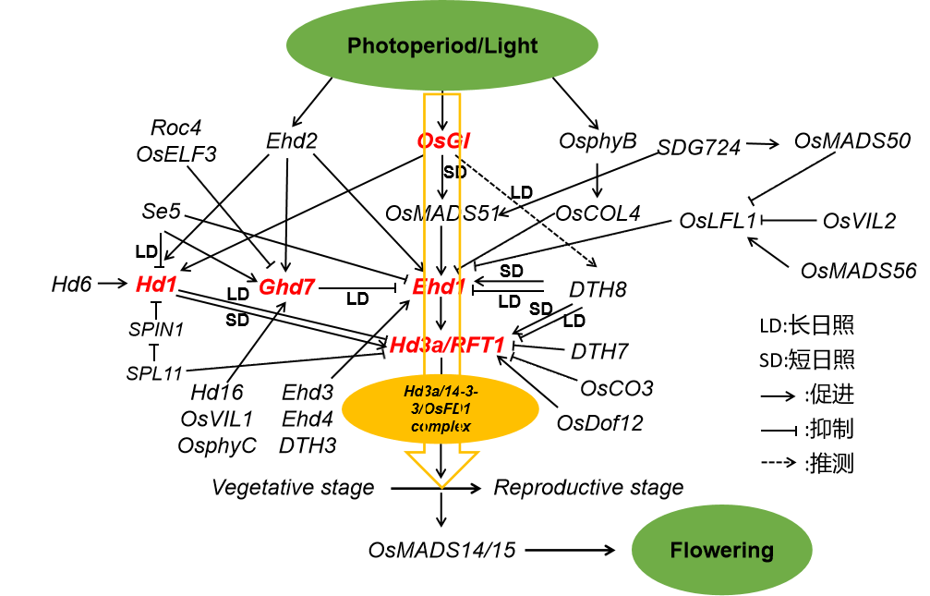
Figure S4. A photoperiod regulation network for heading (flowering) in rice.

