A Peroxidase-like Single-Atom Fe-N₅ Active Site for Effective Killing Human Lung Adenocarcinoma Cells

Liye Zhu^{[a]}, Hong Zhong ^{[b]}, Dan Du^{[b]}, Tao Li^{[d]}, Hoai Nguyen^{[e]}, Scott P. Beckman^{[b]}, Wentao Xu^{[a]}, Jin-Cheng Li ^{[c]*}, Nan Cheng ^{[a]*}, Yuehe Lin ^{[b]*}

*Corresponding author: Nan Cheng, goodluckchengnan@163.com; Yuehe Lin, yuehe.lin@wsu.edu; Jin-Cheng Li, jinchengli@kust.edu.cn

^{[a]} Beijing Laboratory for Food Quality and Safety, College of Food Science and Nutritional Engineering, China Agricultural University, Beijing 100083, China
^{[b]} School of Mechanical and Materials Engineering, Washington State University, Pullman, WA 99164, USA
^{[c]} Faculty of Chemical Engineering, Yunnan Provincial Key Laboratory of Energy Saving in Phosphorus Chemical Engineering and New Phosphorus Materials, Kunming University of Science and Technology, Kunming, 650500, China
^{[d]} Department of Chemistry and Biochemistry, Northern Illinois University, 1425 W. Lincoln Hwy., DeKalb, IL, 60115, USA & X-ray Science Division, Argonne National Laboratory, 9700 S. Cass Ave, Lemont, IL, 60439
^{[e]} Material Science Division, Argonne National Laboratory, 9700 S. Cass Ave, Lemont, IL, 60439

Supplementary Figures and Tables

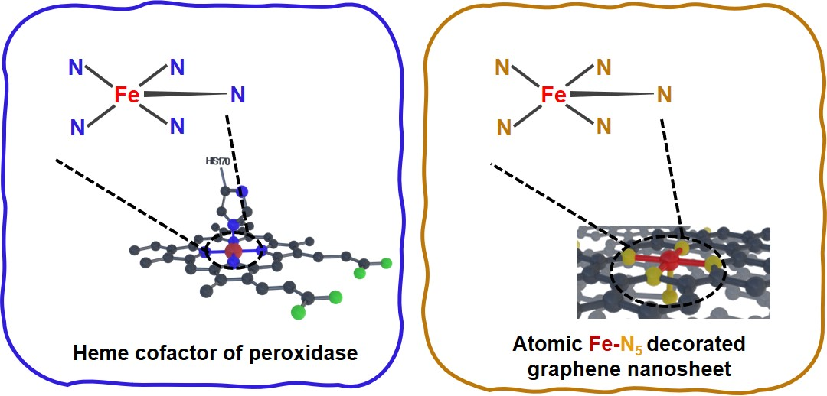
Figure S1. Structural similarity between heme cofactor of peroxidase and atomic Fe-N₅/GN SAC.

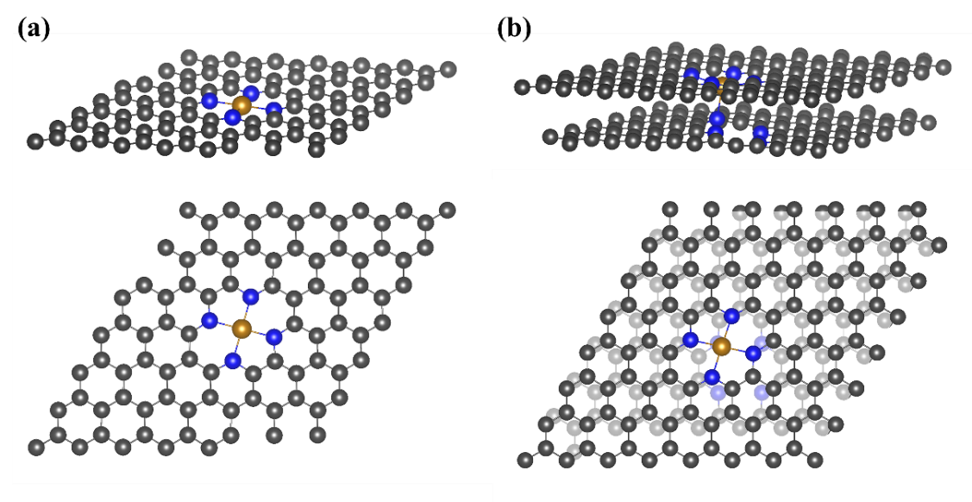
Figure S2. Computational models of Fe-N₄ (a) and Fe-N₅ (b) catalysts. Up: side view; Down: top view. The Gray, bule, and brown balls represent the C, N, and Fe atoms, respectively.

Figure S3. Models under acidic catalytic milieu. The Gray, bule, brown, red, and white balls represent the C, N, Fe, O, and H atoms, respectively.

Figure S4. Projected density of states of d, d_{z2} and d_{x2-y2} orbitals of Fe atom in Fe-N₅ and Fe-N4 models.

Table S1. EXAFS data fitting results of Fe-N₅/GN SAC.

Sample | Scatter | CN | R (Å) | σ² (Å²) | E₀ (eV) | R-Factor
Fe-N₅/GN SAC | Fe-N | 5.4 | 2.017 | 0.009 | 0.7 | 0.006

Table S2. Comparison of peroxidase-like specific activity (U/mg) of the Fe-N₅/SAC, FeN_{x}/SAC, conventional catalysts, and natural HRP

Enzyme | Peroxidase-like specific activity (U/mg) | Ref.
Fe-N₅/SAC | 71.99 | This work
Fe-N_{x}/SAC | 57.76 | Biosensors and Bioelectronics, 2019, 142: 111495.
Fe₃O₄ NPs | 5.143 | Nature protocols, 2018, 13(7): 1506.
Carbon NPs | 3.302 | Nature protocols, 2018, 13(7): 1506.
Au NPs | 1.633 | Nature protocols, 2018, 13(7): 1506.
Natural HRP | 297 | Biosensors and Bioelectronics, 2019, 142: 111495.

Table S3. Comparison of steady-state kinetic parameters of Fe-N₅/SAC and natural HRP.

Enzyme | [E]  (M) | K_{m}  (mM) | v_{max}  (μM min⁻¹) | k_{cat}  (min⁻¹) | k_{cat}/K_{m}  (M⁻¹ min⁻¹) | Ref.
Fe-N₅/SAC | 2.9×10⁻¹¹ | 1.83 | 88.88 | 3.06×10⁶ | 1.69×10⁹ | This work
Natural HRP | 7.6×10⁻¹¹ | 7.19 | 425.32 | 55.96×10⁶ | 7.78×10⁹ | Biosensors and Bioelectronics, 2019, 142: 111495.

Table S4. Primers of some apoptotic-related genes used in RT-PCR

mRNA |  | Sequence( 5’-3’) | Product (bp) | Tm (℃)
β-actin | F-TCGTGCGTGACATTAAGGAG |  | 178 | 56
β-actin | R-AGGAAGGAAGGCTGGAAGAG |  | 178 | 56
Cas-3 | F-CTCCTTCCATCAAATAGAAC |  | 131 | 50
Cas-3 | R-AATTAACAATCATTGCCTCT |  | 131 | 50
Cas-9 | F-TAGAAAACCTTACCCCAGT |  | 197 | 52
Cas-9 | R-ATTGTTGATAATGAGGCAGT |  | 197 | 52
Bcl-2 | F-TCCCTCGCTGCACAAATACTC |  | 97 | 59
Bcl-2 | R- TTCTGCCCCTGCCAAATCT |  | 97 | 59
Bax | F-AACTGGACAGTAACATGGA |  | 148 | 50
Bax | R-CTGGCAAAGTAGAAAAGG |  | 148 | 50

