Supplement 1: Systematic review protocol

Systematic Review: Workplace Wellness Programs for Working Mothers
1. Background
Generally, increasing in many chronic diseases in the workers' population going through with the increase in health care costs [1,2]. This affects the quality of life of workers and their families and undermines the sustainability and economic benefits of the enterprise [1].
It is important to carry out health protection intervention and health promotion in the workplace [1], including disease prevention programs, for all of the employees. Workplace wellness programs supported by policies can have some advantages, such as mitigating health risks and optimizing the employees’ quality of life [3,4] Primary prevention addresses health-related behaviours and risk factors through health counselling or health education classes, and secondary prevention improves disease management [2]. Companies can create an employee-centric culture of wellness; provides supportive environments where safety is assured and health can flourish; provides its employees with opportunities and access to engage the variety of worksite wellness programs [3,4].

2. Objectives and research question
The objective of this systematic review to uncover and synthesise the evidence of employers committed to delivering workplace wellness programs for working mothers.
Review question
This systematic review will be guided by the following research question: What kind of workplace wellness programs are run for working mothers and What is the output/impact of implementing workplace wellness programs for working mothers as reported in studies from 2017 to 2021?

3. Methods
We conduct a systematic review of each type of study. Four databases – AgeLine, Embase, Pubmed and Scopus – will be searched. Primary search terms are workplace AND wellness AND programs AND working AND mothers. The systematic review methodology will follow to the the 2020 Preferred Reporting Items for Systematic Reviews and Meta-Analyses (PRISMA) [11] and PICOS.
Problem/population | Lack of workplace wellness programs for working mothers/working mothers
Intervention | Workplace wellness programs consist of several activities: screening actions to monitor health risks (e.g., biometric measures, measurement of body weight); preventive interventions to address manifest health risks (e.g., weight-reduction counselling, smoking cessation, physical activity, access to fitness facilities, stress management, vaccination, wearing personal protective equipment, supportive social and physical environments); health promotion to improve healthy lifestyle (e.g., healthy food options, health education, workplace bullying, company policies); disease management (e.g., on-site medical clinics for employees and their families, health insurance)
Comparison | Standard intervention or no intervention
Outcomes | Working mothers well-being, four indicators were included: physical health, emotional health, engaging in healthy behaviours, and access to health-related conditions and services. (e.g., physical health, mental health, less stress, burnout, depression, smoking, alcohol consumption, mobbing/bullying, overweight/obesity), work-life balance, and job satisfaction.
Study design | Any kind
Kind of articles | Original articles
Year | 2017-2021
Language | English

3.1 Key terms:
The following important terms and concepts are relevant to this systematic literature review, and their definitions have been taken from these sources:
- Some of worksite wellness program strategies and components consist of access to local fitness facilities, policies that promote healthy life style, health education, a healthy work environment and a work environment free of recognized health and safety threats, health insurance coverage for appropriate preventive screenings with a means to identify and address new problems as they arise [3], and screening to identify health risks [1, 2].
- Working mothers as part of the workers’ community have some speciality in their health compared to men or women, not mothers. Working mothers as a group are vulnerable to various health problems. Health risks come out from both family factors and workplace factors and are sometimes related to each other. They have to face dual responsibilities at once, as housewives-raising children [5] and working women [6]. The amount of work that must be done both at home and work makes working mothers lack time, physical capacity, energy, endurance and psychological acceptance [6,7].

3.2 Search strategy and search terms
This literature search uses peer-reviewed literature found in the following four electronic bibliographic databases: AgeLine, Embase, Pubmed and Scopus.
The search structure will consist of the following:
- terms related to workplace OR Occupational;
- AND wellness;
- AND programs;
- AND working mothers
Search terms used in the main bibliographic databases are listed in Section 4.
The search is also supplemented by checking the reference list for the selected article ("Reference References") to find other related articles.

3.3 Inclusion and exclusion criteria
This review will use the following five key inclusion criteria:
- Types of studies: any kind of studies.
- Focus of studies: workplace wellness programs.
- Data type(s): Must include primary data.
- Intervention and publication dates: 2017 to 2021.
- Public language: English.
The following criteria are used to exclude studies from this review:
- Studies with “no workplace wellness programs” and “no working mothers”
- Review papers.

3.4 Study screening and data extraction
A systematic review of the literature will be conducted by seven reviewers (E, DH, GW, ST, F, M, R): 4 (E, DH, GW, ST) for conceptualization, 4 for data curation (E, M, F, R), 3 for quality assurance (E, M, F). Inconsistencies in the reviewers' selections will be resolved in an inter-reviewer meeting before the selected articles are retrieved.
The data is screened in five stages:
- Electronic database search using terms. The results are imported into the reference management software and duplicates are removed.
- We reviewed the titles and summaries and removed studies that did not meet the selection criteria.
- Manuscript review to remove studies that do not meet the selection criteria. Paper selection.
- Review of references for selected papers.
- Final paper selection, data extraction, and quality evaluation.
Data will be extracted and entered into a standardized Excel database according to the specific points mentioned below
- Citation - study “authors or agency”, year
- Study country
- Aim and purpose
- Discipline of the researcher(s): medical, nursing, physicians, undergraduate, post-graduate medical/nursing/allied healthcare students, primary care, psychologist
- Population type: working mothers
- Research design
- Theoretical framework/approach
- Measurement outcomes (e.g. enablers and barriers including potential including factors, delivery mechanisms, wider impacts)
- Data collection
- Data analysis
- Strengths of research from the literature
- Gap of research from the literature

3.5 Data categorisation and analysis
Organize data findings on key issues of evidence-based quantity and quality. To clarify the final result, the selected surveys are organized using Tables 1 and 2.
Table 1: Quality review criteria adapted from Kmet LM, Lee RC, Cook LS [13]
Criteria for quantitative studies | Criteria for qualitative studies
1. Question/objective sufficiently described?  2. Study design evident and appropriate?  3. Method of subject/comparison group selection or source of information/input variables described and appropriate?  4. Subject (and comparison group, if applicable) characteristics sufficiently described?  5. If the interventional and random allocation was possible, was it described?  6. If interventional and blinding of investigators was possible, was it reported?  7. If interventional and blinding of subjects as possible, was it reported?  8. Outcome and (if applicable) exposure measure(s) well defined and robust to measurement/misclassification bias? means of assessment reported?  9. Sample size appropriate?  10. Analytic methods described/justified and appropriate?  11. Some estimate of variance is reported for the main results?  12. Controlled for confounding?  13. Results reported in sufficient detail?  14. Conclusions supported by the results? | 1. Question/objective sufficiently described?  2. Study design evident and appropriate?  3. Context for the study clear?  4. Connection to a theoretical framework / wider body of knowledge?  5. Sampling strategy described, relevant and justified?  6. Data collection methods clearly described and systematic?  7. Data analysis clearly described and systematic?  8. Use of verification procedure(s) to establish credibility?  9. Conclusions supported by the results?  10. Reflexivity of the account?

Table 2: Quality Rating for Compliant Kmet LM, Lee RC, Cook LS [13]

Level of Quality | Rating of Evidence

Quantitative studies
STRONG | The summary score of >0.80
GOOD | The summary score of 0.71-0.79
ADEQUATE | The summary score of 0.50-0.70
LIMITED | The summary score of <0.50

Qualitative studies
ADEQUATE | The summary score of ≥0.55
Low quality | The summary score of ≤0.54
(A cut-off of 75% as the threshold for quantitative and 55% for qualitative papers will be set up)

4. Search terms used for key bibliographic databases
Sources:
The systematic search for articles was performed in AGELINE, EMBASE, PUBMED, and SCOPUS Databases, on January 12, 2022. The search terms use Boolean operators, such as (“Occupational OR Workplace AND Wellness AND Programs AND Working AND Mothers"). In AGELINE Database search, a restriction is used for publication types such as article journals and publication years (2017-2021) and it found 509 articles. For EMBASE and PUBMED databases, without other restrictions besides publication year (2017-2021), they were only 3 articles journal found in EMBASE and 111 articles in PUBMED Database. For SCOPUS Database, 196 articles were found using restrictions such as publication year, language (English), and article journals.
Concept – occupational or workplace wellness programs for working mothers

References
- Swayne JS, Burke LA. Employee wellness program outcomes: A case study. Journal of Workplace Behavioral Health, 28:1, 46-61
- Mattke S, Liu H, Caloyeras JP, Huang CY, Van Busum KR, Khodyakov D, et al. Workplace wellness programs study; Final report. Santa Monica, CA: RAND Corporation; 2103, p 1–28. [cited 2022 Jan 25]. Available from: https://www.rand.org/pubs/research_reports/RR254.html.
- Centers for Disease Control and Prevention. Workplace health model [cited 2022 Jan 25]. Available from: https://www.cdc.gov/workplacehealthpromotion/model/index.html.
- Centers for Disease Control and Prevention. Workplace health program definition and description [cited 2022 Jan 25]. Available from: https://www.cdc.gov/workplacehealthpromotion/pdf/Workplace-Health-Program-Definition-and-Description.pdf.
- Jayita P, Murali P. Working mothers: How much working, how much mothers, and where is the womanhood?. In: Some issues in womenís studies, and other essays (A.R. Singh and S.A. Singh eds.), MSM, 7, Jan - Dec 2009, p63-79.
- Manimekalai K, Sivakumar I, Geetha S. Working mothers and parenting: health status in India. IJAR 2019; 5(9): 168-173
- Kashefi M, Kermanshahi SMK, Fesharaki MG. The barriers to a healthy lifestyle in employed mothers of toddlers. J Holist Nurs Midwifery. 2018; 28(4):211-217
- Halley MC, Rustagi AS, Torres JS, Linos E, Plaut V, Mangurian C, et al. Physician mothers’ experience of workplace discrimination: a qualitative analysis. BMJ 2018;363:k4867 http://dx.doi.org/10.1136/bmj.k4867
- Madden SK, Blewitt CA, Ahuja KDK, Skouteris H, Bailey CM, Hills AP et al. Workplace healthy lifestyle determinants and wellbeing needs across the preconception and pregnancy Periods: A qualitative study Informed by the COM-B model. Int. J. Environ. Res. Public Health 2021, 18, 4154.
- Osilla KC, Busum KV, Schnyer C, Larkin JW, Eibner C, Mattke S. Systematic review of the impact of worksite wellness programs. (Am J Manag Care. 2012;18(2):e68-e81)
- Page MJ, Moher D, Bossuyt PM, Boutron I, Hoffmann TC, Mulrow CD, et al. PRISMA 2020 explanation and elaboration: updated guidance and exemplars for reporting systematic reviews. BMJ 2021;372:n160. doi: 10.1136/bmj.n160
- Clarke M. Overview of methods. In: Webb C, Roe B, editors. Reviewing research evidence for nursing practice: systematic reviews. Oxford: Blackwell Publishing; 2007. p. 3–7
- Kmet LM, Lee RC, Cook LS. Standard quality assessment criteria for evaluating primary research papers from a variety of fields. Edmonton: Alberta Heritage Foundation for Medical Research (AHFMR). AHFMR - HTA Initiative #13. 2004

Table Supplement 2. Quality assessment of each study

No | Research Paper | Over all score
No | Research Paper | Rater 1 | Rater 2 | Mean | Study | Quality
1 | Christiansen K, Gadhoke P, Pardilla M, Gittelsohn J. (2017) | 0.8 | 0.7 | 0.75 | Qualitative | Adequate
2 | Luthar SS, Curlee A, Tye SJ, Engelman JC, Stonnington CM. (2017) | 0.82 | 0.78 | 0.8 | Quantitative | Strong
3 | Maraolo AE, Ong DSY, Cortez J, Dedić K, Dušek D, Martin-Quiros A, et al (2017). | 0.9 | 0.8 | 0.85 | Quantitative | Strong
4 | Apple R, Samuels LR, McGee-Swope K, Alsup C, Dewey C, Roumie CL. (2020) | 0.9 | 0.8 | 0.85 | Quantitative | Strong

Quality interpretation • For quantitative papers: strong (summary score of >0.80), good (summary score of 0.71-0.79),adequate (summary score of 0.50-0.70) and limited (summary score of <0.50), and • For qualitative papers: a score of ≥0.55 as an ‘adequate quality’ paper. A score of ≤0.54 was deemed as a ‘low quality’ paper.

Figure S1. Quantitative process
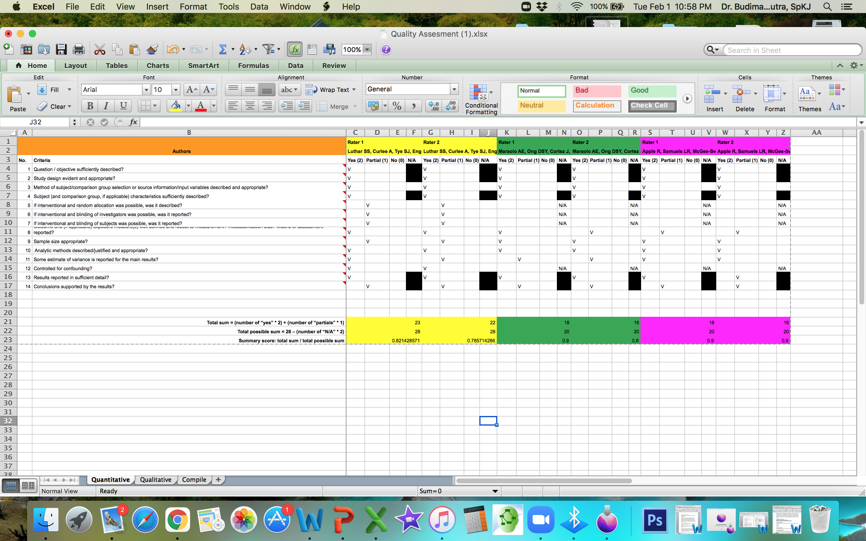

Figure S2. Qualitative process
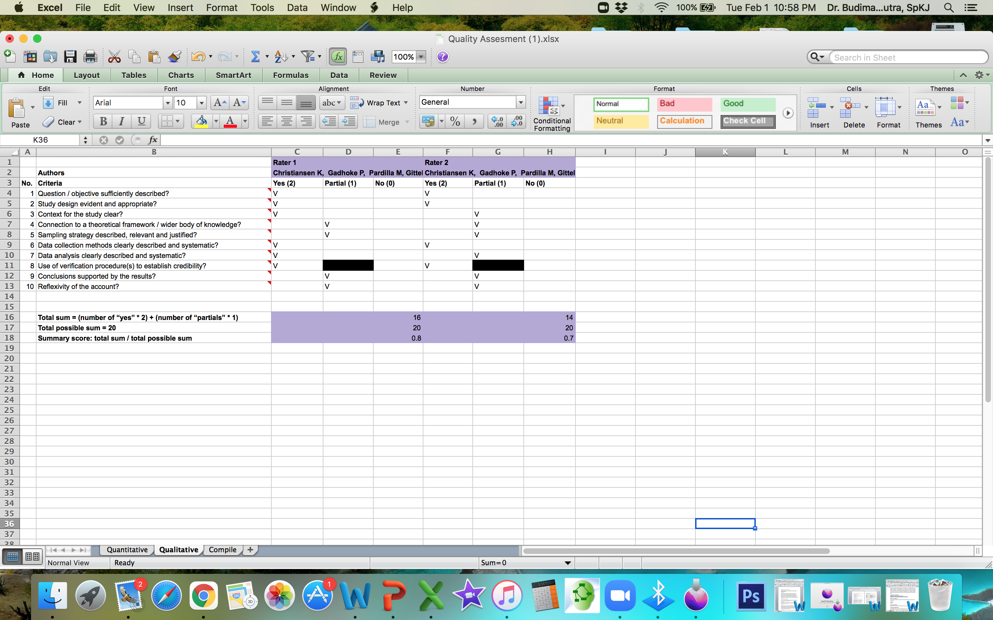

Table Supplement 3. Finding Studies Characteristic

First author, year, journal | Country | Study design  Time research | Participants characteristics |  |  |  | Intervention  Wellness programs | Control | Measures | Outcomes  Wellness or wellbeing or job satisfaction or work life balance | Other
First author, year, journal | Country | Study design  Time research | Total N | Working mothers | Occupation | Age in years  Mean (SD)
Christiansen K (2017)  Ethnicity and Health. April 2017 DOI: 10.1080/13557858.2017.1313964 | USA | Qualitative  July 2010 and August 2011 | 180 adults (90% women)  35 children | 89 eligible for FGD and in depth interview | Female primary caregivers, schools, the tribal employees from tribal agencies, enterprises (such as the casino and gas station) | Adults 18-75 all women  Children 6-17 | Indoor walking clubs, worksite pedometer challenges, recipe contests, and social support (exercise or eat healthier together, presented extra break time during the workday for workers to exercise or choose a continuing education class), incentives to engage in healthier behaviours | None | In depth interview and FGD identify recurrent themes related to work-life balance, and stresses or support within the domains of work and family  The codes were then organized using an adapted framework of hypothesized antecedents to work-life conflict, which included structural characteristics, role stressors, and social support | - Work life balance  - Work family balance  - Healthy behaviours (regular eating, activity schedule, physical activity, healthy diet)  Positive response to the respondents | Workers with nonstandard hours cannot join these programs
Luthar SS (2017)  Women's Health Issues xxx-xx (2017) 1–9. http://dx.doi.org/10.1016/j.whi.2017.02.007 | USA | RCT  February and November 2015 | 40 (randomize divided to intervention and control) | Intervention: 21  Control: 19  Inclusion required at least one child 18 years of age or younger. | PhD clinicians,  physicians, physician assistants, nurse practitioners | Mean ages of participants (SD) were 38.76 years (6.13) and 39.39 years (4.83) | Authentic Connections Groups (ACG) based on the structured Relational Psychotherapy Mothers’ Groups (RPMG) with 12 sessions (stress management) | No treatment | Participants were assessed at baseline, after the intervention, and at 3 months of follow-up using questionnaires used in prior research, along with measures of plasma cortisol  Global symptoms and depression: the Brief Symptom Index and the Beck Depression Inventory  The Self- Compassion Scale has 26 items (5-point scale; a 1⁄4 0.88), and feeling loved was assessed by four questions (7-point scale; a 1⁄4 0.93), For physical affection, participants rated satisfaction on three items (5-point scale; a 1⁄4 0.91)  The Parenting Stress Inventory has 36 items (5-point scale; a 1⁄4 0.68)  The Maslach Burnout Inventory has three subscales of which the first, emotional exhaustion, was central to our analyses (a 1⁄4 0.93; values were a 1⁄4 0.86 for depersonalization and a 1⁄4 0.68 for personal accomplishment). | - Mental health (less depression, less stress, lower stress hormone)  Results of ANCOVAs, indicated that after the intervention group differences were significant on global symptoms and depression, with moderate effect sizes (hp2 1⁄4 0.13 and 0.11). At the 3-month follow-up, differences were statistically significant on all central outcomes except emotional exhaustion (p 1⁄4 .09), with most effect sizes moderate or larger (h 2 1⁄4 0.08–0.20; median, 0.16). Differences became more pronounced between the post-treatment and follow-up assessments.  Results of repeated measures ANOVAs, were consistent, with significant Group Time effects for five of the seven primary outcomes. Again, significant effects were well above “small” (hp2 1⁄4 0.02), generally closer to the medium value of 0.13.  Paired t tests comparing change in individual cortisol levels showed significant reductions from baseline to A) after treatment for the 19 ACG women (1 outlier excluded, M % SEM 1⁄4 "14.89 % 7.775 ng/mL), t(18) 1⁄4 1.916, p < .05, and also B) to follow-up, with data on 15 women (2 outliers excluded, M % SEM 1⁄4 "16.89 % 9.157 ng/mL), t(14) 1⁄4 1.845, p < .05. For the control group, paired t tests showed nonsignificant changes in both instances.  In additional analyses, we compared AC and controls on changes in cortisol levels. A trend toward significance was observed for mean individual differences between ACG and controls at after the intervention (M % SEM 1⁄4 16.59 % 10.40 ng/mL), t(37) 1⁄4 1.596, p 1⁄4 .06; and follow-up (M % SEM 1⁄4 14.59 % 10.02 ng/mL), t(31) 1⁄4 1.457, p 1⁄4 .08. | The control group, paired t tests showed nonsignificant changes in both instances
Maraolo AE (2017)  Eur J Clin Microbiol Infect Dis (2017) 36:1287–1295 DOI 10.1007/s10096-017-2937-4 | UK | Questionnaire survey  26 April - 13 July 2015 | 416  259 females  157 males | 83 | Physicians | Mean age of 32 years [standard deviation (SD) 5 years] | Working hour flexibility, stimulating work environment, activities during free time, paternity/maternity leaves | None | The open source software Lime Survey (Lime Survey GmbH, Hamburg, Germany) address several aspects of trainees’ QoL: work flexibility for physicians becoming parents during training, workplace mobbing experience (i.e. bullying of an individual by a group; it concerns repetitive behaviours by peers and superiors that makes the workplace and daily activities of the subject uncomfortable), burnout feelings, adequate trainee representation on boards where the policy on training conditions is discussed, presence of a stimulating work environment, activities during free time and alcohol consumption.  No differences were observed concerning gender, speciality and workplace. Female physicians from benefit more from maternity leaves 77.1%, respectively  Working hours flexibility for breastfeeding mothers showed that 43/87 (49.4%) enjoyed this benefit.  Overall, 128/416 (31%) found their work environment not stimulating.  Regular physical activity, defined as at least 1 h of gym/running every other day, was reported by 264 (44%) respondents.  Although not statistically significant, there was a tendency for more mobbing experience among females  Females have more major burnout feelings than males | - Work life balance (maternity leave) > 50%  - Healthy behaviours < 50% (physical activity)  - Mental health < 50% (stress management) | Limited by the inherent limitations of opinion-based surveys. We did not combine these quantitative data with qualitative data in order to explore perceptions in parenthood, mobbing experience and burnout more in depth.
Apple R (2020)  Journal of Occupational and Environmental Medicine JOEM Volume 62, Number 1, January 2020. DOI: 10.1097/JOM.0000000000001774 | USA | Cross-sectional  5 - 30 September 2018 | 558, secondary outcome data  N = 340 for stress related (primary outcome)  N = 336 for burnout (secondary outcome)  Affiliated:  N 155 (primary outcome)  N 154 (secondary outcome)  Not affiliated  N 185 primary outcome)  N 182  (secondary outcome) | Who had at least one child in one of VUMC’s five affiliated childcare centres or were on the waitlist for VUMC-affiliated childcare. | Physicians; house staff physicians; other clinical provider; non-clinical support or administration non-clinical faculty | None | Institution-affiliated childcare (supportive social and physical environments) | Not affiliated childcare | The survey was offered in English and consisted of 58 items that queried participants in the following constructs: demographics, childcare use, stress, burnout, and career decisions.  Personal stress was measured using six items,  The Maslach burnout inventory for burnout  The median overall stress score for individuals with institution-affiliated childcare was 51.2 (IQR 41.4, 60.1). The median overall stress score for individuals without institution-affiliated childcare was 57.5 (IQR 48.0, 65.0). Multivariable linear regression estimated that institution-affiliated childcare was associated with an overall stress score that was lower by  4.86 points (95% confidence interval [CI] [1.72, 8.01], P 1⁄4 0.002)  Institution-affiliated childcare was associated with lower childcare (finding and securing) stress scores ( – 14.2 points, CI [ – 19.2, – 9.2], P < 0.0001).  Institution-affiliated childcare was also associated with lower financial stress scores ( – 9.9 points, CI [ – 15.9, – 3.8], P 1⁄4 0.001) and lower personal health stress scores ( – 6.2 points, CI [ – 11.8, – 0.6], P 1⁄4 0.03).  In multivariable ordinal logistic regression models examining the relationship between institution-affiliated childcare and individual components of burnout, participation in institution-affiliated childcare was associated with lower adjusted odds of experiencing a decreased feeling of accomplishment (odds ratio [OR] 0.6, CI (0.4, 0.9), P 1⁄4 0.01).  This result and those for the remaining burnout questions, none of which were significant at the 5% level.  Differences between groups related to job, relationship with spouse, or parental responsibilities were not statistically significant. | - Mental health (less stress and burnout)

