Table Supplement 2. Quality assessment of each study

No | Research Paper | Over all score
No | Research Paper | Rater 1 | Rater 2 | Mean | Study | Quality
1 | Christiansen K, Gadhoke P, Pardilla M, Gittelsohn J. (2017) | 0.8 | 0.7 | 0.75 | Qualitative | Adequate
2 | Luthar SS, Curlee A, Tye SJ, Engelman JC, Stonnington CM. (2017) | 0.82 | 0.78 | 0.8 | Quantitative | Strong
3 | Maraolo AE, Ong DSY, Cortez J, Dedić K, Dušek D, Martin-Quiros A, et al (2017). | 0.9 | 0.8 | 0.85 | Quantitative | Strong
4 | Apple R, Samuels LR, McGee-Swope K, Alsup C, Dewey C, Roumie CL. (2020) | 0.9 | 0.8 | 0.85 | Quantitative | Strong

Quality interpretation • For quantitative papers: strong (summary score of >0.80), good (summary score of 0.71-0.79),adequate (summary score of 0.50-0.70) and limited (summary score of <0.50), and • For qualitative papers: a score of ≥0.55 as an ‘adequate quality’ paper. A score of ≤0.54 was deemed as a ‘low quality’ paper.

Figure S1. Quantitative process
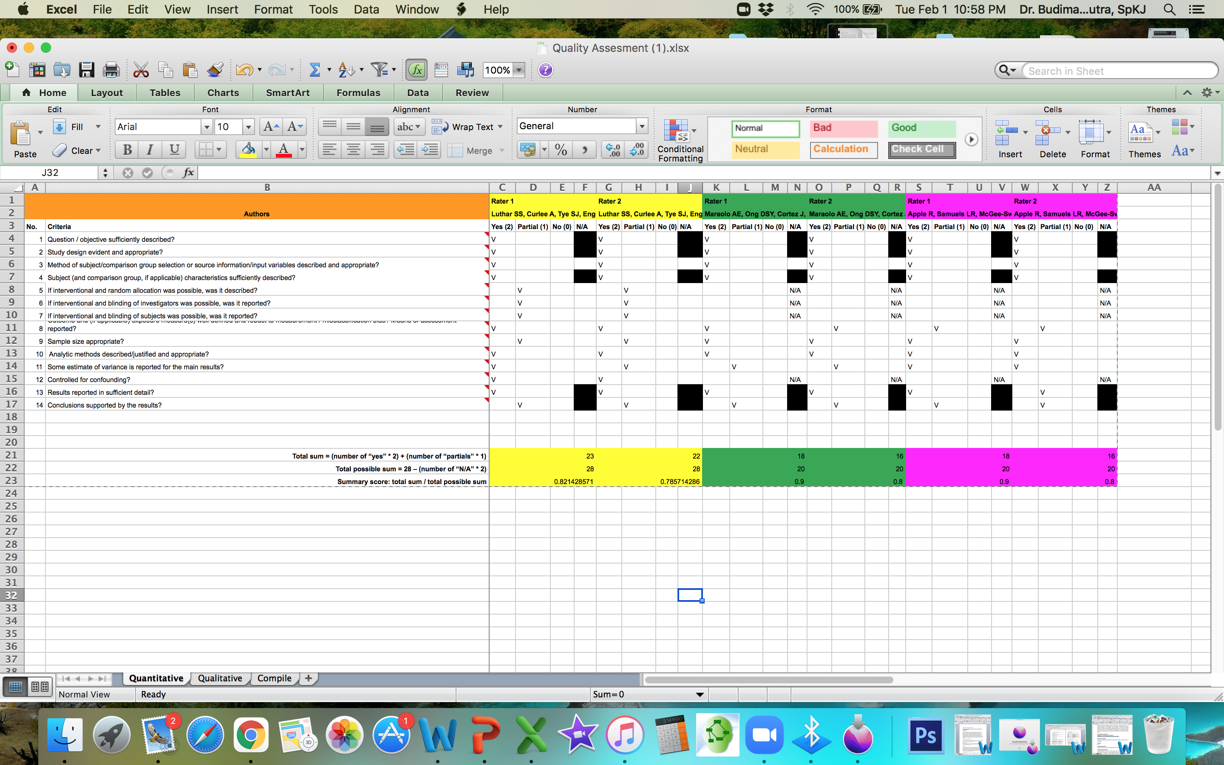

Figure S2. Qualitative process

Table Supplement 3. Finding Studies Characteristic

First author, year, journal | Country | Study design  Time research | Participants characteristics |  |  |  | Intervention  Wellness programs | Control | Measures | Outcomes  Wellness or wellbeing or job satisfaction or work life balance | Other
First author, year, journal | Country | Study design  Time research | Total N | Working mothers | Occupation | Age in years  Mean (SD)
Christiansen K (2017)  Ethnicity and Health. April 2017 DOI: 10.1080/13557858.2017.1313964 | USA | Qualitative  July 2010 and August 2011 | 180 adults (90% women)  35 children | 89 eligible for FGD and in depth interview | Female primary caregivers, schools, the tribal employees from tribal agencies, enterprises (such as the casino and gas station) | Adults 18-75 all women  Children 6-17 | Indoor walking clubs, worksite pedometer challenges, recipe contests, and social support (exercise or eat healthier together, presented extra break time during the workday for workers to exercise or choose a continuing education class), incentives to engage in healthier behaviours | None | In depth interview and FGD identify recurrent themes related to work-life balance, and stresses or support within the domains of work and family  The codes were then organized using an adapted framework of hypothesized antecedents to work-life conflict, which included structural characteristics, role stressors, and social support | - Work life balance  - Work family balance  - Healthy behaviours (regular eating, activity schedule, physical activity, healthy diet)  Positive response to the respondents | Workers with nonstandard hours cannot join these programs
Luthar SS (2017)  Women's Health Issues xxx-xx (2017) 1–9. http://dx.doi.org/10.1016/j.whi.2017.02.007 | USA | RCT  February and November 2015 | 40 (randomize divided to intervention and control) | Intervention: 21  Control: 19  Inclusion required at least one child 18 years of age or younger. | PhD clinicians,  physicians, physician assistants, nurse practitioners | Mean ages of participants (SD) were 38.76 years (6.13) and 39.39 years (4.83) | Authentic Connections Groups (ACG) based on the structured Relational Psychotherapy Mothers’ Groups (RPMG) with 12 sessions (stress management) | No treatment | Participants were assessed at baseline, after the intervention, and at 3 months of follow-up using questionnaires used in prior research, along with measures of plasma cortisol  Global symptoms and depression: the Brief Symptom Index and the Beck Depression Inventory  The Self- Compassion Scale has 26 items (5-point scale; a 1⁄4 0.88), and feeling loved was assessed by four questions (7-point scale; a 1⁄4 0.93), For physical affection, participants rated satisfaction on three items (5-point scale; a 1⁄4 0.91)  The Parenting Stress Inventory has 36 items (5-point scale; a 1⁄4 0.68)  The Maslach Burnout Inventory has three subscales of which the first, emotional exhaustion, was central to our analyses (a 1⁄4 0.93; values were a 1⁄4 0.86 for depersonalization and a 1⁄4 0.68 for personal accomplishment). | - Mental health (less depression, less stress, lower stress hormone)  Results of ANCOVAs, indicated that after the intervention group differences were significant on global symptoms and depression, with moderate effect sizes (hp2 1⁄4 0.13 and 0.11). At the 3-month follow-up, differences were statistically significant on all central outcomes except emotional exhaustion (p 1⁄4 .09), with most effect sizes moderate or larger (h 2 1⁄4 0.08–0.20; median, 0.16). Differences became more pronounced between the post-treatment and follow-up assessments.  Results of repeated measures ANOVAs, were consistent, with significant Group Time effects for five of the seven primary outcomes. Again, significant effects were well above “small” (hp2 1⁄4 0.02), generally closer to the medium value of 0.13.  Paired t tests comparing change in individual cortisol levels showed significant reductions from baseline to A) after treatment for the 19 ACG women (1 outlier excluded, M % SEM 1⁄4 "14.89 % 7.775 ng/mL), t(18) 1⁄4 1.916, p < .05, and also B) to follow-up, with data on 15 women (2 outliers excluded, M % SEM 1⁄4 "16.89 % 9.157 ng/mL), t(14) 1⁄4 1.845, p < .05. For the control group, paired t tests showed nonsignificant changes in both instances.  In additional analyses, we compared AC and controls on changes in cortisol levels. A trend toward significance was observed for mean individual differences between ACG and controls at after the intervention (M % SEM 1⁄4 16.59 % 10.40 ng/mL), t(37) 1⁄4 1.596, p 1⁄4 .06; and follow-up (M % SEM 1⁄4 14.59 % 10.02 ng/mL), t(31) 1⁄4 1.457, p 1⁄4 .08. | The control group, paired t tests showed nonsignificant changes in both instances
Maraolo AE (2017)  Eur J Clin Microbiol Infect Dis (2017) 36:1287–1295 DOI 10.1007/s10096-017-2937-4 | UK | Questionnaire survey  26 April - 13 July 2015 | 416  259 females  157 males | 83 | Physicians | Mean age of 32 years [standard deviation (SD) 5 years] | Working hour flexibility, stimulating work environment, activities during free time, paternity/maternity leaves | None | The open source software Lime Survey (Lime Survey GmbH, Hamburg, Germany) address several aspects of trainees’ QoL: work flexibility for physicians becoming parents during training, workplace mobbing experience (i.e. bullying of an individual by a group; it concerns repetitive behaviours by peers and superiors that makes the workplace and daily activities of the subject uncomfortable), burnout feelings, adequate trainee representation on boards where the policy on training conditions is discussed, presence of a stimulating work environment, activities during free time and alcohol consumption.  No differences were observed concerning gender, speciality and workplace. Female physicians from benefit more from maternity leaves 77.1%, respectively  Working hours flexibility for breastfeeding mothers showed that 43/87 (49.4%) enjoyed this benefit.  Overall, 128/416 (31%) found their work environment not stimulating.  Regular physical activity, defined as at least 1 h of gym/running every other day, was reported by 264 (44%) respondents.  Although not statistically significant, there was a tendency for more mobbing experience among females  Females have more major burnout feelings than males | - Work life balance (maternity leave) > 50%  - Healthy behaviours < 50% (physical activity)  - Mental health < 50% (stress management) | Limited by the inherent limitations of opinion-based surveys. We did not combine these quantitative data with qualitative data in order to explore perceptions in parenthood, mobbing experience and burnout more in depth.
Apple R (2020)  Journal of Occupational and Environmental Medicine JOEM Volume 62, Number 1, January 2020. DOI: 10.1097/JOM.0000000000001774 | USA | Cross-sectional  5 - 30 September 2018 | 558, secondary outcome data  N = 340 for stress related (primary outcome)  N = 336 for burnout (secondary outcome)  Affiliated:  N 155 (primary outcome)  N 154 (secondary outcome)  Not affiliated  N 185 primary outcome)  N 182  (secondary outcome) | Who had at least one child in one of VUMC’s five affiliated childcare centres or were on the waitlist for VUMC-affiliated childcare. | Physicians; house staff physicians; other clinical provider; non-clinical support or administration non-clinical faculty | None | Institution-affiliated childcare (supportive social and physical environments) | Not affiliated childcare | The survey was offered in English and consisted of 58 items that queried participants in the following constructs: demographics, childcare use, stress, burnout, and career decisions.  Personal stress was measured using six items,  The Maslach burnout inventory for burnout  The median overall stress score for individuals with institution-affiliated childcare was 51.2 (IQR 41.4, 60.1). The median overall stress score for individuals without institution-affiliated childcare was 57.5 (IQR 48.0, 65.0). Multivariable linear regression estimated that institution-affiliated childcare was associated with an overall stress score that was lower by  4.86 points (95% confidence interval [CI] [1.72, 8.01], P 1⁄4 0.002)  Institution-affiliated childcare was associated with lower childcare (finding and securing) stress scores ( – 14.2 points, CI [ – 19.2, – 9.2], P < 0.0001).  Institution-affiliated childcare was also associated with lower financial stress scores ( – 9.9 points, CI [ – 15.9, – 3.8], P 1⁄4 0.001) and lower personal health stress scores ( – 6.2 points, CI [ – 11.8, – 0.6], P 1⁄4 0.03).  In multivariable ordinal logistic regression models examining the relationship between institution-affiliated childcare and individual components of burnout, participation in institution-affiliated childcare was associated with lower adjusted odds of experiencing a decreased feeling of accomplishment (odds ratio [OR] 0.6, CI (0.4, 0.9), P 1⁄4 0.01).  This result and those for the remaining burnout questions, none of which were significant at the 5% level.  Differences between groups related to job, relationship with spouse, or parental responsibilities were not statistically significant. | - Mental health (less stress and burnout)

